Windows Vista™ Hardware Start Button
Draft Preview: Version 0.92
March 20, 2006
© 2006 Microsoft Corporation. All rights reserved.
Abstract
This specification provides hardware designers and product planners with the requirements and recommendations necessary to implement the Windows Vista™ Hardware Start Button in their products.
The Hardware Start Button is designed to be an attractive and discoverable actuator to launch the new Start menu and search experiences introduced in the Windows Vista family of operating systems. The Hardware Start Button creates and deepens the affinity between physical hardware and the Windows Vista user experience, and complements the brand platforms and product design languages of hardware manufacturers. A preliminary version of the new Start menu is included in the Windows Vista Beta.
Contents
What Is the Hardware Start Button? 3
Hardware Start Button Requirements 5
Windows Logo Program 5
Detailed Hardware Start Button Requirements 5
Conventional Keycap Design Requirements 5
Non-Conventional Keycap Design Requirements 11
Lens Insert Requirements 15
Resources 2
Appendix A 2
Conventional Keycap Recommendations 2
Non-Conventional Keycap Recommendations 2

Disclaimer
The information contained in this document represents the current view of Microsoft Corporation on the issues discussed as of the date of publication. Because Microsoft must respond to changing market conditions, it should not be interpreted to be a commitment on the part of Microsoft, and Microsoft cannot guarantee the accuracy of any information presented after the date of publication.

This document is for informational purposes only. MICROSOFT MAKES NO WARRANTIES, EXPRESS, IMPLIED OR STATUTORY, AS TO THE INFORMATION IN THIS DOCUMENT.

Complying with all applicable copyright laws is the responsibility of the user. Without limiting the rights under copyright, no part of this document may be reproduced, stored in or introduced into a retrieval system, or transmitted in any form or by any means (electronic, mechanical, photocopying, recording, or otherwise), or for any purpose, without the express written permission of Microsoft Corporation.

Microsoft may have patents, patent applications, trademarks, copyrights, or other intellectual property rights covering subject matter in this document. Except as expressly provided in any written license agreement from Microsoft, the furnishing of this document does not give you any license to these patents, trademarks, copyrights, or other intellectual property.

You have no obligation to give Microsoft any suggestions, comments or other feedback ("Feedback") relating to the information contained in this document. However, any Feedback you voluntarily provide may be used in Microsoft Products and related specifications or other documentation (collectively, "Microsoft Offerings") which in turn may be relied upon by other third parties to develop their own Products. Accordingly, if You do give Microsoft Feedback on any version of this document or the Microsoft Offerings to which they apply, You agree: (a) Microsoft may freely use, reproduce, license, distribute, and otherwise commercialize Your Feedback in any Microsoft Offering; (b) You also grant third parties, without charge, only those patent rights necessary to enable other Products to use or interface with any specific parts of a Microsoft Product that incorporate Your Feedback; and (c) You will not give Microsoft any Feedback (i) that You have reason to believe is subject to any patent, copyright or other intellectual property claim or right of any third party; or (ii) subject to license terms which seek to require any Microsoft Offering incorporating or derived from such Feedback, or other Microsoft intellectual property, to be licensed to or otherwise shared with any third party.

© 2006 Microsoft Corporation. All rights reserved.

Microsoft and Windows Vista are either trademarks or registered trademarks of Microsoft Corporation or its affiliates in the United States and/or other countries.

The names of actual companies and products mentioned herein may be the trademarks of their respective owners.



What Is the Hardware Start Button?
The Hardware Start Button for the Windows Vista family of operating systems is designed to be an attractive, efficient, and discoverable actuator to launch both the Start menu and the powerful new search experience in Windows Vista™. The Hardware Start Button creates and deepens the affinity with Windows Vista while complementing the brand platforms and products of hardware manufacturers. Because the new Start experience in Windows Vista provides a text search that the user would typically access from the keyboard, it is more compelling to launch the Start menu with the Hardware Start Button than in previous Windows operating systems. A preliminary version of the new Start menu is included in the Windows Vista Beta.
This specification provides the requirements and recommendations necessary to create a keyboard that includes one or more Hardware Start Buttons, consisting of a polished dome with a Windows Flag Logo applied to the keycap.
The Hardware Start Button is a visual update to the Windows Key typically found on a PC keyboard. It sends the same scan codes or Human Interface Device (HID) usages as the Windows Key. Figure 1 illustrates some example implementations of the Hardware Start Button.
Products that implement a Hardware Start Button must use the term “Windows Start Button” to describe it in any documentation or packaging.
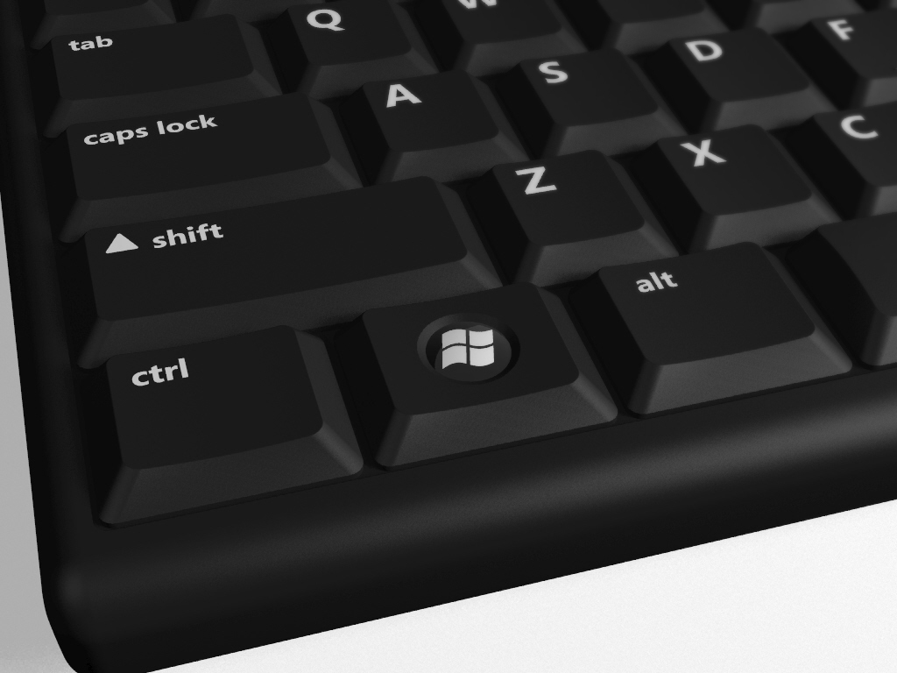

Figure 1: Example implementation of the Hardware Start Button
Figure 2 shows some perspective renderings of example Hardware Start Button implementations that follow the requirements and recommendations included in this specification. These requirements provide a reference for product designers. These illustrations provide examples of standard, very short, and very small keycaps.
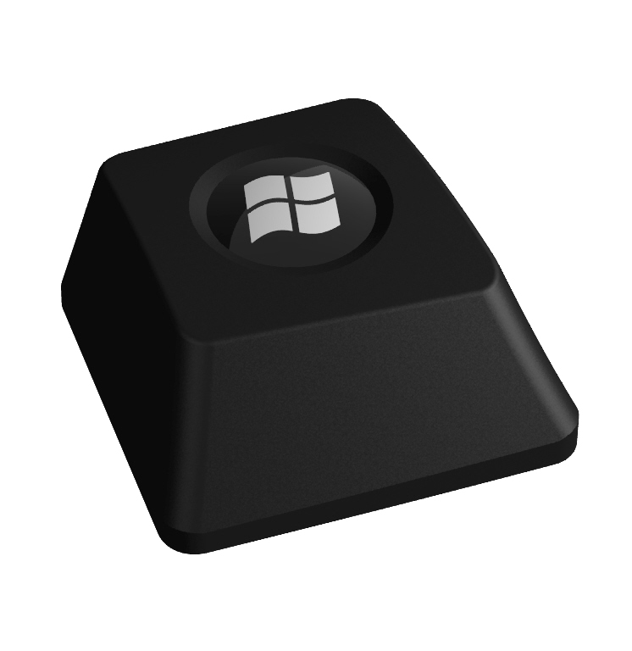
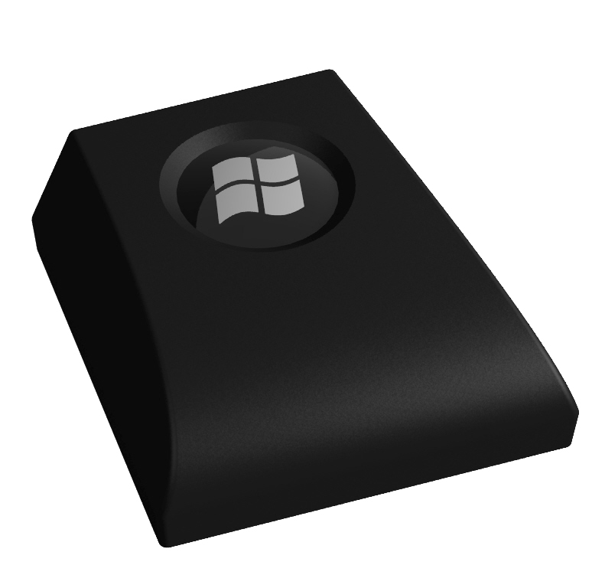
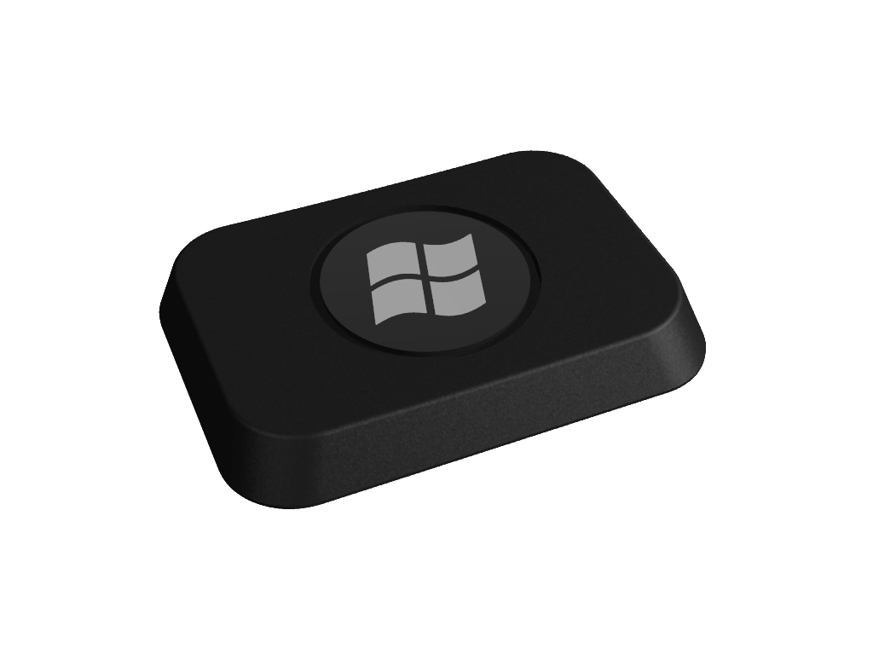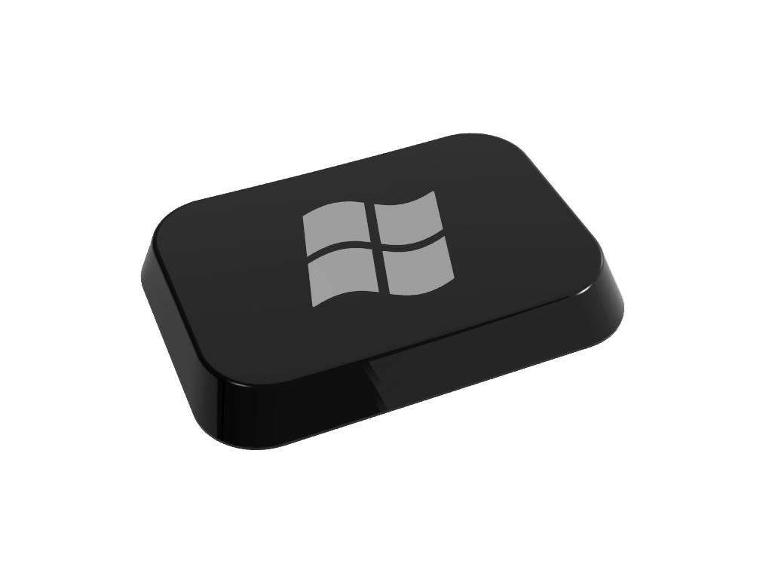
Figure 2: Example perspective renderings of Hardware Start Button implementations

Hardware Start Button Requirements
This section includes the requirements and recommendations for implementing the Hardware Start Button functionality. See Appendix A for example implementations of some of these requirements and recommendations.

Windows Logo Program
The Windows Logo Program Device Requirements for Windows Vista Client and Windows Server code named “Longhorn” Version 3.0 document requires the implementation of the Hardware Start Button on keyboards. These Logo requirements are available to Hardware Logo partners. Please see the Windows Logo Program Device Requirements for Windows Vista Client and Windows Server code named “Longhorn” Version 3.0 document for additional details.
A link to the Windows Logo Program Device Requirements for Windows Vista Client and Windows Server code named “Longhorn” Version 3.0 is included in the appendix.

Detailed Hardware Start Button Requirements
Implementing the Hardware Start Button requires meeting all of the detailed requirements listed below for conventional keycaps, as well as any additional requirements and exceptions provided for non-conventional keycaps.

Conventional Keycap Design Requirements

1.0 Keycaps meet additional requirements
Keycaps must meet the all the requirements for conventional keycaps listed below. Exceptions to the requirements are specifically stated in the “Non-Conventional Keycap Design Requirements” section in this specification.
The following list defines the requirements for implementing the molded dome and associated chamfer on a conventional, rectangular keycap:
- The dimensions of dome in the keycap must be meet the size requirements in Table 1.
- The molded dome must be separated from any keycap edge or feature by the distance specified in the offset requirements listed in Table 1 below.
- The dome must be polished to an SPI SPE industry specification of A2 or equivalent.
- The Windows Flag Logo must be applied to the dome and centered horizontally and vertically with reference to the dome as illustrated in Figure 6.
- The Windows Flag Logo must have a contrast ratio of at least 3:1 with respect to background it is applied to.
- The Windows Flag Logo must be proportional in size to the dome as illustrated in Figure 6.
- The Windows Flag Logo must be oriented vertically with a 0 degree angle of offset in relationship to the keycap orientation as illustrated in Figure 6.
- The outer diameter of the chamfer must be 120 percent of the diameter of the dome. The dome must be centered within the chamfer.
- The chamfer must be polished to SPI SPE industry specification of A2 or equivalent.
- The depth of the chamfer must meet the requirements as specified in Table 1 below.
- The dome must be positioned on the keycap to allow the user’s finger to naturally strike directly and comfortably on the dome. Typically this is best done by centering the dome horizontally and vertically on the keycap.
- A matte finish with a consistent texture of MT11000 or equivalent may be used on the Hardware Start Button dome and chamfer instead of an SPI A2 gloss finish until December 31, 2007, provided the following requirements are met:
  - The keyboard releases to market with one or more Hardware Start Button(s) prior to October 31, 2006.
  - The keyboard receives a TUV-GS mark in compliance with EK1-ITB-2000, including the requirements for Germany.
This exception allows keyboard designs that are at or near the limit of gloss finish allowable under the German TUV-GS to add the Hardware Start Button without affecting their ability to receive the German TUV-GS mark. It is recommended that an SPI A2 finish is used, if possible.

Figures 3–5 provide a reference for applying the requirements and recommendations above when implementing a molded dome on a keycap.
For additional examples of conventional keycap designs, see the “Conventional Keycap Recommendations” section in Appendix A.
Table 1: Determining Standard Keycap Dimensions
Dimension | Minimum | Recommended | Maximum
Diameter of the Dome | The larger of 48% of the MinSS* or 6.6mm | 56% of the MinSS* | 64% of the MinSS*
Diameter of the Chamfer | 120% of the diameter of the dome | 120% of the diameter of the dome | 120% of the diameter of the dome
Diameter of the Offset | 130% of the diameter of the chamfer | 150% of the diameter of the chamfer | N/A
Chamfer Depth | The larger of either 0.25mm or 2.8% of the diameter of the dome | 6.6% of the diameter of the dome | N/A
Dome Height | 6.6% of the diameter of the dome | 6.6% of the diameter of the dome | 10% of the diameter of the dome
* The Minimum Strike Surface (MinSS) is equal to the smaller of the width of the strike surface (WSS) dimension or the depth of the strike surface (DSS) dimension. See Figure 8 for examples of how to determine the MinSS.

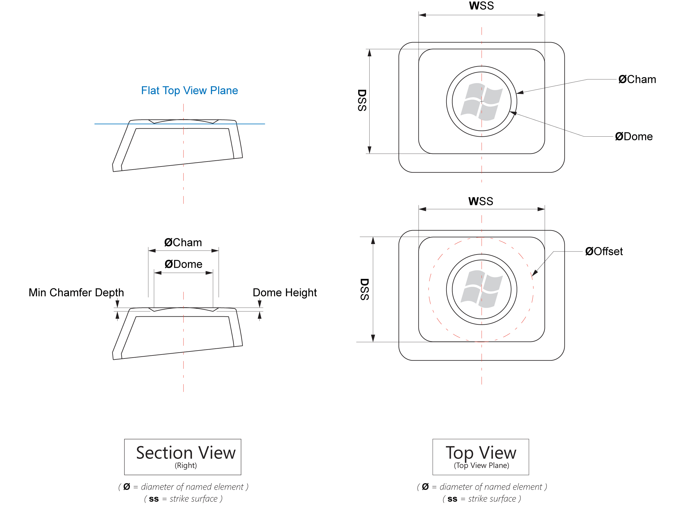
Figure 3: Keycap dimensions for flat keycaps
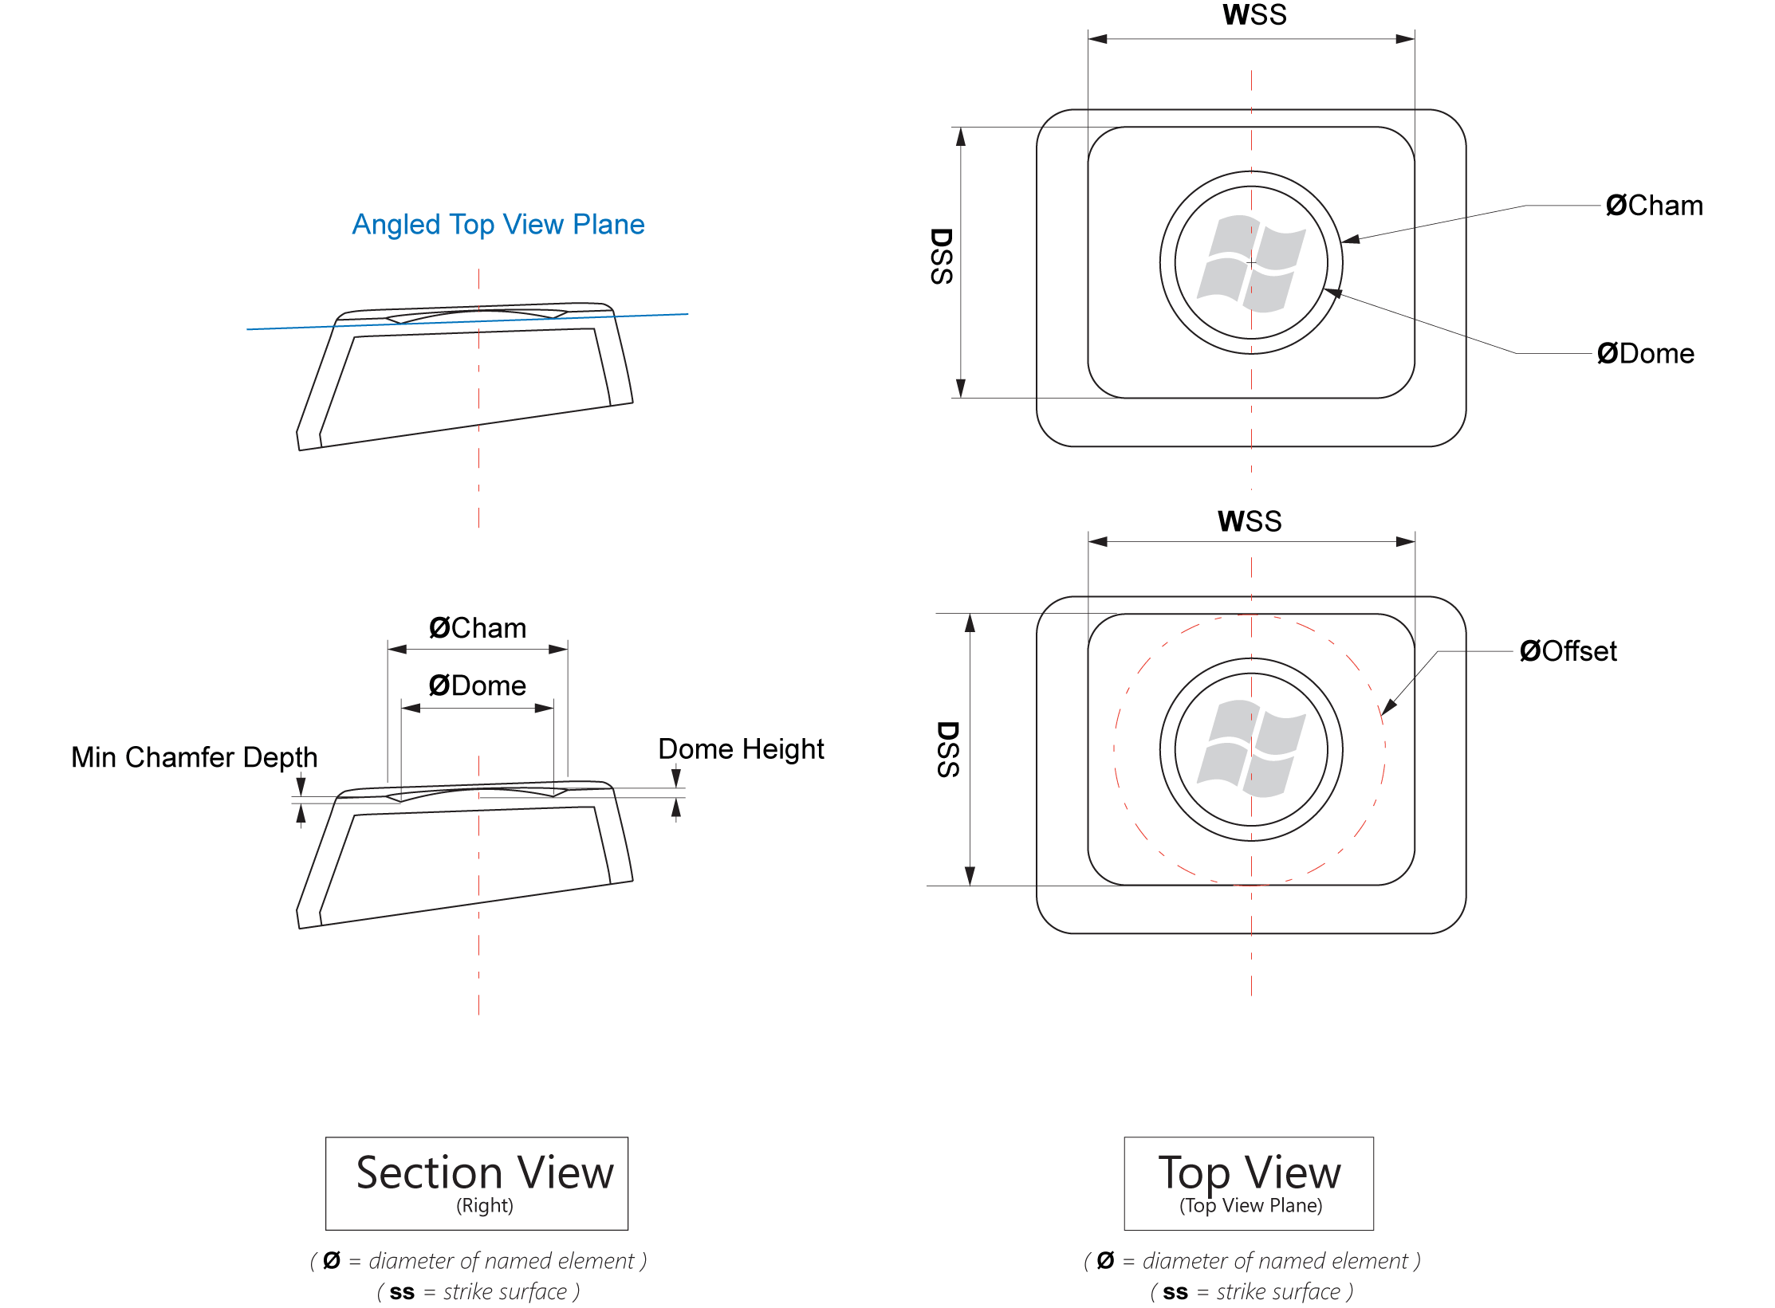
Figure 4: Keycap dimensions for concave keycaps
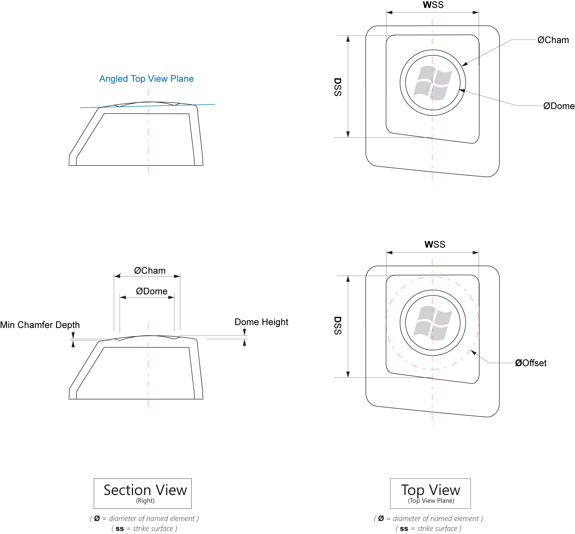
Figure 5: Keycap dimensions for convex keycaps
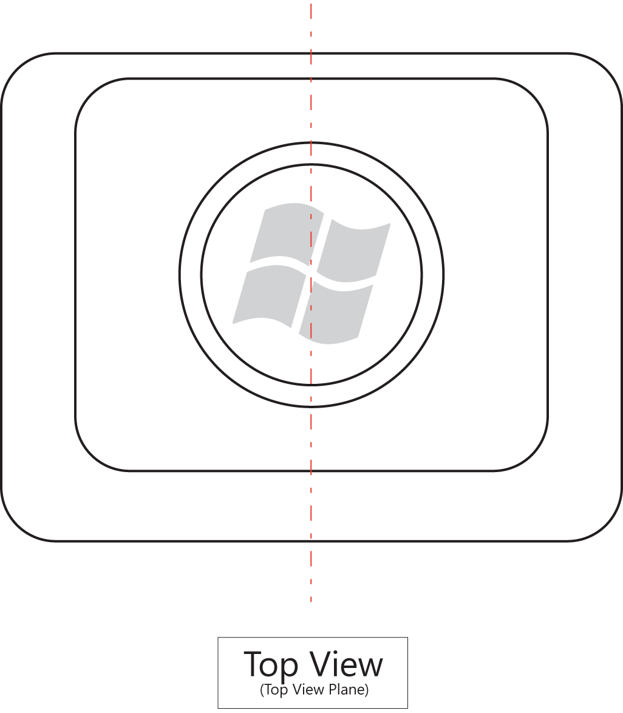
Figure 6: Determining the Windows Flag Logo positioning, orientation and size
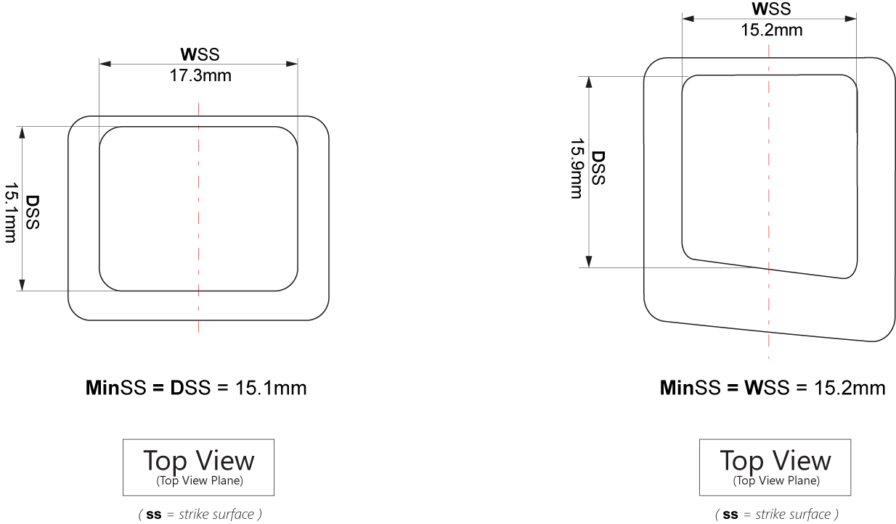
Figure 7: Two examples of determining the MinSS dimension

Non-Conventional Keycap Design Requirements
There are certain common keycap designs that require additional requirements to implement the Hardware Start Button. All requirements of a conventional keycap apply except where explicitly noted.

Very Short Keycap (Laptop) Designs

2.0 Very short keycaps meet additional requirements
If the distance from the base of keycap to the strike surface is less than 2.7mm, the keycap qualifies as a very short keycap. Keycap height is determined by measuring from the base of the keycap to the highest point, not including any post or other mounting hardware (if present). See Figure 8 for an illustration of how to measure keycap height. Keycaps with a very short keycap height may use a fully-polished circle with a reveal, instead of a dome with a chamfer if vertical height of the keycap makes a dome and chamfer impractical. On a very short keycap, the following set of requirements may be implemented instead of a dome:
- The keycap must have a textured strike surface with a centered, fully polished circle as specified in Figure 9 and Table 2.
- The circle must be polished to SPI SPE industry specification of A2 or equivalent. The complete surface of the circle must be polished from the edge to the center.
- The Windows Flag Logo must be printed in the center of the circle and sized proportionally to the polished circle as shown in Figure 9.
- The polished circle must meet the requirements for a reveal as specified in Figure 9 and Table 2.

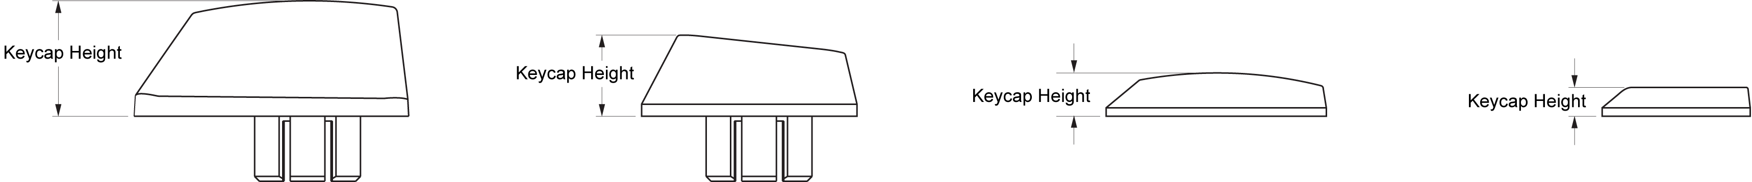
Figure 8: Determining keycap height
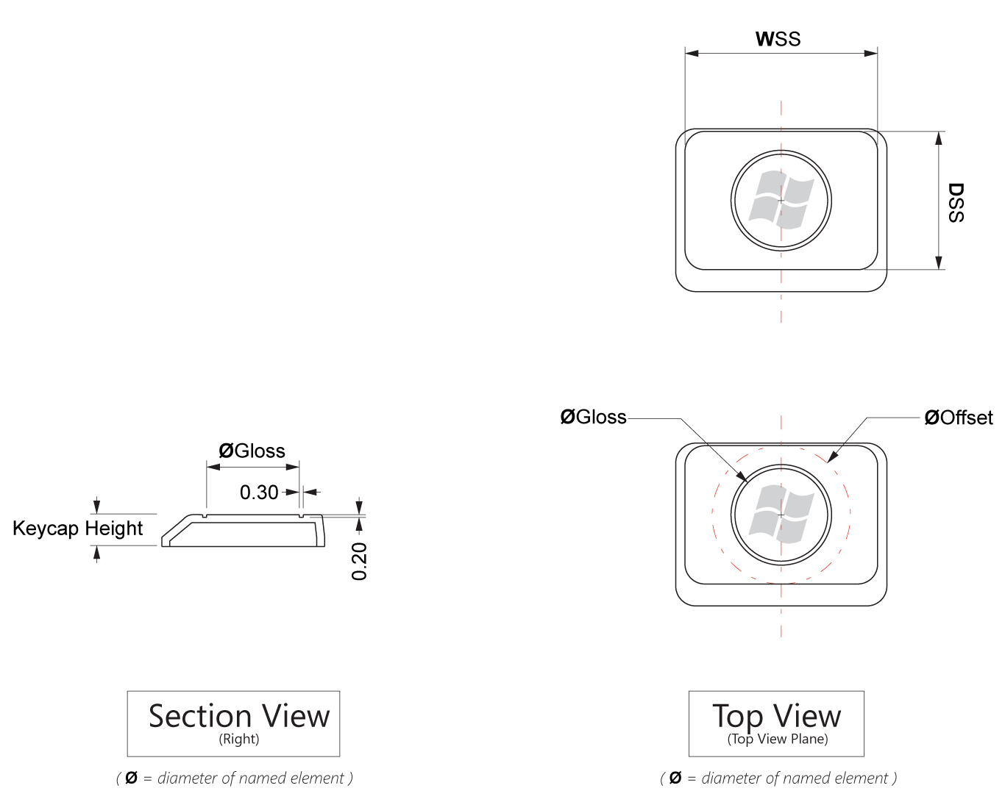
Figure 9: Determining keycap dimensions for very short keycaps

Table 2: Determining Dimensions for Very Short Keycaps
Dimension | Requirement
Diameter of offset | 100 percent of the MinSS
Diameter of polished circle | 66 percent of the MinSS
Reveal depth and width | - No reveal is required. If no reveal is used, maintain a crisp clean line between the textured and polished portions of a keycap.  - If implemented, the reveal must be 0.1mm deep and 0.3mm wide.  - If implemented, the reveal should be 0.2mm deep and 0.3mm wide.

Very Small Keycap (Ultramobile PC or Small Device) Designs

3.0 Very small keycaps meet additional requirements
If the MinSS is less than 8.2mm, then the keycap qualifies as a very small keycap. The MinSS dimension is equal to the smaller of either the WSS dimension or the DSS dimension. See Figure 7 for examples of how to determine the MinSS dimension. Very small keycaps must use a Windows Flag Logo centered on a fully polished strike surface instead of a dome or polished circle, regardless of keycap height. The following additional requirements must also be met:
- The Windows Flag Logo must be centered on the keycap.
- The Windows Flag Logo must be large enough that 122 percent of the Windows Flag Logo is equal to the MinSS size, as illustrated in Figure 10.
- If the keycap is not painted, the entire strike surface of the keycap must be polished to SPI SPE industry specification of A2 or equivalent.
- The non-strike surface of the keycap must be textured to match the surrounding keycaps.

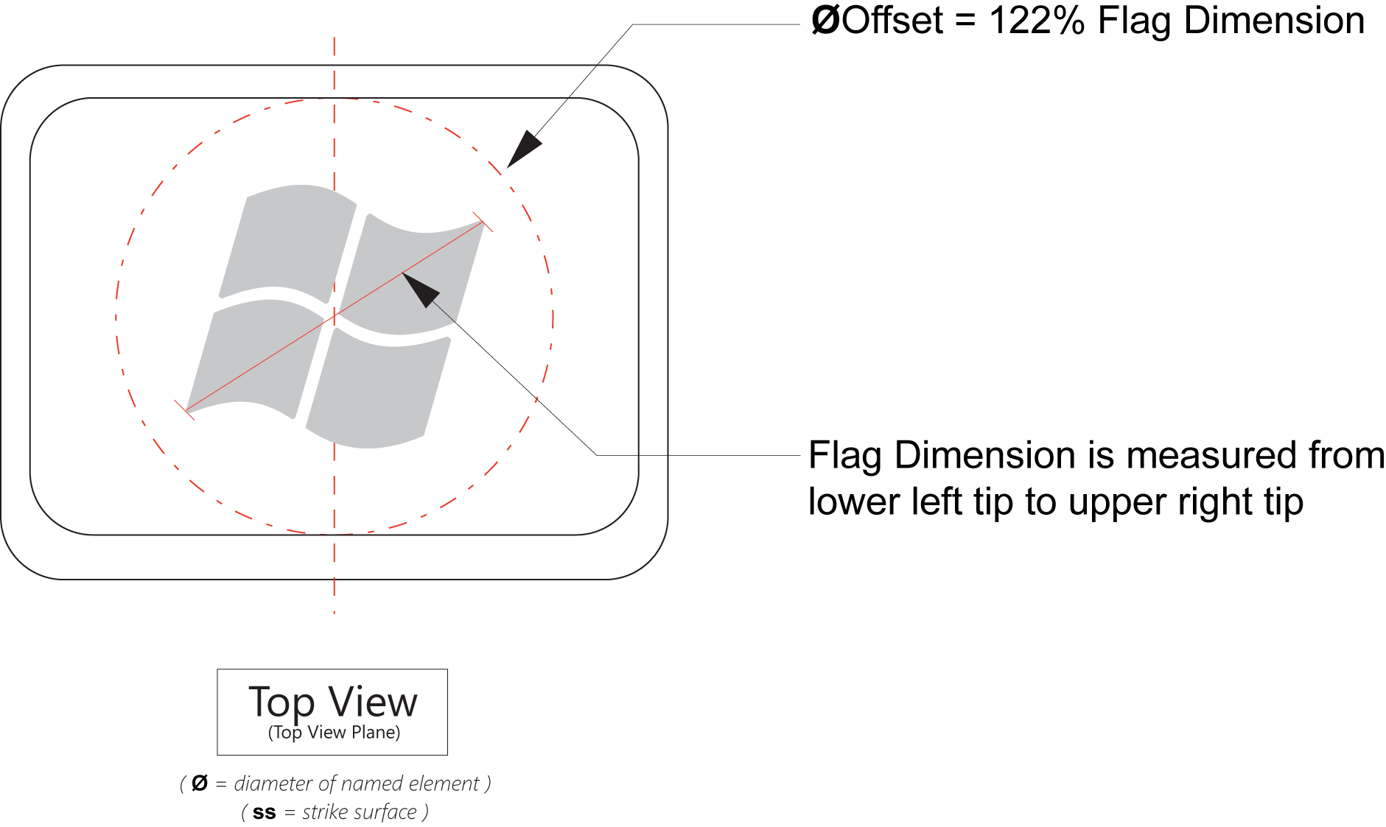
Figure 10: Applying the Windows Flag Logo to very small keycaps

Parallelogram Keycap Designs

4.0 Parallelogram keycap meets design requirements
Figure 11 illustrates how to implement the standard Hardware Start Button keycap requirements on a parallelogram keycap design. Use this figure with Table 1 to determine the correct dimensions and dome placement.
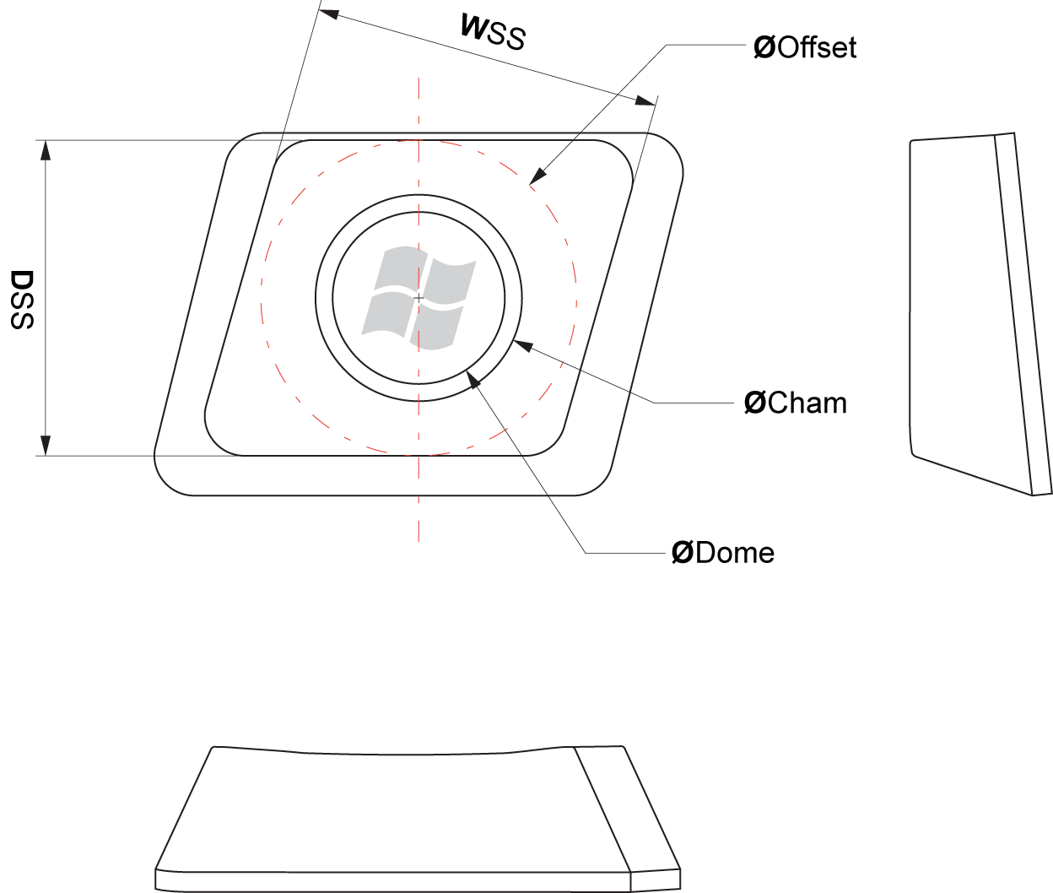
Figure 11: Parallelogram keycap example

Soft Keycap Designs

Soft keycap meets design requirements
Soft keycaps do not have a clean obvious break between the strike surface and the front keycap surface, but a soft, sloping keycap surface that terminates at the front edge of the keycap. Figure 12 illustrates how to implement the Hardware Start Button requirements on a soft keycap design. Use this figure with Table 1 to determine the correct dimensions and dome placement.
Note: When implementing the Hardware Start Button on soft keycaps, particular attention must be placed on determining the placement of the dome to ensure that when a user presses key on the dome, pressure is applied in such a way to prevent binding of the post or other mechanical elements.
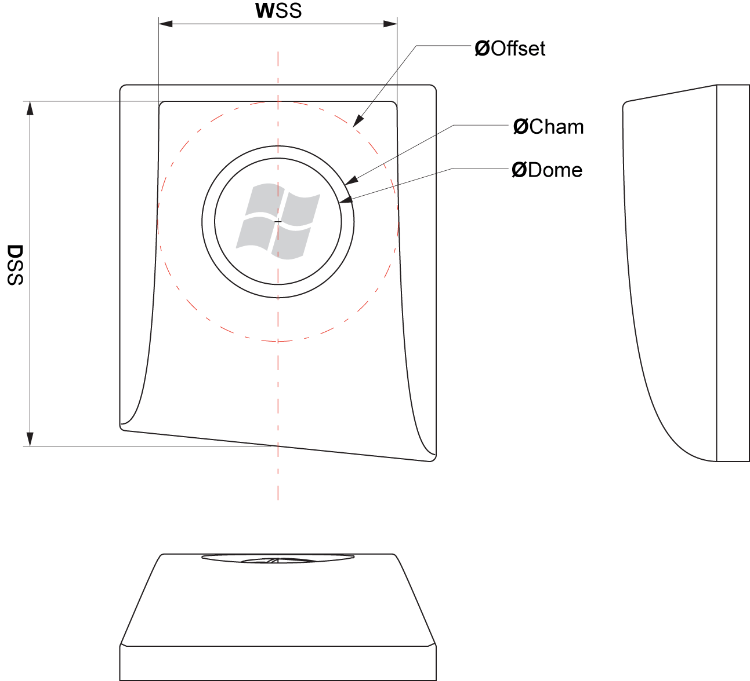
Figure 12: Soft keycap specifications

Circular Keycap Designs

Circular keycap meets design requirements
Figures 13 and 14 illustrate how to implement the Hardware Start Button requirements on a circular keycap design. The circular keycap must meet the following requirements:
- The dome must be 8.4mm in diameter or greater.
- On circular Hardware Start Button keycap designs, the standard offset requirements do not apply.
- For circle-on-square keycap designs, a minimum of a 1-mm clearance is required between the keycap edge and the outer chamfer edge, as illustrated in Figure 13.

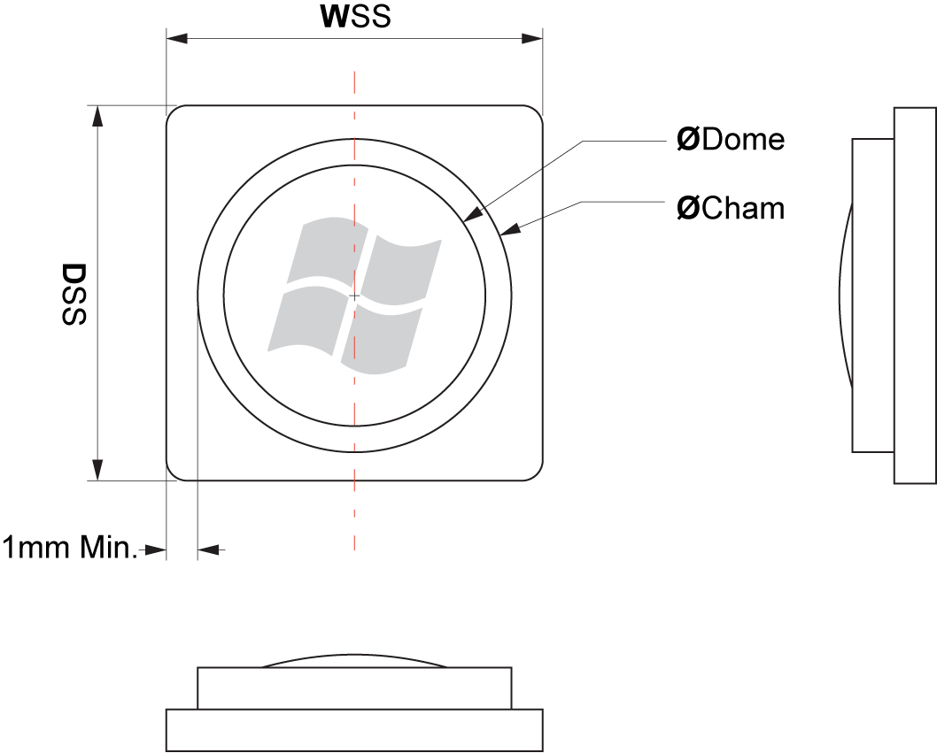
Figure 13: Circle on square keycap example
For example implementations of non-conventional keycaps, see the “Non-Conventional Keycap Recommendations” section in Appendix A.

Dome Requirements

7.0 Dome is parallel to the top view plane
The dome must be parallel to a top view plane keycap. This prevents the dome from appearing to be at an odd angle to the keycap or keyboard. For examples of how to implement this requirement see Figures 3-5 and 11-13.

Defining the Top View Plane
A top view plane is defined as a plane passing through four corner points of the top of the keycap. The top surface of the keycap is aligned with the top view plane, but the top surface of the keycap may be flat, convex, or concave. This method of determining the top view applies to keys with both concave and convex top surfaces. Examples of top view planes as applied to concave and convex keys are illustrated in Figure 14.
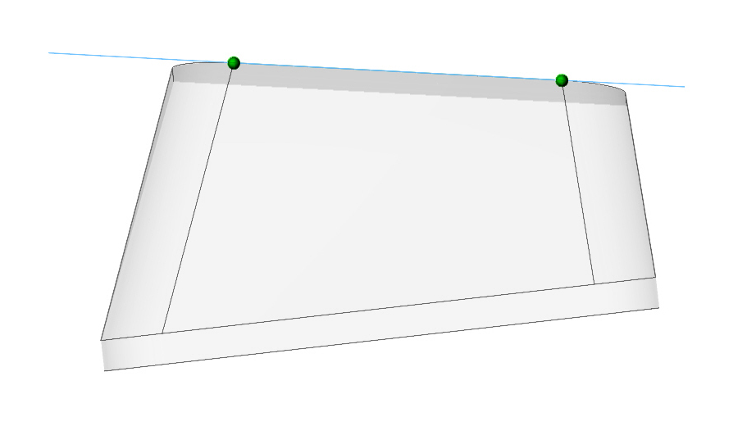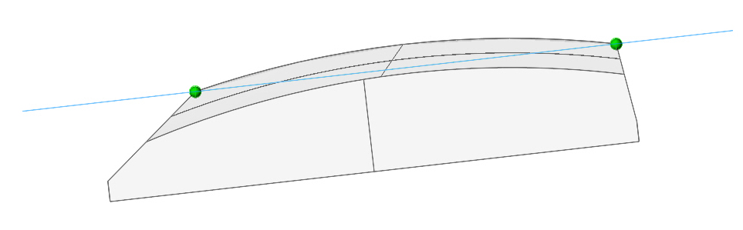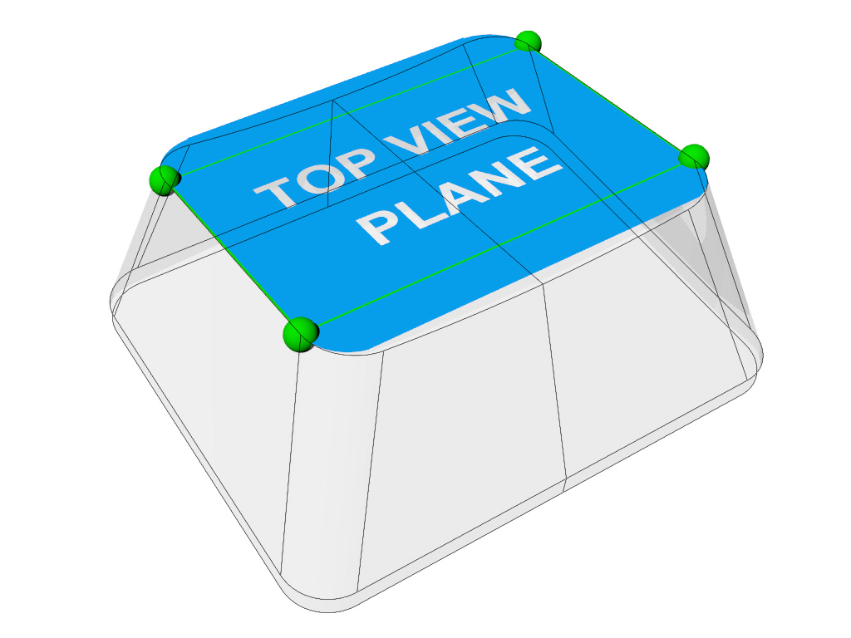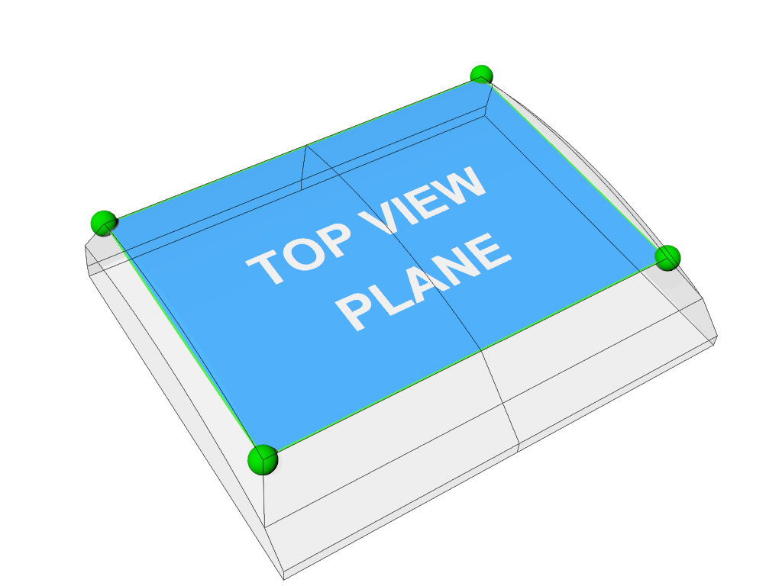
Figure 14: Examples of top view planes on concave and convex keys

Hero Keycap Designs

8.0 Hero keycap button lens meets design requirements
The Hero Start Button uses a lens insert placed directly below the space bar. The hero keycap button lens must meet the following requirements:
- The insert must be acquired from a licensed Windows Vista Logo Lens Insert manufacturer. Note, this approved lens insert will be 15 mm in diameter.
- The diameter of the chamfer around the lens insert must be 19.1 mm.
- The minimum depth of the chamfer is .42 mm.
- The chamfer and lens are separate. The chamfer is fixed and does not move when the lens is actuated.
- On Hero Hardware Start Button keycap designs, the standard offset requirements do not apply.
- The center of the lens must be located within 20 mm below the lower edge of the space bar and the center of the lens should be directly below the center of the space bar.
- The Lens Insert must be parallel to the surrounding keyboard surface. This prevents the dome from appearing to be at an odd angle to the keyboard.
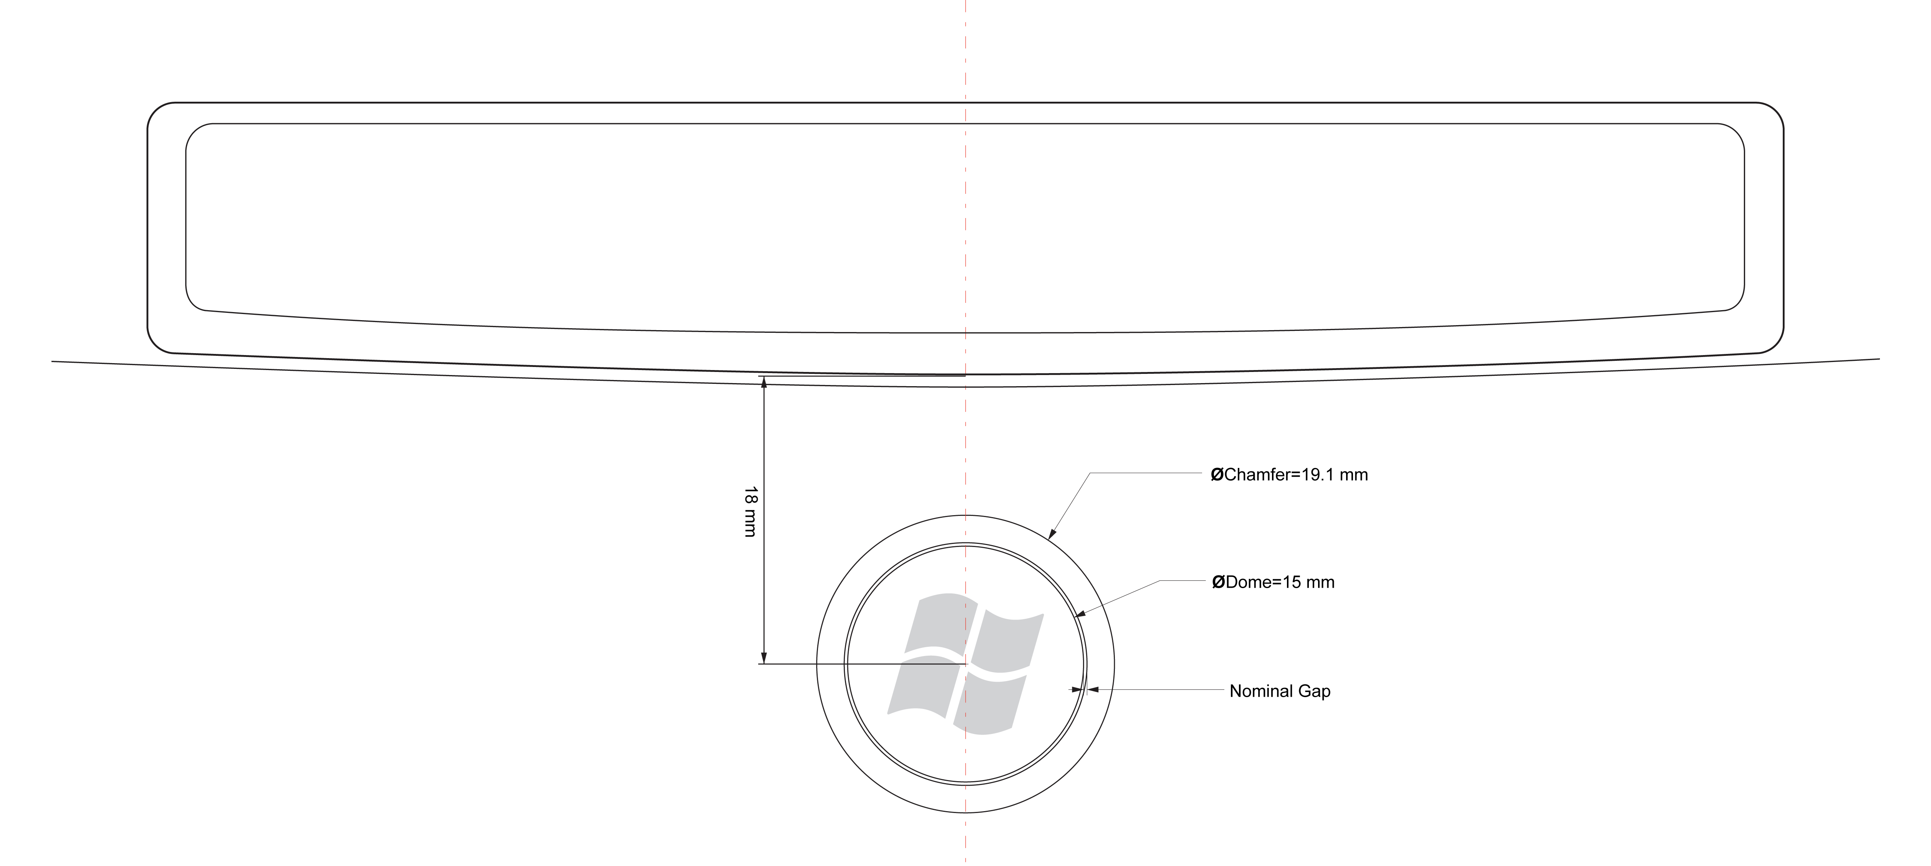
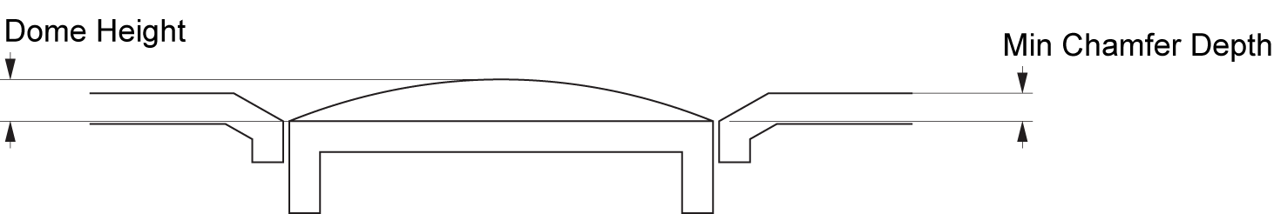
Figure 15: Hero keycap example

9.0 Hero Hardware Start Button uses approved Windows Vista Logo Lens Insert
A Windows Logo Lens Insert is a transparent dome that contains the Windows Flag Logo and is inserted into the keycap, as illustrated in Figure 16.

Figure 16: Example Windows Vista Logo Lens Insert
If implemented, the Hero Hardware Start Button must use a Windows Vista Logo Lens Insert acquired from a licensed Windows Vista Logo Lens Insert manufacturer.

Details of the Windows Vista Logo Lens Insert
The formal requirements for the Windows Vista Logo Lens Insert will be provided in a separate document to be titled “Windows Vista Logo Lens Insert.” The details of the lens insert requirements are listed here for reference only, in order to illustrate the requirements a licensed insert manufacturer must meet. The requirements for the lens insert include:
- The lens dome must be manufactured from a non-tacky urethane or epoxy, or molded polycarbonate.
- The lens must achieve a high-durometer rating of at least 55 Shore D, or equivalent.
- The lens must provide UV protection to prevent yellowing.
- The logo substrate must be Mylar or equivalent.
- The insert must feature either a keyed backing or a mechanism designed for enabling a mechanical application technique for orientation.
- The insert must use a high-strength adhesive, such as 3M 9495LE, 3M 467MP, or equivalents.
- Inserts will be available in a 15-mm diameter.
- The lens insert must include an image of the full-color Windows Vista Flag Logo.

Future versions of this specification will provide a list of licensed lens insert manufacturers in the “Resources” section.

10.0 Lens insert is correctly oriented on Hero Hardware Start Button keycap
A mechanical keying mechanism or a mechanism designed for enabling a mechanical application of the lens must be used to guarantee that the lens insert, and therefore the Windows Flag Logo, is oriented vertically with a 0 degree angle of offset in relationship to the keycap and keyboard with a tolerance of 2.5 degrees, as illustrated in Figure 17. Hardware Manufacturers may work with an approved lens supplier to design the keying mechanism to preference. This keying mechanism must not affect the visual appearance of the lens when implemented in the keyboard.
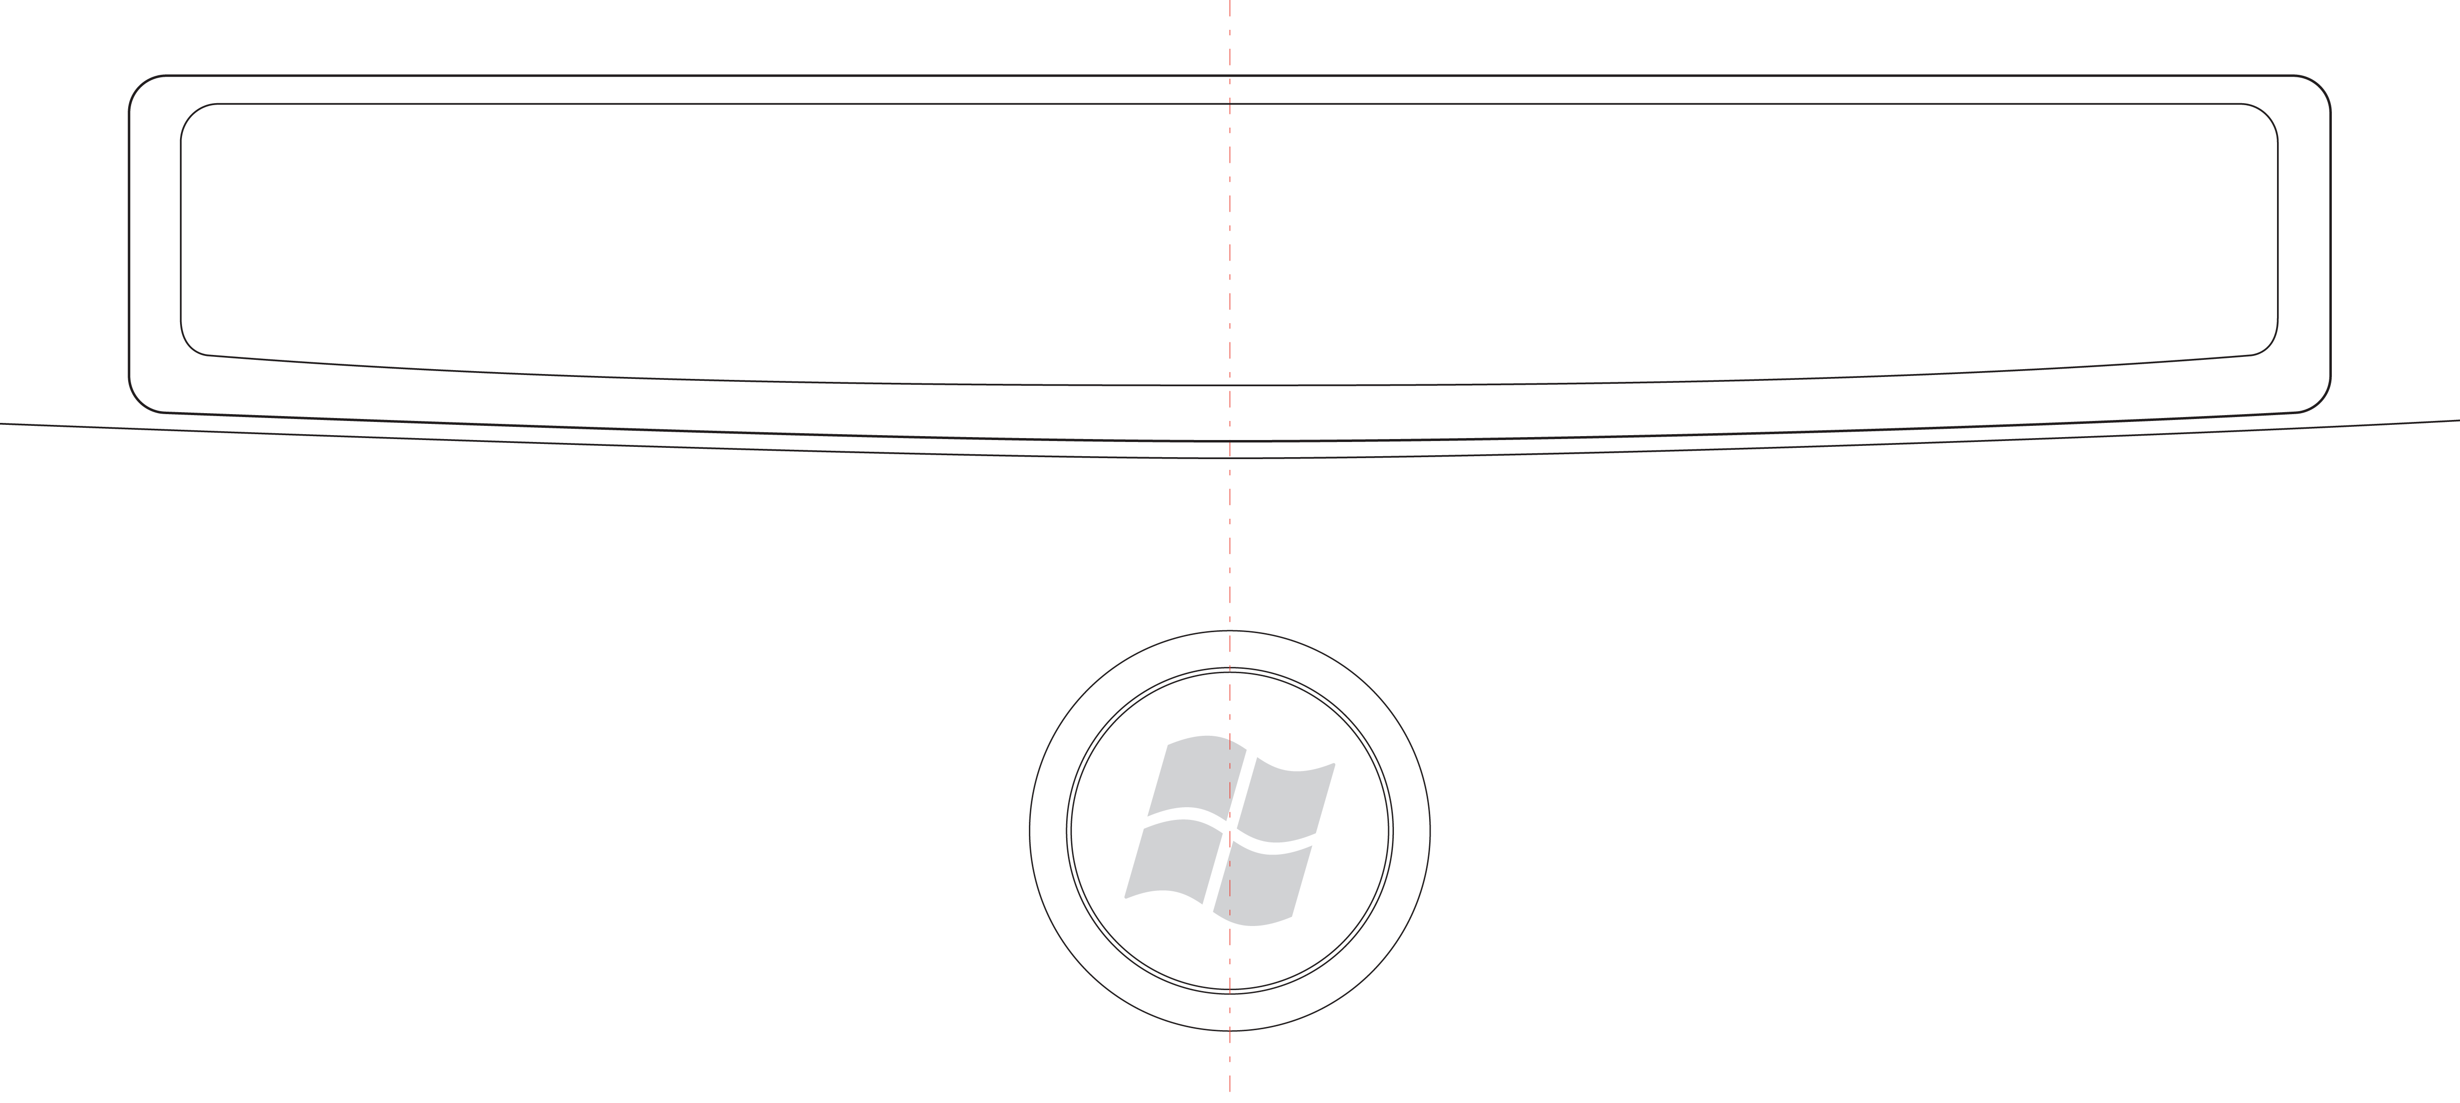
Figure 17: Lens insert orientation
The manufacturing process must guarantee this offset either through a keying device on the keycap and Windows Vista Logo Lens Insert, or through an automated mechanical application of the Windows Vista Logo or Lens Insert.

Resources
Future versions of this specification will provide additional resources for Hardware Start Button design and manufacturing, including links to licensed insert manufacturers of the Windows Vista Logo Lens Insert.

"Designed for Windows" Logo Program for Hardware
- Windows Logo Program Device Requirements for Windows Vista Client and Windows Server code named “Longhorn” Version 3.0
http://www.microsoft.com/whdc/winlogo/hwrequirements.mspx
- The Microsoft Windows Logo Key Logo License Agreement (see the February 2006 or later edition)
https://winqual.microsoft.com/members/legal_agreements.asp
and "Key Support, Keyboard Scan Codes, and Windows"
http://www.microsoft.com/whdc/device/input/Scancode.mspx

Additional Resources for HID Devices
- Input/HID – Architecture and Driver Support for Microsoft Windows
http://www.microsoft.com/whdc/device/input/default.mspx
- Device Class Definitions for HID and other HID-Related Specifications:
http://www.usb.org/developers/hidpage/#Class_Definition

Appendix A
This appendix includes example implementations and recommendations for Hardware Start Button design and manufacturing.

Conventional Keycap Recommendations
The examples in Figure 18 are representative of keycaps designed for standard keyboard keys.
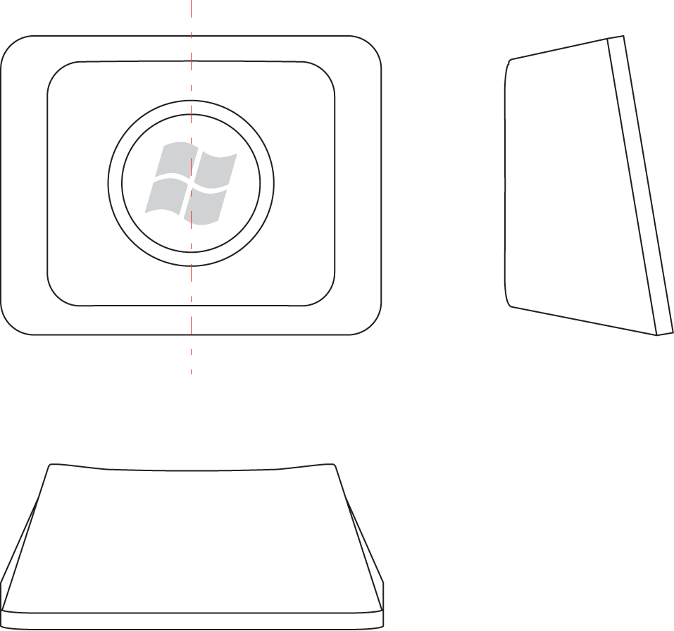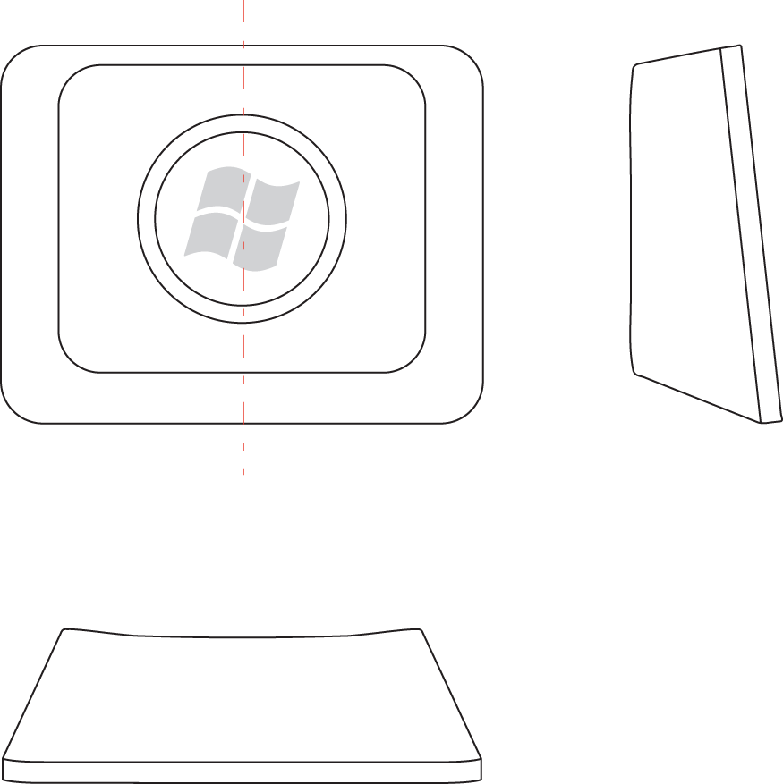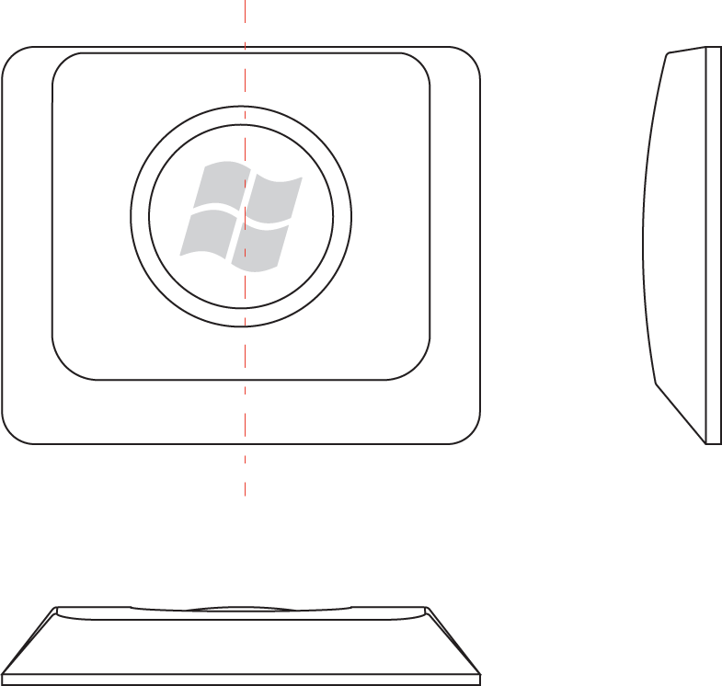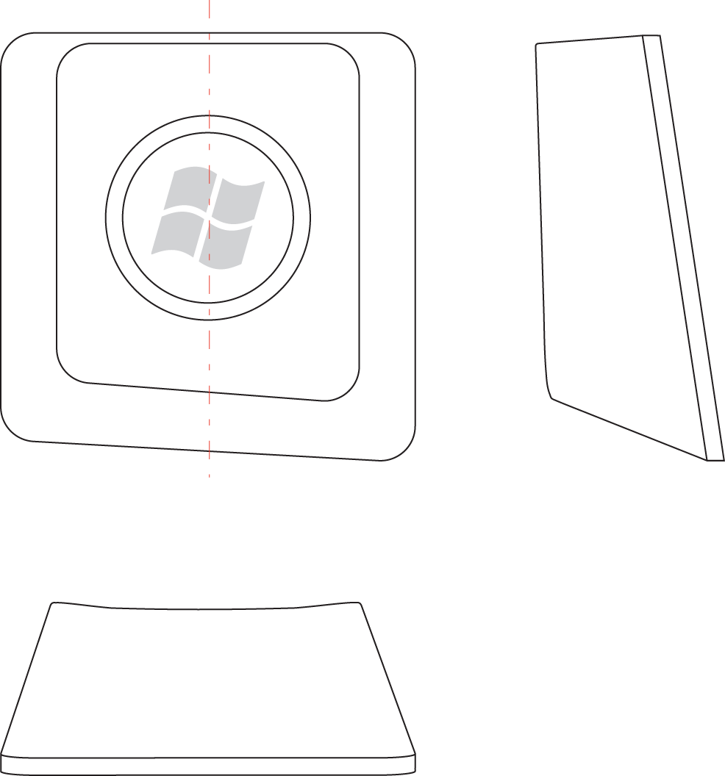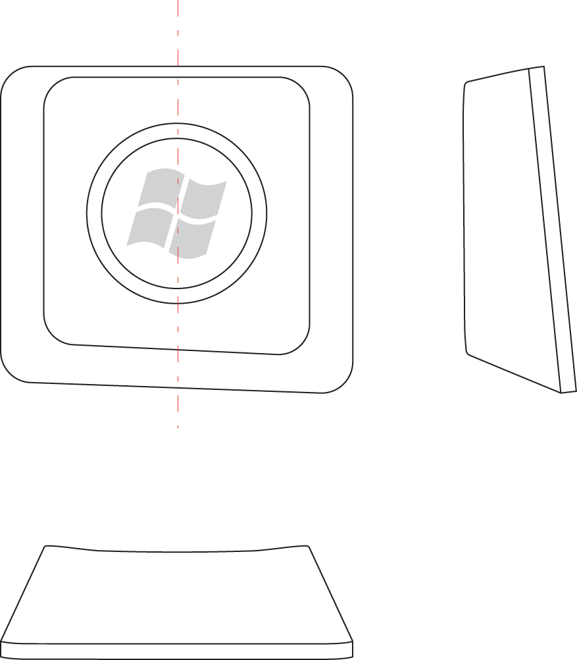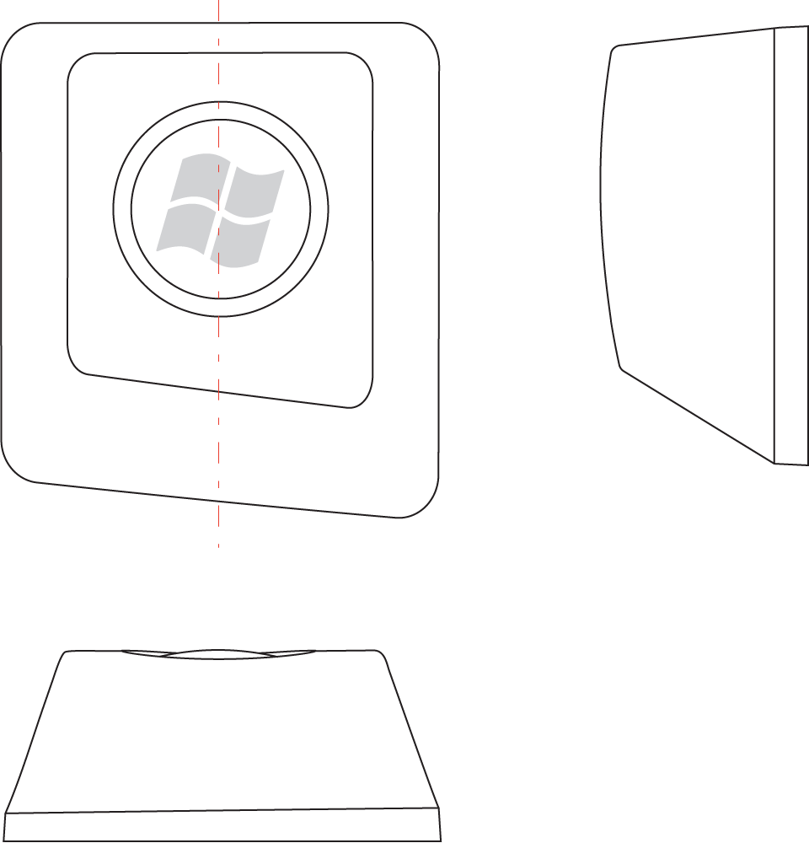
Figure 18: Example views of the Hardware Start Button for standard keyboard keycaps
The examples in Figure 19 are representative of small form factor keycaps designed for keyboards such as mobile, or small embedded keyboards.

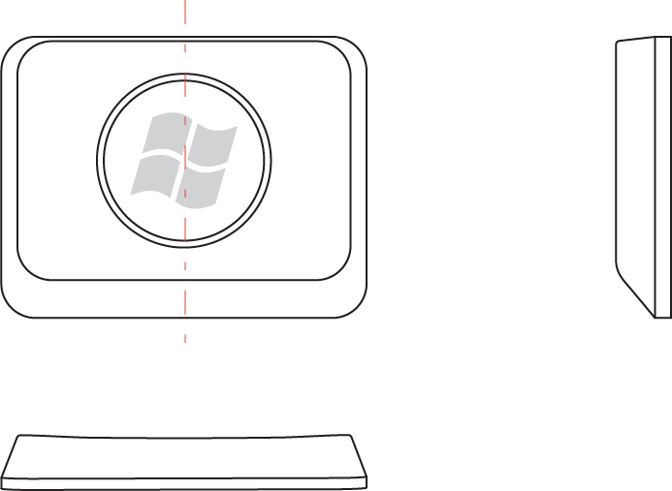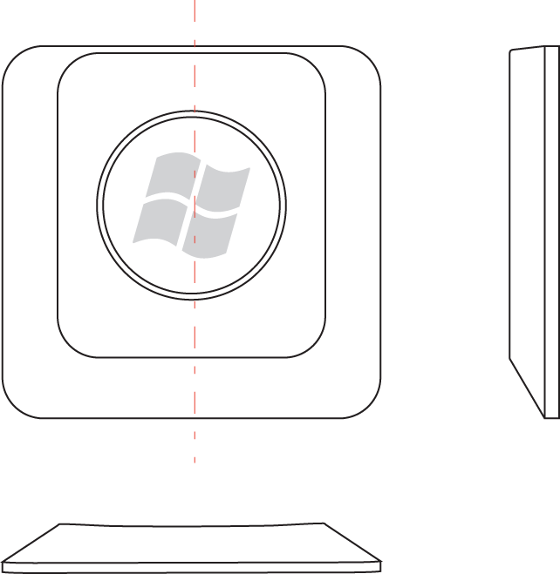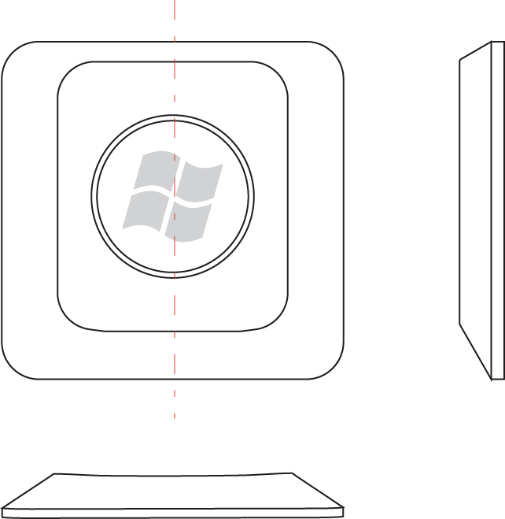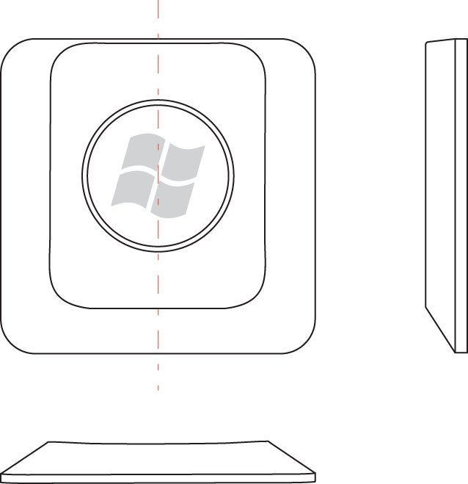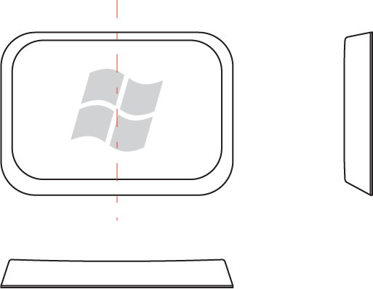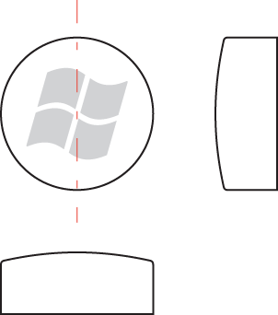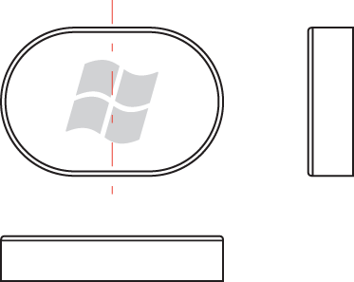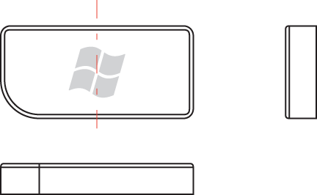
Figure 19: Example views of the Hardware Start Button for very short keycap and very small keycaps

Non-Conventional Keycap Recommendations
The examples in Figure 20 include one conventional keycap design and two non-conventional keycap designs for reference.
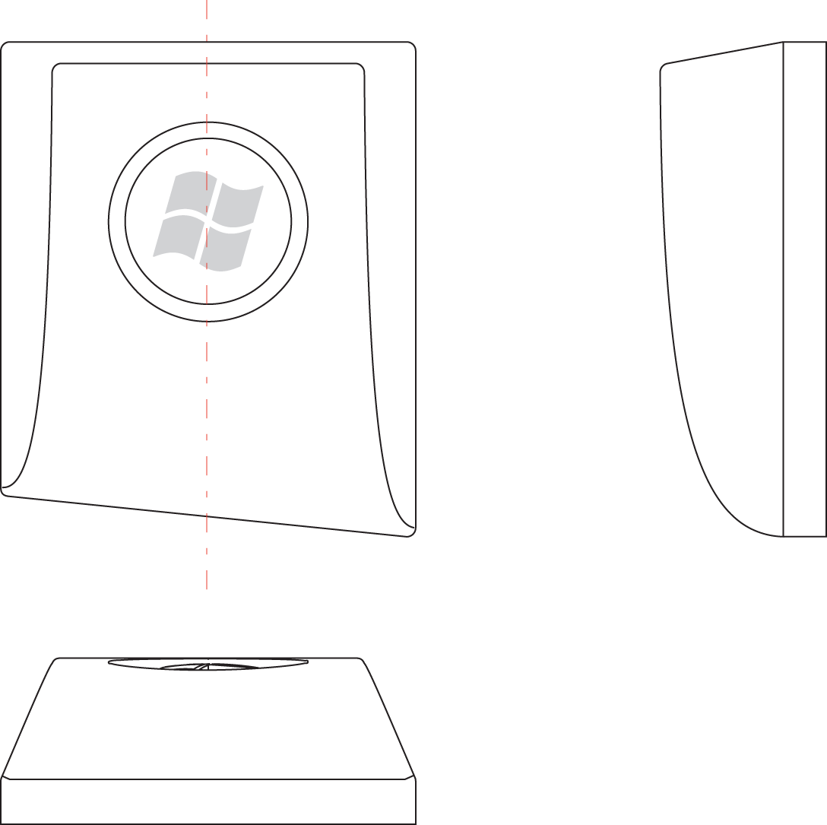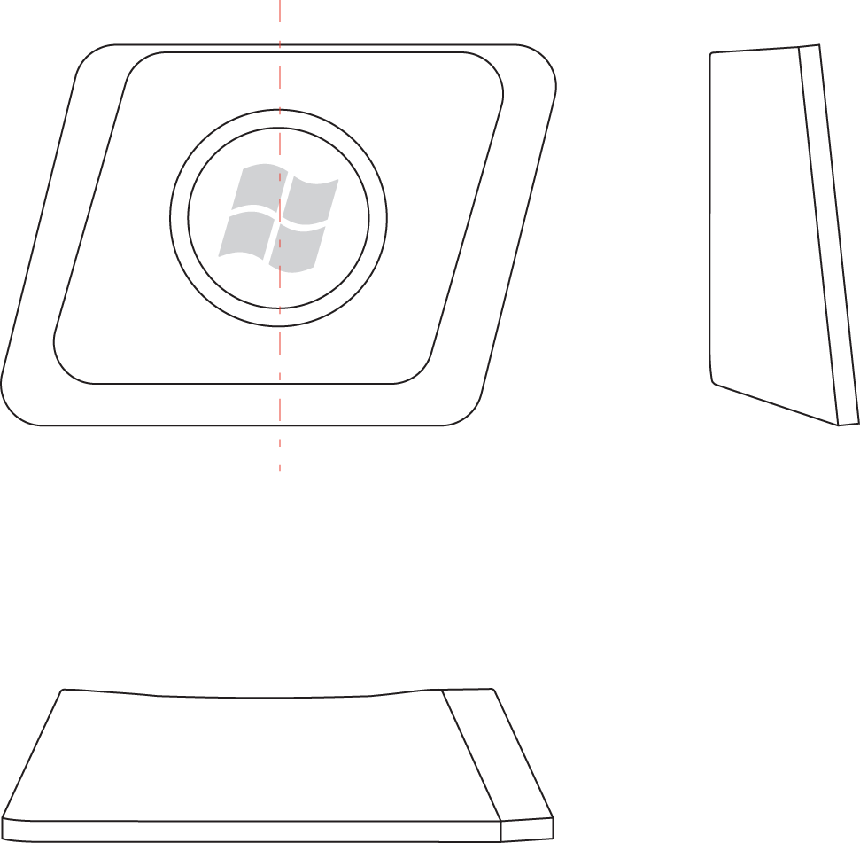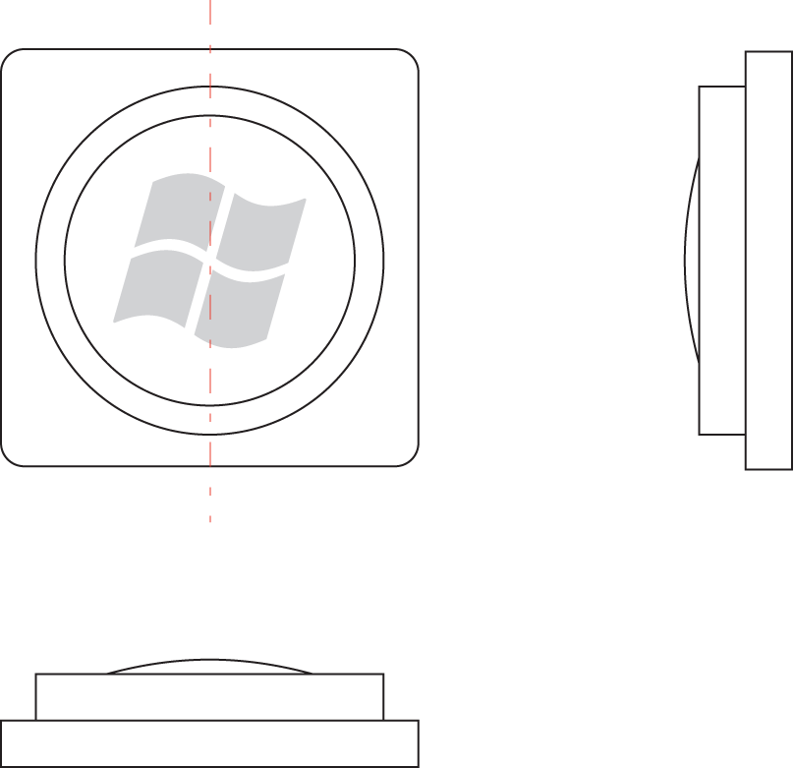
Figure 20: Example views of Hardware Start Buttons for non-conventional keyboard keycaps (with a conventional keycap for reference)

