|  |  |  |  |
| --- | --- | --- | --- |
| Overview  Partner Description  Zipper by Enfo is an IT solutions provider and Microsoft® Gold Certified Partner in Sweden. It has offices in Stockholm, Gothenburg, and Malmö, and it employs 125 people.  Business Situation  IT departments can become overburdened when required to constantly perform basic account provisioning and management tasks. The emerging hybrid world of on-premise systems and cloud-based services makes seamless administration even more challenging.  Solution  Zipper integrated their existing ZervicePoint portal with the Business Productivity Online Suite in order to further streamline a variety of provisioning processes and workflows.  The new integrated solution eliminates most manual provisioning tasks and provides a unified browser-based portal that works with Suite services and provides provisioning workflows that automate the bulk of the process while still ensuring appropriate review and approval cycles.  The enhanced ZervicePoint portal enables employees to self-provision any combination of on-premise and Business Productivity Online Suite accounts, and supports requisitions for computers, software, mobile devices, and more.  Benefits   * Significantly faster implementation * Increased flexibility for customers * Reduced IT costs * Better control and security |  |  | “Zipper by Enfo’s ZervicePoint adds transparent administration to both on-premises systems and Microsoft Online Services accounts. With ZervicePoint, end users and administrators alike have a single, unified portal to simply all their provisioning tasks.”  Anders Grönlund, Marketing Manager, Zipper by Enfo  Companies spend an extraordinary amount of time and effort manually handling tasks such as processing a new employee’s user accounts and equipment. What becomes especially burdensome is the process of approving and provisioning accounts and systems when they may reside on-premise as well as in the cloud.  Zipper by Enfo is a Microsoft Gold Certified Partner in Sweden. They decided to extend their existing Microsoft® Windows® SharePoint® Services-based ZervicePoint portal by integrating it with the Microsoft Online Services Business Productivity Online Suite.  C:\Projects\MSO Solution Briefs\Zipper\CreateUser.pngBy integrating with the Suite, ZervicePoint automates a company’s provisioning process for accounts, services, and equipment for both on-premise systems as well as from the Suite. In essence, ZervicePoint portal acts as a company’s IT management foundation, seamlessly working between local and cloud-based systems. Using SharePoint workflows, ZervicePoint streamlines the requisition process by automating requests while still enforcing reviews and approvals, and delivers a custom provisioning solution that shortens lead times, enforces appropriate review cycles, and increases productivity. |

Solution Description

Zipper initially developed their self-provisioning portal called ZervicePoint to work with Microsoft Office SharePoint Server 2007, Windows SharePoint Services 3.0, and Windows Workflow Foundation in order to provide IT managers and end users with a unified online environment to manage and delegate IT-related services, user accounts, computers and mobile devices, and software.

By integrating ZervicePoint with the Business Productivity Online Suite, Zipper was able to further extend the functionality and value of their premiere IT management portal. This enhanced version of ZervicePoint uses Web services and the Microsoft DirSync tool to access Suite services and synchronize directory information between on-premise environments and the Business Productivity Online Suite.

Key Features

Create and Manage On-premise and Cloud-based Accounts

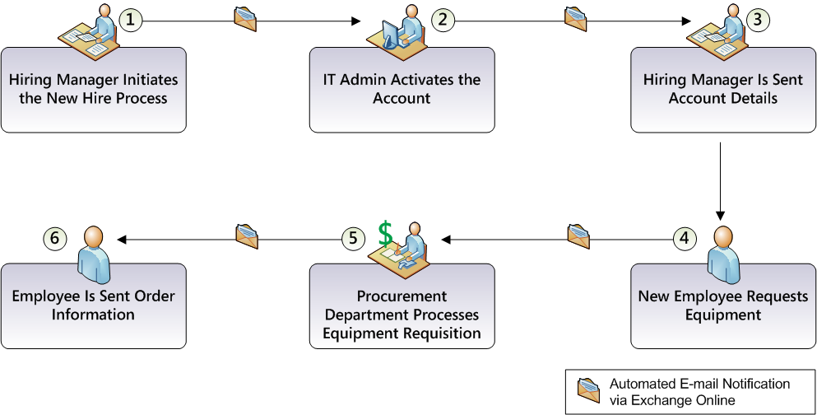The ZervicePoint BPOS module is used to create a new (or move or delete an existing) user account in the customer’s on-premise Active Directory, which can synchronize with the Business Productivity Online Suite automatically. This not only provides a unified interface for administration, but it allows a single set of credentials to be used in both environments.

Aggregate Services and Equipment into a Unified Portal

The ZervicePoint Portal provides a single, unified Web-based interface that administrators and end users alike can use to create and monitor their provisioning requests for hardware, on-premise-based systems, and cloud-based services.

The New Hire Provisioning Process

ZervicePoint can help optimize many business operations. Details of one example—the provisioning process for a new employee—are described here.

In this new hire scenario, ZervicePoint automates the creation of a new user’s Business Productivity Online Suite accounts, and uses SharePoint workflows to streamline equipment requisitions.

The new hire scenario is depicted in the following illustration, and details for each step are described below.

Hiring Manager Initiates the New Hire Process

A new employee has just been hired at a company. The hiring manager enters the new employee information into ZervicePoint, which automatically creates a matching user account in the Business Productivity Online Suite.

IT Admin Activates the Account

The creation of the new account starts a new hire workflow in the on-premise SharePoint, which sends an automated task to the IT administrator to activate the new Business Productivity Online Suite account.

Hiring Manager Is Sent Account Details

Once the IT administrator activates the account, the workflow sends a message via Exchange Online to the hiring manager that provides the user’s account details.

New Employee Requests Equipment

The new employee uses the account information to access ZervicePoint to change her password and request equipment such as a laptop computer with Microsoft Office 2007, as well as a mobile device running Windows Mobile® 6.

When the employee submits her request, ZervicePoint passes the information to a requisition workflow that uses Exchange Online to send the request to the hiring manager for approval.

Procurement Department Processes Equipment Requisition

The hiring manager approves the requisition, so the workflow forwards the request to the Procurement Department, which processes the order with their approved vendors.

Employee Is Sent Order Information

The employee is automatically sent a notice of the order’s status with details about estimated delivery date and tracking code. The system will continue to alert the employee with changes to the order status.

Solution Development and Implementation

Zipper developed the original ZervicePoint in 2007 in order to provide a self-service portal. It leveraged Windows SharePoint Services 3.0 and the Windows Workflow Foundation environment.

The development efforts to integrate Zipper ZervicePoint with the Business Productivity Online Suite were based on a SCRUM methodology. The ZervicePoint interface was built using a combination of SharePoint .NET Framework Web parts and Ajax.

As shown in the accompanying flow chart, the development effort to integrate ZervicePoint with the Business Productivity Online Suite was divided into six main steps.

Step 1: Define Solution Requirements

The development cycle began by identifying key solution objectives:

* Move a local Active Directory® user account from a special organizational unit (OU) or group in order to be able to select what should be moved to the Active Directory in the Business Productivity Online Suite.
* Add Suite-specific entries to the ZervicePoint service catalog in order to allow administrators to select which Suite services they want, and to provision the user account accordingly.

Step 2: Modify the ZervicePoint Portal

The original ZervicePoint portal was modified in the following areas:

1. Three new Active Directory security groups were added to support Exchange Online, SharePoint Online and Communication Services Online.
2. The ZervicePoint interface was updated by adding check boxes in the self-service .NET Web part for the user.
3. Modify the system to correlate a selected check box to adding the user to the appropriate Suite Active Directory group.

Step 3: Repurpose ZervicePoint Modules

In the original ZervicePoint, several modules were created for different administrative tasks such as managing users and groups, ordering equipment, resetting passwords, and overseeing deployment and software asset management.

For cloud environments, ZervicePoint was configured to run on the on-premise SharePoint server and use DirSync to pass requests to the Business Productivity Online Suite.

Step 4: Develop the Directory Synchronization Filter

1. Added a filter to the DirSync tool that causes the Suite to synchronize only the users who belong to the security groups discussed earlier, and then send the information to the Suite in XML format over HTTPS.
2. Programmed ZervicePoint to use the filter to move a user to the Active Directory in the Suite as soon as a Suite service is selected in the portal.

Step 5: Install and Configure Zipper ZervicePoint Application

1. Modified the client-side installer for ZervicePoint and distributed in a single MSI package file, which after installing Windows SharePoint Services or SharePoint Portal, would manage the installation of the application and configuring Microsoft SQL Server®.
2. Configuration tasks were performed in the Active Directory, groups, and system accounts.
3. Depending on the complexity of the system workflows, they were configured with either ZervicePoint or SharePoint Designer.

Step 6: Configure Customer Environment for Synchronization

After a customer signed up for ZervicePoint with Business Productivity Online Suite, ZervicePoint was installed in the customer’s on-premise environment, and the filter developed in step 4 was used to synchronize the on-premise Active Directory with the Suite.

Benefits

Partner Benefits

* Faster implementation of new products and services
* Increased flexibility for customers
* Extends the offerings and services associated with Suite services

Customer Benefits

* Self-service capability reduces IT costs
* Administration tasks can be delegated to the organization using predefined IT workflows and approvals
* Users have a single, unified portal to access for all provisioning requests
* Automated provisioning workflow enforces review and approval process

Introducing the Business Productivity Online Suite

Microsoft Online Services provides software delivered as a hosted service directly from Microsoft data centers, managed by Microsoft staff, and with a guaranteed 99.9 percent Service Level Agreement. These standardized solutions are designed so that partners can rapidly deploy services to their customers at a low, up-front investment with predictable, recurring costs.

The all-new Business Productivity Online Suite provides streamlined communications, simplified management, and business-class reliability and security.

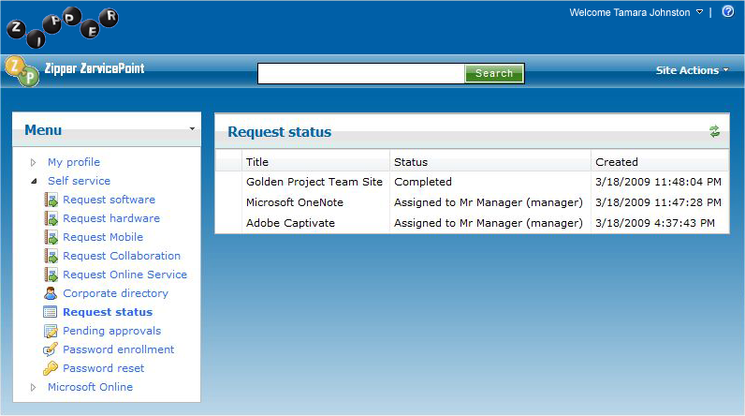 The customer can order this service for as few as five seats at a time.

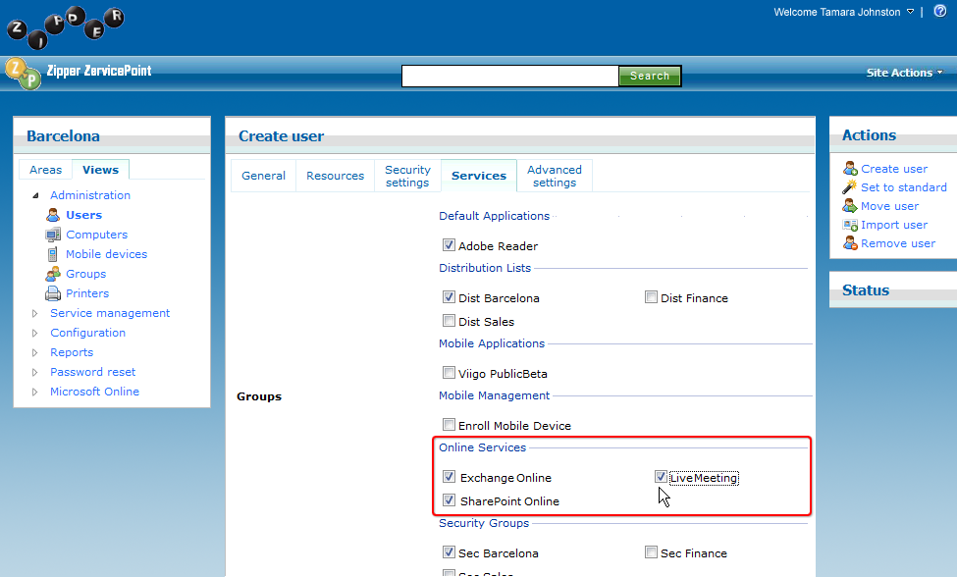The Business Productivity Online Suite includes the following services, which can be purchased on a monthly subscription basis either separately or as part of a suite:

**Microsoft Exchange Online**, based on Microsoft Exchange Server 2007, offers businesses e-mail, calendaring, other messaging-based capabilities, and archiving. It also enables coexistence, which means new online users can interact with users on local servers.

Introducing the Business Productivity Online Suite (Continued)

For More Information

For more information about Microsoft products and services, call the Microsoft Sales Information Center at (800) 426-9400. In Canada, call the Microsoft Canada Information Centre at (877) 568-2495. Customers who are deaf or hard-of-hearing can reach Microsoft text telephone (TTY/TDD) services at (800) 892-5234 in the United States or (905) 568-9641 in Canada. Outside the United States and Canada, please contact your local Microsoft subsidiary. To access information using the World Wide Web, go to [www.microsoft.com](http://www.microsoft.com)

For more information about Microsoft Online Services, visit the Web site at

[www.microsoft.com/online](http://www.microsoft.com/online)

Zipper by Enfo is an IT solutions provider and Microsoft Gold Certified Partner in Sweden. It has offices in Stockholm, Gothenburg, and Malmö, and employs 125 people.

For more information about Zipper by Enfo products and services, call + 46 77 440 44 00 or visit their Web site at: [www.zipper.se](http://www.zipper.se)

|  |  |  |  |  |  |  |
| --- | --- | --- | --- | --- | --- | --- |
| Microsoft Business Productivity Online Suite | |  | | Microsoft Business Productivity Online Suite | | |
| * Microsoft Exchange Online * Microsoft SharePoint Online * Microsoft Office Communications Online * Microsoft Office Live Meeting * Microsoft Exchange Hosted Filtering |  | | Microsoft Exchange Online  Microsoft SharePoint Online  Microsoft Office Communications Online  Microsoft Office Live Meeting  Microsoft Exchange Hosted Filtering | |  |

**Microsoft SharePoint Online**, based on Microsoft Office SharePoint Server 2007, provides a single integrated location where employees can efficiently collaborate with team members, find organizational resources, search, and manage content and workflow.

**Microsoft Office Communications Online** enables people to communicate easily with their colleagues across locations and time zones via instant messaging (text), voice, and video.

**Microsoft Office Live Meeting** is a hosted Web conferencing service that connects people in online meetings, training, and events through a reliable, enterprise-class hosted service.

**Microsoft Exchange Hosted Filtering** protects businesses’ inbound and outbound e-mail from spam, viruses, phishing scams, and e-mail policy violations.

About the Microsoft Business Productivity Online Suite

The Microsoft Business Productivity Online Suite provides businesses with virtually anywhere access to rich communication, collaboration, and productivity applications via subscription-based, Microsoft-hosted, online services. This hosted solution helps organizations offset the burden of managing and maintaining business systems, freeing information technology (IT) resources to focus on initiatives that can deliver competitive advantage to the business. The solution is part of the Microsoft’s Software-plus-Services delivery model to provide customers more choices than traditional, hosted, or on-premises solutions, allowing them to make deployment decisions that best fit the needs of their organization.

For more information about the partner opportunities provided by the Business Productivity Online Suite, see <http://partner.microsoft.com/online>.

© 2009 Microsoft Corporation. All rights reserved. This solution brief is for informational purposes only. MICROSOFT MAKES NO WARRANTIES, EXPRESS OR IMPLIED, IN THIS SUMMARY. Microsoft, Active Directory, SharePoint, SQL Server, Windows, and Windows Mobile are either registered trademarks or trademarks of Microsoft Corporation in the United States and/or other countries. The names of actual companies and products mentioned herein may be the trademarks of their respective owners.

Document published March 2009