|  |  |  |  |
| --- | --- | --- | --- |
| Overview  Customer Profile  C:\Users\markdale\AppData\Local\Microsoft\Windows\Temporary Internet Files\Content.Outlook\FEGL9MJN\xantura_colour.jpg is an innovative and energetic UK based technology and consulting company. Xantura assists local government agencies to improve the lives of their citizens by delivering innovative consulting and technology solutions to help their clients improve service delivery whilst containing costs. Xantura’s solutions are grounded in a strategic and practical understanding of the challenges facing the public sector.  Business Situation  Need for a solution that would enable both people within and outside their organizations share critical data between them in a controlled manner. With teams based out of multiple locations it becomes increasingly difficult to have a system for secure data sharing.  Solution  Xantura collaborated with Sonata Software to build the SharePoint based user interface by utilizing Microsoft Business Productivity Online suite . The solution provides a realistic model for a data sharing platform, with a comprehensive set of parameterized Data Sharing Protocols. The application connects with the SharePoint on-premises site to fetch data. The solution effectively uses both SharePoint on premises and SharePoint Online and provides a classic example of co-existence. The environment also includes a custom approval workflow that leverages Microsoft Exchange Online for sending notifications.  Benefits   * Effective and secure data sharing * Integrated federated search engine * Secure Hosted web application * Automated Business Event notification |  |  | “The Microsoft BPOS suite provides an accelerated mechanism for both software development and its subsequent market deployment.”  Wajid Shafiq, Managing Director of xantura Ltd  There was a need to develop an application for Data Sharing between Local Strategic partnerships (LSPs). These LSPs are non-statutory, multi agency partnership working for local government agencies. Delivering services across the LSP comes with the intrinsic issue of holding multiple instances of citizen based data. This data needs to be stored and its potential effectiveness released across the organizations within the partnership. The Application needed to be multi faceted in its attempt to identify a single citizen instance across all partners and additionally to ensure that citizen based life events are reflected across all affected service areas within all of the LSP partner organizations. A critical success factor for this application is the way in which the application enables effective and secure data sharing procedures to ensure that only authorized system users are able to view data across the multi service areas within multi partner data sets.  Xantura collaborated with Sonata to develop a SharePoint based user interface to enable LSPs to share data in a secure environment. This application was successful in its objective of allowing the LSPs to share data between and amongst themselves. But there was a real challenge in terms of extending the solution outside the intranet. A major concern for the LSP agents was access of data while they were in the field. Since the Xantura Application was built on an intranet site, the agents were not able to access the citizen data while in the field. To overcome this difficulty the solution was designed in order to facilitate access to citizen data remotely.  Sonata Software worked with Xantura to create a customized data sharing application. An application built on BPOS that would enable the agents to access the information while not in the network. The application that was developed on BPOS was integrated with the actual SharePoint on-premises application. The solution on BPOS was designed such that it would integrate with the SharePoint on-premises application to fetch data, while trying to access the application from locations outside the network.  The solution provides a realistic model for a data sharing platform, with a comprehensive set of parameterized Data Sharing Protocols by utilizing the strengths of both SharePoint on premises and SharePoint Online. The environment also includes a custom approval workflow that leverages Microsoft Exchange Online for sending notifications. |

Solution Description

Xantura’s custom Data Sharing solution that is built on top of the Microsoft Online Services Business Productivity Online Suite, integrates SharePoint Online and Exchange Online, and incorporates customized features to meet the customer’s unique business requirements.

The application is an integrated solution built over BPOS for secure data sharing between Local Strategic Partnerships (LSPs).

The SharePoint on-premise application talks with a custom database to pull citizen data. The data transfer is secured using custom built Data Sharing Protocols (DSPs).

When a user requests any information, the DSP identifies the user and provides a token that is used to authorize the user. In the on-premise application, the search web part uses the token to fetch the required data.

Xantura developed wrapper class Web methods, to ensure connectivity between BPOS application and the SharePoint on-premise site. When an agent in the field requests for data, a request is made to On premises application with user details.

The main objective of the system developed is to have a single view of citizen data across the LSPs through a controlled search of data across the partnership entities.

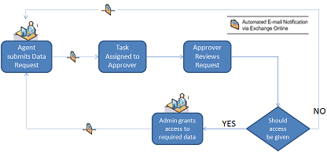

Key Features

Homepage

The default screen will have a task pane, indicating the tasks that are owned by the user. The page will also include components like Announcements and discussion board.

Search

This screen is used to search for any kind of data that is available for any individual across any department that is enlisted within LSP. The result set returns data with relation to any of the text within all available data sources (controlled by application permissions).

Search Result Screen

This screen displays the results of search carried out by the user. The user can select any result to view the complete details of the same or use the results displayed to add them to make further data requests to other data owners within the LSP.

Detailed Results

User will be able to view details of the search result displayed and will be able to do an expanded search on any specific details of a search result. User will also be able to add the search result(s) displayed either individually or collectively to Data request.

Approval Workflow

This Data sharing solution makes use of the SharePoint Online built-in workflow capabilities. This solution uses a one stage approval workflow for sending and approving Data Request.

When a specific data for a case is not accessible to the user in the normal detailed data result, the user is provided with an option to make a “Data Request” to the Data owner.

User submits Data Request to the Data Owner

The user fills in a form in SharePoint Online to request for permission to view the Data.

The task is assigned to the 'Data Owner'. Exchange Online sends an automated e-mail message to the Data Owner. The Data Owner can then approve or reject the request.

Data Owner Reviews and Approves Request

Once the Data Owner reviews the request and approves/rejects the request, Exchange Online sends an e-mail to the user with the status of the request. The user will now be able to view the data accordingly.

Solution Development and Implementation

As shown in the accompanying flow chart, the development effort to build the solution can be divided into five main steps.

Step 1: Gather and Map Business Requirements

Business analysts interact with the company’s key stakeholders to understand the requirements and prepare the software requirements document.

1. Analyze the business requirements.
2. Map the requirements that can be met using out-of-the-box features of SharePoint Online.
3. Identify the requirements that need custom development.

Step 2: Design Wrapper methods

1. Design Wrapper web parts method to connect BPOS site and the SharePoint on-premises site.

Step 3: Build Out the Site

1. Create the site structure for the Home page.

Add the following out-of-the-box Web parts using the SharePoint Online Site Settings feature:

* Announcements Web part
* Search Web part
* Discussion Web part
* Tasks Web part

Step 4: Set UI Branding

All user interface branding is performed through SharePoint Designer. Key branding tasks include:

1. Creation of a new custom master page and setting it as the default master page for all pages in the site.
2. Creation and upload of custom style sheets into the site’s style library.
3. Creation and uploading of images.

Step 5: Develop the Workflow

1. Define the workflow flowchart.
2. Use the Workflow Designer wizard to create the custom workflow.
3. Attach the workflow to the Projects custom list. Configure it to run automatically when a new project is initiated.
4. Use SharePoint Designer to define the various steps of the workflow using built-in actions and conditions.

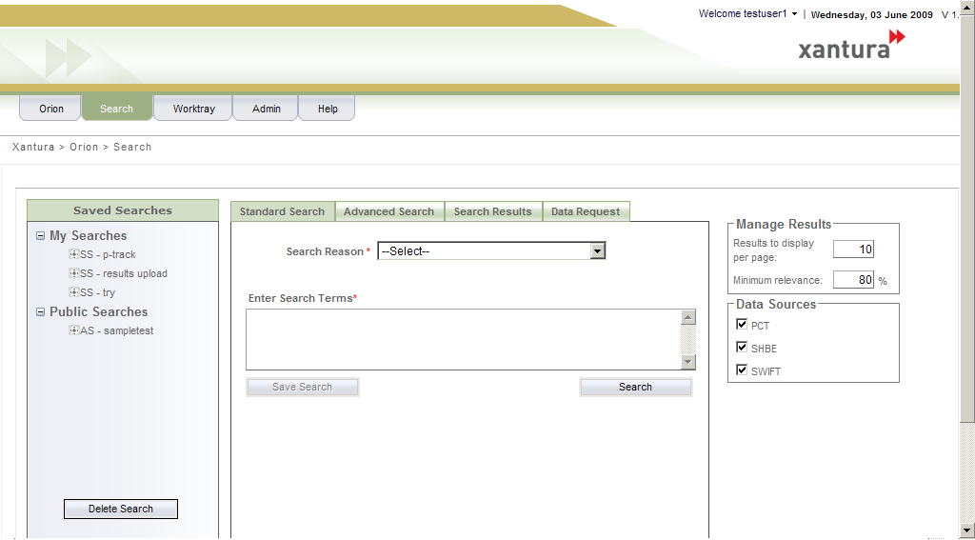

Benefits

* **Effective and secure data sharing procedures** ensure that only authorized system users are able to view data across the multi service areas within multi partner data sets.
* **Parameterized Data Sharing Protocols (DSPs)** are allocated to each system user in order that strictly controlled searching across shared partnership data may be performed.
* **Integrated federated search engine** enables a single view of citizen data to be returned, thus providing a consolidated view across the LSP, and within all distinct service areas.
* **Automated business event notifications** are triggeredperform pre-defined searches which are likely to impact the business operation other service areas.
* **Secure hosted web application** which enables users to access the data and aid the decision making process via a single URL.
* **Audit Trails** capture all data searches, data requests and automated business events and are recorded within a comprehensive system log.
* **Applicability** identifiedwithin the local government space, specifically for Local Strategic Partnerships, however functionality is generic and as such can be applied to other market places.

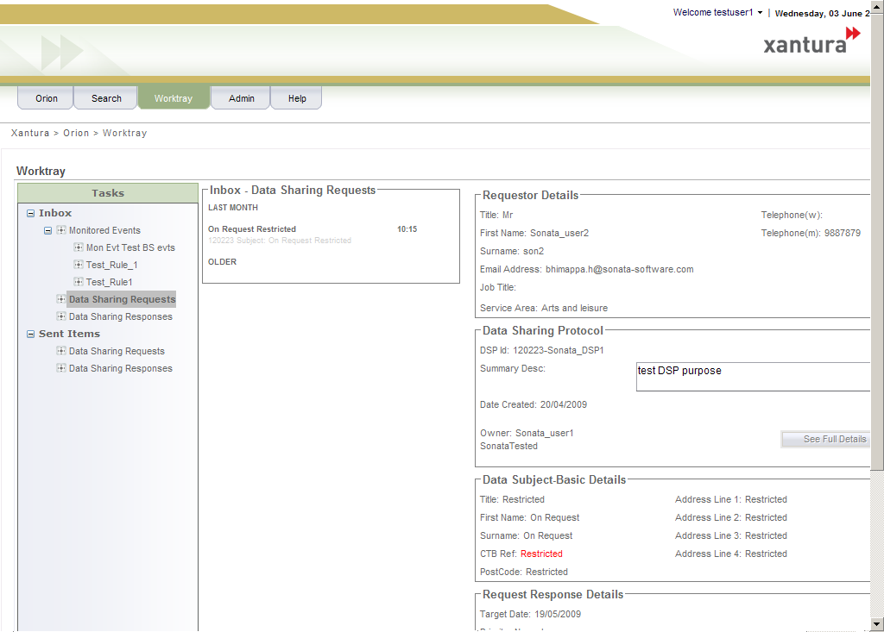Introducing the Business Productivity Online Suite

Microsoft Online Services provide software delivered as a hosted service directly from Microsoft data centers, managed by Microsoft staff, and with a guaranteed 99.9 percent Service Level Agreement. These standardized solutions are designed so that partners can rapidly deploy services to their customers at a low, up-front investment with predictable, recurring costs.

The all-new Business Productivity Online Suite provides streamlined communications, simplified management, and business-class reliability and security.

The customer can order this service for as few as five seats at a time.

The Business Productivity Online Suite includes the following services, which can be purchased on a monthly subscription basis either separately or as part of a suite:

**Microsoft Exchange Online**, based on Microsoft Exchange Server 2007, offers businesses e-mail, calendaring, other messaging-based capabilities, and archiving. It also enables coexistence, which means new online users can interact with users on local servers.

(Introducing the Business Productivity Online Suite, Continued)

For More Information

For more information about Microsoft products and services, call the Microsoft Sales Information Center at (800) 426-9400. In Canada, call the Microsoft Canada Information Centre at (877) 568-2495. Customers who are deaf or hard-of-hearing can reach Microsoft text telephone (TTY/TDD) services at (800) 892-5234 in the United States or (905) 568-9641 in Canada. Outside the United States and Canada, please contact your local Microsoft subsidiary. To access information using the World Wide Web, go to [www.microsoft.com](http://www.microsoft.com)

For more information about Microsoft Online Services, visit the Web site at

[www.microsoft.com/online](http://www.microsoft.com/online)

For more information about company products and services, visit the Web site at [www.sonata-software.com](http://www.sonata-software.com)

|  |  |
| --- | --- |
| Microsoft Business Productivity Online Suite | |
| * Microsoft Exchange Online * Microsoft SharePoint Online * Microsoft Office Communications Online * Microsoft Office Live Meeting * Microsoft Exchange Hosted Filtering |  | |

**Microsoft SharePoint Online**, based on Microsoft Office SharePoint Server 2007, provides a single integrated location where employees can efficiently collaborate with team members, find organizational resources, search, and manage content and workflow.

**Microsoft Office Communications Online** enables people to communicate easily with their colleagues across locations and time zones via instant messaging (text), voice, and video.

**Microsoft Office Live Meeting** is a hosted Web conferencing service that connects people in online meetings, training, and events through a reliable, enterprise-class hosted service.

**Microsoft Exchange Hosted Filtering** protects businesses’ inbound and outbound e-mail from spam, viruses, phishing scams, and e-mail policy violations.

**About the Microsoft Business Productivity Online Suite**

The Microsoft Business Productivity Online Suite provides businesses with virtually anywhere access to rich communication, collaboration, and productivity applications via subscription-based, Microsoft-hosted, online services. This hosted solution helps organizations offset the burden of managing and maintaining business systems, freeing information technology (IT) resources to focus on initiatives that can deliver competitive advantage to the business. The solution is part of the Microsoft’s Software-plus-Services delivery model to provide customers more choices than traditional, hosted, or on-premises solutions, allowing them to make deployment decisions that best fit the needs of their organization.

For more information about the partner opportunities provided by the Business Productivity Online Suite, see <http://partner.microsoft.com/online>.

© 2009 Microsoft Corporation. All rights reserved. This solution brief is for informational purposes only. MICROSOFT MAKES NO WARRANTIES, EXPRESS OR IMPLIED, IN THIS SUMMARY. Microsoft, SharePoint, Win32, and Windows are either registered trademarks or trademarks of Microsoft Corporation in the United States and/or other countries. The names of actual companies and products mentioned herein may be the trademarks of their respective owners.

Document published February 2009