|  |  |  |  |
| --- | --- | --- | --- |
| Overview  Market Opportunity  Many businesses are continually looking at opportunities to increase their collaboration capabilities while leveraging their existing IT investments. The Microsoft Online Services Business Productivity Online Suite allows those businesses to increase those capabilities without needing the extra investment in costly hardware and software.  The challenge comes when companies want to integrate their on-premise applications with online applications or integrate multiple online applications. Businesses typically need to engage development firms to develop the integration capabilities. Statera realized an opportunity existed to provide their customers a custom solution that integrates Microsoft Dynamics CRM (Online or on-premise) with the Suite.  Solution  Statera designed a custom solution that integrates CRM and SharePoint Online to automate the process of creating customized Account and Opportunity sites for their customers. The solution enables sales personnel to upload documents and feed client contact information into SharePoint Online via CRM.  Benefits   * Offers the best features of Microsoft Dynamics CRM and SharePoint Online in a unified environment * Works with both CRM Online and on-premise CRM deployments * Increases collaboration between sales and delivery * Enables co-workers to easily share business data * Provides automated account site provisioning |  |  | “Stratus has enabled customers with substantial existing investments in software and hardware to take advantage of the cloud in a way that works for them. Essentially, Stratus has made moving to the cloud irrelevant. Now, clients can bring the cloud to themselves in a way that empowers their specific needs without having to undergo a large internal system transformation.”  -- Carlos Garcia, Director of Managed Solutions, Statera  For many small- and medium-sized business (SMB) and mid-market companies, sales and delivery organizations need to increase their collaboration capabilities while still being able to leverage their existing customer relationship management (CRM) investments. Sales organizations want to expand the capabilities of their CRM solution without having to learn a new product. Delivery organizations want a robust document management, collaboration, and project management solution, but still need key customer information transferred from CRM.  Both organizations want a simple solution to gain increased visibility into the data and documents stored in both CRM and Microsoft® SharePoint® Online.  C:\Projects\MSO Solution Briefs\Statera\SharePoint Online Screenshot.PNGStatera was able to integrate Microsoft Dynamics® CRM and the Business Productivity Online Suite in order to enable businesses to automate the creation of Account and Opportunity/Project sites in SharePoint Online that enable the collaboration and project management that their delivery teams demand. The sales teams can feed client contact information and upload client documents directly to the SharePoint Online site from within Microsoft Dynamics CRM. Integrating CRM with the Suite enables companies of all sizes to share their internal business data more effectively and streamline their sales-to-delivery workflows. |

Solution Description

As a full-service Microsoft implementation partner, Statera has developed a variety of custom solutions implementing Microsoft Dynamics CRM with Microsoft Office SharePoint Server. In this solution, Statera has incorporated the most common requests and packed them into a framework that works with the Business Productivity Online Suite.

This solution increases sales productivity by adding robust document sharing and team collaboration capabilities to CRM, while at the same time extracting key sales information from CRM and displaying it in SharePoint Online sites to make it available to a broader audience.

Solution Components

Automated Site Provisioning

Sales team members can create new account and opportunity/project sites without IT involvement. Sites are automatically configured to provide access to the correct members of the sales team.

Site Management

Each site is preconfigured to include all the key components necessary to effectively manage customer information (such as contracts, general information, tasks, and events) and project information such as status reports, tasks, issues, and project documentation.

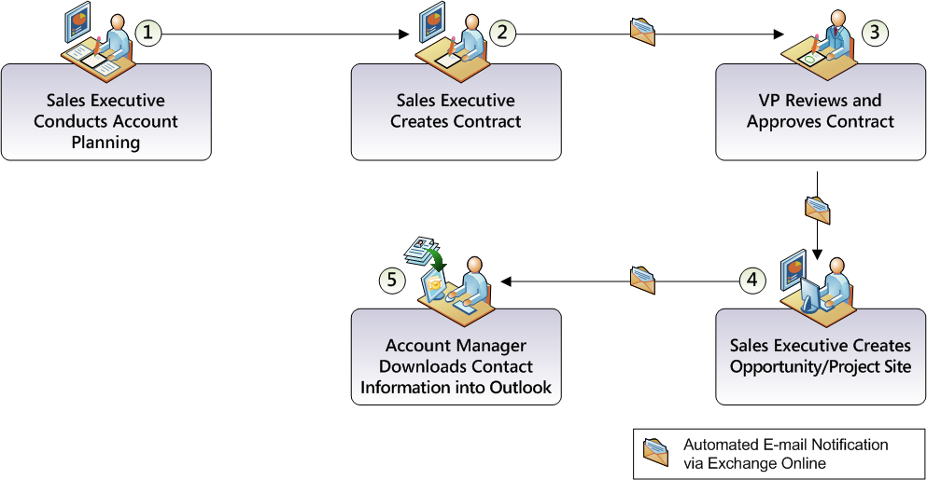Shared File Management

Allow sales teams to easily share relevant account and opportunity/project files from within CRM.

Customer Information Modules

The customer information modules extract key sales information including accounts, opportunities, contacts, and activities and make it available within SharePoint Online sites. The modules allow SharePoint users to see CRM information within SharePoint Online, thus avoiding the task of switching to a different application. When information that is more detailed is needed, the modules drill down directly to the appropriate record in the CRM environment.

Sample Scenario

This solution benefits services-based organizations such as advertising, construction, legal, and professional services, as well as companies that sell services along with their product offerings.

The following workflow illustrates how this solution could be incorporated into a services-based organization scenario to unify sales and delivery into a cohesive business process.

Step 1: Sales Executive Conducts Account Planning

A sales executive conducts her account planning using CRM Online, and with the click of a button, provisions a SharePoint Online site for the account where document sharing and collaboration can be better performed.

Step 2: Sales Executive Creates Contract

The sales executive uses a SharePoint Online document library to create a Microsoft Word contract that is pre-populated with standard legal language as well as account information that originates from CRM Online.

Step 3: VP Reviews and Approves Contract

When the contract is completed and stored in the SharePoint Online Account site, a workflow is initiated that sends a notice via Microsoft Exchange Online to the sales executive’s Vice President to approve the contract.

Step 4: Sales Executive Creates Opportunity/Project Site

The Vice President’s approval of the contract causes the workflow to send a notification to the sales executive, alerting her that she can deliver the contract for signatures. Once the contract is signed, she returns to CRM to finalize the Opportunity details. A click of a button in CRM provisions a SharePoint Opportunity/Project site where ongoing work such as project plans and deliverables are stored and shared.

Step 5: Account Manager Downloads Contact Information into Outlook

When a newly assigned account manager arrives at the SharePoint Account and Opportunity sites at the commencement of the project, he can review the account and project history by viewing the contracts and other sales-related documents that have been stored in SharePoint Online. He can also add all of the account contacts from CRM directly to his Microsoft Outlook® contacts folder by clicking on the contact-card icon next to each contact.

Solution Development and Implementation

Statera approached the design and implementation of the solution using their Balance Methodology, which includes analysis, design, construction, deployment and optimization steps within an iterative process.

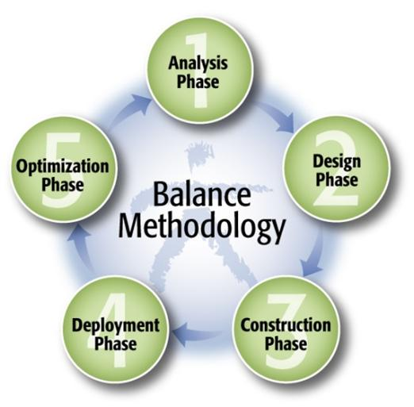

Prior to beginning the analysis phase, Statera identified the critical success factors, which included:

* End users should not be burdened with any browser security messages
* No additional authentication mechanism above and beyond what CRM, the Business Productivity Online Suite, and Active Directory® offer should be required
* User interface appearance should be clean and consistent with existing applications
* Architecture should support ability to host the Stratus Engine in the cloud and be able to service numerous customers with a single instance

Step 1: Analysis

During the analysis phase, Statera identified all of the CRM and SharePoint Online capabilities and information that needed to be shared among the applications. Integration points and user interface additions were identified, a scope matrix was created and prioritized, and a project plan was finalized.

Step 2: Design

The biggest design challenge was to ensure that all interaction between CRM Online and SharePoint Online was accomplished through calls to the available Web services and the delivery of complex JavaScript to the end user’s browser to initiate the communications.

* To help describe and simplify this architecture, the design phase included the development of wireframes showing all of the user interface additions that would be added to CRM and SharePoint online; Swim Lane diagrams describing the interactions and communications between CRM Online, SharePoint Online, the Stratus Engine and the end user’s browser; and service oriented architecture (SOA) message specifications describing what information was communicated with each Web service call.

Step 3: Construction

Construction began with the provisioning of SharePoint and CRM Online accounts needed for development and integration testing as well as the creation of a Microsoft Visual Studio® 2008 solution for the implementation of the integration components.

1. The Visual Studio solution was organized so that it provided WCF endpoints utilizing SOAP, REST and JSON-P protocols in order to facilitate communication from the user’s browser to the SharePoint Online and CRM Online Web services.
2. Two SharePoint site templates were created: one for Account Sites; the other for Opportunity/Project sites. These templates contain customized libraries and lists, predefined workflows, and Web Parts that display information retrieved via calls to the CRM Web services.
3. Customizations were made to the Account and Opportunity objects within CRM Online in order to track and hold which accounts and opportunities were “SharePoint-enabled,” define a new tab where integration into SharePoint was performed, and provide metadata to the Stratus Engine that was needed to retrieve information from the Lists.asmx and SiteData.asmx SharePoint Web services.
4. Authentication mechanisms were developed to support the connection to SharePoint and CRM Online. For SharePoint Online, authentication was accomplished by setting the credentials cache on the Web service calls with the appropriate information for the customer. For CRM Online, authentication was accomplished by integrating a WS-Trust authentication mechanism with the Windows Live™ ID authentication service, and then using the received authentication token as the credentials passed to CRM Online.
5. The unavailability of the SharePoint Online Sites.asmx Web service was solved by implementing a custom HTTP module that used the standard HTTP Get and Post protocols to perform the site provisioning. This module resides on the Stratus Engine server but is accessible from CRM and the user’s browser.
6. Once all the integration components were complete, SharePoint Designer was used to develop a SharePoint Online workflow to support the approval of contracts and legal documents by corporate executives.

Step 4: Deployment

1. When the construction of the Stratus Engine was complete, an MSI was created from the Visual Studio solution, and the SharePoint and CRM configurations were documented and, when possible, exported to a redeployable package.
2. These packages and procedures where then used to deploy the application to test and then to production environments.

Step 5: Optimization

1. Statera carried out numerous quality assurance scenarios including requirement verification, user experience, performance, and load testing.
2. Test results were used to fine-tune the Stratus Engine and optimize the solution.

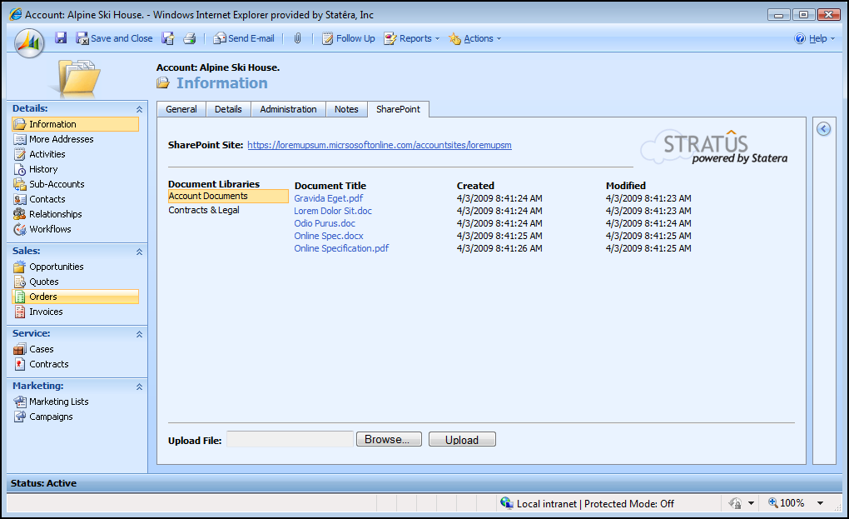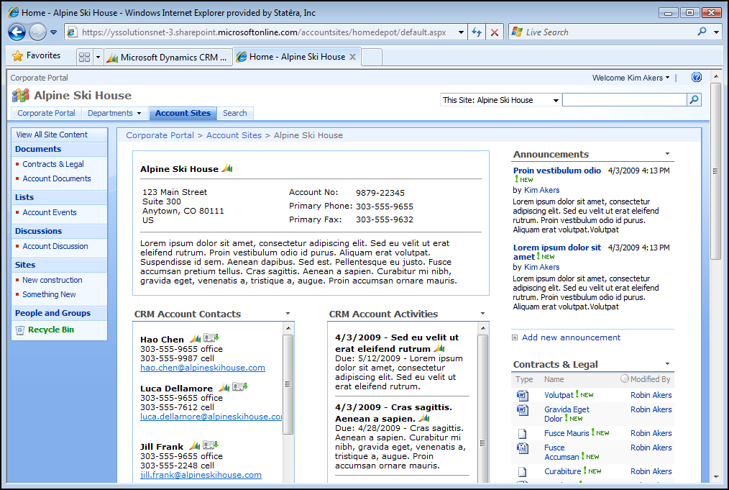Benefits

Partner Benefits

* Opens doors to new accounts
* Provides a platform for additional integration scenarios
* Provides additional opportunities within existing accounts

Customer Benefits

* Increases the value of existing IT investments
* Increases collaboration between sales and operations in service-based organizations
* Provides better visibility to key customer information for both sales and operations
* Provides a mechanism for smoother transitions from on-premise to online services
* Lowers implementation costs

Introducing the Business Productivity Online Suite

Microsoft Online Services provides software delivered as a hosted service directly from Microsoft data centers, managed by Microsoft staff, and with a guaranteed 99.9 percent Service Level Agreement. These standardized solutions are designed so that partners can rapidly deploy services to their customers at a low, up-front investment with predictable, recurring costs.

The all-new Business Productivity Online Suite provides streamlined communications, simplified management, and business-class reliability and security.

The customer can order this service for as few as five seats at a time.

The Business Productivity Online Suite includes the following services, which can be purchased on a monthly subscription basis either separately or as part of a suite:

**Microsoft Exchange Online**, based on Microsoft Exchange Server 2007, offers businesses e-mail, calendaring, other

Introducing the Business Productivity Online Suite, (Continued)

For More Information

For more information about Microsoft products and services, call the Microsoft Sales Information Center at (800) 426-9400. In Canada, call the Microsoft Canada Information Centre at (877) 568-2495. Customers who are deaf or hard-of-hearing can reach Microsoft text telephone (TTY/TDD) services at (800) 892-5234 in the United States or (905) 568-9641 in Canada. Outside the United States and Canada, please contact your local Microsoft subsidiary. To access information using the World Wide Web, go to [www.microsoft.com](http://www.microsoft.com)

For more information about Microsoft Online Services, visit the Web site at

[www.microsoft.com/online](http://www.microsoft.com/online)

Statera is a business and technology services and solutions provider that helps companies large and small optimize organizational performance by mapping strategic goals and objectives to IT initiatives. Their strategic technology solutions provide powerful insight into organizations, helping them solve mission-critical problems and drive performance across the enterprise.

For more information about this solution, please send e-mail to [stratus@statera.com](mailto:stratus@statera.com) or visit [www.statera.com](http://www.statera.com).

|  |  |
| --- | --- |
| Microsoft Business Productivity Online Suite | |
| * Microsoft Exchange Online * Microsoft SharePoint Online * Microsoft Office Communications Online * Microsoft Office Live Meeting * Microsoft Exchange Hosted Filtering |  | |

messaging-based capabilities, and archiving. It also enables coexistence, which means new online users can interact with users on local servers.

**Microsoft SharePoint Online**, based on Microsoft Office SharePoint Server 2007, provides a single integrated location where employees can efficiently collaborate with team members, find organizational resources, search, and manage content and workflow.

**Microsoft Office Communications Online** enables people to communicate easily with their colleagues across locations and time zones via instant messaging (text), voice, and video.

**Microsoft Office Live Meeting** is a hosted Web conferencing service that connects people in online meetings, training, and events through a reliable, enterprise-class hosted service.

**Microsoft Exchange Hosted Filtering** protects businesses’ inbound and outbound e-mail from spam, viruses, phishing scams, and e-mail policy violations.

About the Microsoft Business Productivity Online Suite

The Microsoft Business Productivity Online Suite provides businesses with virtually anywhere access to rich communication, collaboration, and productivity applications via subscription-based, Microsoft-hosted, online services. This hosted solution helps organizations offset the burden of managing and maintaining business systems, freeing information technology (IT) resources to focus on initiatives that can deliver competitive advantage to the business. The solution is part of the Microsoft’s Software-plus-Services delivery model to provide customers more choices than traditional, hosted, or on-premises solutions, allowing them to make deployment decisions that best fit the needs of their organization.

For more information about the partner opportunities provided by the Business Productivity Online Suite, see <http://partner.microsoft.com/online>.

© 2009 Microsoft Corporation. All rights reserved. This solution brief is for informational purposes only. MICROSOFT MAKES NO WARRANTIES, EXPRESS OR IMPLIED, IN THIS SUMMARY. Microsoft, Active Directory, Internet Explorer, Microsoft Dynamics, Outlook, SharePoint, Visual Studio, and Windows Live are either registered trademarks or trademarks of Microsoft Corporation in the United States and/or other countries. The names of actual companies and products mentioned herein may be the trademarks of their respective owners.

Document published April 2009