|  |  |  |  |
| --- | --- | --- | --- |
| Overview  Business Situation  HRC (Hiawatha Rubber Co) needed an enterprise level document management solution to help them manage their library of 10,000+ documents. Additionally, they wanted to enable their office team by increasing collaboration and information sharing. However, HRC did not want to maintain full time IT staff or put forth a substantial up-front investment in their IT infrastructure.  Solution  The Business Productivity Online Suite (BPOS) enabled HRC to quickly implement SharePoint Online and Exchange Online in an integrated fashion for all their office staff while simultaneously reducing infrastructure and support costs.  Benefits   * Immediate availability of enterprise level solutions * Easily scalable as company’s needs grow * Reduction in on-premise infrastructure costs * Monthly subscription fee makes forecasting costs simple * Integrated solution * Rapid Implementation (10 days) |  |  | “The implementation of the Microsoft Online Services has already had a significant impact on our organization.  We have greatly reduced the amount of system administration time and cost compared to our previously in-house hosted email system.  Our first use of SharePoint is allowing our project team members (and soon our customers and suppliers) to plan and track project activities in real time.”  Howard Hauser, VP Operations, Hiawatha Rubber Co  Hiawatha Rubber Company (HRC) is a 50 year old, ISO certified manufacturer of precision molded rubber parts. The ISO compliant manufacturing process results in the creation of multiple documents from various departments, each of which is critical to the business. These documents (currently more then 10,000 total) must be safely stored and managed by various document types (PDF’s, Word documents, JPEG images, emails, amoung others). They will also need to be easily accessible at various points in HRC’s manufacturing processing by staff members who might be from same or different departments. Furthermore, HRC does not have any dedicated IT support and have been operating within a limited existing infrastructure.  Sogeti Minneapolis was actively involved in the pre-release of implementation of Business Productivity Online Suite (BPOS) locally and was a natural fit to help out HRC with their questions about SharePoint Online. Using a brief assessment period with HRC, Sogeti determined that leveraging entire BPOS Solution (Exchange and SharePoint Online) would allow HRC to not only meet their current needs but also generate tremendous cost savings by retiring exisitng applications and foster innovation by collaborating in the cloud. |

Solution Description

Sogeti was engaged to help implement a document management system for Hiawatha Rubber Company that would not only address their current business needs, but also remain simple to use and adaptable to their future growth.

The resulting solution was a mix of document management, customer management and parts management systems. This was accomplished by exploiting SharePoint Online and Exchange Online products available as part of the Microsoft Online Services Business Productivity Suite.

By leveraging BPOS, Sogeti was able to meet the needs of the client while also helping them reduce the costs associated with supporting on-premise infrastructure.

Solution Components

Document Management

Documents in HRC’s manufacturing process can be tied to the production of a given part or to the processes of a specific department. To help manage these files, documents are organized into SharePoint sites based on the part or the department.

Within a particular site, documents are segregated by categories. For instance, design documents are stored separately from production notes, which in turn are separated from quality assurance artifacts.

Lastly, by leveraging SharePoint’s access control lists, HRC can control who can view or update critical documents. This prevents the accidental misplacing of files by allowing proper governance to be enforced.

Reusable Templates

Since new parts and customers are continually being added, it is critical that setting up new sites be a simple process.

To this end, Sogeti created a series of initial site templates. When a new part is added, the system administrator can leverage these templates to make sure that all the appropriate document libraries and other supporting objects are in place.

This approach also supports HRC’s ISO certification by ensuring that even the storage of documents remains a consistently repeatable process.

Customer & Parts Management

Information specific to the customer is stored at the customer site level. This can include contracts, exchanges of emails, or contact information.

Since most client communication occurs via email, Sogeti utilized the integration available between Exchange Online and SharePoint Online to increase accessibility and availability of customer information.

The solution also adds further capability to sales and customer management by enabling client interaction through Live Meeting.

At HRC, parts are usually produced for specific customers and as such, the parts Site is located within the customer Site. It contains high level information including any images or documents or e-mail communication related to the actual part. It also links to other related parts as well as the master part.

Enterprise Search

The solution utilized SharePoint metadata functionality by providing industry and client specific fields to classify documents.

These context specific tags, combined with enterprise search capabilities already available in SharePoint Online gives a powerful tool for locating the appropriate documents with little effort.

Overall, a significant improvement over doing text searches on documents stored in their previous file system based solution.

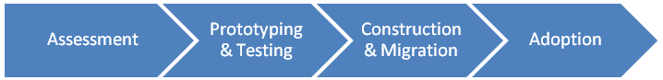Solution Development and Implementation

HRC had set aside a limited amount of funding to this project. This required that the team focus on delivering in a very tight timeframe. Sogeti team working closely with HRC staff not only designed the solution, but also implemented the solution and helped migrate all of HRC’s 45 staff members on-line in just two weeks.

Phase 1: Assessment

Sogeti started by spending some time with HRC team members, interviewing them about their document management needs and existing infrastructure. Based on this information, Sogeti was able to quickly identify several options varying from use of existing on-premise resources such as Windows SharePoint Services (WSS) to leveraging a fully hosted solution like SharePoint Online.

After considering the functionality and expense of the various options, HRC decided to pursue the fully hosted option and use Microsoft’s Business Productivity Online Suite (BPOS). This option gave them the greatest functionality while also offering substantial savings over their existing on-premise infrastructure.

Step 2: Prototyping & Testing

As next step, the Sogeti team prototyped the solution by focusing on SharePoint Online and Exchange Online.

Industry specific tags were defined and their potential values were placed into a SharePoint lists so values could be added as the solution grew. Sample sites were constructed to illustrate how customers and part sites would be organized. Sample document libraries were also implemented with test documents.

Simultaneously, the clients email domain was verified with Microsoft Online Services and an initial synchronization of their Active Directory was performed. A sample inbox was then migrated from the on-premise Exchange Online 2007 server to hosted Exchange.

With these pieces now in place, the client was able to play with a functional prototype and get a feel for how the system would work..

Step 3: Construction & Migration

With the initial prototype approved, Sogeti began to formalize the solution consisting of two parallel streams:

**SharePoint Template Design**: Using SharePoint Designer, site templates were constructed both for Customers and Parts. Initial sites were also created within the collection for the various departments and menus were customized for this implementation.

During this phase, documentation was also generated and stored in SharePoint Online to help the client with training their staff on how to use the system. Even at this stage, SharePoint Online was used to help communicate with all staff members and to collaborate, sharing questions and findings with the entire team.

**Exchange Online Migration**

While the SharePoint Online portion of the solution was being finalized, steps were taken to migrate HRC’s existing Exchange account to Exchange Online.

Using the Migration tool and Active Directory Sync, accounts were moved in batches and the Microsoft Online Services Single Sign-On Client software was deployed to user’s desktops. Over the course of several days, all users were moved to Hosted Exchange.

Step 4: SharePoint Adoption

With all the migration and construction completed, the final stage involved migrating and populating the BPOS solution.

As part of their on-going implementation, HRC is moving data into the hosted solution one customer at a time. This allows them to further refine the solution as additional needs or SharePoint uses are uncovered.

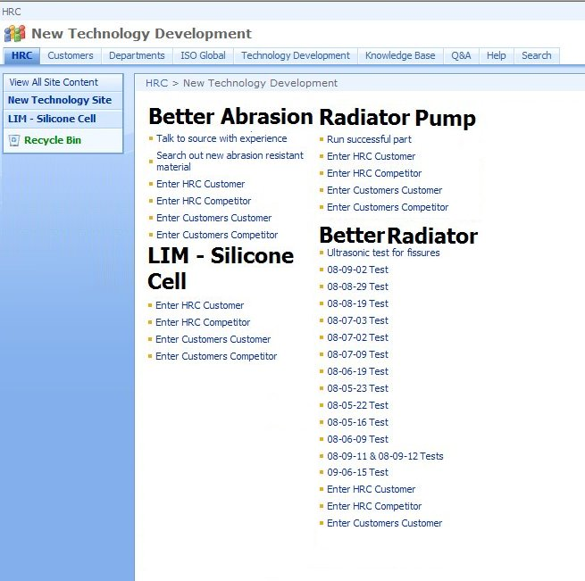

Benefits

Partner Benefits

* Offer customers a choice of flexible cost structure
* Rapid Implementation
* New business opportunities
* Perpetual Innovation

Customer Benefits

* 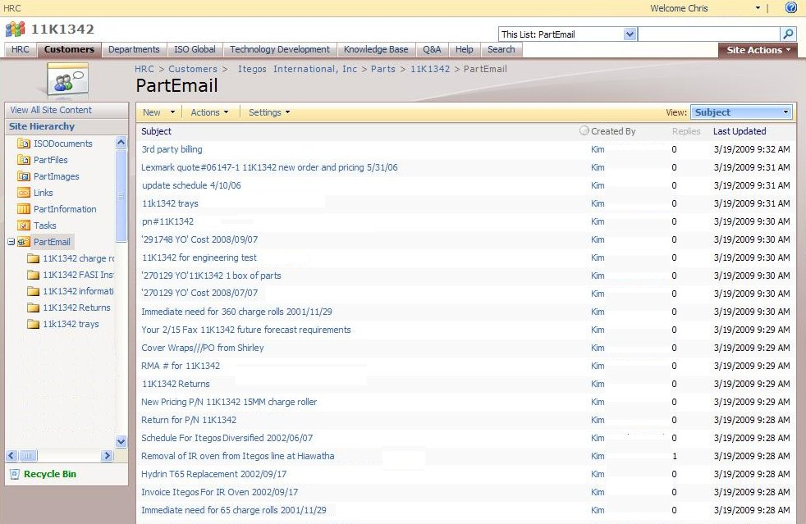Low Startup Costs – Try Before Buy
* Rapid Implementation
* Reduction in Infrastructure Costs
* New capabilities (Live Meeting)
* Perpetual Innovation

Introducing the Business Productivity Online Suite

Microsoft Online Services provide software delivered as a hosted service directly from Microsoft data centers, managed by Microsoft staff, and with a guaranteed 99.9 percent Service Level Agreement. These standardized solutions are designed so that partners can rapidly deploy services to their customers at a low, up-front investment with predictable, recurring costs.

The all-new Business Productivity Online Suite provides streamlined communications, simplified management, and business-class reliability and security.

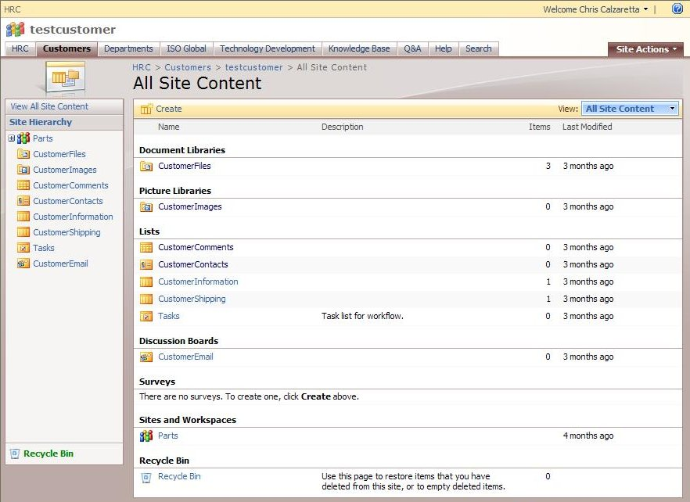

The Business Productivity Online Suite includes the following services, which can be purchased on a monthly subscription basis either separately or as part of a suite:

**Microsoft Exchange Online**, based on Microsoft Exchange Server 2007, offers businesses e-mail, calendaring, other messaging-based capabilities, and archiving. It also enables coexistence, which means new online users can interact with users on local servers.

(Introducing the Business Productivity Online Suite, Continued)

For More Information

For more information about Microsoft products and services, call the Microsoft Sales Information Center at (800) 426-9400. In Canada, call the Microsoft Canada Information Centre at (877) 568-2495. Customers who are deaf or hard-of-hearing can reach Microsoft text telephone (TTY/TDD) services at (800) 892-5234 in the United States or (905) 568-9641 in Canada. Outside the United States and Canada, please contact your local Microsoft subsidiary. To access information using the World Wide Web, go to [www.microsoft.com](http://www.microsoft.com)

For more information about Microsoft Online Services, visit the Web site at

[www.microsoft.com/online](http://www.microsoft.com/online)

For more information about Sogeti USA, visit the Web site at <http://www.us.sogeti.com/>

|  |  |
| --- | --- |
| Microsoft Business Productivity Online Suite | |
| * Microsoft Exchange Online * Microsoft SharePoint Online * Microsoft Office Communications Online * Microsoft Office Live Meeting * Microsoft Exchange Hosted Filtering |  | |

**Microsoft SharePoint Online**, based on Microsoft Office SharePoint Server 2007, provides a single integrated location where employees can efficiently collaborate with team members, find organizational resources, search, and manage content and workflow.

**Microsoft Office Communications Online** enables people to communicate easily with their colleagues across locations and time zones via instant messaging (text), voice, and video.

**Microsoft Office Live Meeting** is a hosted Web conferencing service that connects people in online meetings, training, and events through a reliable, enterprise-class hosted service.

**Microsoft Exchange Hosted Filtering** protects businesses’ inbound and outbound e-mail from spam, viruses, phishing scams, and e-mail policy violations.

**About the Microsoft Business Productivity Online Suite**

The Microsoft Business Productivity Online Suite provides businesses with virtually anywhere access to rich communication, collaboration, and productivity applications via subscription-based, Microsoft-hosted, online services. This hosted solution helps organizations offset the burden of managing and maintaining business systems, freeing information technology (IT) resources to focus on initiatives that can deliver competitive advantage to the business. The solution is part of the Microsoft’s Software-plus-Services delivery model to provide customers more choices than traditional, hosted, or on-premises solutions, allowing them to make deployment decisions that best fit the needs of their organization.

For more information about the partner opportunities provided by the Business Productivity Online Suite, see <http://partner.microsoft.com/online>.

© 2009 Microsoft Corporation. All rights reserved. This solution brief is for informational purposes only. MICROSOFT MAKES NO WARRANTIES, EXPRESS OR IMPLIED, IN THIS SUMMARY. Microsoft, SharePoint, Win32, and Windows are either registered trademarks or trademarks of Microsoft Corporation in the United States and/or other countries. The names of actual companies and products mentioned herein may be the trademarks of their respective owners.

Document published February 2009