|  |  |  |  |
| --- | --- | --- | --- |
| Overview  Market Opportunity  To reduce the administrative costs and burdens of managing messaging and collaboration on-premises, many companies are considering hosted solutions (“the cloud”).  Solution  Quest GroupWise Migrator for Exchange provides efficient, cost-effective migration to Exchange Online, including a direct migration of GroupWise e-mail, calendars, tasks, personal address books, and frequent contacts.  Benefits   * Reduced project timelines – ability to migrate multiple users across multiple migration machines simultaneously. * Reduced help desk and administrator work time – GroupWise Migrator automates manual administrative migration tasks and offers intuitive project management. * Maintain business productivity – migration is totally transparent from end users and there is zero data loss and downtime of e-mail services. |  |  | “This move toward hosted support keeps Quest in line with Microsoft, and one step ahead of our competitors. We are committed to always providing the best and most up-to-date technology for customers who are clamoring for the lower rollout and run rate costs that BPOS provides.”  David Waugh, Vice President of Unified Communications and Collaboration  E-mail, instant messaging, and collaboration services are business-critical and demand high availability. Continually-evolving technologies and an increasing number of data security threats, as well as policy and regulatory requirements can make managing a messaging and collaboration system costly and complex. This creates a challenge in a time of diminishing IT budgets and headcounts.  To reduce the administrative costs and burdens of managing messaging and collaboration on-premises, many companies are considering hosted solutions (“the cloud”). One option is Microsoft’s Business Productivity Online Suite (BPOS): a set of hosted messaging and collaboration solutions including Microsoft Exchange Online, SharePoint Online, and Office Communications Online.  Quest GroupWise Migrator for Exchange provides efficient, cost-effective migration to Exchange Online, including a direct migration of GroupWise e-mail, calendars, tasks, personal address books, and frequent contacts. GroupWise Migrator simplifies administration and reduces costs by automating manual migration tasks and migrating multiple users across multiple migration machines simultaneously. All data is migrated to the cloud without end user involvement, which reduces help desk calls. |

Solution Description

Quest Software helps organizations of any size expedite and simplify their migration from Novell GroupWise to Microsoft Exchange Online.

Solution Components

Archive Before You Migrate

Before migrating to Exchange Online, you can use Quest Archive Manager to reduce the amount of GroupWise data that needs to be migrated to the cloud. This will shorten the coexistence period and the time required to complete the migration, reducing overall project costs.

Intelligent Log Analyzer

GroupWise Migrator includes an intelligent advisor that prevents common configuration issues and displays issue-specific information with resolution techniques if errors are encountered during migration.

Parallel Migration

Multiple users can be migrated across multiple migration machines simultaneously. This will speed the entire migration process and reduce project costs.

Simplified Administration

GroupWise Migrator automates manual administrative tasks, which saves time and prevents errors.

Reduced Help Desk Calls

End-user data is migrated accurately and without user involvement ensuring a secure and reliable migration to the cloud.

Self-Service Desktop Migrator

Quest’s Self-Service Desktop Migrator is used by an end user, or by an administrator on behalf of an end user, to extract a single user’s GroupWise data and migrate it to Exchange Online.

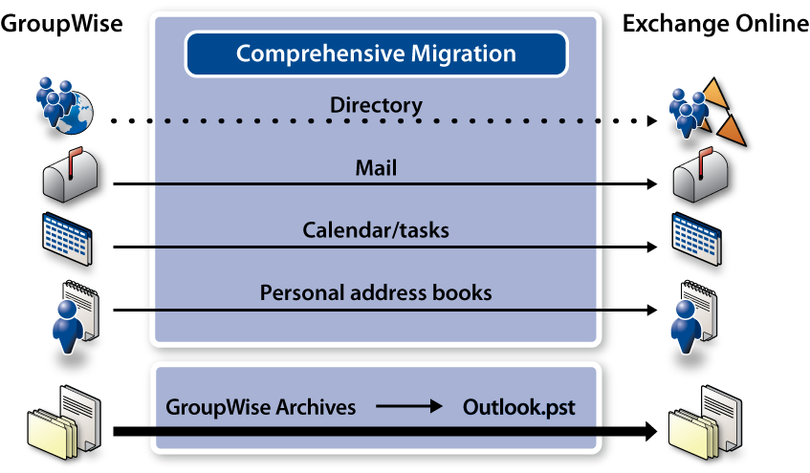

Quest’s Experience

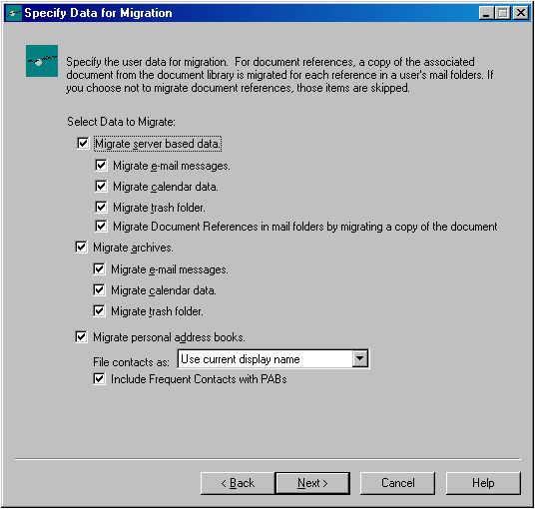

Market-Leading Expertise in Exchange

Management and Migration

* Migrated nearly 20 million mailboxes to Exchange
* Managed 32 million mailboxes in Exchange
* Migrated 5 million GroupWise and Notes users to Exchange

• Twice named Microsoft Global Independent Software Vendor (ISV) Partner of the Year

Introducing the Business Productivity Online Suite

Microsoft Online Services provide software delivered as a hosted service directly from Microsoft data centers, managed by Microsoft staff, and with a guaranteed 99.9 percent Service Level Agreement. These standardized solutions are designed so that partners can rapidly deploy services to their customers at a low, up-front investment with predictable, recurring costs.

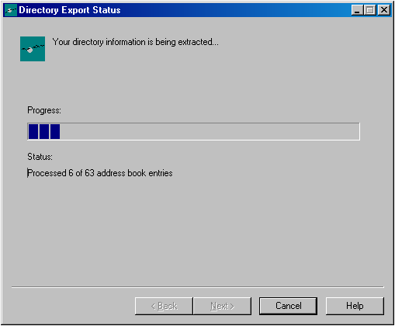

The all-new Business Productivity Online Suite provides streamlined communications, simplified management, and business-class reliability and security.

The customer can order this service for as few as five seats at a time.

The Business Productivity Online Suite includes the following services, which can be purchased on a monthly subscription basis either separately or as part of a suite:

**Microsoft Exchange Online**, based on Microsoft Exchange Server 2007, offers businesses e-mail, calendaring, other messaging-based capabilities, and archiving. It also enables coexistence, which means new online users can interact with users on local servers.

(Introducing the Business Productivity Online Suite, Continued)

For More Information

For more information about Microsoft products and services, call the Microsoft Sales Information Center at (800) 426-9400. In Canada, call the Microsoft Canada Information Centre at (877) 568-2495. Customers who are deaf or hard-of-hearing can reach Microsoft text telephone (TTY/TDD) services at (800) 892-5234 in the United States or (905) 568-9641 in Canada. Outside the United States and Canada, please contact your local Microsoft subsidiary. To access information using the World Wide Web, go to [www.microsoft.com](http://www.microsoft.com)

For more information about Microsoft Online Services, visit the Web site at

[www.microsoft.com/online](http://www.microsoft.com/online)

Quest Software, Inc., a leading enterprise systems management vendor, delivers innovative products that help organizations get more performance and productivity from their applications, databases, Windows infrastructure and virtual environments. Through a deep expertise in IT operations and a continued focus on what works best, Quest helps more than 100,000 customers worldwide meet higher expectations for enterprise

IT.

For more information about Quest Software BPOS products and services, visit the Web site at [www.quest.com/bpos](http://www.quest.com/bpos) or e-mail [sales@quest.com](mailto:sales@quest.com).

|  |  |
| --- | --- |
| Microsoft Business Productivity Online Suite | |
| * Microsoft Exchange Online * Microsoft SharePoint Online * Microsoft Office Communications Online * Microsoft Office Live Meeting * Microsoft Exchange Hosted Filtering |  | |

**Microsoft SharePoint Online**, based on Microsoft Office SharePoint Server 2007, provides a single integrated location where employees can efficiently collaborate with team members, find organizational resources, search, and manage content and workflow.

**Microsoft Office Communications Online** enables people to communicate easily with their colleagues across locations and time zones via instant messaging (text), voice, and video.

**Microsoft Office Live Meeting** is a hosted Web conferencing service that connects people in online meetings, training, and events through a reliable, enterprise-class hosted service.

**Microsoft Exchange Hosted Filtering** protects businesses’ inbound and outbound e-mail from spam, viruses, phishing scams, and e-mail policy violations.

**About the Microsoft Business Productivity Online Suite**

The Microsoft Business Productivity Online Suite provides businesses with virtually anywhere access to rich communication, collaboration, and productivity applications via subscription-based, Microsoft-hosted, online services. This hosted solution helps organizations offset the burden of managing and maintaining business systems, freeing information technology (IT) resources to focus on initiatives that can deliver competitive advantage to the business. The solution is part of the Microsoft’s Software-plus-Services delivery model to provide customers more choices than traditional, hosted, or on-premises solutions, allowing them to make deployment decisions that best fit the needs of their organization.

For more information about the partner opportunities provided by the Business Productivity Online Suite, see <http://partner.microsoft.com/online>.

© 2009 Microsoft Corporation. All rights reserved. This solution brief is for informational purposes only. MICROSOFT MAKES NO WARRANTIES, EXPRESS OR IMPLIED, IN THIS SUMMARY. Microsoft, SharePoint, Win32, and Windows are either registered trademarks or trademarks of Microsoft Corporation in the United States and/or other countries. The names of actual companies and products mentioned herein may be the trademarks of their respective owners.

Document published February 2009