|  |  |  |  |
| --- | --- | --- | --- |
| Solution  The proNestor Booking solution integrates with Exchange Online giving Outlook users a great tool for booking rooms, equipment and food services to their Outlook appointment.  proNestor Booking ensures optimum efficiency and overview for all the parties involved in ordering, preparing, servicing and executing the actual meetings.  Benefits   * *Organizers* will get a complete and enhanced booking option in Outlook * *Management* achieves a unique overview and information about the utilization of resources. * *Reception Desk* can see the daily meeting activities. * *Internal Services* receives up to date information about bookings and a complete overview of the day's tasks. * *The Kitchen receives* information about food orders, and can extract reports for purchasing, production, delivery and sales. * *Accounting departments* gain easy access to expense data for use in invoicing and accounting. Expense data can be automatically imported into the accounting system. |  |  | “We use proNestor Booking to keep track of all of our conference rooms, to plan our numerous daily meetings and to reserve facilities with the desired equipment.  This provides us with a complete overview of the day’s meeting activities and greatly eases everyday planning.  proNestor Booking is a very easy-to-use and clear tool, and is fully integrated with our Outlook calendar. This means that all reservations function as a natural element of meeting planning in Microsoft Outlook”  - Christina Müller, Carnegie Bank, Denmark  Giving the customers the option to move the cloud closer to their business is clearly an option that is important for proNestor’s business. Ensuring that proNestor Booking works seamlessly with Microsoft Business Productivity Online Suite gives the customers the power to go into the cloud without loosing the ability to enhance Outlook with add-ins.  proNestor Booking is an excellent proof that enterprises focusing on time and money saving solutions can benefit from multiple services in the cloud - and that these can work seamlessly together.  proNestor Booking gives users an excellent feature for booking with ease in Microsoft Outlook and users also save time and minimize errors.  Using proNestor Booking the manual meeting booking and scheduling procedures are eliminated and redundant work processes are merged into one workflow for all involved parties. proNestor Booking for Outlook ensures that all departments and parties involved in the ordering process, preparation and actual meeting achieve optimum efficiency and overview.  Using Microsoft Online Services in addition with proNestor Booking will give the customers this time and money saving experience. |

Solution Description

proNestor provides the Outlook user with a tool for booking rooms, equipment and food services. And behind the screen it offers a complete management module for internal service, kitchen, accounting, management and the reception desk.

proNestor has developed the proNestor Booking solution supporting Microsoft Business Productivity Online Suite as well as on-premises installations.

Key Features for the Organizer  
Outlook Booking add-in

proNestor Booking extends Outlook with an intelligent and unique overview of the availability of meeting attendees, rooms and other resources.

It enriches Outlook with booking facilities that aren’t available in standard Outlook/Exchange.

* Natural extension to Microsoft Outlook appointment workflow
* Save time with meeting proposals and filters
* See resources from categories like rooms, AV-equipment, cars, food, beverages etc.
* Reschedule, recur or delete your Outlook appointment - proNestor will automatically handle the same actions for your bookings without any synchronization delay.

The Outlook add-in was developed in MS VSTO 3.0

Web Booking

All booking functionality is also available through a web application. Any bookings created in Outlook will instantly be visible and editable through the web Booking.

The web Booking is a ASP.NET C# 3.5 MVC enabled web application making it a charm to run on Windows 2003/2008 web servers.

Relevant information to relevant parties

proNestor Booking removes the time-consuming manual work and ensures relevant data to the relevant departments.

Receptionist will see all bookings by anyone, kitchen will see their resources and bookings of these and print reports, internal service will see bookings of rooms and AV-equipment, Accounting can extract data to 3.party financial systems, and last the administrator can edit user lists and permissions.

Management Overview

A complete set of reports will reveal financial specifications of meeting expenses, see who utilizes and orders which resources.

Reception Desk Overview

With proNestor Booking it is easy for the reception desk to ensure an uncomplicated and well-planned everyday routine in the company.

Visitors can be directed to their meeting rooms – last minute change of room, equipment and expected visitors are easily managed in proNestor.

Kitchen and



Internal Services Overview

Both kitchen and internal services gains a unique tool for planning, production and invoicing food and beverages ordered for meetings and other events.

* Reduced administration – automatic inventory and accounting functions.
* Reduced waste – electronic overview over expected consumption/purchases.
* Save time – avoid manual entries and error deliveries due to imprecise and inadequate orders
* Better overview – complete overview of the day’s meeting orders.
* Handle changes in meetings are easily managed

Accounting integration

With proNestor Booking, your accounting department gains a unique tool for registering and invoicing expenses in connection with meetings.

This includes export to the companies accounting system.

System configuration

All configuration will be available through an intuitive web panel. Users’ access to backend functions is determined by the user’s role.

Solution Development and Implementation

proNestor Booking first release was back in 2001. It was originally designed for on-premises use. It was developed in C++ with support for Microsoft SQL data storage and other databases.

The whole product has been customer driven, but built as a standard solution with a huge range of configuration options.

To be able to offer proNestor Booking to an international audience we needed to rewrite the solution.

Our focus was to offer our solution online as a service as well as making the deployment easier for customers with on-premise requirements.

We focused on targeting Microsoft customers and supporting the environment they used which is Microsoft Outlook 2003/2007.

Using Microsoft Visual Studio was a obvious choice. We used SCRUM as an iterative framework ensuring that our software did progress in the direction of the customers requirements.

In 2008 we could present a totally rewritten .NET solution that supported on-premise and hosted (S+S) scenarios.

Porting the solution to BPOS was straight forward since we already had an architecture that was designed for setups like BPOS.

The requirements for running a server on-premise or hosted in the cloud has been kept simple – clean Windows setup without any requirements on 3.party services and databases.

Microsoft Windows Server 2003/2008, Microsoft Internet Information Server 6/7, ASP.NET 3.5, ASP.NET MVC, Microsoft Exchange Server 2003/2007, Microsoft SQL Server 2000/2005/2008, Internet Explorer 6.0/7.0/8.0, Microsoft Outlook 2003/2007.

Step 1: Focus

Before the first line of code was written, we were very clear on whom our customers were and what their requirements were.

95% of all our customers on the “old” solution were using Microsoft based servers and 90% was using Microsoft Office on the clients. This let to a simple conclusion that our solution should have a Microsoft Server backend, and the end-user application should target Windows users and Microsoft Office users.

Being able to offer our solution to customers as a hosted service as well as an on-premise solution was also an issue that was on top of mind from day one.

Step 2: Tools selection

It was obvious to change from C++ to C# now that we had the chance.

Hiring new developers was easier since C# support is much better and the language easier to use and understand.

Our choice of development tools was Microsoft Visual Studio 2005/2008.

Step 3: Strategy

It was clear that we needed a web back-end application serving all users (see Solution Description in prior section).

The web application was developed in ASP.NET 3.5. An interesting component in the .NET 3.5 framework was LINQ. We have adopted this component so all data querying is done through LINQ. It’s smooth and very practical.

With early testing of the ASP.NET MVC we were lucky to be able to integrate this framework in our web application making it so much easier to handle the web front-end.

The tricky part was to be able to integrate our solution into Microsoft Outlook without tampering with the customers Exchange Server which they saw as a business critical system.

We got around this hurdle by using developing a Windows application for the booking application, which was controlled by a VSTO component in Outlook.

Using VSTO 3.0 (Visual Studio Tools for Office) we did all our Exchange calendar interaction through Outlook and thereby ensuring that our application did not mangle with the customers Exchange Server

Our add-in communicates with the back-end using a web service – so all dataflow is centralized and controlled.

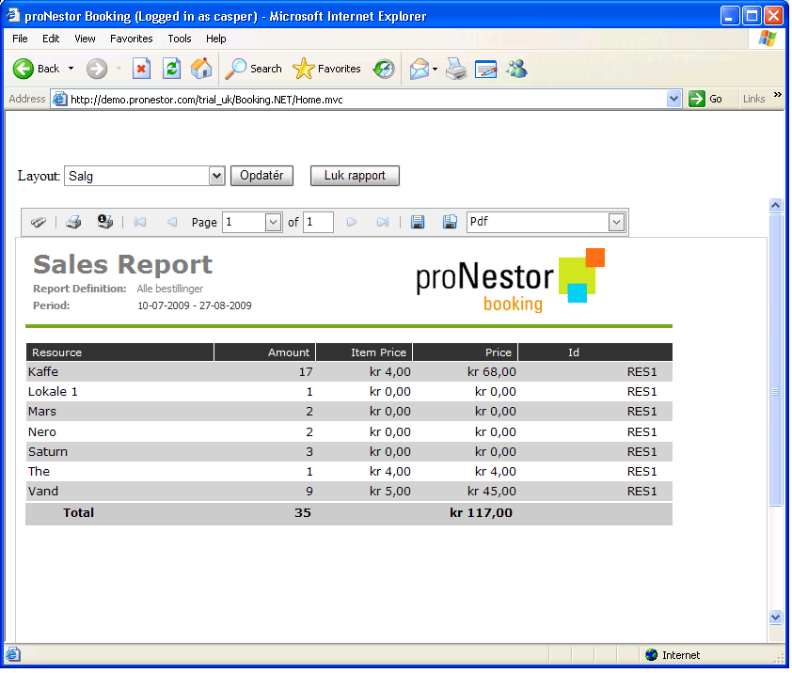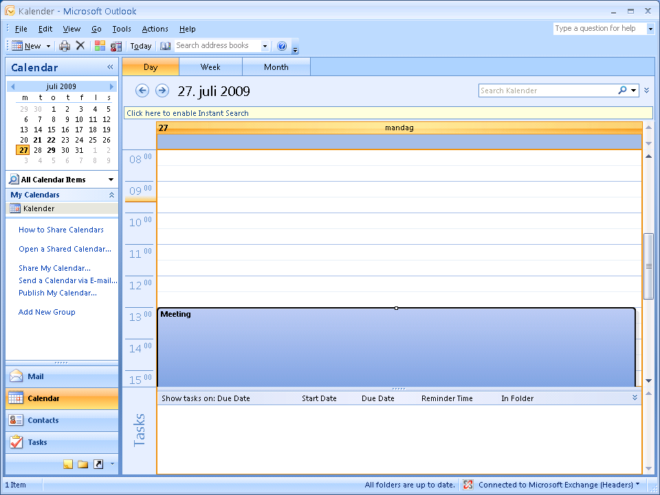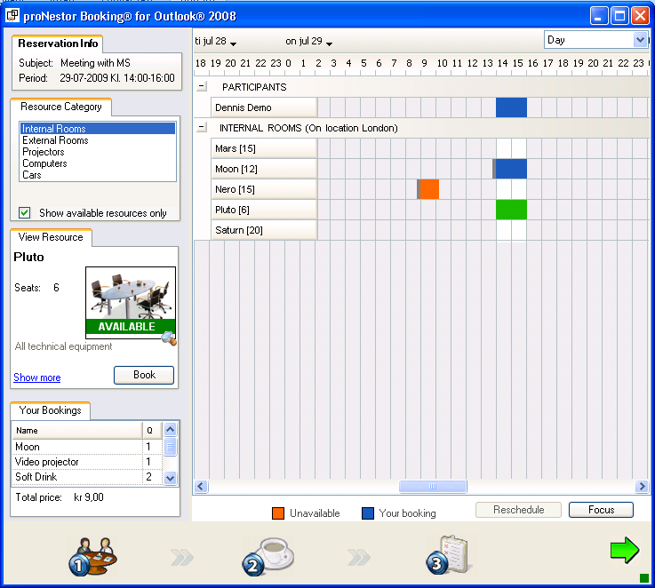

Benefits

Partner Benefits

* Enables one of the first to market in delivering S+S solutions with Exchange Online.
* 8 years of knowledge within booking ready for deployment right away
* integrated with Outlook – and therefore easy for customers to comprehend
* No changes to the Exchange server required

Customer Benefits

* Quickly book room and food services to your Outlook appointment
* Better resource utilization
* Export expenses to financial system
* Efficient workflow support for the kitchen, reception and internal service

Introducing the Business Productivity Online Suite

Microsoft Online Services provide software delivered as a hosted service directly from Microsoft data centers, managed by Microsoft staff, and with a guaranteed 99.9 percent Service Level Agreement. These standardized solutions are designed so that partners can rapidly deploy services to their customers at a low, up-front investment with predictable, recurring costs.

The all-new Business Productivity Online Suite provides streamlined communications, simplified management, and business-class reliability and security.

The Business Productivity Online Suite includes the following services, which can be purchased on a monthly subscription basis either separately or as part of a suite:

**Microsoft Exchange Online**, based on Microsoft Exchange Server 2007, offers businesses e-mail, calendaring, other messaging-based capabilities, and archiving. It also enables coexistence, which means new online users can interact with users on local servers.

(Introducing the Business Productivity Online Suite, Continued)

For More Information

For more information about Microsoft products and services, call the Microsoft Sales Information Center at (800) 426-9400. In Canada, call the Microsoft Canada Information Centre at (877) 568-2495. Customers who are deaf or hard-of-hearing can reach Microsoft text telephone (TTY/TDD) services at (800) 892-5234 in the United States or (905) 568-9641 in Canada. Outside the United States and Canada, please contact your local Microsoft subsidiary. To access information using the World Wide Web, go to [www.microsoft.com](http://www.microsoft.com)

For more information about Microsoft Online Services, visit the Web site at

[www.microsoft.com/online](http://www.microsoft.com/online)

proNestor

Ravnsborggade 8b, 1.st floor

2200 Copenhagen

Denmark

Phone: +45 8853 4884

For more information about company products and services, visit the Web site at [www.pronestor.com](http://www.pronestor.com)

|  |  |
| --- | --- |
| Microsoft Business Productivity Online Suite | |
| * Microsoft Exchange Online * Microsoft SharePoint Online * Microsoft Office Communications Online * Microsoft Office Live Meeting * Microsoft Exchange Hosted Filtering |  | |

**Microsoft SharePoint Online**, based on Microsoft Office SharePoint Server 2007, provides a single integrated location where employees can efficiently collaborate with team members, find organizational resources, search, and manage content and workflow.

**Microsoft Office Communications Online** enables people to communicate easily with their colleagues across locations and time zones via instant messaging (text), voice, and video.

**Microsoft Office Live Meeting** is a hosted Web conferencing service that connects people in online meetings, training, and events through a reliable, enterprise-class hosted service.

**Microsoft Exchange Hosted Filtering** protects businesses’ inbound and outbound e-mail from spam, viruses, phishing scams, and e-mail policy violations.

**About the Microsoft Business Productivity Online Suite**

The Microsoft Business Productivity Online Suite provides businesses with virtually anywhere access to rich communication, collaboration, and productivity applications via subscription-based, Microsoft-hosted, online services. This hosted solution helps organizations offset the burden of managing and maintaining business systems, freeing information technology (IT) resources to focus on initiatives that can deliver competitive advantage to the business. The solution is part of the Microsoft’s Software-plus-Services delivery model to provide customers more choices than traditional, hosted, or on-premises solutions, allowing them to make deployment decisions that best fit the needs of their organization.

For more information about the partner opportunities provided by the Business Productivity Online Suite, see <http://partner.microsoft.com/online>.

© 2009 Microsoft Corporation. All rights reserved. This solution brief is for informational purposes only. MICROSOFT MAKES NO WARRANTIES, EXPRESS OR IMPLIED, IN THIS SUMMARY. Microsoft, SharePoint, Win32, and Windows are either registered trademarks or trademarks of Microsoft Corporation in the United States and/or other countries. The names of actual companies and products mentioned herein may be the trademarks of their respective owners.

Document published February 2009