|  |  |  |  |
| --- | --- | --- | --- |
| Overview  Problem  Email is such an integral part of every business today that any downtime or loss of information has a negative impact on an organizations bottom line. Migration of data to any new service has always been a problem with every business.  Solution  MigrationWiz helps to move companies to Exchange Online seamlessly while lowering upfront costs and improving the total cost of ownership (TCO) by eliminating the need to purchase and manage on-premise software or hiring specialized consultants.  Benefits   * Low cost * No software to install * Easy to use – Little or no technical experience required * Seamless migration of mailbox |  |  | “Email is a critical part of every business today and plays a major role in our daily communications. MigrationWiz helps to easily move and preserve that critical information to Exchange Online.”  Geeman Yip, Founder and CEO - BitTitan  Email is such an integral part of every business today that any downtime or loss of information has a negative impact on an organizations bottom line. Moble devices have made this line of business application a fixture and a primary form of communications.  Migration of data to any new service has always been a problem with every business. While Exchange Online helps organizations to offset the burden of managing and maintaining business systems -- MigrationWiz helps to move companies to this virtually anywhere access environment seamlessly while lowering upfront costs and improving the total cost of ownership (TCO) by eliminating the need to purchase and manage on-premise software or hiring specialized consultants.  MigrationWiz is a single solution designed to meet the needs of individuals, employee-administrators, IT administrators, and Partners interested in migrating mailboxes to Exchange Online. |

Solution Description

MigrationWiz safely and seamlessly moves the critical data stored in your email to Exchange Online without the need to install and maintain local software.

MigrationWiz is a single solution designed to meet the needs of individuals, employee-administrators, IT administrators, and Partners interested in migrating mailboxes to Exchange Online.

Features and Benefits

Pay-Per-Mailbox

Predict costs by paying a fixed fee for each mailbox migrated. We offer a tiered pricing structure based on the number of mailboxes being migrated.

Secure, Automated Migration

Our solution is hosted in a state of the art data center facility. Automated migrations eliminate the need for human interaction with mailbox information and data – providing secure communication between your current environment and Exchange Online.

End-User Password Management

In some instances, administrative access to mailbox data is not possible. MigrationWiz will safely and securely gather that information from each end-user in order to access mailbox content and perform the migration.

Migration Notifications

Get notified when your migration succeeds or fails. MigrationWiz also provides the ability to customize each notification.

Mailbox Grouping

Large migrations can be grouped and scheduled by departments, quantity or any other deciding factor.

Migration Steps

Mailbox migration is as easy as 1-2-3. No software to install and maintain.

1. **Buy Credits** – Each migration credit allows you to perform a single mailbox migration. We offer a tiered pricing structure based on the number of mailboxes migrated.
2. **Migrate Mailboxes** – Provide mailbox information (email address, credentials, etc.) directly from our website or by importing the information from a spreadsheet.
3. **Check Status** – Check the status of your migration from our website or sign up to get notified when your migration succeeds or fails.

Migration Audience

Individual Migration

Individuals can migrate their mailboxes quickly and easily from a single interface. Provide the corresponding mailbox information to our website and MigrationWiz will do the rest. No software to install.

IT Administrator Migration

IT administrators can configure migration information and settings from a spreadsheet. Upload the spreadsheet and MigrationWiz will do the rest.

IT administrators may provide either administrative credentials to access mailboxes or MigrationWiz can reach out to each individual user and obtain their credentials through our service.

Partner Migration

Partners can migrate businesses more effectively without developing their own custom solutions and still maintain the customer relationship and migration flexibility that MigrationWiz has to offer.



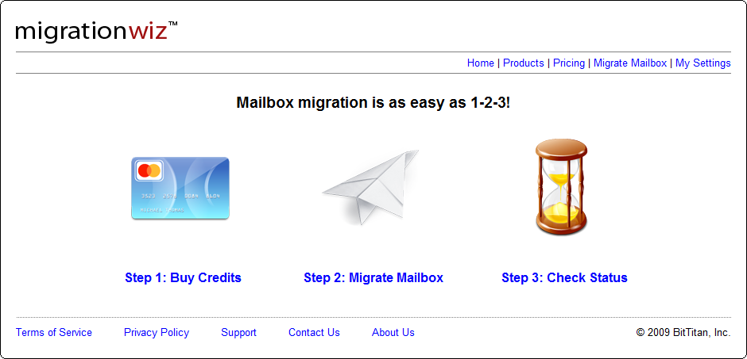

Benefits

* Low cost
* No software to install
* Easy to use – Little or no technical experience required
* Seamless migration of mailbox

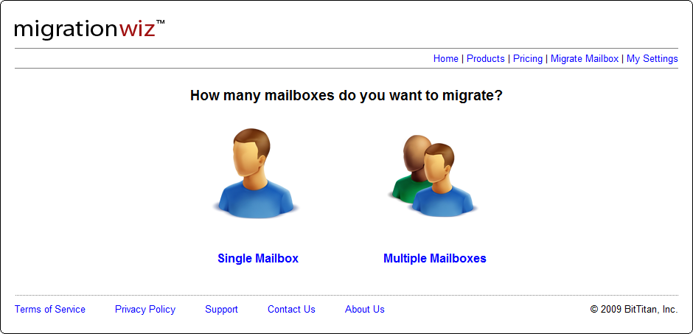

Introducing the Business Productivity Online Suite

Microsoft Online Services provide software delivered as a hosted service directly from Microsoft data centers, managed by Microsoft staff, and with a guaranteed 99.9 percent Service Level Agreement. These standardized solutions are designed so that partners can rapidly deploy services to their customers at a low, up-front investment with predictable, recurring costs.

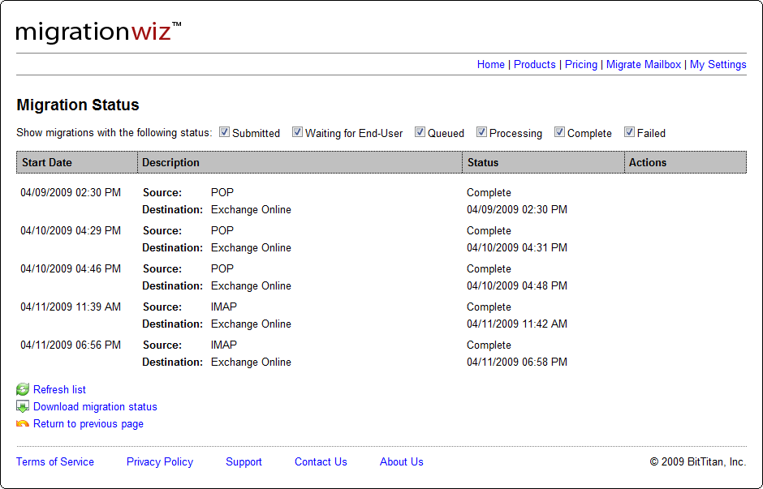The all-new Business Productivity Online Suite provides streamlined communications, simplified management, and business-class reliability and security.

The customer can order this service for as few as five seats at a time.

The Business Productivity Online Suite includes the following services, which can be purchased on a monthly subscription basis either separately or as part of a suite:

**Microsoft Exchange Online**, based on Microsoft Exchange Server 2007, offers businesses e-mail, calendaring, other messaging-based capabilities, and archiving. It also enables coexistence, which means new online users can interact with users on local servers.

(Introducing the Business Productivity Online Suite, Continued)

For More Information

For more information about Microsoft products and services, call the Microsoft Sales Information Center at (800) 426-9400. In Canada, call the Microsoft Canada Information Centre at (877) 568-2495. Customers who are deaf or hard-of-hearing can reach Microsoft text telephone (TTY/TDD) services at (800) 892-5234 in the United States or (905) 568-9641 in Canada. Outside the United States and Canada, please contact your local Microsoft subsidiary. To access information using the World Wide Web, go to [www.microsoft.com](http://www.microsoft.com)

For more information about Microsoft Online Services, visit the Web site at

[www.microsoft.com/online](http://www.microsoft.com/online)

BitTitan is a software development and IT consulting company that specializes in custom application and solution development based on the Microsoft platform, including Windows, .Net , ASP.Net, SQL, SharePoint, Exchange, and Identity Lifecycle Manager. BitTitan develops its own web-based products & services targeted to various consumer, business, public sector, and non-profit customers. These services are deployed on BitTitan’s own highly secure and available data center.

For more information about BitTitan products and services, visit the web site at [www.BitTitan.com](http://www.BitTitan.com)

|  |  |
| --- | --- |
| Microsoft Business Productivity Online Suite | |
| * Microsoft Exchange Online * Microsoft SharePoint Online * Microsoft Office Communications Online * Microsoft Office Live Meeting * Microsoft Exchange Hosted Filtering |  | |

**Microsoft SharePoint Online**, based on Microsoft Office SharePoint Server 2007, provides a single integrated location where employees can efficiently collaborate with team members, find organizational resources, search, and manage content and workflow.

**Microsoft Office Communications Online** enables people to communicate easily with their colleagues across locations and time zones via instant messaging (text), voice, and video.

**Microsoft Office Live Meeting** is a hosted Web conferencing service that connects people in online meetings, training, and events through a reliable, enterprise-class hosted service.

**Microsoft Exchange Hosted Filtering** protects businesses’ inbound and outbound e-mail from spam, viruses, phishing scams, and e-mail policy violations.

**About the Microsoft Business Productivity Online Suite**

The Microsoft Business Productivity Online Suite provides businesses with virtually anywhere access to rich communication, collaboration, and productivity applications via subscription-based, Microsoft-hosted, online services. This hosted solution helps organizations offset the burden of managing and maintaining business systems, freeing information technology (IT) resources to focus on initiatives that can deliver competitive advantage to the business. The solution is part of the Microsoft’s Software-plus-Services delivery model to provide customers more choices than traditional, hosted, or on-premises solutions, allowing them to make deployment decisions that best fit the needs of their organization.

For more information about the partner opportunities provided by the Business Productivity Online Suite, see <http://partner.microsoft.com/online>.

© 2009 Microsoft Corporation. All rights reserved. This solution brief is for informational purposes only. MICROSOFT MAKES NO WARRANTIES, EXPRESS OR IMPLIED, IN THIS SUMMARY. Microsoft, SharePoint, Win32, and Windows are either registered trademarks or trademarks of Microsoft Corporation in the United States and/or other countries. The names of actual companies and products mentioned herein may be the trademarks of their respective owners.

Document published February 2009