MessageOps Exchange Monitor Overview

MessageOps Exchange Monitor allows you to monitor your Microsoft Exchange Online mailboxes. It performs are variety of tests to help identify and isolate problems you may be experiencing. The main screen shows the tests that are currently running.

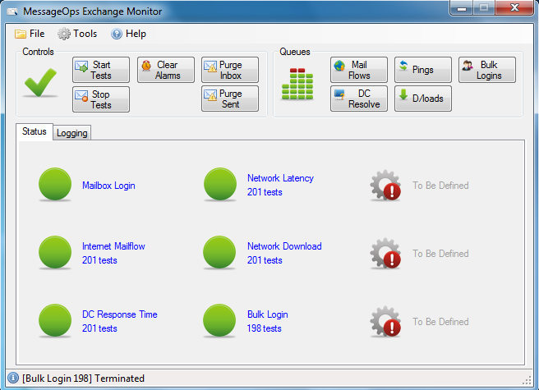

These tests are briefly described below.

Mailbox Login – Exchange Monitor users a Microsoft Online Mailbox to perform several of its tests. If the program is unable to log into the Monitoring mailbox, the Internet Mailflow and DC Response Time tests cannot be performed.

Internet Mailflow – The program logs into the Exchange Online mailbox and sends a message to a mail server on the Internet which automatically replies to the message. The round trip time is then recorded. If a reply is not received in the configured timeframe an alert is raised.

DC Response Time – The program submits a query to the Microsoft Online Domain Controllers to make sure they are responding in a timely fashion.

Network Latency – Measures the latency between the machine running MessageOps Exchange Monitor and the Microsoft Datacenter.

Network Download – Detects if your organizations Internet connection is up by downloading a file from a server on the internet.

Bulk Login – Logs into each of your organizations mailboxes within Microsoft Online and makes sure they are available. If a configured percentage of mailboxes are not available an alert will be raised.

Hovering over any of the tests will display some statistics, as shown below.

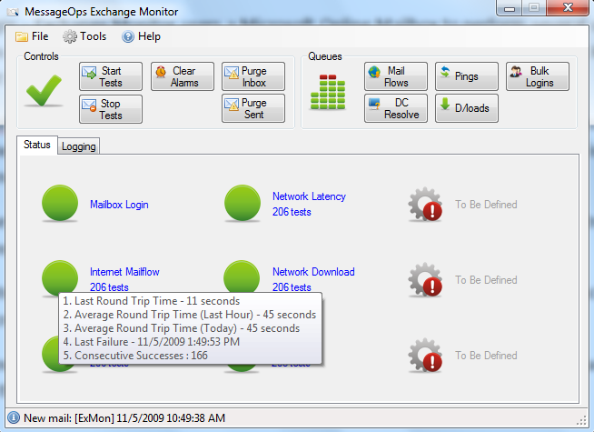

In the example above you can see of the Internet Mailflow test the last round trip time was 11 seconds. The average round trip time today has been 45 seconds.

If you go into settings you’ll be able to configure thresholds for each of the monitors. A few examples are shown below.

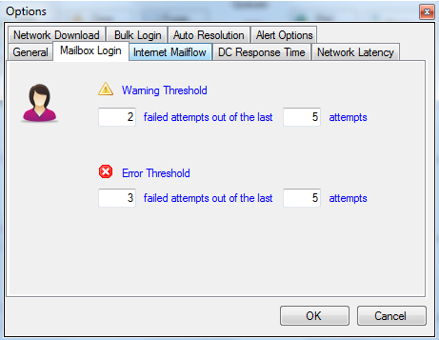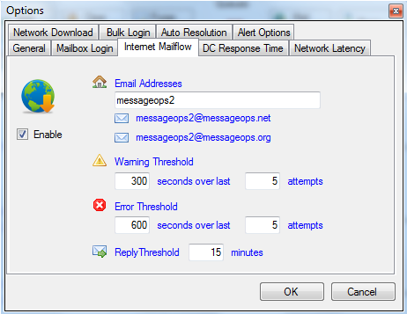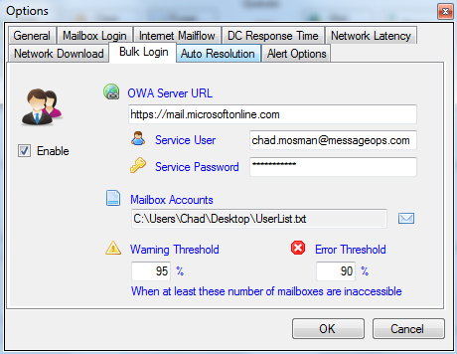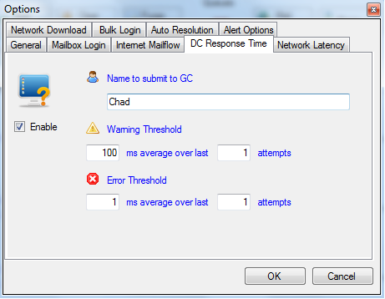

The program also keeps detailed logs of all transactions and provides a daily summary report with statistics for that day. When combined with Excel, you can track performance over time.

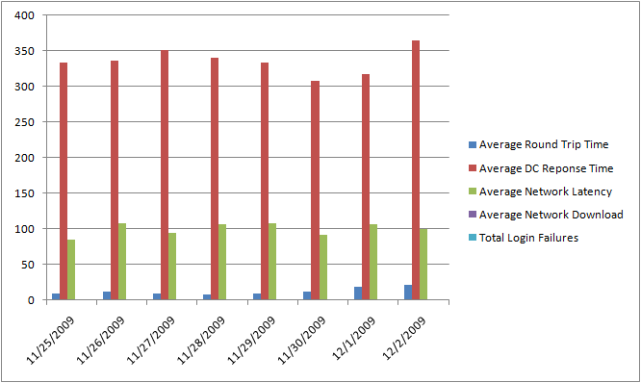

For more information, visit <http://www.messageops.com/ExmonDownload.html>, or email info@messageops.com.