|  |  |  |  |
| --- | --- | --- | --- |
| Overview  Market Opportunity  SharePoint Master Pages, designed so that SharePoint doesn’t look like SharePoint, were costly and not easy to find.  Solution  Developed stylish master pages that are compatible with BPOS and offer them as free downloads.  Benefits   * Configure SharePoint so it doesn’t look like SharePoint * Configure SharePoint to match corporate branding |  |  | “The custom master page developed for our company not only looks great, but installed seamlessly and was a great value.”  IT Manager  Expert SharePoint Consulting, a service line of Miles Consulting Corp (MCC), announces downloadable templates, known as Master Pages, for Microsoft Online Services. To provide additional affordable SharePoint branding solutions, MCC has developed Master Pages that are entirely free. We have also created a library of premium SharePoint Master Pages for download at an extremely attractive price.  Solution Description  Master pages are a feature of ASP.NET 2.0. Master Pages allow you to create a consistent layout for the pages in your application. A single master page defines the look and feel and standard behavior that you want for all of the pages (or a group of pages) in your application. You can then create individual content pages that contain the content you want to display. When users request the content pages, they merge with the master page to produce output that combines the layout of the master page with the content from the content page.  Our master pages provide a custom, non-SharePoint look and feel without the large price tag.  Solution Development and Implementation  The master pages were designed using Photoshop. Once approved they were created in Office SharePoint Designer. The master pages are deployed using SharePoint Designer.  These free master pages can be downloaded from our website. <http://www.expertsharepointconsulting.com/FREE-SharePoint-Online-BPOS-Master-Pages.aspx>. |

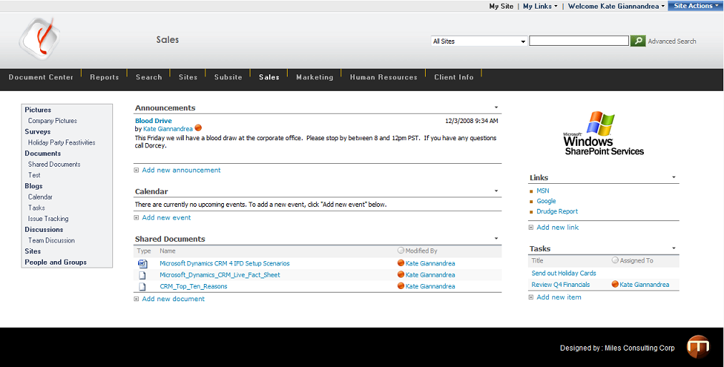

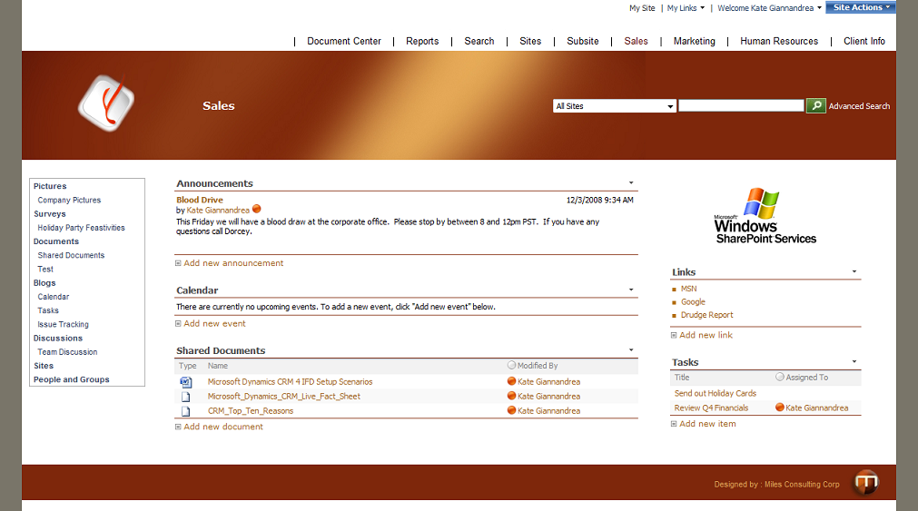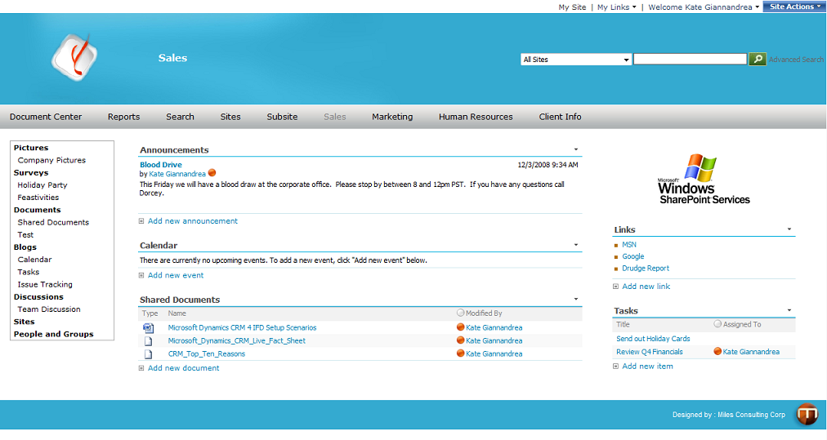

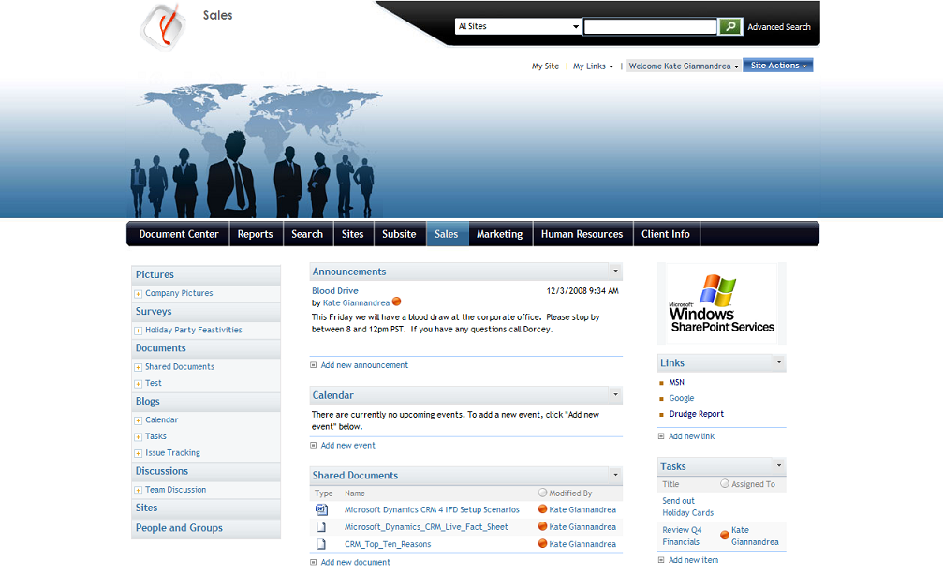Introducing the Business Productivity Online Suite

Microsoft Online Services provide software delivered as a hosted service directly from Microsoft data centers, managed by Microsoft staff, and with a guaranteed 99.9 percent Service Level Agreement. These standardized solutions are designed so that partners can rapidly deploy services to their customers at a low, up-front investment with predictable, recurring costs.

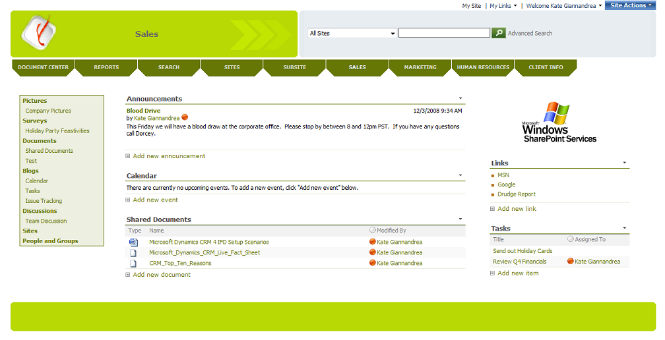The all-new Business Productivity Online Suite provides streamlined communications, simplified management, and business-class reliability and security.

The customer can order this service for as few as five seats at a time.

The Business Productivity Online Suite includes the following services, which can be purchased on a monthly subscription basis either separately or as part of a suite:

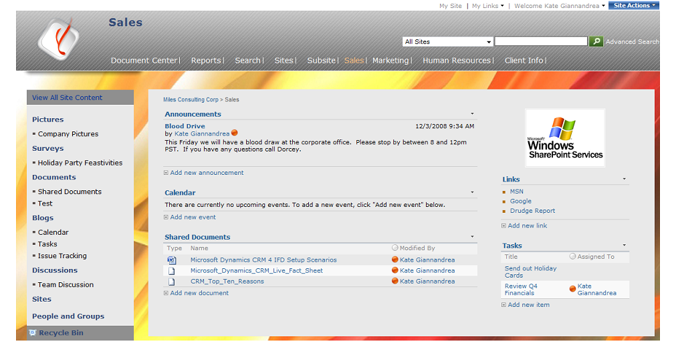**Microsoft Exchange Online**, based on Microsoft Exchange Server 2007, offers businesses e-mail, calendaring, other messaging-based capabilities, and archiving. It also enables coexistence, which means new online users can interact with users on local servers.

(Introducing the Business Productivity Online Suite, Continued)

For More Information

For more information about Microsoft products and services, call the Microsoft Sales Information Center at (800) 426-9400. In Canada, call the Microsoft Canada Information Centre at (877) 568-2495. Customers who are deaf or hard-of-hearing can reach Microsoft text telephone (TTY/TDD) services at (800) 892-5234 in the United States or (905) 568-9641 in Canada. Outside the United States and Canada, please contact your local Microsoft subsidiary. To access information using the World Wide Web, go to [www.microsoft.com](http://www.microsoft.com)

For more information about Microsoft Online Services, visit the Web site at

[www.microsoft.com/online](http://www.microsoft.com/online)

Expert SharePoint Consulting

193 Blue Ravine Road, Suite 160

Folsom, California 95630

(866) 844 – 5055

For more information about company products and services, visit the Web site at [www.expertsharepointconsulting.com](http://www.expertsharepointconsulting.com).

|  |  |
| --- | --- |
| Microsoft Business Productivity Online Suite | |
| * Microsoft Exchange Online * Microsoft SharePoint Online * Microsoft Office Communications Online * Microsoft Office Live Meeting * Microsoft Exchange Hosted Filtering |  | |

**Microsoft SharePoint Online**, based on Microsoft Office SharePoint Server 2007, provides a single integrated location where employees can efficiently collaborate with team members, find organizational resources, search, and manage content and workflow.

**Microsoft Office Communications Online** enables people to communicate easily with their colleagues across locations and time zones via instant messaging (text), voice, and video.

**Microsoft Office Live Meeting** is a hosted Web conferencing service that connects people in online meetings, training, and events through a reliable, enterprise-class hosted service.

**Microsoft Exchange Hosted Filtering** protects businesses’ inbound and outbound e-mail from spam, viruses, phishing scams, and e-mail policy violations.

**About the Microsoft Business Productivity Online Suite**

The Microsoft Business Productivity Online Suite provides businesses with virtually anywhere access to rich communication, collaboration, and productivity applications via subscription-based, Microsoft-hosted, online services. This hosted solution helps organizations offset the burden of managing and maintaining business systems, freeing information technology (IT) resources to focus on initiatives that can deliver competitive advantage to the business. The solution is part of the Microsoft’s Software-plus-Services delivery model to provide customers more choices than traditional, hosted, or on-premises solutions, allowing them to make deployment decisions that best fit the needs of their organization.

For more information about the partner opportunities provided by the Business Productivity Online Suite, see <http://partner.microsoft.com/online>.

© 2009 Microsoft Corporation. All rights reserved. This solution brief is for informational purposes only. MICROSOFT MAKES NO WARRANTIES, EXPRESS OR IMPLIED, IN THIS SUMMARY. Microsoft, SharePoint, Win32, and Windows are either registered trademarks or trademarks of Microsoft Corporation in the United States and/or other countries. The names of actual companies and products mentioned herein may be the trademarks of their respective owners.

Document published February 2009