|  |  |  |  |
| --- | --- | --- | --- |
| Overview  Partner Description  Binary Tree is the world’s largest provider of cross-platform messaging migration and coexistence software having migrated over 15,000,000 users to new messaging platforms. Binary Tree is Microsoft’s go-partner for migrating Lotus Notes users to Microsoft Online Services and has recently helped organizations like Blockbuster, Coca-Cola Enterprises, Ingersoll-Rand, and others to migrate over 200,000 users to Microsoft Exchange Online and the Business Productivity Online Suite (BPOS).  Business Situation  Migrating from the Lotus Notes messaging platform to Microsoft Exchange Online can be a costly, resource-intensive, and time-consuming endeavor. The traditional approach includes buying, installing and configuring special migration hardware and software, and bringing in outside consultants that specialize in managing and performing messaging migrations between diverse environments.  Solution  The Weekend Express Migration makes the migration process much faster and easier with a managed service that can enable organizations with up to 5,000 users to be migrated in one weekend.  Benefits   * Includes the migration of email, calendar, contacts and to-do’s * No migration software or hardware to buy, install or configure * No on-site consultants needed * No expertise on migration needed * Online user training on Microsoft Outlook is included free of charge |  | Experts13_Weekend.jpg | “Binary Tree’s new Weekend Express™ Migration is the fastest and easiest way to migrate your Lotus Notes messaging platform to Microsoft Exchange Online. Quite literally, we can take you from operating Lotus Notes and Domino on Friday to being on Outlook and Microsoft Exchange Online on Monday morning.”  Steven Pivnik, Co-CEO, Binary Tree  The Weekend Express Migration includes migrating the last 90 days of email, the past year of calendar entries, plus all future calendar entries, all contacts, and all to-do entries (additional data options exist). In addition, there’s an option that would enable all of your email-enabled Notes applications to interoperate with Outlook without requiring any modifications. Your users can have what they need to be productive first thing Monday morning on Microsoft Exchange Online Standard.  You don’t need to buy, install, or configure any hardware or software for the migration. Our data center runs the migration for you and can scale to migrate organizations with up to 5,000 users in one weekend. Larger enterprises can be migrated as well but will take longer and should consider the Dedicated offering.  You don’t need to bring in migration consultants to run the migration and you and your team don’t need to learn any migration software or know anything about the migration process. Our data center team processes your migration remotely and will guide you through every step of our proven best practices methodology from initial briefing to the launch of your new messaging environment in Microsoft Online. Plus, there are value added services available from our partners that include related archival, security, ECM, and mobility considerations. |

The Weekend Express Solution

The Weekend Express migration process was borne out of Binary Tree’s vast experience in migrating customers from Lotus Notes to online and on-premises versions of Microsoft Exchange.

And while there is a traditional on-premises version of Weekend Express, this document will focus on the more prominent remotely administered version.

The Weekend Express Data Center

Overview

We uphold our security measures to rigorous standards. Proximity card entry, camera-recorded server room access, and a perimeter security system all protect our main and data center facilities. These security components ensure only our certified Server Engineers have direct access to the data center and individual servers. This restricted access ensures maximum security when maintaining, upgrading, and troubleshooting servers right in the racks.

Certifications

* SAS-70 Type II Compliance
* PCI Compliance

Security

* Restricted Key card Access to Data center
* Video Surveillance Fully Monitors Access Points
* Monitored by 24x7x365 On-site Server Engineers

Connectivity

* Multiple Tier 1 Gigabit Ethernet Connections
* 10 GB/Sec Fiber Connectivity to Ashburn, VA
* Diverse Fiber Conduits for Physical Redundancy
* Redundant Cisco Routers and Carrier Class Juniper Firewalls

Power

* Parallel Redundant Liebert UPS System
* N+1 Redundant Diesel Backup Power Generation

Environmental Controls

* N+1 Redundant Liebert Environmental Control Systems
* FM-200 Gas Fire Suppression Systems
* Raised Flooring controls Air Flow and Steady Temperatures

Binary Tree Software Used by the Data Center Team

For Lotus Notes Audits

CMT Inspector Express is a robust Lotus Notes analysis and reporting tool. CMT Inspector Express enables users to examine Lotus Notes in unprecedented detail, equipping them with vital knowledge to ensure migration success.

For Notes to Exchange Migration

CMT for Exchange is the most comprehensive messaging migration tool available offering unmatched migration management, data fidelity and migration throughput.

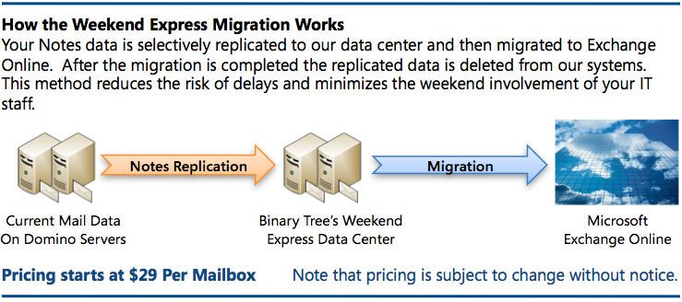For Optional Remediation of Email-Enabled Notes Applications

CMT for Coexistence with ZApp™ enables Outlook users to view and act on email-embedded forms and buttons from Lotus Notes applications.

The Data Center Team

Our data center team has helped to migrate over 15,000,000 users for over 4,000 customers around the world. Our team members will guide you through every step of our proven best practices methodology from initial briefing to the launch of your new messaging environment to ensure your successful transition to Microsoft Exchange Online Standard.

Related Partner Services for Weekend Express

Authorized Binary Tree business partners offer a variety of services related to Weekend Express.

* Pre-migration preparation & planning
* AD preparation & remediation
* Outlook Deployment & Configuration
* End user training
* Executive & VIP special processing
* Post migration support
* Archive & Mobile Device Support
* Detailed Lotus Application assessment
* Application planning & platform strategy
* Application migration & integration
* Post-migration Domino consolidation

The Weekend Express Methodology

The Weekend Express offering is based on a proven methodology for migrating from Notes to Microsoft Exchange Online Standard. And as previously noted, this document will focus on the remotely administered version of Weekend Express.

As shown in the accompanying process chart, the Weekend Express methodology encompasses five main phases. And please note that some preliminary up-front work may be required for the final migration to occur over a single weekend.

Phase 1: An Audit of the Lotus Notes Systems and Pre-Migration Preparation

The data center team will perform an audit of the customer’s Lotus Notes systems to discover any potential environmental variables that could impact the migration.

Phase 2: The Replication of the Customer’s Lotus Notes Data to Our Data Center

Dedicated Domino servers are created in the data center and cross-certified with the customer’s environment. The data center team then replicates all of the relevant email, calendar entries, contacts, and tasks. Depending upon the throughput from the customer’s site, the replication of data will begin 5 to 10 days prior to the migration weekend.

Phase 3: User Communications & Training

Email announcements are scheduled and delivered to the end users that explain the migration initiative, the available online training, and their responsibilities for ensuring the success of the migration. End users will be provided with access to an online training portal that includes reference guides and more in an effort to make sure they are ready to be productive with Microsoft Outlook prior to the migration weekend.

Phase 4: Provisioning and Migration

Prior to the migration weekend, the data center team will setup Active Directory (AD) in the Microsoft Online environment and provision the users in AD. On the Friday of the migration weekend, the data center team will commence with the migration of the user data to Exchange Online Standard.

Phase 5: Validation and Launch

The data center team will run validation tests to confirm the proper migration of the customer’s data into Exchange Online Standard. Then on the Monday after the weekend migration, each user will receive one last email in Lotus Notes with a button to click on that will automatically trigger the configuration of the Microsoft Outlook on their computer where they can access all of their migrated email, calendar entries, contacts and tasks.

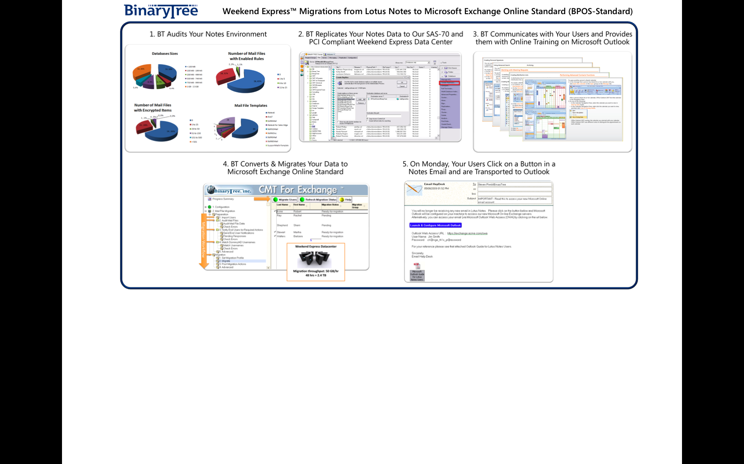Benefits

Partner Benefits

* Offer faster and easier migrations to your customers
* Offer value-added services that provide your customers with a complete solution for transitioning to Microsoft Online

Customer Benefits

* Quickly and easily migrate your email, calendar, contacts and tasks to Microsoft Exchange Online Standard
* No migration software or hardware to buy, install or configure
* No expertise on migration needed
* Online user training on Microsoft Outlook is included free of charge

Introducing the Business Productivity Online Suite

Microsoft Online Services provide software delivered as a hosted service directly from Microsoft data centers, managed by Microsoft staff, and with a guaranteed 99.9 percent Service Level Agreement. These standardized solutions are designed so that partners can rapidly deploy services to their customers at a low, up-front investment with predictable, recurring costs.

The all-new Business Productivity Online Suite provides streamlined communications, simplified management, and business-class reliability and security.

The customer can order this service for as few as five seats at a time.

The Business Productivity Online Suite includes the following services, which can be purchased on a monthly subscription basis either separately or as part of a suite:

**Microsoft Exchange Online**, based on Microsoft Exchange Server 2007, offers businesses e-mail, calendaring, other messaging-based capabilities, and archiving. It also enables coexistence, which means new online users can interact with users on local servers.

Introducing the Business Productivity Online Suite, (Continued)

For More Information

For more information about Microsoft products and services, call the Microsoft Sales Information Center at (800) 426-9400. In Canada, call the Microsoft Canada Information Centre at (877) 568-2495. Customers who are deaf or hard-of-hearing can reach Microsoft text telephone (TTY/TDD) services at (800) 892-5234 in the United States or (905) 568-9641 in Canada. Outside the United States and Canada, please contact your local Microsoft subsidiary. To access information using the World Wide Web, go to [www.microsoft.com](http://www.microsoft.com)

For more information about Microsoft Online Services, visit the Web site at

[www.microsoft.com/online](http://www.microsoft.com/online)

Binary Tree is Microsoft’s go-partner for migrating Lotus Notes users to Microsoft Online Services and has recently helped organizations like Blockbuster, Coca-Cola Enterprises, Ingersoll-Rand, and others to migrate over 200,000 users to Microsoft Exchange Online and the Business Productivity Online Suite (BPOS).

For more information on Weekend Express migrations to Microsoft Online, call Binary Tree at +1 (212) 244-3635 Option 1 or visit their website at:

[www.binarytree.com/bpos](http://www.binarytree.com/bpos).

Binary Tree and Weekend Express are trademarks of Binary Tree, Inc.

|  |  |
| --- | --- |
| Microsoft Business Productivity Online Suite | |
| * Microsoft Exchange Online * Microsoft SharePoint Online * Microsoft Office Communications Online * Microsoft Office Live Meeting * Microsoft Exchange Hosted Filtering |  | |

**Microsoft SharePoint Online**, based on Microsoft Office SharePoint Server 2007, provides a single integrated location where employees can efficiently collaborate with team members, find organizational resources, search, and manage content and workflow.

**Microsoft Office Communications Online** enables people to communicate easily with their colleagues across locations and time zones via instant messaging (text), voice, and video.

**Microsoft Office Live Meeting** is a hosted Web conferencing service that connects people in online meetings, training, and events through a reliable, enterprise-class hosted service.

**Microsoft Exchange Hosted Filtering** protects businesses’ inbound and outbound e-mail from spam, viruses, phishing scams, and e-mail policy violations.

**About the Microsoft Business Productivity Online Suite**

The Microsoft Business Productivity Online Suite provides businesses with virtually anywhere access to rich communication, collaboration, and productivity applications via subscription-based, Microsoft-hosted, online services. This hosted solution helps organizations offset the burden of managing and maintaining business systems, freeing information technology (IT) resources to focus on initiatives that can deliver competitive advantage to the business. The solution is part of the Microsoft’s Software-plus-Services delivery model to provide customers more choices than traditional, hosted, or on-premises solutions, allowing them to make deployment decisions that best fit the needs of their organization.

For more information about the partner opportunities provided by the Business Productivity Online Suite, see <http://partner.microsoft.com/online>.

© 2009 Microsoft Corporation. All rights reserved. This solution brief is for informational purposes only. MICROSOFT MAKES NO WARRANTIES, EXPRESS OR IMPLIED, IN THIS SUMMARY. Microsoft, SharePoint, Win32, and Windows are either registered trademarks or trademarks of Microsoft Corporation in the United States and/or other countries. The names of actual companies and products mentioned herein may be the trademarks of their respective owners.

Document published June 2009