
Windows Update Services – Beta Version

Note: Information in this datasheet is specific to the beta version of Windows Update Services and is subject to change – Microsoft does not guarantee that every capability referred to herein will be available in the production version of Windows Update Services.

Patch and update management is a top pain for IT organizations worldwide. Windows Update Services, previously known as Software Update Services (SUS) 2.0, delivers major enhancements over SUS 1.0 to address this pain and enable effective update management within the organization.

Available as a free add-on, Windows Update Services is the update management component of Windows Server. It benefits IT organizations by helping automate the update management process and by reducing the amount of time, effort, cost, and risk associated with the process.

Windows Update Services represents the first step toward delivering core software distribution and update management infrastructure in Windows. Over time, it is expected that management products from Microsoft and other vendors will build on this core infrastructure to deliver enhanced management solutions and support updating third party and in-house developed software via Windows Update Services infrastructure.

Windows Update Services delivers new functionality to:
• Update additional Microsoft products
• Improve administrative control over the update management process
• Minimize network bandwidth utilization and impact of network issues
• Deliver status reporting capabilities
• Optimize the end user experience
• Improve ease and flexibility of system implementation
• Increase administrator productivity

Infrastructure to Update all Microsoft Products
Unlike SUS 1.0, Windows Update Services has the ability to deliver updates for all Microsoft products. When initially released, Windows Update Services will support updating various versions of Windows, Office, Exchange*, SQL Server* and MSDE*. Support for updating other Microsoft software will be enabled on an on-going basis without requiring an upgrade or re-deployment of existing Windows Update Services implementations.

Windows Update Services also supports additional update types (critical driver updates, non-critical updates, etc.), providing a single mechanism for deploying all types of Microsoft updates.

Flexible Update Management Capabilities
Windows Updates Services significantly expands the scope of functionality and granularity of control for update management. The scanning of systems for missing updates is integrated into the solution, simplifying detection of missing patches and allowing administrators to easily determine which systems need to be updated and which updates need to be deployed to the target systems.

Windows Update Services adds the ability to un-install updates and allows targeting update deployment or un-installation to groups of systems. Administrators can now control the frequency with which clients check for and download approved updates, and specify deadlines by when the installation of an update should be enforced.

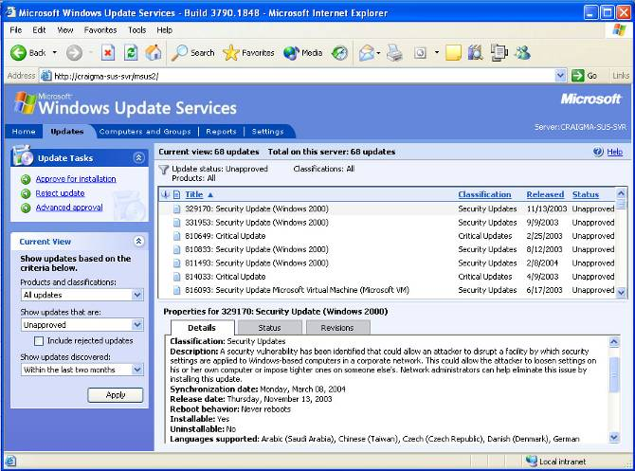

Figure: Update Approvals and Details Screen

Advanced Network Optimization
Windows Update Services leverages core Windows technologies including Background Intelligent Transfer Service (BITS) and Windows Installer Service (MSI), to seamlessly handle network interruptions and minimize the download size and network bandwidth consumption associated with update deployments. Downloads are automatically restarted from the point at which network service is interrupted, only the unused portion of network bandwidth is used by default – resulting in no impact on network responsiveness – and binary delta compression technologies dramatically reduce the size of updates.
Administrators can also specify which updates – by product version and update type – should be downloaded from Microsoft and whether the entire update or only the update metadata should be downloaded to the server to address situations where low bandwidth links connect the central office with branch offices (client systems then get the approved updates directly from Microsoft Update).

Consolidated Status Reports
Windows Update Services delivers a set of essential reports allowing administrators to easily determine key system health and update deployment statistics. Administrators can view reports of missing updates for target systems, as well as success, failure, error, and detail information for new downloads from Microsoft, update distributions to downstream servers and target systems, update installs, etc. Windows Update Services logs extensive information on system and update deployment status to a SQL Server or MSDE database.

When Windows Update Services is deployed in a hierarchical topology, logged status statistics are rolled up to the root server, providing a unified view for all the servers in the hierarchy and their associated clients.

Enhanced End User Experience
Windows Update Services includes features to minimize disruption of end user productivity and optimize the end user experience when such interaction is necessary or desirable. For updates that do not require a reboot, the system can be configured to silently install the updates without user notification or interaction. For updates that require reboots, Windows Update Services groups the installation of patches to consolidate multiple reboots into a single reboot. Additionally for computers running Windows XP SP2, the system can be configured to download and install updates in background mode but defer the reboot till the next system shutdown.

When user interaction is desirable or necessary, Windows Update Services provides MUI support to enable user interaction in any of the languages supported by the Windows Client or Server operating system. For systems not managed centrally, e.g., consumer or unmanaged corporate PCs, one-touch configuration allows easy setup the Windows Update Services client.

Easy, Flexible System Implementation
When Windows Update Services servers are deployed in a hierarchical topology to support distributed computing environments, administrative settings and update approvals can either be inherited from a parent server, enabling centralized administration of the entire deployment or if desired, child servers can be configured and administered independently of parent servers.

Windows Update Services is also designed to automatically upgrade earlier versions of its client, greatly simplifying the task of rolling out Windows Update Services and future versions of the solution across the computing environment.
For additional deployment flexibility, Windows Update Services allows specification of the port to be used for http communications as well as login credentials for Internet proxy servers that require authenticated access.

Windows Update Services verifies the identity of the Microsoft Update download servers it connects to and encrypts communications between an organization’s Windows Update Services servers and the Microsoft Update download servers. The system can also be configured to use encryption for server-server and client-server communications* across the organization’s Windows Update Services environment and for administrative GUI session communications. While update content is not encrypted during download, Windows Update Services clients and servers use digital signatures to validate authenticity and integrity of all content downloaded or installed on a system.

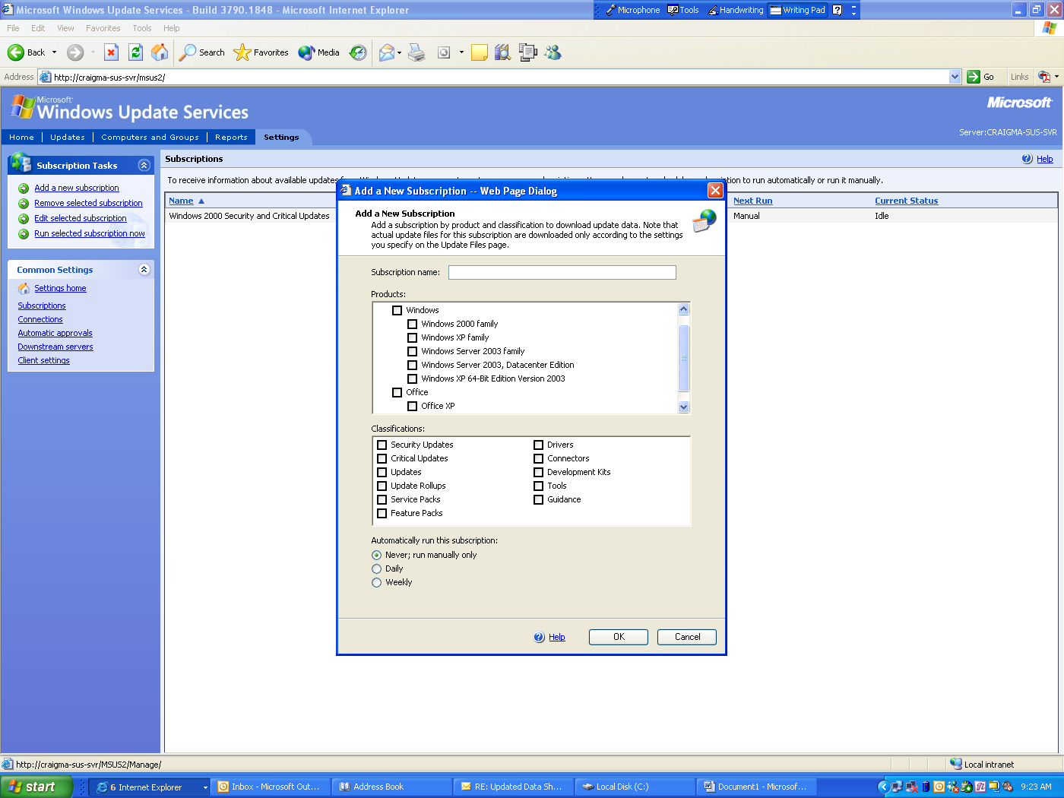

Figure: Specifying a Download Subscription

Increased Administrator Productivity
The new update management functionality described above significantly increase administrative efficiency for the update management process. The new administrative GUI in Windows Update Services is designed to further enhance administrator productivity by making it easy to configure, manage, troubleshoot, and report on various aspects of the update management infrastructure and process. Features such as the ability to specify that certain updates be installed automatically on specific target systems (e.g., in a test environment) and use of a SQL Server or MSDE DB to store all relevant system setting and status, update data and metadata, and update management status information further contribute to administrative efficiency, increased system reliability, and efficient backup and recovery.

Windows Update Services also enables centralized, scalable management in large distributed environments. A distributed deployment can be managed from a single administrative interface, and clients can be centrally configured via Group Policy in Active Directory environments. Windows Update Services also delivers APIs and commands to allow efficient command line and script based administration of the Windows Update Services environment.

Windows Update Services Feature Highlights

Supported Products and Content Types
Operating Systems | • Service Pack 3 and later versions of Windows 2000 Server (all editions) and Windows 2000 Professional  • Windows Server 2003 all editions  • Windows XP Professional and later versions
Servers and Applications | • All editions of Microsoft Office 2003 and Microsoft Office XP Service Pack 2 and above  • Microsoft Exchange 2003* all editions  • Microsoft SQL Server 2000* all editions  • Microsoft SQL Server Desktop Engine (MSDE) 2000* all editions
Content Types | • Security updates  • Non-security updates (critical and non-critical) and update rollups  • Service packs  • Feature packs*  • Critical driver updates
Update Management Features
Detecting Missing Updates | • Automatically detects the OS and supported products installed on each managed system and generates a report of missing updates for the OS & each supported product  • Allows identification of all managed systems missing a specific update or set of updates
Downloading Updates from Microsoft | • Allows automatic or manual download of new updates from Microsoft  • Can specify frequency (daily or weekly) for checking for and downloading new updates  • Can specify the products and content types for which new updates should be downloaded
Targeting Updates | • Allows definition of groups of systems for targeting update management actions (install, uninstall, scan for missing updates, etc.)  • Target groups can be defined based on server-side enumerated lists of systems or client-side registry settings that can be centrally configured via Group Policy in Active Directory environments
Approving Updates | • Non-approved updates are not available for download or installation on managed systems  • Updates can be approved for installation on specific target groups or all managed systems  • Can define rules to auto-approve updates for installation to specific target groups
Distributing Updates | • Can specify the frequency with which managed systems should check for approved updates  • Can specify that the list of approved updates be obtained from the Windows Update Services server, but actual updates be downloaded from worldwide Microsoft Update download servers  • Automatically distributes the appropriate language version of updates to target systems
Installing Updates | • Windows Update Services clients can be configured to automatically install downloaded updates on a specified install schedule or allow the user to select & control installation of downloaded updates  • Administrators can specify a deadline by which an update must be installed and the system will force installation of the update accordingly
Network Optimization Features
Network Resiliency | • Uses BITS to automatically resume downloading from point of network interruption once connection is re-established
Network Transparency | • By default, by leveraging BITS, downloads are done in background mode using only the unused portion of network bandwidth, resulting in no impact on network performance
Minimized Data Transmission Volumes | • Dramatically reduces data transmission volumes associated with update management via use of advanced binary delta updating and compression technologies
Reporting Features
Update Management Reports | • Standard update management reports provide status information on missing updates, update downloads, pending updates, and update installs, on a per update, per computer, or per group basis
Consolidated Reporting | • Reports provide a consolidated view of the entire Windows Update Services implementation – statistics from child servers are rolled up to the parent server
Log Data Storage | • Use of MSDE or SQL Server to store log and update management data increases reliability
User Experience Features
One-click Client Configuration | • Allows easy configuration for clients not centrally configured via Group Policy or scripting
Silent Update Installs | • Updates not requiring a reboot on installation can be installed without user interruption
Install Updates at System Shutdown | • For Windows XP Professional Service Pack 2 updates that need a reboot on install, the reboot can be deferred to occur at normal system shutdown, eliminating the need for any user interruption
User Notification & Control over Installs | • When desirable, provides the ability to notify the user of new updates and / or control when updates are installed on the user’s system
Warning of Impending Reboot | • When the install deadline has passed or an update needs to be installed immediately, users receive notification of the impending reboot allowing them to save their work
Multi-Language Support | • Automatically downloads the appropriate MUI pack and installs on the client if it is not already installed*
System Implementation and Security Features
Automated Client Upgrade | • The Windows Update Services client is included in Windows XP Service Pack 2. For systems with an older version of the client, administrators can configure the system so the new version of the client is automatically deployed to these systems.
Hierarchical Scale-out Server Deployment | • Supports deploying a hierarchy of Windows Update Services servers – both independently administered servers that synchronize update content from a parent server and replica servers* that inherit content and administrative actions from a parent server – in distributed environment or load balancing scenarios.
Port Selection | • Administrators can specify the port to be used for client-server communications
Proxy Authentication | • Allows specification of username and password to be used in authenticating to a firewall / proxy server that mediates connection to the Internet from the Windows Update Services server
Secure Communications | • Communications between Windows Update Services servers and Microsoft Update download servers are encrypted  • Client-server and server-server communications can be configured to be encrypted*  • The administrative GUI is only available to administrators of the system on which SUS server is running. The GUI can be accessed remotely and can be configured to encrypt session communications
Server Identity Validation | • Windows Update Services servers validate the identity of the upstream server from which update content is downloaded
Content Authentication | • Windows Update Services servers check digital signatures on all downloaded files to ensure they are authentic Microsoft updates that have not been tampered with  • Windows Update Services clients verify authenticity & integrity of updates before installs
Administrative Productivity Features
New Data Model | • The new update management data model allows specification of relationships between updates (e.g., pre-requisites, bundle relationships, and supersedence), resulting in higher levels of automation and significantly reduced administrative effort
New Administrative GUI | • The new administrative GUI provides an intuitive, unified console for managing the entire Windows Update Services environment. Administrators can quickly and easily get summary and detailed information on updates, approvals, target groups and managed systems, system health and update management statistics, etc.
Active Directory Based  Group Policy Integration | • Enables scalable centralized administration of geographically distributed environments via Group Policy, allowing efficient configuration of Windows Update Services client settings such as target group specification, preventing end-user access to Windows Update, etc.
Client and Server APIs | • Client and Server APIs allow command-line or programmatic access to Windows Update Services functionality, enabling the creation of scripts to automate administrative tasks
Backup and Recovery | • All relevant system setting and status, update data and metadata, and update management status information stored in a SQL Server or MSDE database enabling reliable and efficient backup and recovery
System Requirements & Language Support
Windows Update Services Server | • Windows 2000 Server – all editions, Service Pack 4 and later versions not including 64-bit editions  • Windows Server 2003 – all editions not including 64-bit editions  • Microsoft Internet Information Services (IIS) 5.5 and later versions  • ASP.NET version 1.1 – this will be automatically installed if it’s not already on the system  • Microsoft SQL Server 2000 Service Pack 3 and later versions or Microsoft SQL Server 2003 or Microsoft SQL Server Desktop Engine (MSDE) 2000  • Minimum RAM: 512 MB; Recommended RAM: 1 GB  • Localized for all Windows Server supported languages (English, German, Japanese for Beta version)
Windows Update Services Client | • Windows XP Professional and later versions not including 64-bit editions  • Windows 2000 Server and Professional – all editions (not 64-bit), Service Pack 3 and later versions  • Windows Server 2003 – all editions, not including 64-bit editions. 64-bit support expected with SP1  • Localized for all Windows Client OS supported languages (English, German, Japanese for Beta version)

Note: This data sheet does not cover all features in Windows Update Services. For the full set of features please refer to the product documentation. For more information about Windows Update Services please visit http://www.microsoft.com/wus

© 2004 Microsoft Corporation. All rights reserved. This data sheet is for informational purposes only. MICROSOFT MAKES NO WARRANTIES, EXPRESS OR IMPLIED, IN THIS SUMMARY. 