
Accounts Receivable

Microsoft Dynamics™ SL

Benefits
- Gain financial flexibility
Set up and control customer records
by means of a wide variety of options,
including the ability to define unique
business parameters and control
information such as default bank
accounts, aging periods, and
customer history retention.

- Minimize support costs
Reduce time spent entering customer
information by using customer class
defaults. Enter data in batch mode,
allowing for review prior to posting
or, in real time, updating customer balances for current information.

- Improve productivity
Speed data entry with recurring invoice
options that automatically default payment terms and other fields
defined in the customer maintenance record. Apply payments manually or automatically to generate recurring invoices on a monthly or periodic basis.

- Manage credit and cash flow
Handle multiple types of credit and
track your collections and cash flow.
Perform credit checks, track credit limits, and receive alerts when credit limits are exceeded or when a customer has exceeded a due date by a specified number of days.

- Invoice flexibly
Print original invoices or reprint
Copies of existing invoices, to get your customers the information they need about their accounts. Print in-process invoices or memos instantly.

Actively manage your customer accounts and identify problems before they occur. Flexible, integrated functions provide you with detailed information and reporting to monitor receivables and do what you
need to enhance your cash flow and bottom line.

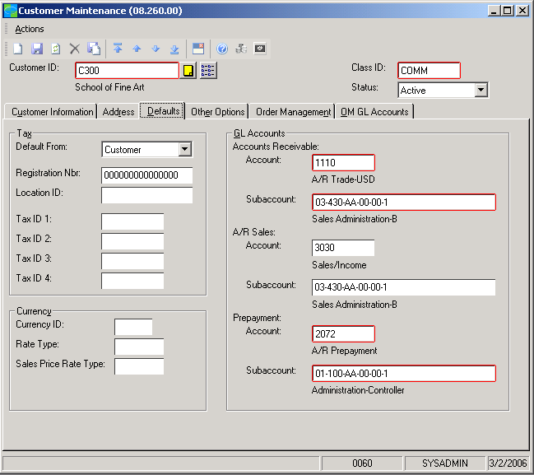
Set Up
customer records and control information such as default bank accounts and customer history retention

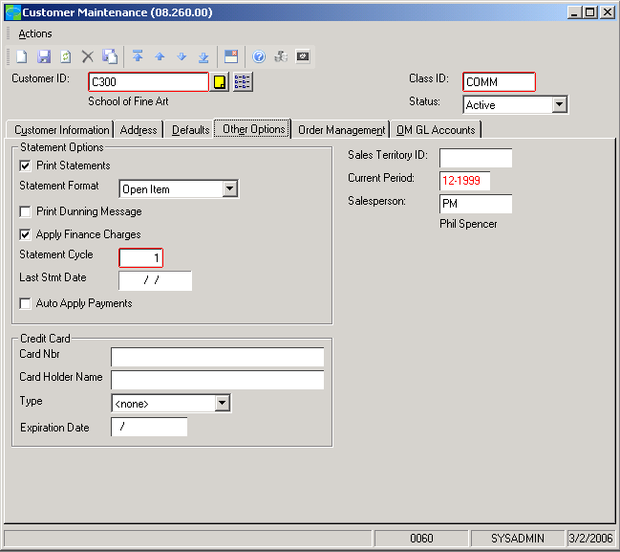

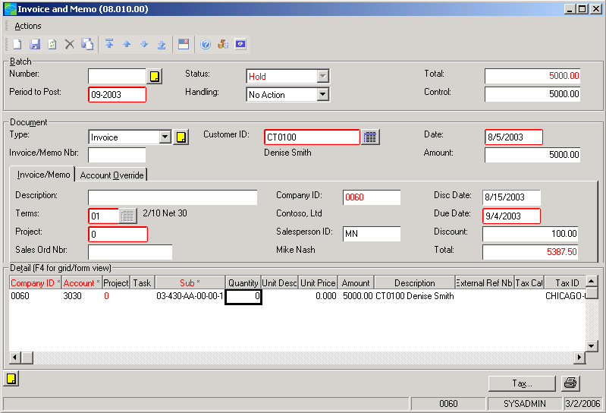

Print
invoices or memos instantly using the Quick Print button

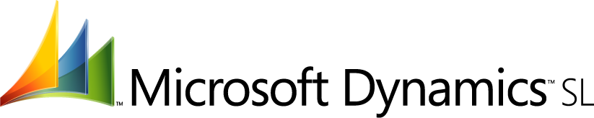

Easy Payment Processing  features  BENEFITS | Apply payments and credit memos to specific unpaid invoices by using  several automatic payment application options to keep customer payment  information consistent and accurate.
Thorough Transaction Information | Work with a variety of standard reports, including aged receivables, customer  trial balance, accounts receivable transactions, document register, recurring  invoices, statement cycles, and the accounts receivable batch register.
Extended Reporting Options | Customize reports to provide the information your business needs. Sort,  select, and filter on any field in a report, and then export the data to multiple  formats, including Microsoft Office Excel, for further analysis. With business  portal, you can provide managers and other users with Web-based access to  reports.
Current Balance Information | Review customer details and drill down to source documents for more detailed  information. Easily locate closed or open customer documents and the payments  applied to them.
Balance Write-off | Dismiss inactive or small balances during payment application or by using the  Small Balance/Credit Write-Off screen.
Powerful Posting Options | Post transaction batches to future or prior periods for period posting control.  Manage all customers as a group within a given control account or sub-account.  Make easy credit/debit adjustments, payment application reversals, and  corrections.
Reliable Controls | Determine customer status and gain more control over sales functions by designating customers as active, inactive, one time, or on credit or administrative  hold.
Productivity Enhancements | With Microsoft Dynamics SL Multi-Company, distribute invoices to various  companies and automatically generate intercompany entries that eliminate  the need for manual adjustments and reclassifications.
Flexible Invoicing | Generate recurring invoices automatically. Add or change customer information  during invoice entry and calculate document discount and due dates with flexible  terms definition.
Customized Setup | Define unique business parameters, such as default values and selection options. Group customers by classes you define, and easily change terms or due dates  for multiple customers in a single action.
Wide-Ranging Options | Set terms for calculating document discount dates and due dates, use balance-  forward and open-item statements, and apply any mix of the comprehensive  service and finance charges available.
For more information about Microsoft Dynamics™ SL, visit: http://www.microsoft.com/dynamics/sl

This document is for information purposes only.
MICROSOFT MAKES NO WARRANTIES, EXPRESS, IMPLIED, OR STATUTORY, AS TO THE INFORMATION IN THIS DOCUMENT.

© 2005 Microsoft Corporation. All rights reserved.
Microsoft, The Microsoft Dynamics Logo, are either registered trademarks or trademarks of Microsoft Corporation or Microsoft Business Solutions ApS in the United States and/or other countries. Microsoft Business Solutions ApS is a subsidiary of Microsoft Corporation.

