

Providing DSL Services on Windows Server 2003

Microsoft Corporation
Published: August 2004

Abstract
Network appliance routers used to terminate Frame-Relay can be expensive and are typically single use devices. By using Windows as your operating system (OS) on a standard, inexpensive computer you can easily expand your service offerings without the need to purchase expensive hardware.

The information contained in this document represents the current view of Microsoft Corporation on the issues discussed as of the date of publication. Because Microsoft must respond to changing market conditions, it should not be interpreted to be a commitment on the part of Microsoft, and Microsoft cannot guarantee the accuracy of any information presented after the date of publication.
This document is for informational purposes only. MICROSOFT MAKES NO WARRANTIES, EXPRESS OR IMPLIED, AS TO THE INFORMATION IN THIS DOCUMENT.
Complying with all applicable copyright laws is the responsibility of the user. Without limiting the rights under copyright, no part of this document may be reproduced, stored in or introduced into a retrieval system, or transmitted in any form or by any means (electronic, mechanical, photocopying, recording, or otherwise), or for any purpose, without the express written permission of Microsoft Corporation.
Microsoft may have patents, patent applications, trademarks, copyrights, or other intellectual property rights covering subject matter in this document. Except as expressly provided in any written license agreement from Microsoft, the furnishing of this document does not give you any license to these patents, trademarks, copyrights, or other intellectual property.
The example companies, organizations, products, people and events depicted herein are fictitious. No association with any real company, organization, product, person or event is intended or should be inferred.
© 2004 Microsoft Corporation. All rights reserved.
Microsoft, Active Directory, Windows, and Windows Server are either registered trademarks or trademarks of Microsoft Corporation in the United States and/or other countries.
The names of actual companies and products mentioned herein may be the trademarks of their respective owners.

Contents
Overview 1
Designing 2
Bridged Connection 3
IP Address Allocation 4
Security 5
Billing/Support 6
The Connection to the Frame-Relay Network 7
Frame-Relay Card Setup 7
IP Addressing 11
RRAS Setup 13
Troubleshooting and monitoring 15
Conclusion 17

Overview
Many internet service providers (ISPs) provide or wish to provide DSL service to their users. This typically requires a connection from the ISP to the local phone company (telco). The phone company would provide the physical connection from the end-user’s home to the nearest DSLAM (Digital Subscriber Line Access Multiplexer). The phone company would then provide a digital connection from the DSLAM to the local Frame Relay or ATM network. The ISP would then have a connection into this Frame Relay or ATM network. This would come in the form of a T1 or some larger connection.

This document will describe how to setup a Windows Server 2003 machines to terminate a T1 Frame-Relay line from your local phone provider to provide the ability serve as an ISP for your DSL customers. A basic understanding of Windows, Microsoft RRAS, Networking, Frame Relay and DSL is required. The T1 connection model should be used for smaller ISPs that cannot or do not want to bear the costs of a DS3 or larger connection to the Telco’s Frame-Relay or ATM network. This document will provide information on connecting to the end user in a bridged connection. This document will not cover connecting via PPPoE or PPPoA.

Designing
You will need to know what DSL speeds are offered by the local phone company. Many phone companies will provide 768 kbps downstream and 128kbps upstream or 256kbps downstream and 256kbps upstream as a default or basic service. The services offered and the SLA (Service level Agreement) you wish to provide will both determine the number of DSL users you will be able to support on each T1 line to the phone company. If the phone company is providing 768/128 service you should be able to have about 16-64 DSL users on a single T1. While 64 users will over-subscribe your T1 line, you should be able to provide a good connection to your users while keeping costs down. By over-subscribing your line, you are betting that most of your users will not be using the internet at the peak connection speed at the same time. While this works in most situations you may find it does not work with your user base or SLA.

The best solution for determining your user-to-line ratio is to start with a small number and slowly add users to the T1 line. You will need to monitor the statistics of the connection to see if your small user ratio is utilizing a high amount of bandwidth.

Bridged Connection
You will need to work with your local telco to determine the steps to provide a bridged connection to your end users. Typically, this will mean that the phone company will provide the end user with pre-programmed CPE (consumer premises equipment, or DSL modem). Most phone companies are responsible for providing the end user with the needed CPE.

IP Address Allocation
Some ISPs have decided to provide NAT or transparent Proxy IPv4 addresses to their users. While this may save money on the ISP side, the end user may have issues if they are unable to use applications that do not work behind NAT or a transparent Proxy. With the NAT approach there are also security issues to keep in mind. For example, when a home user performs an illegal act, a law enforcement agency may come to you with an IP address and expect you to determine who was using the IP during a specific time period. With NAT, the IP address that the agency would come to you with will be that of your NAT server. Then you have the job of determining which one of your users accessed that website or server during that time period.

You will also need to decide how to provide the user with an address. Some ISPs will use DHCP to provide dynamic addresses while other will provide static IP addresses. Depending on the features you wish to offer your users you may wish to provide dynamic for basic users and static for more advanced higher paying users. IP addresses issued via DHCP may make it harder to identify the owner of an IP address when needed.

This document will provide the steps necessary to provide static IPv4 addresses to the end user.

You will need to contact your internet provider to get IPv4 address allocation so that you may provide addresses to your users.

Security
You will also need to determine the location on your network to place your DSL router. This router is best located in your DMZ or other perimeter network. You should keep it behind some kind of a network device that provides ACLs (Access Control Lists) or port filtering. This may come in useful when you detect an attack or compromise. You will want to make sure that DSL users do not have any additional access to any back-end or management network(s). This will help prevent attacks against your internal systems from your user base.

Securing your end users may also be a service you wish to provide. Basic access filters to prevent access to services like Windows File and Print Sharing, and SQL services, can assist in protecting your end users. You will need to evaluate this option to determine if it works with your user base and your SLA.

Billing/Support
You will need to make sure your billing system has a setup for provisioning new DSL users. You will also need to ensure your tech support staff is well aware of your plans to implement DSL. Billing and support issues are beyond the scope of this document.

The Connection to the Frame-Relay Network
You will need to order a Frame-Relay T1 connection from your facility to the local telco’s (the phone company) Frame-Relay network. This will be the connection used to pass the customers data from their home or business into your network. With this connection and your existing connection to the internet you will be able to provide your customers with DSL internet access. Each user’s connection will appear as a PVC on that Frame-Relay line.

Once you get the connection installed you will need to terminate the connection with a CSU/DSU. From your CSU/DSU you will need to connect to a Windows supported PCI Frame-Relay card. For this document we will be using the Sangoma (www.sangoma.com) 5148 Adapter which has an integrated CSU/DSU and an easy-to-use management interface. So the T1 will plug directly into the Sangoma card.

This card will be installed in a Windows Server 2003 Standard edition server. This server will be the machine that terminates the Frame-Relay line and the users’ DSL connection. With the use of Windows RRAS you will be able to route IPv4 addresses to the user through your upstream internet connection. In the steps below we will be routing IPv4 subnets through the new DSL Router.

For the purpose of this document we will assume there will be a /27 (32 IP address) of IPv4 routed to the DSL routers internet facing network interface. It is also assumed that the all routing on the network will be static routes. The use of OSPF or RIP is beyond the scope of this document.

Frame-Relay Card Setup
- Install the card. Follow the manufacture’s instructions for installing the card in your server.
- Download the latest driver. The latest Sangoma drivers can be found at http://www.sangoma.com/windows/drivers
- Install the driver. Follow the manufacture’s instructions for installing the drivers for your card.
- Connect Frame-Relay card to Frame-Relay Demark (where the Frame-Relay providers demarcation point, typically a small box mounted on the wall.)
- Configuring the Frame-Relay Card:
- Open Device Manager and expand Network Adapters

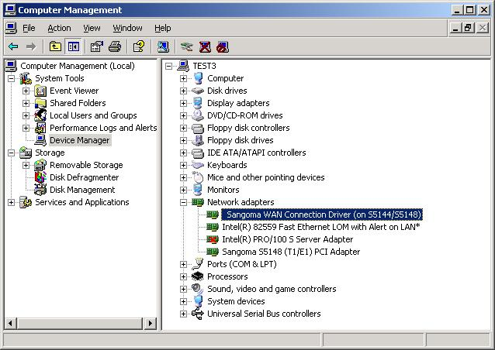
Figure 1 - Select Properties for “Sangoma WAN Connection Driver”
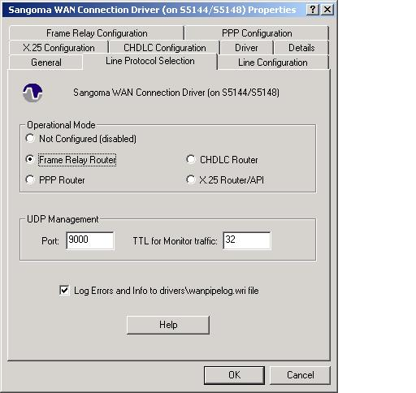
Figure 2 - Under the “Line Protocol Selection” tab select “Frame Relay Router”, leaving the rest default
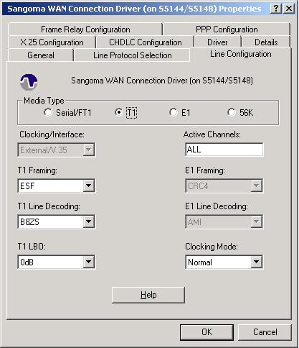
Figure 3 - Under the “Line configuration” tab, select your Line Framing and Decoding. The provider of your T1 will be able to give you more information on these settings.
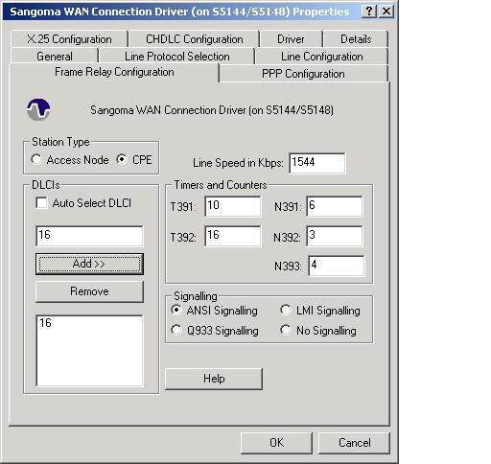
Figure 4 - Under the “Frame Relay Configuration” tab, unselect “Auto Select DLCI”. Enter the DLCIs for your DSL PVCs here. [Note: DLCIs will be assigned by your Frame-Relay provider.]
At this point you should have the Frame-Relay card installed and configured.
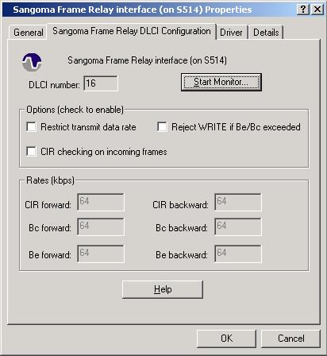
Figure 5 - You can select the “Start Monitor” option under properties for the “Sangoma Frame Relay Interface (on S514)” network adapter in Device Manager to display the monitoring utility for the Frame-Relay card.

If you open “Network Connections”, you should have interfaces listed for each DLCI you entered in the card’s configuration.

IP Addressing
For static IPv4 addresses we will assign /30 subnets to each user. This will allow you to keep user traffic separate from other users. Begin by creating a spread sheet or other method of tracking IP address allocation. For example:
Circuit ID = <PUT your circuit ID here> (subnet mask 255.255.255.252)
Subnet 1 | Customer Name | Phone | UserName | DLCI
x.x.x.16 | Network IP - unusable
x.x.x.17 | Router Frame-Relay Interface
x.x.x.18 | User 1 | (206)-555-1212 |  | 16
x.x.x.19 | Broadcast IP - unusable
Subnet 2 | Customer Name | Phone | UserName | DLCI
x.x.x.20 | Network IP - unusable
x.x.x.21 | Router Frame-Relay Interface
x.x.x.22 | User 2 | (206)-555-1213 |  | 17
x.x.x.23 | Broadcast IP - unusable
Subnet 3 | Customer Name | Phone | UserName | DLCI
x.x.x.24 | Network IP - unusable
x.x.x.25 | Router Frame-Relay Interface
x.x.x.26 | User 2 | (206)-555-1214 |  | 18
x.x.x.27 | Broadcast IP - unusable
Subnet 4 | Customer Name | Phone | UserName | DLCI
x.x.x.28 | Network IP - unusable
x.x.x.29 | Router Frame-Relay Interface
x.x.x.30 | User 3 | (206)-555-1215 |  | 19
x.x.x.31 | Broadcast IP - unusable
Subnet 5 | Customer Name | Phone | UserName | DLCI
x.x.x.32 | Network IP - unusable
x.x.x.33 | Router Frame-Relay Interface
x.x.x.34 | User 4 | (206)-555-1216 |  | 20
x.x.x.35 | Broadcast IP - unusable
Subnet 6 | Customer Name | Phone | UserName | DLCI
x.x.x.36 | Network IP - unusable
x.x.x.37 | Router Frame-Relay Interface
x.x.x.38 | User 5 | (206)-555-1217 |  | 21
x.x.x.39 | Broadcast IP - unusable

After you have your allocations determined, assign the end user’s “gateway” address to the appropriate NIC on the Windows Server. Each DLCI that is created will show up as a Network card under the Network Connections object in the Control Panel. For security reasons you should also disable Windows File and Print Sharing and NetBios over TCP.

Once the end user configures the assigned IPv4 address, default gateway, and DNS settings into their computer, they should be able to ping their default gateway but not beyond that (as we have not configured IP forwarding in RRAS). For this example we are going to use the subnet of 192.168.0.0/30. The End Users IP address will be 192.168.0.2, their network mask would be 255.255.255.252 and their default Gateway would be 192.168.0.1.

Note: When configuring the IP addresses on the Frame Relay (or customer facing) adapters you do not need to put in DNS or Default Gateway information. This information should be set on the internet facing network interface.

RRAS Setup
- To configure RRAS to route the necessary traffic, do the following:
- Navigate to Start > Run and type rrasmgmt.msc. This will open the RRAS MMC snap-in.
- Right click on your Servers Name and select “Configure and Enable Routing and Remote Access”.
- Select “Next” to start the Wizard.
- Select “Custom Configuration” and then Next.
- Check “LAN routing” and then Next.
- Click Finish to complete the RRAS configuration wizard.
- When asked if you wish to start the RRAS service select “Yes”.
- Expand your RRAS server and then expand “IP Routing”.
- Select “Static Routing” and add a new static Route:
  - Select the interface that connects to your upstream router
  - Destination = 0.0.0.0
  - NetMask = 0.0.0.0
  - Gateway = <ip address of your default gateway for this server>
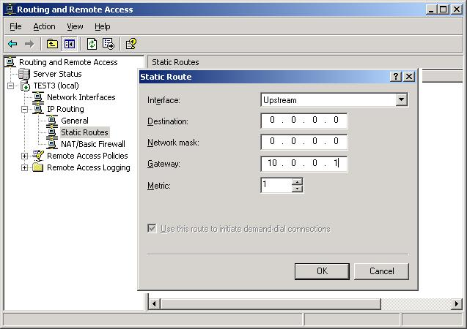
All other IPv4 routes are automatically entered by the interface configuration. You can view your IPv4 routing table by running the command “route print”.

At this point your end user should be able to ping the default gateway and also ping the internet facing interface of your DSL router. Once this is verified your user should be able to open a web browser and surf the internet.

Ordering a DSL line to go through your own DSL service is convenient to have when you wish to troubleshoot DSL issues. Attempting to have your users try many unnecessary troubleshooting steps can be annoying and harmful to customer relations. This also allows you to test that services are running correctly before you start to add users.

Troubleshooting and monitoring
When troubleshooting a DSL connection there should be a verification of access in layers. The layers are End User to Gateway, End User to ISP Network, and End User to internet. For example can the end user contact their upstream DSL router (this test can be preformed by having the end user perform a ping to their default gateway.) If they can not then the connection issue is some where between the user’s computer and the ISPs DSL router.

When troubleshooting with a user have them attempt to get to sites or machines by FQDN (fully qualified domain name like www.microsoft.com) and by IP address (like 192.168.0.1), this will help determine if the issue is a connectivity issue to the DNS server.

Things to investigate when there is a problem:
- Can the end user ping their default gateway?
  - If they can then have them ping another IP in the ISP network
  - Also have the user try to ping a known up IP address on the internet
- Does the Card Management tool show the DLCI and Frame-Relay interface as UP?
  - If the Card Management tool shows T1 or E1 alarms, contact your line provider (Telco)
  - If the Frame-Relay link service or any of the DLCIs are down, contact your Frame-Relay network provider (typically different from your local Telco)
  - If the DLCI shows Up but your user still cannot connect, the problem is probably on the ADSL link
- Can the user trace route (using tracert.exe) to a known up host and IP?
  - If it fails where does it fail, is it inside of the ISP network or is it upstream on the internet
- How many lights are illuminated on their DSL modem?
  - Most DSL modems will have 3 lights Power, DSL Sync and LAN Sync
    - If a light is not on that should be the issue could be with the telco or the users home network
- Are other users reporting the same issue?
  - If a singe user is having a problem the issue is probably with the users machine or at the telco.
  - If all your users are having a problem the issue is probably with the Telco, the DSL Router or the ISP network
- Does your test DSL line work?
  - If your test line fails then you can investigate the problem from their without having the users run lots of test
  - If your test line works you should send your troubleshooting tests to the user
- Can the DSL Router access upstream devices?
  - If the DSL router its self can not access resources (that it should be able to access) the issue might be in the ISP network or upstream internet.

Conclusion
In conclusion using Windows Server 2003 and the Sangoma card to provide DSL services to users is a cost effective solution. The Windows Server 2003 server can also perform other service on your network while providing a link from the end user to the ISP network. ISP administrators must continuously evaluate the utilization of there T1 line to ensure that users are able to get the speed for which their SLA regulates. Some telcos will only provide DSL services over ATM lines (rather then Frame Relay). The Sangoma cards used in this White Paper can also provide termination of ATM T1 Lines. Please see their web site at http://www.sangoma.com for more information.

