
Scalability and High Availability in a Service Provider Environment
White Paper
Published: April 2004
For the latest information, please see http://www.microsoft.com/biztalk
Contents
Introduction 1

BizTalk Server – A SOA Development Paradigm 2

BizTalk Server Architecture 3

Scalability Design Features in BizTalk Server 2004 5

High Availability Databases Using Microsoft Cluster Services 8

Microsoft Server Integrated Performance Optimization 10

Complementary Hardware Options 10

Microsoft Operations Manager Support 11

Conclusion 12

Introduction
Telecommunication service providers today are being challenged by issues and circumstances that are uniquely more complicated than anything previously faced by the telecommunications sector. In just ten years the industry has been transformed by the introduction of disruptive technologies, such as the Internet and wireless communications, as well as de-regulation, industry consolidation, and fierce competition. All of these factors have resulted in unprecedented demands on the Operational Support Systems (OSS) and Business Support Systems (BSS) of service providers to function and interoperate in ways that they were not originally designed to do.
OSS and BSS systems have always been, and still are, the definitive mission critical applications. Even by today’s 24 x 7 up-time and Internet scale performance standards, these systems uniquely differentiate themselves in the following respects:
- By the number of customers that they support
- By the number of real-time functions and interactions that they are executing at any given time
- By the number and size of the databases they are accessing
- By the multiplicity of views and applications that they support
- By the criticality of the business services and functions that are dependent upon them
Furthermore, much OSS and BSS functionality is deeply embedded in legacy mainframe and UNIX platforms, as well as diverse data formats which further complicates the ability to create new applications which are dependent on the functionality or information that resides in the legacy systems. These mainframe and UNIX based systems are comprised of thousands of program modules, databases and data files whose operational procedures, controls and access mechanisms are extensive, rigid and unforgiving. Developing extended programmatic capabilities or attempting to make information accessible in ways that are not defined in these systems is enormously resource, time and capital intensive because the work involved in application integration development has historically been comprised of numerous sequential, low-level programming tasks.
The multiple competitive, technological and regulatory contingencies that have presented themselves, in conjunction with these extraordinary operating conditions, has put tremendous pressure on the IT resources and personnel of service providers to contend with the unrelenting demands for integrated and extended OSS and BSS functionality that is required to address these contingencies. Writing direct interfaces (i.e. point-to-point) has been the prevalent development methodology for integrating and extending these systems. Programmers knowledgeable in the respective APIs of the interfacing applications specify, design, code, and debug custom programs to access the source application’s data (usually in binary format), map and convert the respective data structures, manipulate the data as required, and bring it into the target application. This produces a tightly coupled, highly specific set of functions that exist and execute in the form of procedural code, just like the applications themselves. This type of development effort is typically measured in man-years. The process is highly linear; each step is dependent upon the completion of a previous step and cannot be broken out easily, or at all, into independent tasks executed by distributed resources. Consequently scaling up to meet a growing workload of integration projects only means adding more and more programming resources. Because each integration instance is specialized, and manifested in a monolithic encoded construct that is not modularly re-usable, overall programming efficiency is not leveraged by the proliferation of programming resources.
An alternative integration methodology has been to deploy a middle-ware integration hub or queuing platform. The concept of these products is to capture the proprietary data formats of the enterprise framework applications, using proprietary or custom adapters, and then use the mapping, conversion and transport facilities of the middle-ware platform to facilitate the exchange of data between the adapters. Middleware platforms also provide additional support mechanisms for transactional exchanges, event monitoring, error capture, and security. Platforms of this type do eliminate a substantial amount of procedural coding and minimize the working knowledge of end-point behavior, but they are not always a viable solution. They are costly (software and implementation costs typically run into millions of dollars), complex in their own right, and proprietary. As with point-to-point integration, highly specialized resources are required to actualize the potential efficiencies of these platforms, and the integration interfaces created remain tightly coupled.
Fortunately, a new computing paradigm has emerged that has demonstrated the ability to significantly alleviate the inefficiencies of application integration and process automation development. This methodology has come to be known as the Service Oriented Architecture (SOA) model based on XML and Web Services technologies. In a SOA development and execution environment an application is no longer an opaque procedural implementation mechanism. Instead it is an orchestrated sequence of messaging, transformation, routing and processing events where both the message contents and the functional components that operate on the messages are semantically exposed using XML technologies.

BizTalk Server – A SOA Development Paradigm
BizTalk Server is Microsoft’s highly acclaimed SOA development and run-time platform. Its core integration mechanism is the use of a semantic model, based on XML Schema, to represent the meaning and structure of information received from or forwarded to an application. A mapping tool based on XSLT is used to convert schema formats. An interchange takes place when BizTalk Server receives and identifies a specific document type that the platform recognizes as being the input to another application. The hub executes the format conversion and other processing functions through a series of orchestration steps and forwards the converted document to the receiving application.
BizTalk Server provides significant development efficiencies because it visually models a process application that is constructed from Web Services components. The process application is presented diagrammatically as a BizTalk Server orchestration which can be mutually understood and collaborated on by business analysts and programmers. An orchestration is created by composing high level objects representing messages, messaging events, business rules and logic, information flows, activities, operations, transformations, and sub-processes, using a drop and drag graphic user interface. Each process step is visualized and coupled to a discrete implementation mechanism whose methods are self-documenting. The completed model then directly generates an executable runtime assembly of the process. This results in substantially improved development productivity by eliminating the recursive revision cycles inherent to the linear and typically disjointed development process of defining the requirements of an application, converting it into a formal specification, and finally interpreting that specification into procedural code. Furthermore, interpreting and translating the specifications of complex processes into procedural programming code has always been problematic in that the code generated is typically more complicated and unpredictable than the actual process behavior being modeled. Because a BizTalk orchestration directly generates an executable runtime assembly of the process, the ambiguity and recursive revision cycles that are inherent to the conventional development paradigm of interpreting and translating the intent of a specification are eliminated.
In addition, the implementation mechanisms for highly complex functions, such as two-phase commit and roll-back ACID transaction support, stateful persistence of long running interactions, nested and parallel operations, compensation and exception mechanisms, acknowledgements, and correlation capabilities are built in functions of the objects, further minimizing the need to write procedural code. This results in significant software development efficiencies and lifecycle maintainability. XML based development and deployment platforms are highly compelling because they facilitate the following development and operational benefits:
- They alleviate significant development inefficiencies and impediments to effective lifecycle maintenance
- They facilitate the flexible “loosely coupling” of components on a highly distributed basis
- Any process activity or component can be added, removed or re-configured without disrupting the process
- They can support synchronous interactions as well as long-running, asynchronous transactions which scale well
- Applications are well documented and visible because the process activities, components and functions are exposed and self describing
- They enable the extensibility and re-use of both application components and entire applications
- They leverage the network infrastructure of the Internet and the protocol standards of the World Wide Web
BizTalk Server has been successfully deployed in Service Provider environments throughout the world to significantly improve the efficiencies of integrating applications for service configuration management, service problem management, workforce management, operation information management and network management.
Demonstrating a return on investment based on enhanced productivity is always the first requirement for adopting any new application development technology. However any productivity benefits will be useless if the generated applications cannot provide the level of performance that is required of them in the context of the operating environment they were developed for. In the context of integrating or extending OSS and BSS application functionality, unlimited scalability and 99.999% availability are baseline necessities.

BizTalk Server Architecture
In this document we will discuss the architectural design of BizTalk Server 2004 and how this architecture is supported by technologies from Microsoft and other vendors that allow it to meet the scalability, reliability and availability requirements for deployment in an OSS and BSS environment.
The best way to approach BizTalk Server’s architectural design is to describe what happens to a message when it enters, is processed by, and leaves BizTalk Server. The diagram below illustrates the BizTalk Server components that interact with a message.
When a message is sent to a BizTalk Server, it arrives at a “Receive Location”, which is made up of two components, a Receive Adapter and a Receive Pipeline. A Receive Adapter is a transport specific (HTTP, SMTP, SOAP, etc.) address (URI) implementing the communication mechanism for the respective transport protocol. The Adapter passes the message to the Receive Pipeline which accepts the message in its native format. The Receive Pipeline decrypts or decompresses it, authenticates the identification of the sender of the message, and converts it into an XML format based on the BizTalk schema defined for the message. The XML representation of the message is then written to a MessageBox database where the subscription context properties of the message are “published” so that a subscribing orchestration (a process application) can be made aware of its presence. The MessageBox database persists every change made to a message throughout the process application.
As described earlier a BizTalk orchestration is a development tool for creating a visual model of a Web Services based process application that can then be directly compiled into an executable that runs under the BizTalk Server run-time environment.
The initial step of any BizTalk orchestration is a “Receive” activity – the event of receiving a message. A Receive activity object uses a filter expression to establish the subscription criteria to a particular type of message. When a message is received by the MessageBox database that matches the subscription criteria of an orchestration, it is furnished to the orchestration engine which initiates or continues an instance of the orchestration process. A BizTalk orchestration is shown on the following page.
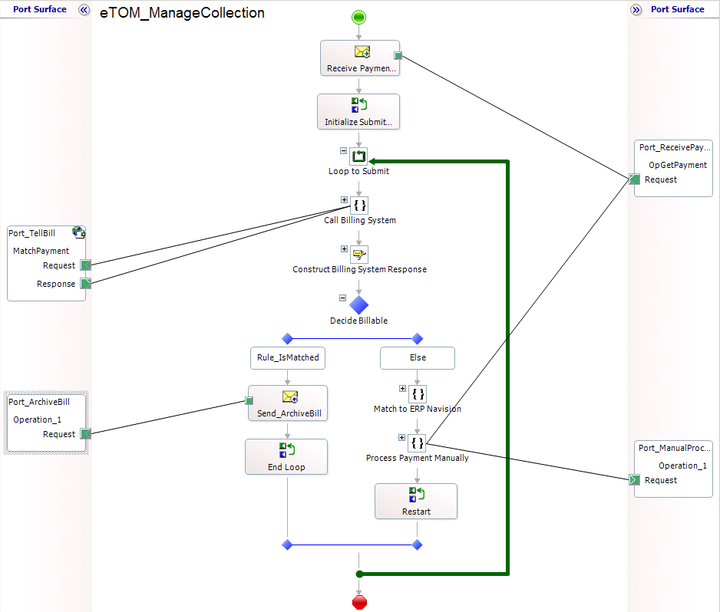
The manipulated message or derivative messages generated by the orchestration are subsequently written back to the MessageBox database. These messages also have context properties that are published by the MessageBox database and subscribed to by a Send Port. Like a Receive Location, a Send Port is comprised of a Send Pipeline and a Send Adapter. The Send Pipeline provides facilities for converting the message into the native format required by the receiving application and encrypting or encoding the message. The Send Pipeline then hands the message off to a Send Adapter which is a transport specific (HTTP, SMTP, SOAP, etc.) address (URI) implementing the communication mechanism for the respective transport protocol.
With this basic understanding of how messages are processed in BizTalk Server we can now describe the features of its architecture that allows it to offer OSS/BSS levels of scalability, reliability and availability.

Scalability Design Features in BizTalk Server 2004
BizTalk Server has been re-designed from the ground up to accommodate the most demanding service provider requirements for scalability and high-availability. One significant improvement in BizTalk Server 2004 that profoundly affects its performance and scalability is that BizTalk 2004 is now fully integrated with Visual Studio.Net and the .Net Framework. A BizTalk 2004 application is now comprised of special Visual Studio.Net projects containing BizTalk components such as schemas, orchestrations, transformation maps, pipelines and other items that are combined in a build to generate a compiled assembly. One or more BizTalk assemblies are then deployed and installed as an application that is executed by the BizTalk run-time engine. In the form of compiled run-time assemblies BizTalk Server 2004 applications now run almost 10 times faster than earlier BizTalk Server applications.
Furthermore these application components can be logically and physically organized to execute in a distributed manner, further extending the scalability and reliability of BizTalk Server. The logical and physical distribution of this functionality can be tailored to the load bearing requirements of the specific application with a high degree of granularity.
A BizTalk Server group is the top level organizational unit of distributed functionality. A BizTalk Server group is simply a logical association of physical servers into a single operating run-time environment for a set of related BizTalk process applications. A BizTalk Server group is then further sub-divided into distributed hosts and databases.
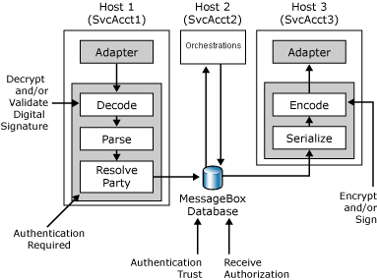
BizTalk Server uses the conventions of logical hosts and physical host instances to organize adapters, pipelines and orchestrations – the BizTalk message processing components, into load balanced and redundant arrays. A BizTalk Server host is a logical organization of these message processing components. By separating processing functions into multiple logical and physical tiers resources can be assigned and configured based on operational requirements with fine grained precision.The following diagram illustrates the concept of host organization. Any number of hosts can be defined for a BizTalk Server group.
A host instance is the physical deployment of a BizTalk Server host on a server. Hosts are the logical containers for BizTalk objects while host instances are the physical containers for these objects. Any number of hosts can be mapped as host instances to any number of servers (but there can only be one instance of a specific host on any server). The database tier can also scale-out by adding multiple MessageBox databases.This distributed architecture facilitates unprecedented scalability, reliability and availability for BizTalk Server process applications. When this distributed processing architecture is combined with the performance capabilities of Windows 2003 Server, it offers mainframe class performance and functions at an unprecedented low cost. The figure on the following page shows the relationship between servers, hosts, and host instances.

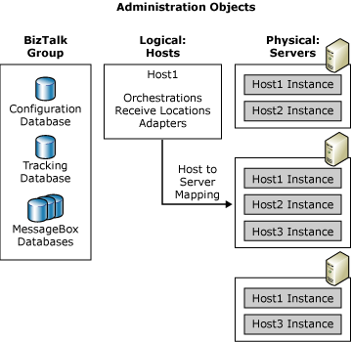
As is indicated by the illustrations above, the various BizTalk Server processing components rely on SQL server databases for persisting message states and tracking the processing events that take place in BizTalk applications. Database performance can directly and easily be scaled by adding physical resources. As with hosts and host instances, BizTalk Server makes it easy to add, configure and manage additional resources. To create an additional MessageBox database a user simply adds it to a BizTalk Server group using the entry screen shown below. BizTalk Server automatically manages the load balancing between the two MessageBox databases with no further configuration.
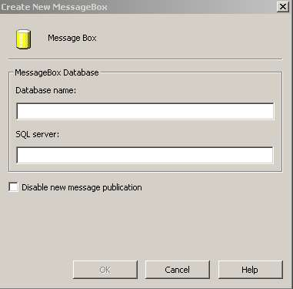

High Availability Databases Using Microsoft Cluster Services
Because BizTalk Server databases are critical shared resources that BizTalk Server message processing components are dependent on they require a fail-over mechanism that facilitates operational reliability and availability. Microsoft Cluster Services (MSCS) provides a fully integrated, out-of-the box solution for building an SQL server infrastructure that can meet the high-availability demands of a service provider datacenter environment.

The Cluster service allows two or more servers to work together as a server cluster to ensure that mission-critical applications and resources remain available to client applications. Cluster service presents multiple instances of an SQL server database as a single system rather than as separate computers. In conjunction with a robust storage system (Redundant Array of Independent Disks, or RAID), the Cluster service provides a cost-effective way to provide reliability for servers that persist data by providing redundant server failover.
The diagram below illustrates a simple two-node SQL server cluster. This design, known as a "share-nothing" architecture, allows both servers to connect to a common physical disk subsystem but only one server owns and control the disk storage at any given time. When Server A is active it has full control over the disk subsystem. Server B is fully operational but in a passive state.

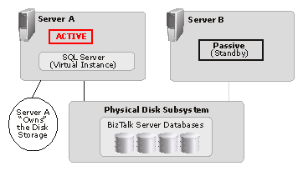
Server A is currently active, which means that it has complete control over the shared storage. Server B is up and running as well but is in a passive state ready to take ownership of the shared storage if the other node fails. The running instance of SQL Server and the shared storage containing the databases are "virtualized" by the Cluster service meaning that both the running instance of SQL and the databases are not associated with a particular server. This means that a BizTalk Server process can access the databases without having to know which of the two servers is active. The Cluster service handles all the processes necessary to make this completely transparent. To connect to the database server, users and applications refer to a "virtual server" name, which is unique and distinct from the server names of the two nodes in the cluster. If there is a hardware failure on Server A, all the virtual resources (that is, the SQL Server instance and disk storage) automatically fall-over as a group to Server B and continue running with no loss of data.

The Cluster service runs on both nodes and constantly monitors each server to ensure that all resources are behaving normally. In the event that a serious hardware or unexpected error occurs, all resources fail-over to the remaining node without human intervention. This fail-over will be detected immediately by monitoring tools such as those provided by Microsoft Operations Manager 2000 (discussed later in this paper) which can be configured to notify operational staff that the server is down and needs attention.
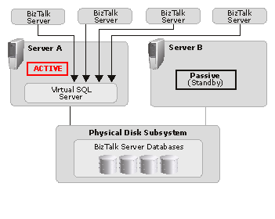
The following illustration shows the same active/passive Cluster service as above but with multiple host instances of BizTalk Server application components communicating with the active server, demonstrating how these two methodologies for scaling and facilitating high-availability complement each other.
An active/active Cluster service can also be configured where separate BizTalk Server host instances running on multiple servers are supported by two active virtual SQL Server nodes. The following diagram illustrates this configuration. Each SQL server node has dual storage subsystems, one to support its own processes and the other to provide fail-over cluster support to the other node.
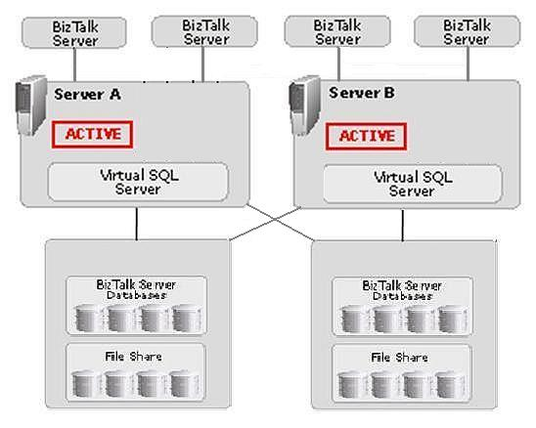
Cluster services can be configured in numerous ways to accommodate changing scalability and availability requirements at any time with no disruption of service. Furthermore, Cluster services capabilities have been significantly expanded in Windows Server 2003 with the addition of the following features:
Greater scalability – Windows Server 2003 provides greater scale-out capabilities by allowing up to eight nodes per cluster, with each node server running up to 64 symmetrical processing CPUs.
Cluster service control through Windows Management Instrumentation (WMI) – WMI can now create, delete, start, or stop cluster resources. The cluster state and the status of cluster applications can be monitored as well.
Improved file system support – the number of shared disks per cluster is no longer limited to 23 drives. Also, if the storage subsystem supports dynamic disk expansion of a disk, it can now be extended online as a cluster node without interrupting running applications.
Better SAN support – Windows Server 2003 can now boot from the SAN, allowing system disks containing a page file and dump file to be on the same external storage system as the cluster's shared disks. Booting from the SAN permits centralized backups and simpler maintenance.
Improved cluster backup and restore – Windows Server 2003 backup utility can now back up a cluster configuration and restore it to any cluster nodes. With Automated System Recovery (ASR), a cluster node can be restored if its local cluster database is damaged, or if its system disk fails or becomes corrupted.
Easier troubleshooting and failure recovery – A cluster node can be diagnosed without bringing it down; a new diagnostics tool (ClusDiag.exe) allows cluster logs and event logs from all nodes in the cluster to be correlated; and a new Error Levels (info, warn, err) log facility provides an easier way to find log entries without sifting through cluster logs.

Microsoft Server Integrated Performance Optimization
For sheer transaction processing power the Enterprise Editions of Windows Server 2003 and SQL Server 2000 now deliver 64-bit processing capabilities with the ability to support up to 64 processors and 512 GB of RAM. Windows Server 2003 provides a general 15% over-all processing improvement over Windows 2000 and with hyperthreading turned on it can deliver an additional 15% performance increase. Furthermore, Windows Server 2003 also introduces new reliability features such as hot-plug PCI, memory mirroring, load balancing and failover for miniport drivers, as well as multi-path I/O.
The combined set of new features and refinements found in BizTalk Server 2004, SQL Server 2000, and Windows 2003 Server results in a BPM/EI software suite that unequivocally has the highest performance to cost ratio of any comparative offering in its genre, and can meet and exceed the demanding OSS/BSS operational criteria of telecommunication service providers. All three platforms are mature, third generation products that incorporate refinements and improvements that have been derived from the feedback of the largest user populations and the considerable R&D resources of Microsoft. And because the architectural support for high availability and scalability is “baked-in” to these platforms they provide a rock-solid and enduring logical foundation on which to build mission critical applications.

Complementary Hardware Options
A logical foundation implies a corresponding physical infrastructure providing complementary capabilities. Today, there are numerous vendor options for configuring high performance servers that are hardened through the deployment of redundant hot-swappable components such as NICs, power supplies, fans, and RAID storage subsystems. Some of the more advanced and sophisticated features offered by vendors who specialize in high-availability servers are:
- Fault-tolerant hardware components that process the same instructions simultaneously using special synchronizing ASICs. This technique ensures that any transient memory errors are detected and isolated without process interruption.
- The isolation of PCI I/O from the rest of the motherboard in order to prevent I/O failure from compromising the operation of any other system components.
- Multiple I/O paths to both internal and external storage subsystems.
- Custom fault-detection hardware logic.
- Redundancy of core system components such as memory, SCSI interfaces, and entire motherboards.
- Embedded software that traps and monitors transient low-level hardware and software errors and anomalies.
When supported by 64-bit symmetrical processors, high availability components, and Windows Server 2003, BizTalk Server and SQL Server can readily achieve the 99.999% uptime that defines the performance standard of service providers.

Microsoft Operations Manager Support
Up until now we have focused on the logical and physical attributes that ensure operational uptime, which is the defining characteristic of a high availability system. There is still another aspect of system scalability and reliability to consider, and that is the capability to effectively track and monitor and extraordinary volume of events taking place in real time as well as the cumulative analysis of events over time. Any enterprise class BPM/EI platform must be capable of monitoring and managing performance metrics and potential failure conditions in a detailed but manageable fashion. This level of operational functionality is highly developed in BizTalk Server 2004 for tracking and monitoring processes and events taking place within BizTalk applications. On an enterprise scale, Microsoft Operations Manager provides world-class capabilities for managing and optimizing the health and performance metrics of an entire datacenter.
BizTalk Server 2004’s Health and Activity Tracking (HAT) and Business Activity Monitoring (BAM) facilities provide exhaustive capabilities for tracking, monitoring and analyzing process events and message properties (both content and context) in near real-time as well as cumulative historical information based on these events and properties. Health and Activity Tracking and Business Activity Monitoring are complementary tools for extracting, presenting and analyzing information that is indicative of the operational status and performance metrics of process and messaging events. Both of these functions are based on SQL databases and can scale as described above.
The effective and comprehensive management of a multi-cluster processing environment is made possible by Microsoft Operations Manager 2000 (MOM) by providing proactive monitoring and alerting of event level activities, automated reporting, and trend analysis. MOM captures a wide variety of system and applications events from multiple servers and aggregates them into a central event repository. Administrators can consolidate these events for an overall view of server and service availability, or they can obtain specific information from the detailed event stream—all from a single view on a desktop console. By utilizing user-defined rule sets, MOM can automatically respond to fault condition messages with a predefined action or set of actions, known as alerts. An alert can represent a single event or multiple events from many sources. An administrator can trace the history of a given alert; the events associated with it, and consult the Knowledge Base articles that MOM automatically serves up in response to an alert. In addition, alerts can optionally trigger e-mail messages, pages, Simple Network Management Protocol (SNMP) traps, and scripts to notify specific system operators and other management systems of emerging problems. MOM has been successfully deployed to manage nearly 1,000 servers generating hundreds of millions of events per day with full redundancy and load balancing.

Conclusion
Over the last three years, based on thousands of successful deployments, BizTalk Server has clearly demonstrated that a platform based on XML technologies can dramatically improve the efficiencies and economics of application integration development. With the numerous innovations being introduced in BizTalk Server 2004 that result in a quantum level improvement in performance scalability it offers telecommunication service providers an application integration development and run-time platform that can deliver unprecedented operational efficiencies and benefits.
As described in this document, the architectural components of BizTalk Server 2004 that facilitate scalability and high-availability are based on robust methodologies and mechanisms embedded and integrated within BizTalk Server, SQL Server and Windows Server 2003. This multi-faceted scalability and high-availability architecture provides numerous options for designing OSS/BSS integration applications that can be expanded to meet any performance and growth contingencies on an incremental or exponential basis without any operational disruption. By any criteria, BizTalk Server 2004’s flexibility and extensibility provides a state-of-the-art solution for large scale application integration requirements.


The information contained in this document represents the current view of Microsoft Corporation on the issues discussed as of the date of publication. Because Microsoft must respond to changing market conditions, it should not be interpreted to be a commitment on the part of Microsoft, and Microsoft cannot guarantee the accuracy of any information presented after the date of publication.
This White Paper is for informational purposes only. MICROSOFT MAKES NO WARRANTIES, EXPRESS OR IMPLIED, AS TO THE INFORMATION IN THIS DOCUMENT.
Complying with all applicable copyright laws is the responsibility of the user. Without limiting the rights under copyright, no part of this document may be reproduced, stored in or introduced into a retrieval system, or transmitted in any form or by any means (electronic, mechanical, photocopying, recording, or otherwise), or for any purpose, without the express written permission of Microsoft Corporation.
Microsoft may have patents, patent applications, trademarks, copyrights, or other intellectual property rights covering subject matter in this document. Except as expressly provided in any written license agreement from Microsoft, the furnishing of this document does not give you any license to these patents, trademarks, copyrights, or other intellectual property.
© 2004 Microsoft Corporation. All rights reserved
Unless otherwise noted, the example companies, organizations, products, domain names, e-mail addresses, logos, people, places and events depicted herein are fictitious, and no association with any real company, organization, product, domain name, e-mail address, logo, person, place or event is intended or should be inferred.
Microsoft, BizTalk, and Visual Studio are either registered trademarks or trademarks of Microsoft Corporation in the United States and/or other countries.
The names of actual companies and products mentioned herein may be the trademarks of their respective owners.

