Role-Based Template for SharePoint My Sites: Controller-Financial Analyst
Technical Overview for
IT Professionals
Template Data and Integration
Role-Based Templates for SharePoint® My Sites are pre-configured to display, in a common environment, role-relevant data from sources such as line of business systems, desktop tools, and portals. The templates make use of Microsoft® Office SharePoint Server 2007 capabilities, such as audience targeting, key performance indicators (KPIs), workflows, Excel® services, Business Data Catalog (BDC), and others. IT departments can integrate the Role-Based Templates for SharePoint My Sites with existing systems, as well as customize, extend and even replicate them. This enables quick deployment of role-based portals and provides cost-effective and easy-to-use solutions that integrate with important IT investments.

The templates are built using existing out-of-the-box SharePoint Web parts, and are flexible, providing a starting point for custom development. They come with a sample SQL Server™ 2005 database, a BDC application file and a SQL Server 2005 Analysis Services (SSAS) cube to show sample data. This datasheet describes the web parts and functionality Microsoft used when designing the templates. The role-based My Site template Setup Guide explains in detail how to configure them for your own data.
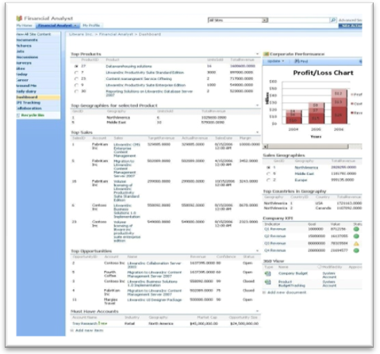

Description of Template
The Controller-Financial Analyst role-based template for SharePoint My Sites helps Controllers and Financial Analysts automate the process of analyzing financial data and information, helping them in their overall decision-making process. The template helps track top performing products and opportunities at different geography levels. It also provides a graphical view of product sales and revenue. The overall design of this Role-Based My Site template is to help Controllers-Financial Analysts achieve their goals of communicating overall corporate performance, budget and future growth projection to the management, investors and other stakeholders.

Customized Pages and Web Parts Utilized in this Role-Based My Site Template

The following is a list of all the custom pages that make up the Controller-Financial Analyst role-based My Site template. Also included is a description of the web parts utilized on each page.

Today: Provides a quick glance into the user’s personal inbox, calendar and task list. It also displays user tasks assigned to them on SharePoint sites.
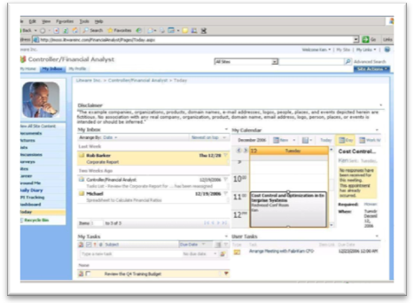
- My Inbox, My Calendar, and My Tasks utilize Outlook® Web Access web parts to fetch data from the Microsoft Exchange Server and display the user’s personal inbox, calendar and task list. These web parts are configured with the mail server address and take in the user context by default to display their data from the Exchange Server.
- User Tasks web part displays the tasks assigned to the user in SharePoint tasks lists, enabling them to view and update the SharePoint tasks.

Dashboard: Displays information pulled from Business Data Catalog (BDC) and creates dynamic views of the data, including top products, sales and geographies. It can show corporate performance by a profit/loss chart.
- Top Products, Top Sales and Sale Geographies use Business Data List web parts to display information on the Dashboard page and are defined in the BDC application metadata file. Top Products shows the top five performing products and Top Sales displays the top five sales; both are configured to an entity, such as ‘Top 5 Products’ and ‘Top 5 Sales’ in this template.
- Top Geographies for selected Product and Top Countries in Geography use Business Data Related List web parts, dynamically displaying information related to the Business Data List web parts. Top Geographies for selected Product is connected to the Top Products web part, returning the Top Geographies entity for the selected product and showing top geography by sales. Top Countries in Geography is connected to the Sales Geographies Business Data List web part, returning the Top Performing Countries entity for the selected geography.
- Corporate Performance is an Excel Web Access web part that indicates the performance of the organization or business unit with a chart using parameters such as profit/loss.
- 360 View displays the status of reports and documents uploaded by the Controller that have been routed through an Approval workflow. It is connected to the 360 View document library.

KPI Tracking: Provides sales and opportunity details for the products. It shows performance metrics, such as product revenue and unit sales, and provides Key Performance Indicators (KPIs) that can be filtered by product.
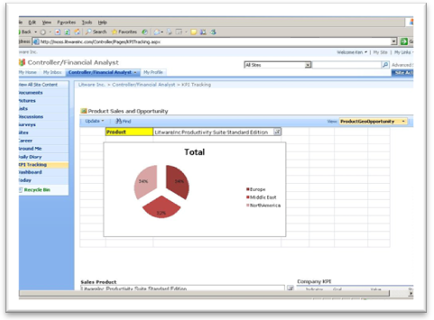
- Product Sales and Opportunity is an Excel Web Access web part displaying the geographical distribution of sales and opportunities for the selected product. It displays Pivot Tables and Charts contained in an Excel spreadsheet and published using Excel Services to the 360 View document library. The published Chart appears as views in the Product Sales and Opportunity web part, displaying the report parameters and enabling dynamic interaction with the Chart.
- Sales Product, Sales Geography and Fiscal Quarter are SQL Server Analysis Services (SSAS) Filter web parts that enable the Controller to select the product, geography and/or fiscal quarter to see the status of Quarterly Revenue and Unit Sales. Results are displayed in the Product KPI and Company KPI web parts. The KPI web parts are connected to the SSAS Filter web part to receive the selected product and filter the details accordingly. The SSAS Filter web part is connected to the data through an Office Data Connection file (.odc) residing in the Data Connections library.

Daily Diary: Provides links, contacts, meeting outcomes, and a document repository with frequently used reports, analyses, presentations, and other templates. The Controller can also create ad hoc projects and track them with a Gantt Chart.
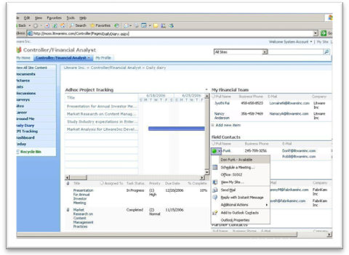
- Ad hoc Project Tracking web part lists tasks associated to a project, displaying data in a Gantt Chart view.
- Meeting Outcomes and My Uploads are Library View web parts. Meeting Outcomes is attached to the Meeting Outcomes form library which has a Microsoft Office InfoPath® form template attached. My Uploads is attached to the My Uploads document library, a repository for uploading analyses and reports. A Collect Feedback workflow is attached to this document library and workflow status is displayed in the My Uploads web part.
- Templates Gallery and Previous Years Reports are Content Query web parts. Templates Gallery displays the standard templates and forms used by the Controller to prepare corporate reports and presentations. It is tied to the Templates Gallery document library. Previous Years Reports displays reports from earlier years and is tied to the Corporate Reports document library.
- Contacts and Links are List View web parts. The three Contacts lists (Field, Marketing and Partner) are enabled with the presence icon. The two Links lists (Internal and External) display links to other systems and websites.

Around Me and Career: Around Me provides one page to keep track of news, announcement and events relevant to the Controller to keep them informed and in touch with the company. The Career page helps facilitate career planning by providing a place to keep track of objectives and performance.
- Around Me: Corporate News, International News and Industry News are RSS Feed Viewer web parts and display news feeds from external web sites. Corporate and System Downtime announcements are List View web parts and display announcement details by the administrator. Team Announcements is a list view web part that displays announcements created by the Controller. Corporate, Industry and Marketing Events are List View web parts that display corresponding company and industry events. An Alerts workflow is attached to these lists.
- Career: Training Details, Awards and Rewards, Organization Objectives and Self Defined Objectives are List View web parts that help keep a track of one’s career. All have personalized views so that only items created or modified by the logged-in Controller are visible.

Technical Dependencies
To use the Controller-Financial Analyst template, you must have a server running the following:
- Microsoft Office SharePoint Server 2007
- Microsoft Office SharePoint Server 2007 Client Access License, Enterprise Edition
For more information on additional dependencies, please review the Setup Guide.
Licensing information can be found at: http://go.microsoft.com/fwlink/?LinkId=86927

More Information
For more information on the technologies described in this article, please visit:

Microsoft Office SharePoint Server 2007:  http://www.microsoft.com/sharepoint | Role-Based Templates for SharePoint My Sites:  http://go.microsoft.com/?linkid=6060804
Business Intelligence with Office SharePoint Server 2007:
http://go.microsoft.com/fwlink/?LinkId=86668

