Microsoft® Office
Communications Server 2007
Enterprise Voice
Planning and Deployment Guide
A Software-Powered VoIP Solution
Published: July 2007

Information in this document, including URL and other Internet Web site references, is subject to change without notice. Unless otherwise noted, the companies, organizations, products, domain names, e-mail addresses, logos, people, places, and events depicted in examples herein are fictitious. No association with any real company, organization, product, domain name, e-mail address, logo, person, place, or event is intended or should be inferred. Complying with all applicable copyright laws is the responsibility of the user. Without limiting the rights under copyright, no part of this document may be reproduced, stored in or introduced into a retrieval system, or transmitted in any form or by any means (electronic, mechanical, photocopying, recording, or otherwise), or for any purpose, without the express written permission of Microsoft Corporation.

Microsoft may have patents, patent applications, trademarks, copyrights, or other intellectual property rights covering subject matter in this document. Except as expressly provided in any written license agreement from Microsoft, the furnishing of this document does not give you any license to these patents, trademarks, copyrights, or other intellectual property.

© 2007 Microsoft Corporation. All rights reserved.

Microsoft, Active Directory, Outlook, Windows, and Windows Server are trademarks of the Microsoft group of companies.
All other trademarks are property of their respective owners.

Contents
Introduction 2
Enterprise Voice and Unified Communications 2
Important Voice Considerations: Please Read 4
Chapter 1 Technical Overview 5
Architecture 5
Exchange Unified Messaging 14
Phone Number Normalization 20
Location Profiles 20
Phone Usage Records 23
Routes 23
Chapter 2 Planning for Enterprise Voice 26
Overview 26
Determine the Number and Distribution of Users 27
Select a Deployment Option 27
Migration Paths and Integration Strategies 36
Plan for Media Gateways 38
Plan for Media Gateway Security 43
Plan for User Authorization and Outbound Call Routing 44
Plan for Exchange Server 2007 SP1 Unified Messaging 64
Planning to Move Users to Enterprise Voice 69
Chapter 3 Deploying Enterprise Voice 72
Step 1 Configure Exchange UM to Work with Communications Server 75
Step 2 Create Location Profiles 82
Step 3 Configure Communications Server to Work with Exchange UM 88
Step 4 Assign Location Profile to Pool 90
Step 5 Deploy a Media Gateway 91
Step 6 Configure Call Authorization 108
Step 7 Configure Outbound Call Routing 113
Step 8 Enable Users for Enterprise Voice 116
Step 9 Enable Users for PBX Integration (optional) 118
Chapter 4 Managing Enterprise Voice 120
Appendix A Glossary 130
Appendix B Enterprise Voice Planning Checklist 134
Appendix C Enterprise Voice Deployment Checklist 135

Introduction
Welcome to the Microsoft® Office Communications Server 2007 Enterprise Voice Planning and Deployment Guide. Enterprise Voice is Microsoft’s software-powered VoIP solution, a SIP-based implementation of IP telephony for the enterprise that does not rely on proprietary hardware investments. Enterprise Voice is a full-featured VoIP solution that includes connectivity with PSTN (Public Switched Telephone Network) gateways and interoperation with PBX (Private Branch Exchange) installations. Enterprise Voice, IM (instant messaging), group IM, enhanced presence, and audio-video conferencing together constitute Microsoft’s Unified Communications solution.
This guide offers in a single volume the conceptual, planning, deployment, and management information that you need to successfully integrate Enterprise Voice into your Communications Server 2007 infrastructure. Following this introduction, this guide consists of the following chapters:
- Chapter 1. Technical Overview
Surveys the architecture, components, and call routing logic of Enterprise Voice. In addition to providing useful context for critical planning and deployment decisions, this section can help decision makers understand the advantages of Enterprise Voice compared to hardware-based IP telephony offerings.
- Chapter 2. Planning for Enterprise Voice
Discusses the important choices you need to consider before you deploy Enterprise Voice. Planning is essential to successful deployment, so it is important to read this section before you begin deployment.
- Chapter 3. Deploying Enterprise Voice
Provides step-by-step instructions for deploying Enterprise Voice.
- Chapter 4. Managing Enterprise Voice
Provides step-by-step instructions for performing fundamental management tasks.
This guide concludes with the following appendixes:
- Appendix A. Glossary
- Appendix B. Enterprise Voice Planning Checklist
- Appendix C. Enterprise Voice Deployment Checklist

Enterprise Voice and Unified Communications
Unified Communications uses the Communications Server 2007 platform to combine voice, IM, enhanced presence, audio-video conferencing, and e-mail into a familiar, integrated communications experience. Microsoft’s Unified Communications solution offers a completely new way of communicating that offers the following benefits:
- Enhanced presence notifications across a variety of applications keep users informed of the availability of contacts.
- Integration of IM, voice, conferencing, e-mail and other communication modes enables users to choose the mode that is most appropriate for the task at hand. Users can also switch from one mode to another as needed.
- Availability of communications alternatives from any location where an Internet connection is available.
- A smart client (Communicator 2007) for telephony, IM, and conferencing. The Office Communicator Phone Edition is for users who want the convenience and power of Communicator in the familiar form of a desktop phone.
- Continuity of user experience across multiple devices.
Enterprise Voice enables users to:
- Place calls over the IP network from PC to PC, PC to PBX/PSTN phone, or PBX/PSTN phone to PC. This means that users have all their principle communications choices — voice, e-mail, instant messaging, and conferencing — available and integrated on their desktop computer.
- Participate in IP voice sessions that traverse NATs and firewalls. This means that users working at home or on the road can call the enterprise from anywhere an Internet connection is available, without incurring long-distance charges or resorting to a VPN (virtual private network).
- Place calls to other Enterprise Voice users, coworkers who are hosted on a PBX, or PSTN numbers.
- Retain existing telephone numbers and dialing habits.
- Enjoy the benefits of call answering, call forwarding, and other call-control features.
For the business customer, Enterprise Voice provides the following benefits over and above those the productivity enhancements that accrue to users:
- Enterprise Voice can be deployed with only modest modifications to existing Communications Server 2007 and telephony infrastructures.
- Communications Server 2007 uses smart, least-cost routing algorithms for calls to the PSTN.
- Enterprise Voice features centralized administration using familiar tools.
- Enterprise Voice supports integration with existing PBX and RCC (Remote Call Control) solutions.
- A distributed architecture that reduces bottlenecks and the likelihood of single points of failure.

Important Voice Considerations: Please Read

Power, Network, or Telephone Service Outages
If there is an outage, disruption, or other degradation of the power, network, or telephone services at your location, the voice, instant messaging, presence, and other features of Office Communications Server 2007 and any device connected to Office Communications Server 2007 may not work properly.

Enterprise Voice Depends on Server Availability and Voice Client and Hardware Operability
Voice communications via Office Communications Server 2007 depend upon the availability of the server software and the proper functioning of the voice clients or the hardware phone devices connecting to the server software.

Alternative Means of Accessing Emergency Services
For those locations where you install a voice client (e.g., a PC running Office Communicator 2007 or an Office Communicator Phone Edition device), it is recommended that you maintain a backup option for users to call emergency services (911, 999, etc.) in case of a power failure, network connectivity degradation, telephone service outage, or other problem that may inhibit operation of Office Communications Server 2007, Office Communicator 2007, or the Phone Edition devices. Such alternative options could include a telephone connected to a standard PSTN line or a cell phone.

Emergency Calls and Multi-Line Telephone Systems
Please note that the use of a multi-line telephone system (MLTS) may be subject to U.S. (state and/or federal) and foreign MLTS laws that require the MLTS to provide a caller’s telephone number, extension, and/or physical location to applicable emergency services when a caller makes a call to emergency services (e.g., when dialing an emergency access number such as 911 or 999). Neither Office Communications Server 2007, Office Communicator 2007,nor Office Communicator Phone Edition Devices provide the caller’s physical location to emergency services when a caller dials emergency services. Compliance with such MLTS laws is the sole responsibility of the purchaser of Office Communications Server 2007, Office Communicator 2007, and Office Communicator Phone Edition devices.

Chapter 1 Technical Overview
This chapter provides a technical survey of the main components of Enterprise Voice. The following topics describe the software and hardware components that work together to provide a rich voice experience whose quality and reliability are comparable to that of traditional telephone networks. This chapter also introduces concepts and terminology that are discussed in greater detail in the chapters and topics that follow.

Architecture
All Communications Server 2007 topologies support Enterprise Voice. The following figure illustrates a generic topology, showing how new Communications Server 2007 voice components work with other components supporting IM, enhanced presence, conferencing, and federation.
Figure 1. Office Communications Server 2007 Reference Architecture
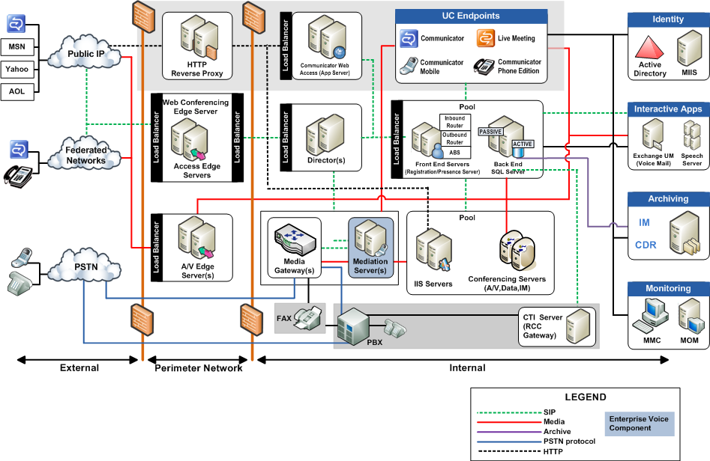
The following figure shows the essential Enterprise Voice components extracted from the overall Communications Server 2007 architecture shown in Figure 1.
Figure 2. Enterprise Voice Components
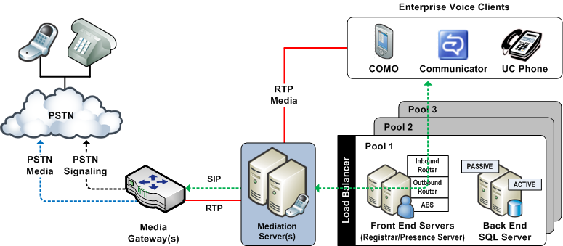

When an on-site worker places a call from his Enterprise Voice client to a PSTN destination, the calls moves through the Enterprise Voice infrastructure as follows:
- User places call from an Enterprise Voice client by dialing or clicking the name in the name or number of a contact in Communicator or Microsoft Outlook®.
- Server normalizes number to E.164 format and invokes routing rules based on location profile and user policy, and directs call to appropriate Mediation Server.
- Mediation Server performs any necessary media transcoding and routes call to IP-PSTN gateway.
- Gateway, based on topology, applies local dialing rules or PBX dialing rules and passes call to the PSTN or PBX.

Protocols
Enterprise Voice is an implementation of IP telephony that uses SIP (Session Initiation Protocol) for signaling and RTP (Real-Time Transport Protocol) for voice. Figure 2 shows the path of SIP signaling and RTP media transport through the Communications Server 2007 infrastructure.
SIP is an industry standard, application layer signaling protocol for starting, controlling, and ending communication sessions in an IP-based network. SIP is formally described in the IETF (Internet Engineering Task Force) reference specification RFC 3261. Using SIP, one user can explicitly invite another to join a conversation or multimedia session. A SIP session begins when the second user accepts a SIP INVITE request.
In Communications Server 2007, SIP is used for IM, conferencing, presence subscriptions, video, and voice, enabling Enterprise Voice clients to provide a common user experience across all these communication modes. Signaling for phone calls coming from the PSTN is converted to SIP by the media (PSTN) gateway.
Although SIP sessions can include the sharing of real-time media, SIP itself does not handle the actual media data, such as audio, video, and application sharing. In practical terms, this separation means that SIP and various media protocols can evolve independently.
Enterprise Voice uses RTP for media. Like SIP, RTP is an IETF standard. It defines a packet format for carrying audio and video over IP networks.

Office Communications Server 2007 Server Voice Components
Communications Server 2007 is responsible for seamlessly routing all voice calls for users who are enabled for Enterprise Voice. Core routing components and logic for Enterprise Voice reside on the following Communications Server 2007 roles:
- Standard Edition Server in the role of Front End Server or Director
- Enterprise Edition Front End Server
The core routing components are the Translation Service, Inbound Routing Component, and Outbound Routing Component:

Translation Service
The Translation Service is the server component that is responsible for translating a dialed number into E.164 format, using normalization rules based on location profiles that are defined by the administrator.

Inbound Routing Component
The Inbound Routing Component handles incoming calls largely according to preferences that are specified by users on their Enterprise Voice clients. For example, users specify whether unanswered calls are to be forwarded or simply logged for notification. If call forwarding is enabled, users can then specify whether unanswered calls should be forwarded to another number or to an Exchange 2007 Unified Messaging server that has been configured to provide call answering. The Inbound Routing Component is installed by default on all Standard Edition Servers and Enterprise Edition Front End Servers.

Outbound Routing Component
The Outbound Routing Component routes calls to PBX or PSTN destinations. It applies call authorization rules to callers and determines the optimal media gateway for routing each call. The Outbound Routing Component is installed by default on all Standard Edition Servers and Enterprise Edition Front End Servers.
The routing logic that is used by the Outbound Routing Component is in large measure configured by network or telephony administrators according to the requirements of their organizations. This guide is primarily devoted to explaining how to plan and configure data structures that the Outbound Routing Component uses to route outgoing calls. These data structures include phone usage records, voice policies, and routes.

Other Server Components
Other components residing on the Communications Server 2007 Front End or Director that provide essential support for voice but are not themselves voice components, include User Services, User Replicator, and ABS (Address Book Service).
User Services performs reverse number lookup on the target phone number of each incoming call and matches that number to the SIP-URI of the destination user. Using this information, the Inbound Routing Component forks the call to that user’s registered SIP endpoints. User Services is a core component on all Front End Servers and Directors.
User Replicator extracts user phone numbers from Active Directory® and writes them to tables in the RTC database, where they are available to User Services and Address Book Service. The User Replicator is a core component on all Front End Servers and Directors.
Address Book Service normalizes enterprise user phone numbers written to the RTC database to E.164 format for the purpose of provisioning user Contacts in Communicator 2007. Address Book Service is installed by default on all Front End Servers and Directors.

Call Flow
The following figure illustrates the flow of a call through the Communications Server and how each server component in the path of the call responds to the SIP INVITE request.
Figure 3. Call flow through a Front End Server or Director
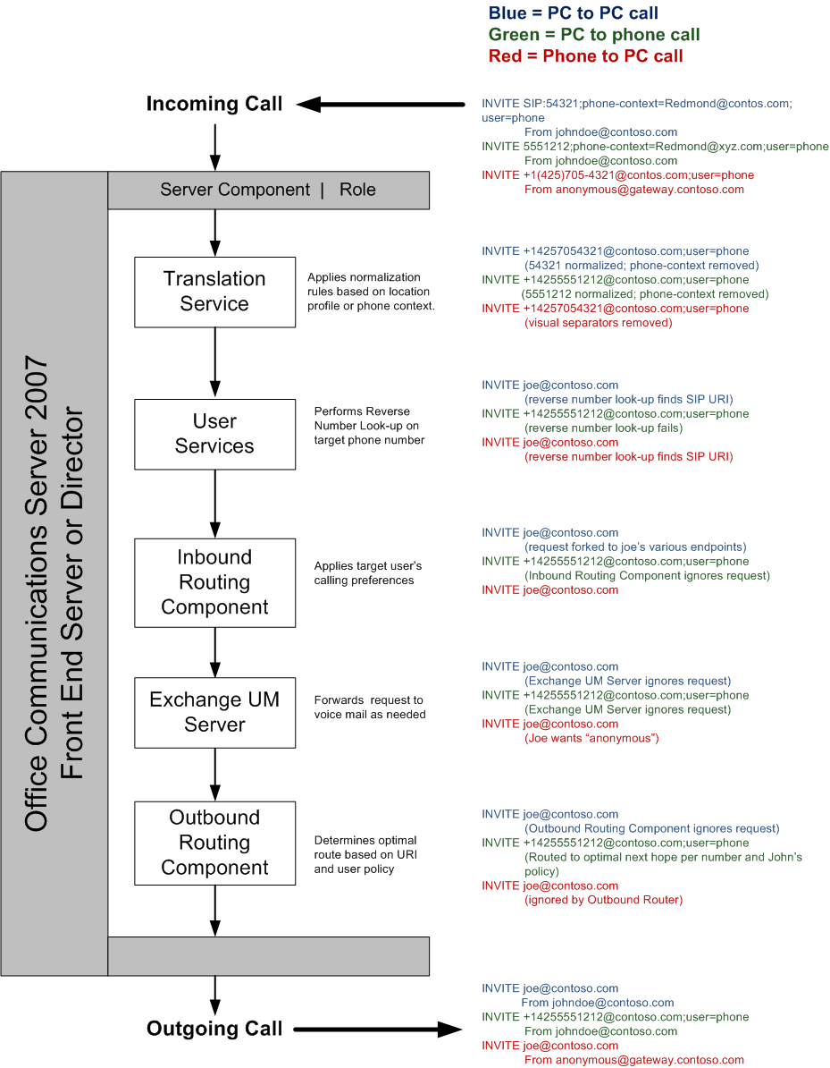
The following figure shows another way to visualize the call flow through the Enterprise Voice infrastructure:
Figure 4. Call flow through the Enterprise Voice Infrastructure
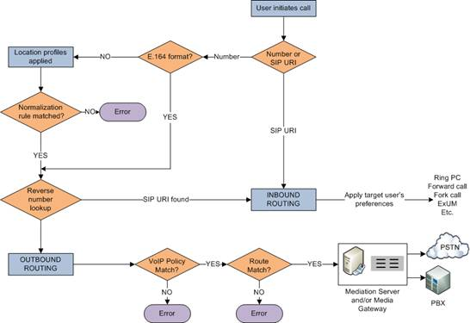

The call flows shown in Figure 4 include:
- PC to PC
- PC to PBX/PSTN phone
- PBX/PSTN phone to PC
The SIP INVITE requests for each type of call are shown in the column on the right.

Media Gateways
An enterprise-grade IP telephony solution obviously must provide for calls to and from the PSTN without any decline in quality of service. In addition, users placing and receiving calls should not be aware of the underlying technology. From their perspective, a call between the Enterprise Voice infrastructure and the PSTN should seem like just another SIP session.
Media gateways are third-party devices that translate signaling and media between the PSTN and the Enterprise Voice infrastructure. Communications Server 2007 supports three types of media gateways:
- Basic Media Gateway
A Basic Media Gateway requires the assistance of a new Communications Server 2007 server role, the Mediation Server, to present a PSTN call to an Enterprise Voice client connection. The Mediation Server also presents calls from Enterprise Voice clients to the Basic Media Gateway for routing to the PSTN.
- Advanced Media Gateway
An Advanced Media Gateway combines the functionality of a Basic Media Gateway and the Mediation Server. An Advanced Media Gateway does not require a separate Mediation Server to handle the signal and media translation that is necessary to present a PSTN call as an Enterprise Voice client connection.
- Basic Hybrid Media Gateway
A Basic Hybrid Media Gateway collocates a Basic Media Gateway with a Mediation Server on a single Microsoft Windows Server® 2003 computer. This third-party device installation and management overhead compared to deploying a Basic Media Gateway and Mediation Server on separate computers.

Mediation Server
The Communications Server 2007, Mediation Server provides signaling and media translation between the Enterprise Voice infrastructure and a Basic Media Gateway. A Mediation Server is also used to link Communications Server and a PBX in both departmental deployment and PBX integration topologies.
The Mediation Server is deployed as a stand-alone application inside the corporate firewall. On the Enterprise Voice side, Mediation Server listens on one mutual TLS transport addresses, each with a unique port that is associated with a single media gateway. On the gateway side, Mediation Server can be configured to listen on either a TLS or TCP transport address.
The main functions of the Mediation Server are as follows:
- In deployments where the gateway link is configured for TCP, translating SIP over TCP (on the gateway side to SIP over TLS on the Enterprise Voice side.
- Encrypting and decrypting SRTP on the Communications Server side.
- Translating media streams between Communications Server and the media gateway.
- Connecting clients that are outside the network to internal ICE (Interactive Connectivity Establishment) components, which enable media traversal of firewalls.
- Acting as an intermediary for call flows that a gateway doesn’t support, such as calls from remote workers on an Enterprise Voice client.
The following figure shows the signaling and media protocols used by the Mediation Server when communicating with a Basic Media Gateway and the Enterprise Voice infrastructure.
Figure 5. Signaling and media protocols used by the Mediation Server
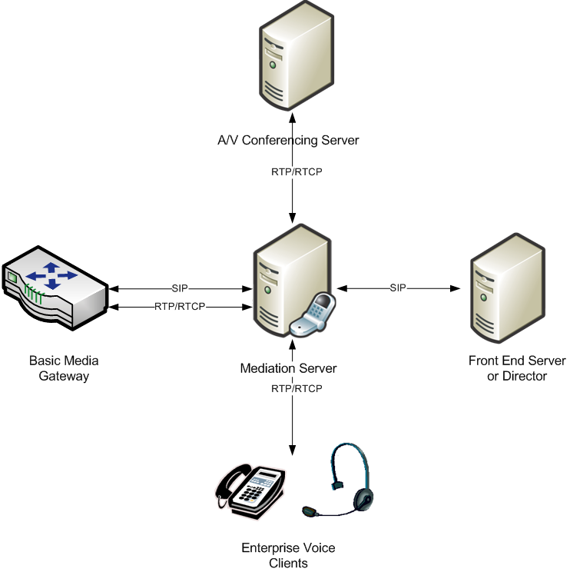
From the perspective of the Enterprise Voice infrastructure, the combination of Basic Media Gateway and Mediation Server appear as a single entity. Together, they are the logical and functional equivalent of an Advanced Media Gateway. At such time as Advanced Media Gateways become available, enterprises that choose to deploy them will no longer have any need for Mediation Server. Meanwhile, the Basic Hybrid Media Gateway provides an interim solution for organizations that prefer to avoid deploying and managing gateway and Mediation Server separately.
The following figure shows the logical equivalence of an Advanced Media Gateway and the combination of a Basic Media Gateway and Mediation Server.
Figure 6. Equivalent Media Gateway Topologies
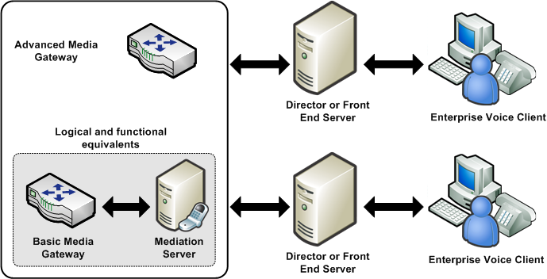

A typical organization will support multiple gateway-Mediation Server combinations, depending on the number of office locations, the number and distribution of Enterprise Voice users, network traffic, and performance requirements.

Edge Servers
Outside callers using Communicator for individual or conference calls rely on the following edge servers for voice communication with coworkers. For information about deploying edge servers, see the Microsoft Office Communications Server 2007 Edge Server Deployment Guide.

Access Edge Server
The Communications Server 2007 Access Edge Server provides SIP signaling for calls from Communicator users who are outside the corporate firewall.

A/V Edge Server
The Communications Server 2007 A/V Edge Server enables media traversal of firewalls. A caller using Communicator 2007 from outside the corporate firewall relies on the A/V Edge Server for both individual and conference calls.
The A/V Authentication Service is collocated with, and provides authentication services for, the A/V Edge Server. Outside users attempting to connect to the A/V Edge Server require an authentication token provided by the A/V Authentication Service before their calls can go through.

Voice Clients
Communications Server 2007 supports Microsoft Office Communicator 2007 as the primary voice client. For a more traditional phone-like experience, users may prefer the Microsoft Office Communicator Phone Edition.

Microsoft Office Communicator 2007
Communicator 2007 is the principal client for Enterprise Voice. Communicator supports the following types of calls:
- PC to PC.
- PC to PBX/PSTN phone.
- PBX/PSTN phone to PC.
- PC to audio conference.
- Video calls and conferencing.
- Call control features such as call forwarding and deflection, call transfer, and call hold and retrieve.
Communications Server 2007 provisions Communicator 2007 with user names and phone numbers, enriched presence information, and location profiles.
Users outside the enterprise can use Communicator 2007 to call users inside the enterprise regardless whether those users are enabled for Enterprise Voice.

Microsoft Office Communicator Phone Edition
Microsoft has developed the Microsoft Office Communicator Phone Edition telephone for organizations or users who are more comfortable making calls from a phone-like device than from the Communicator software client. For most purposes the Communicator Phone Edition phone is a physical version of Communicator, with a similar user interface and comparable functionality. Like Communicator, the Microsoft Office Communicator Phone Edition allows you to place a call either by using a numeric touchpad or by clicking one of your contacts. The Microsoft Office Communicator Phone Edition also supports enhanced presence, SIP signaling, and a user experience similar to that of Communicator, all in a desktop telephone. The Microsoft Office Communicator Phone Edition can be used to connect from home as well as in the office.
The Microsoft Office Communicator Phone Edition requires Communications Server 2007, with Media Gateways deployed to enable PSTN interoperation. Like Communicator, the Microsoft Office Communicator Phone Edition is provisioned for voice by the Communications Server.

Exchange Unified Messaging
Exchange Server 2007 Unified Messaging (UM) is one of several server roles that you can install and configure on a computer that is running Exchange 2007. For stand-alone Enterprise Voice deployments, Unified Messaging combines voice messaging and e-mail messaging into a single store that is accessible from a telephone (Outlook Voice Access) or computer. Unified Messaging and Communications Server working together provide call answering, Outlook Voice Access, and auto-attendant services to departmental and greenfield Enterprise Voice deployments.

Call Answering
Note
Exchange UM is not required for Enterprise Voice deployments with PBX integration because the PBX, if so desired, can continue to provide voice mail and related services to all users. For more information, see Communications Server-PBX Coexistence.
Call answering is the taking of voice messages on behalf of users whose extensions are not answered or are busy. It includes playing a personal greeting, recording a message, and submitting the message to the Exchange Hub Transport Server to be queued up for eventual delivery to the user’s mailbox, which is stored on the Exchange mailbox server.
If a caller leaves a message, the message shows up in the user’s inbox. If a caller chooses not to leave a message, a missed call notification is stored in the user’s mailbox. Users can then access their inboxes using Microsoft Outlook® messaging and collaboration client, Outlook Web Access, Exchange ActiveSync, or Outlook Voice Access. The subject and priority of calls can be displayed in a way similar to that of e-mail.

Outlook Voice Access
Outlook Voice Access enables an Enterprise Voice user to access not just voice mail, but the Exchange inbox including e-mail, voice messages, calendar, and contacts from a telephony interface. The subscriber access number is assigned by an Exchange UM administrator.

Auto-Attendant
An auto-attendant is a feature of Exchange 2007 UM that can be used to configure a phone number that outside users can dial to reach company representatives. In particular, it provides a series of voice prompts that assist an external caller in navigating a menu system. The list of available options is configured on the Exchange UM server by the administrator.

User Scenarios
The following user scenarios illustrate the capabilities that Exchange UM integration brings to Communications Server Enterprise Voice:

Call Notification
User 1 calls User 2, who does not answer. User 1 hangs up, and User 2 receives a missed call notification that User 1 called at a certain time.

Divert to Voice Mail
User 1 calls User 2, who does not answer. Because User 2 has not configured call forwarding to another number, the call is diverted to Exchange UM. The Exchange UM service plays a greeting previously recorded by User 2, after which User 1 records a message. User 2 receives the voice mail message in e-mail. Outlook and Outlook Web Access both display this message along with an embedded player to play the message.

Outlook Voice Access
Users without access to Outlook or Outlook Web Access can retrieve their voice mail in the traditional way, by calling an Outlook Voice Access number. For example, User 2 checks voice mail by calling the subscriber access number assigned to all users. When prompted, User 2 enters a PIN, which authenticates User 2 and enables access to his or her personal mailbox. User 2 can either listen to voice mail or, courtesy of text-to-speech technology, to a reading of e-mail messages or personal calendar.
Upon listening to a voice mail from User 1, User 2 elects to call back immediately. User 2 accesses the options menu and selects the call back option. User 2's call is placed to User 1.

Auto-Attendant
User 1 does not know User 2's extension and so calls the public access number for User 2's organization. User 1 is connected to the Automated Attendant service, which offers various options, including connecting the call to User 2's extension.

Working Together
To provide the features and services described previously in this section to your Enterprise Voice users, you must deploy the following Exchange Server 2007 server roles:
- Unified Messaging Server, which provides a single storage location for e-mail, and voice mail. The Unified Messaging server connects Exchange Server 2007 with Communications Server 2007.
- Hub Transport Server, which routes e-mail messages from the UM server to user mailboxes.
- Client Access Server, which hosts client protocols, such as Post Office Protocol 3 (POP3), Internet Message Access Protocol 4 (IMAP4), Secure Hypertext Transfer Protocol (HTTPS), Outlook Anywhere, Availability service, and Autodiscover service. The Client Access Server also hosts Web services.
- Mailbox Server, which hosts user mailboxes.
The following figure shows how calls are routed between the various Exchange Server 2007 server roles and the Communications Server 2007 infrastructure to provide call notification, voice mail, subscriber access, and auto-attendant. The call routing depicted in this figure is as follows:
- External user calls Communications Server 2007 user.
- Communications Server rings user’s client.
- User does not answer.
- Communications Server routes calls to Exchange UM.
- Exchange UM looks up the Communications Server user’s name in Active Directory, fetches corresponding greeting from user’s mailbox, plays the greeting and records a message, and submits the caller’s message to the user’s Mailbox server for storage.
- Exchange Hub Transport delivers the message to user’s Mailbox server for storage.
- Using various clients, user retrieves the message by means of the Client Access server, which fetches it from the user’s Mailbox server.
Figure 7. Call routing between Communications Server and Exchange Server.
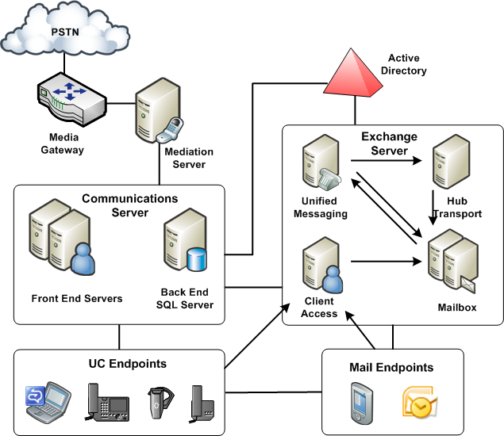
You can deploy Exchange Server and Communications Server in one of the topologies described in Supported Topologies.

Exchange UM Active Directory Objects
Exchange UM Active Directory objects integrate Exchange Server 2007 Unified Messaging features with the Communications Server Enterprise Voice infrastructure. In order to successfully deploy Exchange Server 2007 Unified Messaging in your organization, you must fully understand the relationship between the following UM Active Directory objects and their counterparts in Enterprise Voice.

UM SIP dial plan
A UM dial plan is the basic unit of configuration in Exchange UM. A UM dial plan can be of type TelExtn, E164, or Sip_Name. When Exchange UM is deployed with Communications Server, the dial plan type is always Sip_Name. All dial plan users have both a SIP-URI and a fixed extension. Each dial plan must correspond to an Enterprise Voice location profile. The name of each location profile should match the forest FQDN of the UM SIP dial plan.

UM IP gateway
The UM IP gateway object logically represents each Communications Server pool from which calls can be received. Each IP gateway object encapsulates configuration elements related to the corresponding pool or server. After a UM IP gateway is created, it is associated with one or more UM hunt groups.

UM Hunt group
The UM hunt group associates a UM IP gateway with a UM dial plan. By creating multiple UM hunt groups, you can associate a single UM IP gateway with multiple UM dial plans and, therefore, with multiple Enterprise Voice location profiles.
The following figure illustrates the relationships between the UM objects and the Enterprise Voice infrastructure.
Figure 8. Exchange 2007 SP1, UM, and Communications Server 2007 objects
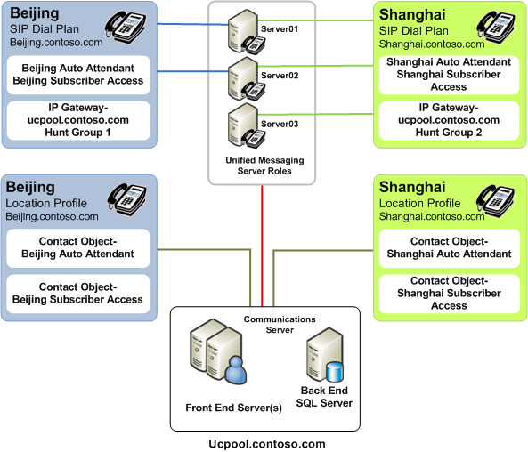

Communications Server 2007 Contact Objects
Subscriber access and auto-attendant services both require users to dial specific phone numbers. These numbers must be routable by Enterprise Voice, which means that each number must be mapped to a SIP-URI. Communications Server can route the SIP-URI to an unconditional forwarding address on the appropriate Exchange UM server. This mapping is encapsulated in a special Active Directory contact object, which includes the following properties: SIP-URI, phone number, unconditional call forwarding address, and object type (that is, whether it represents an auto-attendant number or a subscriber access number).

Integration Overview
Integrating Exchange UM with Communications Server requires you to complete the following tasks:
- Grant Communications Servers read-only permission on Exchange UM Active Directory objects.
- Create one or more Exchange UM dial plans that each map to a corresponding Communications Server location profile.
- Create an Exchange UM IP gateway for every Communications Server pool that hosts users who are enabled for Enterprise Voice.
- Create an Exchange UM hunt group for each gateway. The hunt group should specify the Exchange UM dial plan that is to be used for that gateway.
For additional information about these tasks, see Plan for Exchange Server 2007 SP1 Unified Messaging.

Phone Number Normalization
Phone number normalization is the process of translating number strings that are entered in various formats into a single standard format. Enterprise Voice requires normalized phone numbers to:
- Provide a consistent reference for reverse number look-up. Reverse number look-up is the process of mapping a user’s number to a corresponding SIP-URI for the purpose of routing calls over the IP network to multiple user endpoints, including Office Communicator, the Office Communicator Telephone Experience, and call-handling options such as call forwarding and call answering.
- Identify and apply phone usage authorization (comparable to traditional “class of service” options) for the calling party.
- Route calls to the appropriate media gateway.
Communications Server 2007 normalizes numbers prior to performing reverse number lookup. If the normalized number matches the designated primary work number of a user with an Active Directory identity, the call is forked to the endpoints associated with that user’s SIP-URI. If the server does not find a match, which means the target number is probably outside the enterprise, the Outbound Routing component checks the caller’s phone usage to determine if a call to that number is authorized, and then either directs the call to the appropriate media gateway or notifies the caller that the call is not allowed.

Location Profiles
Organizations that conduct business in more than one geographic location require some way to translate identical phone number strings into numbers that are valid for each location. A traditional PBX system solves the problem by maintaining separate numbering plans for each site. When a PBX receives a call to a particular user extension, there is no ambiguity about the appropriate destination because the PBX is configured only for the site where it is deployed. The Enterprise Voice infrastructure, however, is quite different. Unlike the site-specific PBX, Enterprise Voice is distributed across the enterprise network, and dialing, say, extension 55555 will reach one number in Redmond and other, different numbers in Dallas, London, or Singapore.
The solution is location profiles. A location profile is a named set of normalization rules that translate phone numbers for a named location to a single standard (E.164) format for purposes of phone authorization and call routing. The normalization rules define how phone numbers expressed in various formats are to be routed for the named location. The same number string may be interpreted and translated differently depending on the locale from which it is dialed.
Because the Enterprise Voice solution aims to provide a seamless experience to end users as they transition from an existing telephony system, it is critical that dialing habits are preserved through the transition. For example, if Bob at site-A used to dial 12345 to reach Joe, it should be possible for him to continue to be able to reach Joe by dialing 12345 after he has moved to Enterprise Voice.
A large organization may need a separate location profile for each location where it maintains an office. If your organization has a legacy PBX deployed, as most do, you can use its dial plan to create location profiles.
Enterprise Voice clients are configured with a location profile, and when making a call to a destination that is not referenced as E.164 or SIP-URI (user URI), the clients include a phone-context attribute that specifies the name of the location profile that needs to be used to translate the number.
For example: INVITE SIP:5550100;phone-context=redmond@contoso.com
The following mechanisms configure Enterprise Voice clients with the appropriate location profiles:

Office Communicator
- Each Communications Server 2007 pool is configured with a location profile, and this is sent to Communicator by means of in-band provisioning.
- Since a pool can serve multiple locations, the pool-level location profile might not be sufficient. Therefore, Communicator also supports configuring the location profile for the user by means of GPO (Group Policy Objects).

Microsoft Office Communicator Phone Edition
- The list of supported location profiles and the pool-level default is sent to the device by means of in-band provisioning.
- Users have the flexibility of setting the default location profile using the device interface.
Each Location Profile has an ordered list of normalization rules, which are used to translate a dialed number. A normalization rule contains:
- Number pattern – regular expression
- Translation – translation pattern
For example:
NormRule1 ^5(\d{4})$ +1425555$1,
translates the dialed number 50100 to the E.164 format +14255550100. The regular expression (^5(\d{4})$) matches any number that starts with the numeral 5 followed by any 4 digits.
Note
The order of the normalization rules in a location profile has significance because the first rule that matches is used to translate the number. If no match is found, an error response is sent to the caller.
The following figure illustrates three location profiles for locations in Redmond, Dallas, and New York, and contains some example normalization rules that are contained as part of the location profiles:
Figure 9. Location profiles for Redmond, Dallas, and New York
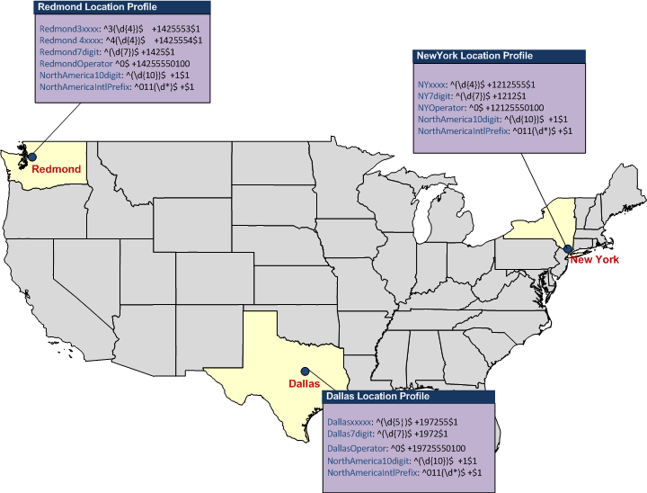

Phone Usage Records
Phone usage records provide a quick, simple way to assign call permissions to users as well as facilitate route prioritization and selection. For example, a temporary contract employee might not be authorized to make long-distance calls, or only certain employees or workgroups might be allowed to place international calls. A phone usage record is an arbitrary label that you create to identify a category of call destinations. Examples include “Local”, “Area Code”, “State”, “Province, “USA”, “Singapore”, and “International.” In this regard, phone usage records are similar to what in traditional telephony is known as “class of service.” Phone usage records, however, offer greater flexibility because they are applied to both user policies and routes, making it possible to formulate very precise phone authorizations for both individuals and groups.
By assigning phone usage records to both user policies and outbound call routes, you indicate which users are allowed to make calls that utilize particular routes. When a user places a call, Communications Server 2007 matches the caller with the route. If the phone usage record for the route also appears in the voice policy assigned to the caller, the call is allowed to go through. If the caller does not have a phone usage record that matches one of those that are assigned to the particular route used for the called number, the server refuses the call.
Following are the steps involved in using phone usage records:
- Administrators create policies that contain a set of phone-usage attributes.
Note
The sequence of phone usage attributes in the policy has significance; we recommended that you arrange attributes from most-preferred to least-preferred.
- Users are assigned a policy based on their calling privileges.
- Routes are assigned phone usage records, which serve to match routes with users authorized to use them. That is, users can place calls that utilize routes for which they have matching phone usage records.

Routes
When Communications Server determines that a dialed number needs to be routed to a PSTN gateway, the routing table is queried to determine the optimal gateway for the call.
The policy of the calling user (or a user transferring the call), along with the dialed number, together determine the gateway to which the call should be routed. The following example illustrates the logic used by the routing application:
routeList = null;
foreach ( usage in caller.usages ) – order of usages matters
foreach ( route in routesWithUsage[ usage ] )
if ( route.RegexPattern.Matches ( targetPhoneNumber ) )
routeList.Append ( route );
The following are examples of failover logic related to gateway selection:
- When there are multiple gateways that serve a particular route, a round-robin algorithm is used to distribute the calls across the multiple gateways.
- Each gateway is configured with a maximum number of failed call attempts before traffic to the gateway is throttled. The default number of attempts is 10, but this value can be changed using a WMI (Windows® Management Interface) script. For a particular call, a given gateway may not be attempted more than once. If all gateways that serve a particular route are marked as unavailable, the server drops the call and notifies the client. You can also configure a gateway to be removed from the selection logic for some period of time. The unresponsive gateway is removed from the list of available gateways for increasingly longer periods of time, up to a maximum of 60 minutes, during which time the server repeatedly attempts to elicit a positive response. Upon receiving a positive response, the server returns the gateway to the list of available gateways.
Figure 10. Example of routing logic
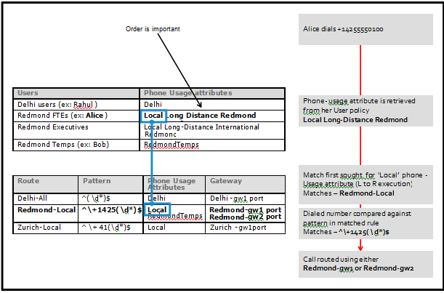
Note
Only calls from users who are enabled for Enterprise Voice are routed using the previously defined procedure. If no match is found in the routing table, the call is refused.
Additional examples and best practice recommendations in subsequent sections provide further clarity around this routing function.

Chapter 2 Planning for Enterprise Voice
Planning is essential for a smooth, successful Enterprise Voice deployment. This section of the Enterprise Voice guide:
- Discusses the various opportunities and constraints that will shape your planning decisions and available options for meeting these challenges.
- Alerts you to possible deployment pain points and recommends actions to manage or avoid them.
- Helps you assess your hardware and infrastructure needs.
- Recommends the order in which to approach deployment tasks to ease the process and avoid potential problems.

Overview
This guide divides the planning process for Enterprise Voice into the following topics:
- Determine the Number and Distribution of Users
Explains how the number and distribution of users affects other planning decisions.
- Select a Deployment Option
Describes two main deployment options — Communications Server stand-alone and Communications Server-PBX coexistence — and the topologies they support.
- Plan for Media Gateways
Discusses factors that affect the size and number of media gateways that your organization requires and where and how those gateways might be located.
- Plan for Call Authorization and Routing
Discusses what you need to consider when creating location profiles, normalization rules, phone usage records, and routes.
- Plan for Exchange Server 2007 SP1 Unified Messaging
Describes what you need to consider when deploying Exchange 2007 SP1 Unified Messaging to provide call answering, call notification, subscriber access, and auto call attendant services for Enterprise Voice.
- Planning to Move Users to Enterprise Voice
Provides an overview of the steps that are required to move users from an existing PBX and enable them for Enterprise Voice.

Determine the Number and Distribution of Users
The total number of users to be enabled for Enterprise Voice is less important than the distribution of users among the locations where your organization conducts business.
For each location, you need to:
- Determine valid dialing patterns for each location and create location profiles consisting of normalization rules that convert those patterns to E.164 format.
- Estimate call traffic and decide on the size, number, and location of the media gateways that are required. See Plan for Media Gateways.
- Enable users for Enterprise Voice and create voice policies that specify the types of calls various individuals and user groups are allowed to make.

Select a Deployment Option
Enterprise Voice provides several deployment scenarios that address various deployment strategies, timelines, and existing telephony investments. These scenarios fall into two groups:
- Communications Server-PBX Coexistence
- Communications Server stand-alone

Communications Server-PBX Coexistence
This option involves a PBX coexisting with Office Communications Server 2007 and Office Communicator 2007 to provide a flexible and powerful combination of traditional telephony and the benefits of unified communications, including rich audio, intuitive call control, enhanced presence notification, and the ability to communicate directly from Microsoft Office applications.
This Communications Server-PBX Coexistence option offers two alternatives:
- Native IP-PBX integration
- TDM-PBX integration through a media gateway

Native IP-PBX Integration
Native IP-PBX integration refers to full coexistence between Communications Server and a PBX that natively supports SIP and IP media in a format that is interoperable with Microsoft Enterprise Voice. With native PBX integration, all users in an organization can make and receive phone calls using their existing desktop PBX phone or Office Communicator 2007.
A call is anchored on the system that originates the call. Calls from the PSTN or internal PBX phones are anchored on the PBX; calls initiated in Communicator are anchored on Communications Server. The system anchoring a call is configured to “fork” the call to the other system in addition to ringing its own endpoints. All signaling and media is terminated and normalized on the Mediation Server, which mediates both signaling and media between the two systems.
The following diagram shows a typical topology for PBX Integration.
Figure 11. Native IP-PBX integration deployment option
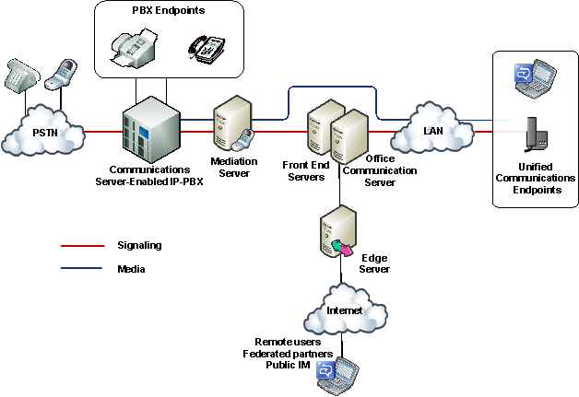
PBX integration is possible only with an IP PBX that natively supports SIP and Internet protocol media in a form that is interoperable with Communications Server.
Only the latest IP PBX models support native PBX integration and even then it is likely that a software upgrade needs to be provided by the PBX vendor. These next-generation IP PBXs are being developed by several third-party vendors (for a list of vendors, see http://r.office.microsoft.com/r/rlidOCS?clid=1033&p1=IPpbxVend) and should be available soon, if they are not already. For information about the availability and functionality consult each vendor directly.
The following simple call scenarios demonstrate how PBX integration works.

Outside Call to Internal User
Bob calls Alice from the PSTN. The call is routed by the PSTN service provider to the enterprise PBX, which rings Alice’s desktop PBX phone and also forks the call to Communications Server. The PBX forks the call by translating the incoming call alert to a SIP INVITE transaction and passing this request to the Mediation Server that connects it with Communications Server. In turn, Communications Server performs reverse number lookup on the called number to obtain all of Alice’s registered SIP endpoints and, upon finding them, rings all the endpoints. Alice has the choice of answering the call on whichever endpoint device is most convenient. When Alice answers the call on one of her endpoints, all other endpoints stop ringing.
Ann, a mobile worker, calls Alice from her laptop by clicking Alice’s name in her Communicator Contacts list. The call takes the form of a SIP INVITE request. Communications Server performs reverse number lookup on the called number and rings all of Alice’s SIP endpoints. Communications Server also forks the call to the PBX, which understands SIP and therefore uses the TEL URI to ring Alice’s desktop PBX phone. Once again, Alice has the option of answering the call on whichever device is most convenient.
Note
Voice calls between users outside the corporate firewall who are enabled for Enterprise Voice and using Office Communicator 2007 and internal users who are enabled for Communications Server 2005 SP1 and using Office Communicator 2005 should not be expected to work.

Internal Calls Among Users
Because all internal users are enabled for both PBX and VoIP calls, the device each user chooses to place a call determines which system handles the routing. If Alice uses her PBX phone to call Dan’s extension, the call is routed to Dan’s desktop phone by the PBX. But the PBX also fork the call to Communications Server, which routes the call to all Dan’s SIP endpoints.
If Alice uses Communicator or a SIP phone to make the call, the SIP INVITE is sent to Communications Server, which routes the INVITE to all Dan’s SIP endpoints and also forwards it to the PBX, which rings Dan’s desktop PBX phone.

Internal Call to Outside User
The routing of calls to external numbers depends on routing rules that are configured on both the PBX and Communications Server. Routing rules can be configure on Communications Server to route calls to phone numbers to the PBX or to a media gateway, if deployed.

Voice Mail
Users who are enabled for PBX integration do not have access to Communications Server voice mail. Therefore, when deploying PBX integration, you should plan to keep the voice mail system on your PBX. If you eventually retire the voice mail system on your PBX, you can then disable PBX integration and reconfigure voice mail on Exchange Unified Messaging, as described in this guide.

Call Forwarding
Call forwarding can be configured on Communicator, the PBX phone, or both. If both are configured, then both should point to the same destination.
If RCC is enabled, then only the PBX forwarding options are shown, and a single option can be set on the PBX side. If RCC is not enabled, then the user can set forwarding independently for Enterprise Voice and the PBX. It is recommended that the user manually synchronize the forwarding options for the two systems.

Conferencing
Conference calls are established on the system that initiates the conference. If Communicator establishes a conference on the Communications Server A/V Conferencing Server, PBX telephones are enrolled in the conference by means of “dial out” as an outbound call leg. If a PBX user initiates a PBX conference, an Enterprise Voice user can join or be “dialed in” to the conference as a normal inbound or outbound call leg.

RCC
RCC allows users to use Communicator to monitor and control their PBX phones. This feature is disabled for Enterprise Voice, but remains available with PBX integration. In order for RCC to work in a PBX integration scenario, each user must be configured with the same SIP and/or TEL URI for both RCC and Enterprise Voice. Otherwise, a call received through either of these systems cannot be correlated to the same calling party. As a result, a user might be presented with two toasts announcing the same call.
Two phone number formats are supported for both RCC and Enterprise Voice:
- E.164, such as tel:+14257221234
- E.164 + Extension, such as tel:+14257221234;ext=21234
If a user receives a call from a remote party, then the caller ID must be populated with these formats and must be consistent across the two systems.
Following are some examples and guidelines to consider for ensuring that dual forking and remote call control work together:
Note
Although an RCC user can also be configured with a private phone number, such as tel:21234;phone-context=xxx, Enterprise Voice does not support private numbers. Therefore, if a user has a private number it must be configured as E.164 with an extension, using a global E.164 access number to the user’s domain.
- If a PBX can handle E.164 numbers natively and can provide such numbers in the URIs delivered by means of both RCC and SIP, and if all the numbers are Direct Inward Dialing (DID) numbers, then there is no need to configure extensions in Active Directory for individual users.
- If a PBX uses extensions to route calls — the typical case — then the PBX uses an extension to designate the users both making and receiving a call. Because the PBX does not natively correlate the extensions with E.164 equivalents, it needs to access Active Directory to convert the extensions to E.164 for both parties when using RCC to communicate with Enterprise Voice users. There are 2 cases to consider here, all of which assume that a single extension can uniquely identify a user even if a call traverses several PBXs with DIDs that are potentially from completely different locations:
- Case 1: The PBX has a unique E.164 DID number for each user, and the internal extension used by internal callers is a subset of this DID number.
For this case, each individual user can be represented in the Active Directory Line URI by either an E.164 number or an E.164 number + extension. For example, if the user has an E.164 DID number of tel:+14257272133, either this number or tel:+14257272133;ext=72133 can be entered in the Line URI field. If the PBX is capable of parsing entries in the Line URI field when it needs to convert an extension to E.164, then no additional configuration is necessary. An alternative way to associate a user with the appropriate extension, is to configure one of the other fields in Active Directory — such as the phone-office-other field associated with the user — with the value of the extension.
- Case 2: The PBX does not have a unique E.164 DID number for each user. To reach a particular user from the PSTN, an outside caller must dial the E.164 number of the PBX and specify the extension when prompted by the Interactive Voice Response.
For this case, the Active Directory Line URI for ach user must contain an E.164 number + extension. if the PBX is capable of parsing the Line URI field when it needs to convert an extension, then no additional configuration is necessary. An alternative way to associate a user with the appropriate extension, is to configure one of the other fields in Active Directory — such as the phone-office-other field associated with the user — with the value of the extension.
For more information on how to configure RCC for users who are enabled for PBX integration, see Step 9 Enable Users for PBX Integration.

TDM-PBX Integration Through a Media Gateway
In order to enable the coexistence scenario, in the event you have TDM-PBX infrastructure that supports forking of calls, an alternative approach is to deploy a Microsoft-certified media gateway or gateway/Mediation Server combination between Office Communications Server and the PBX. A number of these media gateways are available within the Microsoft Unified Communications Media Gateway partner program (for the current list, see http://r.office.microsoft.com/r/rlidOCS?clid=1033&p1=IPpbxVend ). These media gateways interoperate with the Office Communications Server Mediation Server by means of SIP and IP media and with the PBX by means of various telephony protocols.
Figure 12 TDM-PBX Integration Through a Media Gateway
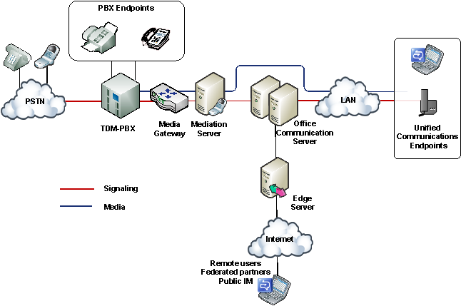

Communications Server Stand-Alone
Three deployment scenarios use Communications Server 2007 as the sole telephony solution for part or all of an organization. These scenarios include the following deployments:
- Departmental deployment
- Greenfield deployment
The following topics describe these scenarios in detail.

Departmental Deployment
In this scenario, Communications Server is deployed as the sole telephony solution for individual teams or departments, while the rest of the users in an organization continue using a PBX. This incremental deployment strategy provides one way to introduce IP telephony into your enterprise through controlled pilot programs. Workgroups whose communication needs are best served by Microsoft Unified Communications are moved to Enterprise Voice, while other users remain on the existing PBX. Additional workgroups can be migrated to VoIP as needed.
The departmental option is recommended for clearly defined user groups that share communication requirements in common and lend themselves to centralized management. This option is also attractive for teams or departments that are spread over wide geographic areas, where the savings in long-distance charges can be significant. In fact, this option is useful for creating virtual teams whose members might be scattered across the globe. Such teams can be created, amended, or disbanded in rapid response to shifting business requirements.
The following figure shows the generic topology for deployment of Enterprise Voice behind a PBX. This is the recommended topology for departmental deployment.
Figure 13. Departmental migration option
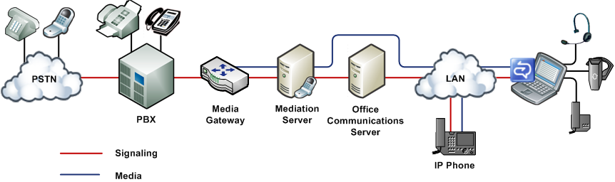
In this topology, selected departments or workgroups are enabled for VoIP. A media gateway links the VoIP-enabled workgroup to the PBX. Users enabled for VoIP, including remote workers, communicate across the IP network. Calls by VoIP users to the PSTN and to coworkers who are not enabled for VoIP are routed to the appropriate media gateway. Calls from colleagues who are still on the PBX system, or from callers on the PSTN, are routed to the media gateway, which forwards them to Communications Server 2007 for routing.
There are two recommended topologies for connecting Enterprise Voice with an existing PBX infrastructure for interoperability:
- Enterprise Voice behind the PBX. In this topology, all calls from the PSTN arrive at the PBX, which routes calls to Enterprise Voice users to a media gateway, and calls to PBX users in the usual way. Table 1 shows the advantages and disadvantages of this topology.
Table 1. Advantages and disadvantages of deploying Enterprise Voice behind a PBX
Advantages | Disadvantages
The PBX still serves users not enabled for Enterprise Voice. | If necessary, tie line board in the PBX must be added for gateway connection.
The PBX handles all legacy devices. | The PBX must be configured to route Enterprise Voice numbers to the gateway.
Users can keep the same phone numbers.

- Enterprise Voice in front of the PBX. In this topology, all calls arrive at the media gateway, which routes calls for Enterprise Voice users to Communications Server and calls for PBX users to the PBX. Calls to the PSTN from both Enterprise Voice and PBX users are routed over the IP network to the most cost-efficient media gateway. Table 2 shows the advantages and disadvantages of this topology.
Table 2. Advantages and disadvantages of deploying Enterprise Voice in front of a PBX
Advantages | Disadvantages
The PBX still serves users not enabled for Enterprise Voice. | Existing gateways might not support desired features or capacity.
The PBX handles all legacy devices. | It might be necessary to reset trunks from the local exchange carrier to point to the media gateway.
Enterprise Voice users keep the same phone numbers.

The departmental option assumes that you have an existing PBX infrastructure and intend to introduce Enterprise Voice incrementally to smaller groups or teams within your organization. The greenfield option assumes that you are considering deploying Enterprise Voice at a site without traditional telephony infrastructure.

Greenfield Deployment
Enterprise Voice provides new businesses or even new office sites for existing businesses with the opportunity to implement a full-featured VoIP solution without having to worry about PBX integration or incurring the substantial deployment and maintenance costs of an IP PBX infrastructure. This solution supports both onsite and remote workers.
In this scenario, all calls are routed over the IP network. Calls to the PSTN are routed to the appropriate media gateway. Communicator serves as a softphone. RCC is unavailable in this scenario because Communicator Phone Edition, like Communicator, provides click-to-call capability. Voice mail and auto-attendant services are available through the optional deployment of Exchange Unified Messaging.
Note
In addition to the network infrastructure that is required to support Communications Server 2007, a greenfield deployment might require a small PBX to support fax machines and analog or ISDN devices. In certain scenarios, this might require a new PRI (Primary Rate Interface) link with a new set of numbers.
The following figure shows a typical topology for a greenfield deployment.
Figure 14. Greenfield deployment option
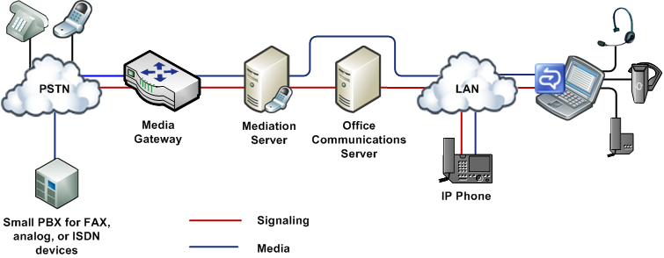

Migration Paths and Integration Strategies
The following table lists the requirements and recommended deployment steps for the deployment options described above.
Table 3 Enterprise Voice Deployment Options
Deployment Option | Requirements | Deployment Steps
PBX coexistence | An IP PBX that natively supports SIP and IP media in a format that is interoperable with Office Communications Server.  OR  A PBX combined with a media gateway that connects the PBX to the Communications Server infrastructure.  A/V Edge Server for media relay across NATs and firewalls.  Mediation Server configured with the IP address of the PBX and the FQDN of the A/V Edge Server.  Users enabled for Enterprise Voice and PBX integration.  Voice mail configured on the PBX. | - Deploy Office Communications Server, including Mediation Server that connects to PBX.  - Deploy Office Communicator 2007.  - Enable users for IM and presence.  - Configure Communications Server for Enterprise Voice.  - Configure PBX to fork calls to Communications Server.  - Deploy media gateways (if required).  - Deploy RCC gateway (if required).  - Enable users for Enterprise Voice and PBX integration.
Stand-Alone Options
Departmental | IP or TDM PBX.  Basic, basic hybrid, or advanced media gateway configured to connect departmental deployment with the PBX.  Additional other gateways as required for PSTN connections.  A/V Edge Server for media relay across NATs and firewalls.  Mediation server configured with the IP address of basic or basic hybrid media gateway (not required for advanced gateway).  Users enabled for Enterprise Voice.  Exchange UM deployed and configured to provide voice mail for Enterprise Voice users. | - Deploy Office Communications Server.  - Deploy Office Communicator 2007.  - Configure Communications Server for Enterprise Voice.  - Enable users for IM and presence.  - Deploy Exchange Server 2007 Unified Messaging and configure to integrate with Communications Server.  - Deploy media gateways.  - Enable one or more subsets of users for Enterprise Voice.  - Migrate users to Enterprise Voice in one or more phases.
Greenfield | Basic, basic hybrid, or advanced media gateway configured to connect to the PSTN.  A/V Edge Server for media relay across NATs and firewalls.  Mediation server configured with the IP address of basic or basic hybrid media gateway (not required for advanced gateway).  Users enabled for Enterprise Voice.  Call forwarding configured on Communicator.  Exchange UM deployed and configured to provide voice mail.  A small PBX for fax and 911.  An additional gateway to connect to a small PBX. | - Deploy Office Communications Server.  - Deploy Office Communicator 2007.  - Configure Communications Server for Enterprise Voice.  - Deploy Exchange Server 2007 Unified Messaging and configure to integrate with Communications Server.  - Deploy media gateways.  - Enable users for Enterprise Voice.
PBX integration to stand-alone  NOTE  This migration path is used only when PBX integration is used as a stepping stone to a stand-alone Communications Server deployment. | Basic, basic hybrid, or advanced media gateway configured to connect to the PSTN. (If one or more gateways are already deployed, they might have to be repurposed for new role in the network.)  SIP phones, such as the Communicator Phone Edition, are optional. | - Deploy media gateways.  - Reassign DID numbers (if any) to media gateways.  - Deploy and configure Exchange UM. This can be done before, after, or concurrently with deployment of media gateways.  - If necessary, rename location profiles to the FQDN of their corresponding Exchange UM dial plans.  - Replace PBX desktop phones with Communicator and/or Communicator Phone Edition or other SIP clients.

Plan for Media Gateways
The number, size, and location of media gateways is perhaps the most important and potentially costly decision you must make when planning your Enterprise Voice infrastructure. The main questions to answer are:
- What type of gateway should you deploy?
- How many media gateways are needed? The answer depends at least in part on the size of the gateways and where they are to be deployed.
- What size should the gateways be? The answer depends in part on how many you plan to deploy and where you plan to put them.
- Where should the gateways be located? The answer depends in part on the topology and geographic distribution of your organization.
In other words, no one of the previous questions can be answered independently of the other three. Answers to all four depend ultimately on how much telephone traffic you anticipate and how that traffic is distributed across your organization. But that is only the beginning, the base data, so to speak. You must also consider your gateway topology options.

Choosing the Type of Gateway to Deploy
Communications Server 2007 supports three types of media gateways: Advanced, Basic, and Basic Hybrid. To review the differences between these gateway types, see Media Gateways. You can find a current list of qualified gateways that work with Communications Server at http://r.office.microsoft.com/r/rlidOCS?clid=1033&p1=IPpbxVend.The advantages and disadvantages of these three gateway types are summarized in the following table:
Table 4. Basic and Collocated Gateways Compared
Gateway Type | Advantages | Disadvantages
Basic Media Gateway | Existing hardware can perhaps be used for Mediation Server. | Mediation Server entails additional overhead for installation, configuration, and management.
Basic Hybrid  Media Gateway | Does not require separate Mediation Server.  Installation, configuration, and management are simpler than for combination of Basic Media Gateway and Mediation Server.
Advanced Media Gateway | Does not require separate Mediation server. Installation, configuration, and management, are simpler than that of other gateway types

Gateway Topologies
When attempting to answer the four fundamental questions of gateway deployment listed earlier in Plan for Media Gateways, the obvious approach is to:
- Count the sites at which your organization has offices.
- Estimate the traffic at each site.
- Deploy one or more gateways at each site to handle the anticipated traffic.
The resulting distributed gateway topology is shown in the following figure.
Figure 15. Distributed gateway topology
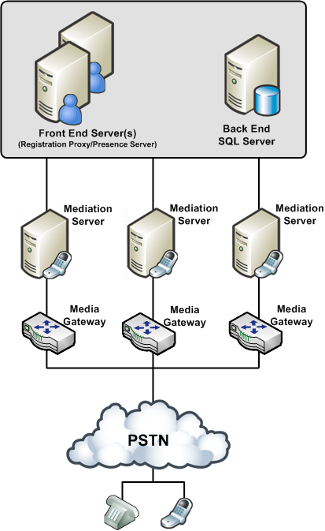
With this topology, calls among workers at each site and between the sites are all routed over the company intranet. Calls to the PSTN are routed over the enterprise IP network to the gateways that are closest to the location of the destination numbers.
But what if your organization supports dozens or hundreds or even thousands of sites spread across one or more continents, as many financial institutions and other large enterprises do? In such cases deploying a separate gateway at each site is impractical.
To address this problem, many large companies prefer to deploy one or a few large telephony data centers, as shown in the following figure.
Figure 16. Datacenter Gateway Topology
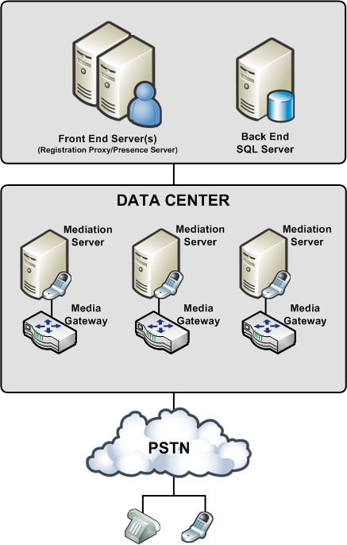

In this topology, several large gateways sufficient to accommodate the anticipated user load are deployed at each data center. All calls to users in the enterprise are forwarded by the company’s telephone service provider to a data center. Routing logic at the data center determines whether the call should be routed over the intranet or to the PSTN.
Placing a gateway at every site on the one hand or at a single data center on the other represent the extremes of a deployment continuum along which seemingly infinite combinations are possible. You can deploy single gateways at several sites and several gateways at a data center in nearly any possible combination. The best solution in each case depends on a variety of factors that are specific to each organization.

Gateway Location
Gateway location may also determine the types of gateways you choose and how they are configured. There are dozens of PSTN protocols, and these vary from country to country. If all your gateways are located in a single country, this is not an issue, but if you locate gateways in several countries, each must be configured according to the PSTN standards of that country. Moreover, gateways that are certified for operation in, say, Canada, may not be certified in India, Brazil, or the European Union.

Gateway Size and Number
The media gateways that most organizations will consider deploying range in size from 2 to as many as 960 ports. (There are even larger gateways, but these are used mainly by telephone service providers.) When estimating the number of ports your organization requires, use the following guidelines:
- Light telephony users (1 PSTN call per hour) should allocate 1 port for every 15 users. For example, if you have 20 users, you will require a gateway with 2 ports.
- Moderate telephony users (2 PSTN calls per hour) should allocate 1 port for every 10 users. For example, if you have 100 users, you will require a total of 10 ports allocated among one or more gateways.
- Heavy telephony users (3 or more PSTN calls per hour) should allocation 1 port for every 5 users. For example, if you have 47,000 users, you will require a total of 9,400 ports allocated among at least 10 large gateways.
- Additional ports can be acquired as the number of users or amount of traffic in your organization increases.
For any given number of users you must support, you have the choice of deploying fewer, larger gateways, or more smaller ones. As a rule, a minimum of two gateways for an organization is recommended in the event one goes down. Beyond that, the number and size of gateways that an organization deploys are going to vary widely, based on a careful analysis of each organization’s volume of telephone traffic.
Each basic media gateway that you deploy must have at least one corresponding Mediation Server. It is possible, though not recommended, to point a single gateway to multiple Mediation Servers, but you cannot point a single Mediation Server to more than one media gateway.
Note
A basic hybrid media gateway is configured to work only with the collocated Mediation Server and therefore should not be pointed to other Mediation Servers.

Mediation Server Hardware Requirements
The following table indicates minimum hardware requirements for Mediation Server based on the required transmission standard (T1 or E1) and the desired number of T1 or E1 interfaces:
Table 5. Mediation Server hardware requirements
Hardware | T1 | E1
Single processor, dual core, 2 Ghz, Memory: 2GB RAM  2 x 1 GBit NIC | 4 | 3
Single processor, dual core, 3 Ghz  Memory: 2GB RAM  2 x 1 GBit NIC | 5 | 4
Dual processor, dual core, 3 Ghz  Memory: 2GB RAM  2 x 1 GBit NIC | 10 | 8
Dual Proc/ Quad Core 2.66 Ghz,  Memory: 2GB RAM  2 x 1 GBit NIC | 18 | 14

CPU utilization is assumed to be 75 percent of the capacity, a conservative estimate that allows sufficient performance capacity for traffic and bandwidth spikes.

Configure Dual Interface Cards for Mediation Server
To help ensure the physical as well as logical separation of your Enterprise Voice infrastructure from the media gateways, you should install Mediation Server on a computer that is equipped with two network interface cards (NICs). One card faces the gateway; the second card faces the Communications Server 2007 server that acts as the Mediation Server’s internal next hop.
When you install Mediation Server, the Deployment Wizard detects the presence of the two network cards and writes their IP addresses to the Communications Server listening IP address list and the Gateway listening IP address list, both on the General tab of the Mediation Server properties dialog box.
The Communications Server listening IP address is the address on an advanced media gateway that listens for call traffic from Communications Server. Until advanced media gateways are available, this address corresponds to the network card that serves as the internal edge of the Mediation Server.
Important
The IP address that you select from the Communications Server listening IP address must match the address that is returned by a DNS query on the Mediation Server’s FQDN. If the two addresses do not match, the IP address listed in DNS for your FQDN you will not be able to connect, and call traffic will be directed to an interface that isn’t listening for OCS traffic rather than to the one that is listening.
The Gateway listening IP address is the address on the Mediation Server that lists traffic from a basic media gateway or Basic Hybrid Media Gateway. For Communications Server 2007, this address corresponds to the network card that serves as the external edge of the Mediation Server.
Note
It is possible to configure both edges on a single adapter card, but this alternative is not recommended.

Media Bandwidth
For basic media gateways, the bandwidth requirement between gateway and Mediation Server is 64,000 bps (bits per second) for each concurrent call. Multiplying this number by the number of ports for each gateway is a fair estimate of the required bandwidth on the gateway side of the Mediation Server. On the Communications Server side, the bandwidth requirement is considerably lower.
When configuring Mediation Server, you are advised to accept the default media port gateway range of 60,000 to 64,000. The default range media port range enables the server to handle up to 1,000 simultaneous voice calls. Reducing the port range greatly reduces server capacity and should be undertaken only for specific reasons by an administrator who is knowledgeable about media port requirements and scenarios. For this reasons, altering the default port range is not recommended.
High-bandwidth traffic such as voice and video tends to stress poorly provisioned networks. Limiting media traffic to a known range of ports makes troubleshooting such problems easier.

Plan for Media Gateway Security
Because a media gateway receives calls from the PSTN, it presents a potential security vulnerability. The recommended mititgation is to:
- Enable TLS on the link between the gateway and the Mediation Server. This will assure that signaling is encrypted end to end between the gateway and your internal users.
- Physically isolate the media gateway from the internal network by deploying the Mediation Server on a computer with two network interface cards: one accepting traffic only from the internal network; the second accepting traffic from a media gateway. Each card is configured with a separate listening address so that there is always clear separation between trusted traffic originating in the Communications Server network and untrusted traffic from the PSTN.
The internal edge of a Mediation Server should be configured to correspond to a unique static route that is described by an IP address and a port number. The default port is 5061.
The external edge of a Mediation Server should be configured as the internal next-hop proxy for the media gateway. It should be identified by a unique combination of IP address and port number. The IP address should not be the same as that of the internal edge, but the default port is 5060.

Encryption
Media flowing both directions between the Mediation Server and Communications Server network is encrypted using SRTP.
Organizations that rely on IPSec for packet security are strongly advised to create an exception on a small media port range if they are to deploy Enterprise Voice. The security negotiations required by IPSec work fine for normal UDP or TCP connections, but they can slow down call setup to unacceptable levels.

Plan for User Authorization and Outbound Call Routing
Outbound call routing applies to calls that are destined for a PBX or the PSTN. User authorization refers to policies that specify which users have permission to place calls along which routes.
To configure user authorization and outbound call routing for your organization, you must create the following Active Directory objects:
Table 6. Communication Server Active Directory Objects for Enterprise Voice
Object | Description
Location profile | A location profile defines all phone numbers that can be dialed from a named location. A location contains one or, typically, more normalization rules.
Normalization rule | A normalization rule is a .NET regular expression that defines a phone number pattern. A set of normalization rules associated with a particular location constitute a location profile.
Phone usage record | A phone usage record specifies a class of call (internal, local, long distance, or whatever) that can be made by various users, or groups of users, in an organization.
Voice policy | A voice policy associates one or more phone-usage records with one or a group of users.
Route | A voice route associates target phone numbers with particular IP-PSTN gateways and phone usage records.

The following figure illustrates the relationship among the various routing components. You may find it helpful to refer to this diagram as you go through the configuration process.
Figure 17. Configuring Outbound Routing
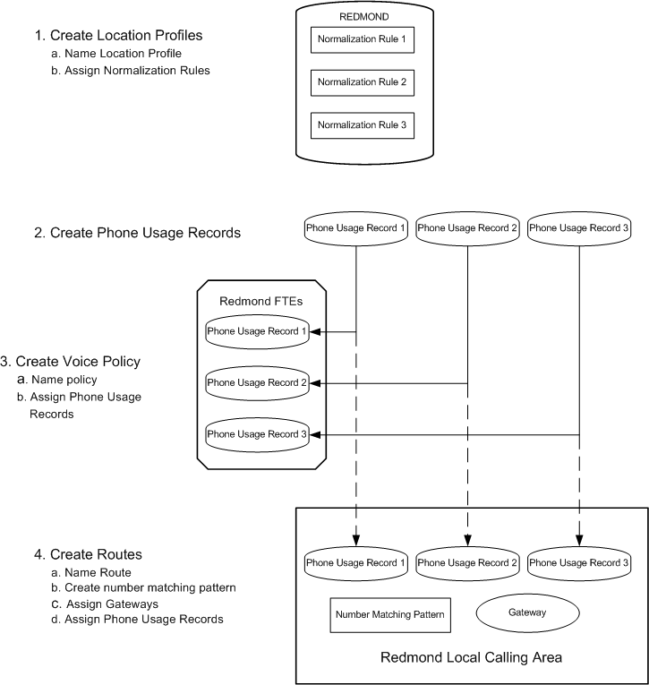
You use the Office Communications Server 2007 Administrative Tools to create the Active Directory objects shown in the above figure. The following topics explain how to configure outbound call routing for your organization and the issues you need to consider when you do so.
Note
Enterprise Voice Route Helper provides an alternative to the Office Communications Server 2007 Administrative Tools for viewing and modifying Enterprise Voice number normalization rules, location profiles, voice policy, and routes. Route Helper is available in the Office Communications Server 2007 Resource Kit.

Location Profiles
Planning location profiles consists of:
- Listing all the locales in which your organization has an office.
In a large multinational company with numerous small branch offices this can be a time-consuming task. The list must be up to date and complete. It will need to be revised as company organization evolves.
- Identifying valid number patterns for each locale.
The most time-consuming part of planning your location profiles is identifying the valid number patterns for each location. In some cases, you may be able to copy normalization rules that you have written for one location profile to other location profiles, especially if the corresponding locales are within the same country or even on the same continent. In other cases, small changes may be enough to make normalization rules appropriate in other locations.
- Developing an organization-wide scheme for naming location profiles and their corresponding Exchange Server 2007 UM dial plans.
Adopting a standard naming scheme assures that names assigned to location profiles and their corresponding UM dial plans are consistent across the organization and over time, regardless of who or how many people are doing the work.
- Deciding whether multiple location profiles are required for a single location.
If your organization maintains a single dial plan across multiple locations, you may still need to create a separate dial plan for Enterprise Voice users who are migrating from a PBX and need to have their existing extensions retained.
- Deciding whether to deploy Exchange UM before or after you have created location profiles.
If you deploy Exchange UM before you create location profiles (recommended), then assigning names to location profiles consists simply of using the FQDN of their corresponding dial plans.
If you create location profiles before you deploy Exchange UM, you have two main options:
- Rename the location profiles later, when you know the FQDNs of their corresponding UM dial plans.
- Duplicate existing location profiles and rename the copies with the FQDNs of their corresponding UM dial plans. You can keep the old location profiles, so long as you use the new ones when configuring Exchange UM.
- Assigning location profiles to Communications Server Front End Server, Enterprise Edition Pool, and Mediation Servers (or Advanced Media Gateways).
Mediation Servers use location profiles to convert incoming numbers from a national number format to E.164 format for purposes of routing to Communications Server. Each Communications Server 2007 Front End Server and pool must be associated with a location profile to determine how outgoing calls to the PSTN or a PBX are to be routed.
- Determining whether you will need to configure your location profiles to handle scenarios in which Exchange UM initiates calls on a user’s behalf. For more information about this issue, along with the pros and cons of two options, see Configuring Location Profiles for Exchange UM Call Initiation Scenarios.
When you create a location profile, you must provide a name, a description, and a set of normalization rules.

Name
A location profile name normally should reflect the location to which it applies, and within certain constraints the choice is yours. However, integrating Exchange UM with Communications Server imposes an additional requirement on location profile names; namely, that they match the FQDNs of their corresponding UM dial plans. For example, if the name of a UM dial plan is, say, “London”, then the name of the corresponding location profile must be London.forestFQDN, where forest FQDN is the forest in which the UM dial plan is located.
These values are captured in the phone-context attribute of the Exchange UM dial plan. For example, if the Exchange UM dial plan name is, say, London, then the phone-context attribute is set to London.forestFQDN. And if the forest FQDN is Contoso.com, then the name of the London location profile should be London.Contoso.com.
With regard to naming location profiles, you have two deployment options:
Regardless of the order of deployment, a separate location profile must exist for each Exchange UM dial plan. If the same dial plan name is used in multiple Exchange forests, a matching location profile must be created that matches the UM dial plan FQDN for each forest.
The OCSUMUtil tool that is included with Office Communications Server 2007 can be used to validate location profile names. The tool does not correct invalid names; it simply alerts you to the need to do so. For information about using this tool, see Step 1 Configure Exchange UM to Work with Communications Server.
Note
If you are not deploying Exchange 2007 Unified Messaging, then you can, with only a few constraints, give whatever name you like to a location profile, so long as that name is unique.

Description
We recommend that you type the common, recognizable name of the geographic location to which the corresponding location profile applies. For example, if the location profile name is London.Contoso.com, then the recommended Description would be London. If you have deployed the Office Communicator 2007 Phone Edition, the name in this field will be displayed to end users for the purpose of allowing them to select the appropriate location profile for a call.

Normalization rules
Normalization rules specify how to convert numbers dialed in various formats to standard E.164 format. Normalization rules are necessary for call routing and authorization because users can, and do, use various formats when entering phone numbers in their contact lists.
Normalizing user-supplied phone numbers provides a consistent format that facilitates:
- Matching a dialed number to the intended recipient’s SIP-URI.
- Applying dialing authorization rules to the calling party.
The following number fields are among those that your normalization rules may need to account for:
- Dial plan
- Country Code
- Area Code
- Length of extension
- Site prefix
You create normalization rules in the Communications Server 2007 snap-in for MMC, using .NET Regular Expressions. Table 7 shows sample normalization rules that are written as .NET regular expressions. The samples are examples only and are not meant to be a prescriptive reference for creating normalization rules.

Table 7. Normalization Rules Using .NET Regular Expressions
Rule Name | Description | Number Pattern | Translation | Example
4digitExtension | Translates 4-digit extensions | ^(\d{4})$ | +1425555$1 | 0100 is translated to +1425550100
5digitExtension | Translates 5-digit extensions | ^5(\d{4})$ | +1425555$1 | 50100 is translated to +14255550100
7digitcallingRedmond | Translates 7-digit numbers to Redmond local number | ^(\d{7})$ | +1425$1 | 5550100 is translated to +14255550100
7digitcallingDallas | Translates 7-digit numbers to Dallas local number | ^(\d{7})$ | +1972$1 | 5550100 is translated to +19725550100
10digitcallingUS | Translates 10-digit numbers in US | ^(\d{10})$ | +1$1 | 2065550100 is translated to +12065550100
LDCallingUS | Translates numbers with LD prefix in US | ^1(\d{10})$ | +$1 | 12145550100 is translated to +12145550100
IntlCallingUS | Translates numbers with international prefix in US | ^011(\d*)$ | +$1 | 01191445550100 is translated to +91445550100
RedmondOperator | Translates 0 to Redmond Operator | ^0$ | +14255550100 | 0 is translated to +14255550100
RedmondSitePrefix | Translates numbers with on-net prefix (6) and Redmond site code (222) | ^6222(\d{4})$ | +1425555$1 | 62220100 is translated to +14255550100
NYSitePrefix | Translates numbers with on-net prefix (6) and NY site code (333) | ^6333(\d{4})$ | +1202555$1 | 63330100 is translated to +12025550100
DallasSitePrefix | Translates numbers with on-net prefix (6) and Dallas site code (444) | ^6444(\d{4})$ | +1972555$1 | 64440100 is translated to +19725550100

The normalization rules contained in location profiles are used by the Communicator Phone Edition to optimize the user’s dialing experience. When the Communicator Phone Edition is off hook while a user is entering digits, it uses the rules contained in the location profile to determine if sufficient digits have been entered in order to generate an INVITE request to Communications Server.
For detailed information about using .NET regular expressions, see .NET Framework Regular Expressions at http://r.office.microsoft.com/r/rlidOCS?clid=1033&p1=RegExpr.
Note
For additional assistance with regular expressions, consider using the Route Helper application that is included in the Office Communications Server 2007 Resource Kit. Route Helper is an alternative to the MMC snap-in for viewing and modifying Enterprise Voice number normalization rules, location profiles, voice policy, and routes.
The following table illustrates a sample location profile for Redmond, Washington, USA, based on the normalization rules shown in the previous table.
Table 8. Redmond location profile based on Table 7 normalization rules
Redmond.forestFQDN
5digitExtension
7digitcallingRedmond
10digitcallingUS
IntlCallingUS
RedmondSitePrefix
NYSitePrefix
DallasSitePrefix
RedmondOperator

Note
The normalization rules names shown in the preceding table do not include spaces, but this is a matter of choice. The first name in the table, for example, could have been written “5 digit extension” or “5-digit Extension” and still be valid.

Phone Usage Records
Configuring Location Profiles for Exchange UM Call Initiation Scenarios
Multiple scenarios, such as playing a voice message on the phone or calling a personal contact, require Exchange UM to initiate calls on a user’s behalf. Often, the targets of such calls are users in the GAL or people in a user’s personal contacts. Calls initiated by UM are routed through Communications Server, just like calls from other clients.
When Exchange UM SP1 sends an E.164 number to Communications Server, UM does not pass the prefixed plus sign (+) required for E.164 numbers. To work around this problem, two options are available to administrators:
Option 1: Define one location profile for both UM and Communications Server clients.
This option requires that you add rules to the location profile that identify E.164 numbers whose plus sign (+) prefix is missing. For example, a Redmond, WA, USA, location profile might require a rule that prefixes the plus sign (+) to all 11-digit numbers starting with the number 1. In practice, formulating rules that correctly identify all instances of E.164 numbers whose initial plus sign (+) is missing can be difficult and time-consuming.
This is the recommended option when the dial patterns are similar across Communications Server clients and UM (for example, when there is no requirement for an off-net prefix).
Even when dialing patterns are not similar across Communications Server clients and UM, administrators have the option of defining and ordering normalization rules to cater to both scenarios. This approach introduces additional complexity, but enables Communications Server clients to make calls from Outlook contact lists, even if the number format does not adhere to the normal dial plan.
Option 2: Define two location profiles - one that translates numbers from Communications Server clients, and another one that translates numbers from Exchange UM.
This option eliminates the complexity of having to assure that a single location profile accounts for two sets of dialing patterns, one from Exchange UM, the other from Communications Server clients. The disadvantage is the need to configure and maintain two location profiles.
Planning phone usage records consists mainly of listing all the call permissions that are currently in force in your organization, from the CEO down to temporary workers, consultants, and contingent staff. This process also provides an opportunity to re-examine existing permissions and revise them if desired. You can create phone usage records only for those permissions that apply to your anticipated Enterprise Voice users, but a better long-range solution might be to simply create phone usage records for all permissions regardless of whether some may not currently apply to the group of users to be enabled for Enterprise Voice. If permissions change or new users with different permissions are added, you will have already created the required phone usage records.
Table 9 shows a typical phone usage table:
Table 9. Phone Usage Records
Phone Attribute | Description
Local | Local calls
Long-Distance | Long distance calls
International | International calls
Delhi | Delhi full-time employees
Redmond | Redmond full-time employees
RedmondTemps | Redmond temporary employees
Zurich | Zurich full-time employees

By themselves, phone usage records don’t do anything. For them to work, you must associate them with:
- Voice policies, which are assigned to users.
- Routes, which are assigned to phone numbers.
The following two topics describe voice policies and routes. For information about how to create and configure them, see Step 7 Configure Outbound Call Routing.

Voice Policies
Enterprise Voice policies are essentially collections of phone usage records that are assigned to one or more users. Policies also include an option of enabling or disabling the simultaneous ringing feature. The simultaneous ringing feature enables users to configure Communicator such that incoming calls, in addition to ringing the users registered endpoints, also ring an additional nonregistered endpoint, such as a personal mobile phone. Normally, simultaneous ringing should be enabled, but in the event of excessive congestion, you have the ability to disable this feature.
Most organizations will have multiple voice policies, typically a default policy that applies to all users and one or more special policies that are applied on a per-user basis. You have the option of creating your own voice policies from scratch or editing existing policies.
Phone usage order is critical because in matching users to routes, the server compares phone usages from top to bottom. If the first usage matches the call route, the call is routed. The remaining phone usages provide backup in the event of route congestion or call failure.
Defining voice policies for users includes:
- Creating a default policy for your organization. This policy will apply to all users to whom you have not explicitly assigned a per user policy.
- Defining one or more per-user policies as needed.
- Adding one or more phone usage records (see “To Create a Phone Usage Record” in Step 7. Configure Outbound Call Routing).
- Specifying whether to enable the simultaneous ringing feature for Enterprise Voice users (not supported for PBX coexistence scenarios).
You create voice policies in the Communications Server 2007 MMC snap-in.
- If you want to apply a single policy to all Enterprise Voice users in your organization, then you need only to choose or customize the default policy.
- If you want to apply special policies to certain individuals or groups of Enterprise Voice users, then you must choose the “Use per user” option, and then create one or more special policies and explicitly assign them to specific individuals or groups of users. Any users to whom you do not explicitly assign a policy will be governed by the default policy.

Call Routes
Enterprise Voice Routes specify how Communications Server 2007 handles calls placed by Enterprise Voice users. When a user places a call, the server, if necessary, normalizes the phone number to E.164 format and attempts to match it to a SIP-URI. If the server is unable to make the match, it applies outgoing call routing logic based on the number. You define that logic in the form of a separate route for each set of target phone numbers that are listed in the location profile for each locale.
Before you define outbound call routes, you should have completed the following steps:
- Deployed one or more media gateways and, if necessary, Communications Server 2007, Mediation Servers.
- Created a location profile consisting of normalization rules for target phone numbers.
- Created phone usage records.
In addition, to enable outbound call routing, you must also create and assign one or more voice policies, but this step can be done either before or after you define outbound call routes.
For each route, you must specify:
- A name by which it can be readily identified.
- An optional description in cases where the name alone may not be sufficient to describe the route.
- The regular expression that identifies the target phone numbers to which the route is applied.
- The FQDNs of the gateways that can route to the target numbers.
- The phone usages that users must have in order to call numbers matching the target phone number regular expression.
You create routes in the Communications Server 2007 snap-in for MMC. These routes populate the routing table, which embodies the outbound call routing logic that is followed by the server for numbers to the PSTN.

Least Cost Routing
The ability to specify the PSTN gateways to which various numbers are routed enables you to determine which routes incur the lowest costs and implement them accordingly. The rule of thumb in selecting gateways is to choose the one closest to the location of the destination number in order to minimize long-distance charges. For example, if you are in New York and calling a number in Rome, you would carry the call over the IP network to the gateway in your Rome office, thereby incurring a charge only for a local call.

Additional Routing Logic
In creating outbound call routes, you should be aware of the following factors affecting routing logic:
- If the domain portion of the Request URI does not contain a supported domain for the enterprise, the outbound routing component on the server does not process the call. For example, In certain scenarios where a call is established over a federated boundary, the domain portion of the URI is used to route the call over to the enterprise that is responsible for applying the outbound routing logic.
- If a user is not enabled for Enterprise Voice, the server applies other routing logic as appropriate.
- If a call is routed to a gateway that is fully occupied (all trunk lines are busy) the gateway will reject the call and the Outbound Routing Component will redirect the call to the next-least-cost route. Careful consideration should be given to this because a gateway sized for a small office overseas (for example, Zurich), may actually carry a significant amount of non-local traffic for international calls to Switzerland. If the Gateway is not correctly sized for this additional traffic, calls to Switzerland may be routed by way of a gateway in Germany, resulting in larger toll charges.

Routing Configuration Examples
This section will provide guidance on routing configuration on some common scenarios, this is by no means a prescriptive guidance, but is just meant to illustrate the flexibility offered by the routing framework.
As mentioned earlier, the routing logic uses the phone usage attribute assigned to the caller as well as the dialed number in order to determine the optimal route, the following scenarios include configuration settings for phone usages for the user and routing table configuration to accomplish the desired routing behavior.
Important
The following examples demonstrate how routes are configured in Communications Server. For these routes to work, numbers routed to each gateway must be localized on the gateway, using the gateway’s administrative interface.
The following figure captures the gateway deployment and site topology that will be used to illustrate the scenarios in this section:
Figure 18. Gateway deployment and site topology
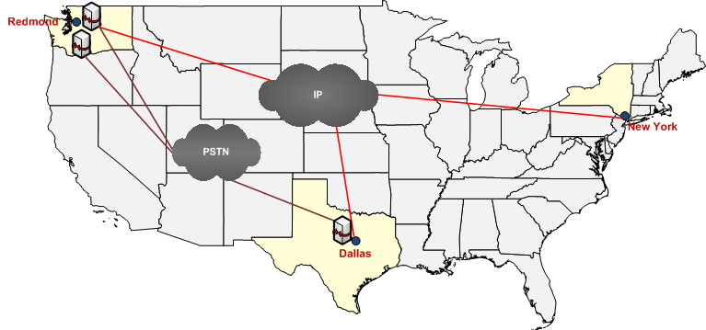
The following are the characteristics in the sample deployment:
- 3 sites (Redmond, Dallas, New York)
- Redmond site has 2 gateways (Red-GW1, Red-GW2)
- Dallas site has 1 gateway (Dallas-GW1)
The example scenarios in this section assume that the normalization rule and location profiles have been configured, and the post-translated number is what is used for the routing decision.
Note
The examples in this section assume that gateways have been deployed and configured, please refer to the Deployment guide for instructions on gateway deployment.

Basic Routing Setup
Assuming that a few users from Redmond, Dallas, and New York are being enabled for Enterprise Voice, here is a sample definition of a phone usages and routes that enable a very basic routing setup:
Note
The phone usage names used in the following examples omit spaces, but this is a matter of taste or convention. Spaces are valid for phone usage names.
User Policy | Phone Usages
Default Calling Policy | GlobalPSTNHopoff

Route Name | Number Pattern | Phone Usages | Gateway
Universal Route | ^\+?(\d*)$ | GlobalPSTNHopoff | Red-GW1  Red-GW2  Dallas-GW1

Description:
In the previous example, all the users that are being enabled for Enterprise Voice in the 3 sites are assigned a policy of DefaultCallingPolicy
The illustrated route is configured to direct all calls from users with a phone usage of GlobalPSTNHopoff (users with DefaultCallingPolicy, in this example) to one of 3 gateways (the \+? indicates that the leading + is optional).

Using correct gateway for local calls
Extending the previous simple example, if administrators would like to configure the routes so that calls that are local to the context of the gateway are routed via that gateway, and other calls are routed through any of the gateways, the following configuration enables that scenario:
User Policy | Phone Usages
Default Calling Policy | Local  GlobalPSTNHopoff

Route Name | Number Pattern | Phone Usages | Gateway
Redmond Local Route | ^\+1(425|206|253)(\d{7})$ | Local | Red-GW1  Red-GW2
Dallas Local Route | ^\+1(972|214|469)(\d{7})$ | Local | Dallas-GW1
Universal Route | ^\+?(\d*)$ | GlobalPSTNHopoff | Red-GW1  Red-GW2  Dallas-GW1

- All users are assigned the Default Calling Policy.
- The policy has 2 phone usage attributes, Local and GlobalPSTNHopOff. For any number dialed by users with this policy, a route matching the Local phone usage attribute is sought first before trying to match a route with the GlobalPSTNHopoff phone usage attribute.
- Redmond Local Route: This route will be used for calls made to a number that starts with ‘+1’ followed by either 425, 206 or 253, followed by 7-digits, for users with a phone usage of Local.
- Dallas Local Route: This route will be used for calls made to a number that starts with ‘+1’ followed by either 972, 214, 469, or 817, followed by 7-digits, for users with a phone usage of Local.
Examples:
- Calls made to +14255550100 are routed using either Red-GW1 or Red-GW2 (Redmond Local Route).
- Calls made to +12145550100 are routed using Dallas-GW1 (Dallas Local Route).
- Calls made to +12035550100 are routed using either Red-GW1, Red-GW2, or Dallas-GW1 (Universal Route).
- If Dallas-GW1 is unavailable, calls made to +12145550100 are routed using the Universal Route (based on using the globalPSTNHopOff phone usage).

Limit certain users to only call local numbers
This scenario illustrates an example where an administrator in Redmond would like to set up a calling policy to limit certain users in Redmond to just call local numbers in the Redmond Area:
User Policy | Phone Usages
Default Calling Policy | Local  GlobalPSTNHopoff
Redmond Local Policy | RedmondLocal

Route Name | Number Pattern | Phone Usages | Gateway
Redmond Local Route | ^\+1(425|206|253)(\d{7})$ | Local  RedmondLocal | Red-GW1  Red-GW2
Dallas Local Route | ^\+1(972|214|469)(\d{7})$ | Local | Dallas-GW1
Universal Route | ^\+?(\d*)$ | GlobalPSTNHopoff | Red-GW1  Red-GW2  Dallas-GW1

- Administrators assign the ‘Redmond Local Policy’ to users for whom they would like to restrict the calling to just Redmond destinations.
- Since the only route that has the RedmondLocal phone usage is ‘Redmond Local Route’, that is the only authorized route for users with the ‘Redmond Local Policy.’

Source-Based Routing
There are certain situations where the administrator would like to limit the gateway that is used for calls from users from a particular location. The following configuration illustrates how this may be accomplished for a situation where an administrator would like to limit calls from Dallas users to always exit out of the Dallas gateway:
User Policy | Phone Usages
Default Calling Policy | Local  GlobalPSTNHopoff
Redmond Local Policy | RedmondLocal
Dallas Calling Policy | DallasUsers

Route Name | Number Pattern | Phone Usages | Gateway
Redmond Local Route | ^\+1(425|206|253)(\d{7})$ | Local  RedmondLocal | Red-GW1  Red-GW2
Dallas Local Route | ^\+1(972|214|469)(\d{7})$ | Local | Dallas-GW1
Universal Route | ^\+?(\d*)$ | GlobalPSTNHopoff | Red-GW1  Red-GW2  Dallas-GW1
Dallas Users Route | ^\+?(\d*)$ | DallasUsers | Dallas-GW1

- Administrator creates a policy called Dallas Calling Policy and assigns a phone usage of DallasUsers to it.
- All users in Dallas are assigned the Dallas Calling Policy.
- For a call originated by a user with this policy, since the only route that contains this policy is the Dallas Users Route, Dallas-GW1 is always selected as the egress gateway for all calls.
- Please note that the previous configuration example does not preclude users from other locations (for example, with Default Calling Policy) from using the gateway located in Dallas.

Configuring a failover route
Extending the previous example, if an administrator wants to define a failover route that may be used in case the Dallas-GW1 is brought down for maintenance, or is unavailable, the following example illustrates the required configuration change:
User Policy | Phone Usages
Default Calling Policy | Local  GlobalPSTNHopoff
Redmond Local Policy | RedmondLocal
Dallas Calling Policy | DallasUsers  GlobalPSTNHopoff

Route Name | Number Pattern | Phone Usages | Gateway
Redmond Local Route | ^\+1(425|206|253)(\d{7})$ | Local  RedmondLocal | Red-GW1  Red-GW2
Dallas Local Route | ^\+1(972|214|469)(\d{7})$ | Local | Dallas-GW1
Universal Route | ^\+?(\d*)$ | GlobalPSTNHopoff | Red-GW1  Red-GW2  Dallas-GW1
Dallas Users Route | ^\+?(\d*)$ | DallasUsers | Dallas-GW1

- In the previous example, a phone usage of GlobalPSTNHopoff is added after the DallasUsers phone usage in the Dallas Calling Policy.
- This enables calls with the Dallas Calling policy to use routes that are configured for the GlobalPSTNHopoff if a route for DallasUsers phone usage is unavailable.

Setting up basic 911 routing
Basic 911 routing requires that calls to 911 is routed to the gateway local to the location of the user, this may be accomplished using the following configuration:
User Policy | Phone Usages
Default Calling Policy | Local  GlobalPSTNHopoff
Redmond Calling Policy | Redmond911  Local  GlobalPSTNHopoff
Redmond Local Policy | Redmond911 RedmondLocal
Dallas Calling Policy | Dallas911  DallasUsers  GlobalPSTNHopoff

Route Name | Number Pattern | Phone Usages | Gateway
Redmond Local Route | ^\+1(425|206|253)(\d{7})$ | Local  RedmondLocal | Red-GW1  Red-GW2
Dallas Local Route | ^\+1(972|214|469)(\d{7})$ | Local | Dallas-GW1
Universal Route | ^\+?(\d*)$ | GlobalPSTNHopoff | Red-GW1  Red-GW2  Dallas-GW1
Dallas Users Route | ^\+?(\d*)$ | DallasUsers | Dallas-GW1
Redmond 911 route | ^911$ | Redmond911 | Red-GW1
Dallas 911 route | ^911$ | Dallas911 | Dallas-GW1

- A new policy called Redmond Calling Policy is created and a phone usage of Redmond911 is added to it, similarly a phone usage of Dallas911 is added to the Dallas Calling Policy.
- 911 calls made from users with a phone usage of Redmond911 will be routed via Red-GW1 using the Redmond 911 route, and users with a phone usage of Dallas911 are routed via the Dallas 911 route.
The previous configuration illustrates the flexibility where the same number is routed via different gateways based on the calling user.

Setting up an International Gateway
Due to lower negotiated international calling rates from a particular site, administrators might want to route all international calls from the US through a particular gateway, the following configuration illustrates how all international calls are routed via Red-GW1.
User Policy | Phone Usages
Default Calling Policy | Local  International  GlobalPSTNHopoff

Route Name | Number Pattern | Phone Usages | Gateway
Redmond Local Route | ^\+1(425|206|253)(\d{7})$ | Local | Red-GW1  Red-GW2
Dallas Local Route | ^\+1(972|214|469)(\d{7})$ | Local | Dallas-GW1
Universal Route | ^\+?(\d*)$ | GlobalPSTNHopoff | Red-GW1  Red-GW2  Dallas-GW1
Intl Route | ^\+([2-9])(\d*)$ | International | Red-GW1

Though there are different ways to implement regular expression patterns, the previous example shows a sample configuration.
- A phone usage of International is added to the policy.
- An Intl route is introduced that matches a number that starts with +2 through +9 (international to the US), and has a phone usage of international.

Configuring a new gateway
If for instance, the administrator decided to deploy a new gateway, once the gateway is setup and configured, the gateway can be configured into the Routing tables. In this example, a new gateway is deployed in New York and is configured to be the gateway of choice for local New York numbers and also is used as part of the Universal Route.
User Policy | Phone Usages
Default Calling Policy | Local  International  GlobalPSTNHopoff

Route Name | Number Pattern | Phone Usages | Gateway
Redmond Local Route | ^\+1(425|206|253)(\d{7})$ | Local | Red-GW1  Red-GW2
Dallas Local Route | ^\+1(972|214|469)(\d{7})$ | Local | Dallas-GW1
NY Local Route | ^\+1(212|646|917)(\d{7})$ | Local | NY-GW1
Universal Route | ^\+?(\d*)$ | GlobalPSTNHopoff | Red-GW1  Red-GW2  Dallas-GW1  NY-GW1
Intl Route | ^\+([2-9])(\d*)$ | International | Red-GW1

A new route is created to route calls local to NY via the new NY-GW1.
The same gateway is also added to the Universal route to help with load sharing.

Blocking calls to certain Destination Numbers
There are situations where the administrator would like to block calls from the enterprise to certain destinations due to toll-charges (ex: premium numbers like 1900 numbers, operator assistance, 1411, etc.).
Please note that the current release of OCS does not allow for a configuration that can be used to explicitly block a destination, calls are blocked implicitly if there is no matching pattern found in the Routing table.
For example, if the administrator chooses to block calls to 1900 and 1411 numbers, they would have to define regular expressions that exclude 1900*. The following configuration shows an example of how this may be accomplished, and does not preclude other ways of accomplishing the same effect:
User Policy | Phone Usages
Default Calling Policy | Local  International  GlobalPSTNHopoff

Route Name | Number Pattern | Phone Usages | Gateway
Redmond Local Route | ^\+1(425|206|253)(\d{7})$ | Local | Red-GW1  Red-GW2
Dallas Local Route | ^\+1(972|214|469)(\d{7})$ | Local | Dallas-GW1
NY Local Route | ^\+1(212|646|917)(\d{7})$ | Local | NY-GW1
Universal Route | ^\+?(?!(1900|1411))(\d*)$ | GlobalPSTNHopoff | Red-GW1  Red-GW2  Dallas-GW1  NY-GW1
Intl Route | ^\+([2-9])(\d*)$ | International | Red-GW1
The Universal Route is modified to route on all numbers except 1900 or 1411 numbers with an optional leading ‘+’

Plan for Exchange Server 2007 SP1 Unified Messaging
Exchange 2007 Unified Messaging (UM) combines voice messaging, and e-mail messaging into a single messaging infrastructure. Office Communications Server 2007 Enterprise Voice leverages the UM infrastructure to provide call answering, subscriber access, call notification, and auto attendant services. Implementing these services requires integrating Exchange UM and Communications Server in a shared Active Directory topology.
Important
If you are implementing the PBX integration deployment option, in which all users are provisioned both for Enterprise Voice and a legacy PBX, the recommendation is to continue to use the existing PBX or Exchange UM installation for voice mail and related services. At such time as you may move all or part of an organization to a stand-alone Enterprise Voice deployment, you will need to deploy Exchange UM for those users who are no longer homed on the PBX.
To integrate Exchange UM with Communications Server you must perform the five following tasks:
- Deploy the following Exchange Server 2007 SP1 server roles: Unified Messaging, Hub Transport, Client Access, and Mailbox in either the same or a different forest as Communications Server 2007 (see Supported Topologies for details). For information about deploying Exchange 2007 see the Exchange Server 2007 product documentation at http://r.office.microsoft.com/r/rlidOCS?clid=1033&p1=ExcProdDoc.
- On the Exchange UM Server:
- Create a SIP dial plan based on your specific deployment requirements (see your Exchange documentation for details). An Enterprise Voice location profile should be created that matches the dial plan FQDN.
- Associate users with the appropriate SIP dial plan.
- Also on the Exchange UM server, open the Exchange Management Shell and run the exchucutil.ps1 script, which:
- Creates a UM IP gateway object in Active Directory for each Communications Server pool or Standard Edition Server that hosts users who are enabled for Enterprise Voice.
- Creates an Exchange UM hunt group for each gateway. The hunt group pilot identifier will be the name of the dial plan associated with the corresponding gateway.
- Grants Communications Server permission to read Exchange UM Active Directory objects, specifically, the SIP dial plans created in the previous task.
- On the Communications Server, run Exchange UM Integration Utility, which:
- Creates contact objects for subscriber access and auto-attendant.
- Validates that there is a location profile name whose name matches the Exchange UM dialplan.FQDN.

Supported Topologies
Office Communications Server 2007 supports the following topologies for Exchange 2007 Unified Messaging integration:

Single Forest
This is the simplest topology to deploy and manage and the one most commonly used by companies that deploy Active Directory.
Single Domain
Small and medium-sized companies tend to favor a single forest consisting of a single domain. In this configuration, Communications Server, Exchange, and users all reside in the same domain. Authentication and trust relationships are simplified compared to more complicated topologies, making both deployment and management easier as well.
Figure 19. Single domain topology
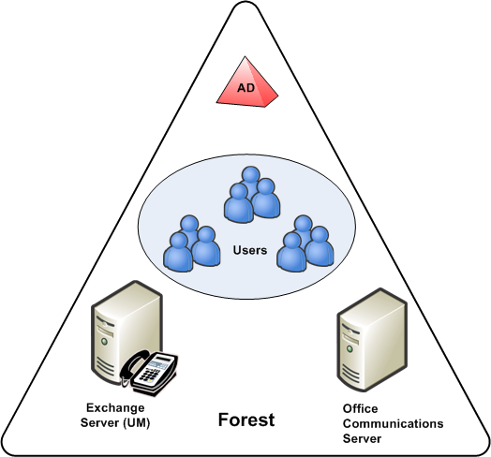
Multiple Domain
A more complex Active Directory structure is the single forest with multiple domains. This configuration consists of a root domain and one or more child domains. You can deploy Communications Server and Exchange servers in different domains from the domain where you create users. An Enterprise pool must be deployed within a single domain, but each domain can host its own pool. A UM server does not have to reside in the same domain as the pool it supports.

Multiple Forest
Larger organizations that have multiple business units may prefer to deploy a separate Active Directory forest for each unit. Communications Server 2007 must be deployed in a single forest, but users can be distributed across multiple forests. Exchange Server 2007 can be deployed in multiple forests.
Communications Server 2007 supports a single multiple-forest topology: resource forest. Exchange UM should be deployed in the same forest as Communications Server.
Resource Forest
The resource forest topology features a single forest — the resource forest — that hosts server applications and one or more other forests that host users. For the purposes of this discussion, assume that the resource forest hosts both Exchange UM and Communications Server. In this topology, users from other forests are represented in the resource forest as disabled user accounts, which are enabled for both Communications Server and an Exchange mailbox.
The resource forest topology offers two principal benefits:
- Centralized server administration.
- The Active Directory schema needs extending only in the resource forest itself.
Figure 20. Resource forest topology
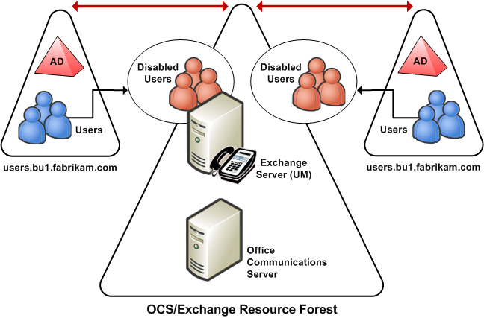

Security Levels
An Exchange UM dial-plan supports three different security levels: Unsecured, SIPSecured, and Secured. You configure security levels by means of the UM dial-plan’s VoipSecurity parameter. The following table shows appropriate dial plan security levels depending on whether Mutual TLS and/or SRTP are enabled or disabled.
Table 10. VoipSecurity values for various combinations of Mutual TLS and SRTP
Security Level | Mutual TLS | SRTP
Unsecured | Disabled | Disabled
SIPSecured | Enabled (required) | Disabled
Secured | Enabled (required) | Enabled (required)

When integrating Exchange UM with Communications Server 2007, you need to select the most appropriate dial plan security level for each voice profile. In making this selection, you should consider the following:
- Mutual TLS is required between Exchange UM and Communications Server. Therefore, the dial-plan security level must not be set to Unsecured.
- Communicator 2005 does not support SRTP. Instead, it uses DES media encryption, which is not supported by Exchange UM. If you require Exchange UM to take calls from Communicator 2005 clients, you need to set the UM dial-plan to SIPSecured. In addition, the Communicator 2005 client encryption level must be set to either rejected or optional.
- When setting dial plan security to SIPSecured, SRTP is disabled. In this case, Communicator 2007 client encryption level must be set to either rejected or optional.
- When setting dial plan security to Secured, SRTP (Secure Real-Time Transport Protocol) is enabled and is required by Exchange UM. In this case, Communicator 2007 client encryption level must be set to either optional or required.

Planning Tasks
Before you begin, make sure you complete the following tasks:
- Work with Exchange administrators, if necessary, to verify the tasks that each of you will perform to assure a smooth, successful integration.
- Deploy the Exchange Mailbox, HubTransport, ClientAccess, and UnifiedMessaging roles in each forest where Exchange UM is deployed. For information about installing Exchange server roles, see your Exchange 2007 documentation.
- Obtain a certificate for each Exchange UM server from a trusted root CA (certificate authority). The certificates are required for mutual TLS between the servers running Exchange UM and Communications Server.
Important
When Exchange 2007 SP1 UM is installed, it is configured to use a self-signed certificate (to view the certificate, type
Get-ExchangeCertificate | fl run
from the Management Console on the Exchange 2007 SP1 UM server).
Do not delete the self-signed certificate. Without it, Exchange 2007 UM cannot communicate with other Exchange 2007 server roles including the Hub Transport Server, which sends voice mail notifications.
The self-signed certificate, however, does not enable Communications Server and Exchange 2007 UM to trust each other, which is why it is necessary to request a separate certificate from a CA that both trust.
- If Communications Server and Exchange UM are installed in different forests, configure each Exchange forest to trust the Communications Server forest.
- If necessary, install the Exchange Management Console on each UM server.
- Deploy a Communications Server 2007 Standard Edition server (minimum requirement) or Enterprise Edition pool. For information about installing Communications Server 2007 Standard Edition, see Microsoft Office Communications Server 2007 Standard Edition and Microsoft Office Communicator 2007 Deployment Quick Start.
- Obtain valid phone numbers for Outlook Voice Access, and auto-attendant.
- Coordinate names for Exchange UM dial plans and Enterprise Voice location profiles.
- For each Exchange UM dial plan, select the SIP gateway
After completing the preparations listed previously in this section, you are ready to begin the procedures for integrating Exchange 2007 UM with Communications Server 2007 Enterprise Voice. For step-by-step instructions, see Step 1 Configure Exchange UM to Work with Communications Server.

Planning to Move Users to Enterprise Voice
The process of moving users from an existing telephony infrastructure to Enterprise Voice consists of the following steps:
- Designate primary phone numbers.
- Enable users for Enterprise Voice.
- Enable users for PBX integration.
- Plan user voice policies.
- Configure PBX to reroute calls for users enabled for Enterprise Voice.
- Move users to Exchange Unified Messaging.
This topic describes the planning that is necessary for each of these steps.

Step 1 Designate primary phone numbers
Enterprise Voice integrates voice with other messaging media, such that when an incoming call arrives at the server, the server maps the number to the user’s SIP-URI and then forks the call to all the client endpoints associated with that SIP-URI. This process, known as reverse number lookup, requires that each user be associated with a primary phone number.
A Primary Phone Number must be:
- Globally unique or, in the case of internal extensions, unique in the enterprise.
- Owned by and routable in the enterprise. Personal numbers should not be used.
Enterprise users may have two or more telephone numbers listed for them in Active Directory. All the telephone numbers associated with a particular user can be viewed or changed on the property sheet for that user in the Active Directory Users and Computers snap-in.
- The Telephone number text box on the General tab of the User Properties dialog should contain the user’s main work number. This number will usually be designated as the user’s Primary Phone Number.
Certain users may have exceptional requirements (for example, an executive who wants all incoming calls routed through an administrative assistant), but such exceptions should be limited only to those where the need is clear and critical.
Once a primary number is chosen, it must be:
- Normalized to E.164 format, wherever possible.
- Copied to the Active Directory msRTCSIP-line attribute
Coexisting with Remote Call Control
Remote call control is the ability to use Office Communicator to monitor and control a desktop PBX phone. Control is routed through the server, which acts as a gateway to the PBX. Remote call control first became available with Live Communications Server 2005 with SP1 and Communicator 1.0. Communications Server 2007 and Communicator 2007 together continue to provide remote call control to users who are not enabled for Enterprise Voice.
If you have enabled remote call control in your organization, you know that remote call control also uses the msRTCSIP-line attribute to designate the primary phone number for users. If your organization will have some users enabled for Enterprise Voice and others, perhaps most, still connected to a PBX, you may be concerned about whether Enterprise Voice and remote call control can coexist.
There are two methods for populating the msRTCSIP-line attribute:
- Advanced settings in the Office Communications Server snap-in for the Active Directory Users and Computers management console.
- MIIS (Microsoft Identity Integration Server) or WMI (Windows Management Instrumentation) scripts. MIIS is recommended for this purpose.
Where many phone numbers must be processed, a script is the obvious choice. Depending on how your organization represents telephone numbers in Active Directory, the script may have to normalize primary phone numbers to E.164 format before copying them to the msRTCSIP-line attribute.
- If your organization maintains all telephone numbers in Active Directory in a single format, and if that format is E.164, then your script only needs to write each Primary Telephone Number to the msRTCSIP-line attribute.
- If your organization maintains all telephone numbers in Active Directory in a single format, but that format is not E.164, then your script should define an appropriate normalization rule to convert Primary Telephone Numbers from their existing format to E.164 before writing them to the msRTCSIP-line attribute.
- If your organization does not enforce a standard format for telephone numbers in Active Directory, then your script should define appropriate normalization rules to convert Primary Phone Numbers from their various formats to E.164 compliance before writing the Primary Telephone Numbers to the msRTCSIP-line attribute. For assistance in translating Active Directory user phone attributes into valid telephone URIs, see “Configure Telephone URI Script” in the Readme for the Office Communications Server 2007 Resource Kit.
Your script will also have to insert the prefix Tel: before each primary number before writing them to the msRTCSIP-line attribute.
The expected format of the number specified in this attribute is:
- Tel:+14255550100;ext=50100.
- tel:+14255550101;ext=12345 (for private numbers within the enterprise)
Important
The normalization performed by ABS does not replace or otherwise eliminate the need to normalize each user’s primary phone number in Active Directory because ABS does not have access to Active Directory and therefore cannot copy primary numbers to the msRTCSIP-line attribute.

Step 2 Enable users for Enterprise Voice
Other than identifying which users are to be enabled, no special planning is required to complete this step. For step-by-step instructions for enabling users for Enterprise Voice, see Step 8 Enable Users for Enterprise Voice.

Step 3 Enable users for PBX integration (optional)
Users who are enabled for Enterprise Voice can also be enabled for PBX integration. If you have elected to deploy Communications Server using the PBX integration option, then you must enable users for PBX integration for the option to work. If you do not have a PBX enabled for Communications Server, enabling users for PBX integration will have no effect. Communications Server will continue forking calls to all endpoints, but the PBX will be unable to fork incoming calls to a user’s SIP endpoints.
For information about deploying Communications Server with PBX integration, see Communications Server-PBX Coexistence. For step-by-step instructions for enabling users for PBX integration, see Step 9 Enable Users for PBX Integration.

Step 4 Plan user voice policies
User class-of service settings on a legacy PBX, such as the right to make long-distance or international calls from company phones, must be reconfigured as VoIP policies for users moved to Enterprise Voice. For more information on planning and creating policies for Enterprise Voice, see Voice Policies and Step 6 Configure Call Authorization.

Step 5 Configure PBX to reroute calls for Enterprise Voice users
Users who formerly were hosted on a traditional PBX retain their phone numbers after the move. The only requirement is that after the move, the PBX must be reconfigured to route incoming calls for Enterprise Voice users to the media gateway that connects to the Communications Server 2007 infrastructure. Contact your PBX vendor for details on how to configure dual forking.

Step 6 Move users to Exchange Unified Messaging (optional)
Moving users to Exchange Unified Messaging consists of the following tasks:
Configuring Exchange UM and Communications Server to work together (see Plan for Exchange Server 2007 SP1 Unified Messaging).
Enable users for Exchange UM call answering and Outlook Voice Access. This task is performed on the Exchange UM server using Exchange Server 2007 product documentation, which is available at http://r.office.microsoft.com/r/rlidOCS?clid=1033&p1=ExcProdDoc.

Chapter 3 Deploying Enterprise Voice
This section guides you through the deployment of Microsoft® Office Communications Server 2007 Enterprise Voice. Typically you deploy Enterprise Voice as the final step in your Office Communications Server 2007 deployment. For recommended deployment scenarios, see Select a Deployment Option. For information about planning your Enterprise Voice deployment, see Chapter 2 Planning for Enterprise Voice.

Prerequisites
For an optimum experience when deploying Enterprise Voice, make sure that your IT infrastructure, network, and systems meet the following prerequisites:
- Microsoft Office Communications Server 2007 Standard Edition or Enterprise Edition is installed and operational on your network.
- All edge servers are deployed and operational in your perimeter network, including Access Edge Server, Audio/Video Conferencing Edge Server, Web Conferencing Edge Server, and a reverse proxy.
- Exchange Server 2007 SP1 is required for integrating Exchange Unified Messaging with Communications Server.
- One or more users have been created and enabled for Communications Server 2007 .
- A primary phone number has been designated, normalized, and copied to the msRTCSIP-line attribute for each user who is to be enabled for Enterprise Voice. The administrator is responsible for ensuring that this number is unique.
- Administrators deploying Enterprise Voice should be members of the RTCUniversalServerAdmins group.
- Office Communicator 2007 and Live Meeting 2007 are successfully deployed.
- MKI (Managed Key Infrastructure) is deployed and configured, using either a Microsoft or a third-party CA (certification authority) infrastructure.
- Each computer on which you install Mediation Server must be:
- Running Microsoft Windows Server 2003 Service Pack 1.
- Prepped for Active Directory. For Active Directory prep procedures, see Office Communications Server 2007 Active Directory Guide.
- One or more media gateways are available for deployment.

Choosing Your Deployment Path
The recommended sequence of steps for deploying Enterprise Voice varies according to whether you plan to deploy Communications Server with PBX integration and, if not, whether you intend to use Exchange Server 2007 SP1 Unified Messaging to provide call answering, Outlook Voice Access, and auto-attendant services.
The following figure summarizes the recommended deployment path for Enterprise Voice:
Figure 21. Choosing Your Enterprise Voice Deployment Path
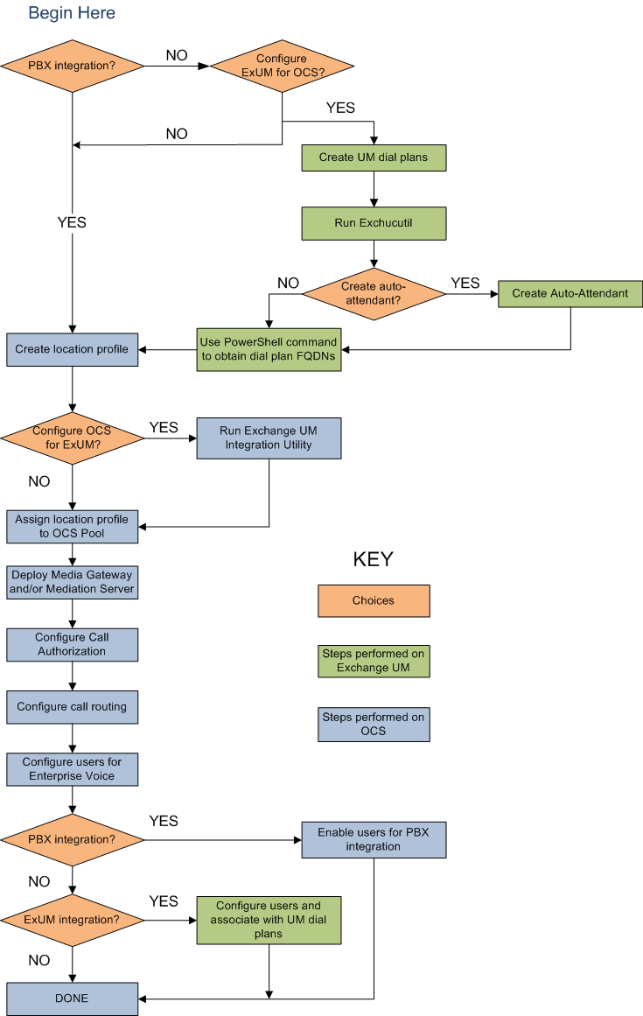

Step 1 Configure Exchange UM to Work with Communications Server
Important
If you are not using Exchange UM to provide call answering, Outlook Voice Access, or auto-attendant services for Enterprise Voice (as might be the case, for example, if you deploy Communications Server in a PBX coexistence scenario), skip this step and proceed to Step 2 Create Location Profiles.
The following tools must be available on each Exchange UM SP1server:
- The Exchange Server 2007 SP1 Management Shell (also known as the “Power Shell” or “Monad Shell”), which is a snap-in for the Windows PowerShell.
- The script exchucutil.ps1, which performs the following tasks:
- Creates a UM IP gateway for each Communications Server 2007 Enterprise Pool.
- Creates a hunt group for each gateway. (The pilot identifier of each hunt group specifies the UM dial plan used by the Enterprise Pool that is associated with the gateway.)
- Grants Communications Server permission to read Exchange UM objects in Active Directory.
The script exchucutil.ps1 is by default installed in <exchange_install_directory>\Scripts\.

Requirements and Recommendations
Before you begin:
- Make sure that you have deployed the following Exchange server roles either (in the same or a different forest as Communications Server 207): Hub Transport, Client Access, Mailbox, and Unified Messaging. For information about deploying Exchange Server 2007 SP1, see Exchange Server 2007 SP1 product documentation at http://r.office.microsoft.com/r/rlidOCS?clid=1033&p1=ExcProdDoc.
- Read Plan for Exchange Server 2007 SP1 Unified Messaging. Integrating Exchange UM and Communications Server requires careful planning and a clear understanding of the technologies involved, the features you want to enable, and important configuration details that you must be aware of to successfully complete your deployment.
Also note the following:
- If Exchange UM is installed in multiple forests, the Exchange integration steps must be performed for each UM forest. In addition, each UM forest must be configured to trust the forest in which Communications server is deployed.
- The integration steps are performed on both Exchange UM server and Communications Server. You should perform the Exchange UM integration steps before you do the Communications Server integration steps.
- For an overview of the Exchange 2007 SP1 UM integration process, descriptions of supported topologies, and a list of planning tasks, see Plan for Exchange Server 2007 SP1 Unified Messaging. You are strongly urged to read this topic before you begin the following procedures.

Overview
Configuring Exchange UM to work with Enterprise Voice consists of the following tasks:
- Creating one or more UM dial plans as needed, and then creating corresponding location profiles.
- Creating a SIP URI for each user and associating users with a UM dial plan.
- Using the exchucutil.ps1 script to:
- Create UM IP gateways.
- Create UM hunt groups.
- Grant Communications Server permission to read UM Active Directory objects.
- Creating a UM auto-attendant object.

Configuring Exchange UM using Exchucutil.ps1
Use the following steps to configure Exchange UM to work with Office Communications Server 2007.
You can perform this procedure using either the Exchange Management Console or the Exchange Management Shell command line. For information about how to use these management tools, see your Exchange 2007 SP1 documentation.
Important
The commands shown in the following procedure are examples only. You need to modify them to fit your particular configuration and requirements.
To configure an Exchange 2007 SP1 UM Server
- Create a UM dial plan for each of your Enterprise Voice location profiles. If you choose to use the Exchange Management Console, create a new dial plan with the security setting SIP Secured. If you use the Exchange Management Shell, type the following script:
new-umdialplan -name <dial plan name> -UriType "SipName" -VoipSecurity <SIPSecured|Secured> -NumberOfDigitsInExtension <number of digits> -AccessTelephoneNumbers “<access number in E.164 format>”
Important
The dial plan name that you create must also be a valid Communications Server location profile name. Therefore, it must contain no more than 256 alphanumeric characters and must not contain spaces or special characters other than hyphens (-) or periods (.).
Note
Whether you select a security level of SIPSecured or Secured depends on whether SRTP is activated or deactivated for media encryption. For guidance information about selecting the appropriate VoipSecurity setting, see Security Levels.
- Obtain the FQDN for each UM dial plan.
(Get-UMDialPlan <dialplanname>).PhoneContext
- Record the dialplanname of each UM dial plan. You will use the FQDN of each dialplanname later as the name of each UM dial plan’s corresponding Communications Server location profile.
- Add the dial plan to the UM server. If you choose to use the Exchange Management Console, you can add the dial plan from the property sheet for the server. For specific instructions, see your Exchange 2007 SP1 documentation. If you use the Exchange Management Shell, type the following script:
$ums=get-umserver;
$dp=get-umdialplan –id <name of dial-plan created in step 1>;
$ums.DialPlans +=$dp.Identity;
$ums | set-umserver

Note
Before performing the following step, make sure that all Enterprise Voice users have been configured with an Exchange 2007 or SP1 mailbox. For information about configuring users with a mailbox, see Exchange Server 2007 product documentation at http://r.office.microsoft.com/r/rlidOCS?clid=1033&p1=ExcProdDoc.
When specifying a mailbox policy for each dial plan that you created in step 1, select either the default policy or one that you have created.
- Navigate to <Exchange installation directory>\Scripts, and then if Exchange is deployed in a single forest, type:
exchucutil.ps1
exchucutil.ps1 –verify
If Exchange is deployed in multiple forests, type:
exchucutil.ps1 -Forest:“<forest FQDN>” for multiple forest deployments
where forest FQDN specifies the forest in which Office Communications Server is deployed. If you have one or more UM dial plans that are associated with multiple IP gateways, continue with step 6. If your dial plans are each associated with only a single IP gateway, skip step 6.
- Using either the Exchange Management Shell or Exchange Management Console, disable outbound calling for all but one of the IP gateways associated with each of your dial plans.
Note
This step is necessary to ensure that outbound calls by Exchange UM to external users (as is the case, for example, with play-on-phone scenarios) reliably traverse the corporate firewall.
Important
When selecting the UM IP gateway through which to allow outgoing calls, choose the one that is likely to handle the most traffic In any case, do not allow outgoing traffic through an IP gateway that connects to a pool of Communications Server Directors.
- If you use the Exchange Management Shell, disable each IP gateway by running the following command:
Set-UMIPGateway <gatewayname> -OutcallsAllowed $false

- If you use the Exchange Management Console, clear the Allow outgoing calls through this IP gateway check box, as shown in the following figure.
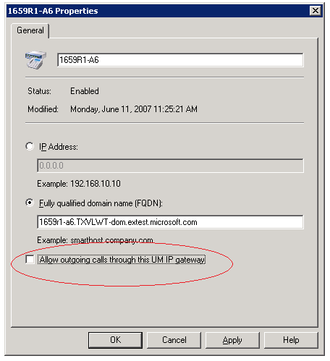
Important
If your UM dial plan is associated with only a single IP gateway, do not disallow outgoing calls through this gateway.
- Create a UM auto-attendant for each Communications Server location profile.
New-umautoattendant -name <auto attendant name> -umdialplan < name of dial plan created in step 1> -PilotIdentifierList <auto attendant phone number in E.164 format> -SpeechEnabled $true -Status Enabled
The following step should be performed for each user after you have enabled Communications Server users for Enterprise Voice and know their SIP URIs.
- Associate Exchange UM users (each of whom should be configured with an Exchange 2007 mail box) with the UM dial plan and create a SIP URI for each user.
Note
The SIPResourceIdentifier in the following sample must be the SIP address of the Communications Server user.
enable-ummailbox -id <user alias> -ummailboxpolicy <name of the mailbox policy for the dial plan created in step 1> -Extensions <extension> -SIPResourceIdentifier "<user alias>@<full domain name>" -PIN <user pin>

Configuring Certificates on the Exchange UM Server
Use the following procedures to configure the certificate on the Exchange UM server.
The Exchange Server must be configured with a server certificate in order to connect to Office Communications Servers:
- Download the CA certificate for the Exchange Server.
- Install the CA certificate for the Exchange Server.
- Verify that the CA is in the list of trusted root CAs of the Exchange Server.
- Create a certificate request for the Exchange Server and install the certificate.
- Assign the certificate for the Exchange Server.
To download the CA certificate for the Exchange 2007 SP1 UM Server
- Click Start, click Run, type http://<name of your Issuing CA Server>/certsrv, and then click OK.
- Under Select a task, click Download a CA certificate, certificate chain, or CRL.
- Under Download a CA Certificate, Certificate Chain, or CRL, select Encoding Method to Base 64 and click Download CA certificate.
- In the File Download dialog box, click Save. Save the .cer file to the hard disk on the server.
To install the CA certificate for the Exchange 2007 SP1 UM Server
- Open an MMC console. Click Start, and then click Run. In the Open box, type mmc, and then click OK.
- On the File menu, click Add/Remove Snap-in, and then click Add.
- In the Add Standalone Snap-ins box, click Certificates, and then click Add.
- In the Certificate snap-in dialog box, click Computer account, and then click Next.
- In the Select Computer dialog box, ensure that the Local computer: (the computer this console is running on) check box is selected, and then click Finish.
- Click Close, and then click OK.
- In the console tree, expand Certificates (Local Computer), expand Trusted Root Certification Authorities, and then click Certificates.
- Right-click Certificates, click All Tasks and click Import.
- Click Next.
- Click Browse and locate the .cer file, and then click Next.
- Click Place All Certificates in the following store.
- Click Browse and select Trusted Root Certification Authorities.
- Click Next to verify the settings, and then click Finish.
To verify that the CA is in the list of trusted root CAs on the Exchange UM Server
- In the MMC console, expand Certificates (Local Computer), expand Trusted Root Certification Authorities, and then click Certificates.
- In the details pane, verify that your CA is on the list of trusted CAs.
To create a certificate request and install the certificate
- Click Start, click Run, type http://<name of your Issuing CA Server>/certsrv, and then click OK.
- Under Select a task, click Request a Certificate.
- Under Request a Certificate, click Advanced certificate request.
- Under Advanced Certificate Request, click Create and submit a request to this CA.
- Under Advanced Certificate Request, select Web server or another server certificate template configured for server authentication.
- Under Identifying Information for Offline Template, in the Name box, type the FQDN of the Exchange Server. You must enter the FQDN of the Exchange Server for communications to work.
- Under Key Options, click the Store certificate in the local computer certificate store checkbox.
- Click the Submit button in the bottom of the Web page.
- A dialog box will open asking for confirmation. Click Yes to continue to go to Certificate Issued page.
- Under Certificate Issued, click Install this certificate.
- A dialog box will open asking for confirmation. Click Yes.
- Verify the page says “Your new certificate has been successfully installed.
- Submit this file to your CA (by e-mail or other method supported by your organization for your Enterprise CA). If your CA is configured for automatic approval, proceed to the next procedure. If your CA requires CA administrator approval to issue a certificate, the administrator must manually approve or deny the certificate issuance request on the issuing CA before you can assign it.
To assign the certificate for the Exchange 2007 SP1 UM Server
- Open the MMC console.
- In the console tree, expand Personal and then click Certificates.
- In the details pane, verify that personal certificate is displayed.
- Double click the certificate to read its details and ensure it is valid. It may take a few minutes before the certificate displays as valid.
- Restart the Microsoft Exchange Unified Messaging service. Exchange UM will automatically retrieve the correct certificate.
- Open Event Viewer and look for Event ID 1112. This event will specify what certificate Exchange UM has retrieved.

Step 2 Create Location Profiles
Important
If you are want to deploy Exchange UM for call answering and other services, go to Step 1 Configure Exchange UM to Work with Enterprise Voice. Otherwise, skip Step 1 and begin your Enterprise Voice deployment here.
Location profiles specify how Communications Server is to interpret and route phone numbers that are dialed from various locations. You need to create a separate location profile for each geographic location where your organization maintains an office. If you maintain a single dial plan for your organization, you may nevertheless need a separate location profile for users who are enabled for Enterprise Voice.
A location profile is essentially a named set of normalization rules. Normalization rules translate dialed numbers in various formats into a standard (E.164) format. You need to create one or more normalization rules for each location profile. You can copy an existing normalization rule in one location profile to a new location profile.

Recommendations
If you are configuring Exchange UM to work with Enterprise Voice, it is recommended that you perform that step before you create location profiles. For more information, see Choosing Your Deployment Path.
If you are deploying Communications Server in PBX integration mode, then you will not use Exchange UM to provide voice mail. This frees you from the need to name a location profile with the FQDN of the corresponding Exchange UM dial plan. However, at such time as you transition users from PBX integration to stand-alone Enterprise Voice, you will need to deploy Exchange UM to provide voice mail for the transitioned users, at which time the requirement for naming location profiles using the FQDN of the corresponding Exchange UM dial plan will be in force.
Before you begin, you should understand location profiles, phone number normalization rules, and the roles they play in Enterprise Voice. For more information, see Location Profiles.
Note
Enterprise Voice Route Helper provides an alternative to the Office Communications Server 2007 Administrative Tools for viewing and modifying Enterprise Voice number normalization rules, location profiles, voice policy, and routes. Route Helper is available in the Office Communications Server 2007 Resource Kit.

Overview
Creating a location profile consists of the following tasks:
- Assigning a name to a new location profile.
- Providing a description that will describe the location profile to users.
- Creating one or more normalization rules.
To create a location profile
- Open the Communications Server 2007 administrative snap-in.
- In the console pane, right-click the Forest node, point to Properties, and click Voice Properties.
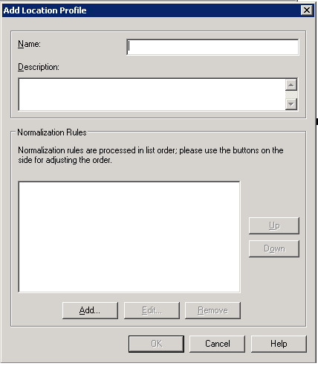
- On the Location Profiles tab, click Add to create a new location profile. Repeat this step as needed to create all the location profiles that your organization requires.
- In the Name box, type one of the following:
- If you have configured Exchange UM for Enterprise Voice and have completed Step 1, type the FQDN of the corresponding Exchange UM dial plan.
- A useful descriptive name. This name must be unique and cannot exceed 256 Unicode characters, each of which can be an alphabetic or numeric character, a hyphen (-),a dot (.), a plus sign (+), underscore ( _ ), or either left or right parenthesis: ) or (.
Important
If you are planning to configure Exchange UM for Enterprise Voice but have not yet done so, stop now and perform Step 1 before you continue creating location profiles.
- In the Description box, it is recommended that you type the common, recognizable name of the geographic location to which the location profile applies. For example, if the location profile name is London.Contoso.com, then the recommended Description would be London. If you have deployed the Office Communicator 2007 Phone Edition, the name is this field will be displayed to end users for the purpose of allowing them to select the appropriate location profile for a call.
- Click Add to open the Add Phone Number Normalization Rule dialog box.
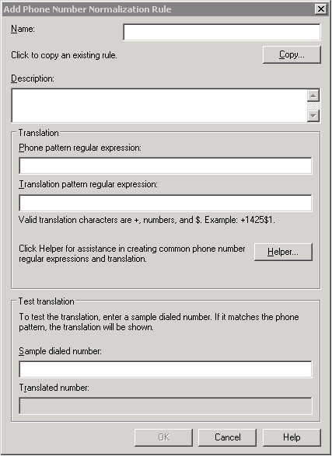
- In the Name box, type a name that describes the number pattern being normalized; for example, 5DigitExtension or 7 digit calling Toronto.
- If you want to create a new normalization rule, skip this and the following step. If you want to copy the phone pattern and translation pattern of an existing normalization rule, click Copy.
- In the Copy Phone Number Normalization Rule dialog box, select the normalization rule that you want to copy, and then click OK. If you want to view a normalization rule before copying it, select the rule, and then click View.
- In the Description box, type a brief description (optional) of the normalization rule; for example “Translates 5-digit extensions” or “Translates 7-digit numbers to Toronto local number.
- In the Phone pattern regular expression box, use .NET Framework regular expressions to describe a phone number pattern; for example, ^9(\d{7})$, which describes a phone number pattern consisting of the number 9 followed by any seven digits. For information about using .NET Framework regular expressions, see http://r.office.microsoft.com/r/rlidOCS?clid=1033&p1=RegExpr.
- In the Translation pattern regular expression box, use .NET Framework regular expressions to describe the E.164 phone number corresponding to the number entered in the Phone pattern regular expression box.
- Click Helper if you require assistance in formulating regular expressions.
- In the Sample dialed number box, type a phone number to test whether the number translation works properly. If the number matches the phone pattern, the translation is shown in the Translated number box.
- If the translation matches the phone pattern, click OK.
- Create as many normalization rules as your location profile requires.
- When you are done, click OK.

Step 3 Configure Communications Server to Work with Exchange UM
Important
If you are deploying Communications Server with PBX integration, skip this step and go to Step 4 Assign Location Profile to Pool.
This step requires the Exchange UM Integration Utility (ocsumutil.exe). This tool is located on the Office Communications Server at <installation directory>\Office Communication Server 2007\Server\Support.
The Exchange UM Integration Utility must be run from a user account with the following characteristics:
- Membership in the RTCUniversalUserAdmins group (which includes rights to read Exchange UM settings).
- Domain rights to create contact objects in the specified OU container.
The Exchange UM Integration Utility performs the following tasks:
- Creates contact objects for each auto-attendant and subscriber access number to be used by Enterprise Voice users.
- Verifies that the name of each Enterprise Voice location profile matches its corresponding UM dial plan phone context.
Important
Before running the Exchange UM Integration Utility, you should have created one or more UM SIP dial plans, as described in Step 1 Configure Exchange UM to Work with Communications Server, and a Communications Server location profile for each dial plan, as described in Step 2 Create Location Profiles.
You also should have created an auto-attendant and made sure that both the subscriber access number and auto-attendant number are in E.164 format.
To run the Exchange UM Integration Utility
- On a Front End Server, open a command prompt and then go to <installation directory>\Office Communication Server 2007\Server\Support, where ocsumutil.exe is located. (Or open Windows Explorer, navigate to this folder, and then click OCSUMUtil.exe.)
- Click OcsUMUtil.exe.
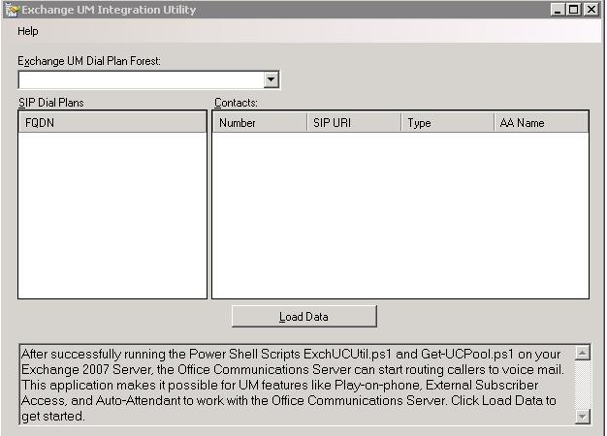
- Click Load Data to find all trusted Exchange forests.
- In the SIP Dial Plans list, select a UM SIP dial plan for which you want to create contact objects, and then click Add.
- In the OU Picker box, either select the OU you want and click OK or click Make New OU to create a new organizational unit under the root or any other OU in the domain. For example “OU=RTC Special Accounts,DC=fourthcoffee,DC=com”. When you finish, click OK. The distinguished name of the organizational unit that you have selected or created is now displayed on the Contact box in Organizational Unit.
- In the Contact box, either accept the default dial plan name or type a new user-friendly name for the contact object that you are creating in the Name box. For example, if you are creating a subscriber access contact object, you might simply name it Subscriber Access.
- In the SIP Address box, either accept the default SIP address or type a new SIP address. If you type a new SIP address, it must begin with SIP:.
- In the list, select the SIP domain for the contact object.
- In the Server or Pool list, select the Standard Edition Server or Enterprise Pool in which the contact object is to be enabled. Preferably, the pool you select is the same one pool where users enabled for Enterprise Voice and Exchange UM are deployed.
- In the Contact Type list, select the contact type that you want to create, and then click OK.
- Repeat steps 1 through 11 for additional contact objects that you want to create. You should create at least one contact for each auto attendant and, if you want external access, you also need a Subscriber Access contact.
To verify that the contact objects have been created, open Active Directory Users and Computers and select the OU in which the objects were created. The contact objects should appear in the details pane.

Step 4 Assign Location Profile to Pool
A Communications Server pool hosting Enterprise Voice users requires a default location profile in order to route outbound calls. Different pools at various locations will require different location profiles
To assign a location profile to a Communications Server pool
- Click Start, point to Programs, point to Administrative Tools, and click Office Communications server 2007. The Office Communications Server 2007 administrative snap-in shows your Communications Server 2007 topology.
- Expand the Forest node.
- If you are configuring a Standard Edition Server, expand Standard Edition Servers, right-click the Standard Edition pool that you want to configure (not the server itself but the pool-level node for that server), point to Properties, and then click Front End Properties.
- If you are configuring an Enterprise Edition Pool, expand Enterprise Pools, expand the pool that you want to configure, right-click Front Ends, and then click Properties.
- On the Voice tab, select the default location profile for the pool. (To view the location profile, click View.)
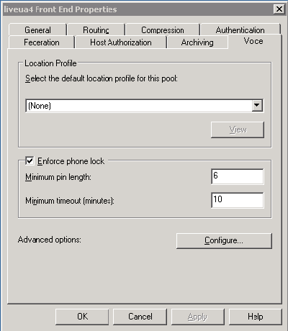

Step 5 Deploy a Media Gateway
You can deploy a third-party Basic Media Gateway either before or after you deploy a Mediation Server, but whichever order you choose, these two components must be configured to function as a logical unit. For information about configuring a Mediation Server, see Configure Mediation Server.
The settings that you must configure on your Basic Media Gateway are specified in the following list, but for information about how to configure these settings on a given gateway, refer to the manufacturer’s product documentation. For information about selecting gateways for Enterprise Voice, see Plan for Media Gateways.
Each gateway must be configured according to the vendor’s documentation. Depending on the vendor, there are potentially many attributes that must be set, but the attributes specific to Enterprise Voice are as follows:
- The FQDN and IP Address of the Mediation Server that is associated with the gateway.
- The listening port (5060) that is used for TCP connections to the Mediation Server
Important
The previous settings must match those of corresponding settings for the Mediation Server. If the settings do not match, the connection between the gateway and Mediation Server will fail.
- SIP Transport – specify either TLS (recommended) or TCP.
- If the SIP transport for the link between the gateway and the Mediation Server is set to TLS, the gateway must be configured with a certificate for purposes of authentication during the MTLS handshake with the Mediation Server. The certificate on the gateway must be configured as follows:
Important
If you specify TLS as the SIP transport to be used by your basic or basic-hybrid media gateway, you must also configure the corresponding Mediation Server for TLS. For instructions on how to configure a Mediation Server for TLS, see Configure Mediation Server.
- The certificate may be directly signed by the trusted CA configured in the Mediation Server. Alternatively, a certificate chain may have to be traversed to verify the certificate provided by the gateway. The gateway must provide this chain as part of its TLS handshake with the Mediation Server.
- The CN part of the subject field should be set to the FQDN of the gateway. If the FQDN in the CN part of the subject field does not match the expected and configured FQDN for the gateway, the certificate must also contain a SAN (subject alternate name) that lists the expected and configured FQDN for the gateway.
The Mediation Server validates the certificate provided by the gateway by checking that the FQDN on the certificate exactly matches the gateway FQDN configured on the Mediation Server. If the FQDNs do not match, the session is terminated. Additional validation includes checking the signature and expiration date, and making sure that the certificate has not been revoked.
- If the SIP transport for the link between the gateway and the Mediation Server is set to TLS, separate ports must be opened for the TLS connection to the gateway and the TLS connection to the Office Communications Server pool. The port assignments should be configured as follows:
- TLS link between media gateway and Mediation Server: 5060
- TLS link between Mediation Server and Office Communications Server pool:5061
- Each gateway must be configured so that the E.164 numbers routed by Enterprise Voice to the gateway are normalized to a locally dialable format.
- Each gateway must also be configured to pass only E.164 numbers to the Mediation Server. Please see each gateway vendor’s documentation for specific instructions on how to normalize source phone numbers to E.164.
- Each gateway should be configured to convert the source number (the number presented as caller id) to a normalized E.164 number. This ensures the caller ID can be matched to a Communicator contact, an Outlook contact, or a member of the corporate directory, thereby enabling Communicator to provide additional information about the caller. This number will also appear in e-mails notifying the user of missed calls and voice mail, allowing the user to click the phone number in order to quickly return a call. If the number has been normalized by the gateway, no further processing is required. If for some reason the number cannot be normalized by the gateway, then the normalization rules defined by the location profile will be applied when returning a call. It might be necessary to add normalization rules to a location profile to handle numbers that cannot be normalized by the gateway. Please see each gateway vendor’s documentation for specific instructions on how to normalize source phone numbers to E.164.
For a list of media gateway vendors, see http://r.office.microsoft.com/r/rlidOCS?clid=1033&p1=IPpbxVendhttp://www.microsoft.com/uc/pdgtrials/default.mspx.

Install and Activate Mediation Server
Communications Server 2007, Mediation Server and a third-party basic media gateway function as a single logical unit to enable communication between the users enabled for Enterprise Voice and the public switched telephone network. This step describes how to install and activate Mediation Server.
Mediation Server deployment is an integrated component of Office Communications Server 2007 setup. When you install and activate Mediation Server, the Communications Server 2007 Deployment Tool copies the required files to a local computer, but it does not activate the service. The activation step becomes available only after installation is complete. Activation performs two tasks:
- Creates Mediation Server objects in Active Directory.
- Activates the domain service account on the server.

Requirements
To install or activate Mediation Server you must be a member of the RTCUniversalServerAdmins group or have been delegated to perform these tasks by a member of that group.
Mediation Server must be installed on Windows Server 2003 SP1 (or later) and must not be installed with any other application.
Microsoft .NET Framework 2.0 (available on the Communications Server 2007 CD) must be installed on the Mediation Server.
The minimum recommended hardware configuration (for up to 125 concurrent calls or 5 T1) is as follows. For more details, see Mediation Server Hardware Requirements:
- Single Processor Dual Core running at 3GHz
- 2GB RAM
- 30GB hard disk
- A single network interface card is the minimal requirement, but two cards are recommended for all deployments, including those where TLS has been enabled for the gateway link.
A certificate is required.

Recommendations
- Even if you enable TLS on the gateway link, two network interface cards are recommended on the Mediation Server for additional security: one card to communicate with the gateway and a separate card to communicate with the Office Communications Server internal infrastructure.
- You can install Mediation Server on multiple computers, but each Mediation Server must have a corresponding basic media gateway. If you are planning to install multiple Mediation Servers, it is good practice to install and test a single Mediation Server before attempting to deploy them all.
- To optimize performance, Mediation Server should not be collocated with any other Communications Server 2007 server role, and all unnecessary applications and services should be disabled on the computer.
To install Mediation Server files
- Log on to a computer on which you want to install Mediation Server.
- Insert the Office Communications Server 2007 CD. Setup starts and launches the Deployment Tool. If you are installing from a network share, navigate to the \Setup\i386 folder, and then double-click Setup.exe.
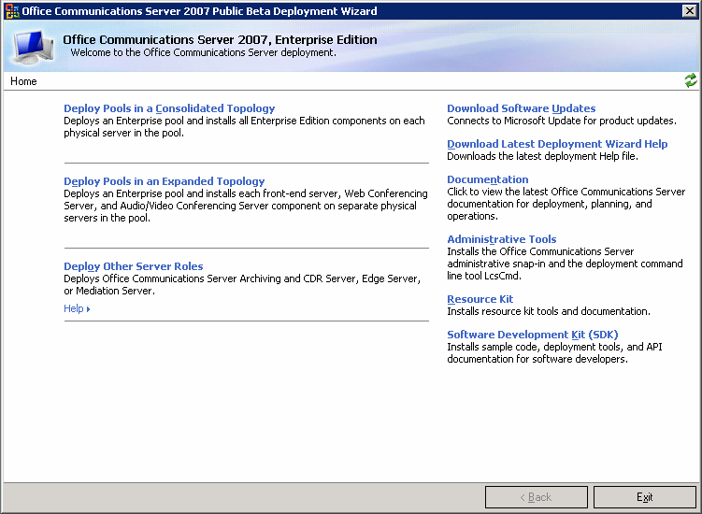
- At the welcome screen click Deploy Other Server Roles.
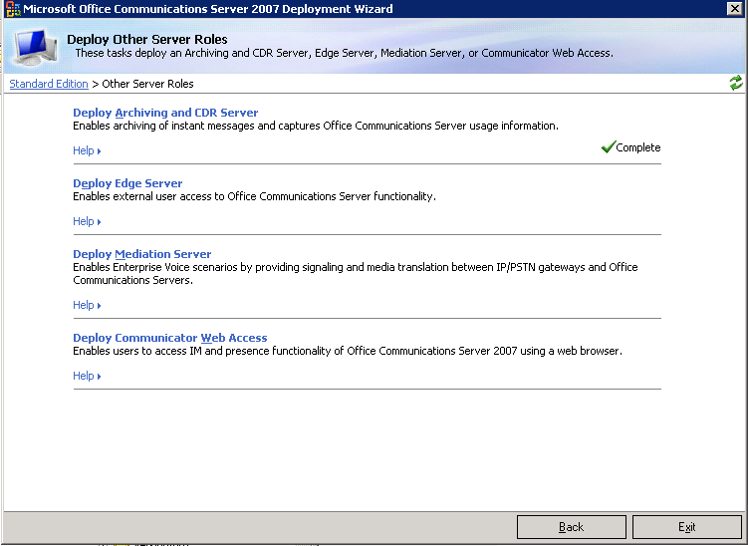
- At the Deploy Other Server Roles screen, click Deploy Mediation Server.
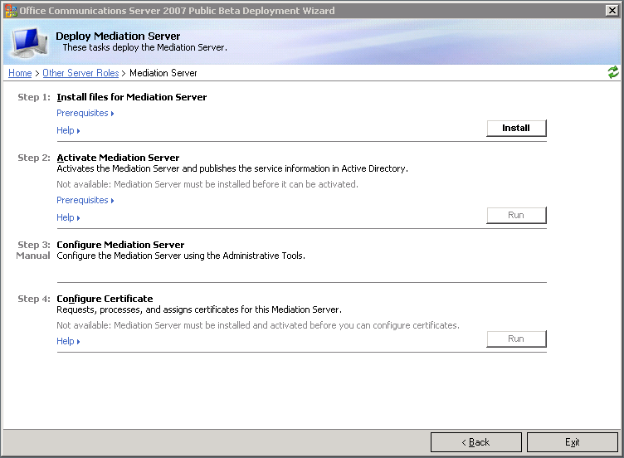

- At Step 1: Install Files for Mediation Server, click Install.
- On the Welcome page, click Next.
- On the License Agreement page, if you agree to the licensing terms, click I accept the terms in the licensing agreement, and then click Next.
- On the Install location page, select the location where you want to install the Mediation Server files, and click Next.
- On the Confirm Installation page, click Next to confirm.
- On the Installation Complete page, click Close.
To activate Mediation Server
Note
You must install Mediation Server before you can activate it.
- Log on to a computer on which you want to activate Mediation Server.
- Insert the Office Communications Server 2007 CD. Setup starts and launches the Deployment Tool. If you are installing from a network share, navigate to the \Setup\i386 folder, and then double-click Setup.exe.
- At the welcome screen, click Deploy Other Server Roles.
- At the Deploy Other Server Roles screen, click Deploy Mediation Server.
- At Step 2: Activate Mediation Server, click Run.
- On the Welcome page of the activation wizard, click Next.
- On the Select Service Account page, you have two choices:
- If you accept the existing account (recommended), enter password for the service account, and then click Next. The default account is MCU and Web component services account.
- If you choose to create a new account, click Create a New Account and type a new Account Name and Password. When you are done, click Next.
- On the Ready to Activate Mediation Server page, review your settings. If your Current Settings are incorrect, click Back and make whatever corrections are required. If your Current Settings are correct, click Next.
- On the Activate Mediation Server Wizard Has Completed page, select the View the log when you click the ‘Finish’ check box, and then click Finish.
- In the log file, verify that “Success” appears under the Execution Result column. Optionally, look for “Success” Execution Result at the end of each task to verify its successful completion. Close the log window when you finish.
Caution
Care must be taken in deactivating a Mediation Server. If you remove it from service without first taking precautionary steps, you may drop calls. For instructions on how to properly deactivate a Mediation Server, see Deactivating a Mediation Server.

Configure Mediation Server
You must configure Mediation Server to communicate with Communications Server 2007 on one side and media gateways on the other. To configure a Mediation Server, you must specify the following:
- The SIP transport used to communicate with a media gateway. There are two choices: TLS or TCP.
- TLS: The recommended transport is TLS, which provides encrypted signaling between the Mediation Server and the media gateway, which is connected to the PSTN. If you configure your gateway link for TLS, then calls to and from the PSTN are encrypted end to end.
- TCP: It is possible, but not recommended, to configure the Mediation Server to use TCP instead of TLS. If you configure the gateway link for TCP, that link presents a potential security vulnerability. For this reason, it is good practice to install two network interface cards, one facing the media gateway and the other facing the internal network.
- The IP addresses on which the Mediation Server listens for call traffic from Communications Server on one side and media gateways on the other. The Communications Server listening IP address is the IP address of the internal (that is, the Communications Server-facing) edge of the Mediation Server. The Gateway listening IP address is the IP address of the external (that is, the gateway-facing) edge of the Mediation Server.
Important
The link between Mediation Server and the internal Communications Server 2007 infrastructure is always configured for TLS, even in cases where the gateway link is configured for TCP. This requirement means that you must always configure a certificate on the Mediation Server. If you configure the gateway link for TLS, you must also configure a certificate on the gateway.
- The FQDN of the collocated A/V Edge Server and Media Relay Authentication Server for this Mediation Server.
- The default location profile used by this Mediation Server.
- The default Media port range.
- The FQDN and port of the Communications Server internal next hop. This server will likely be either a Director, Standard Edition Server, or Enterprise Edition Front End Server.
- The IP address and port for the media gateway to which this Media Server is connected.
To configure Mediation Server you must be a member of the RTCUniversalServerAdmins group or have been delegated to perform this task by a member of that group.
Note
Most Mediation Server configuration is performed using the Office Communications Server 2007 administrative snap-in. Support for TLS, however, requires running a configuration file, MediationServerSvc.exe.config. To obtain this configuration file you must download and install Office Communcation Server Mediation Server hotfix package as described below in the procedure “To configure gateway link for TLS”.
To configure Mediation Server
- Log on to a Communications Server 2007 Mediation Server.
- Click Start, point to Administrative Tools, and then click Office Communications Server 2007.
- Expand the appropriate forest node.
- Expand the Mediation Servers node, right-click the Mediation Server to be configured, click Properties, and then click the General tab.
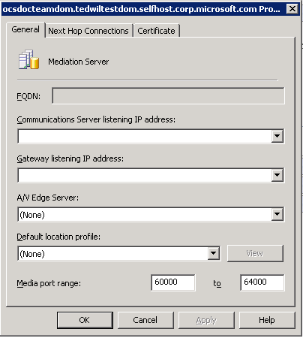
- In the FQDN box, make sure the FQDN listed matches that of the Mediation Server you have selected.
- Open a command prompt, change to the root directory, and type nslookup <fqdn of Mediation Server>, using the FQDN displayed on the Mediation Server General tab, and then press Enter.
- From the list of IP addresses displayed in the Communications Server listening IP address list, select the IP address returned in step 6.
Important
If the IP address selected in step 7 does not match the IP address in step 6, Communications Server traffic will be directed toward an interface that is not listening for such traffic and away from the one that is.
- From the list of two IP addresses displayed in the Gateway listening IP address list, select the other IP address (that is, the one not already selected in step 7).
Note
The address selected in Step 8 can be that of either a media gateway or a PBX.
- From the A/V Edge Server list, select the A/V Edge Server that hosts the A/V Authentication Service for this Mediation Server.
Important
If the A/V Edge Server that hosts the A/V Authentication Service for this Mediation Server does not appear in the list, that means that the A/V Edge Server on which the service is collocated has not been entered into the A/V Edge Servers list on the Edge Servers tab of the Global Properties page. You will need to add the A/V Edge Server to the previous list before it will appear in the A/V Edge Server list on the Mediation Server tab. For more information, see the Microsoft Office Communications Server 2007 Edge Server Deployment Guide.
- In the Default location profile list, select the default location profile for this Mediation Server.
Important
The default range media port range enables the server to handle up to 1000 simultaneous calls. Reducing the port range greatly reduces server capacity and should be undertaken only for specific reasons by an administrator who is knowledgeable about media port requirements, and scenarios. For this reasons, altering the default port range is not generally recommended.
Organizations that employ IPSec for packet security are advised to disable it for media ports because the security handshake required by IPSec delays call setup. IPSec is unnecessary for media ports because SRTP encryption secures all media traffic between the Mediation Server and the internal Communications Server network.

- In Media port range accept the default range of 60,000 to 64,000.
- Click the Next Hop Connections tab.
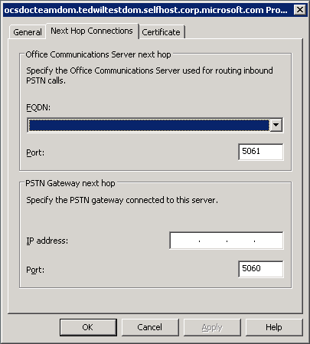
- On the Next Hop Connections tab under Office Communications Server next hop:
- In the FQDN list, select the FQDN of the next-hop internal server. This server could be a Director or pool.
- In the Port box, accept the default of 5061 for TLS.
- On the Next Hop Connections tab under PSTN Gateway next hop:
- In the IP address box, specify the IP address of the PSTN Gateway or the PBX associated with this Mediation Server.
- In the Port box, accept the default of 5060 for TCP.
- Click OK.
To configure the media gateway link for TLS
- Download and install the two following hotfixes from http://r.office.microsoft.com/r/rlidOCS?clid=1033&p1=MediationServerHotFix.:
- Office Communications Server 2007, Unified Communications Managed API v1.0 Redist: December 17, 2007 KB 944285 Version 3.0.6362.36
- Description of the Update for Office Communication Server 2007, Mediation Server: December 17, 2007 KB 944285 Version 3.0.6362.36
- Configure a certificate on the media gateway. This certificate must be from a CA that is trusted by the Mediation Server.
- In a text editor, create an XML file in the following format:
<?xml version="1.0" encoding="utf-8" ?>
<configuration>
<appSettings>
<add key="GatewayTls" value="On" />
<add key="GatewayFqdn" value="gateway.domain.com" />
</appSettings>
</configuration>
The GatewayTls property can have a value of either “On” or “Off”. To enable TLS on the gateway link, this property must be set to “On”. If you set the value to “Off”, the transport protocol for the gateway link will revert to TCP. Setting the value to “Off” is the same as deleting the file. However, should you have reason to temporarily revert to TCP, you can enable TLS once again by resetting the property back to “On” and saving the file.
The GatewayFqdn property must match the FQDN in the certificate provided by the gateway. For more information on certificate requirements for a media gateway, see Deploy a Media Gateway.

Configure a Certificate for Mediation Server
The Mediation Server must be configured with a server certificate in order to connect to other Office Communications Servers. Step 3 describes the following procedures that you must perform to configure a certificate for Mediation Server:
- Download the CA certification path for the Mediation Server.
- Install the CA certification path for the Mediation Server.
- Verify that the CA is in the list of trusted root CAs of the Mediation Server.
- Create the certificate request for the Mediation Server.
- Import the certificate for the Mediation Server.
- Assign the certificate for the Mediation Server.
You can use the Communications Certificate Wizard to complete most of these the following certificate setup procedures. These procedures describe how to access the Communications Certificate Wizard from the Office Communications Server 2007 Deployment Wizard. You can also access it from the Office Communications Server 2007 Administrative Tools interface on each mediation server.
Note
The steps of these procedures are based on using a Windows Server 2003 Enterprise CA or a Windows Server 2003 R2 CA . For step-by-step guidance for any other CAs, consult the documentation of the CA.
To download the CA certification path for the Mediation Server
- With your Enterprise root CA offline and your Enterprise subordinate (issuing) CA Server online, log on to the Mediation Server as a member of the RTCUniversalServerAdmins group.
- Click Start, click Run, type http://<name of your Issuing CA Server>/certsrv, and then click OK.
- Under Select a task, click Download a CA certificate, certificate chain, or CRL.
- Under Download a CA Certificate, Certificate Chain, or CRL, click Download CA certificate chain.
- In the File Download dialog box, click Save.
- Save the .p7b file to the hard disk on the server, and then copy it to a folder on the Mediation Server. If you open this file, the file should contain all the certificates that are in the certification path. To view the certification path, open the server certificate and click the certification path.
To install the CA certification chain for the Mediation Server
- In the Deployment Wizard (which should still be open), click Deploy Other Server Roles, and then click Deploy Mediation Server.
- On the Deploy Mediation Server page, next to Step 4 Configure Certificates, click Run to start the Communications Certificate Wizard.
- On the Welcome page, click Next.
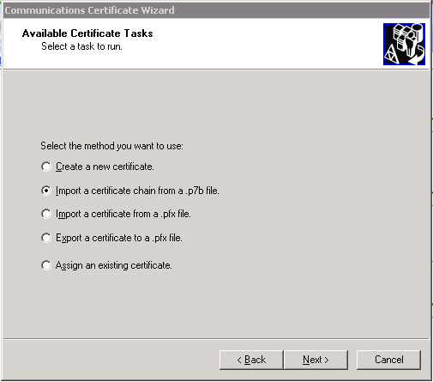
- On the Available certificate tasks page, click Import a certificate chain from a .p7b file, and then click Next.
- On Import Certificate Chain page, click Browse to locate the .p7b file, locate the file, and then click Next.
- Click Finish.
To verify that your CA is in the list of trusted root CAs
- Open an MMC console. Click Start, and then click Run. In the Open box, type mmc, and then click OK.
- On the File menu, click Add/Remove Snap-in, and then click Add.
- In the Add Standalone Snap-ins box, click Certificates, and then click Add.
- In the Certificate snap-in dialog box, click Computer account, and then click Next.
- In the Select Computer dialog box, ensure that the Local computer: (the computer this console is running on) check box is selected, and then click Finish.
- Click Close, and then click OK.
- In the console tree, expand Certificates (Local Computer), expand Trusted Root Certification Authorities, and then click Certificates.
- In the details pane, verify that your CA is on the list of trusted CAs.
To create the certificate request for the Mediation Server
- In Deployment Wizard, on the Deploy Mediation Server page, next to Step 3, Configure Certificates for the Mediation Server, click Run to start the Communications Certificate Wizard.
- On the Welcome page, click Next.
- On the Available Certificate Tasks page, click Create a new certificate, and then click Next.
Note
If you already have a certificate available, click Assign an Existing Certificate and continue with steps 3 through 7 in the procedure To Assign the Certificate to the Mediation Server later in this section.
- On the Delayed or Immediate Request page, select one of the following options:
- Prepare the request now, but send later if you intend to output your request to a text file and then send that file to an offline CA.
Note
If you choose this option, you will later have to import the certificate and assign it to the Mediation Server.
- Send the request immediately to an online CA, in which case you will not have to import the certificate but will still have to assign it to the Mediation Server.
When you are done, click Next.
- On the Name and Security Settings page, type a friendly name for the certificate, and specify the bit length (typically, the default of 1024), select the Mark certificate as exportable check box, and then click Next.
- On the Organization Information page, enter the name for the organization and the organizational unit (such as a division or department, if appropriate), and then click Next.
- On the Your Server’s Subject Name page, type or select the subject name and subject alternate name of the Mediation Server. The subject name should match the FQDN of the Mediation Server:
If your deployment includes multiple SIP domain names, in Subject alternate name, do the following:
- Type the same name that you typed in Subject name, and then click Add.
- Type each additional SIP domain name, separating each name with a comma.
- Click Next.
- On the Geographical Information page, type the location information, and then click Next.
- The next page you see depends on which option you chose in Step 4:
- If you selected “Send the request immediately to an online CA” in Step 4, then on the Choose a Certification Authority page, select your certification authority (CA) from the drop-down list or type the name of your CA in the Certification Authority box. If you type an external CA name, a dialog box appears. Type the user name and password for the external CA, and then click OK. When you are finished, click Next.
- If you selected “Prepare the request now but send later” in Step 4, then type the file name and path to which the request is to be saved , and then click Next. Submit this file to your CA (by e-mail or other method supported by your organization for your Enterprise CA) and, when you receive the response file, copy the new certificate to this computer so it is available for import.
- On the Request Summary page, click Next.
- On the Certificate Wizard Completed page, verify successful completion, and then click Finish.
To import the certificate for the Mediation Server
Note
If you obtained your certificate from an online CA skip this step and proceed directly to assign the following procedure: To assign the certificate to the Mediation Server.
- In Deployment Wizard, on the Deploy Mediation Server page, next to Step 4, Configure Certificates, click Run to start the Communications Certificate Wizard.
- On the Welcome page, click Next.
- On the Pending certificate tasks page, click Process a pending request and import the certificate, and then click Next.
- In the Path and file name box, type the full path and file name of the certificate that you requested for the Mediation Server (or click Browse to locate and select the certificate), and then click Next.
- On the wizard completion page, verify successful completion, and the click Finish.
To assign the certificate to the Mediation Server
- In the Deployment Wizard, on the Deploy Mediation Server page, next to Step 4, Configure Certificates, click Run to start the Communications Certificate Wizard.
- On the Welcome page, click Next.
- On the Available certificate tasks page, click Assign an existing certificate, and then click Next.
- On the Available Certificates page, select the certificate that you requested for the Mediation Server, and then click Next.
- Review your settings, and then click Next to assign the certificates.
- On the Certificate Wizard Completed page, click Finish.

Start Mediation Server
After configuring the Mediation Server, start is as follows:
To start Mediation Server
- On a Front End Server, click Start, point to Programs, point to Administrative Tools, and then click Office Communications server 2007.
- Expand the Mediation Servers node.
- Right-click the appropriate Mediation Server, and then click Start.
- On the Mediation Server, open the Windows 2003 Start menu click Run and then type services.msc. Verify that “Office Communications Server Mediation” appears in the list of services.

Step 6 Configure Call Authorization
Configuring call authorization consists of defining phone usage records and voice policies.
- Phone usage records are named classes of calls (for example, local, long-distance, or international). Phone usage records are assigned to both routes (see Step 7 Configure Outbound Call Routing) and users for the purposes of specifying call authorization.
- Policies are named sets of phone usage records. Policies are used to assign call privileges to users.
You can define either a single global policy that applies to all users, or you can define multiple policies and assign them variously to individuals and groups of users. However, if you specify a global policy, you cannot also assign additional policies on a per-user basis.
Before you configure call authorizations for your organization, you are urged to read Plan for User Authorization and Outbound Call Routing.
You configure call authorization using the Office Communications Server 2007 snap-in for MMC.
To create a phone usage record
- On a Front End Server, click Start, point to Programs, point to Administrative Tools, and then click Office Communications Server 2007.
- Right-click the Forest node, point to Properties, and then click Voice Properties.
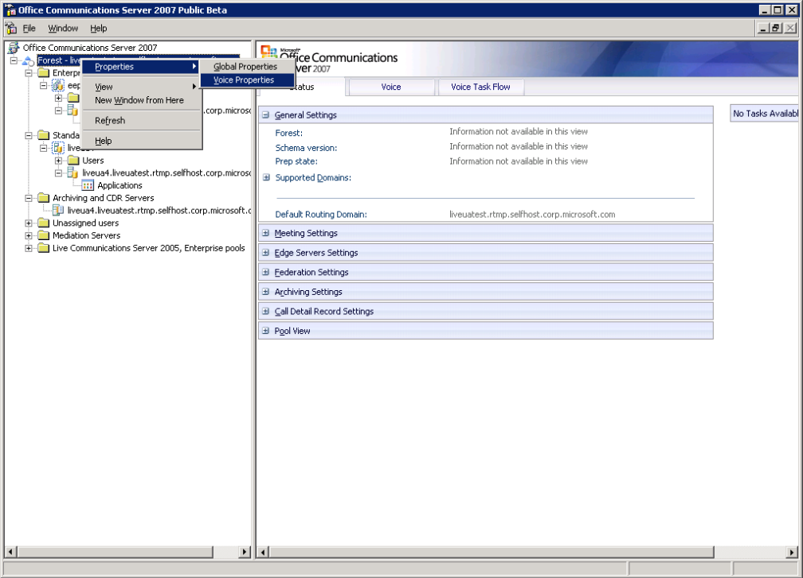
- On the Phone Usages tab, click Add to create a new phone usage record.
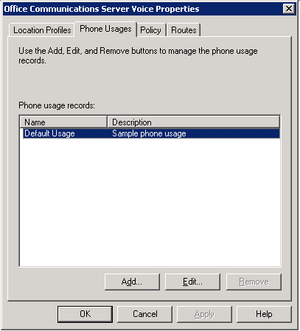
- In the Add Phone Usage Record dialog box, type a unique name in the Name box and type an optional description of the record in the Description box. Continue adding phone usage records as needed. When you are finished, click OK.
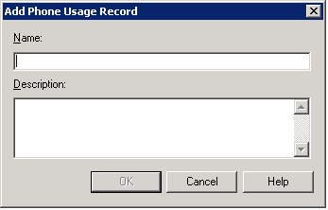
- Repeat steps 1 and 2 to create additional phone uses.
- When you are done, click OK.

To create a voice policy
Note
A voice policy is a named set of phone usage records. The recommended way of creating a voice policy is to create the appropriate phone usage records first, then create the policy and add the appropriate phone usage records.
As an alternative, you can create one or more policies and add the phone usage records later. However, should you forget to add the phone usage records and then apply the policy to one or more users, the policy will have no effect whatsoever.
- On a Front End Server, click Start, point to Programs, point to Administrative Tools, and then click Office Communications Server 2007.
- Right-click the Forest node, point to Properties, and then click Voice Properties.
- On the Properties dialog, click the appropriate tab for the task you want to perform.
- On the Policy tab, click Add.
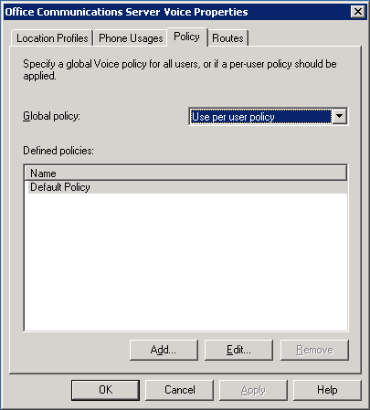
- In the Add Policy dialog box, type a name in the Policy name box.
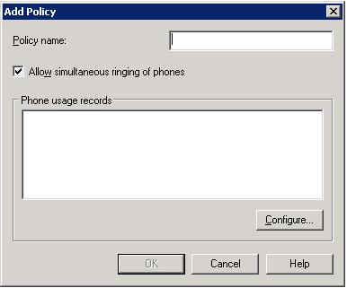
- If you want to enable simultaneous ringing of phones to this policy, select the Allow simultaneous ringing of phones check box. If the check box is selected and you want to disable simultaneous ringing, clear the check box.
Note
Simultaneous ringing is not supported in PBX coexistence scenarios.
- Click Configure to add phone usages to the policy.
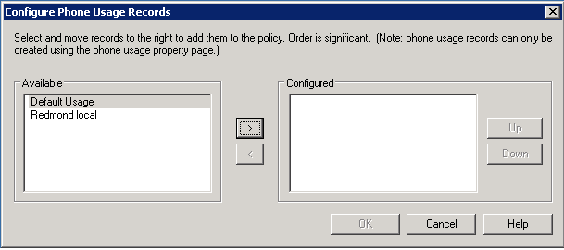
- In the Configure Phone Usage Records dialog, select a phone usage from the Available list, and then click the right arrow to add the usage to the Configured list.
- Continue adding as many phone usages as you like. If you want to remove a phone usage from the list of Configured phone usages, select the policy and then click the left arrow button. If you want to change the order in which the policies are processed, select a policy and then click Up or Down to move it to the desired position.
- When you are finished, click OK. The phone usages you added now appear in the list of Phone usage records in the Add Policy or Edit Policy dialogs.
- When you are finished, click OK.
To select a global voice policy
- On the Policy tab, open the Global policy list and select a policy. Or, if you do not want to select a global policy, select Use per user policy.
- Click OK.

Step 7 Configure Outbound Call Routing
Configuring outbound call routing consists of instructing Communications Server how to route calls from Enterprise Voice users to phone numbers on the PSTN or a PBX. These instructions are embodied an Enterprise Voice Route. An Enterprise Voice Route consists of:
- A unique name and optional description that identify and describe the route.
- One or more regular expressions that specify target phone numbers that can use this route. Numbers that do not match the pattern of the target number cannot use this route.
- One or more phone usage records that must be present in a caller’s voice policy in order for that caller to place calls to target phone numbers associated with this route. If a user’s voice policy does not include a phone usage record associated with this route, the user is not authorized to place calls to those numbers.
- One or more media gateways that are to be used for this route.
For detailed information about planning call routes, see Call Routes.
To create an outbound call route
- On a Front End Server, click Start, point to Programs, point to Administrative Tools, and click Office Communications Server 2007.
- Right-click the Forest node, point to Properties, and then click Voice Properties.
- On the Properties dialog, click the appropriate tab for the task you want to perform.
- On the Routes tab, click Add.
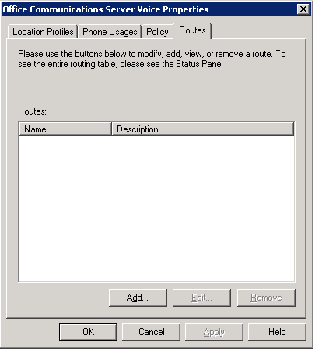
- In the Add Route dialog box, do the following:
- In the Name box, type a unique name for the new call route.
- In the Description box, type an optional description of the new call route.
- In Target phone numbers, use .NET Framework Regular Expressions to describe the pattern of the phone numbers that are to use this route. If you need assistance, click Helper.
- Click Add to add a media gateway or Mediation Server to the Gateways list. Only those gateways and/or Mediation Servers that have been correctly installed and configured will appear in this list.
- Click Configure to add a phone usage record to this call route.
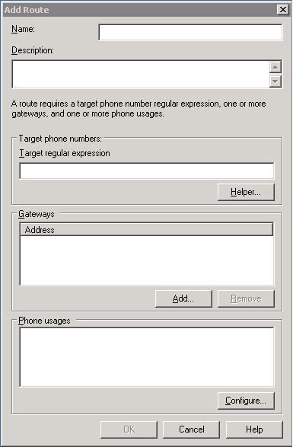
- In the Configure Phone Usage Records dialog box, select the phone usage record you want to add from the Available list, and then click the Right Arrow key (>) to add the record to the Configured list. Continue adding phone usage records as needed. When you are finished, click OK.
- Create as many routes as you need. When you are finished, click OK to close the Voice Properties page or click Apply to continue.

Step 8 Enable Users for Enterprise Voice
This step is performed using the Office Communications Server 2007, Administrative tools.
To configure users for Enterprise Voice
- Click Start, point to Programs, point to Administrative Tools, and click Office Communications Server 2007. The Office Communications Server 2007 administrative snap-in shows your Communications Server 2007 topology.
- Expand the Enterprise pool or Standard Edition server node where your users reside.
- Expand the pool or server where your users reside and then click the Users node.
- In the right pane, right-click one or more users whom you want to configure, and then click Configure users. This launches the Configure Users Wizard.
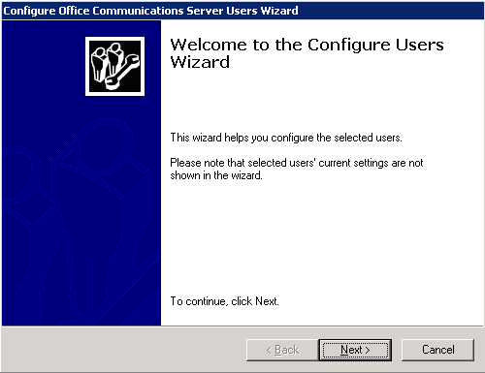
- On the Welcome to the Configure Users Wizard page, click Next.
- On the Configure User Settings page, click Next.
- On the Configure User Settings organize meetings page, click Next.
- On the Configure User Settings specify meeting policy page, click Next.
- On the Configure Enterprise Voice Settings page, click Change Enterprise Voice Settings, and then click Enable Voice.
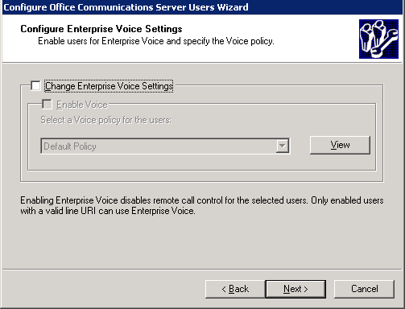
- Select a Voice policy from the drop-down list and click Next. (To view a policy before applying it, select a policy and click View.)
- On the Configure Operation Status page, verify that the operation succeeded and click Finish. If there are failures, return to step 1.
- On your Exchange UM servers, configure users enabled for Enterprise Voice for Exchange UM (for more information see Step 1 Configure Exchange UM to Work with Communications Server.
Note
For information about provisioning users for call answering and Outlook Voice Access, see your Exchange Server 2007 documentation.

Step 9 Enable Users for PBX Integration (optional)
Important
Perform this step only if you are deploying Communications Server with PBX integration.
Enabling users for PBX integration means that their calls are managed by both Communications Server and their legacy PBX. They can send or receive phone calls using either their desktop PBX phone or Office Communicator. Calls originating in one system are forked to the other, so that all user endpoints are rung. For information on planning for PBX integration, see Communications Server-PBX Coexistence.
To enable users for PBX integration
- Click Start, point to Programs, point to Administrative Tools, and click Office Communications Server 2007. The Office Communications Server 2007 administrative snap-in shows your Communications Server 2007 topology.
- Expand the Enterprise pool or Standard Edition server node where your users reside.
- Expand the pool or server where your users reside and then click the Users node.
- In the right pane, right-click one or more users whom you want to configure, and then click Properties.
- On the Communications page, click Configure.
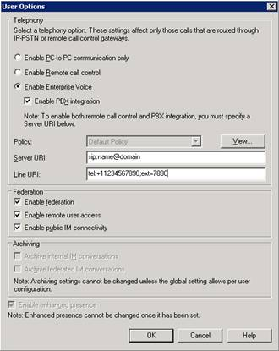
- If the user is not yet enabled for Enterprise Voice, click Enable for Enterprise Voice. This activates Enable PBX integration.
- Click Enable PBX integration.
- If you want to enable RCC in addition to PBX integration, in Server URI type the URI of the RCC server.
- Click OK.
If your PBX is unable to parse the Active Directory Line URI field, you also need to enter the extension associated with each user in the Telephone number box of the User Properties page.

Chapter 4 Managing Enterprise Voice
The Office Communications Server 2007 Administrative Tools enable you to accomplish the following Enterprise Voice management tasks:
- Configure global and pool settings for Enterprise Voice.
- Configure settings for a single Standard Edition Server functioning as a pool or for the Communications Server 2007, Mediation Server.
- Configure your Enterprise Voice infrastructure for routing calls among Enterprise Voice users and to numbers managed by a legacy PBX users and the PSTN.
- Specify route-based user call authorizations.
- Enable and configure users for Enterprise Voice.

Using the Communications Server 2007 Administrative Snap-in
The Communications Server 2007 administrative snap-in for MMC is installed by default on all Communications Servers. In addition, you can install the tools separately on a computer from which you want to manage Communications Servers remotely.
You can run the Office Communications Server 2007 Administrative Tools on the following operating systems:
- Windows Vista™, Business Edition
- Microsoft Windows Vista, Enterprise Edition
- Microsoft Windows® XP with Service Pack 2 (SP2) and greater
- Microsoft Windows Server® 2003 with Service Pack 1 (SP1) and greater
- Microsoft Windows Server 2003 R2
Office Communications Server 2007 administrative tools can also run in Windows 32-bit on Windows 64-bit (WOW64) mode on 64-bit versions of Windows, but not as a native 64-bit application
Windows 2000 is not supported for running the Office Communications Server 2007 Administrator Tools.
For information about the system platform prerequisites for Office Communications Server 2007, see the Microsoft Office Communications Server 2007 Planning Guide.
To open the Office Communications Server 2007 Administrative Tools, do one of the following:
- Click Start, point to All Programs, point to Administrative Tools, and then click Office Communications Server 2007.
- Click Start, point to Administrative Tools, and then click Office Communications Server 2007.
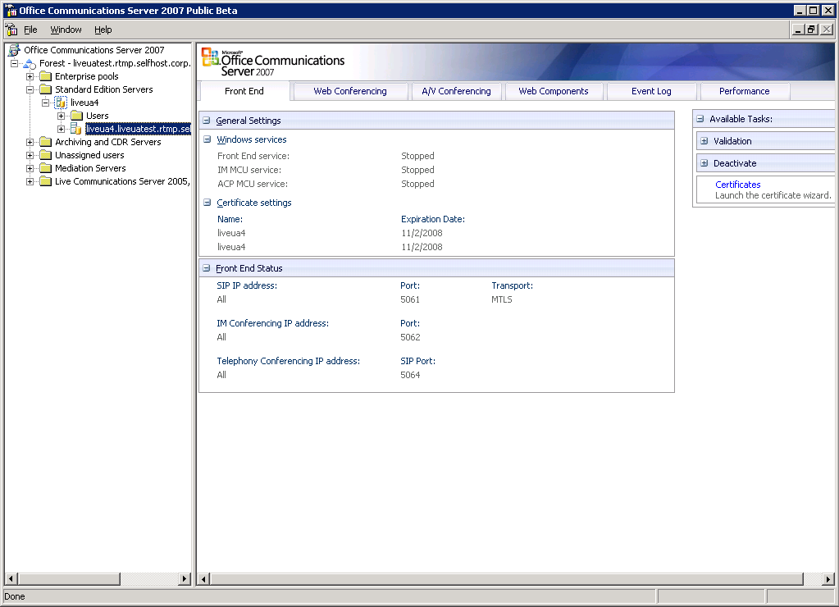
As shown in the preceding figure, the administrative snap-has two panes: the console pane and the details pane. The console pane, on the left, represents your Communications Server topology as a tree of nodes. The details pane, on the right, displays status, settings, and other information for the node selected in the console pane. The details pane often contains several tabs, each displaying a different type of information.

Viewing Voice Settings
You can view your settings for Enterprise Voice in the detail pane of the Communications Server 2007 administrative snap-in.
To view global settings for Enterprise Voice
- Open the Communications Server 2007 administrative snap-in.
- In the console pane, click the forest node.
- In the details pane, click the Voice tab.
- Expand one or more of the following to view the corresponding settings for Voice:
- Global Policy
- Phone Usages
- Normalization Rules
- Location Profiles
- Routes
To view voice configuration task flow
- Open the Communications Server 2007 administrative snap-in.
- In the console pane, click the Forest node.
- In the details pane, click the Voice Task Flow tab. The Voice Task Flow tab presents the main voice configuration tasks as a series of steps.
- To view the property page corresponding to each step, click the MMC Reference path.
- Click Help to view the online help for each property page.
To To view voice settings for a pool
- Open the Communications Server 2007 administrative snap-in.
- In the console pane, click the pool whose settings you want to view.
- In the details pane, expand Voice Settings. Voice Settings displays pool-level settings for phone lock, location profile, and quality of service.
- Expand the settings you want to view.

Viewing Voice Properties
Most of the management procedures described in this chapter require you to access Voice properties.
To view pool-level properties
- Open the Communications Server 2007 administrative snap-in.
- Click Start, point to Programs, point to Administrative Tools, and click Office Communications server 2007. The Office Communications Server 2007 administrative snap-in shows your Communications Server 2007 topology.
- Expand the Forest node.
- If you are configuring a Standard Edition Server, expand Standard Edition Servers, right-click the Standard Edition pool that you want to configure (not the server itself but the pool-level node for that server), point to Properties, and then click Front End Properties.
- If you are configuring an Enterprise Edition Pool, expand Enterprise Pools, expand the pool that you want to configure, right-click Front Ends, and then click Properties.

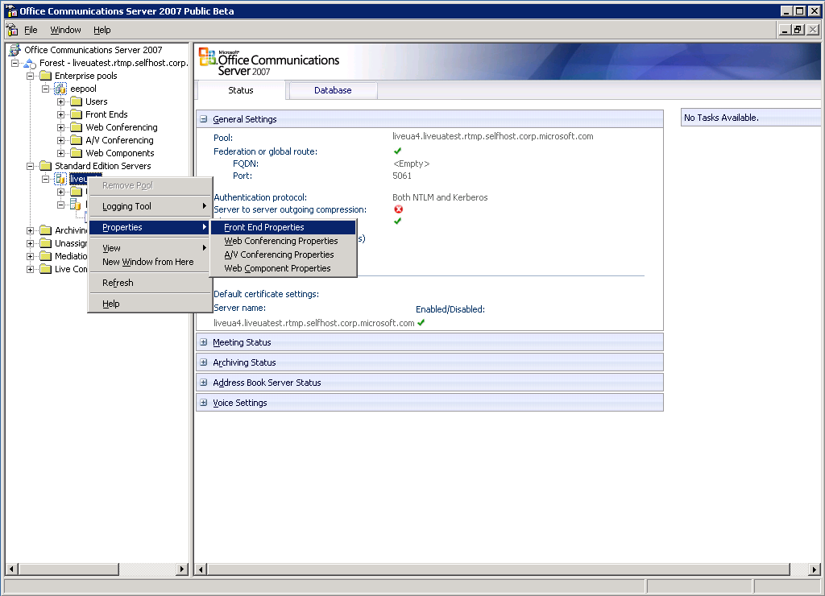
- On the Front End Properties page, click the Voice tab.
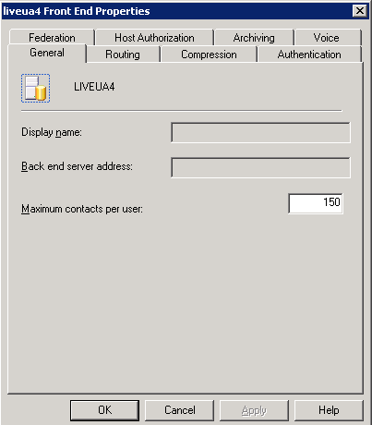

Configuring Global Settings for Enterprise Voice
Global settings govern the routing of calls that originate with Enterprise Voice users throughout a forest.
To view global voice properties
- Open the Communications Server 2007 administrative snap-in.
- In the console pane, right-click the Forest node, point to Properties, and click Voice Properties.
The global voice property page contains four tabs: Location Profiles, Phone Usages, Policy, and Routes, each corresponding to an Enterprise Voice Active Directory object. To create a new object or change the settings of an existing object, click the appropriate tab.
If you are making changes on one tab only, click OK. If you make changes on more than one tab, click Apply after you finish making changes on a tab, and then press OK when you finish making changes on the last tab.

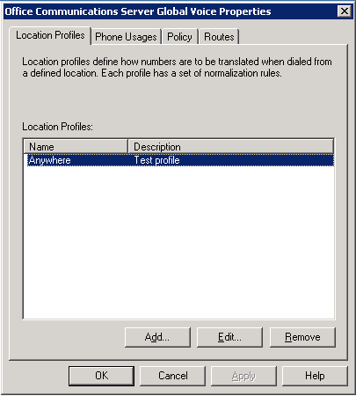
Global settings include the following:
- Location profiles specify which normalization rules apply to calls from a particular locale. To create, edit, or remove location profiles, see Step 2 Create Location Profiles.
- Phone usage records define user calling privileges. A single policy may include multiple phone usage records. To create, edit, or remove phone usage records, see Step 6 Configure Call Authorization.
- Policies specify which phone usage records apply to which users. They also specify whether endpoint devices are enabled for simultaneous ringing. To create, edit, or remove voice policies, see Step 6 Configure Call Authorization.
- Routes define how calls are routed through the Enterprise Voice infrastructure. A route consists of a target telephone number, one or more media gateways that are designated to handle that number, and the phone usage records that a user must have for permission to call the target number. To create, edit, or remove a route, see Step 7 Configure Outbound Call Routing.

Configuring Pool Settings for Enterprise Voice
The Communications Server 2007 Enterprise Pool, or a Standard Edition Server functioning as a pool, must be configured with a location profile. The location profile translates dialed numbers into E.164 format for reverse number look-up and call routing.
In addition to specifying a location profile for the pool or home server, you can also configure settings for the Microsoft Office Communicator Phone Edition.
To select a default location profile for a pool or Standard Edition Server
- Open the Front End Properties page for a chosen pool or server, and then click the Voice tab.
- Select the default location profile, and then click View to review the contents of the location profile. If the location profile is not the one you want, continue viewing additional location profiles until you find it If the location profile you want does not exist, you must create a new one (for details, see Step 2 Create Location Profiles).
- Click OK.
To configure phone lock for the Microsoft Office Communicator Phone Edition
- Open the Front End Properties page for a chosen pool or server, and then click the Voice tab.
- Click Enforce phone lock.
- Accept the default values for Minimum pin length and Minimum timeout or type new values. Acceptable value ranges are shown in the following table:
Table 11. Valid ranges for PIN length and timeout length
PIN Length | Timeout Length (in minutes)
4–15 characters; default 6 | 0–60 minutes; default 10

- Click OK.
To configure quality of service for the Microsoft Office Communicator Phone Edition
- Open the Front End Properties page for a chosen pool or server, and then click the Voice tab.
- Click Configure.
- In the Advanced Voice Options dialog, accept the default values for QoS and 802.1p Voice or type new values. Acceptable value ranges are shown in the following table:
Table 12. Valid ranges for QoS and 801.2 Voice
QOS | 801.2 Voice
0-63; default 40 | 0–7; default 0

- Click OK.
To configure security settings for Microsoft Office Communicator Phone Edition
- Open the Front End Properties page for a chosen pool or server, and then click the Voice tab.
- Click Configure.
- In the Advanced Voice Options dialog, accept or change the SIP security mode, and then click OK.
Note
Click Help for information about the settings for the SIP security modes.
- Click OK.

Configuring a Mediation Server
A Mediation Server must be able to pass SIP requests and media between the Enterprise Voice infrastructure and a media gateway connected to the PSTN. This requires configuring the following settings:
- The IP address used to listen for calls.
- The name of the Audio/Video Access Edge Server that will host the A/V Authentication Service for this Mediation Server.
- The location profile to be used by the Mediation Server.
- The port range for media exchange.
- The FQDN and TLS port of the internal next hop server used by this Mediation Server.
- The FQDN and TCP port of the media (PSTN) gateway used by this Mediation Server.
- To configure a mediation server, see Configure Mediation Server.

Deactivating a Mediation Server
From time to time you may need to take a Mediation Server offline for purposes of maintenance or replacement. Care must be taken in deactivating a Mediation Server because if you simply remove it from service without first taking precautionary steps, you will cause any active calls to be dropped. There are three ways to safely deactivate a mediation server:
- Deactivate the Mediation Server on the weekend or holiday, or in the middle of the night, but only after you have checked the call logs to make sure nobody is using that particular gateway.
- Change routes on the Communications Server so that no new calls are routed through the Mediation Server to be activated. Then wait for all calls to hang up.
- A combination of the first two options in which you change routes on the Communications Server during off-hours, after all calls have completed.

Enabling Call Detail Records for Enterprise Voice
Communications Server 2007 uses the CDR (Call Detail Records) infrastructure to capture Enterprise Voice call details.
Note
Before you administer call detail recording, you must first install an Archiving Server and all its prerequisites as well as enable call detail recording according to the instructions in the Microsoft Office Communications Server 2007 Archiving and CDR Server Deployment Guide. Also ensure that you have enabled archiving according to the instructions in the “Enable Archiving” section of this document.
To enable call detail recording for Enterprise Voice
- Log on to a server in the forest where you installed Communications Server 2007 that has the Office Communications Server, Administration Tools installed using an account in the RTCUniversalServerAdmins group.
- Click Start, point to Control Panel, point to Administrative Tools, and then click Office Communications Server 2007.
- Right-click the Forest node, point to Properties, and then click Global Properties.
- Click the Call Detail Records tab.
- Click Voice call details, and then click OK.

Appendix A Glossary

A/V Authentication Service | A service that authenticates media transactions originating outside the enterprise firewall. The A/V Authentication Service is collocated on the Audio/Video Edge Server.
Address Book Service | A service that runs on an Office Communications Server Front End Server and daily synchronizes phone numbers on the client with refreshes from Active Directory.
Advanced Media Gateway | A PSTN gateway that tightly integrates the functionality of the Basic Media Gateway with the signaling and media translation services of the Mediation Server in a single piece of hardware.
Audio Conference Provider | A third-party telephony provider that enables conferencing on legacy PBX systems.
Audio/Video Edge Server | An Office Communications Server that resides in the perimeter network and provides a trusted point through which media traffic can traverse firewalls.
Auto Attendant | A set of voice prompts that gives external users access to the Exchange 2007 Unified Messaging system. An auto attendant lets the user use either the telephone keypad or speech inputs to navigate the menu structure, place a call to a user, or locate a user and then place a call to that user.
Basic Hybrid Media Gateway | A PSTN gateway collocated with Mediation Server on a single computer. The functionality of gateway and Mediation Server are separate, just as they are with a basic media gateway, but they are collocated on a single piece of hardware rather than deployed on separate ones.
Basic Media Gateway | A PSTN gateway that uses SIP and RTP to communicate with a Mediation Server, and various telephony signaling and media protocols to communicate with the PSTN (or a PBX).
Call Forwarding | The process of automatically forwarding a missed call to a user-designated number, which can be another user, a PSTN number, or voice mail. In Enterprise Voice, call forwarding consists of sending a SIP INVITE to the designated number.
Call Notification | The process of alerting a user that a call has been received. In Enterprise Voice, the alert is typically in the form of e-mail from Exchange UM.
Call Route | A named association of a defined set of target numbers, one or more gateways, and one or more phone usage records. An Enterprise Voice call route specifies the gateways to which target numbers matching a certain pattern are to be directed and the permissions that a caller must have to make calls that use the route.
Departmental Deployment | An Enterprise Voice deployment in a department or workgroup within an organization where other users remain deployed on a legacy PBX. In a departmental deployment, a user is enabled either for Enterprise Voice or the PBX, but not both, as is the case with PBX Integration.
Dial Plan | The expected number and pattern of digits in telephone numbers for a given location. For instance, the North American Numbering Plan (NANP) uses a 10-digit dial plan that includes a 3-digit area code and a 7-digit telephone number. Also see Exchange UM Dial Plan.
E.164 | A standard industry format for number normalization. The E.164 format consists of a country code (1–3 digits) and a National Significant Number (12–14 digits). Excluding prefixes, E.164 numbers cannot exceed 15 digits.
Enterprise Voice | Microsoft’s SIP-Powered VoIP Solution. An implementation of VoIP telephony based on the industry standard SIP protocol.
Exchange UM Dial Plan | A data structure in Exchange that maps Communications Server users to a particular set of UM servers and assigns configuration parameters to that set of users and servers.
Exchange Unified Messaging | An Exchange Server 2007 server role that combines voice messaging, fax, and e-mail into one Inbox, which can be accessed from the telephone and the computer. Exchange UM can be configured to provide voice mail and other services to Enterprise Voice deployments where such services are not already provided by a PBX.
Greenfield Deployment | An Enterprise Voice deployment in an environment where no legacy PBX system exists. A new company or new facility are typical examples.
Inbound Routing | A component on the Communications Server Front End Server that manages the routing of calls received by Enterprise Voice users.
IP Telephony | A telephony system in which signaling and media are carried over an IP network. In other words, VoIP.
IP-PBX | A PBX that has a network adapter and is capable of sending and receiving data packets over the Internet, including VoIP calls.
Location Profile | A location profile defines all phone numbers that can be dialed from a named location. A location contains one or, typically, more normalization rules.
Media Gateway | A device that connects the PSTN to your LAN. A media gateway translates both signaling and media between an Enterprise Voice infrastructure and the PSTN or a legacy PBX.
Mediation Server | A Communications Server that translates signaling and media for calls (SIP transactions) flowing between Communications Server and a media gateway connected to the PSTN. A Mediation Server combined with a Basic Media Gateway is required for PSTN connectivity. An advanced media gateway integrates the functionality of gateway and Mediation Server in a single piece of hardware.
Normalization (phone number) | The process of converting user phone numbers in various formats to a numeric string of uniform format. The format used by Enterprise Voice is E.164.
Normalization Rule | A regular expression that specifies how to convert phone numbers following a particular pattern to E.164 format.
PBX Integration | An Enterprise Voice deployment that coexists with an IP PBX such that users are enabled on both systems, and each system forks incoming calls to the other.
Phone Usage Record | In Enterprise Voice, an arbitrary label that identifies a collection of routes. Examples include Local, Area Code, State, Province, USA, Singapore, and International.
Primary Phone Number | A user’s primary work number as specified in the Active Directory msRTCSIP-line attribute. Communications Server performs reverse number lookup on a user’s primary phone number to obtain all the user’s SIP endpoints.
PSTN | Public Switched Telephone Network. The traditional worldwide circuit-switched telephone network.
Real-time Transport Protocol (RTP) | A standardized format for delivering audio and video over the Internet.
Remote Call Control | The ability to manage and control a PBX phone using a CSTA (Computer Supported Telecommunications Application) such as Office Communicator.
Remote Worker | An external user with a persistent Active Directory identity within the organization.
Route | See Call Route.
RTP | Real-time Transport Protocol.
Secure Real-time Transport Protocol (SRTP) | A form of RTP designed to provide encryption, authentication, and data integrity for media packets carried over the Internet.
Session Initiation Protocol (SIP) | An IETF (Internet Engineering Task Force) signaling protocol for real-time communications, including IM, multimedia conferencing, and VoIP. Communications Server and Enterprise Voice use SIP as the standard signaling protocol.
SIP | Session Initiation Protocol.
SIP Endpoint | A device that terminates a SIP transaction; an end node in a SIP network. In Communications Server, a user’s SIP endpoints are all the devices on which a user can receive A SIP INVITE request.
Softphone | A software application, such as Office Communicator, that can act as a telephone in a VoIP network.
SRTP | Secure Real-Time Transport Protocol.
Subscriber Access | An Exchange UM service that provides dial-in access for company users.
TDM | Time-division multiplexing, a method for sending multiple signals over a single phone line. A TDM PBX lacks a network adapter and cannot pass IP packets. For these reasons a TDM PBX cannot be enabled to integrate with Enterprise Voice.
Hunt Group | A group of PBX resources or extension numbers that are shared by users. A hunt group is used by Exchange UM to efficiently distribute calls into or out of a given business unit or set of Enterprise Voice users.
UM IP Gateway | An Exchange UM Active Directory container object that represents a physical media gateway separating Exchange UM and Enterprise Voice.
UM SIP Dial Plan | An Exchange UM Active Directory container object that logically represents the set of extension numbers shared by a group of Enterprise Voice users.
Unified Communications | Microsoft’s software-powered, user-centered, multimode communications solution. Unified Communications enables a user to send IM, view presence data of contacts, participate in real-time conferences, and place calls using VoIP from a desktop computer or other client device.
Voice Policy | A named set of Phone Usage Records. A voice policy defines call privileges for one or more users.
VoIP | Voice over Internet Protocol.

Appendix B
Enterprise Voice Planning Checklist

Determine the number and distribution of users.
Select your deployment option: PBX integration, departmental, greenfield, or remote user.
For PBX integration, make sure that your IP-PBX is either enabled for Enterprise Voice or can be enabled through a software upgrade from the vendor. (If you have a TDM PBX, you cannot implement PBX integration.)
For departmental deployment, decide whether to deploy Communications Server in front of or behind your existing PBX.
Select type of Media Gateway to deploy: basic, basic hybrid, or advanced.
Determine where to locate gateways.
Determine size and number of gateways that will be required.
If you choose to deploy the Basic Media Gateway, plan hardware requirements for Mediation Server. (NOTE: If you implement PBX integration, you must deploy a Mediation Server between Communications Server and your PBX.)
Determine what normalization rules will be required to translate PBX dial plans into Enterprise Voice Location Profiles.
Analyze the various call authorizations currently used by your organization and plan how to convert them to Phone Usage Records.
Analyze required call routes for your organization and plan how to convert them to Enterprise Voice Routes.
Determine which users will be moved from the existing PBX to the Enterprise Voice infrastructure.
Plan how to normalize user primary phone numbers in Active Directory.
Determine which administrators will deploy and configure Exchange 2007 Unified Messaging.
Determine whether Exchange 2007 UM will be deployed in the same or a different forest as Communications Server 2007.
Obtain valid phone numbers for users, subscriber access, and auto-attendant.

Appendix C
Enterprise Voice Deployment Checklist

Enter the FQDNs of A/V Edge Servers in the Global Properties Edge Servers tab. This is required in order to complete configuration of the Mediation Server.
Install and activate Mediation Server (required only if you are deploying Basic Media Gateway). You must deploy one Mediation Server for each gateway. If you are implementing PBX integration, you must also deploy a Mediation Server between your PBX and Communications Server.
Configure a certificate for Mediation Server (required regardless of whether the Mediation Server is stand alone or part of a Collocated Media Gateway).
Select listening IP address for Mediation Server.
Select A/V Authentication Service.
Create Location Profiles.
Select the default Location Profile.
Accept the default Media Port Range.
Specify the FQDN and mutual TLS listening port for the internal next hop.
Specify the IP address and TCP listening port for the gateway.
Start Mediation Server.
Define normalization rules for outbound calls.
Create Phone Usage Records.
Create voice Policies and assign appropriate Phone Usage Records to each policy.
Create outbound call Routes and assign appropriate Phone Usage Records to each route.
Specify matching number pattern for each route.
Specify gateway for each route.
Enable users for Enterprise Voice.
Enable users for PBX integration, if appropriate.
Assign voice Policies to users.
Configure Communications Server 2007 pool for Enterprise Voice.
Configure Exchange UM server to integrate with Communications Server.
On the Exchange UM server, grant Communications Server permission to read Exchange UM Active Directory objects.
On the Communications Server Front End, run the ocsumutil tool.

