Overview  Country or Region: Singapore  Industry: Electronics  Customer Profile  Hitachi Asia co-ordinates marketing and sales activities for industrial, electrical, and electronics products.  Business Situation  Hitachi Asia wanted to improve the operational efficiency of its supply chain by deriving more business value from internal IT systems.  Solution  The group deployed Microsoft® SQL ServerTM 2005 and SQL Server Reporting Services to enhance reporting and analysis functions and boost the efficiency of its e-procurement operations.  Benefits  - Business intelligence improves analysis.  - Microsoft Select License reduces costs.  - Reporting tools improve supply chain efficiency.  - SSIS saves time and resources. |  |  | “We brought our application to the Microsoft labs and Microsoft tested the migration itself. Consequently, we were certain it was risk free when the time came to introduce it to our environment.”  Yeow Shih Yeh, General Manager, Information Technology Centre, Hitachi Asia
 |  |  | Hitachi Asia developed an electronic procurement system based on Microsoft® SQL ServerTM 2000. The company decided to upgrade this architecture and take advantage of a range of new business intelligence features available with Microsoft SQL ServerTM 2005. In particular the company wanted to use the rich reporting functionality of SQL Server 2005 to increase the business value of its IT systems. Specifically, it aimed to reduce costs by assessing the service delivery of suppliers more effectively. As a member of the Microsoft Select License programme, Hitachi Asia received significant support for the new technology roll out, while minimising deployment costs. The company has now enriched its reporting processes and enhanced efficiency through increased understanding of its supplier base.
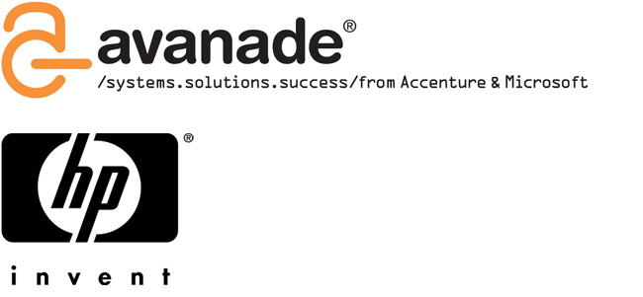 |  |  |   

Situation
Hitachi Asia was formed in Singapore in 1989 and is one of the company’s four regional headquarters, with the other three located in the United States, Europe, and China. Hitachi Asia offers a wide range of systems, products, and services in market sectors such as information systems, power and industrial systems, digital media systems, consumer products, and international procurement.

To maximise productivity and increase efficiency across the supply chain, Hitachi Asia produces a wealth of reports. These outline performance data such as supplier turnaround times, purchase order (PO) acknowledgement times, delivery forecasts, and order balances.

For five years, Hitachi Asia used Microsoft® SQL ServerTM 2000 to keep track of this information, and provide rapid analysis of its supply chain data. However, the group identified areas of the supply chain where efficiency could be increased. In particular, it wanted to derive more business value from internal IT systems and reduce costs by accurately analysing the efficiency of suppliers.

To achieve this, the group needed to upgrade its internal reporting facilities. In doing so, it hoped to:
• Provide end-users with tools to analyse supplier performance.
• Reduce manual intervention and speed up reporting processes.

Solution
Hitachi Asia is a member of the Microsoft Select License programme. This is a software volume licensing initiative designed for corporate, government, and academic customers with more than 250 desktops and mixed product and purchasing requirements. Select License customers receive a volume price level for each pool of products they select (applications, systems, or servers) based on a three-year software forecast.

As a participant in the Select License programme, Hitachi Asia was able to replace its existing SQL Server 2000 infrastructure with SQL Server 2005. While the company was still satisfied with SQL Server 2000, the latest version of the technology offers a range of new data analysis features. In addition, the Select License programme made it possible to upgrade the technology at low cost.

In particular, Hitachi Asia wanted to explore the depth and scope of SQL Server Reporting Services and the business intelligence capabilities of SQL Server 2005. The new functionality available with the latest release of the technology greatly increases the efficiency of report creation and analysis.

HP supported the migration to SQL Server 2005. Diane Liau, Alliance Manager, HP, says: “HP provided test platforms for Hitachi's technical benchmarking and evaluation. HP Server technology, including 32-bit Proliant servers, was the technical platform that Hitachi used to conduct testing for the proof of concept (POC). The remote manageability of the HP servers and ease of deployment during upgrades helped Hitachi in its technical deployment challenge. HP also provided server installation support during POC testing.”

Together with Microsoft Gold Certified Partner Avanade Asia, Hitachi Asia began rolling out a pilot business intelligence system based on SQL Server 2005 in August 2005. The whole process took just eight weeks to complete. The procedure was broken down into three stages:
• Requirements gathering and design (two weeks)
• Development (two weeks)
• Pilot (four weeks)
Low Yin Yee, Senior Business Applications Consultant, Avanade Asia, says: “Hitachi Asia’s e-procurement system was the data source for the pilot. We worked closely with the Hitachi Asia team to ensure the SQL Server 2005 implementation process was kept simple, with minimal disruption to users and minimal negative impact on the system.”

Because the data was migrated from SQL Server 2000 to SQL Server 2005, the whole process was very simple. It followed three stages:
• Requirements were gathered for the scope of the prototype.
• Data was extracted from the e-procurement system, transformed, cleansed, and loaded into a SQL Server 2005 database.
• Users perform reporting and analysis using a combination of SQL Server 2005 Reporting Services and ProClarity Desktop Professional.
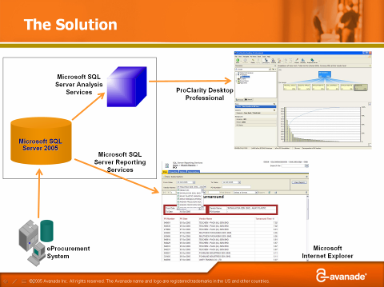

Yin Yee from Avanade Asia, says: “The value of a business intelligence solution is only as good as the quality of the information we seek to get from the system. To help Hitachi Asia extract the most value from the solution, the source data was transformed and cleansed. We also created a number of reports and an Analysis Services 2005 cube to help Hitachi users analyse and track fulfilment and response times.”

The reports list the time required for suppliers to acknowledge purchase orders (POs) and map delivery forecasts and order balances. The Analysis Services cube facilitates analyses of supplier PO cancellation behaviour in the following measures:
• Number of POs issued.
• PO amounts.
• Number of POs cancelled by suppliers.
• Cancelled PO amounts.

Yeow Shih Yeh, General Manager, Information Technology Centre, Hitachi Asia, says: “We had good support from Microsoft. We brought our application to the Microsoft labs and Microsoft tested the migration itself. Consequently, we were certain it was risk free when the time came to introduce it to our environment. Microsoft was on hand at all times to ensure the migration was seamless and no disruptions occurred.”

Benefits
The migration to SQL Server 2005 has provided Hitachi Asia with a range of benefits, as well as enhancing a number of features the group already used.
“Business intelligence improves our analysis and reporting structure, making life easier for the developer and the user.”
Yeow Shih Yeh, General Manager, Information Technology Centre, Hitachi Asia
Business Intelligence Improves Analysis
The business intelligence functionality was a valuable addition to the group. Shih Yeh says: “Business intelligence improves our analysis and reporting structure, making life easier for the developer and the user. With integrated reporting controls, developers can more easily conceptualise data to form better drill-down information for individual users. In addition, the front-end interface is much more user friendly thanks to its simple and clear dashboard tool set.”

Microsoft Select License Reduces Costs
Because it was already a member of the Microsoft Select License programme, Hitachi Asia was able to save money in its acquisition and deployment of SQL Server 2005. Shih Yeh says: “The Select Programme gave us huge discounts on new technology and we received excellent value from Microsoft.”

In addition, Hitachi Asia is enjoying greater value, manageability, and assistance, through the Microsoft Software Assurance programme. This provides a powerful combination of benefits that include new version rights, the Home Use programme, productivity benefits, support, tools, and training to ensure Hitachi Asia’s migration was seamless.

Reporting Tools Improve Supply Chain Efficiency
The rich functionality of Reporting Services has helped the group monitor and enhance the performance of its suppliers. Because Reporting Services allows e-procurement users to better analyse and understand the activities of its suppliers, Hitachi Asia can identify those that are under-performing. In the past, this would have involved individual report requests that took up to a week to produce. Now, this information is available instantly, helping the group maintain maximum efficiency across the supply chain.

SSIS Saves Time and Resources
The SQL Server Integration Services (SSIS) element of SQL Server 2005 has proved extremely valuable for users, helping them to drill down into individual projects, and achieve time savings of approximately 50 per cent. The new version of SSIS goes beyond the extract, transform, load (ETL) tools definition, allowing users to orchestrate code and create workflow that is clear and concise.
Microsoft Windows Server System
For More Information
For more information about Microsoft products and services, call the Microsoft Sales Information Center at (800) 426-9400. In Canada, call the Microsoft Canada Information Centre at (877) 568-2495. Customers who are deaf or hard-of-hearing can reach Microsoft text telephone (TTY/TDD) services at (800) 892-5234 in the United States or (905) 568-9641 in Canada. Outside the 50 United States and Canada, please contact your local Microsoft subsidiary. To access information using the World Wide Web, go to: www.microsoft.com

For more information about Avanade Asia Pte Ltd products and services, call 65 6394 7888 or visit the Web site at: www.avanade.com

For more information about Hewlett-Packard Singapore (Sales) Pte Ltd products and services, call 65 6275 3888 or visit the Web site at:
www.hp.com

For more information about Hitachi Asia Ltd products and services, call 65 6535 2100 or visit the Web site at: www.hitachi.com.sg

© 2006 Microsoft Corporation. All rights reserved. This case study is for informational purposes only. MICROSOFT MAKES NO WARRANTIES, EXPRESS OR IMPLIED, IN THIS SUMMARY. Microsoft, Windows, the Windows logo, Windows Server, and Windows Server System are either registered trademarks or trademarks of Microsoft Corporation in the United States and/or other countries. The names of actual companies and products mentioned herein may be the trademarks of their respective owners.

Document published April, 2006

Software and Services
- Microsoft Windows Server System Engineered
- Microsoft SQL Server 2005

Microsoft Windows Server System is a line of integrated and manageable server software designed to reduce the complexity and cost of IT. Windows Server System enables you to spend less time and budget on managing your systems so that you can focus your resources on other priorities for you and your business.

For more information about Windows Server System, go to:
www.microsoft.com/sql

