Using Proofing Tools with Word 97

What you will learn from this lesson

With Word 97 you will:
- Check your spelling.
- Check your grammar.
- Use the thesaurus to find other words.
- Change the language that Word 97 uses by default.

What you should do before you start this lesson
- Start Word 97.
- Open a new document.

Exploring the lesson
Word 97 can help improve your and your students’ writing technique. Built-in features in Word 97 help improve writing style and correct misspellings, grammar, and word choices. By encouraging students to take advantage of these powerful features, you make it easier for them to focus on the content and purpose of their writing.

Getting help with your spelling
As soon as you type a word that Word 97 thinks may be a misspelling, a red wavy line appears below the word. If you right-click the word, a list of possible corrections appears, and you can make a correction. This spelling feature provides immediate feedback and reinforcement.
Checking your spelling
- Type comupter. Note the red wavy line below the word.
- Right-click the misspelled word comupter to see suggested spellings.
- Click the correct spelling.
Sometimes a word is underlined because it may be capitalized in some situations. When that happens, you can click the Ignore All button.

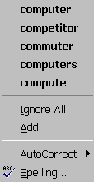

Getting help with your grammar
You can use the spelling and grammar tools to improve your report writing and presentations. Errors and possible errors are underlined to help you notice them. You can ignore the suggestions, or correct them immediately.
Checking your grammar
Note
Use the Spelling and Grammar dialog box to select different options for checking spelling and grammar. The Custom.dic file contains all the spelling words you have added.

- On a new line in the document you have open, type The window are stuck. and press enter.
- Right-click the green underlined words.
- Click Grammar to see an explanation of why this usage is questionable and suggested changes.
- Click Options to see available settings for how Word 97 checks grammar.
- In the Writing style list box, click Casual.
- Click OK.

Once you have learned about the possible corrections to a word or phrase, you can make the corrections by following the suggestions, or you can choose to ignore the suggestions.

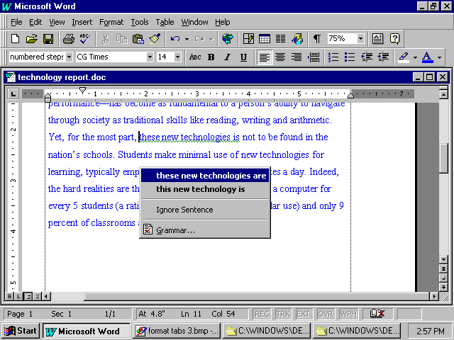

Getting help with your choice of words
The task of finding the right word or making the best word choice to convey your meaning is easier to do using Word 97. The built-in thesaurus offers suggestions and meanings, making it easy to choose words and phrases for your documents.
Checking the thesaurus
- On a new line in the document you have open, type frustrate, and select the word.
- On the Tools menu, click Language, and then click Thesaurus.
- Click baffle.
- Click Look Up.
- Click hindrance.
- Click Replace to change “frustrate” to “hindrance.”

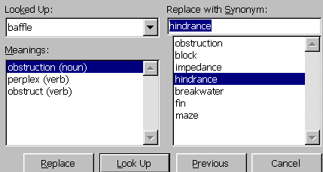

How you can use what you learned
The Spelling and Grammar tools can improve sentence structure. Word 97 makes it easy for you and your students to think and write freely, then go back and improve your writing. Both you and your students can take advantage of the automatic features that make it easier to write, revise, and finalize your reports and presentations.

Extensions
Are any of your students bilinguals? Will they be writing in a language other than English to friends or family members? Try using the dictionary for that language to check their grammar and spelling.

Changing the default language
As you and your students become more globally connected through travel, Internet, connections, two-way television, and our mobile society, you have more exposure to other languages and expressions.
Changing the default language
- On the Tools menu, click Language, and then click Set Language.
- Scroll down the list to select the language of your choice.
- Click Default to change the language Word 97 uses by default to the language you just selected.
- Click Yes to confirm changing all new documents.
- Click OK.

Summarizing what you can do with what you learned
Through this chapter, you have explored and practiced:
- Using the built-in spelling checker.
- Using the built-in grammar checker.
- Changing the writing style.
- Using the built-in thesaurus.
- Changing the default language.

