GENERAL LEDGER
ASSIGNMENT TWO

Objective:
1. Set up the Option feature for your database.
2. Enter Catawaba’s Chart of Accounts.

In order to make your work a little easier, you will want to select some options on the “Option” tab on the Solomon toolbar menu.

Click on the “Option” tab and select each one of the items that are checked below by clicking on each one. (After you click on an option, the option window will disappear. To select the other ones you have to click back on the “Option” tab.) Once you have all of the ones checked, click on “Options Save” to save everything you have selected.

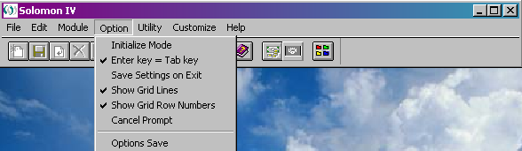

The following is a list of accounts that Alfred Sink would like you to set up as Catawaba Sailboat Sales’ Chart of Accounts. Instructions on guiding you through setting up these accounts in the Solomon software are following this list of accounts.

101 Cash
102 Accounts Receivable
103 Interest Receivable
104 Inventory
105 Supplies
117 Prepaid Insurance
140 Note Receivable, Long-term
160 Furniture
161 Accumulated Depreciation – Furniture
201 Accounts Payable
204 Salary Payable
207 Interest Payable
208 Unearned Sales Revenue
220 Note Payable, Long-term
301 Alfred I. Sink, Capital
302 Alfred I. Sink, Withdrawal
303 Retained Earnings
304 Year to Date Income
401 Sales Revenue
402 Sales Discount
403 Sales Returns & Allowances
410 Interest Revenue
501 Cost of Goods Sold
510 Salary Expense
513 Rent Expense
514 Depreciation Expense-Furniture
516 Insurance Expense
517 Utilities Expense
518 Supplies Expense
519 Interest Expense

To enter these accounts in the General Ledger, you will need to follow these steps:

1. Click on “Module” and then “General Ledger.” The following screen
will appear:
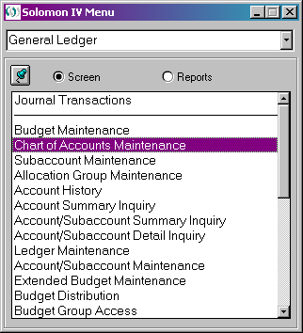

2. Click on “Chart of Accounts Maintenance.”

The “Chart of Accounts Maintenance” window will appear. You will have 2 accounts (303 Retained Earnings & 304 Year to Date Income) already set up in your chart of accounts that needs in there for General Ledger setup purposes. These accounts are bolded in your listing above and you can just ignore these two accounts since it is already entered for you.

The chart of accounts maintenance screen looks like a spreadsheet. For easier data entry, change the view to the form view by clicking on the “F4” key on the keyboard, to look like the example below. (Remember, General Ledger Assignment One explained this F4 feature).

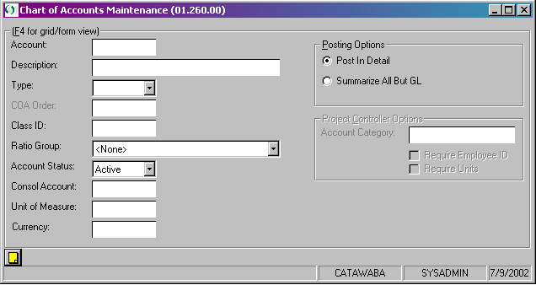
For each account, you will enter the “Account Number”, “Description”, and “Type”. The “Type” will be an asset, liability, revenue, or expense. (In Solomon, owners equity is considered a liability). Choose the type by clicking on the arrow to the right of the type field.

To start entering the accounts:

1. Type in the number in the “Account” field. (If you type over an
account number already in this field with a different account
number, Solomon will bring up a new record and not type over the
current record).

2. Next, enter the description of the account in the “Description”
field.

3. Choose the type of the account in the “Type” field.

*Hint: Chart of Accounts should have an orderly, logical structure based on a specific number scheme. The purpose of this is to make the accounts distinguishable from the other accounts. A typical structure divides the chart of accounts into these groups (asset, liability, income, expense). For example: only assets will start with number 1; like Cash “101”.

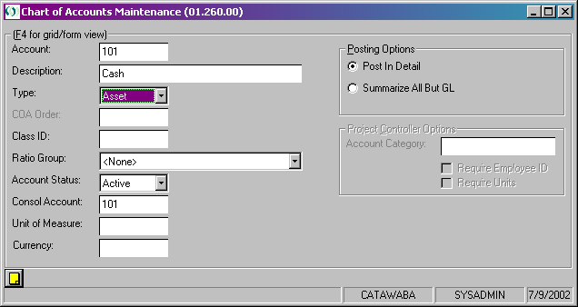

Once these first 3 fields (Account, Description, and Type) are completed, you will click on the “Finish Flag” on the Solomon toolbar to save the account record and bring up a blank record for the next account number that needs to be entered. *Remember, you can press F4 on the keyboard at anytime to take you back to the “grid” view to see the listing of accounts you have entered so far.
Once all of the accounts have been entered, you will print the Chart of Accounts. To do this:

1. Click on “Module” on the Solomon toolbar
2. Click on “General Ledger”
3. Click on the bullet next to “Reports”. This takes you to the
available reports in the General Ledger.

*In order to print any type of report in Solomon (in any module),
you have to select the “Reports” bullet and then select the type of
report to print.

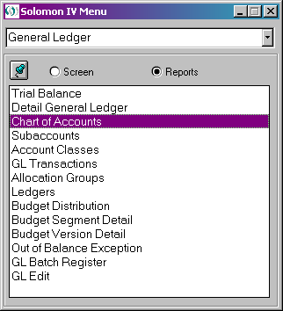

4. Click on “Chart of Accounts”

If you would like to preview the report before printing, click on the “Print Preview..” button. To print the report, click on the “Print...” button.

Print a copy of the Chart of Accounts and turn them in to the instructional assistant in the Solomon lab. Make sure your name is printed at the top of the report!!!!!

Alfred knows you are working hard and he likes your progress. He may even be considering doubling your salary!

