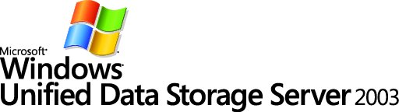

Microsoft Windows Unified Data Storage Server 2003

Microsoft Corporation
Published: October 2006

Abstract
Businesses of all sizes are seeking effective storage management solutions to help them deal with the rapid growth in stored data. This white paper examines the common problems faced by storage administrators and shows how the new storage management tools integrated into Microsoft® Windows Unified Data Storage Server™ 2003 provide manageable, reliable, and cost-effective solutions designed to meet those challenges. The document provides an introduction to Microsoft® Windows Unified Data Storage Server™ and describes how the tools within this software solution can deliver business value to Microsoft Windows administrators.

The information contained in this document represents the current view of Microsoft Corporation on the issues discussed as of the date of publication. Because Microsoft must respond to changing market conditions, it should not be interpreted to be a commitment on the part of Microsoft, and Microsoft cannot guarantee the accuracy of any information presented after the date of publication.
This white paper is for informational purposes only. MICROSOFT MAKES NO WARRANTIES, EXPRESS, IMPLIED OR STATUTORY, AS TO THE INFORMATION IN THIS DOCUMENT.
Complying with all applicable copyright laws is the responsibility of the user. Without limiting the rights under copyright, no part of this document may be reproduced, stored in or introduced into a retrieval system, or transmitted in any form or by any means (electronic, mechanical, photocopying, recording, or otherwise), or for any purpose, without the express written permission of Microsoft Corporation.
Microsoft may have patents, patent applications, trademarks, copyrights, or other intellectual property rights covering subject matter in this document. Except as expressly provided in any written license agreement from Microsoft, the furnishing of this document does not give you any license to these patents, trademarks, copyrights, or other intellectual property.
© 2006 Microsoft Corporation. All rights reserved.
Microsoft, Windows, Windows Server, Windows Storage Server, and Windows Unified Data Storage Server are either registered trademarks or trademarks of Microsoft Corporation in the United States and/or other countries.
The names of actual companies and products mentioned herein may be the trademarks of their respective owners.
Contents
Introduction 1
Storage Management: An Overview 2
Storage Administration—Who Does It? 2
Storage Management Challenges 3
Scalability 3
Fault Tolerance 3
Data Protection and Recovery 3
Manageability 3
Cost Effectiveness 4
Storage Management—Scope 5
Microsoft Windows Unified Data Storage Server 2003 7
Initial Configuration Tasks 7
Microsoft Windows Unified Data Storage Server Management Console 9
Share and Storage Management 11
Remote Administration Enhancements 11
Microsoft RDP Client 12
iSCSI Software Target 12
Microsoft iSCSI Software Target Snap-in 14
File Server Resource Manager 15
Quota Management 15
Policy Management 15
Storage Manager for SANs 15
Access-based Enumeration 17
User Scenarios and Benefits 19
Summary 22
Related Links 23

Introduction
Microsoft Windows Unified Data Storage Server 2003 continues the evolution of the Microsoft Windows Storage Server 2003 product line and includes new features such as the Microsoft® iSCSI Software Target technology, a new and revised storage server setup experience, new integrated share and storage management snap-ins, among many other new and enhanced features. Microsoft Windows Unified Data Storage Server 2003 is a full-featured unified storage solution leveraging iSCSI storage area networking (SAN) solutions built on the Microsoft® Windows® platform and using the file storage services of Microsoft Windows. The Microsoft iSCSI Target Application Pack is a software-based iSCSI SAN solution designed and optimized for the Microsoft Windows platform built by String Bean Software, whose technical assets were recently acquired by Microsoft, and incorporated into Microsoft Windows Unified Data Storage Server 2003. It is a cost-effective scalable solution designed to enable customers to quickly install and configure a full-featured storage solution that delivers immediate benefits.
The advanced features and scalability of Microsoft Windows Unified Data Storage Server 2003 delivers the capacity and performance demanded by mission-critical systems in the small enterprise space, as well as less complex SMB requirements.
This white paper will explore many of the new features and enhancements introduced in the forthcoming release of Microsoft Windows Unified Data Storage Server 2003. Although some of these features can be added to Microsoft Windows Storage Server 2003 R2 through the implementation of the iSCSI Target Application Pack, the focus of this white paper will be on Microsoft Windows Unified Data Storage Server 2003.

Storage Management: An Overview
A Microsoft Windows administrator tasked with storage management today faces a plethora of challenges. Due to the rapid growth of e-business and new regulatory compliance requirements, storage requirements are typically growing at a rate of 60-100% per year. Administrators are expected to protect mission critical data, ensure the data is available 24x7, and support complex applications that are increasingly demanding of storage resources.
Adding to the current situation for Microsoft Windows administrators, many companies still struggle to minimize the shortcomings of Direct Attached Storage (DAS). As a given server outgrows its storage capacity, new storage for that server has to be acquired and attached—even if there are other servers in the organization with plenty of storage space available. Since many applications are not storage-aware, and require manual configuration to utilize available storage resources, managing data for backup and transport can be a difficult and inefficient process.
Many companies that implemented networked storage solutions in an attempt to avoid the inefficiencies of DAS have struggled with the complexity and support costs of those solutions. For nearly every networked storage solution on the market, there is a separate vendor-specific disk management application. Management consoles are not standardized, making training and usage unnecessarily difficult, and the burden of managing these complicated storage environments has fallen on the shoulders of administrators.
With the introduction of a storage area network (SAN), storage systems moved to a separate network which can be accessed through servers that have connections to both the regular network as well as the SAN. Backing up and transferring data can be done directly, without tying up server processing resources. Most importantly, storage is pooled and resources can be shared. The problem of underutilization of storage resources associated with DAS is dramatically reduced with SANs.
The Microsoft® Windows Server® platform can help address the needs of Microsoft Windows administrators for storage management in many ways. The following sections of this white paper will explore the problems faced by administrators, the broad scope of storage management, the history of Microsoft’s support of those needs, and Microsoft’s newest tools to help storage administrators: File Server Resource Manager, Storage Manager for SANs and Microsoft Windows Unified Data Storage Server 2003, and the iSCSI Target Application Pack for Microsoft Windows Storage Server 2003 R2.

Storage Administration—Who Does It?
SANs and especially Fibre Channel SANs are a new concept to many businesses today; expertise with this technology resides primarily with larger enterprises. However, in relation to the issues raised in the previous section, we know that today businesses of all sizes need to be smarter about the way they manage their storage resources.
Historically, businesses have had IT administrators or Microsoft Windows administrators, but “Storage Administrator” is a rare title. Storage administration is often viewed as a secondary task, and is not the main focus of the IT group, so IT administrators may not know the “ins and outs” of storage. This makes the automation of storage management, seamless enforcement of policy, and easy-to-use reporting tools critically important to all businesses.

Storage Management Challenges
Microsoft Windows administrators who are managing storage face a number of ongoing challenges, regardless of the size of their business. The growing data storage needs of the organization need to be met. Stored data must be available on demand—usually on a 24x7 basis. And the mission-critical corporate information contained in the data must be protected from a variety of risks including hardware failures, security vulnerabilities, and natural disasters.
There are five key aspects of storage solutions that must be addressed in any storage management solution to meet the needs of business owners and Microsoft Windows administrators:
- Scalability
- Fault tolerance
- Data protection and recovery
- Manageability
- Cost effectiveness
This section will explore each of these needs in more detail.

Scalability
As discussed earlier in this document, Direct Attached Storage (DAS) is the most common way to store data and provides the simplest storage solution. In this scenario the typical way to add more storage capacity is to add more discrete hard drives or additional servers. However, as DAS systems grow in this decentralized fashion, data can become dispersed throughout the organization, creating potential information sourcing, version control, and backup issues for storage administrators.

Fault Tolerance
Worldwide access to company services and information on a 24x7 basis is a necessity for many businesses today. For larger, distributed organizations, timely replication of key business data to sites around the world is also a must. These requirements create a need for fault tolerance in storage-related hardware components, which is typically addressed through redundant servers, mirrored storage devices, and/or RAID (redundant array of inexpensive disks) subsystems.

Data Protection and Recovery
System administrators must protect data not only from hardware failure, but also from data corruption, user error, and disasters. The most common means of protecting data from these problems is through regularly scheduled backups. In a distributed DAS environment, responsibility for backing up data may fall to department-level administrators or branch office managers. However, these managers may not be effective in performing reliable backups or restoration, so system administrators strongly advocate storing critical documents and data to a server, where they can be regularly backed up.

Manageability
IT system administration can become extremely complex, especially in midsize and large organizations. IT administrators are typically responsible for managing a variety of servers and for maintaining the type of fault tolerance that will ensure effective performance and high availability. Administrators in organizations that have implemented storage area networks may also be responsible for managing multi-vendor storage devices, each with a vendor-specific disk management application. Management consoles are not standardized across these systems, requiring user training on each system.

Cost Effectiveness
The business requirement to deliver reliable and scalable storage solutions often occurs within the context of an IT budget that remains flat or has declined. One way that companies have strived to deliver cost-effective storage solutions is by consolidating existing storage resources. For example, consolidating 10-25 file servers into a single network-attached storage (NAS) device can add storage capacity while curtailing equipment and licensing costs, and reducing the associated administrative overhead. Many organizations have chosen Microsoft Windows Storage Server 2003 products to bring this type of NAS functionality to their IT infrastructure.

Storage Management—Scope
Looking at the list of challenges facing storage administrators from the preceding section, it is clear that the domain of storage management has a very broad scope. Therefore, storage management software solutions must include a very broad set of capabilities, as well as simplify the tasks surrounding storage administration.
There are many tasks that fall under the realm of storage management. Storage management administration includes: asset management, configuration management, data and media migration, event management, performance and availability management, media management, capacity management, charge-backs, policy management, quota management, and disaster recovery management.
Software tools for storage management have the challenge of being flexible enough to span the many tasks listed above. In the past, Microsoft has incorporated tools and technologies into Microsoft Windows that collectively allowed administrators to meet some of their storage management requirements. But now, with the introduction of Storage Manager for SANs and File Server Resource Manager available in Microsoft Windows Unified Data Storage Server 2003 and the previous R2 edition, Microsoft has added two tools to complement existing software and address a broad range of storage management tasks. A comparison of the suite of tools and technologies is outlined in the table below:
Component | Microsoft Windows Tool
Asset management | Fibre Channel Information Tool (FCINFO.EXE)
 | Virtual Disk Service (VDS)
Capacity management | File Server Resource Manager and Reporting
Charge-backs | Indirect support through File Server Resource Manager
Configuration management | VDS
 | Storage Manager for SANs for SAN management
 | Storage tracing
Data and media migration | File Server Migration Toolkit
Event management | Microsoft® Operations Manager
 | Fibre Channel Information Tool
Performance and availability management | Microsoft Operations Manager
Policy management | File Server Resource Manager (file screening)
Quota management | File Server Resource Manager
Media management | NA

Microsoft Windows Server 2003: Designed for SANs. When developing Microsoft Windows Server 2003, Microsoft made a conscious effort to develop a platform that provided enhanced support for networked storage solutions. The Microsoft Windows Server 2003 platform has been enhanced with a number of new services and drivers designed specifically to support higher performance and fabric management of Fibre Channel SANs. While some of these SAN management capabilities have been back-ported to support Microsoft Windows 2000 Server, the majority are unique to Microsoft Windows Server 2003 and Microsoft Windows Storage Server 2003 editions.
Microsoft Windows Server 2003 Service Pack 1: Building on Momentum. The most recent update to the Microsoft Windows Server product line prior to R2, Service Pack 1 boasts broad changes to storage technology support. SP1s support for large volumes has been enhanced to include:
- Support for GUID Partition Table (GPT) disks on all Microsoft Windows Server platforms
- Support for logical storage units (LUNs) larger than 2 TB
- A maximum NTFS file system size of 256 TB
- Support for storage tracing
- Support for VSS revert
Since Microsoft first delivered basic Windows connectivity to storage area networks, support for SANs has become an integral part of the company’s storage initiatives. By delivering increasingly sophisticated solutions for networked storage, Microsoft shows its commitment to providing businesses with robust and secure SAN solutions. Now with the tools included in Microsoft Windows Unified Data Storage Server 2003 and the earlier R2 edition, i.e. Storage Manager for SANs and File Server Resource Manager, Microsoft has expanded their support of networked storage technologies. In the next section we will focus on Microsoft Windows Unified Data Storage Server 2003 and the new features it brings to storage management.

Microsoft Windows Unified Data Storage Server 2003
Microsoft Windows Unified Data Storage Server 2003 is a solid mid-market to small enterprise storage solution and includes all the original storage management features of Microsoft Windows Storage Server 2003, all the improvements introduced with R2, and adds many additional new features. Microsoft Windows Unified Data Storage Server 2003 solidifies the concept of unified data storage management.
Microsoft Windows Unified Data Storage Server 2003 will be available in the following editions:
• Microsoft Windows Unified Data Storage Server 2003, Standard Edition
• Microsoft Windows Unified Data Storage Server 2003, Standard x64 Edition
• Microsoft Windows Unified Data Storage Server 2003, Enterprise Edition
• Microsoft Windows Unified Data Storage Server 2003, Enterprise x64 Edition

Newly introduced with Microsoft Windows Unified Data Storage Server 2003:
- A new out-of-the-box experience for installation
- A new management console with Unified Share and Storage Management snap-ins
- Unification of SMB and NFS share provisioning, share and storage provisioning, and a unified overview of storage and shares
- Integration of existing snap-ins
- Functionality to support remote administration from non-Windows clients
- iSCSI Target Software

Initial Configuration Tasks
The new out-of-the-box experience with Microsoft Windows Unified Data Storage Server system management interface supports “Initial Configuration Tasks” which will start automatically at logon. Administrators will be guided through the initial setup. During setup, administrators will:
- Specify credentials: Administrative password, network settings, computer name, and domain membership
- Configure networking.
- Specify a computer name and domain
- Set regional settings, date/time, and language
- Configure Microsoft Windows Update and download updates
- Create or join a cluster and create a highly available file server instance (cluster group)
- Set up identity mapping for Microsoft Services for NFS (using the new Microsoft Services for NFS Configuration Guide and the new Identity Mapping Setup Wizard)

Initial Configuration Tasks
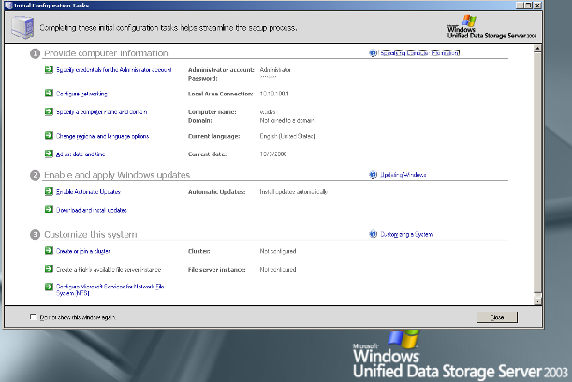

The Initial Configuration Tasks list will simplify an administrator’s efforts in setting up a Microsoft Windows Unified Data Storage Server 2003 system the first time, assuring all the necessary setup tasks are easily completed for a smooth installation. In previous versions of the Microsoft Windows Storage Server products, upon the initial startup, an administrator had to be knowledgeable about the requirements for joining a domain, configuring the network, specifying the computer name, and many other configuration tasks. All system administrators currently have the required skill set to complete the tasks, however you had to know what you had to do and in what order to complete the tasks to make the installation smooth and functional. Today with the new out-of-the-box experience, the “Initial Tasks” to-do list will prompt you through the initial configuration tasks in a logical, orderly fashion.

Microsoft Windows Unified Data Storage Server Management Console
A new Microsoft® Management Console, the Microsoft Windows Unified Data Storage Server Management Console, aggregates and simplifies access to the main functions for managing the “Storage” solution, providing a new layout, updated scenarios, and new system configuration and management options.
At the top most level of the tree is File Server Management. This provides a centralized tool for managing your file server. You can use File Server Management to perform many tasks, such as creating LUNs, formatting volumes, creating and managing shares, defragmenting volumes, setting quota limits, creating storage utilization reports, replicating data to and from the file server, managing storage area networks (SANs), and sharing files with UNIX and Macintosh systems.

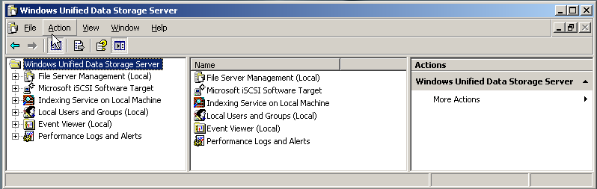

TREE RESULTS ACTION

As you can see the new Management Console is divided into three functional areas:
- The tree is a hierarchical structure in the left pane of the MMC window. The tree shows the items that are available in a snap-in console. These items can include folders, snap-ins, controls, Web pages, and other tools. You can hide or show the tree in the console as well as easily add additional snap-in using the File/Add feature.
- The results pane is the center pane of a snap-in console. It displays objects contained in, or information about, the item currently selected in the tree. The results pane is always visible, but the contents and appearance are dependent on the item that is selected in the tree. This could be referred to as a contextual reference.
- The action pane is the right pane of a snap-in console. It displays the available actions for the items selected in the tree and the results pane. You can show or hide the action pane.
You will notice that the tree pane is very comprehensive in the functions that it contains. Virtually every storage management function you need to complete is contained within this single MMC 3.0 console.
Just as you could in Microsoft Management Console 2.0 (MMC 2.0), you can create or author custom consoles and add them to the console.
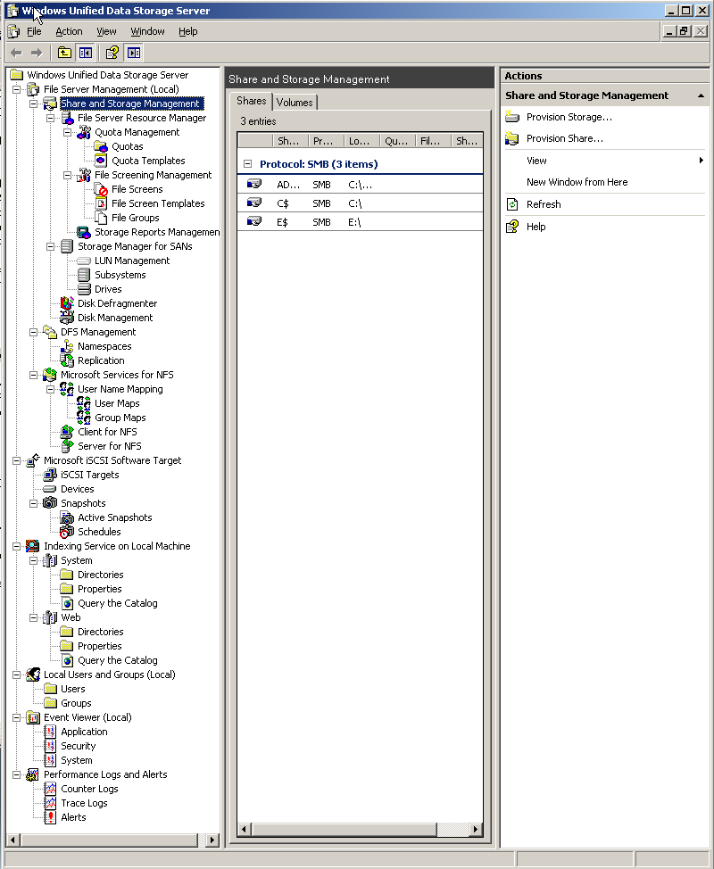

The consolidation of the management tools brings all the tools for File Server, Share and Storage, FSRM, Storage Manager for SANs, Disk Defragmenter, DFS Management, and Microsoft Services for NFS all under one single console, providing easy standardized access to all the tools required to set up and manage your storage. You will not have to be working in a Microsoft Windows console to manage SMB shares and then move to a command line environment for configuring and managing NFS shares. All of this can be accomplished from the same single console.
The same is true for managing the iSCSI Software Target configurations and you can also access the Event Viewer, Performance Logs, and alerts from the same console, once again simplifying the management of the storage environment.

Share and Storage Management
Share and Storage Management is a new MMC snap-in, providing a unified view of storage and shares, allowing for the easy provisioning of shares for SMB and NFS as well as allowing for the provisioning and management of volumes and their key properties.
Having the ability to create SMB shares and NFS shares without having to go in and out of Microsoft Windows applets and command line utilities to complete these tasks make them easier to accomplish. Having an easy tabbed view of the shares and volumes and their key properties once again simplifies the management of the shares, being able to provision and allocate storage including creating a LUN, formatting a volume, and extending volume size as well as deleting or reallocating disk space from a single MMC console reduces the complexity of storage management.

Remote Administration Enhancements
Remote administration can now be accomplished from either a Microsoft Windows or a non-Windows machine, simply by calling http://servername/admin. In the case of a Microsoft Windows machine, client detection occurs within the browser window and an ActiveX Remote Desktop Protocol (RDP) client launches. In the case of non-Windows clients, a Java RDP client is launched. This is accomplished with the aid of a standard IIS installation. This remote management functionality enhances the ability to manage the storage resources of an organization across an enterprise or in remote branch office situations. One important note to remember is that there is no reduction in management capabilities between the Microsoft RDP client and the Java RDP client.

Microsoft RDP Client

iSCSI Software Target
The new Microsoft iSCSI Software Target is a natural expansion of Microsoft’s Windows Storage Server product line and represents the company’s commitment to bring highly functional storage solutions built on industry-standard hardware to the mainstream. Adding Microsoft iSCSI Software Target to Microsoft Windows Unified Data Storage Server 2003 will allow customers to migrate easily to a software-based iSCSI Storage Networking Solution.
The Microsoft iSCSI Software Target snap-in available in Microsoft Windows Unified Data Storage Server 2003 now makes it possible not only for the storage server to connect to remote iSCSI targets, but also to serve as an iSCSI target. With Microsoft iSCSI Software Target, you can create and manage iSCSI targets, create and manage disks for storage, and implement backup and recovery support using snapshots.
The Microsoft iSCSI Software Target is a software-based iSCSI SAN solution that provides the functionality to centralize, consolidate, and manage storage centrally. It is a cost-effective, scalable solution designed to enable customers to quickly install and configure a full-featured storage solution as well as manage other storage already deployed in their environment, and provides support for a broad range of file serving protocols making possible simple and effective file sharing across heterogeneous environments including UNIX, Novell, Apple, and Microsoft Windows. Additionally, support for MPIO allows for easy growth to higher bandwidth capabilities, easily achieving 10 GB network speeds while also providing for a wide range of fault tolerant configurations for disk access.
The Microsoft iSCSI Software Target also supports security protocols and configuration such as:
- iSNS integration
- IPv6
- IPsec
- CHAP authentication
- Supported with applications running on Microsoft Windows including Exchange, SQL, MSCS
The disks you create using iSCSI Software Target are iSCSI virtual disks. These are files in the virtual hard disk (VHD) format. These virtual disks offer flexible and effective storage. They are dynamically extendable to provide extra capacity on demand, enable efficient storage utilization, and minimize the time required to create new disks and the down time typically required to install new disks.
To support creation and management of iSCSI targets, virtual disks, and snapshots, the iSCSI Software Target snap-in provides the following wizards:
- Create an iSCSI Target Wizard
- Create a Virtual Disk Wizard
- Import a Virtual Disk Wizard
- Extend a Virtual Disk Wizard
- Schedule a Snapshot Wizard
- Export a Snapshot Wizard
To provide support for advanced management of iSCSI virtual disks and snapshots, you can install the appropriate hardware providers. These hardware providers, available on the installation CD, include:
• Microsoft iSCSI Software Target Virtual Disk Service Hardware Provider
Microsoft Windows Server 2003 introduced Virtual Disk Service (VDS), a set of application programming interfaces (APIs) that provides a single interface for managing disks. VDS provides an end-to-end solution for managing storage hardware and disks, and for creating volumes on those disks. The Microsoft iSCSI Software Target VDS Hardware Provider is required to manage virtual disks on a storage subsystem.
You install the Microsoft iSCSI Software Target VDS Hardware Provider on each iSCSI initiator computer running a storage management application (such as Storage Manager for SANs) that uses the hardware provider to manage storage, as described later in this guide.
• Microsoft iSCSI Software Target Volume Shadow Copy Service Hardware Provider
iSCSI snapshots are created using Volume Shadow Copy Service and a storage array with a hardware provider designed for use with Volume Shadow Copy Service. A Microsoft iSCSI Software Target VSS Hardware Provider is required to create transportable snapshots of iSCSI virtual disks and create application consistent snapshots from iSCSI initiators.
You install this hardware provider on the iSCSI initiator server and the server that is to perform backups. The backup software you use must support transporting snapshots.

Microsoft iSCSI Software Target Snap-in

Windows Unified Data Storage Server 2003 also includes the following tools and features that enhance and reduce the challenges associated to storage management.

File Server Resource Manager
File Server Resource manager is a suite of tools that enables administrators to understand, control, and manage the quantity and type of data stored on their servers. By using File Server Resource Manager, storage administrators can configure quotas to limit the amount of data stored at the folder, share, or volume level. File Server Resource Manager also enables administrators to actively screen files and folders, and generate comprehensive storage reports. This set of advanced instruments not only helps the administrator to efficiently monitor existing storage resources, but it also aids in the planning and implementation of future policy changes. With File Server Resource Manager, administrators have a valuable tool that allows them to more proactively manage their storage versus the traditional “throw more disk space at the problem” approach.
Three of the major challenges of storage management—capacity management, policy management, and quota management—are all addressed by File Server Resource Manager through the use of quotas and templates.

Quota Management
To assist administrators with the complexity of managing many different sets of user needs, File Server Resource Manager allows the creation of quota templates. By using a quota template, standard quota limits (e.g. storage limits on users folders on a server) can be created and standard sets of notification thresholds that can be applied to a set of quotas. Notification thresholds can be configured so that when the quota limit is approached, various actions are executed automatically. For each threshold defined, e-mail notifications can be sent, events logged, a command or script can be run, or storage reports can be generated. For example, an event can be configured to notify the administrator (and the owner/user involved) when a folder reaches 85 percent of its quota limit, and send another notification when the quota limit is reached. In some cases, administrators may want to run a script that raises the quota limit automatically when a threshold is reached.

Policy Management
File screening in File Server Resource Manager addresses the issue of Policy Management. Administrators typically have no easy way to control the type of data stored on file servers. Unwanted content must be identified manually. File screening can help eliminate non-business files, thereby improving storage utilization and reducing management costs. Implementing policies to restrict unauthorized files also limits legal exposure and can help promote a culture of accountability.
File screens can be applied to a folder tree or volume. Screening rules are based on file groups allowing for differing policies for different sets of files. Screening itself is based on file name patterns (i.e. *.mp3, FY04*). Rules apply to all user files in the folder. Passive and active screening is supported.

Storage Manager for SANs
A storage area network (SAN) is defined as a set of interconnected devices (for example, disks and tapes) and servers that are connected to a common communication and data transfer infrastructure such as Fibre Channel or iSCSI. The purpose of the SAN is to allow multiple servers access to pooled storage—ideally, any server can potentially access any storage unit. In this type of environment, management of storage resources plays a large role in ensuring access for application and users.
The market currently provides a wide variety of storage management software, but most of it is proprietary to a vendor’s hardware offerings and in many cases very expensive. Many larger enterprises have standardized existing offerings, and are now tied to a particular vendor. According to recent industry surveys (ESG, IDC) 35% of small and midsized businesses (SMBs) have moved from direct attached storage to networked storage, and 40% of SMBs are considering moving to networked storage. Many of these organizations have deployed Microsoft Windows as their server platform of choice, in fact, 43% of installed Microsoft Windows servers are in environments where there are less than 15 servers. This data makes it clear that there is an immediate need for a tool that can make it easier to deploy and manage SANs in a Microsoft Windows environment.
Microsoft developed Storage Manager for SANs to address the challenges of storage administrators discussed earlier in this document. Storage Manager for SANs supplies much-needed functionality to organizations requiring a provisioning application for smaller SANs. Storage Manager for SANs is implemented in a familiar and easy to use GUI, based on the widely supported Microsoft® Management Console.
Based on Microsoft Virtual Disk Service (VDS) technology, Storage Manager for SANs allows provisioning on Fibre Channel and Internet SCSI (iSCSI) storage devices. This enables storage administrators to quickly and easily create and assign logical connections to storage devices, regardless of the underlying technologies.
On devices with a VDS 1.1 hardware provider installed, the following setup tasks can be performed:
- For a Fibre Channel storage device:
  - Discover servers and configure their host bus adapter (HBA) ports
- For an iSCSI storage device, perform the following setup tasks:
  - Discover servers and configure their iSCSI initiators
  - Create one or more iSCSI targets on the storage, and enable portals for targets
  - Configure security on targets and portals
The GUI interface enables the discovery of storage devices on a Fibre Channel or iSCSI SAN, including storage device properties. It also allows storage administrators to create, delete, and expand storage devices, configure storage options (such as RAID levels), allocate connections to specific servers on the SAN, and monitor the status/health of servers and storage devices. The following table summarizes the high-level tasks that can be performed using Storage Manager for SANs:

Storage Resource | Tasks
LUNs | - Configure the server and subsystem for LUN deployment. Create LUNs and assign server access, optionally configuring a volume for the LUN  - Rename, extend, and delete LUNs  - View information about LUNs—the subsystem, LUN type, and LUN size; the server or target to which the LUN is assigned; the drives containing extents for the LUN and the I/O paths for the LUN
Subsystems | - View information about storage subsystems—the total capacity, available capacity, and percentage of capacity available; the health and status of the subsystem); controllers and drives on the subsystem  - Rename a subsystem
Drives | - View information about drives—the status and health of the drive; the number of buses and slots; the LUNs that have extents on a drive  - Blink the drive (generally for physical identification purposes)

Existing tools are complex and expensive—Storage Manager for SANs is free, and integrated into Microsoft Windows Unified Data Storage Server 2003 and the previous R2 edition. This is great news for administrators that have limited experience with SAN technologies, but still need a solution to their growing storage management challenges. Storage Manager for SANs provides an easy-to-use way for Microsoft Windows administrators to start sharing and managing storage among servers in their organization, without spending thousands of dollars on additional technology.
System Requirements for Storage Manager for SANs:
Supported Operating Systems: Microsoft® Windows Server™ 2003 Service Pack 1
To use Storage Manager for SANs, the server and the storage subsystem must meet the following requirements:
- The server must be running Microsoft Windows Server 2003 R2 with the Storage Manager for SANs component installed
- The VDS hardware provider for the subsystem must be installed on the server
To use Storage Manager for SANs with an iSCSI subsystem, the Microsoft iSCSI Software Initiator Version 2.0 must be installed on the server. For information about how to download and install Microsoft iSCSI Software Initiator Version 2.0, see Microsoft iSCSI Software Initiator Version 2.0 (http://go.microsoft.com/fwlink/?LinkId=44352)

Access-based Enumeration
File servers are a critical part of every organization’s IT infrastructure and the crucial aspects of effective file sharing—data security and ease of access—must be balanced against each other. To help with this, Microsoft created Access-based Enumeration (ABE) and included it with Microsoft® Windows Server™ 2003 Service Pack 1 to increase security around file sharing, reliably streamline large directory structures for customers, and provide customers with a more seamless migration experience from foreign platforms. ABE filters shared folders visible to a user based on that individual user’s access rights, preventing the display of folders or other shared resources that the user does not have rights to access.
Single Instance Storage
Single Instance Storage works by searching a volume to identify duplicate files. When SIS finds identical files, it saves one copy of the file to a central repository, called the SIS Common Store, and replaces other copies with pointers to the stored versions. The process is transparent to users. A user still sees a file name in the directory, and then clicks it to open the file.
Built-in Collaboration with SharePoint Services
Many organizations with large document management and team collaboration needs rely on Microsoft Windows SharePoint® Services, which is an ideal candidate to extend functionality with Microsoft Windows Storage Server 2003 R2.
Full Indexed Text Search
Indexing Service extracts the information from a set of documents and organizes it in a way that makes it quick and easy to access that information through the Search function for computers running Microsoft® Windows® 2000 or Microsoft® Windows® XP. This information can include text from within a document (its contents), and the characteristics and parameters of the document (its properties), such as the author's name. Once the index is created you can query the index for documents that contain key words, phrases, or properties. For example, you can query all documents containing the word "product," or you can query for all Microsoft® Office® documents written by a specific author. Indexing Service returns a list of all documents that meet your search criteria.
Fast Data Recovery and Background Shadow Copy Creation
With the Volume Shadow Copy Service (VSS), Microsoft Windows Unified Data Storage Server 2003 has the built-in capability to provide extremely fast recovery of lost data—recovery times can be dramatically reduced to minutes rather than the hours or days it can take to recover from tape. Shadow copies, also known as point-in-time images or data "snapshots," can be made as frequently as an administrator deems necessary.
Scalability and Reliability
Devices built on Microsoft Windows Unified Data Storage Server 2003 can range in storage capacity from 160 gigabytes (GBs) to several terabytes. Because disk capacity can be extended by adding new disks to devices without the need for network or server downtime, the process of making additional storage available is simple and non-disruptive. In addition to scalability benefits, existing NAS devices built on Microsoft Windows Storage Server 2003 R2 are highly reliable and have low maintenance requirements and can be completely managed from a Microsoft Unified Data Storage Server 2003 Management Console.

User Scenarios and Benefits
Microsoft Unified Data Storage Server 2003 has been created to address many of the current challenges faced by system or storage administrators today to easily and quickly provision storage resources on demand. Reducing the complexity of storage management while reducing the learning curve for storage administrators is crucial. By addressing these issues Microsoft has addressed the TCO on storage for organizations and shortened the ROI on investments in this technology. Let’s look at how administrative challenges can be addressed through the deployment of Microsoft Windows Unified Data Storage Server 2003.

Storage Consolidation and Centralized Management
Organizations with islands of storage from different vendors can be consolidated for management under a single Microsoft Windows Unified Data Storage Server 2003 management console. This will simplify the overall management of the storage and also ensure that the maximum use and benefit of the storage can be obtained. Also in these types of scenarios the implementation of DFS can greatly enhance how disk space is utilized without the end users knowing where data is actually stored. Through the use of the Microsoft Windows Data Storage Server 2003, Unified Data Storage Server management console, you can manage DFS, shares and share permissions, and disk allocation and assignment, as well as easily add more space to volumes. This, of course, is dependent on the iSCSI Target Software running on the managed servers and the other storage solutions supporting VDS 1.1.
In the scenario depicted in the above diagram, an organization invests in the Microsoft Windows Unified Data Storage Server 2003 to add additional storage to their environment. This organization gains not only the additional storage space, but also the ability to manage their other storage assets through the implementation of the iSCSI Target Software, thereby simplifying storage asset management and configuration.
Data Protection
The traditional approach to protecting data is to deploy backup software and tape hardware in each location. Either the necessary technical staff is hired or untrained employees are given the task of the daily administration of tape backup, rotation, and restore operations. All daily backup and recovery operations are either centralized or decentralized, depending on the specific customer scenario with little or no assistance from the trained technical administrators in the regional data center. This approach to data protection is both risky and costly.
The business needs to invest in tape hardware, backup software, and support expenses for each and every office. Additional IT staff may be required to help support or perform those daily backup and recovery operations. The optional and less costly approach is to rely upon untrained staff to perform daily backup administration activities increasing the risk of data loss.
Backups can fail and go unnoticed, backup policies may not be followed correctly, and poor tape handling (rotation, tracking, and storage on and off site) may lead to significant data issues. Also, the data issues typically become known at the worst possible time—during a recovery. Although this approach may avoid the need for networking connectivity between the branch office and the regional data center, there are significant equipment and personnel costs as well as critical information at risk.
Through the use of Microsoft Windows Unified Data Storage Server 2003, Microsoft System Center Data Protection Manager, and third-party backup software, a simpler, more unified approach to data protection can be achieved. This is depicted in the above diagram; this solution is providing a “Disk-to-Disk-to-Tape” backup solution leveraging VSS and Snap-shots as well as third-party backup software.
One of the biggest issues associated with backups is the window of time available for the backup opportunity. As the volume of data grows, the time window does not change and backups run into work time.
Using the Snap-shot capabilities of Microsoft System Center Data Protection Manager 2006, capturing frequent point-in-time copies of critical business data, many if not all of the issues associated with traditional data backup solutions can be overcome.
Application Support
Enhancing the performance and increasing the availability and resiliency of applications is another key area where Microsoft Unified Data Storage Server 2003 can add great value, either through the support of clustering the application or simply providing enhanced disk protection failure. In the case of both Microsoft® Exchange 2003 and SQL 2005, full clustering support and functionality is supported. Applications like Microsoft Exchange 2003 and SQL 2005 rely on fast access to data. Disk or block data is served to the applications through the use of the Microsoft Windows Unified Data Storage Server 2003 capabilities.
In the drawing below, the disk systems required to support the clustering of the applications are all served up from the Microsoft Unified Data Storage Server 2003 system, which is also configured in a cluster for failover while hosting the databases for both Exchange and SQL, as well as their log files. Utilizing Microsoft Windows Storage Server 2003, the disk is carved up into the required number of volumes and volumes are sized and assigned their roles for each of the specific applications. For example, a volume can be carved out and assigned as the location for placing the mail stores, another volume can be carved out and assigned to hosting the log files, while additional volumes can be carved out of the disk set to host the SQL Database and a separate one for the SQL log files and so on. A separate volume can be carved out for each of the applications to host the Quorum disk required for clustering.
In this configuration you are providing redundancy and resiliency to hardware and application failures. In combination with the data protection scenario in the previous section you can provide rapid recovery to data in the event of a failure or accidental deletion of data. Clients who implement configurations based on Microsoft Windows Unified Data Storage Server 2003 will also gain many administrative advantages, i.e. as more space is required for one of the applications it is easy to add physical disk space and expand the individual volumes.

Summary
Microsoft Windows Unified Data Storage Server 2003 provides the ability to consolidate and manage all the storage resources in an organization into a single unified console, providing immense value to an organization. A familiar Microsoft Windows operating system environment, familiar tools, and management consoles all contribute to the reduction in administrative overhead.
The new Microsoft iSCSI Software Target snap-in available in Microsoft Windows Unified Data Storage Server 2003 now makes it possible not only for the storage server to connect to remote iSCSI targets, but also to serve as an iSCSI target. Using the MMC-based Microsoft iSCSI Software Target snap-in, customers can create and manage iSCSI targets, create and manage disks for storage, and implement backup and recovery support using snapshots.
Remote management of storage resources is greatly enhanced with the introduction of the Web browser management functionality, the setup task list ensures that the initial implementation tasks are completed in an orderly and complete fashion, and the single management console completes the storage management story.
The new Share and Storage Management snap-in available with File Server Management integrates shared folder and storage management functionality, providing the following:
• MMC-based management of shared folders and storage
• Provision Storage Wizard for creating and configuring storage, including creating a logical unit number (LUN) and formatting a volume
• Provision a Shared Folder Wizard for creating and configuring shared folders that can be accessed using either the server message block (SMB) or Network File System (NFS) protocol
The integration of these components and functionality makes it possible to complete most of the administrative tasks required to create and manage shared folders and volumes without having to use the Shared Folders, Storage Manager for SANs, or Disk Management MMCs.
Access to managing physical disks, volume creation and assignment, DFS, NTFS Share creation and permission assignment, assigning and managing disk quotas, snapshot management, access to performance and event log—virtually all storage management functions are contained in a single unified management console.
Microsoft Windows Unified Data Storage Server 2003 offers the most flexible and comprehensive solution to the implementation and management of storage solutions for organization in the mid to small enterprise space. The new features in Microsoft Windows Unified Storage Server 2003 provide a scalable and extensible storage solution for the management of existing storage components from disparate storage providers.

Related Links
See the following resources for further information:
- Microsoft Storage Home
http://www.microsoft.com/windowsserversystem/storage/default.mspx
- Windows Unified Data Storage Server 2003 Home
http://www.microsoft.com/windowsserversystem/storage/wudss.mspx
- Windows Servers in a SAN Environment white paper
http://www.microsoft.com/windowsserversystem/wss2003/techinfo/plandeploy/mssans.mspx
- WS03 and Windows Storage Server 2003: Meeting the Storage Challenges of Today’s Businesses
http://www.microsoft.com/windowsserversystem/wss2003/techinfo/plandeploy/wss2k3storagechal.mspx
- Storage Management Using Windows Server 2003 and Windows Storage Server 2003 Virtual Disk Service and Volume Shadow Copy Service
http://www.microsoft.com/windowsserversystem/wss2003/techinfo/plandeploy/stormgtusingvdsvss.mspx
- String Bean Software performance paper
http://www.stringbeansoftware.com/KB/SBS-Neterion-Bandwidth-Aggregation.pdf

For the latest information about Windows Server 2003, see the Windows Server 2003 Web site at http://www.microsoft.com/windowsserver2003.

