QUICK START GUIDE for the Hosted Archive Service: Microsoft Exchange Server 5.5

Welcome to the Hosted Archive Service! Follow this guide to set up our services in 6 easy steps.

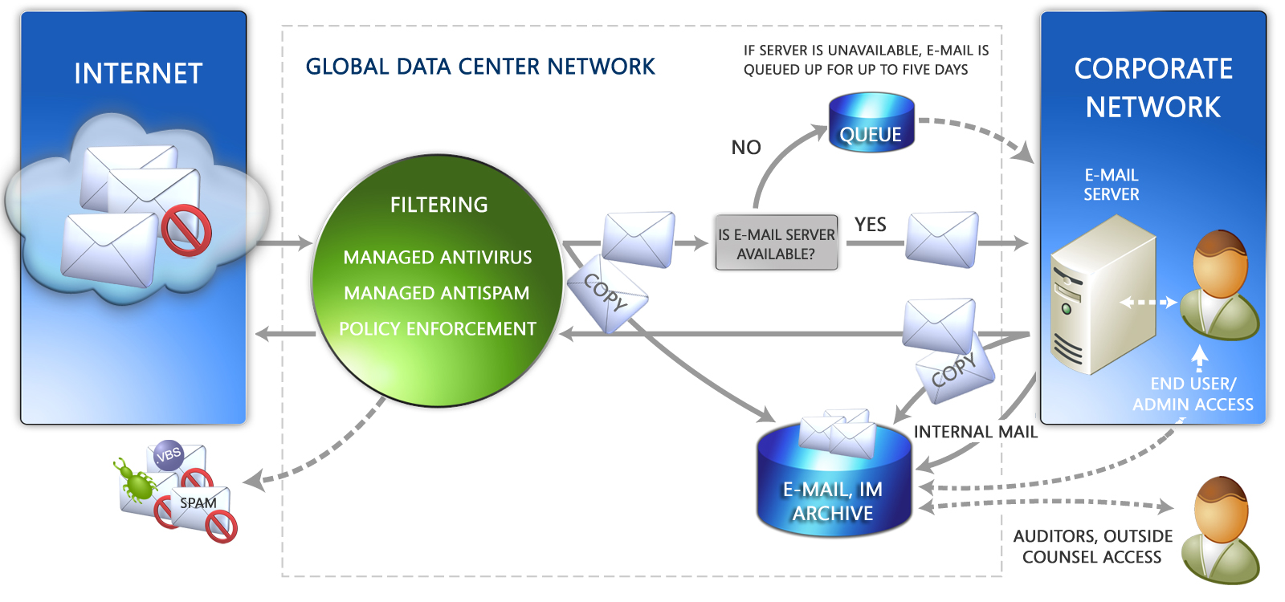

- Configure IP Addresses on Your Firewall

Please ensure that your firewall is able to accept port 25 traffic from the IP address (our data centers), located on the Configuration Info section of the Administration Center.

- Journaling Setup

Please refer to the following link for step by step instructions on how to setup journaling for Exchange Server 5.5:

http://support.microsoft.com/default.aspx?scid=http://support.microsoft.com:80/support/kb/articles/Q239/4/27.ASP&NoWebContent=1
In summary, your server must be configured for Message Journaling. Use Microsoft Windows NT Server registry settings to enable and configure Message Journaling. To configure your server:

- Specify where your messages are to be saved by adding a registry key with the DN of a mailbox, public folder or custom recipient.
- Specify that if Message Journaling is to be done at the server level, site level or organization level.
- To be copied correctly, all Internet Mail Service messages must be routed through the private information store.
- To be copied correctly, local messages must be routed through the MTA.
.
Next, you configure mail journaling to silently send a copy of all mail to the Hosted Archive:
- Create a SMTP contact within Exchange 5.5 Global Address List. This SMTP e-mail address should be set to: copy.nnnn@archive.messaging.microsoft.com (‘nnnn’ will be a numeric ID provided to your organization).
- In the delivery option tab of the journal mailbox, point to the contact created above.

- SMTP Connector and TLS

We recommend that you configure a dedicated SMTP Connector for all of the mail destined for the archive (archive.messaging.microsoft.com) to route directly to the MX record for the archive domain (jmail.messaging.microsoft.com).

Note: If you are a Hosted Archive EMEA customer, configure a dedicated SMTP Connector for all of the mail destined for the archive (emea.archive.messaging.microsoft.com) to route directly to the MX record for the archive domain (emea-mail.messaging.microsoft.com.)

Should you have additional questions please contact a technical support representative.

Configure the connector to use DNS to discover the IP address, and to establish not more than 50 concurrent connections per outbound IP. Keep the number of messages per connection to 50 or below.

In addition we recommend that you configure TLS on this connector to encrypt any outbound traffic.

- Rerouting Inbound Messages Through the Hosted Filtering Service
After you have enabled routing inbound messages by journaling in Step Two, and tested it for approximately 48 hours, you will need to change your MX record to: mail.global.frontbridge.com.

Important: do not resolve mail.global.frontbridge.com to an IP address. For optimal performance, this should be your only MX record.

- Outbound Hosted Filtering Setup

(Note: Prior to configuring, please make sure you are not being used as an open relay.)

Since outbound access through the Hosted Filtering network is IP restricted, please provide all network IP addresses from which you will be sending e-mail to technical support.

Configure your e-mail server to direct all outbound e-mail to mail.global.frontbridge.com.

- Activate the Hosted Archive

If your organization will use the Hosted Archive Directory Synchronization feature please review the Directory Synchronization Tool Installation and Setup Guide before activating your hosted archive.

In order for the Hosted Archive to begin capturing mail in your hosted archive, the hosted archive needs to be activated. Perform the following steps to activate your service:

- Log on at https://archive.messaging.microsoft.com. If you are a Hosted Archive EMEA customer, log on to https://emea.archive.messaging.microsoft.com.

- Enter your username and password as provided by a Client Services representative.

- Click Activate your account.

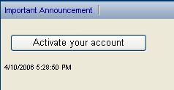

- A confirmation message will appear when the hosted archive is successfully activated. Once activated it may take approximately 10 minutes for messages to appear in the hosted archive.

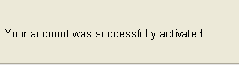

Default Settings for Hosted Filtering Prior to Hosted Archive

You can use the Web-based interfaces to review the settings for Hosted Filtering.
Administration Center Log on: http://admin.global.frontbridge.com

Spam Quarantine Log on:
https://spam.frontbridge.com

Your username and password will be provided to you by a Client Services representative.

Spam Filtering: Spam Quarantine

Spam Quarantine is the most frequently used spam capturing option. Spam is captured at the perimeter. Spam is stored by individual unique e-mail addresses and may be accessed by the Administrator to the account OR by individual end-users (refer to the ‘Spam Filter’ section of the Admin Tutorial document).

24/7 Hosted Services Technical Support:
support@frontbridge.com
1.866.291.SPAM (7726) USA and Canada
204.927.2580 International

In countries/regions supporting UIFN phone routing the EHS support number is 800-00000060. For example, a customer calling from Australia would dial 0011 800-00000060.

Countries/Regions with UIFN support and their dialing codes are as follows:
Australia 0011
Austria 00
Costa Rica 00
Denmark 00
Finland 00
France 00
Germany 00
Hong Kong SAR 001
Italy 00
Japan 0061-010 if Telco is IDC 0041 010 if Telco is Japan Telecom
Luxembourg 00
Netherlands 00
Norway 00
Switzerland 00

The countries/regions that do not support UIFN, will have individual numbers. Those are:
Mexico 001-8885086467
Belgium 0800-75013

Information in this document, including URL and other Internet Web site references, is subject to change without notice. Unless otherwise noted, the companies, organizations, products, domain names, e-mail addresses, logos, people, places, and events depicted in examples herein are fictitious. No association with any real company, organization, product, domain name, e-mail address, logo, person, place, or event is intended or should be inferred. Complying with all applicable copyright laws is the responsibility of the user. Without limiting the rights under copyright, no part of this document may be reproduced, stored in or introduced into a retrieval system, or transmitted in any form or by any means (electronic, mechanical, photocopying, recording, or otherwise), or for any purpose, without the express written permission of Microsoft Corporation.

Microsoft may have patents, patent applications, trademarks, copyrights, or other intellectual property rights covering subject matter in this document. Except as expressly provided in any written license agreement from Microsoft, the furnishing of this document does not give you any license to these patents, trademarks, copyrights, or other intellectual property.

© 2008 Microsoft Corporation. All rights reserved.

Microsoft is a trademark of the Microsoft group of companies.

