Step-by-Step Instructions for Accessing the MCP and MCT Member Sites
The Microsoft Certified Professional (MCP) and Microsoft Certified Trainer (MCT) Member sites use Microsoft Passport Network as their logon authentication technology. Passport Network provides personal authentication services that make it easier for you to move among Web sites. Before you can use Passport Network to enter the MCP and MCT Member sites, you must complete the following process, which is called migration:
- First, associate your Passport Network identification with your Microsoft certification credentials.
- Second, verify or update your profile information.
- Third, specify if you want to receive communications from Microsoft or Microsoft partners for purposes other than administration of the Microsoft Training and Certification Program.
Note that you can view the Microsoft Training and Certification Program Privacy Statement at any time during the migration process by clicking Privacy Statement (MCP/MCT Sites) at the bottom of the member site pages.
To set up access to the MCP or MCT Member sites:
- Begin the MCP Member site authentication process by going to https://mcp.microsoft.com/Authenticate/login.aspx and clicking the Passport Network Sign In button.
- Type the e-mail address and password for your Passport Network account (Figure 1), and then click Sign In. We recommend that you use your existing Passport Network account to enter the MCP Member site instead of creating a new one.
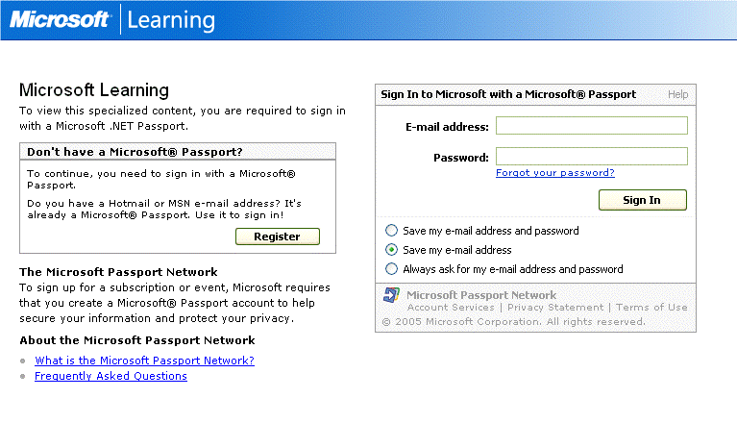
Figure 1
- After you are signed in to the Microsoft Learning Portal (Figure 2), verify that you are a Microsoft Certified Professional by clicking Yes, and then click Next.
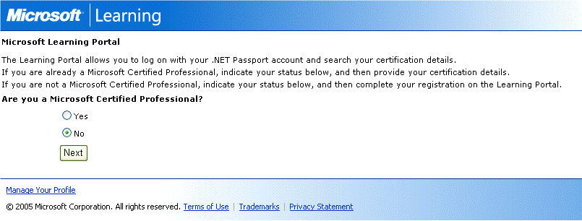
Figure 2
- Enter your MCP ID and the Access Code you received via e-mail, and then click Next. (Access Codes are now provided after passing an initial MCP exam and are good for a maximum of seven days.) This associates your Passport Network account with your MCP certification credentials so that you can access the MCP or MCT Member site (Figure 3). You will need to enter this information only once; future access to the Member site will be done solely via your Passport Network account.
Contact your <link to <http://www.microsoft.com/learning/support/worldsites.asp>Regional Service Center</link> if:
  - You received your Access Code more than seven days ago and the code has expired.
  - You passed your initial exam before January 1, 2005, and need an Access Code to enter the site.
  - You have had access to the Member site but no longer remember the Passport Network account you used.
  - You are unable to migrate successfully.

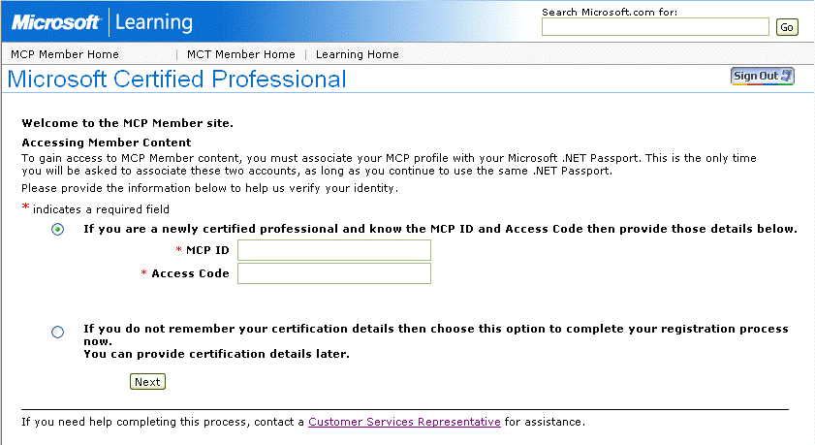
Figure 3

- In the MCP program Profile Editor, update your personal information (Figures 4 and 5), and then click Continue. All required fields are necessary to complete the migration process. The street address, e-mail address, and other information in your profile is the information Microsoft uses to deliver your MCP program benefits and important program-related information.
  - You can access the Profile Editor on the MCP Member site to update your information at any time.
  - The information in the Profile Editor is associated with the Microsoft certification program and your Microsoft.com profile; this information is not associated with your Microsoft Passport Network profile information.
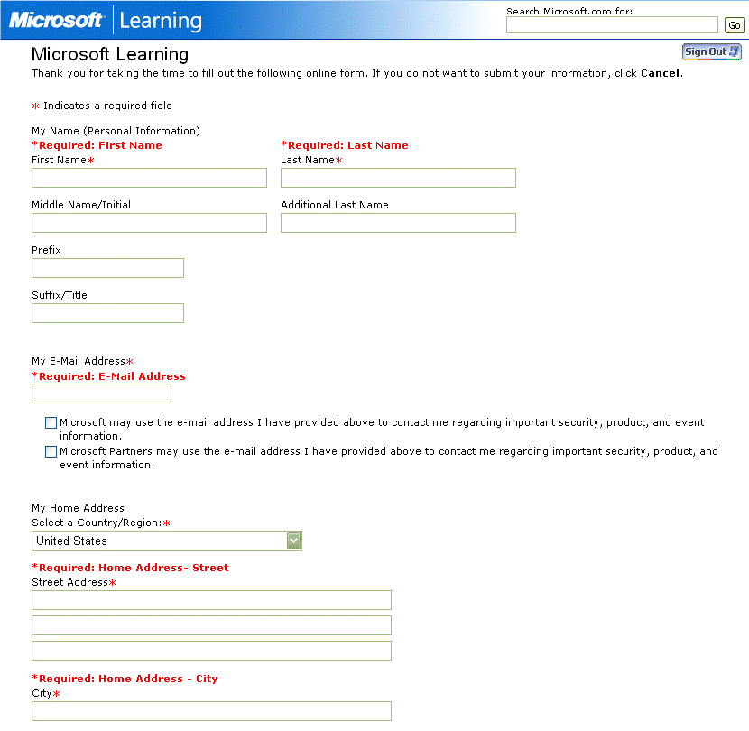
Figure 4
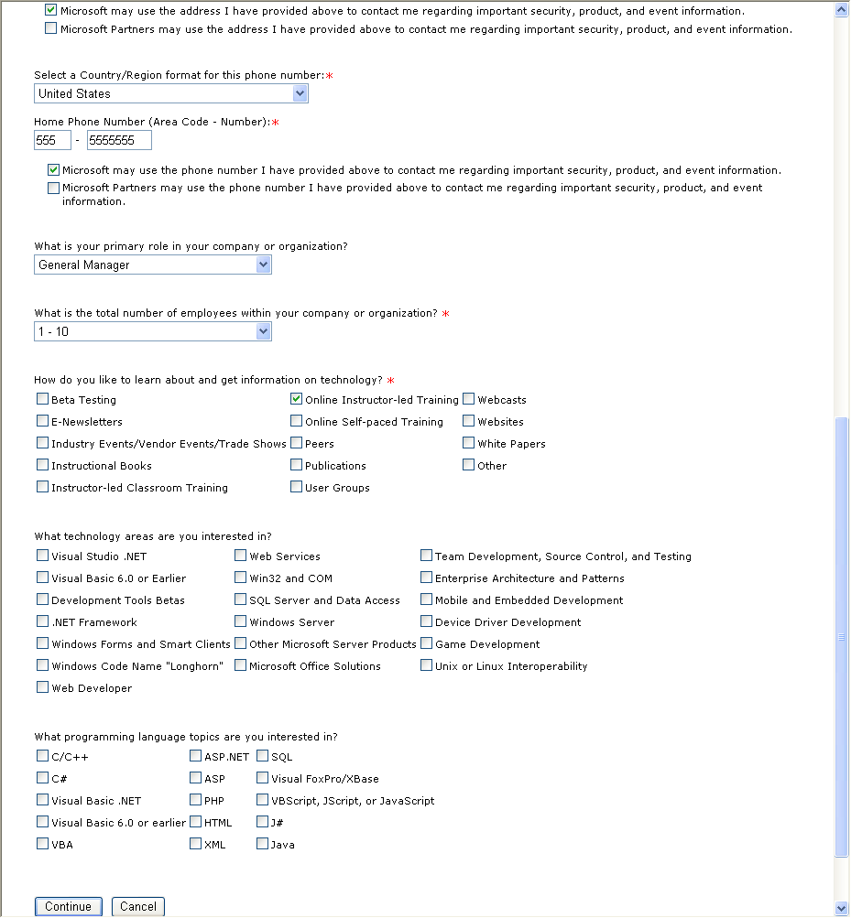
Figure 5
- On the E-mail Confirmation Screen (Figure 6), click Continue. This sends an e-mail message to the e-mail account you provided during migration. To activate your profile, click the link in the e-mail message (Figure 7). Activating your profile is the only way to receive various MCP benefits, such as monthly newsflashes and invitations to participate in beta exams.
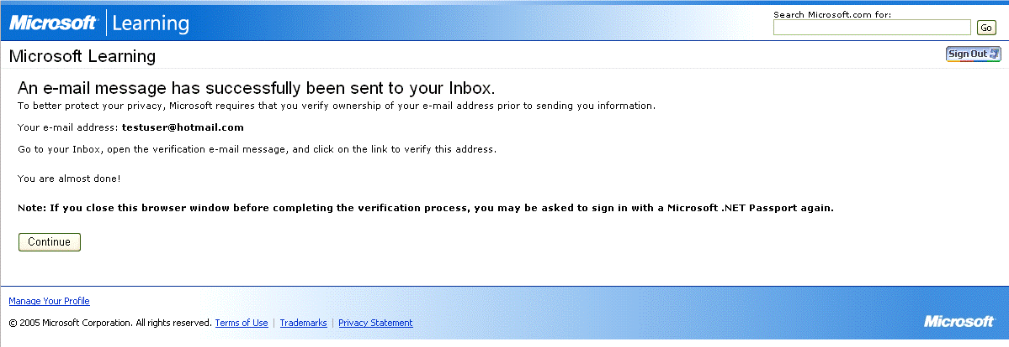
Figure 6
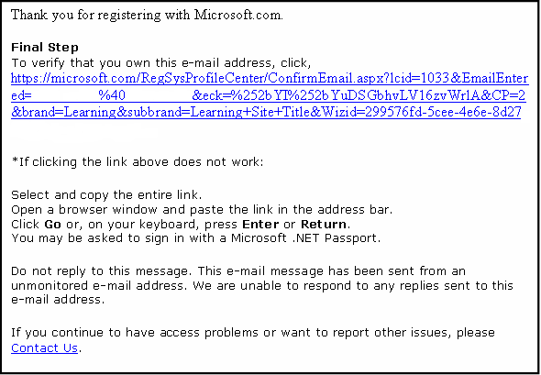
Figure 7
- After you have verified your e-mail address, the Passport Network and Member site migration process is complete. The next time you want to enter the Member site, you will be prompted only for your Passport Network e-mail address and password. No other information will be needed to access the site.
Note: The contact preferences you select during the migration process apply to the Microsoft MCP and MCT Member sites as well as to the Microsoft.com Profile Center. You can make changes to your profile information at any time from any www.microsoft.com/ or www.microsoft.com/learning Web site by clicking Manage Your Profile at the bottom of the page (Figure 8).

Figure 8

If you have recently reached a new certification, don't forget to order your Welcome Kit today!

<link to http://www.microsoft.com/learning/mcpexams/faq/benefits.asp> Welcome Kit </link>

