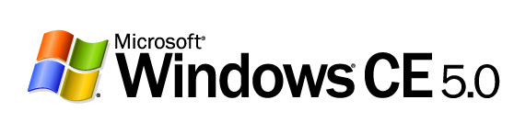
Network Gateway Devices
Microsoft® Windows® CE—A Flexible, Comprehensive Software Platform for Building Network Gateways

Microsoft Corporation
Published: June 2004

Balz Wyss, Ph.D.
Product Manager,
Mobility & Embedded Division (MED)

Abstract
In an increasingly connected world, gateways are rapidly becoming the focal device for connecting digital devices across home and enterprise networks. This white paper summarizes trends in the gateway device industry and presents a detailed description of the Windows CE 5.0 operating system, Microsoft‘s solution for original equipment manufacturers (OEMs) and service operators who want to build and deploy reliable, adaptable gateway devices that end users can easily set up and configure at home or in a small office.

Windows CE 5.0 offers a complete network gateway solution that includes an extensive layer of network protocols, security features, and reliable remote management tools, as well as a ready-to-use sample configuration that allows OEMs and service operators to rapidly build, test, deploy, and service customized network devices. This comprehensive solution also gives partners the flexibility to quickly design and deploy intuitive gateway user interfaces based on familiar Windows experiences, getting to market faster and saving on development and maintenance cost.

The information contained in this document represents the current view of Microsoft Corporation on the issues discussed as of the date of publication. Because Microsoft must respond to changing market conditions, it should not be interpreted to be a commitment on the part of Microsoft, and Microsoft cannot guarantee the accuracy of any information presented after the date of publication.
This document is for informational purposes only. MICROSOFT MAKES NO WARRANTIES, EXPRESS OR IMPLIED, AS TO THE INFORMATION IN THIS DOCUMENT.
Complying with all applicable copyright laws is the responsibility of the user. Without limiting the rights under copyright, no part of this document may be reproduced, stored in or introduced into a retrieval system, or transmitted in any form or by any means (electronic, mechanical, photocopying, recording, or otherwise), or for any purpose, without the express written permission of Microsoft Corporation.
Microsoft may have patents, patent applications, trademarks, copyrights, or other intellectual property rights covering subject matter in this document. Except as expressly provided in any written license agreement from Microsoft, the furnishing of this document does not give you any license to these patents, trademarks, copyrights, or other intellectual property.
©2004 Microsoft Corporation. All rights reserved.
Microsoft, Active Directory, ActiveSync, DirectX,Visual C++, Visual Studio, Windows NT, Windows, the Windows logo, and Windows Media are either registered trademarks or trademarks of Microsoft Corporation in the United States and/or other countries.
The names of actual companies and products mentioned herein may be the trademarks of their respective owners.
Microsoft Corporation • One Microsoft Way • Redmond, WA 98052-6399 • USA

Contents
Introduction 1
Gateway Industry Trends 2
The Roles of Gateway Devices 2
Drivers for Gateway Industry Growth 3
Common Types of Gateway Devices 6
The Microsoft Strategy for Gateway Devices 8
The Microsoft Solution: Windows CE 5.0 8
Windows CE 5.0 Network Gateway Platform Overview 11
Network Protocol Layer Support 11
Applications and Web Services Support 17
Security Services and Features 19
Gateway User Interface Template 24
Additional Benefits of Windows CE 5.0 27
Summary 29
For More Information 30

Introduction
Network communication and Internet connectivity are increasingly important in daily activities and the economy. Whether at work or at home, people rely on digital devices—from personal computers and laptops to mobile and handheld devices, telephones, digital media devices, and game consoles—that are connected to public networks (such as the Internet) and private networks (such as enterprise Intranets and home networks) to accomplish daily tasks. Gateway devices are at the center of the trend toward connectivity. By offering dedicated network protection services, gateways can help secure and provide access to an expanding range of information. Gateways can also give users access to compelling services and applications over public and private networks.
This white paper discusses trends in the gateway industry and provides an overview of common types of gateway devices. It also discusses Microsoft’s strategy for network gateway devices, based on the highly customizable, reliable, ready-to-use components of Windows CE 5.0. The latest version of the Windows CE operating system software enables OEMs to quickly design and bring to market gateways that are easy for end users to set up and configure, and that give users access to a range of services offered by network operators and service providers.

Gateway Industry Trends
Home and business computing gained popularity throughout the 1980s when personal computers emerged as a prominent device category. In the 1990s, an increasing number of other digital devices became popular—such as laptops, handheld devices, digital cameras, TVs, entertainment systems, and gaming systems. As with personal computers, however, these devices usually operated in isolation from home or business networks.
The increasing number of corporate networks and the rapid emergence of the Internet initially offered simple network services, such as e-mail and Web browsing, to personal-computer users. With the recent growth in broadband access, more comprehensive network services, such as e-commerce and multimedia services, are becoming available to the public, along with an increasing number of digital devices.

The Roles of Gateway Devices
A gateway is typically an always-on appliance that connects devices in a small office or home to create a local area network (LAN). A gateway also connects a LAN to other LANs and to wide area networks (WANs) such as the Internet or a corporate intranet. A gateway device allows users to protect, share, store, and access data over any available network.
In the trend toward a digitally connected world, gateway devices fulfill two primary functions:
- Connecting devices to each other (local area network, LAN). Many homes and small businesses use more than one personal computer, in addition to a variety of peripheral devices such as printers and scanners. A gateway connects devices to help users store, share, and protect information within a home or small business network. For example, family members can store items such as photos, videos, music, and schedules on a gateway device to share the files with others. Some gateways provide advanced authentication and user-preference features that enable users to access personal collections of content, such as favorite music and photos, from any device connected to the network or even from the public Internet.
- Connecting networked devices to other networks and services (wide area network, WAN). Gateways enable users to not only connect devices to each other, but also to simultaneously connect their devices to public and private networks. Having access to the network infrastructure allows users to access a broad variety of remote applications and services. For example, users can reserve airline tickets over the Internet or shop online, employees can access corporate e-mail from home and mobile devices, and homeowners can remotely access automated home control systems while at work or on vacation.
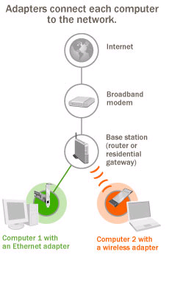
Figure 1. Example of a Basic Setup of a LAN Connected to a WAN

Drivers for Gateway Industry Growth
Most market research reports indicate significant unit and revenue growth for gateways. For example, In-Stat/MDR estimates that the overall value of equipment with a home networking connection of some sort will grow to over $11 billion in 2005, $3.9 billion of which is attributed to gateway-type devices. International Data Corporation (IDC) also predicts considerable growth, predicting total revenue for gateway devices, including hardware, services, and applications to reach $1.1 billion US by 2005.
The growth of the gateway device industry is driven by three primary factors:
- Broadband access
- Multiple-computer households
- Networked applications and services
Broadband Access
As the Internet matures, more and more users are switching from dial-up access to high-speed broadband access—a service that was once available only to large enterprise customers. According to research by Cahners In-Stat Group, broadband subscriptions are expected to increase from 52.7 million in 2003 to nearly 84 million in 2005, an increase of 59 percent. Parks Associates believes that the rate of broadband penetration in the home and small business markets “will be a function of the application and services that are made available” and to which smart gateway devices can provide access. Growth of broadband access will occur primarily in cable and DSL subscriptions, with additional growth in satellite, fixed wireless, and fiber-to-the-home subscriptions.
Multiple-Computer Households
An increasing number of small offices and homes use more than one personal computer, including desktops, laptops, and common peripheral devices, such as printers, scanners, and digital cameras. They may also use an additional array of mobile, telephone, TV, gaming, and entertainment devices. While not all of these multiple-computer households will have a LAN that connects the various devices, a significant number are expected to have a networked home or small office environment. IDC predicts that in 2005 an estimated 23.5 million or 83 percent of multiple-computer households in the United States will have a home LAN.
Networked Applications and Services
Used in home and business environments, gateways initially were designed to provide access to basic network services. Increasingly gateways come with rich features and advanced application functionality, enabling service providers and enterprises to provide office and home users a broad variety of value-added services. IDC estimates that network services revenues will grow at a compound annual growth rate (CAGR) of 29.5 percent from 2002-2007, reaching over $300 million by 2007. For example, some gateways provide high-quality audio and video encoding in addition to multimedia sharing features. Other gateways come with storage features that enable data and device sharing scenarios and allow users to access favorite music, video, photo collections, and printers from digital devices connected to the network.
Gateways may also include features such as a firewall that protects networked devices from unauthorized access, e-mail filtering to detect junk e-mail, and parental controls to help parents determine which content a child can access on the Internet. Other features include Voice over Internet Protocol (VoIP) telephony services, which can bring sophisticated call signaling features, such as call conferencing, call forwarding, and call transfer to a home or small office using advanced digital phones and the IP network for service. Using network security features such as a virtual private network (VPN), users can access confidential data such as corporate e-mail or online bank records over public networks such as the Internet. Advanced gateways can include device management features that enable corporate security policy management and remote management of networked devices to provide software updates.

Common Types of Gateway Devices
Gateway devices are commonly divided into the following three functional categories, or any combination of these three:
- Data Gateway. Data gateways are simple routers primarily used for data throughput. They provide pass-through support for network protocols and services and typically support both wired and wireless networking. Data gateways can be used to pool multiple Internet connections and secure private networks using a firewall. Some data gateways may also provide storage, such as e-mail and voice mail storage.
- Multimedia Gateway. In addition to data gateway features, multimedia gateways provide features targeted to audio and video content delivery. Multimedia gateways are often used in conjunction with digital entertainment devices (including TVs, stereo systems, and gaming consoles) and can provide centralized storage, acting as a home server for digital media, such as photos, videos, MP3 files, and Web site hosting. Audio and video streaming are important features in an entertainment gateway, because they enable users to subscribe to Web-based services such as Video-On-Demand (VOD) and VoIP telephony features. Multimedia gateways also typically include encoding capabilities that transcode analog audio and video signals so users can enjoy media such as cable TV on a personal computer screen.
- Home Control Gateway. A home control gateway enables home control and security service management over a network. For example, users with a home control gateway can access automated lighting, heating, and security systems from work or while on vacation. Home control gateways also allow network service providers to offer new service packages and generate new revenue streams. For example, through affiliation with local utilities, service providers can securely expose energy consumption patterns to customers and provide informed opportunities such as time-of-day usage pricing.
While many products currently marketed as gateways are basic modems and home routers, the trend is towards versatile, multifunctional devices that provide a variety of easy-to-use networking tools and features. According to In-Stat/MDR, by 2007 over 25 percent of all hubs providing access to the network will be gateways, which combine router functionality with various other features such as multi-media, VoIP, and storage.
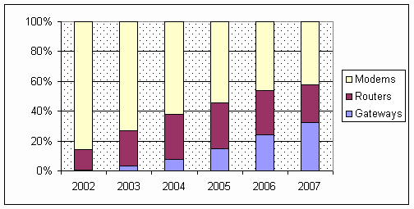
Figure 2. Customer Premises Equipment (CPE) Evolution in Percentage Terms: Modem, router, and Residential Gateway; In-Stat/MDR, 2003.

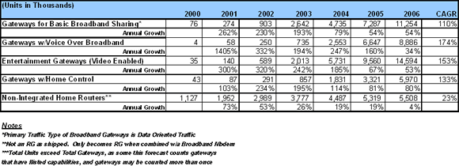 Figure 3. Residential Gateway Units with Service Capabilities (units in thousands), In-Stat/MDR, 2002.

The Microsoft Strategy for Gateway Devices
Device manufacturers and service providers face several challenges when designing and deploying gateway devices, from selecting the most suitable hardware platform, to identifying the features that users want, and determining the appropriate software platform for those features. As gateways become more versatile with advanced features sets for protecting, storing, routing, and accessing audio, video and data files, device manufacturers face three primary challenges:
- Using a comprehensive and robust set of network protocols. Gateway platforms often lack support for networking protocols that adhere to industry standards—preventing device manufacturers, equipment providers, and distributors from rapidly adapting to changing industry trends by developing new gateways or adding feature sets that meet changing user demands.
- Providing extensive security and management capabilities. Many gateways lack the capability to integrate with existing IT infrastructures or provide reliable local and remote access to data, applications, and services over a network—preventing users from more securely sharing, storing, and accessing information or capitalizing on existing IT investments.
- Creating a compelling user experience. Today, many gateways lack easy-to-use interfaces that can provide intuitive access to installation, management, and networking features—preventing users from quickly and easily connecting their digital devices to each other and to other networks.

The Microsoft Solution: Windows CE 5.0
Windows CE 5.0 combines an advanced, real-time embedded operating system with the most powerful tools for rapidly creating, deploying, and managing smart, connected, and small-footprint network devices. The latest version of Microsoft’s componentized operating system provides functionality to build a broad range of network gateway devices with intuitive user interfaces, robust administration and security features, and comprehensive networking capability.
The network gateway solution of Windows CE 5.0 enables OEMs and developers to develop a broad variety of customized gateways. The gateway solution includes the following key features:
- A comprehensive set of networking protocols and features, helping device manufacturers and service providers to rapidly and effectively build and deploy devices with standard wired/wireless network and communication functionality. Newly added features, such as USB Flash Config and Native 802.11, complement the existing set of protocols and features, which include Dynamic Host Control Protocol (DHCP), Network Address Translation (NAT), Ethernet, Bluetooth, Firewall, and Universal Plug and Play (UPnP).
- Robust security features and easy-to-use remote administration tools, enabling efficient integration with enterprise and service operator infrastructures. These include a broad range of widely used protocols and management features such as Kerberos/NTLM authentication, VPN support including IP Security Protocol (IPSec)-based Layer 2 Tunneling Protocol (L2TP), Internet Protocol version 6 (IPv6), Firewall, Systems Management Server (SMS) 2003 device management client software, and support for file and print sharing features. Device manufacturers, service providers and enterprises can flexibly use Windows CE 5.0 components to customize network gateways and better support the broad range of technical and end-user requirements for advanced gateway devices.
- A production quality, easy-to-use, reference gateway user interface (RGUI) for end users, designed to assist device manufacturers, service providers and enterprises in better understanding and implementing customized end-user interfaces that offer user-friendly settings and configuration options.
Network gateways built on Windows CE 5.0 can provide seamless integration with Windows-based client and server systems such as Windows XP desktops and Windows Server™ environments. Core technologies, including Network Driver Interface Specification (NDIS) 5.1, Winsock 2.0, IPv6, and UPnP enable instant interoperability between Windows CE–based network gateways and personal computers, servers, and Web services, making it easy for end users to install and manage a Windows CE–based gateway and devices connected to it.
The footprint size of a gateway depends on the Windows CE components included in the device. The default gateway configuration in Platform Builder, the Microsoft drag-and-drop toolkit to develop Windows CE devices, is approximately 950 KB and can be modified depending on component selection. Advanced power management enables faster gateway performance, while improved memory management provides considerable ROM-size savings, ensuring memory management optimization so applications can run efficiently and seamlessly.
Windows CE is an advanced, real-time operating system (RTOS) for embedded devices. With 256 priority levels and nested interrupt support, Windows CE 5.0 meets demanding, deterministic performance requirements and uses hard real-time response requirements, as well as ultra-low bounded Interrupt Service Routine (ISR) and Interrupt Service Thread (IST) latency. Gateway-specific features, flexible choice of components, and the proven real-time platform provided by Windows CE 5.0 enable device manufacturers, service providers, and enterprises to efficiently address the challenges they face in delivering, deploying, and maintaining smart gateway devices to market. In addition, Windows CE–based devices can be quickly adapted in response to changing end-user demands, so that you can provide new services or update existing ones, and therefore increase worker productivity and generate new revenue streams.

Windows CE 5.0 Network Gateway Platform Overview
This section provides an overview of the Windows CE-based architecture for gateways and its various components. Windows CE runs on various hardware platforms optimized for network gateways. Broad support for common hardware solutions means that device manufacturers and network operators can choose preferred hardware on which to implement a customized gateway device configuration. A broad range of data and network protocols provide data exchange and network security for devices connected to the gateway. A production-quality, pluggable browser-based reference gateway user interface (RGUI) enables users to easily set up and configure the gateway device, including LAN preference settings, parental control configurations, and gateway status options.
Figure 4. Windows CE 5.0 Network Gateway Communications Architecture

Network Protocol Layer Support
Windows CE 5.0 offers a comprehensive layer of network protocols, enabling gateway devices to seamlessly connect a broad range of home and small office devices and networks through wired or wireless access. The following illustration shows the Windows CE 5.0 network protocol layers, including key wired and wireless, dynamic routing, and remote access protocols:
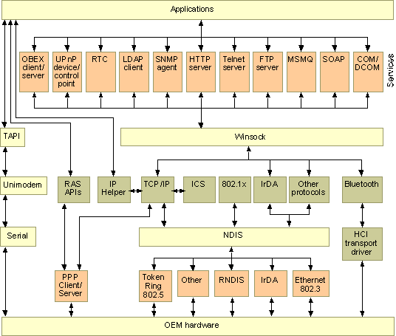
Figure 5. Windows CE 5.0 Network Protocol Layering
The following table lists common network protocols supported by Windows CE 5.0. Many protocols supported in Windows CE 5.0 function as a server towards networked client devices in a LAN (such as personal computers, laptops, and game consoles) and as a client toward devices, applications, and services accessed over a WAN.
Windows CE 5.0 Network Protocol Layer Support | Description
Data Protocols | Network protocol support includes:  - Session Description Protocol (SDP). SDP enables developers to plug in third-party Real-time Transport Protocol (RTP) to support real-time transmission of digital audio and video data.  - Hypertext Transport Protocol (HTTP). HTTP is used primarily to connect to a Web server on the Internet, download HTML page content to a client browser, and define how data is formatted and transmitted.  - File Transfer Protocol (FTP). FTP is used primarily to transfer files between a file server and a client over the Internet and typically requires authentication before a transaction can occur.  - Telnet Protocol. Telnet Protocol is a terminal emulation protocol that allows remote administration of Web servers from a personal computer over a TCP/IP network. Telnet protocol is available in both headless devices, such as gateways, and display-based devices.  - Session Initiation Protocol (SIP). SIP is a signaling protocol that enables IP telephony, alerts, and instant messaging. SIP also initiates data handling, such as routing and authentication, for devices connected over a network and managed as a single domain.  - Simple Network Time Protocol (SNTP). SNTP is a simplified version of the Network Time Protocol (NTP) used to synchronize clocks across a network. Windows CE provides support for both SNTP client and server functionality.
File Transport Protocol Server (FTP Server) | Windows CE 5.0 contains a sample FTP server that can be used for copying files to and from a remote device over a TCP/IP network with a standard FTP client.
Internet Connection Sharing (ICS) | ICS is a collection of technologies that work together to enable multiple devices on a private network to share a single Internet connection. Support for ICS in Windows includes:  - Dynamic Host Configuration Protocol (DHCP) Allocation. A variety of DHCP Server features are supported in Windows CE 5.0. DHCP allocation simplifies network configuration. For example, dynamically assigning IP addresses to devices on a network simplifies administration tasks and allows multiple users to access the Internet at one time.  - Domain Name System (DNS) Proxy (Relay). A DNS proxy server can be used to improve gateway device performance and to set up filters, such as parental controls, for network requests.  - IPv6 DNS Proxy. In Windows CE 5.0, the DNS proxy enables clients to send DNS queries over IPv6. The proxy listens for DNS queries on the well-known, site-local address, and then relays those queries to the current public network IPv4 DNS server. This functionality allows IPv6 clients to perform DNS name resolution.  - Media Access Control (MAC) Address Control. A MAC address is a unique serial number burned into Ethernet and token ring network cards. The MAC layer of a series of protocols controls how a device on a network gains access to view or transmit data. A MAC identifies a device as a unique, addressable unit within a network of devices.  - Virtual Servers. Virtual servers, also called virtual hosts, lower the cost of hosting a Web site by sharing resources with other Web servers. Multiple virtual servers can be managed as one server or system image for an operating system, simplifying network administration.  - Port Forwarding Support. Windows CE-based gateway devices can allocate incoming data to the correct type of port (such as HTTP, audio, or video) on a networked device, or block incoming data based on the type of port for which the data is intended. For example, an enterprise can enable employees to view videos or to listen to streaming media over a corporate intranet, or the enterprise can block the usage of multimedia files.  - Application Layer Gateway (ALG) Support. ALG support allows customized NAT traversal filters to be plugged into the gateway to support address and port translation for non-standard protocols such as DirectX games. ALG enables efficient through-put of PC games based on DirectX technology, increasing the performance of games and other entertainment experiences for end users.
Universal Plug and Play (UPnP) Internet Gateway Device (IGD) Schema | UPnP is architecture for pervasive peer-to-peer network connectivity of devices of all form factors, including intelligent appliances and wireless devices. UPnP is a distributed, open networking architecture that leverages TCP/IP and the Web to enable seamless-proximity networking in addition to control and data transfer among networked devices in the home, office, and everywhere in between.  The key benefit of UPnP is that it allows a device to automatically recognize other devices and their characteristics. In other words, as soon as an end user connects a new device to a network, the device automatically integrates into the network by identifying itself to other devices and is recognized in turn, allowing instant interoperability.  The Windows CE UPnP AV Framework makes it easier to develop UPnP AV devices and control points. It does this by providing a set of C++ classes that define UPnP AV-specific methods and functionality.
Network Bridging | Network bridges interconnect network segments in a multiple-segment network by forwarding frames from one segment to another. Windows CE 5.0 contains Media Access Control–Internet Protocol (MAC–IP) bridge support to control how devices gain access to or transmit data over a network.
Network Utilities | Network Utilities are a collection of utilities, including IPConfig, Ping, and Route, that can be used to troubleshoot various network problems.
Remote Access Server/ PPTP Server (Incoming) (RAS Server/PPTP Server) | Windows CE 5.0 contains the RAS/PPTP server, a remote server that clients can use to create dial-up remote access server (RAS) or VPN connections to a Windows CE-based device.
Simple Network Management Protocol (SNMP) version 2.0 | Windows CE 5.0 supports SNMP, a request-response protocol that transfers management information between managed protocol entities such as hosts, routers, bridges, and hubs and enables monitoring of remote connections to a network. With this standard Internet protocol for monitoring and managing networks, a Windows CE-based device can function as an SNMP agent.
Simple Object Access Protocol (SOAP) | SOAP is an XML-based protocol for object exchange and remote procedure calling. Web Service Description Language (WSDL) and Web Services Meta Language (WSML) files describe these calls.
WAN Connection Support | A WAN typically covers a large geographic region and connects devices over a public network, such as the Internet. WANs also introduce security and authentication challenges, many of which can be resolved by a gateway device. WAN support in Windows CE 5.0 includes:  - Point-to-Point Protocol (PPP) Client. A set of standardized framing and authentication protocols that enable dial-up networking through any server that supports PPP.  - Point-to-Point Protocol over Ethernet (PPPoE). A suite of control protocols that incorporates PPP into cable modem connections. Pope provides the ability to connect a network of hosts to a remote access concentrator over a simple bridging access device.  - Dynamic Host Configuration Protocol (DHCP) Client. A protocol for assigning dynamic IP addresses to devices on a network. Dynamic addressing simplifies network administration tasks by enabling software to track, add, and remove IP addresses without manual intervention.  - IP Auto-Configuration Support. If a DHCP server is unavailable at system start time, Windows CE–based clients can automatically configure an IP address and subnet mask. This feature, Automatic Private IP Addressing (APIPA), is useful for clients on small private networks, such as a small business office, a home office, or a remote access client.
Windows Networking API/Redirector (SMB/CIFS) | The Windows Networking API/Redirector (SMB/CIFS) manages network connections and accesses remote Server Message Block (SMB)/Common Internet File System (CIFS) file systems and printers.
Windows Sockets (Winsock) Support | Winsock is a general-purpose networking API that provides access to multiple TCP/IP protocol stacks, including IPv6. Windows Sockets 2.2 provides enhanced capabilities over Winsock 1.1, including installable service providers for additional third-party protocols and MediaSense, a mechanism for the network adapter to notify the protocol stack of media-connect and media-disconnect events.
Wired LAN Support | Many protocols supported in Windows CE 5.0 function as a server towards networked devices in a LAN and as a client towards devices, applications, and services accessed over a WAN. Windows CE-based gateways support the following wired network protocols and technologies:  - 802.3 (Ethernet). Institute of Electrical and Electronics Engineers (IEEE) standard for LAN access methods.  - Network Driver Interface Specification (NDIS) 5.1. Describes the standard network driver architecture for all Windows-based platforms. In a Windows CE-based device, NDIS is implemented as an intermediate driver and used for network bridging and routing. The intermediate driver appears as a miniport to the protocol layer above it, and as a protocol driver to the miniport driver to which it binds.  - Home Phoneline Networking Alliance (HomePNA). Enables the creation of home communication networks using existing phone lines.  - Digital Subscriber Line (DSL). Increases the digital capacity of existing telephone lines without interfering with voice bands. Windows CE 5.0 does not ship with DSL technologies, however, third-party DSL technologies can be added to Windows CE-based gateway devices.
Wireless LAN Support | Wireless networking support includes:  - Bluetooth. A short-range wireless technology that enables data communication between devices. It also provides the capability for using a Bluetooth-enabled cellular phone as a data modem, exchanging information with other Bluetooth devices and providing network access.  - 802.11. Enables gateways to function as wireless access points providing high bandwidth connectivity. Windows CE includes support for 802.11a (a maximum of 11 megabits per second [Mbps]; requires drivers), 802.11b (a maximum of 54 Mbps; requires drivers), and 802.11g. 802.11 Zero Configuration in Windows CE 5.0 simplifies setup of 802.11 networks and enables seamless roaming from one 802.11 network to another.  - Native 802.11. Specifies a wireless LAN framework that provides an improved 802.11 user experience, and lower 802.11 device and infrastructure deployments costs. Native 802.11 provides enhanced wireless networking options such as security power management, roaming, load balancing, Quality of Service (QoS), and location awareness.  - 802.1x. Helps provide secure access to the network to support wireless LANs and Ethernet. It enables interoperable user identification, centralized authentication, and dynamic key management, and can secure both wired and wireless LAN access.
Serial Communications | Serial I/O is the simplest form of communication supported by Windows CE. It includes the serial port driver and support for Infrared Data Association (IrDA) communications.
This extensive range of networking and security features provided with Windows CE 5.0 enables device manufacturers and OEMs to rapidly develop and deliver extensible, customized gateways.

Applications and Web Services Support
The Windows CE platform enables OEMs, service providers and enterprises to add applications and services to gateway devices, including such features as voice mail, e-mail filtering, and multimedia applications for managing audio, video, and other media types. Windows CE 5.0 provides an application layer with device and application management services that includes the features in the following table:
Windows CE 5.0 Applications and Web Services Support | Description
File and Print Sharing | File and print sharing features, which are included with Windows CE 5.0, allow users to manage network connections and access remote file systems and printers through the Windows Networking API/Redirector. Due to the fact that some Server Message Block (SMB) functionality is included in Windows CE 5.0, printer and file redirection through Windows computers functions without users having to install any additional drivers.
Logging | Windows CE 5.0 supports the logging of errors, events, database transactions, and data such as a list of visited Web sites. Error reporting (Dr. Watson) is also available.
Error Reporting | Error reporting is provided as a Catalog item you can use in your OS design. This error reporting allows a device to automatically save the state of the machine at the time of an exception. You have the option of transferring the saved information to a file and uploading the file to the Watson Web site at Microsoft. The standard error-report format includes extremely useful information for developers, such as the following:  Stack details  - Some system information  - A list of loaded modules  - Exception type  - Global and local variables
Management Information Base (MIB-II) | Windows CE 5.0 supports MIB-II, which is a map of the hierarchical order of all managed objects or MIB variables. Each system in a network—for example, workstations, servers, routers, or bridges—maintains a MIB that reflects the status of the managed resources in that system, simplifying administration.
Web Server (HTTPD) | Contained in Windows CE 5.0, Web Server (HTTPD) is a lightweight HTTP server that provides a means for remote configuration on headless devices and offers ASP and ISAPI extension and filter support, in addition to Secure Socket Layer (SSL) support. HTTPD supports:  - Active Server Pages (ASP). Provides a server-side scripting environment to create and run dynamic, interactive Web server applications.  - Web Administration ISAPI Extensions. Provides remote device configuration, device browsing, file uploading and downloading, and registry editing.
USB Flash Config | The USB Flash Config Tool directly addresses the pain points a user encounters configuring networked devices, particularly wireless. The USB Flash Config tool was developed to support a significant better together scenario using Windows XP Service Pack 2. The USB Flash Config Tool uses a subset of the XML schema that is supported in the service pack to automate the association of networked devices. It currently supports WEP (40 bit , 84 bit ) and WPAPSK.
Quality of Service (QoS) | Windows CE 5.0 supports Differentiated Services (diffserv), enabling quality of service (QoS) by marking IP packets for priority migration across routers.

Security Services and Features
With the broad range of security features available in Windows CE 5.0, device manufacturers, service providers, and enterprises can provide more secured network gateways to help protect the data, communications, and privacy of office and home users alike. The following illustration shows how the application layer supports security and administration services and features in a Windows CE-based device.

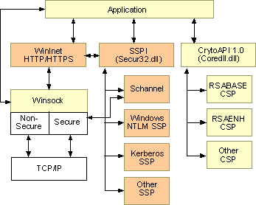
Figure 6. Key Windows CE 5.0 Security Services and Features
The following three tables outline the key security technologies that are available in Windows CE. The encryption and authentication features listed below are a sampling of those included in the latest version of the operating system platform:
Windows CE 5.0 Encryption and Authentication Features | Description
Cryptographic API 2.0 (CryptoAPI 2.0) | In addition to CryptoAPI 1.0, Windows CE 5.0 supports certificate creation using CryptoAPI 2.0. CryptoAPI is an interface that provides basic cryptography services, such as data encryption/decryption schemes, authentication using digital certificates, and encoding/decoding to and from ASN.1 to their Microsoft Win32®–based applications. CryptoAPI also enables users to manage X.509 digital certificates. You can use the functions in CryptoAPI without detailed knowledge of the underlying implementation.  A cryptographic service provider (CSP) contains implementations of cryptographic standards and algorithms. Examples of CSPs included with Windows CE 5.0 are Smart Card Encryption Provider, the Microsoft Digital Signature Standard (DSS), and Diffie-Hellman Cryptographic Providers.
Internet Key Exchange (IKE) | Windows CE 5.0 supports IKE, which is an encryption/decryption method that uses public key cryptology to transmit a secret key to a recipient device so data can be decrypted. IKE also authenticates users when negotiating encryption and keys.
Virtual Private Networking (VPN) | Windows CE 5.0 enables VPN—a private network configured within a public network such as the Internet—for home and small business communications and data sharing. A VPN uses security services and encryption protocols such as RAS and PPTP to control access to the network. Windows CE 5.0 contains a PPTP VPN client and server in addition to an L2TP/IPSec VPN client. VPN services are available on headless devices, such as gateways, and display-based devices.
Point-to-Point Tunneling Protocol (PPTP) | Windows CE 5.0 supports PPTP, a protocol that provides an encrypted and secured connection so a user can communicate or exchange data securely with another IP-connected device or a remote network. By supporting multiple protocols and data encryption technologies, PPTP provides secured, on-demand, virtual networks over dial-up lines, LANs, and WANs including the Internet and other public TCP/IP-based networks. Windows CE 5.0 supports both the PPTP client and server. Having client-side and server-side PPTP available in Windows CE enables PPTP pass-through scenarios, such as using the PPTP client from within a LAN to connect to a WAN, in addition to the reverse scenarios, such as connecting to the LAN from the WAN, for example a VPN connection from a public Internet terminal or a corporate PC to the home network.
Protected Store | In a home or small business network where two or more users can access the same devices, the protected store API provides a convenient solution to cryptography, key management, and user experience issues while protecting sensitive information and preventing data tampering. Windows CE 5.0 uses two CryptoAPI functions, CryptProtectData and CryptUnprotectData, to take user logon credentials and lock and unlock private data. Using Protected Store, OEMs can add smart card or biometric credential functionality to a device.
Authentication Services | Windows CE provides security services for user authentication, credential management, and message protection through a programming interface called the Security Support Provider Interface (SSPI). SSPI is a well-defined, common interface for obtaining integrated security services for authentication, message integrity, and message privacy. It provides an abstraction layer between application-level protocols and security protocols, enabling users to access one of several security providers without knowing the details of the security protocol. The security providers included with Windows CE are Kerberos, NTLM, and Schannel.  - Kerberos. A protocol for mutual authentication between entities that uses unique keys to enable the exchange of private information on an open network.  - NTLM. The default authentication protocol for Windows NT®. NTLM is a challenge/response authentication protocol and includes the Windows NT LAN Manager.  - Schannel. A protocol for secure authentication and encryption using SSL 2, SSL 3, and Transport Layer Security (TLS/SSL 3.1) public key-based protocols.  OEMs also have the option of writing their own security package and adding it to the registry for applications to use.
Credential Manager | This feature is automatically included with Kerberos and NTLM authentication service in the Windows CE 5.0 Catalog. The Credential Manager enables users to save a name, password, and other authentication information on a device and keeps track of that information.
Extensible Authentication Protocol (EAP) | EAP provides a standardized support mechanism for authentication schemes, such as token cards, certificates, Public Keys, and S/Key. EAP allows OEMs to plug in additional authentication schemes. On a Windows CE-based device, 802.1x, PPP, and PPTP can support EAP.
Protected Extensible Authentication Protocol (PEAP) | PEAP is an EAP extension for Windows CE that provides increased security during authentication. PEAP allows for secure mutual authentication between an EAP client and an EAP server using username/password authentication instead of client certificate authentication.
Public Key Infrastructure (PKI) | Windows CE 5.0 contains support for PKI, an authentication technology that uses digital certificates issued by certificate authorities (CA) to authenticate users (or messages signed with a digital certificate) on public and private networks.
Smart Card Support | Windows CE provides a smart card subsystem that supports CryptoAPI and the Windows CE-based device driver model for developing smart card readers. The subsystem provides a link between smart card reader hardware and applications that are smart card aware, and consists of dynamic-link libraries (DLLs), the smart card resource manager API, and the smart card reader hardware device drivers. Additional PC/SC support facilitates the porting of existing smart card reader drivers and service providers.
Secure Socket Layer (SSL) | SSL enables an application to use secured sockets to send and receive encoded data over communication lines. Windows CE supports SSL versions 2.0, 3.0, and 3.1—SSL version 3.1 is also known as Transport Layer Security (TLS)—which are available through Windows Internet Services (WinInet) or directly from Windows Sockets (Winsock).

Windows CE 5.0 also contains support for the following security protocols:
Windows CE 5.0 Security Protocols | Description
Layer 2 Tunneling Protocol/IP Security (L2TP/IPSec) | Windows CE enables L2TP/IPSec client functionality and can be used to provide confidentiality and data integrity protection in a VPN. L2TP uses IPSec encryption to help protect a remote VPN connection through a gateway device to a home or small office LAN. IPSec is an Internet-based security protocol that provides authentication and encryption to all devices within a network.
VPN Pass Through | Windows CE Network Address Translation (NAT) has built-in handling that allows multiple PPTP sessions to pass through, allowing multiple clients on a private (internal) network to connect and maintain PPTP sessions to external PPTP servers.
Wi-Fi Protected Access (WPA)/802.1x | WPA implements 802.1x and Extensible Authentication Protocol (EAP), and uses Temporal Key Integrity Protocol (TKIP) to address known Wired Equivalent Privacy (WEP) issues, increasing data protection and access control for wireless networks. Windows CE 5.0 includes client-side support for WPA.  802.1x is a security protocol that provides authenticated access to 802.11 wireless networks and to wired Ethernet networks. 802.1x minimizes wireless network security risks by providing user and computer identification, centralized authentication, and encryption services based on the WEP algorithm. 802.1x addresses WEP shortcomings with enhanced mutual authentication and dynamic key distribution, and includes TKIP. 802.1x also supports the EAP that allows you to use different authentication methods, such as smart cards and certificates.

In addition, Windows CE 5.0 contains the following firewall and filtering technologies:
Windows CE 5.0 Firewall and Filtering Technologies | Description
Internet Connection Firewall (ICF) | Windows CE includes firewall software that blocks unsolicited connections originating from the Internet (also known as the packet filter). To accomplish this, the firewall uses Network Address Translation (NAT) logic to validate incoming requests for access to a network or the local ICF host. The firewall also allows rules to be created based on source and destination information, ports, and other criteria.  ICF can protect a single device or a home network from network attacks. ICF also makes files and folders that are shared among networked devices invisible to other users on the Internet.  ICF features in Windows CE 5.0 include:  - Port Filtering. Silently discards unsolicited communications, stopping common hacking attempts such as port scanning. ICF can create a security log to view the activity that is tracked by the firewall.  - Internet Control Message Protocol (ICMP) Filtering. Provides a way to create a security log of firewall activity.  - Stateful Packet Inspection. ICF monitors all aspects of the communications that cross its path and inspects the source and destination address of each message that it handles.  - Denial of Service (DoS) Attack Prevention. Allows you to set the allowable size of the ICF security log to prevent the potential overflow that could be caused by denial of service attacks.  - Demilitarized Zone (DMZ). ICF provides packet filtering capabilities to computers on a perimeter network, also sometimes referred to as a demilitarized zone. A DMZ is a boundary between the Internet and an internal network's line of defense, usually a combination of firewalls and bastion hosts, which are gateways between private and public networks. DMZ support enables hosting of Internet services without sacrificing unauthorized access to a private network.  - Firewall Support for Internet Protocol version 6.0 (IPv6). IPv6 addresses many of the IPv4 limitations. The latest version of the protocol provides increased address space, uses hierarchical routing tables, and supports both stateful and stateless IP address configuration.
Internet Protocol version 6.0 (IPv6) | Windows CE 5.0 supports IPv6, a suite of standard network layer protocols that uses 128-bit addresses to provide more IP addresses than its predecessor, IPv4, which uses 32-bit addresses. IPv6 uses hierarchical routing tables, supports both stateful and stateless IP address configuration, and is available in headless devices and display-based devices. Windows CE 5.0 includes IPv6 components specifically designed for gateway devices that enable the richest IPv6 experience for clients sitting behind the gateway, providing protection while ensuring connectivity.
IPv6/IPv4 Tunneling | Windows CE 5.0 provides support for IPv4 and IPv6 coexistence and migration technologies such as 6to4, an address assignment and router-to-router automatic tunneling technology used to provide unicast IPv6 connectivity between IPv6 sites and hosts across the IPv4 Internet.

Gateway User Interface Template
Windows CE 5.0 contains a production-quality RGUI that provides end users with easy access to setup, administration, and application and service configuration options. The RGUI is Web-based and builds on familiar Windows experiences, making it intuitive to users. Since the RGUI is shipped in source code, device manufacturers, service providers, and enterprises can easily modify the RGUI to better meet user requirements for a customized device.
The RGUI Catalog item includes a set of HTML pages that can be used for gateway devices. Functionality includes providing a wizard framework for initial setup and common tasks. The UI also provides support for common user tasks, such as parental control, setting up the firewall, security settings and configuring advanced features.
The OEM can customize the RGUI template to include branding and other hardware specific functionalities. The UI framework has also been componentized to allow developers to easily adapt the UI to a wide range of headless devices.
Using the RGUI, home and small business users can configure network features such as the preferred network connection, security settings, content filters, logging databases, and backup and restore features. The following graphics show examples of configuration and status options in the integrated Windows CE 5.0 RGUI:
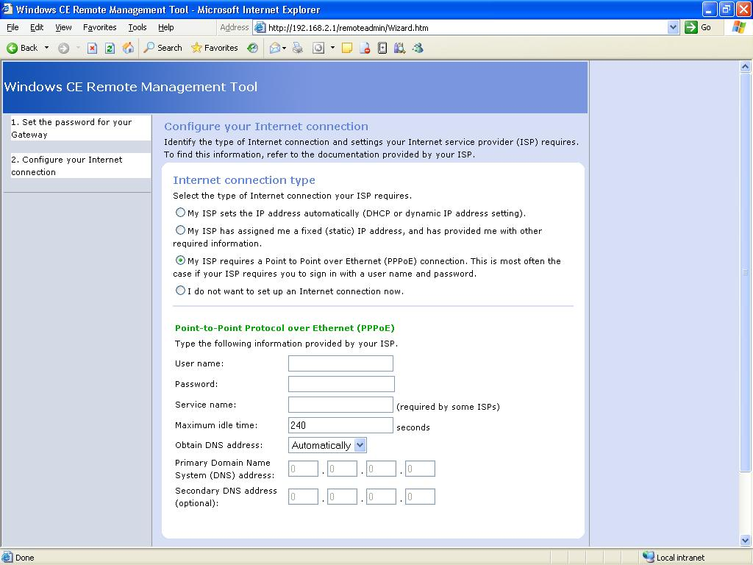
Figure 7. Configure Your Internet Connection Screen of the RGUI.

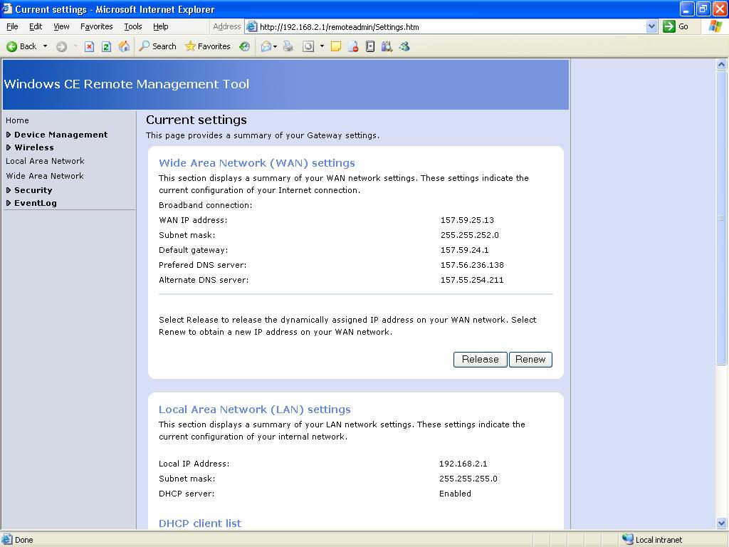
Figure 8: Current Settings Screen of RGUI.

Additional Benefits of Windows CE 5.0
Windows CE 5.0 ships with many additional development tools and features to help you build an adaptable, reliable gateway device, for example:
Additional Windows CE 5.0 Features | Description
ActiveSync | Windows CE 5.0 supports ActiveSync®, a service manager that maintains a device partnership with a computer host and enables remote procedure calls and data synchronization. You can add the following ActiveSync features to a gateway device:  - File Sync. Provides file synchronization.  - Inbox Sync. Synchronizes e-mail messages in conjunction with the Pocket Outlook Object Model (POOM) API.  - Pocket Outlook Database Sync. Synchronizes personal information manager (PIM) components, such as calendar, contacts, and tasks; also works in conjunction with the POOM API.
Broad Hardware Support | Windows CE-based devices run on a variety of commonly used hardware platforms, including four common families of microprocessors:  - ARM  - MIPS  - SH  - X86  Many silicon vendor partners also provide hardware platforms and reference designs optimized for Windows CE-based gateway devices. For the current list of supported hardware platforms, visit the Windows CE Supported Processors page.
Lightweight Directory Access Protocol (LDAP) Client | Windows CE supports the LDAP client, a protocol that is used to access a directory that stores names, addresses, phone numbers, and other types of information. The client consists of LDAP and a C API, which simplifies writing directory applications and can be used to query, add, update, and delete entries in any LDAP-compliant directory, such as Microsoft Active Directory®.
Multilingual Support | Windows CE comes with multilingual support based on the Multilingual User Interface (MUI). The MUI allows device designers, manufacturers, and network operators to change a device UI language and deploy the UI in multiple languages.
Trusted Environment Model | To help secure your operating system from potentially unsafe operations, Windows CE 5.0 supports the trusted environment model, which allows users to specify a trusted environment where only certified applications can run. A trusted environment can prevent unknown modules from loading, restrict access to system APIs, and prevent write access to certain parts of the system registry.
Windows Media® 9 Series Audio and Video Codecs | Audio and video codecs enable encoding/decoding and compression/decompression of multimedia signals at the gateway device. For example, a gateway can decode data from a broadband connection and deliver it to a personal computer, or data may be decoded by the personal computer within the home or home network.  Windows CE 5.0 supports WMA and MP3 local playback and streaming. It also supports WMV and MPEG 4 streaming. The extension .wma or .wmv is used to specify an Advanced Streaming Format (ASF) file that contains content encoded with the Windows Media Audio and/or Windows Media Video codecs. For more information about multimedia technologies in Windows CE, see the Latest Multimedia page.

Windows CE 5.0-based gateways make it easy to integrate a broad variety of devices into a network, including digital entertainment systems, mobile and handheld devices, thin clients, personal computers, gaming devices, set-top boxes, and a variety of other consumer electronics. Windows CE 5.0 provides customizable solutions for these device platforms. A key feature in operating-system support for these platforms is the addition of the Microsoft .NET Compact Framework 1.0, which enables software developers to write an application once that will then run on any .NET Framework Windows device.
Another key feature is support for native and managed code for writing applications for Windows CE 5.0. Microsoft offers a rich set of languages for creating managed .NET-enabled or unmanaged (native) applications. This means that device manufacturers and network operators can use their preferred application framework to implement a Windows CE gateway device solution. For managed code, Microsoft Visual Studio® .NET should be used, and for native code Microsoft eMbedded Visual C++® 4.0.
For more information on managed and native application development for Windows CE, visit the Application Development Resources page.
In addition, the Windows CE operating system software contains or supports some Visual C++ libraries and runtimes, Common Language Runtime (CLR), and three levels of Component Object Model (COM) support: Minimal COM, COM, and DCOM. Windows CE 5.0 also supports Web service development with Microsoft Message Queuing (MSMQ), Microsoft XML (MSXML) Core Services, and XML Web Services.

Summary
OEMs and network service providers face many challenges for delivering network gateways that are easy to set up and configure in home or small office environments. To meet these challenges, Windows CE 5.0 provides a customizable user interface that OEMs and network service providers can use to expose a comprehensive and robust set of network protocols and extensive security and remote management capabilities in a user-friendly way.
Offering an integrated development environment and a highly componentized operating system, Windows CE 5.0 provides flexibility and extensibility to partners who want to cost-effectively develop, deploy, and manage a broad range of network devices—from small-footprint data routers to powerful, feature-rich gateways with multimedia, storage, and voice capabilities. Windows CE is also Microsoft .NET-enabled so device manufacturers and service providers can support compelling services and applications and multimedia content in advanced gateway designs.
Windows CE comes with an easy-to-use, end-to-end tool set that includes Platform Builder (PB) and a new Platform Wizard which can enhance developer productivity. In addition to sophisticated tools for developers, Microsoft provides the following partner services as part of Windows CE:
- Easy Licensing. Microsoft’s simple, straightforward licensing agreements have been developed to work well with the business models of OEMs.
- Accountable World Class Support. Microsoft provides world-class support for all its products, even many years after the product is discontinued. In the long run, the gateway industry will be able to depend on Microsoft to provide support.
- Adherence to Industry Standards. Windows provides an end-to-end solution for the needs of gateway device manufacturers and network operators. Microsoft adheres to industry standards.
- Secured Platform. Microsoft continues to invest heavily in making Windows more secure for the gateway industry.
- Standards and Tools. Windows comes with readily available development tools such as Platform Builder (PB).

For More Information

- For the latest information on Windows CE 5.0, visit the Windows CE Web site: http://msdn.microsoft.com/embedded/ce/

- For technical information about embedded operating system development, visit the Windows Embedded Developer Center:
http://msdn.microsoft.com/embedded/default.aspx

- View the Windows CE online product documentation:
http://msdn.microsoft.com/library/default.asp?url=/library/en-us/wcelib40/html/pb_start.asp

- Check out the Windows Embedded newsgroups: http://msdn.microsoft.com/embedded/community/community/newsgrp/default.aspx

- Participate in a Windows Embedded chat: http://msdn.microsoft.com/chats/

- Get tips and advice in the Windows Embedded Community: http://msdn.microsoft.com/embedded/community/community/default.aspx

Michael Wolf, “Digital Domicile 2004: Home Networking hits the Big Time”. In-Stat MDR, Report no. IN0401227RC, April 2004.
Bumback, Jaclynn, “Home Networking Software: The Secret Sauce of the Residential Gateway,” In-Stat MDR, Report no. IN020242RC, June 2002.
Olhava, Schelley, “U.S. Residential Gateway Market Forecast and Analysis, 2001–2005,” International Data Corporation, Report no. 25878, 2001.
Kurt Scherf, Michael Greeson, and others, “Drivers for Home Networks and Residential Gateways: 2002,” Parks Associates (2002).
International Data Corporation, Report no. 24888 (July 2001).
Jonathan Gaw, “Home Networking Services Forecast, 2003-2007”, Report no. 30585, IDC, December 2003.
Michael Wolf, “The Broadband CPE BIG Three: Residential Gateway, Modem & SOHO Router Market Analysis”, In-Stat/MDR, report no IN030659RC, October 2003.
Michael Wolf, “Residential Gateways: The Coming Battle for the Digital Living Room”, Report no. IN0202233, March 2002.

