MS Reports Platform for End User Reporting and Analysis
Situation
Microsoft's reporting platform was no longer poised to meet business needs. There existed a lack of processes, tools and coordinated infrastructure to support an efficient workflow. Providing consolidated reports from Microsoft's numerous reporting groups, each with unique applications and incompatible data structures, was overly difficult.
Solution
Microsoft developed MS Reports, a suite of tools integrated to form a complete reporting platform with a common user experience. MS Reports extends Excel 2003 as a rich client using Web services to connect dynamically to the various reporting databases.
Benefits
- MS Reports standardizes how users access data from independent sources
- Catalog provides one central repository of reports using permissions to limit the reports a user can see and access
- Increased manager usage due to simplified interface and new detail drill-down and drill-across functionality that provides report viewers with instant access to related details through clickable links embedded into the reports
- Coordinated reporting infrastructure eliminates the need to maintain multiple report formats and provides efficient workflow allowing faster report turnaround
Products & Technologies
- Microsoft Windows Server 2003
- Microsoft Office Excel 2003
- Microsoft SQL Server 2000
- Microsoft SQL Server 2005
- Microsoft Visual Studio .NET 2003
- Microsoft .NET Framework version 1.1
- Internet Information Services version 6.0
- Web services
- Information Rights Management
Published: December 2004
The new MS Reports reporting platform supports multiple Microsoft teams that require reporting. MS Reports: Analytics, Catalog and Assistant are custom Excel 2003 add-ins that extend Microsoft Office Excel 2003 functionality and use Web services to access discrete backend SQL Server databases. This allows users to quickly consume and analyze data using familiar tools and interfaces without understanding the data sources and systems.
Situation
Microsoft® Office Professional Enterprise Edition 2003 added XML support to enhance its smart client capabilities. By using XML to connect to Web services, an enterprise can quickly and easily customize any Microsoft Office Professional Enterprise Edition 2003 application to meet its specific needs. This allows the organization to use the existing functionality of familiar tools as a foundation to develop custom applications. The following story is an example of how Microsoft IT extended Office Professional Enterprise Edition 2003 to develop an internal suite of applications that were integrated into a complete reporting platform.
As with any large multi-national enterprise, Microsoft has a complex reporting environment with numerous teams supporting its reporting needs. Many of these groups have unique management applications to collect specialized data. Because these independent applications are not designed to communicate with each other, the data they collect is often stored in incompatible data structures. Even the data stored by the various applications within the same group may be incompatible. Therefore, to enable consolidated reporting between incompatible databases, some groups port their data into custom data warehouses where the reports are generated. These individual reporting group efforts have created a complex environment of silo applications, numerous incompatible databases and multiple data warehouses. However, for executive level reporting, data from each group must be consolidated into standardized enterprise-wide management reports for high-level analysis and decision-making. This was accomplished using a very cumbersome manual cut-and-paste process. In addition to standardized executive level reporting, the investment to support executive level strategic reviews was significant.
Adding to the complexity, the groups lacked a common reporting platform. Many groups had developed custom reporting tools, processes and reports. There was no central directory available to locate or publish reports. In addition, there was no standard report development, update or delivery process. The absence of a common platform made the workflow very inefficient for analysts and managers with multiple reporting group responsibilities. Without a common platform, the reporting environment was too complex for many managers to navigate effectively and required an analyst to manually refresh, format and deliver each report. In addition, analysts had to manually manipulate the data to fulfill subsequent requests for further detail. The time required to do this delayed report delivery and at times, prevented the manager from responding in a timely manner to emerging trends. Because of these inefficiencies, the environment became reactive. The reporting and business measurement platform could no longer efficiently meet business needs.
Additionally, Microsoft’s significant legacy system investment further complicates implementing a global strategy across business areas. Providing the connectivity required for consolidated reporting or a common user experience between the accumulating silo applications is still a challenge. Many of the reporting groups duplicated their IT investments by building redundant features and functionality including approval, security and Web services. For example, many of the groups were using different security models that complicated data integration across systems. This aged reporting infrastructure exposed several challenges that many reporting groups felt required immediate attention.
Solution
“MS Reports allows me to use Excel for my reporting as before, only with new functionality that allows me to do everything from within the Excel interface.”
Rich Berry
Senior Reporting Manager
Microsoft Corporation

To address these concerns, six groups from Microsoft's business reporting community in Microsoft IT collaborated to develop a new reporting platform that they named MS Reports. MS Reports was initially developed to support Microsoft Finance, Sales, Marketing and Human Resources. It is expected that other reporting groups will adopt it over time. MS Reports is a suite of tools that collectively provide a coordinated reporting platform and a common user experience utilizing Excel 2003 as a rich client. Installed as custom Excel 2003 add-ins, these tools extend Microsoft Excel 2003 functionality by using Web services to access discrete backend SQL Server databases. This allows users to quickly consume and analyze data using familiar tools and interfaces without requiring them to understand the data sources and the systems. In addition, the MS Reports platform uses SQL Reporting Services to provide scheduled report publishing in order to improve system performance and utilize report subscriptions as a report delivery option.
MS Reports Components
The suite of tools includes:
- Analytics. Creates ad hoc reports on relational data sources
- Catalog. Provides a centralized report directory
- Assistant. Renders SQL Reporting Services (SRS) reports in Excel 2003 with enhanced and integrated capabilities
Each tool consists of an individual custom Excel 2003 add-in for the client, a Web service to provide connectivity and a single SQL Server database used to store report locations, permissions and other user information.
Analytics
MS Reports Analytics is an ad hoc reporting tool used to create reports based on relational data sources. The reporting interface hides the reporting database complexity and allows the user to create reports by specifying the desired fields and their orientation on the report. Analytics resolves and executes the SQL code then delivers the data in Microsoft Excel PivotTables®, Microsoft Excel Worksheets or Access tables.
The Analytics workspace allows analysts to drag and drop available fields and criteria from a reporting application database into a common report layout. By selecting the Run Now button, Analytics automatically creates a report that is dynamically connected to the required applications. Using PivotTable functionality, the fields within the generated reports provide links to the detail behind the field. This allows a viewer to click on the field and generate a dynamic report with this detail. In addition, Analytics enables an analyst to schedule a report refresh based on a time or an event. When a report is complete, the user is notified by e-mail.
Catalog
“If I wasn't able to use Excel as a rich client, developing even a limited feature set to replace the expected functionality would likely double the project cost making it cost prohibitive.”
Jeff Sargent
Senior Manager
Microsoft Corporation

The MS Reports Catalog is the central repository for all reports published collectively by the administrators or analysts of each reporting application. The purpose of the Catalog is to provide one central repository that everyone uses to simplify the process of publishing and locating reports. With the Catalog, permissions can be used to limit report access. For example, if a user has access to MS Sales and Finance reports, then the Catalog displays both MS Sales and Finance reports, but hides all other reports. The reports are published or removed from the Catalog and report permissions are granted using the Catalog Admin tool. The Catalog Admin tool is only provided to the administrators or analysts for each reporting application. The Catalog Admin is one of the installable components in the suite of tools.
The Catalog user interface (UI) consists of a familiar tree view of various report types that reside in logical folders displayed in Excel 2003. The top folder in the tree view is the Favorites folder. By right clicking on a report and selecting the appropriate choice in the menu, users can add reports to this folder and then rename or delete them. The collapsible filter section provides the ability to search for a particular report in a catalog.
The Catalog has two delivery platforms including an add-in with Excel 2003 and a Web page through the Microsoft Internet Explorer. The Web version of the Catalog uses SQL Reporting Services to render SRS based reports, but provides access to the same central report repository through a Web parts version of the interface.
Assistant
With the MS Reports Assistant, SQL Reporting Services (SRS) reports that are opened in the Catalog are not opened in a Web browser, as with other SRS reports. The Assistant renders and refreshes SRS reports in Excel 2003 so a user can take advantage of Excel's functionality. In addition, hyperlinks within the report that come from registered SRS servers are also opened in Excel 2003. When a user opens a SRS report within the Catalog, the application adds an Assistant tab to the Catalog interface that is used to select criteria and refresh the report. This provides the user with the same ability to manipulate the SRS report as is available within the Web version. Users dynamically receive the criteria controls and values from the Report Definition Language (RDL), which is a set of XML instructions that describe layout and query information for a report. A SRS report can be saved locally when rendered by the Assistant by selecting the File->Save menu option in Excel 2003. When the saved report is opened, the MS Reports Assistant launches automatically and the Assistant Criteria tab is activated as shown in Figure 1. Alternate Views is a collapsible section that automatically expands to display related reports when they are available.
The Assistant also provides a toolbar for added functionality. This toolbar enables the user to navigate through reports with a Back and a Forward button. This toolbar also provides a Refresh and a Refresh All button when opening additional reports in the same workbook. Finally, a Copy Worksheet button creates an additional copy of a report to manipulate or compare to the original report.
The Assistant supports Information Rights Management (IRM) functionality provided with Microsoft Office Professional Enterprise Edition 2003 and Windows Rights Management Server to help prevent unauthorized access to sensitive report information. The Assistant can restrict these activities with individual or group permissions.
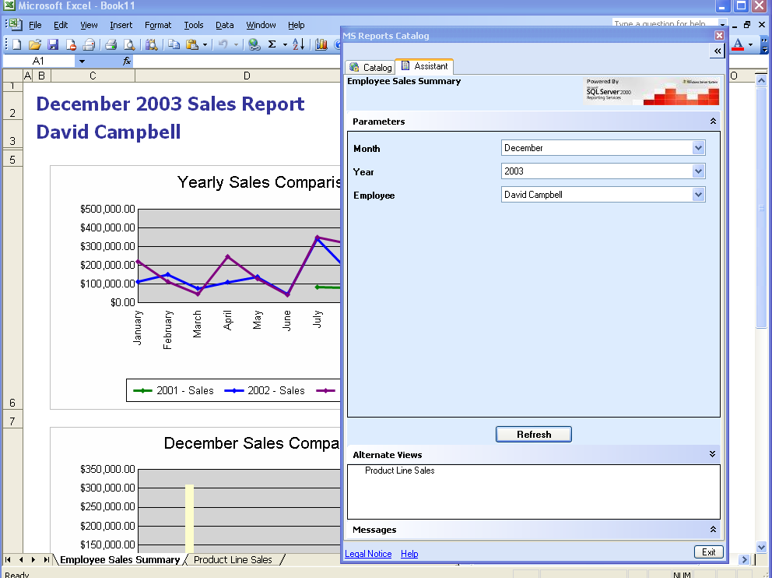
Figure 1 - The MS Reports Assistant User Interface
Architecture
Two development teams built MS Reports’ suite of tools using two different architectures. The Catalog and the Assistant use three-tier architecture built on Web Services as shown in Figure 2. Analytics, on the other hand, use two-tier client server architecture as shown in Figure 3.
Common Architecture
Excel 2003 functionality is the foundation of the MS Reports platform. The tools utilize custom Excel 2003 add-ins to provide additional functionality. The technology used to build the Excel 2003 add-ins includes: Windows Forms in Visual C#®; .Net framework; Visual Basic® .Net and ADO.Net. The custom add-ins must be installed on each client workstation to connect the user to the MS Reports system. The Catalog and Analytics are started individually and controlled using a custom menu and custom toolbar provided by the add-ins. If the Assistant is installed, it will launch with the Catalog when the Catalog is launched. The Catalog also has a Web client that enables connectivity to the centralized report repository through the Internet.
MS Reports Analytics Architecture
The server-tier hosts Analytics’ business logic that allows the tool to build reports and connect to the reporting databases. Analytics is built entirely from SQL code located on the SQL Server, leveraging SQL Server 2005 technology. The server-tier includes a pair of SQL Server 2005 servers in mirrored-pair configuration to simplify fail-over, a Witness server to monitor server-tier status, and an application server used by the clients to provide reference to the appropriate server-tier server. The mirrored-pair uses SQL Service Broker (SSB) to load balance and queue reports for multiple reporting servers. They also use partitioning to streamline reports and improve performance.
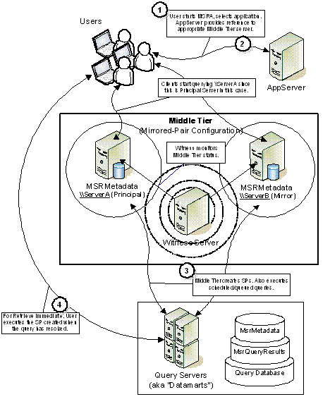
Figure 2 - MS Reports Analytics Architecture
Within the client UI, users can chose an application and its available attributes to generate a report. When the clients submit this query to the middle-tier, the query is first directed through the application server to provide reference to the correct middle-tier server. When queries are submitted to the middle-tier servers, the service broker queue activates a stored procedure that uses selected attributes to generate a SQL statement. The middle-tier server then sends the SQL statement through the service broker to the reporting servers for execution locally on the reporting server. This provides high availability because the report will execute successfully even if the middle-tier fails during execution.
MS Reports Catalog and Assistant Architecture
The XML Web services host the business logic for the Catalog and the Assistant that allow the tools to provide their custom functionality. The Web services sit on a shared cluster of four Internet Information Services (IIS) 6.0 servers. The cluster hosts a multitude of unrelated IIS services as well the MS Reports Web services. Each MS Reports component with the exception of Analytics has its own Web services executable and setup procedure. For security between tiers, MS Reports uses integrated Windows Authentication. The Web services act as a clearinghouse between the clients and the reports that provide connectivity to the backend databases. The Catalog stores its information in a shared SQL Server 2000 database that is connected to the Web services as a third tier. The SQL Server hosts numerous unrelated databases in addition to the Catalog database. The Catalog database stores a link to the published reports rather than a copy of the actual report. The SQL coding within the reports provide the connectivity to the backend reporting databases. In addition, the Catalog database stores other pertinent system and user information related to MS Reports. The Catalog database is currently 2.5 gigabytes.
Once the MS Reports Catalog and the Assistant are in place and the Catalog is launched, the client software makes a call to the Web services to query the Catalog SQL database for available reports. The results are filtered based on user permissions and added to the Catalog UI. When a report is selected from the Catalog UI, the client makes a call to the Web services to query the Catalog SQL database for the report location and renders the report into Excel 2003. Rendering the report in Excel 2003 runs the embedded SQL code that queries the reporting database and refreshes the variables in the report. The SQL code is run each time the report is refreshed through the MS Reports UI.
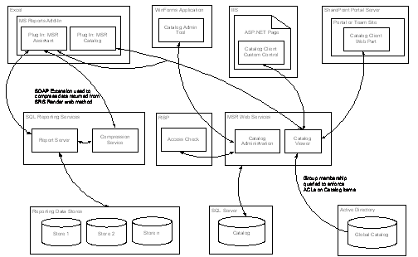

Figure 3 - MS Reports Catalog and Assistant Architecture
Development
Six groups from Microsoft's business reporting community collaborated to define the MS Reports reporting platform requirements and functionality. The basis of the collaboration was to meet these high level goals:
- Develop a common reporting platform to standardize how users access data from different independent sources.
- Provide a common user experience using familiar tools to simplify workflow.
- Leverage the solution across the business reporting community to reduce cost and increase user satisfaction.
- Provide casual users with familiar tools to consume data quickly without the need to understand the underlying technological complexities.
- Provide analysts that understand the data and systems with powerful tools to analyze the data.
The collaboration planning effort took about three months and led to the detailed specification for three different tools that would be combined using Excel 2003 as a common interface. This suite of tools was intended to extend Excel’s functionality as the favorite tool used collectively by Microsoft analysts. The development effort was divided between two teams including the Analytics development team and a combined Catalog and Assistant development team that was also responsible for the Catalog Admin tool. Analytics was developed and tested in-house while the combined Catalog and Assistant development effort was outsourced. Both teams were committed to testing and installing components as they became available during the development process.
The Analytics development team consisted of five developers and four testers. The developer group included three C# developers, one SQL developer and one developer whose time was split equally between both disciplines. The development effort took 12 months costing $675,000 US. Testing required four individuals for nine months costing $427,000. The total cost to develop Analytics was $1,102,000.
The Catalog development effort required five developers for eight months and cost $200,000. The Assistant development effort required six developers for eight months and cost $230,000. Both tools were tested together by five testers over a six-month period and cost $75,000. The total cost to develop the Catalog and the Assistant was $505,000. Including Analytics, the grand total for the entire MS Reports suite of tools came to $1,607,000.
Deployment
MS Reports was deployed in four phases:
- MS Reports Infrastructure. MS Reports has two separate infrastructures supporting the suite of tools. The Analytics infrastructure was already in place as it was developed internally requiring only the Excel 2003 add-ins installation to provide functionality. But the Catalog and the Assistant infrastructure required the Web services installation on the IIS server for the Catalog Admin, the Catalog and the Assistant. The Catalog and the Assistant development team provided the detailed installation documentation for these tools. Prior to the Web services being installed, MS Reports required:
- .NET Framework. A .NET v1.1 framework or later and ASP .NET v1.1.4322 was required to be installed on the IIS server.
- Empty Database. An empty database was required for the Catalog Web service setup to be associated with the service to hold the required database objects.
- Phased Report Rollout. The new SRS reports are currently being published in a phased rollout schedule. They are being rolled out over a three month period that began November 2004.
- MS Reports Training. MS Reports training was provided to the end users by two different teams. The Platforms Services team rolled out the Catalog and the Assistant and the Analytics development team rolled out Analytics. The training process enabled the end users to install and use the clients on their own computer. Training was provided live and online for those that could not attend the live sessions. The live sessions were held at multiple times to accommodate different schedules and to keep class sizes manageable.
- Client Installation. After completing training, the users received an internal website link to a webpage with detailed instructions on how to download and install the client applications. The respective development groups provided additional installation assistance when required.
Benefits
In addition to solving the most critical issues experienced with the old reporting tools and substantially improving on their capabilities, MS Reports actually changes the reporting paradigm by providing a complete integrated reporting platform with a common user experience and workflow. This platform approach is in sharp contrast to the assortment of independent custom reporting solutions provided previously. In addition, by utilizing Microsoft's new emerging technologies, familiar tools and interfaces, and by using existing Microsoft technologies whenever possible, MS Reports is now aligned with Microsoft global system strategies. The strategically aligned reporting infrastructure can now meet Microsoft's current reporting needs much more efficiently and expand its functionality to meet future demands.
Integrated Reporting Platform
- Centralized Report Repository. The Catalog provides one centralized report repository and uses permissions to limit the reports a user can access. With permissions, the reporting teams can now easily meet existing security and privacy requirements. The central repository enables users to publish and access reports much more efficiently and eliminates the need to manually deliver reports to requestors per request or per schedule. With the Catalog, analysts can publish or delete their reports with the Catalog Admin tool. Users can access reports using either the Excel 2003 or Web Catalog version. In each version, a report directory enables the user to access only the reports that they have permission to use.
- Simplified Access to Independent Data Sources. MS Reports standardizes how users access data from different data sources including Finance, HR, Sales and Corporate Services. With SRS standardization, the reporting groups have access to various data structures and enhanced data handling capabilities. In addition, the MS Reports Analytics report building tool hides the data extraction complexities from end users by embedding the SQL code within the reports. Casual users can refresh and manipulate reports or access more detail with the MS Reports interface without the need to understand the underlying technological complexities.
- Dual Report Format Elimination. Analysts require Excel 2003 to analyze or manipulate a report. However, many managers prefer to receive the report in a web format. This requires the analyst to maintain both formats for many reports. With the Assistant, Web-based SRS reports can be rendered and manipulated in Excel 2003, eliminating the need to maintain both formats. Moving to a single reporting format, Microsoft is significantly reducing the number of managed reports and increasing analyst productivity.
Improved Reporting Capabilities
- Automated Report Manipulation. The new drill-down and drill-across functionality provides instant access to related details through links embedded into the reports. Clicking on the linked figures within a report launches a new report providing further detail. This enables instant report investigation without requiring an analyst. Previously, report investigation required an analyst to generate a second report that often led to further requests for more detail. In order to obtain more detail, the analyst sometimes had to physically visit the other reporting systems for access or to transfer the request to another analyst. This significantly delayed the delivery of the detail.
- Ad Hoc Report Manipulation. The SRS report parameters can be modified using the Assistant tab in Excel 2003. Report parameters can also be modified in the SRS report interface when using the Catalog Web client. A drop-down list for each criterion enables the user to change the combination of values and refresh the report. With this capability, a user can manipulate a report without the need to understand the underlying technology or data structure complexity.
- Automated Report Delivery. With SQL reporting services, users can subscribe to a report and automatically receive notice when the report has been published. Subscription capabilities automate the delivery process for the analyst and eliminate the amount of time that was previously required to deliver a new published report to a list of end users.
- Automated Scheduled Reporting. With SQL reporting services, analysts can automate the reporting process for any reoccurring report with a scheduled report refresh. With this service, analysts can refresh a report automatically as scheduled and have it delivered automatically by activating the subscription service. Once all required recipients are added to the report subscription, the entire process becomes automated.
Consistent with Microsoft Global System Strategies
- Faster Report Turnaround. The coordinated reporting infrastructure improves the workflow and enables faster report turnaround. Through workflow standardization, centralization and automation in addition to a common user experience, the process is now much more efficient. Report automation, creation and publication are simple while access to report detail and new report manipulation options streamline complicated tasks.
- Increased Fiscal Monitoring. Management usage of the reporting system has increased substantially due to the simplified interface, faster report turnaround, report manipulation and detail investigation capabilities, and automated report delivery. Greater fiscal trend awareness due to increased management usage is expected to improve fiscal performance over time.
- Development Simplification. By leveraging the latest Microsoft reporting technologies from SQL Server 2005 and Office Professional Enterprise Edition 2003, much of the required functionality was already available and reduced the amount of custom development required to produce the MS Reports suite of tools. Existing technologies included the SRS report format, scheduled report refreshing, report subscriptions, drill-down and across as well as report manipulation capabilities, simplified access to independent data sources, and the Excel 2003 client functionality.
- Familiar Tools and Interfaces. Excel is the standard tool used by analysts everywhere to manipulate report data. Therefore, the benefits of using Excel 2003 as the rich client for MS Reports are obvious. The users are already familiar with the client and require its existing functionality that would otherwise have to be duplicated within a custom application. By using Excel's add-in functionality to build custom functionality, the resulting application interface is familiar and intuitive and requires minimal training. Using the standard tree view for the Catalog interface, the users are familiar with its functionality and intuitively understand how to access reports.
Best Practices
Microsoft IT identified the following best practices as it designed and deployed the MS Reports suite of tools at Microsoft:
- Leverage across User Community. Because a new reporting platform affects all reporting groups that are using the platform, the platform definition, development and deployment should be a collaborated effort to increase user satisfaction and adoption. In addition, by spreading the costs between the groups, the development effort becomes more affordable to everyone.
- Consolidate IT Investments. By using existing technologies and common data structures, IT expenditures can be reduced. Microsoft found that many of the reporting groups were duplicating their IT investments by building redundant features and functionality including approval, security and Web services. For example, many of the groups were using different security models that complicated the data integration across systems.
- Capitalize on Emerging Technologies. Much of the required functionality already exists in new technologies such as XML, Office Professional Enterprise Edition 2003, Web services, SharePoint® services, SQL Server 2005 and SRS. By capitalizing on these technologies, the Microsoft business community was able to greatly simplify the development process while using familiar tools such as Excel.
- Performance Considerations. While the new platform provided superior functionality and benefits, the first version of MS Reports Catalog and Assistant was too slow and this made it unusable. Because of this, the rollout of these two components was delayed. Previous solutions pull static versions of the reports while MS Reports produces dynamic reports that are refreshed each time the report is opened. This dynamic refresh created an intolerable wait for analysts opening a report to manipulate. The performance of a new solution must be the same or better than the previous solution to be accepted by the user community.
Conclusion
MS Reports is an elegant solution to a difficult problem. By hiding the complex underlying technologies from the user, utilizing familiar tools and interfaces, automating repetitive tasks, providing self-service report manipulation and integrating the workflow, reporting is now vastly simplified, intuitive and inviting even to the casual user.
By leveraging the latest Microsoft reporting technologies from SQL Server 2005 and Office Professional Enterprise Editions 2003, much of the required functionality was already available reducing the amount of custom development required to produce the MS Reports suite of tools. By using these familiar tools and interfaces, the training time is now minimal and productivity has increased. By adhering to Microsoft's global system strategies, the reporting infrastructure is far better positioned to meet Microsoft's current reporting needs and to expand its capabilities for future needs.
The benefits of MS Reports are significant to all the reporting groups. By simplifying access to independent data sources, MS Reports eliminates the need for costly infrastructure changes, interim fixes, or manual cut and paste processes to provide consolidated executive reporting. By standardizing workflow, formats, data access and by providing a common user experience, the reporting platform is much more efficient allowing more work to be done by fewer people. With a new simplified interface encouraging the use of the self-service report manipulation capabilities, management is able to proactively manage their numbers much easier.
For More Information
For more information about Microsoft products or services, call the Microsoft Sales Information Center at (800) 426-9400. In Canada, call the Microsoft Canada information Centre at (800) 563-9048. Outside the 50 United States and Canada, please contact your local Microsoft subsidiary. To access information via the World Wide Web, go to:
http://www.microsoft.com
http://www.microsoft.com/office
http://www.microsoft.com/itshowcase
http://www.microsoft.com/technet/itshowcase
© 2004 Microsoft Corporation. All rights reserved.
This document is for informational purposes only. MICROSOFT MAKES NO WARRANTIES, EXPRESS OR IMPLIED, IN THIS SUMMARY. Microsoft, Windows, PivotTables, Visual Basic, Visual C# and Windows Server are either registered trademarks or trademarks of Microsoft Corporation in the United States and/or other countries. The names of actual companies and products mentioned herein may be the trademarks of their respective owners.

