Virtual Server 2005 – IDE to SCSI Virtual Machine Migration
Author: Nelson Araujo

Table of Contents
Virtual Server 2005 – IDE to SCSI Virtual Machine Migration 1
Table of Contents 1
Introduction 1
Assumptions 1
Problem Statement 1
Preparing for Migration 2
Backing up the virtual machine 2
Enabling Undo Disks 3
Preparing the Guest Operating System 3
Installing a SCSI Adapter 3
Changing the drive from IDE to SCSI 4
Changing the disk boot order 5
Booting the Operating System SCSI disk 6
Performance Fine Tuning 6
Option 1 – Install or Reinstall Virtual Machine Additions 6
Option 2 – Manually Install the Virtual Machine SCSI Controller 7
For More Information 8

Introduction
This whitepaper describes tips and methods to help you migrate your Microsoft Virtual Server 2005 virtual machine from IDE to SCSI bus.

Assumptions
This document assumes you have used the Virtual Server Web Administration Web site and have basic Virtual Server administration skills

Problem Statement
You can increase overall virtual machine performance in most scenarios up to 20% by using SCSI virtual hard disks instead of IDE. For more information on virtual machine performance see Virtual Server 2005 performance tips at http://support.microsoft.com/Default.aspx?id=903748.
When you install Windows operating system, the setup procedure only installs the drivers necessary to the computer operation. In other words, it will install only the drivers for the devices the computer that are installed at that time.
Because of this, virtual machines that were installed using the default IDE bus lack SCSI support and simply changing the virtual disk drive bus to SCSI will not work. If you change the bus in an “unprepared” virtual machine, your next boot will fail with a stop error, shown in Figure 1.
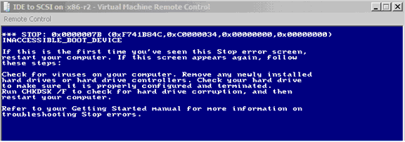
Figure 1 – Stop error screen, when missing SCSI support.

When Not To Use SCSI Disks
If you are using the disks between Virtual Server and Virtual PC you should keep using IDE disks as Virtual PC does not have SCSI support.

Preparing for Migration
Important
Backup all your virtual machine data before performing this procedure. Any problems during this procedure might render your virtual machine unusable, so backing it up is critical to avoid any data loss.

Backing up the virtual machine
First, determine if your virtual machine is using the Undo Disks feature. If undo disks are enable, not all changes to your virtual machine are currently stored in a single VHD file. All changes since last commit are stored in the undo disks. Undo disk is a feature of Virtual Server to allow the customers to checkpoint their virtual machines. If undo disks are enabled, all changes made to the virtual hard disk are saved in a separate file. At a later time, the customer can decide to either commit (merge) or discard the undo disk. If he discards the undo disk, all changes made to the disk since the last checkpoint will be lost.
To verify if you’re using Undo Disks, perform the following actions in the Virtual Server Administration Web site:
- Select your virtual machine and Select Edit Configuration
- Select Hard Disks
- Check if the checkbox Enable Undo Disks is selected

If the box is checked, you can choose one of the following actions:
- Merge the undo disks
- Backup the undo disks

Option 1 – Merging the undo disks
This is the safest operation for preserving data, because at the end of the merge process you will have your VHD file with all the changes committed to it. However, you must be comfortable with all changes since the last commit, because they cannot be undone.

Option 2 – Backup the undo disks
If you choose to backup the undo disks, the first step is to determine the location of those files. You can view them using the Virtual Server Administration We site in the General Properties of your virtual machine. Make sure you backup all the undo disks listed there.

Enabling Undo Disks
To make it easier to rollback or retry the changes if the migration process has any issues, you can enable Undo Disks in the virtual machine. This allows you to discard all changes since the beginning of the process and start over if there is a problem.
WARNING
If you decide to use Undo Disks for this purpose, make sure you committed all previous changes before starting the process.

Preparing the Guest Operating System

Installing a SCSI Adapter
Before you change the boot disk from IDE to SCSI, make sure the guest Windows operating system contains all the necessary SCSI drivers to boot the system. To accomplish this you can boot the guest system once with a SCSI adapter in it. This will force the Plug-and-Play subsystem to install the generic SCSI drivers in the operating system.
To install the SCSI Adapter drivers:
- Stop the virtual machine
- Select Edit Configuration
- Click SCSI Adapters
- Click Add SCSI Adapter
- Click OK

Next, boot the virtual machine and allow the operating system to install the SCSI drivers in the virtual machine. You should see the notification as shown in Figure 2.
Figure 2 – Plug And Play detecting SCSI adapter
To verify the installation was successful:
- Login into the virtual machine
- Right-click My Computer
- Select Properties
- Select Hardware tab
- Click Device Manager

Upon successful installation of the SCSI adapter, you should see an instance of the Adapter AIC-7870 PCI SCSI Controller installed, shown in Figure 3.
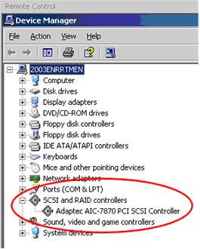
Figure 3 – SCSI adapter successfully installed.

Changing the drive from IDE to SCSI
Now that the operating system supports SCSI devices, you can move the disk to the SCSI bus.
To change the drive from IDE to SCSI:
- Select Edit Properties
- Click Hard Disks
- Select SCSI ID 0 in attachment
- Press OK

Figure 4 illustrates the selection:
Figure 4 – Selecting SCSI ID 0 for disk

Changing the disk boot order
If you have multiple disks, it is a good idea to set the boot disk as the first disk in the virtual machine BIOS. It is sometimes mandatory if you have multiple bootable disks in your virtual machine, but want to boot to a specific one.
To change the boot order
- Turn on the virtual machine
- While the boot screen shows, press Delete to enter BIOS
- Navigate to the Boot menu
  - Select Boot Device Priority
  - In the 1st Boot Device, select Hard Drive
- Press ESC to return to previous menu
- Select Hard Disk Drives
  - In the 1st Hard Disk Drive slot, select the virtual disk that contains the operating system boot. The disks are shown following the format:
    - [04,AIC-7870A:XX MS], where XX is the device ID.
For example [04,AIC-7870A:00 MS]
- Press ESC to return to the previous menu
- Navigate to Exit
- Select Exit Saving Changes
- Confirm and exit by selecting OK and pressing Enter

NOTE: Multiple SCSI Adapters
The BIOS recognizes only the first SCSI adapter. If you have multiple SCSI adapters, make sure the boot disk is located in the first SCSI adapter (SCSI 0).

Booting the Operating System SCSI disk
Start the virtual machine. After the normal boot process, verify that the disk is displayed as MS Virtual SCSI Disk Device, as shown in Figure 5.
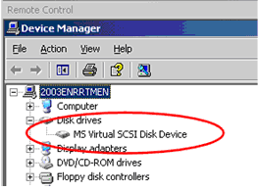
Figure 5 – Disk drive shown as SCSI disk
More information on SCSI boot disks can be found at: https://www.microsoft.com/technet/prodtechnol/virtualserver/2005/proddocs/vs_operate_HT_configVMstart_SCSI.mspx?mfr=true
Windows Product Activation
When your boot disk changes from IDE to SCSI the Windows Product Activation will appear and require you to register the Virtual Machine with Microsoft again. Be prepared to perform the registration process. You can do that automatically if you have internet access, or by telephone. You will have 3 days to perform the registration before the machine ceases to operate normally.

Performance Fine Tuning
At this point you have your machine up and running again, but the drivers installed on the system are not optimized to work with Virtual Server. To improve performance you must either reinstall Virtual Machine Additions, or manually install the Virtual Machine SCSI Controller.

Option 1 – Install or Reinstall Virtual Machine Additions (recommended)
If you reinstall the Virtual Machine Additions available on Virtual Server the enhanced SCSI driver will be installed automatically. If you have a previous version of the additions installed, you need to remove them using Add/Remove Programs option on Control Panel.

Option 2 – Manually Install the Virtual Machine SCSI Controller
If do not want to reinstall the additions and only want to update the driver, you can update it using Device Manager. You must upgrade from the generic SCSI driver (aic78xx.sys) to the enhanced driver (mscmscsi.sys).
To upgrade the driver, execute the following steps in your guest operating system:
- Open Device Manager
  - Right-click My Computer
  - Select Manage
  - Select Device Manager node
- Expand the SCSI and RAID controllers node
- Select the Adapter AIC-7870 PCI SCSI Controller
- Right-click it and select Update Driver

Welcome to Hardware Update Wizard will launch

- Provide the following answers for the wizard and click Next:
  - Can Windows connect to Windows Update to search for software?
    - No, not at this time
  - What do you want the wizard to do?
    - Install from a list or specific location (Advanced)
  - Installation options
    - Don’t search. I will choose the driver to install

- Click “Have Disk”
  - Install from disk
    - Provide the location of the additions driver. It is located on VMADD folder under your Windows directory, C:\WINDOWS\VMADD by default.
- Click OK
- Select the “Microsoft Virtual Machine PCI SCSI Controller” driver.
- Click Next

Windows will copy the necessary files and install the driver

- Click Finish

Restart your virtual machine for the changes to take effect. Figure 6 shows Device Manager when the new driver is in place.
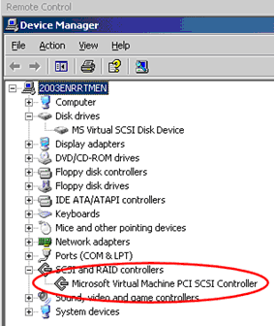
Figure 6 – Virtual machine with enhanced SCSI driver installed

For More Information
Virtual Server Best Practices
http://technet2.microsoft.com/WindowsServer/en/library/3bc3c85f-668e-4730-bfd8-73fd2d12c21c1033.mspx?mfr=true
Virtual Server 2005 performance tips
http://support.microsoft.com/Default.aspx?id=903748
To specify a SCSI disk as the startup device
https://www.microsoft.com/technet/prodtechnol/virtualserver/2005/proddocs/vs_operate_HT_configVMstart_SCSI.mspx?mfr=true

