Technology and Tools
Benefit Administration
User Guide

A reference guide for administering the Technology and Tools Benefits

Windows Pre-Installation Environment (WinPE)

Corporate Error Reporting (CER)

September 2003
© 2003 Microsoft Corporation. All rights reserved.
This document is for informational purposes only. Microsoft makes no warranties, express or implied, in this summary.
Microsoft, FrontPage, InfoPath, OneNote, Outlook, PowerPoint, SharePoint, Windows, and Visio are either registered trademarks or trademarks of Microsoft Corporation in the United States and/or other countries.
The example companies, organizations, products, domain names, e-mail addresses, logos, people, places, and events depicted herein are fictitious. No association with any real company, organization, product, domain name, e-mail address, logo, person, places, or events is intended or should be inferred.

Technology and Tools Benefits
The Windows Pre-Installation Edition (WinPE) benefit allows companies to automate and/or customize the pre-installation of Windows to workstations and servers.
Corporate Error Reporting (CER) allows companies to collect and report on application and system crashes, and control what error data is sent to Microsoft.

This guide covers the following topics:
Activating the Technology and Tools Benefits
Viewing the Technology and Tools Benefits Details
Updating Benefit Contact Information for the Technology and Tools Benefits
Placing a Hold on the Technology and Tools Benefits
Viewing the Technology and Tools Benefits History
Actions on the Technology and Tools Benefits
Technology and Tools Benefits Enrollment E-mail
Using the Technology and Tools Benefits
Assistance with the Technology and Tools Benefit
Glossary of Terms

Activating the Technology and Tools Benefits

To determine if activation is necessary, check the Enrollment Status of the WinPE or Corporate Error Reporting benefit on the Benefit Summary window.
If the status is Not Enrolled, you must activate the benefit in order to begin using it. If the status is Enrolled, activation has already been completed.

To activate the WinPE or Corporate Error Reporting benefit:

    - Click on the SA Windows Pre-Installation Edition (WinPE) or SA Corporate Error Reporting (CER) hyperlink in the Benefit column.

Note: If the link to either the SA Windows Pre-Installation Edition (WinPE) or SA Corporate Error Reporting (CER) is not active it means that you have not purchased the required number of products to use this benefit (but you have purchased some qualifying products otherwise the benefit would not be shown on the window).
If the link to SA Windows Pre-Installation Edition (WinPE) or SA Corporate Error Reporting (CER) is not displayed, it means that either you do not have benefit administration rights for the benefit, or no qualifying products have been purchased.

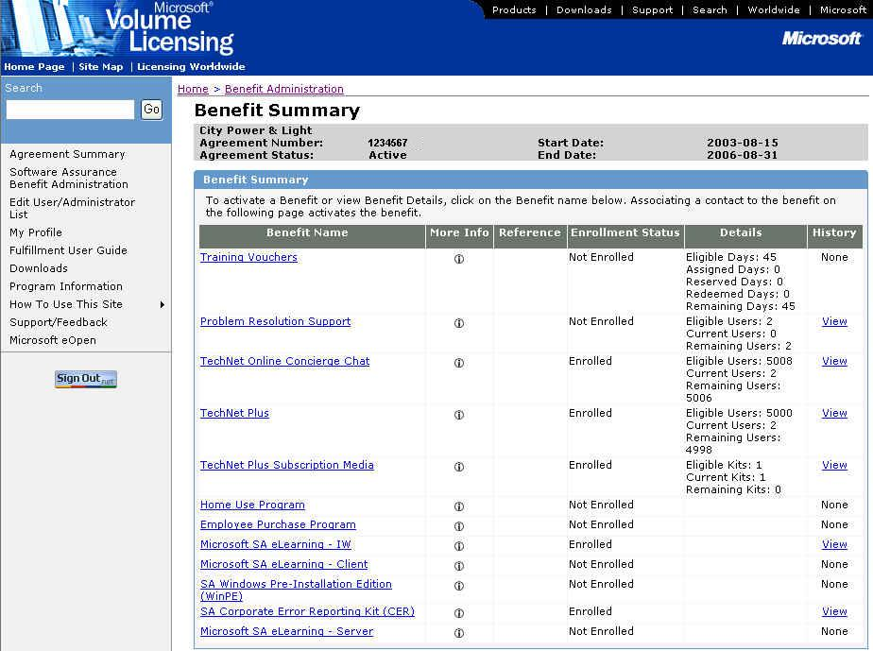

    - The Choose Existing Benefit Contact window appears.

Note: This window only appears if another benefit for this agreement has been activated. If this is the first benefit activated for the agreement, the Activate Benefit window appears (see Step 5).

Note: To activate the WinPE or Corporate Error Reporting benefit, one benefit contact must be specified. The benefit contact will be the person who receives the media or is responsible for downloading the tools. Please be sure the contact you specify is the proper person. The benefit contact must be a Benefit Administrator with MVLS access in order to download the tools.
To search the list of existing benefit contacts, enter the First Name and/or Last Name and click OK.

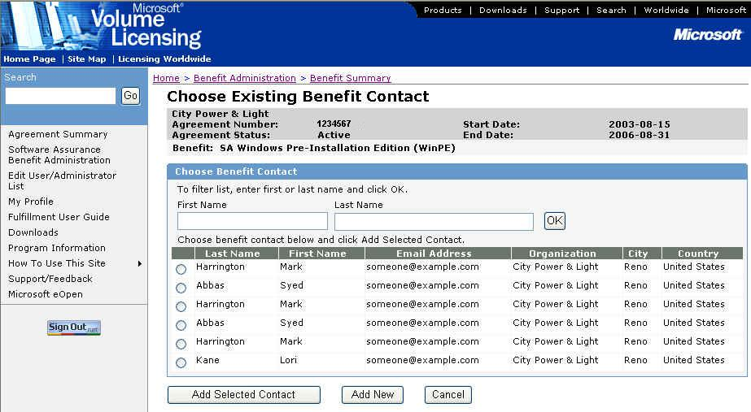

    - If the person you wish to designate as the benefit contact is shown on the Choose Existing Benefit Contact window, select the radio button next to their name and click Add Selected Contact. (Go to Step 5.)

    - If the person you wish to designate as the benefit contact is not shown on the Choose Existing Benefit Contact window, click Add New.

    - The Activate Benefit window appears.

If you selected an existing contact, their information will be shown in the Benefit Subscriber Detail section of the window. The information will be grayed out and you can not modify it. (If you need to modify the contact information for the person selected, see Updating Benefit Contact Information for the Technology and Tools Benefits.)

If you did not select an existing contact, enter the information about the Benefit Contact. The organization information will be pre-populated.

Note: Select the appropriate fulfillment languages for the Technology and Tools media from the Fulfillment Languages drop down box in the Benefit Details section of this window. This is the language in which the media kit will be sent. You cannot change this language once the benefit is activated.

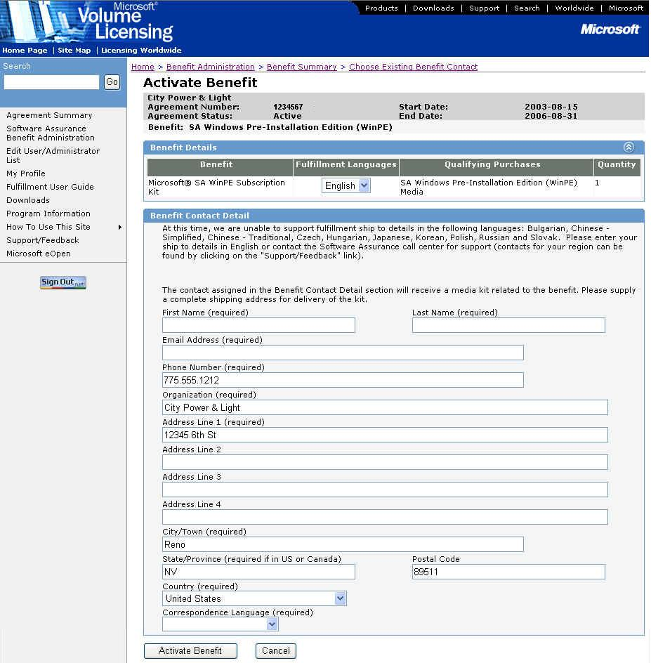

    - Click Activate Benefit.

Note: If you click Cancel, a confirmation dialog box stating “Canceling will cause you to lose all changes. Are you sure you want to cancel?” will appear. If you click OK, all changes will be deleted and the Benefit Summary window appears. If you click Cancel, you will return to the Activate Benefit window.

    - The Benefit Activation Confirmation window appears.

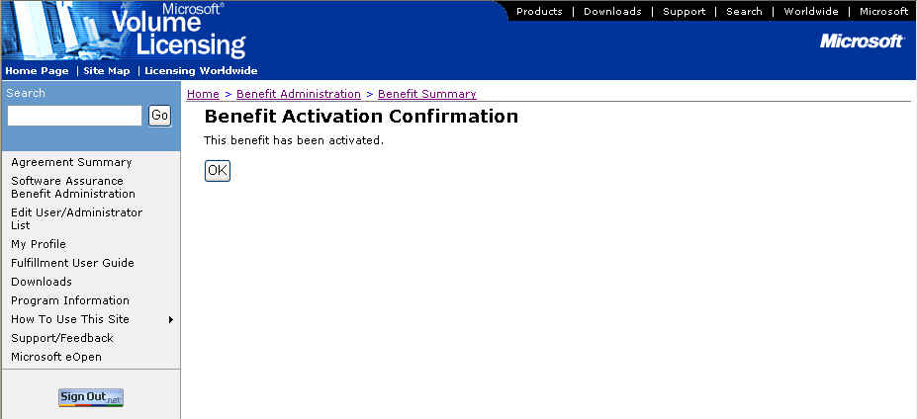

    - Click OK to display the Benefit Details window.

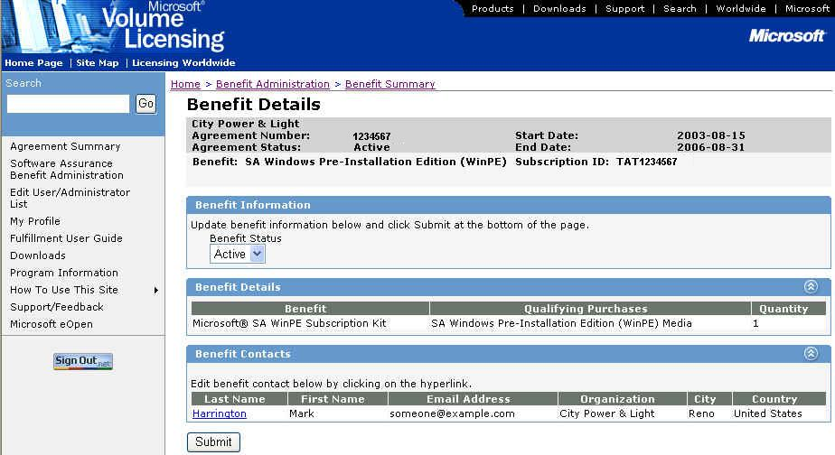

Once the benefit has been activated:
- The Enrollment Status on the Benefits Summary window is changed to Enrolled and the History column value changes to View. To view the benefit history, see Viewing the Technology and Tools Benefits History.
- The designated benefit contact receives the Technology and Tools enrollment e-mail. See Technology and Tools Benefits Enrollment E-mail for the full text of this e-mail.
- The designated benefit contact receives a media shipment of the appropriate tool (WinPE or Corporate Error Reporting).

Return to Topic List

Viewing the Technology and Tools Benefits Details

To view the WinPE or Corporate Error Reporting benefit details:

    - On the Benefit Summary window, click on either the SA Windows Pre-Installation Edition (WinPE) or SA Corporate Error Reporting (CER) hyperlink in the Benefit column.

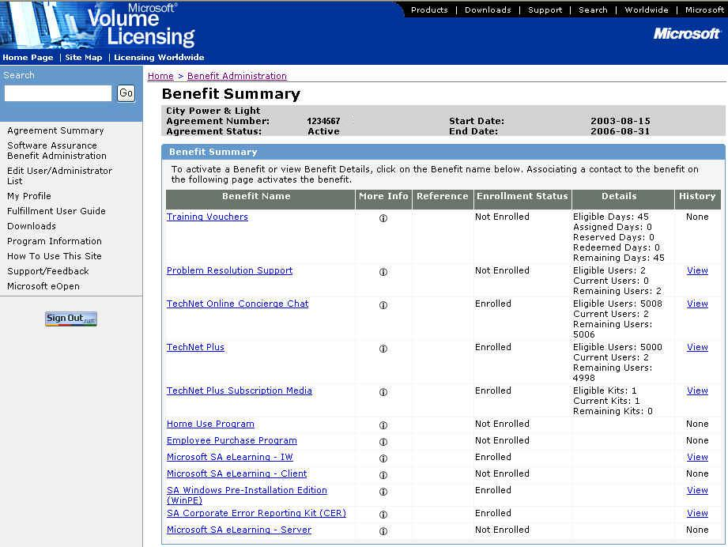

    - The Benefit Details window appears showing the benefit contact information.

Benefit Information – The benefit status is shown and can be changed here. The available benefit statuses are:
- Active – Benefit is available for consumption.
- Hold – Prevents use of the existing benefit.
- Ended – Benefit subscription has come to an end. This status is set only by the MVLS system.
- Inactive – Prevents the use of the existing benefit. This status can only be set by Microsoft administrators.
- Expired – Indicates that the agreement/benefit has reached the end date. This status is set automatically by the MVLS system.
- HAR (Held Awaiting Reactivation) – Indicates that the subscription has been placed into a transitory state where the subscription may not be used to consume a benefit. The subscription has not been ended and may be reactivated at a later date with the existing associated contact information. This status is set only by the MVLS system.
Benefit Contacts – For the WinPE and Corporate Error Reporting benefit, only one benefit contact is allowed.
- To update the contact details, see Updating Benefit Contact Information for the Technology and Tools Benefits.
- The benefit contact cannot be changed.

Return to Topic List

Updating Benefit Contact Information for the Technology and Tools Benefits

To update the benefit contact information for the WinPE or Corporate Error Reporting benefit:

- On the Benefit Summary window, click on the SA Windows Pre-Installation Edition (WinPE) or SA Corporate Error Reporting (CER) hyperlink in the Benefit column.

- The Benefit Details window appears showing the benefit contact information.

    - Click on the Last Name hyperlink. The Edit Benefit Contact Detail window appears.

Note: Use the Edit Benefit Contact Detail window to edit an existing contact’s information. This window should not be used to “replace” or “create” a new contact.

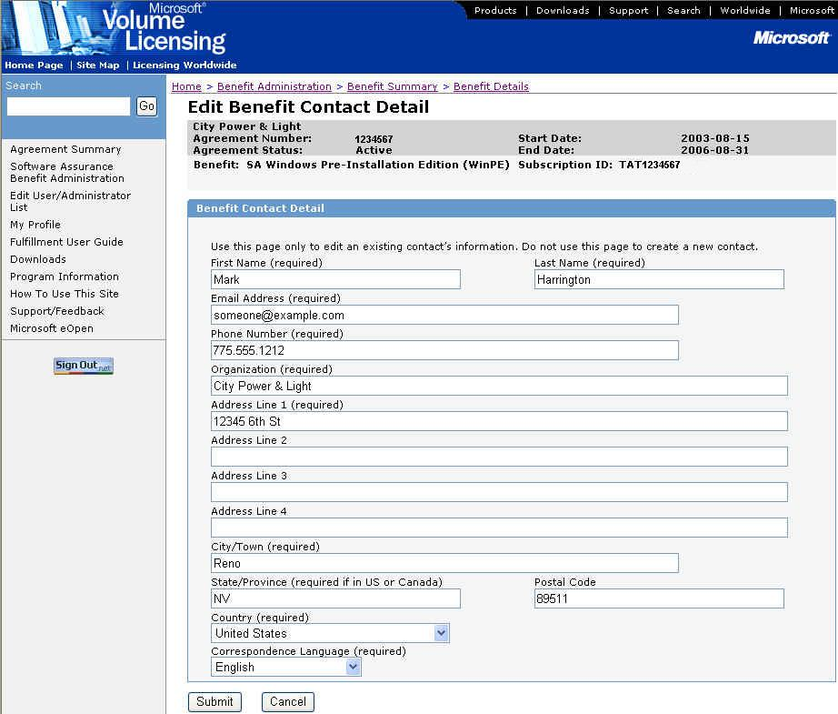

    - Edit the contact information and click Submit. The Benefit Details window is displayed.

Return to Topic List

Placing a Hold on the Technology and Tools Benefits

To place a hold on the WinPE or Corporate Error Reporting benefit:

    - On the Benefit Summary window, click on either the SA Windows Pre-Installation Edition (WinPE) or SA Corporate Error Reporting (CER) hyperlink in the Benefit column.

    - The Benefit Details window appears.

    - In the Benefit Status drop-down box, select the Hold status. This will place a hold on the subscription. Click Submit.
Note: See Actions on the Tools and Technology Benefit to see which actions are allowed for the different Status settings.

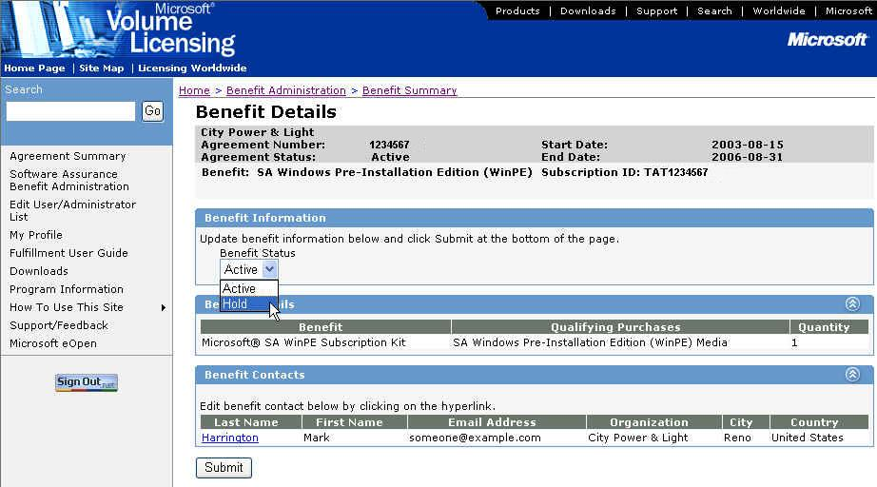

The subscription will remain on hold until the status is changed to Active by the benefit administrator or Ended by the system.

    - To set the status back to active, follow the steps above but select Active status and click Submit.

Return to Topic List

Viewing the Technology and Tools Benefit History

To view the Technology and Tools benefit history:

- On the Benefit Summary window, click on the View hyperlink in the History column for the appropriate Technology and Tools benefit.
Note: If the benefit is not currently Active, the history will not have a View link, instead the word None will be displayed without a hyperlink.

- The History window appears.
The History window displays information about the current and previously activated (and/or ended) subscriptions of the benefit under the agreement.
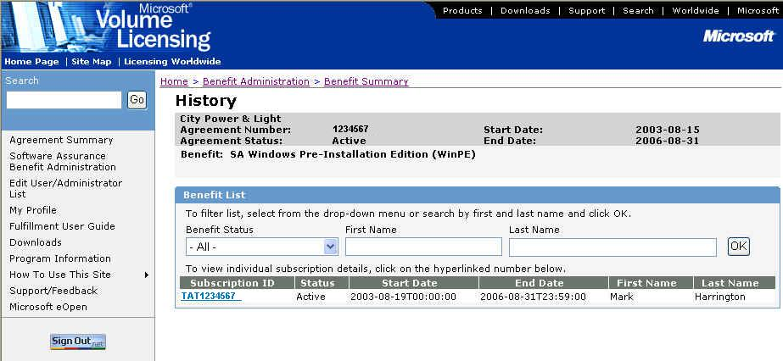

Return to Topic List

Actions on the Technology and Tools Benefits

Different actions can be taken on the Technology and Tools benefits based on the current status. The table below outlines these actions and when they can be performed.
Benefit Name | Subscription  Status | Edit Contact Detail * | Edit User Authentication ** | Status Change in UI  (Allowed - Change To)
SA Corporate Error Reporting (CER)  SA Windows Pre-Installation  Edition (WinPE) | Active | Yes | N/A | Yes - Hold
 | Expired | No | N/A | No
 | Ended | No | N/A | No
 | HAR | No | N/A | No  ( Active - Process Only)
 | Hold | Yes | N/A | Yes - Active
 | Inactive | No | N/A | No

Return to Topic List

Technology and Tools Benefits Enrollment E-mail

When the WinPE or Corporate Error Reporting benefit is activated, the benefit contact specified during the activation process will receive an automated e-mail. The e-mail contains program information as well as download information for the WinPE and Corporate Error Reporting tools.

Text of the Technology and Tools enrollment e-mail:

Subject: Your Microsoft® Software Assurance Technology & Tools benefit is now available.

From: <Benefit Administrator E-mail Address>

Body:
Dear <First Name> <Last Name>,

Please note that the contents of this e-mail have been created by the Microsoft Worldwide Software Assurance enhancements team and are being sent to you by Microsoft, on behalf of your Benefit Administrator <Insert BA name> within your organization.

Welcome to Microsoft® Software Assurance enhancements. As a Software Assurance customer, your organization is eligible for benefits which can help you get the most value from up-to-date technology. The Microsoft Technology & Tools is one of these enhancements and you have been selected as the Benefits Contact. In this capacity, you will be responsible for the deployment of this benefit within your organization.

Software Assurance Technology & Tools benefit offers the following:

- Corporate Error Reporting (CER): CER gives IT Professionals a clear and easy way to monitor and review error information so they can control deployment of fixes and resolutions. It provides the ability for applications and the operating system to collect and report crashes in the system.
- Windows® Preinstallation Environment (WinPE): WinPE allows IT staff to build custom solutions that speed up deployment through automation so they spend less time and effort keeping desktops updated.
With WinPE, IT Professionals can leverage the latest technology available, giving their company a business edge.

How do you obtain this Technology & Tools benefit?

You may obtain your Technology & Tools materials by either of the following methods:

- Microsoft Licensing Fulfillment Media Shipment
The media for the Software Assurance Technology & Tools benefits are available free of charge and are included in separate fulfillment kits which, when selected by the Benefits Administrator, will be sent to you.
Should you have any difficulty in obtaining this media, please contact your Benefit Administrator <Insert BA Name> or your Channel Partner who will work with Microsoft to resolve any queries you might have.

- Software download from the Microsoft Volume Licensing Services (MVLS)
web site:
The materials for the Software Assurance Technology & Tools benefits can also be downloaded from the MVLS web site: <https://licensing.microsoft.com>. Should you have any difficulty with this download, please request assistance using the support page available on the MVLS web site.

Please note that use and deployment of the Technology and Tools software, and any other software provided to your organization in connection with Microsoft’s Software Assurance Enhancements, is subject to the terms and conditions of the Volume License Agreement, the Product Use Rights (PUR) and the applicable eligibility criteria set forth in the Microsoft Product List and the MVLS web site.

Once again, we welcome you to Microsoft Software Assurance enhancements! We trust you will enjoy these benefits and we look forward to your participation and feedback. Feedback for your country or region can be provided at https://licensing.microsoft.com by clicking on the Support/Feedback link.

Thank You,

Microsoft, on behalf of your Benefits Administrator

Return to Topic List

Using the Technology and Tools Benefits

To use the WinPE or Corporate Error Reporting benefit, follow the instructions in the enrollment e-mail and download the tools. In addition, a media shipment will be sent to the designated benefit contact upon benefit activation.

Note: The Corporate Error Reporting tool will be available in late 2003.

Return to Topic List

Assistance with the Technology and Tools Benefits

For assistance administering the WinPE benefit, go to the MVLS Support page (select Support from the left navigation bar on the MVLS site).
For benefit contact assistance with the WinPE benefit, go to http://support.microsoft.com/common/international.aspx.

Return to Topic List

Glossary of Terms

Windows Pre-Installation Environment (WinPE) – A version of Windows XP Professional that supports booting off CD, DVE, PXE (network), or a hard disk drive that aids deployment, administration, and end-user productivity.

Corporate Error Reporting (CER) – A tool that allows companies to collect application error and crash data internally, and then decide what data will be sent to Microsoft.

Return to Topic List

