Microsoft® Windows® Access Control:
A path toward Compliance, Risk Management, and Productivity
Revised July 20, 2005

July 2005
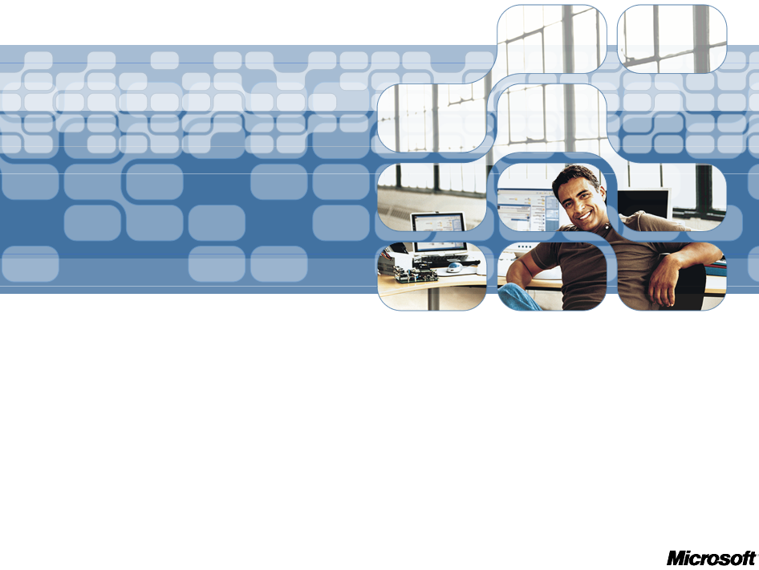
- The information contained in this document represents the current view of Microsoft Corporation on the issues discussed as of the date of publication. Because Microsoft must respond to changing market conditions, it should not be interpreted to be a commitment on the part of Microsoft, and Microsoft cannot guarantee the accuracy of any information presented after the date of publication.
- This White Paper is for informational purposes only. MICROSOFT MAKES NO WARRANTIES, EXPRESS, IMPLIED OR STATUTORY, AS TO THE INFORMATION IN THIS DOCUMENT.
- Complying with all applicable copyright laws is the responsibility of the user. Without limiting the rights under copyright, no part of this document may be reproduced, stored in or introduced into a retrieval system, or transmitted in any form or by any means (electronic, mechanical, photocopying, recording, or otherwise), or for any purpose, without the express written permission of Microsoft Corporation.
- Microsoft may have patents, patent applications, trademarks, copyrights, or other intellectual property rights covering subject matter in this document. Except as expressly provided in any written license agreement from Microsoft, the furnishing of this document does not give you any license to these patents, trademarks, copyrights, or other intellectual property.
- Unless otherwise noted, the example companies, organizations, products, domain names, e-mail addresses, logos, people, places, and events depicted herein are fictitious, and no association with any real company, organization, product, domain name, email address, logo, person, place, or event is intended or should be inferred.
- © 2005 Microsoft Corporation. All rights reserved.
- Microsoft, BizTalk, SQL Server, Windows, Windows Server, Windows Server System are either registered trademarks or trademarks of Microsoft Corporation in the United States and/or other countries.
- All other trademarks are property of their respective owners

Contents
Introduction 4
What is Access Control? 4
Primary Components of Access Control 4
System Integrity – Foundational Protection 6
Running as Administrator Exposes Systems to Malware 6
Limiting Exposure with User Account Protection 6
Additional Technologies Supporting System Integrity 7
Trustworthy Identity – Authenticating the Users 9
Passwords – an Inadequate Access Control Model 9
Microsoft Smartcard Infrastructure for Multi-factor Authentication 10
Additional Technologies Supporting Trustworthy Identity 11
Access Policy Management – Authorizing for Access 13
The Application Challenge 13
Role-based Access Control 13
Authorization Manager 14
Additional Technologies Supporting Access Policy Management 15
Web Services 15
Information Protection – Enabling Proper Use 16
Rights Management Service: Controlling Distribution of Sensitive Data 16
Additional Technologies Supporting Information Protection 17
Network Access 17
Legal Compliance & Access Control 19
Access Control and Audit 19
Summary 20

Introduction

What is Access Control?
At its simplest, the goal of access control is to protect an organization’s resources from unauthorized access while facilitating seamless and legitimate use of these resources. In today’s information age, users need access to those resources through a broad variety of devices, such as PCs, laptops, PDAs, smart phones, and kiosks. Organizations need to provide their business partners, customers, and employees with access to applications, documents, and data from any device—whether it is inside or outside the corporate network – and as securely as possible. Although advances in Internet connectivity have helped to enable productivity in our increasingly mobile work force, they also expose enterprise resources to an ever-increasing number of security threats.
Fundamental goals of security include confidentiality for controlling who gets to access information and resources; integrity for providing control of how information changes or resources are used; availability for timely access to information and resources; and accountability for knowing who has access to information and resources.
Access control is a foundational component of security that helps achieve these goals. Access Control is collection of technologies that help organizations realize their identity and access management solution while mitigating the information security threats and vulnerabilities. To establish effective access control, IT professionals need to develop a cohesive security strategy and assemble the right balance of technologies to secure their system, application, data and networks. The ultimate result of that security will be the ability to comply with a number of government regulations, a reduction in liability risks, reduced cost of IT management and increased productivity.

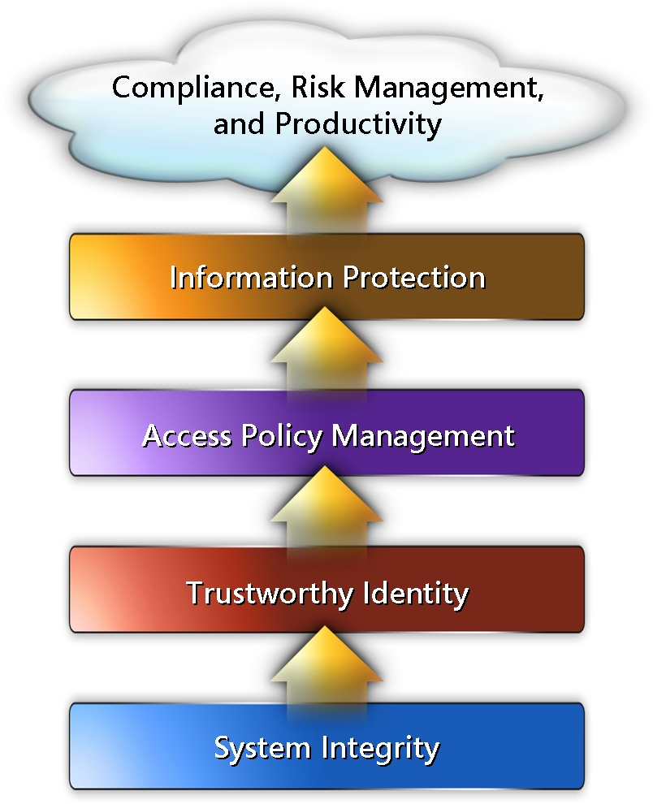
Primary Components of Access Control
The foundation for any access control system begins with System Integrity—the technologies and process that help secure system hardware, software, and data using technologies that prevent malicious software attacks. Vulnerabilities include: weak authentication, unprotected communications channels, or compromised data storage.
The second layer, Trustworthy Identity, is the critical process of identifying and authenticating users, computers, and applications to confirm that principals (users) are who they claim to be.
Access Policy Management, the third level, is the portion of access control that ensures fine-grained and reliable authorization of users based on rules and roles. Access control policy defines the tasks that principal can perform and resources they can access, and provides an audit trail for compliance purposes.
The fourth tier is Information Protection, which is focused on protecting data throughout its lifecycle, wherever it may be stored or transmitted. For copyrighted, confidential, and protected data, such as financial records, this component is business critical.
When deployed strategically, Windows Access Control technologies can provide important components of a broader system of policies and technologies that help manage security risks effectively, enable compliance with regulations, protect business assets and intellectual property, and reduce the risk of liability.
This whitepaper provides an overview of these primary access control components from Microsoft and illustrates each of these components by providing typical real-life examples of how Microsoft technologies can be used to solve critical security challenges relating to access control.
Woodgrove Bank, a fictitious company, will be used throughout this paper to explore each component in the real world business and IT environment.

System Integrity – Foundational Protection
The foundation of an effective access control system is the integrity of the operating system itself. If the system (hardware or software) is compromised, malicious code can modify applications and data without being detected, thereby rendering the rest of the security capabilities ineffective.
System integrity demonstrates control over systems through security policy, which governs the behavior of principals and their use of systems.
System integrity consists of the following aspects:
- Users are running the known and approved operating system.
- Users and applications are not impersonated.
- If malicious code does get on a system, access to administrator-level functions is restricted.
To work toward system integrity, IT administrators need both processes and tools. From a tools perspective, system integrity requires solutions like vulnerability assessment antivirus/anti-malware tools to provide protection and detection and data recovery tools for remediation. In addition, the operating system needs to be more resilient to prevent and limit the impact of potential attacks.

Running as Administrator Exposes Systems to Malware
One of the most insidious threats that enterprises encounter today is malware. Malware is a malicious type of software designed to transparently install itself, often requiring no interaction from the user.
Malware takes advantage of the fact that many users use accounts with administrative privileges while running their systems. Applications running in administrator mode bypass a number of security protections and potentially open access for malware to a variety of critical system-level functions. This scenario results in compromised system integrity and significant damage, such as harvesting confidential data, credit card numbers, user-ids/passwords, etc.

Limiting Exposure with User Account Protection
Microsoft Windows offers a series of tools and guidance to help prevent malware attacks, including Microsoft Windows Firewall, Microsoft Malicious Software Removal Tool, Microsoft Anti-Spyware, and the upcoming Network Access Protection tool. The next version of the Windows operating system, code-named Longhorn, will add User Account Protection as an additional, fundamental, defense mechanism to provide protection against malware at the system level.
The User Account Protection feature in Longhorn helps prevent the impact of malware execution by running all applications and services with limited permissions and by limiting administrator-level capabilities to only authorized processes (and applications) and user-initiated events.
When users attempt to perform administrative tasks, either intentionally or unintentionally, Longhorn explicitly asks them to confirm their intentions or provide administrative credentials, depending on the policy setting expressed through Group Policy Objects (GPO).
Registry and file virtualization in Longhorn redirects per-machine file and registry writes to per-user locations if the user does not have administrative privileges. This enables standard accounts to run applications that need to write to areas of the registry or file system that only administrators can access.
With User Account Protection, Woodgrove Bank can preserve flexibility for its information workers by allowing them to perform all common application and system tasks while simultaneously enforcing individual desktop lock-down policy to prevent installation of unauthorized applications and unapproved changes to system settings. As a result of aligning the company application and configuration policies, the total cost of ownership for desktop management is significantly reduced.

Additional Technologies Supporting System Integrity
User Account Protection is a key component of System Integrity, which solves a fundamental challenge in the way applications operate. There are several additional components that help ensure the integrity of enterprise systems in Windows. These components include:
- Secure Startup is a hardware-based security feature that uses a Trusted Platform Module to ensure boot-time security, protect user data, and to ensure that a PC running Longhorn has not been tampered with while the system was offline. Secure Startup provides enterprise information workers, both mobile and in the office, with a higher degree of data protection against any offline attacks on their systems.
- Code Integrity improves the security of the operating system by validating the integrity of each binary image against a signed catalog of per-page hashes as each page is loaded into the system. Images that fail per-page hash validation will not be loaded because they have been corrupted (either inadvertently or maliciously).
- Software Restriction Policy (SRP) is a policy management technology that helps prevent damage to systems by identifying software running on an enterprise domain and controlling its ability to run. System integrity is often compromised by malicious (and unauthorized) applications being inadvertently run. SRP provides a method for organizations to enforce the execution of authorized applications only.
- Microsoft Authenticode® is a technology that identifies the publisher of signed software and verifies that it has not been tampered with before users download it to their PCs. Phishing is the process of a user being tricked into believing that a malicious program and/or site is same as the otherwise trusted applications and/or sites. Authenticode provides the ability for the user to validate the identity of the software publisher, thereby avoiding some forms of phishing.

Trustworthy Identity – Authenticating the Users
Improvements in distributed computing proliferated in variety of access points to business applications across organizations. To respond to increased access requirements and time to market demands, businesses organized user identity information into local directories and databases, resulting in users with multiple identities, an increased cost of IT operations, and vulnerable IT environments.
To increase their competitive advantage, companies continue to extend their boundaries and expose more of their information systems to customers, partners, and employees who work remotely. Before two (or more) parties can enter into a trusted relationship to conduct business transactions, they must validate the identity of the other parties. In a distributed environment, such as the Internet, where the original identity cannot be ascertained by a face-to-face meeting, it is especially important to have a way for enterprises to mutually establish trusted credentials and a secure environment.
In this increasingly complex environment, managing the lifecycle of digital identity—who users are, how they prove their ID, what they can access, and how and when to retire that privilege—is a complex problem leading to risk exposure and loss of productivity. To establish a “trustworthy identity,” enterprises must have the ability to have a common framework to assign strong credentials and manage the lifecycle of the credentials, including the delegation of trust to third parties.
Trustworthy identity consists of two technological elements: strong authentication and credential management. Strong authentication, also called multifactor authentication, refers to users’ (security principals) ability to prove to the system that they are who they claim to be. Credential management, on the other hand, is the foundation for associating the identity to digital credentials and managing the credential lifecycle.

Passwords – an Inadequate Access Control Model
User name and password combinations have typically been used to provide authentication and authorization to network resources. For example, strong passwords that use a large number of sequence of special characters and numbers can provide an effective security mechanism. However, many users favor convenience over security, so they choose a password that can easily be compromised.
For Woodgrove Bank, there is a real cost to passwords—brokers in the service division must log on to as many as 14 applications in a given day, which requires an average of 100 hours a year, per person. Not only does this amount to a significant loss of time and opportunity, but it also results in brokers writing down their passwords on sticky notes—a serious violation of corporate security policies.
Multifactor authentication is an excellent solution to the password problem because it uses multiple forms of identification to validate user access. This, in turn, makes it harder for intruders to break into a network, enables administrators to reduce the vulnerability of passwords, and provides an audit trail to determine whether trusted users have violated security policy. Multifactor authentication uses a combination of something user knows, such as a password or personal identification number (PIN), and something the user has, such as a biometric characteristic or a hardware token—for example, a smart card or a One Time Password (OTP) devices such as RSA SecureID.
Smart card deployment is becoming increasingly popular. As proponents of the Electronic ID (eID) programs around Europe and other regions in the world will attest, smart cards are an excellent way to establish multi-factor identification. Not only do they augment passwords but they can be used in a broad variety of access control scenarios—physical access (photo ID, swipe card, or RFID badge), network authentication, and application access.

The Need for Unified Identities
In addition to passwords, a proliferation of user accounts across legacy systems can create a management nightmare and significantly inhibit user productivity. Microsoft Identity Integration Server (MIIS) provides enterprises with the capability to integrate identity information across multiple repositories, systems, and platforms. MIIS augments Active Directory by enabling the integration or synchronization of a wide range of prevalent identity repositories, such as directories, databases, and flat-files; provisioning and de-provisioning of accounts and identity information across systems and platforms; and enabling self-service and helpdesk initiated password management and reset from a Web browser.

Microsoft Smartcard Infrastructure for Multi-factor Authentication
Microsoft provides a straightforward smart card infrastructure platform natively in the Windows operating system that includes a number of advanced components to simplify the process of developing smart card software and deploying smart cards.
Windows Longhorn includes new advances in the smartcard infrastructure components, such as a common Cryptographic Service Provider (CSP) and integrated third-party Card Communication Modules. Card Communication Modules facilitate rapid deployment and enable secure, predictable communications between the CSP and the card middleware.
The Microsoft base smartcard CSP implements all of the standard back-end cryptographic functions for hardware manufacturers and software developers. With a common CSP, the resulting security model is dramatically simplified, much less error-prone, and more secure—providing a more reliable total solution and allowing for simpler integration.
In addition to authenticating to network access, Microsoft Smartcard infrastructure can enable:
- Secure Remote Access. Many companies have deployed Virtual Private Network (VPN) solutions to enable users to access the company network from outside the facility. A VPN provides a secure channel for communicating information between the company network and the user’s computer. When a user connects to the network through a VPN, the company cannot ensure the physical identity of the user to the same extent that it can when the user is in the office. This factor makes multifactor authentication an important preventive measure.
- Administrative Account Protection. Many companies have deployed Terminal Services—a built-in remote desktop in Microsoft Windows Server™ 2003—to provide remote access to server consoles and applications. Because Terminal Services can enable full administrative access to servers and provide access from a location outside a facility, it is critical to ensure the identity of the user. Use of Microsoft Smartcard in this scenario can enable stronger authentication of the users.
- E-Mail. For example, when a Woodgrove user sends an e-mail message that contains confidential company information, the company needs to encrypt the message and certify the identity of the sender. Multifactor authentication can be used to validate a user’s identity, by using a private key stored on a smart card to certify the e-mail message. When the message is sent, the recipient can use the sender’s public key to validate the sender’s identity.

Additional Technologies Supporting Trustworthy Identity
In addition to smart cards, there are a number of Microsoft technologies that help ensure trust across all applications—e-mail, Web browsing, instant messaging, file sharing, document collaboration, and Web services. These technologies include:
- Kerberos is a network authentication protocol designed to provide strong authentication for client/server applications by using secret-key cryptography to prove mutual identity across insecure network connections. Kerberos enables single sign-on across heterogeneous environments.
- Certificate Services is a comprehensive set of Public Key Infrastructure (PKI) services built into the Microsoft Windows Server platform that delivers the business benefits of public key cryptography. It includes certificates, certificate templates, certificate authorities, certificate enrollment, Web enrollment pages, smart card support, and public key policies.
- Internet Authentication Service (IAS) is the Microsoft implementation of a Remote Authentication Dial-in User Service (RADIUS) server and proxy. As a RADIUS server, IAS performs centralized connection authentication, authorization, and accounting for many types of network access, including wireless and virtual private network (VPN) connections. As a RADIUS proxy, IAS forwards authentication and accounting messages to other RADIUS servers.
- Directory Services bring multiple data stores (e.g. directories, flat files, databases) together to provide a single source for digital identity information. Microsoft Active Directory is a highly available, distributed directory store provided as part of Windows Server. It serves as the focal point for management and administration of user accounts, authentication, security principles and policies, and enterprise resources, such as computers, printers, and servers.
- Federation Services is a standards-based technology that enables distributed identification, authentication, and authorization across organizational and platform boundaries. Federation enables an organization to create a standardized and secure way to express the services it makes available to trusted partners and customers. It also enables organizations to create a standardized and secure way to express policies it uses to runs its business, such as what other organizations and users it trusts, what types of credentials and requests it accepts, and its privacy policies.
- Identity Metasystem - Universal adoption of a single digital identity system or technology is unlikely ever to occur, a successful and widely employed identity solution for the Internet requires a different approach — one with the capability to connect existing and future identity systems into an identity metasystem. This metasystem, or system of systems, would leverage the strengths of its constituent identity systems, provide interoperability between them, and enable creation of a consistent and straightforward user interface to them all. The resulting improvements in cyberspace would benefit everyone, making the Internet a safer place with the potential to boost e-commerce, combat phishing, and solve other digital identity challenges.
- Infocard is the code name for a component of the WinFX Runtime that provides consistent user experience required by the identity metasystem. It is specifically hardened against tampering and spoofing to protect the end user's digital identities and maintain end-user control. A visual "Information Card" in the client user interface represents each digital identity managed by "InfoCard". The user selects identities represented by "InfoCards" to authenticate to participating services. It is used when building federated applications with the WS-* claims-based identity model.

Access Policy Management – Authorizing for Access
With the advent of customer data, privacy regulations and paperless information systems, it is increasingly challenging to ensure that only validated and approved users have access to sensitive information. Organizations must set up security policies to ensure that access to resources can be controlled and managed.
Security policies are a set of permissions or rules that the system must evaluate and apply whenever a user, device, or application seeks access to a resource. These policies also define how applications should behave and what rules should be followed in regard to user authorization.
As the number of users, devices, applications, and resources increases, administrators need to have a way to express and store and evaluate and enforce access policies, and to monitor exceptions to those policies.
Access policies are necessary to balance security requirements; organizations must also ensure that an increased level of security does not curtail productivity and prevent employees, customers, and business partners from obtaining the information they need to conduct business.

The Application Challenge
In a world of mergers, acquisitions, and legacy computing systems establishing a common set of security policies across an entire organization presents a number of technical, management, and configuration challenges. Enterprise administrators have to manage access control for hundreds of applications and servers across the organization. In addition to providing access, administrators must be able to query, audit, change, and enforce access control policies in a timely manner. Access control policies that are not centrally managed are costly to maintain and make the auditing and compliance reporting process very difficult.
To address these problems, enterprises need an access control policy management framework and system to unify security policies across systems and allow a smaller number of administrators across the organization to define roles for delegating certain tasks, including the permissions required to perform those tasks. With Microsoft Access Control policy technologies, permissions that define a role can now span multiple applications across an enterprise—a dramatic improvement over the complexity and inconsistency caused by each application introducing a distinct authorization management paradigm.

Role-based Access Control
Role-Based Access Control (RBAC) is a mechanism for restricting access to resources based on a person’s or group’s role. In a RBAC system, users can be assigned to roles such as doctor, lawyer, or accounts payable clerk. Once the roles have been assigned, business rules such as “only doctors can access medical information” can be defined. Security groups in Active Directory could also be used to perform some of the same functionality. However, using security groups has certain limitations:
- Security groups are only valid within the system in which they were created
- Security groups can only be applied to tangible resources and not operations
- A security group definition cannot be transported with data in a general fashion
- Security groups cannot easily be defined at design time across applications

Prior to the availability of Windows Access Control components, many organizations and independent software vendors (ISVs) had to write their own code to implement an access control model resulting in longer software development time and cost. Microsoft Active Directory and Microsoft Authorization Manager were developed to solve this problem by providing a framework for access control that is integrated with the Windows platform.
Active Directory provides single-sign-on capability and a central repository for information for an enterprise’s entire infrastructure, vastly simplifying user and computer management and providing superior access to networked resources.

Authorization Manager
Authorization Manager is an authorization framework that provides the ability to control access to applications and resources based on an end user's role in his or her organization—for example, broker, executive, or human resources. This assignment is done by using Active Directory policies or another set of role-based permissions, such as application-specific tasks. Authorization Manager can help implement policies to protect sensitive data, to safeguard intellectual property, and ensure legal and regulatory compliance by extending Security Groups and Group Policy Objects in Active Directory or an existing directory services infrastructure with a simple access control administration model for applications.
Through the concept of roles, Authorization Manager provides an easy way to define the access privileges associated with business processes and tasks—helping provide a more secure, consistent, and flexible level of access control.
Administrators can now quickly and efficiently grant a user the appropriate permissions by using the Microsoft Management Console add-in from Authorization Manager to assign that user to his or her defined role. When a user leaves or changes positions within the organization, the user’s access privileges are either removed or updated to their new role system-wide. In addition, administrators can quickly audit a user’s permissions by running queries against the centralized role-based access control (RBAC) policy.
To comply with legal requirements, such as the Health Information Protection Accountability Act (HIPAA), Sarbanes-Oxley (SOX), and Gramm-Leach-Bliley, Woodgrove Bank’s IT team needs to carefully control access to financial documents based on user roles. For example, brokers, account administrators, and loan officers need access to Woodgrove Bank’s database to view their customer’s brokerage account records, but should not have access to retail banking records.
Woodgrove Bank’s administrator can use Authorization Manager to assign a user the “Broker” role—instantly providing all required permissions and appropriate access to brokerage applications and data. When a broker leaves, his or her permissions will be eliminated to close off access to sensitive data. Because the role allows access to be granted in terms of a company's organizational model, it is a more intuitive and natural way for administrators to specify access control.

Additional Technologies Supporting Access Policy Management
In addition to Authorization Manager, there are number of Microsoft technologies that enable access policy management to reduce total cost of ownership (TCO).
- Group Policy Management Console (GPMP) is a Microsoft Management Console snap-in that provides a single solution for managing all Group Policy Objects related tasks for multiple domains and sites within one or more forests, all in a simplified user interface with drag-and-drop support. These tasks/operations are fully scriptable, which lets administrators customize and automate system management tasks, resulting in more cost-effective management of the environment
- Software Restriction Policy is a security capability that helps prevent damage to systems by identifying software running on an enterprise domain and controlling its ability to run.

Web Services
A key benefit of the emerging Web services architecture is the ability to deliver integrated, interoperable solutions. Responding to concerns expressed both from our customers and the industry, IBM and Microsoft have collaborated on this proposed Web services security plan and roadmap for developing a set of Web Service Security specifications that address how to provide protection for messages exchanged in a Web service environment. The Web Services Security (WS-Security) roadmap describes Microsoft's strategy for addressing security within a Web service environment. It defines a comprehensive Web service security model that supports, integrates, and unifies several popular security models, mechanisms, and technologies (including both symmetric and public key technologies) in a way that enables a variety of systems to securely interoperate in a platform- and language-neutral manner. It describes scenarios that show how the following specifications might be used together.

Information Protection – Enabling Proper Use
In today’s information age, application and system data are abundant in any organization, and are subject to a myriad of threats from an increasing number of sources. Loss of confidential information, customer data, or intellectual property can be a damaging to the reputation and long term survival of an organization. Information loss can result in loss of revenue, competitive advantage, and customer confidence.
Information protection challenges typically follow the information lifecycle: creation and storage of data, distribution of information, and usage. With the exponential growth of mobile users, PDAs, and laptops, critical corporate information needs to be protected across these form factors. Hard-drive data must be protected from attackers in case the drive is lost or stolen, and data in e-mails, on the Web, and on intranets must be secured. Administrators need a way to ensure the confidentiality, integrity, and non-repudiation of information during distribution, and a means to enforce policies governing who can receive the data, how the data can be used, and when use of the data expires.

Rights Management Service: Controlling Distribution of Sensitive Data
One of the biggest challenges to securing information is the control, sharing, and distribution of sensitive information. Accidental or intentional information leaks can occur when information is forwarded to an unauthorized recipient and, after information leaves a company’s firewall, it is difficult to track or secure. In addition, with increasing globalization and cooperation between companies, the need for information sharing outside a company that is both secure and user-friendly has become an imperative business requirement.
Microsoft Windows Rights Management Services (RMS) is an information protection technology that works with RMS-enabled applications to help safeguard digital information from unauthorized use—both online and offline—inside and outside of the firewall. RMS combines proven security technologies—including encryption, certificates, and authentication—to help organizations create reliable information protection solutions. RMS augments an organization’s security strategy by providing policy enforcement, centralized management, and protection of information through persistent usage policies that remain with the information, no matter where it goes.
With RMS, information workers can define exactly how the recipient can use the information, such as who can open, modify, print, forward, and take other actions. Organizations can create custom usage policy templates such as “Confidential - Read Only” that can be applied directly to information, such as financial reports, product specifications, customer data, and e-mail messages. Authors can also set expiration dates so that time-sensitive content, such as a monthly sales price list, can no longer be accessed once it is out of date.
In Windows Longhorn, RMS will support a number of additional features, including smart card authentication, encryption, and ad hoc collaboration.

Additional Technologies Supporting Information Protection
In addition to the capabilities discussed above, there are a number of Microsoft technologies that help attain resource protection in the access control context. These technologies include.
- Full Volume Encryption (FVE) is new feature in Longhorn that protects an entire volume (hard disk), including the registry, from attacks. It also prevents data on a lost or stolen drive from being accessed or modified.
- Encrypting File System (EFS) is core file encryption technology used to store encrypted files on NTFS file system volumes. Encryption is transparent to the user that encrypts the file. Using EFS is similar to using permissions on files and folders, and both methods can be used to restrict access to data. However, an intruder who gains unauthorized physical access to your encrypted files or folders will be prevented from reading them.
- Crypto Services is the underlying cryptographic technology that allows for secure transmission (S/MIME, WS-* Security), storage (Encrypting File System, Data Protection API), and connection of files, applications, and e-mail.
- Microsoft Authenticode® is a technology that identifies the publisher of signed software (code signing and time-stamping) and verifies that it has not been tampered with before users download software to their PCs.
- Data Protection API (DPAPI) is an Operating System level service for protecting the confidentiality of the data through encryption.

Network Access
It is becoming increasingly difficult to define the perimeters for resource protection; it is a system-wide challenge. Resource protection includes information, application, and network resources.
Today, businesses need to respond to employee, customer, and partner demands at an increasingly rapid pace. The more that people connect to the Internet, the greater the business opportunity –and the greater likelihood that corporate resources will be compromised. Today’s complex computing environment demands a better way of granting access to network resources: Network Access Technologies. Network Access Technologies include:
- Internet Authentication Server (IAS)
IAS performs centralized connection authentication, authorization, and accounting for many types of network access –including wireless, authenticating switch, remote access dial-up, and virtual private network (VPN) connections. By using IAS, enterprises can centralize authentication, authorization, and auditing of remote access connections, and more easily manage remote access policies.
- Internet Security & Acceleration Server (ISA)
Microsoft Internet Security and Acceleration (ISA) Server is the advanced stateful packet and application-layer inspection firewall, virtual private network (VPN), and Web cache solution for improving network security and performance.
- Virtual Private Network (VPN)
Unsecured Data sent across the public Internet is highly vulnerable to unauthorized use. However, a virtual private network (VPN) connection can make Internet communications secure by utilizing a combination of tunneling and data encryption technologies.
- IPsec
Internet Protocol security (IPsec) is a framework of open standards for helping to ensure private, secure communications over Internet Protocol (IP) networks through the use of cryptographic security services. IPsec helps provide defense-in-depth against: network-based attacks from un-trusted computers; data corruption and theft; user-credential theft; and unauthorized administrative control of servers, other computers, and the network.
- Network Access Protection (NAP)
A policy enforcement platform built into the Microsoft Windows operating system that allows IT professionals to set policy (for example, operating system and antivirus update policy) and restrict client computers from accessing a network until they can demonstrate security policy compliance.

Legal Compliance & Access Control
Organizations are subject to an increasing number of laws, and liabilities for non-compliance. Some are industry-specific while others have broader implications, adding to the complexity of understanding and achieving compliance.
Compounding the impact of the sheer number of laws and legal requirements is the fact that many statutory texts contain very few prescriptive details, if any, on what companies need to do to achieve compliance and avoid liabilities.
To address legal obligations, companies must be able to show system-wide compliance. When deployed as a whole, access control technologies can help provide an integrated, manageable system of policies and technologies that help with legal compliance, protect business assets, and significantly reduce risk.

Access Control and Audit
Auditing security-related events is extremely important for any organization for two reasons. First, audit logs may be the only indication that an administrator has made unauthorized changes to the system. If administrators or users periodically make changes to computer configurations, auditing and regular analysis will enable security personnel to validate the security configuration of each computer and to determine the extent of a breech should one occur.
Second, auditing helps ensure compliance with data protection and disclosure regulations by documenting who has had access to customer and financial data. To help demonstrate the integrity required under many laws, audit logs should include questions like: Who did what, when did it happen, where did it happen, and which computers, data, and applications were used?
There has been an exponential growth in security events due to the installation of intrusion detection systems, authentication systems, physical access control, and collection of data from the operating system, network, and application audit logs. The number and variety of these logs, combined with an ever-increasing number of regulatory requirements, potential threats, and modes of transmission, have created a highly complex security information management problem.
Companies are seeking better ways to automate security event management and threat assessment. Microsoft Audit Collection Services (ACS) is an auditing platform that helps companies manage operating system audit logs by collecting and filtering Windows security events so that they can be analyzed for real-time and forensic reporting purposes.

Summary
The nature and complexity of online threats and attacks continue to evolve as attackers get more and more sophisticated. In addition, there has been a fundamental change in cyber-criminal motives—identity theft has become one of the more popular and profitable reasons to create malware and hack systems. As a result, enterprises need easier and more effective ways to protect their data, their computers, and their networks as a whole, rather than focusing on the data store alone.
Windows Access Control provides the foundation technologies and solutions required to grant access to resources based on policy, help protect resources from attackers, and to keep an audit trail of access-related system events for compliance purposes.
 | Access Control Elements |  |  |  | Windows Operating System
Technologies | System Integrity | Trustworthy Identity | Access Policy Management | Information Protection | Windows 2000 Pro | Windows 2000 Server | Windows XP SP2 | Windows Server 2003 SP1/R2 | Longhorn
Authenticode |  | ▪ | ▪ | ▪ | + | + | + | + | +
Authorization Manager | ▪ | ▪ |  |  | + | + | + | + | ++
Audit Collection Service (ACS) | ▪ | ▪ |  | ▪ |  |  |  |  | +
Certificate Services (PKI) |  |  |  |  | + | + | ++ | ++ | ++
Code Integrity |  | ▪ | ▪ | ▪ |  |  |  | ++ | ++
Crypto Services (CAPI, CNG, DAPI) |  | ▪ | ▪ |  | + | + | ++ | ++ | ++
Encrypting File System (EFS) | ▪ | ▪ | ▪ |  | + | + | + | + | ++
Directory Services (AD, ADAM) | ▪ |  |  | ▪ | + | + | + | + | ++
Federation Services (ADFS) | ▪ |  |  | ▪ |  |  |  | + | ++
Full Volume Encryption |  | ▪ | ▪ |  |  |  |  |  | +
Group Policy Management Console (GPMC) | ▪ | ▪ |  | ▪ | + | + | + | + | ++
Internet Authentication Service (IAS) | ▪ |  |  | ▪ | + | + | + | + | ++
Internet Protocol Security (IPsec) |  |  |  | ▪ | + | + | + | + | ++
Kerberos | ▪ |  |  | ▪ | + | + | + | + | ++
Rights Management Services (RMS) | ▪ | ▪ | ▪ |  |  |  | + | + | ++
Secure Startup |  | ▪ | ▪ | ▪ |  |  |  |  | +
Software Restriction Policy |  | ▪ |  | ▪ |  |  |  |  | +
Smartcard | ▪ |  | ▪ | ▪ | + | + | ++ | ++ | ++
User Account Protection |  | ▪ | ▪ | ▪ |  |  |  |  | +
Legend: + New, ++ Enhanced

Microsoft continues to make security its top priority, investing in technology innovation, prescriptive guidance, and industry leadership by partnering with governments and industry leaders to address the key societal challenges of IT.

