Microsoft® Office Visio® Connector for Microsoft® Baseline Security Analyzer 2.0 ReadMe File
August 2005
© Microsoft Corporation, 2005. All rights reserved.

System Requirements
Computer and processor
Personal computer with an Intel Pentium 233-megahertz (MHz) or higher processor, Pentium III or higher recommended.

Memory
256 megabytes (MB) of RAM or above recommended

Operating system
Microsoft Windows® 2000 Professional with Service Pack 5 or later
Microsoft Windows 2000 Server with Service Pack 5 or later
Microsoft Windows 2000 Advanced Server with Service Pack 5 or later
Microsoft Windows XP with Service Pack 2 or later
Microsoft Windows 2003 Server

Software requirements
Microsoft Office Visio 2003 Professional with Service Pack 1 or later
Microsoft Baseline Security Analyzer 1.2.1
Microsoft .NET Framework 1.1
Microsoft Internet Explorer 5.5 or later

Getting Started
The Microsoft® Office Visio® Connector for Microsoft® Baseline Security Analyzer lets you view the results of a Microsoft® Baseline Security Analyzer (MBSA) scan in a clear, comprehensive Visio network diagram.

Creating a network diagram for MBSA
The Microsoft® Office Visio® Connector for Microsoft® Baseline Security Analyzer is a COM Add-In that starts up automatically with Visio 2003. The add-in monitors network shapes that are added to any Visio drawing with the following Custom Properties:
- Network Name
- Computer Name
- IP Address

To create a new drawing for use with MBSA:
- Start Visio 2003 and from the Choose Drawing Type dialog, choose the Network category and the Basic Network Diagram template.
- From the Network and Peripherals stencil, drag and drop a Server shape onto the drawing page. After the shape is added to the page you should now see an MBSA menu item on the main Visio menu.
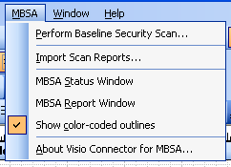
- With the Server shape still selected choose Custom Properties from the Shape menu.
- In the Custom Properties dialog fill out the Network Name property with a valid network name and click the OK button.
- The Server shape is now configured for use with MBSA. If you hover the mouse over the Server shape a smart tag will be visible. This smart tag contains the same Perform Baseline Security Scan menu item that is also in the main MBSA menu.
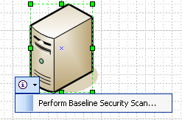
- Selecting the Perform Baseline Security Scan menu item from the smart tag menu or the main MBSA menu will display the Perform Scan dialog with the available scanning options.
- The Perform Scan dialog will list any shape in the drawing that is properly configured for use with MBSA. Select from the list the machines you wish to scan, select the appropriate scan options and click the OK button.
- During the scan the Status window is displayed showing the current status of the running scan. From this window you can also cancel the current scan by pressing the Cancel button.
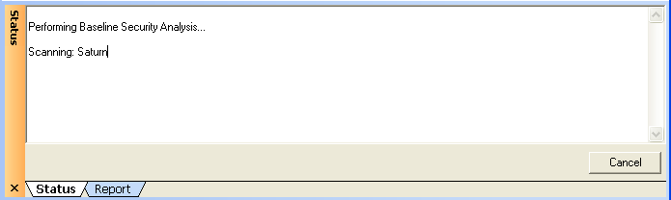
- After the scan has completed successfully, the report window will display the contents of the scan report that was generated by MBSA.
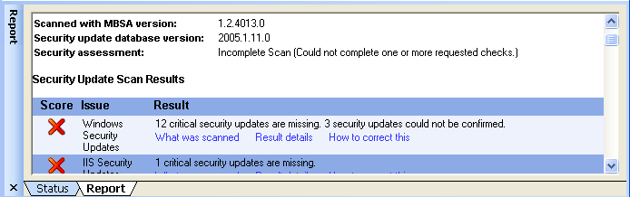
Each scan report is stored in the individual shape and is visible in the Report window when a shape that contains a scan report is selected, this way these shapes can be copied to other drawings and the scan report data will stay with the shape.

MBSA Menu
When a network diagram is open in Visio, the MBSA menu will be available on the main menu.

Perform Baseline Security Scan
This menu item displays the Perform Baseline Security Scan dialog that contains all the options for what machines to scan and what options to use when scanning the selected machines.
Refer to the MBSA help topics for details on each option presented in this dialog.

Import Scan Reports
This menu item displays a dialog that allows the selection of existing reports to be imported into the current drawing. Data from the report is used to match the report to existing shapes in the drawing.

MBSA Status Window
This menu item displays or hides the MBSA Status window. The MBSA Status window displays the current status of any scans that are running or the results from a scan that just completed.

MBSA Report Window
This menu item displays or hides the MBSA Report window. The MBSA Report window displays the scan report of a currently selected Visio shape that contains a scan report.

Show color-coded outlines
This menu item displays or hides the color-coded outlines that are applied to Visio shapes that have completed a scan and contain a valid scan report.

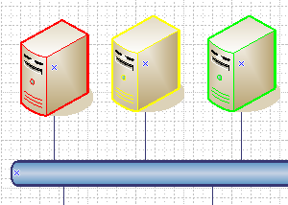

Below is a list of the color codes:
- Red – Severe Risk
- Yellow – Potential Risk
- Blue - Informational
- Green – Strong Security
- Black – Has not been scanned or a scan could not be completed

Known Issues

Installing Visio Connector for MBSA 2.0 on machines with .NET Framework 2.0
The installation of the Visio Connector for MBSA 2.0 will fail if the target machine has either Microsoft Visual Studio 2005 Beta 2 or Microsoft .NET Framework Version 2.0 Redistributable Package Beta 2 (x86) installed. The Visio Connector 2.0 installation will near completion and then roll back, reporting “Installation ended prematurely because of an error.”

Workaround:
- Uninstall Microsoft Visual Studio 2005 Beta 2 or .NET Framework Version 2.0 Redistributable Package Beta 2 (x86)
- Install the Visio Connector for MBSA 2.0
- Reinstall Microsoft Visual Studio 2005 Beta 2 or .NET Framework Version 2.0 Redistributable Package Beta 2 (x86)

