

Using ISA Server to Extend Server and Domain Isolation Interoperability

Microsoft Corporation
Published: January 2007

Abstract
When planning, developing, or evolving a Server and Domain Isolation solution based on Microsoft® Windows® IPsec and Microsoft® Active Directory®, IT administrators frequently want to include machines that are not able to support Internet Protocol security (IPsec) standards. These might include non-Windows devices and legacy systems. By using Microsoft® Internet Security and Acceleration (ISA) Server as an IPsec gateway or proxy running on Microsoft® Windows Server 2003, IT administrators can extend interoperability and security while leveraging their existing system software and expertise.
This white paper details how to use ISA Server as an IPsec gateway or proxy within a Server and Domain Isolation solution, from preparation to installation and configuration, and includes best practices to keep in mind during the process. It is written for enterprise technical decision makers, IT administrators, and architects who want to gain a better understanding of the processes and implementation of ISA Server as an IPsec gateway or proxy to extend IPsec interoperability.
The information contained in this document represents the current view of Microsoft Corporation on the issues discussed as of the date of publication. Because Microsoft must respond to changing market conditions, it should not be interpreted to be a commitment on the part of Microsoft, and Microsoft cannot guarantee the accuracy of any information presented after the date of publication.
This White Paper is for informational purposes only. MICROSOFT MAKES NO WARRANTIES, EXPRESS, IMPLIED OR STATUTORY, AS TO THE INFORMATION IN THIS DOCUMENT.
Complying with all applicable copyright laws is the responsibility of the user. Without limiting the rights under copyright, no part of this document may be reproduced, stored in or introduced into a retrieval system, or transmitted in any form or by any means (electronic, mechanical, photocopying, recording, or otherwise), or for any purpose, without the express written permission of Microsoft Corporation.
Microsoft may have patents, patent applications, trademarks, copyrights, or other intellectual property rights covering subject matter in this document. Except as expressly provided in any written license agreement from Microsoft, the furnishing of this document does not give you any license to these patents, trademarks, copyrights, or other intellectual property.
Unless otherwise noted, the example companies, organizations, products, domain names, e-mail addresses, logos, people, places, and events depicted herein are fictitious, and no association with any real company, organization, product, domain name, email address, logo, person, place, or event is intended or should be inferred.
© 2007 Microsoft Corporation. All rights reserved.
Microsoft, Active Directory, ISA Server 2004, ISA Server 2006, Windows Server 2003, Windows XP, Windows 2000, Windows NT 4.0 and Microsoft® Windows® IPsec are either registered trademarks or trademarks of Microsoft Corporation in the United States and/or other countries.
All other trademarks are property of their respective owners.

Contents
Introduction 4
Background 5
Introduction to IPsec 5
Server and Domain Isolation 5
IPsec Gateways for Interoperability 5
ISA Server as an IPsec Gateway 6
Solution Overview 7
Scenario 1: Isolated client access to a non-IPsec enabled server. 7
Scenario 2: Non-IPsec clients need to access a server on an isolation domain. 8
Scenario 3: Allowing full access to isolated domains for business-critical exceptions 9
Deploying the Solution 10
Before You Begin 10
Installing ISA Server 10
Disabling Routing 10
Configuring Rules 11
Creating a Network Rule for Network Address Translation (NAT) 12
Creating an Access Rule for Internet Key Exchange (IKE) 13
Creating a Server Publishing Rule 15
Creating a Web Publishing Rule 19
Creating an Additional Access Rule 21
Security Implications of this Solution 23
Best Practices 23
Related Links and Resources 23

Introduction
A Server and Domain Isolation solution based on Microsoft® Windows® IPsec and Microsoft® Active Directory® enables IT administrators to dynamically segment a Windows environment into more secure and isolated logical networks without costly changes to the network infrastructure or applications. This creates an additional layer of policy-driven protection, allowing IT administrators to greatly reduce the risk of network attacks, helping to prevent unauthorized access to trusted networked resources, and reducing operational costs.
By implementing Server and Domain Isolation, IT professionals have a low-cost way to better safeguard sensitive data. This security makes it easier to achieve compliance with regulatory requirements such as the Health Insurance Portability and Accountability Act (HIPAA), Sarbanes-Oxley, the Gramm-Leach-Bliley Act (GLBA), and the Federal Information Security Management Act (FISMA).
However, when planning, developing, or evolving a Server and Domain Isolation solution, administrators frequently have to consider machines that do not support Internet Protocol security (IPsec) standards. These might include mainframes, non-Windows devices, older versions of Windows, or other hosts where implementing IPsec support is not standard practice. It is important to protect these systems from unauthorized access and network-based attacks while allowing them to communicate with IPsec-enabled network assets. Often, administrators also want to enable IPsec-protected systems to communicate with trusted non-IPsec assets. A number of options to mitigate risk in these scenarios while enabling the desired interoperability are possible.
This paper discusses how to use Microsoft Internet Security and Acceleration (ISA) Server running on Microsoft Windows Server 2003 as an IPsec proxy or gateway. With this solution, IT administrators can extend a Server and Domain Isolation deployment for greater interoperability while leveraging existing system software and expertise.
Each enterprise environment has unique circumstances; therefore, each organization should adapt the plans described in this paper to meet its specific needs.

Background

Introduction to IPsec
Designed by the Internet Engineering Task Force (IETF) as the security architecture for the Internet Protocol (IP), IP security (IPsec) defines IP packet formats and related infrastructure to provide end-to-end strong authentication, integrity, anti-replay, and (optionally) confidentiality for network traffic. Internet Key Exchange (IKE), part of IPsec, specifies an on-demand security negotiation and automatic key management service. All recent versions of the Windows operating system from Windows 2000 Server to Windows Vista™ and Windows Server “Longhorn” offer Windows IPsec, a robust implementation of IPsec, to help simplify the deployment and management of network security.
A Standards-Based Framework of Security Protocols and Cryptographic Services
IPsec refers to a framework of security protocols and cryptographic services for Internet Protocol (IP) packets. Implementing end-point authentication using IPsec makes it much more difficult for an attacker to gain access to a protected machine. IPsec can be deployed as a local policy or a domain-based Group Policy. Local policies can be deployed with a Microsoft Management Console (MMC) snap-in, or via command line tools such as netsh.exe (Windows Server 2003 and later), ipseccmd.exe (Windows XP), and ipsecpol.exe (Windows 2000).

Server and Domain Isolation
Server Isolation creates a more secure, logically isolated network around a specific set of servers and/or applications and the data that support it. For example, this could be an organization’s financial servers and the hosts used by the finance department. By logically isolating these critical servers and data, network access can be restricted to only those that have a business requirement to connect to them. This greatly reduces unauthorized access to sensitive data.
Domain Isolation extends this model to an entire managed domain (i.e., those hosts that are joined to the Active Directory) to reduce the risk of unmanaged or rogue devices from impacting the security or integrity of managed, trusted hosts.
This solution is based on policy (i.e., Active Directory Group Policy) rather than the network topology and removes the need to change existing applications. Thus, Server and Domain Isolation processes are able to change dynamically based on changes in organization or business requirements.
For more information on Server and Domain Isolation, please visit http://www.microsoft.com/sdisolation.

IPsec Gateways for Interoperability
The purpose of a Server and Domain Isolation solution is to limit the risk of unauthorized access (external and internal) to trusted assets. Today’s networks, however, often include machines that do not natively support IPsec standards.
An IPsec gateway is an easy-to-deploy option for interoperability with these machines. It acts as a demarcation point and connection between the IPsec-enabled isolation domain and the non-IPsec domain. Other defense-in-depth security controls are then recommended to secure the non-IPsec network segment or subnet.
The IPsec gateway has separate network interfaces connecting it to both domains. It supports the end-point authentication provided by Server and Domain Isolation when communicating with computers on the IPsec-enabled isolation domain, and uses plain text when communicating with computers on the non-IPsec domain.
An IPsec gateway enables transparent interdomain communication by routing traffic between the domains while converting IPsec-protected traffic to plain text and vice versa. The IPsec gateway checks IP addresses and verifies integrity of the traffic it sends on behalf of computers in the non-IPsec domain. Since Server and Domain Isolation policy is not supported on the non-IPsec computers, the IPsec gateway also ensures that only traffic permitted by the security policy is allowed to flow between the domains.
The advantages of the IPsec gateway approach are as follows:
- Enables computers lacking full IPsec support to participate in and benefit from the defenses of Server and Domain Isolation.
- Centralizes configuration in one computer, the IPsec gateway.
- Eliminates the need for special exception rules in IPsec policy.

ISA Server as an IPsec Gateway
ISA Server is ideally suited for the role of IPsec gateway as it includes all of the necessary gateway functionality: firewall protection, network address translation (NAT) and IPsec-based isolation support. ISA Server enables seamless communication with non-IPsec capable computers without compromising security. By using ISA Server running on Windows Server 2003 as an IPsec gateway for non-IPsec devices, IT administrators can improve network and data security while extending interoperability.
This application of ISA Server builds upon existing investments in Windows Vista, Windows Server 2003, Windows XP or Windows 2000 and Microsoft Active Directory to provide a flexible solution that can be deployed today without the need to install additional software on the hosts. By using Windows IPsec, these enhanced security benefits are implemented at the network layer, removing the need to make changes to applications. Additionally, the deployment does not require potentially disruptive changes to network topology or costly network hardware upgrades to enable policy-driven, logical network segmentation.

Solution Overview
The three most common scenarios for choosing to use ISA Server as an IPsec gateway or proxy in a network are described below.

Scenario 1: Isolated Client Needs Access to a Non-IPsec-Enabled Server
When a business-critical server cannot be protected with IPsec but still needs to be accessed by IPsec-enabled clients, and the IT administrator wants to secure as much of the path as possible, the machines can be connected using ISA Server as an IPsec gateway. The non-IPsec server should continue to be protected with separate defense-in-depth security measures after gateway deployment.
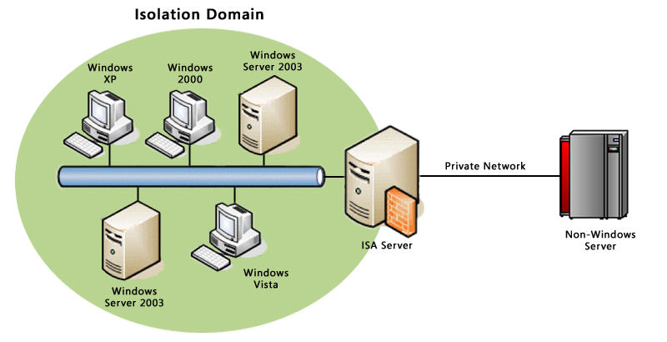
Figure 1: ISA Server as an IPsec Gateway
To access the services provided by the non-IPsec host, all systems in the Isolation Domain will connect to the ISA Server public IP address, and IPsec transport mode will be authenticating and (optionally) encrypting this network traffic. ISA Server proxies the traffic to the non-IPsec device, which receives the connection in clear and unaware that IPsec is part of the communication path.
Note: A secondary IPsec session can be established between the ISA Server system and the non-IPsec host or device if desired. This can be useful for systems that do not support the full set of IPsec features required for the Server and Domain Isolation solution but have basic IPsec support, allowing some data sharing over a fully IPsec-enabled path.

Scenario 2: Non-IPsec Client Needs Access to a Server on an IPsec-Enabled, Isolation Domain
When a non-isolated client machine cannot run IPsec but security policies have determined it is authorized to access trusted network resources that are isolated via domain isolation, the IT administrator can connect the hosts using ISA Server as a proxy.
This figure shows a typical deployment of ISA Server as an IPsec proxy. The dual-homed gateway has one interface using IPsec in the isolation domain, while the other interface is connected to the non-Windows or legacy systems.
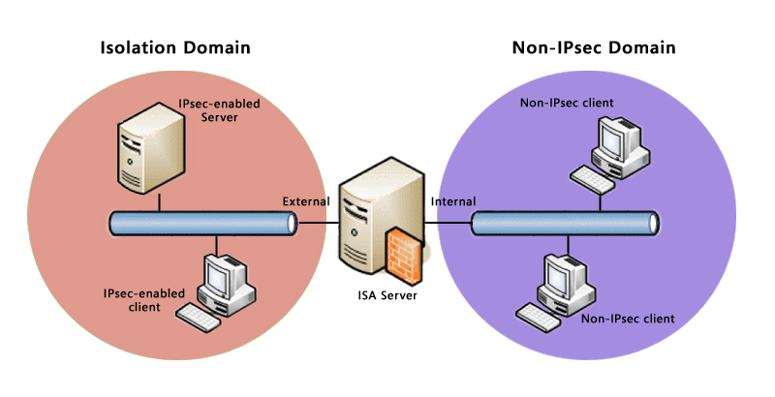
Figure 2: ISA Server as an IPsec Proxy

Scenario 3: Allowing Full Access to Isolated Domains for Business-Critical Exceptions
Specialized non-IPsec-enabled machines that require unlimited access to the isolated domain (for vulnerability scanning or licensing compliance checks, for example) can be accommodated with ISA Server.
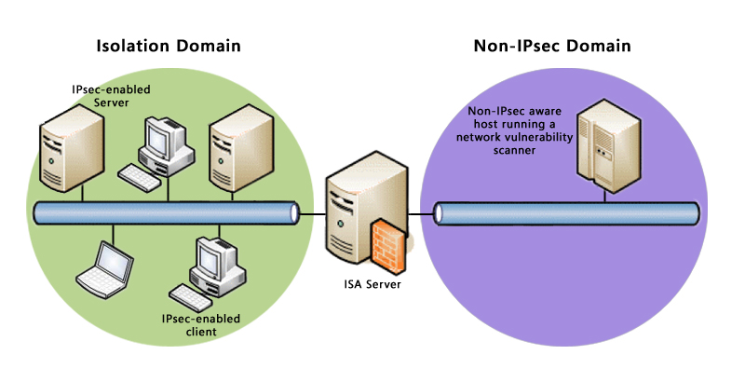
Figure 3: Peer-to-Peer Communication
To enable this type of communication, administrators can create an access rule, allowing access from the ISA Server’s internal network (hosting the non-IPsec machine) to its external network (hosting the IPsec machines) on the protocol of interest.
It is important to note that access checks provided by ISA Server in this situation will rely on IP addresses, which can be falsified. If an intruder is able to obtain the key IP address, access would be granted if no other security measures are in place.

Deploying the Solution
Setting up ISA Server is the same for all three scenarios. This section describes the preparation, installation, and setup process; it then details how to configure ISA Server for each scenario.

Before You Begin
Take the time to thoroughly prepare for the ISA Server deployment and configuration.
- Identify affected assets. Map out allowed communications paths and boundary machines, and document any policy exceptions.
- Create a rollout schedule.
- Communicate with users.
- Hardware and software requirements:
  - Hardware: ISA Server as an IPsec gateway requires a PC with a 733 megahertz (Mhz) Pentium III or higher processor, a hard drive with a NTFS-formatted local partition with 150 megabytes (MB) of available space, and a minimum of 512 MB random access memory (RAM), with two network interface cards. It is recommended that at least one card support IPsec offload.
  - Software: Windows Server 2003 with Service Pack 1 (SP1) or Windows Server 2003 R2. ISA Server 2006 Standard Edition or ISA Server 2004 Standard Edition.

Installing ISA Server
- Begin the installation of ISA Server, and select the Typical installation. Click Next to continue the installation.
- Define the ISA Server Internal Network using the subnet that connects with the non-IPsec enabled machines, and click Next.
- The ISA Server setup program will inform the administrator that the domain is outside the internal network, and the system policies will be configured to allow Active Directory communication. Click Next until the installation is complete.
- After the installation is complete, reboot the machine. If running ISA Server 2004, install the ISA 2004 Service Pack 2, and reboot again if necessary.
Disabling Routing
After installing ISA Server, you must disable routing. This will instruct Windows not to attempt to forward packets directly in the between the networks and will enable ISA Server to do required translation. To disable routing:
- Expand ISA Server Management console tree, expand the array node, expand Configuration, and select General.
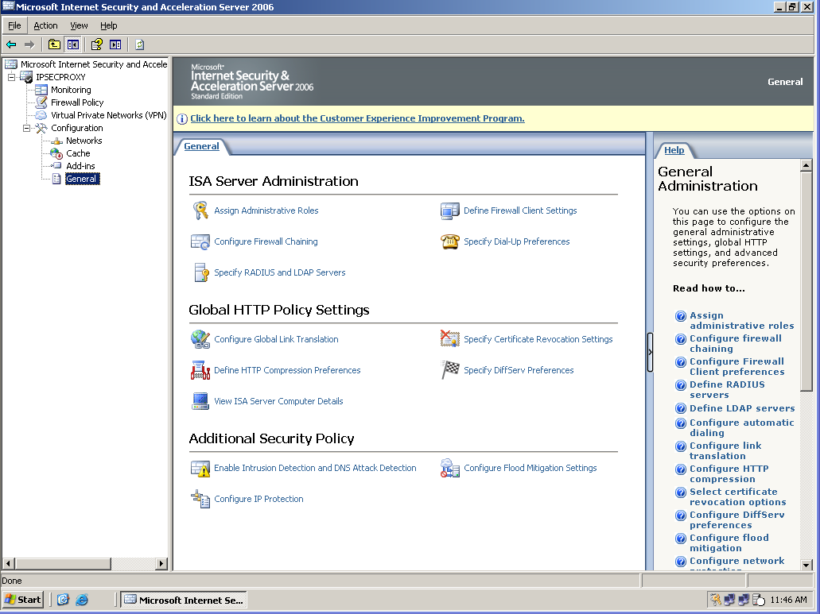
- In the details pane, under Additional Security Policy, select Configure IP Protection.
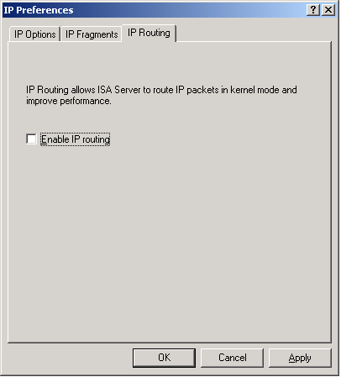
- On the IP Routing tab, clear Enable IP routing.

Configuring Rules
After completing the installation of ISA Server, the next step is to create the necessary access and publishing rules. Appropriate rules need to be created to enable and control access to or from the non-IPsec machine(s).
All three scenarios require a network rule for NAT and an IKE access rule. Each scenario then requires additional specific rules, as described later in this topic, beginning with “Creating a Web Publishing Rule.”
Creating a Network Rule for Network Address Translation (NAT)
Network rules determine whether or not there is a relationship between two network entities and what type of relationship is defined. All three scenarios require creation of a network rule on ISA Server to establish a NAT relationship between the IPsec and non-IPsec network entities.
To create the NAT network rule, follow these steps:
- In the Microsoft ISA Server Management console tree, expand the ISA Server array node, expand Configuration, right-click Networks, point to New, and select Network Rule. This starts the New Network Rule Wizard.
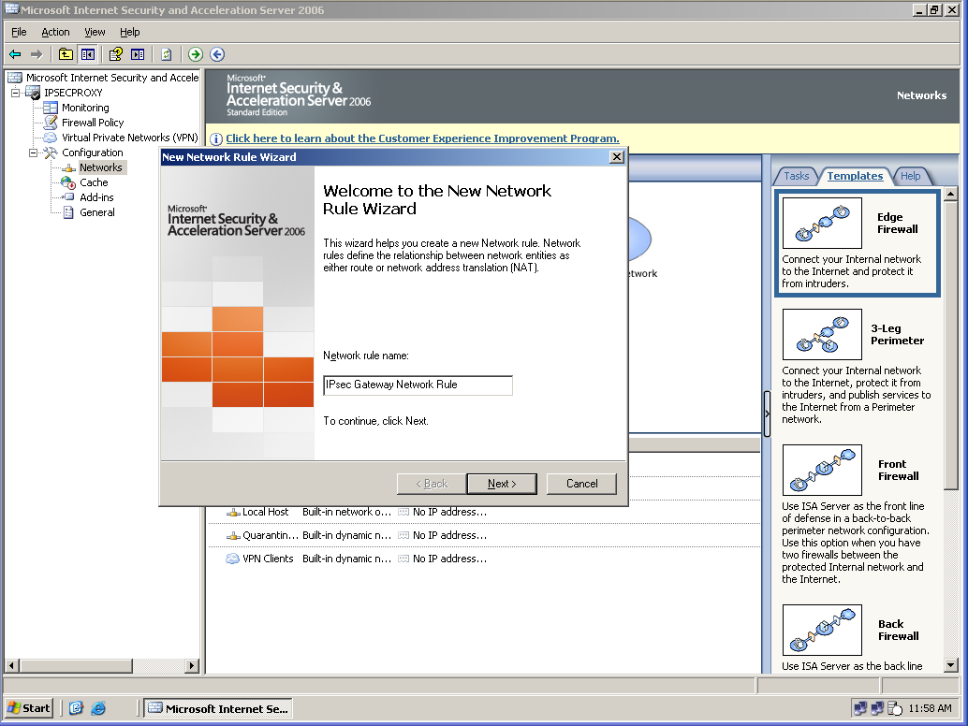
- On the Welcome page of the wizard, enter the name for the network rule, and then click Next.
- On the Network Traffic Sources page, click Add to open the Add Network Entities dialog box.
- Expand Networks, select the IPsec network, click Add, and then click Close. On the Network Traffic Sources page, click Next.
- On the Network Traffic Destinations page, click Add to open the Add Network Entities dialog box, expand Networks, select the non-IPsec enabled network, click Add, and then click Close. On the Network Traffic Destinations page, click Next.
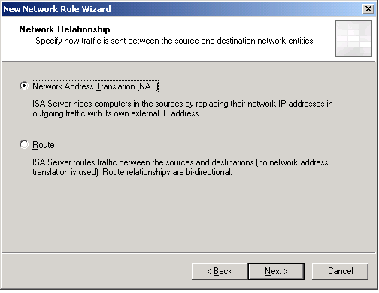
- On the Network Relationship page, select Network Address Translation (NAT), and then click Next.
- Review the information on the wizard summary page, and then click Finish.
- In the ISA Server details pane, click Apply to apply the new network rule.
Creating an Access Rule for Internet Key Exchange (IKE)
Follow these steps to create an access rule allowing traffic on the IKE Client protocol from the IPsec-enabled network (the External network) to the Local Host (the ISA Server computer or array). This rule is required for all three scenarios.
- In the Microsoft ISA Server Management console tree, select Firewall Policy.
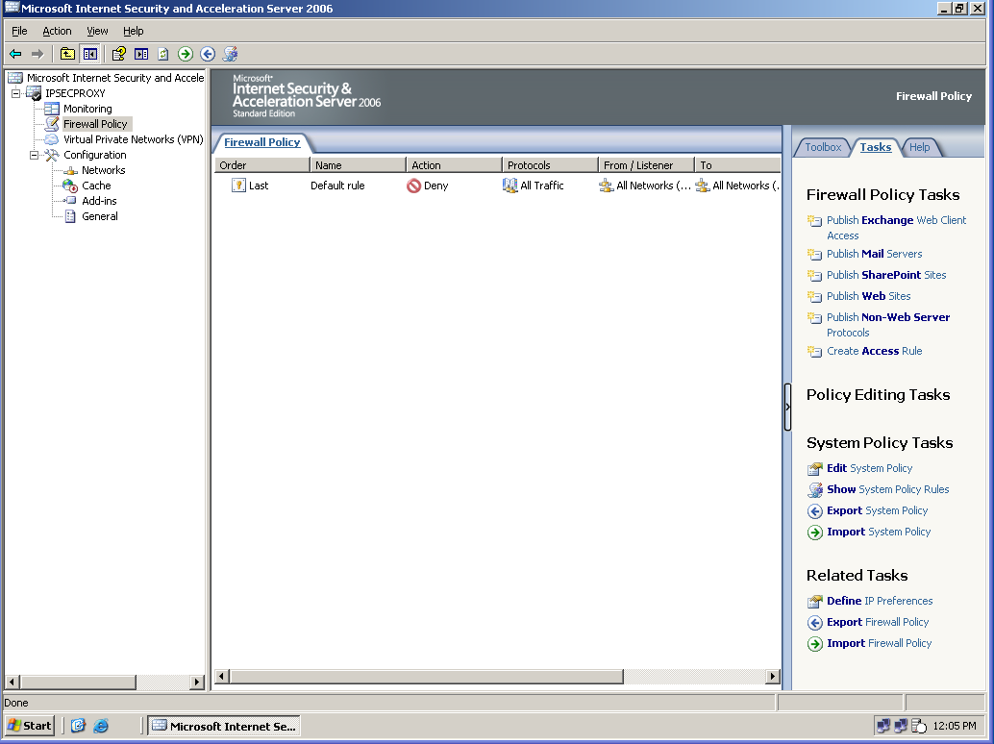
- In the task pane, on the Tasks tab, select Create New Access Rule to start the New Access Rule Wizard.
- On the Welcome page of the wizard, enter the name for the access rule, and then click Next.
- On the Rule Action page, select Allow, and then click Next.
- On the Protocols page, select Selected protocols and click Add, expand All Protocols, select IKE Client, click Add, and then click Close.
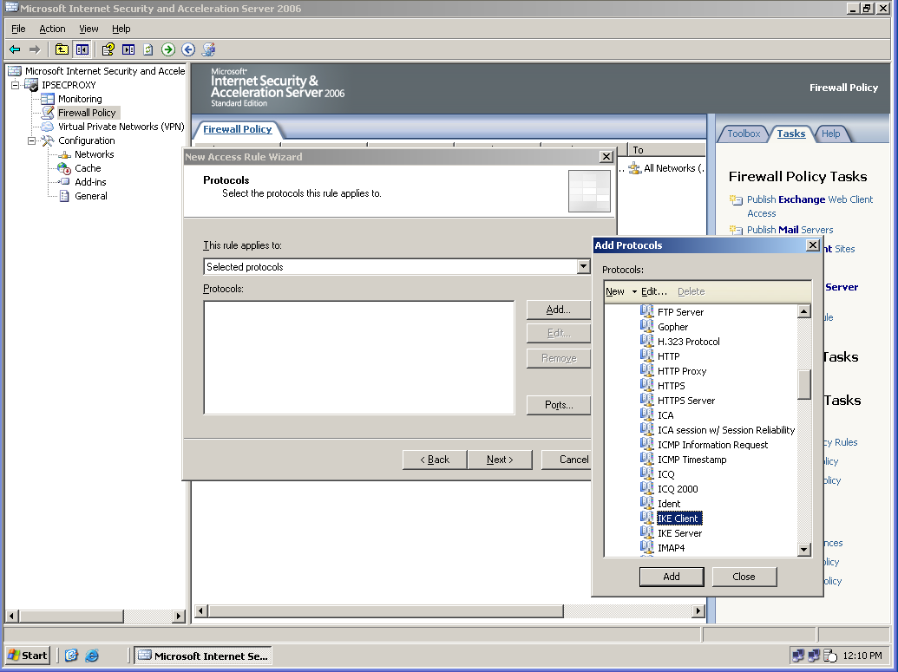
- On the Protocols page, click Next.
- On the Access Rule Sources page, click Add to open the Add Network Entities dialog box, expand Networks, select the non-IPsec network, click Add, select the Local Host network, click Add, and then click Close. On the Access Rule Sources page, click Next.
- On the Access Rule Destinations page, click Add to open the Add Network Entities dialog box, expand Networks, select the External network, click Add, select the Local Host network, click Add, and then click Close. On the Access Rule Destinations page, click Next.
- On the User Sets page, if your rule applies to all users, you can leave the user set All users in place and proceed to the next page of the wizard. If the rule applies to specific users, select All users and click Remove. Then, use the Add button to open the Add Users dialog box, from which you can add the user set to which the rule applies. The Add Users dialog box also provides access to the New User Sets Wizard through the New menu item. When you have completed the user set selection, click Next.
- Review the information on the wizard summary page, and then click Finish.
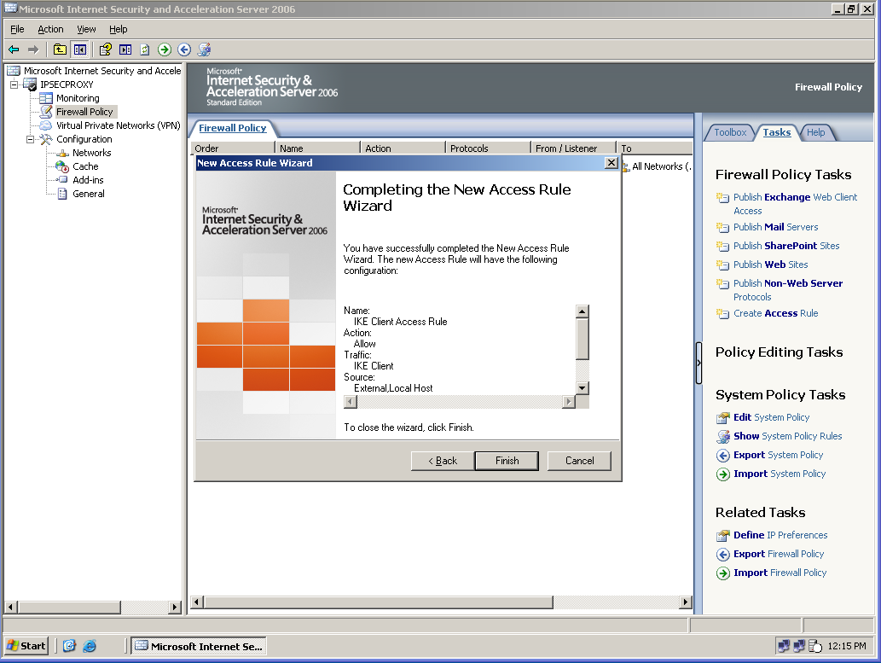
- In the Firewall Policy details pane, click Apply to apply the new access rule. It may take a few moments for the rule to be applied.
- Order your access rules to match your Internet access policy. If you change the order, you will need to click Apply to apply the changes.
At this point, additional specific rules must be created and applied to support each scenario. These are described in the following sections.
Creating a Server Publishing Rule
To publish a non-HTTP server, you must create a server publishing rule that configures a single port for handling the traffic to server. This applies in Scenario 1 and Scenario 2.
- For Scenario 1 (Isolated Client Needs Access to a Non-IPsec Server), create a server publishing rule to enable non-HTTP communication as described below. For HTTP communication, create a Web publishing rule as described in the topic “Creating a Web Publishing Rule.” Your server publishing rule should listen on the non-IPsec network and publish a server on the IPsec-enabled network.
- For Scenario 2 (Non-IPsec Client Needs Access to a Server on an IPsec-Enabled, Isolation Domain), create a server publishing rule to enable non-HTTP communication. For HTTP communication, create a Web publishing rule as described in the topic “Creating a Web Publishing Rule.” Your server publishing rule should listen on the IPsec-enabled network and publish a server on the non-IPsec network.
To create the publishing rule, follow these steps. The example screenshots illustrate Scenario 1.
- In ISA Server Management, right-click Firewall Policy, point to New, and select Non-Web Server Protocol Publishing Rule.
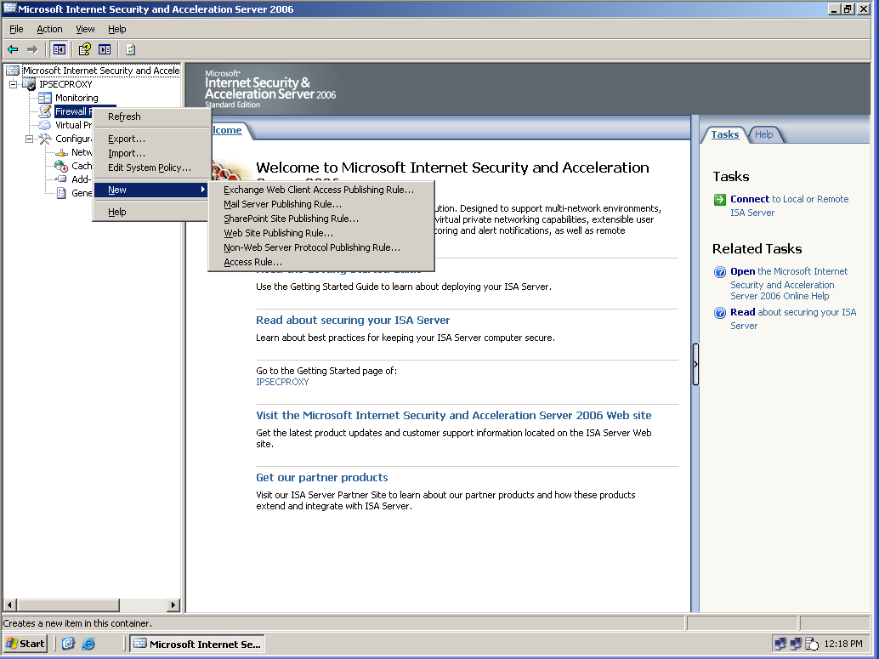
- On the New Server Publishing Rule Wizard Welcome page, provide a name for the rule. Click Next.
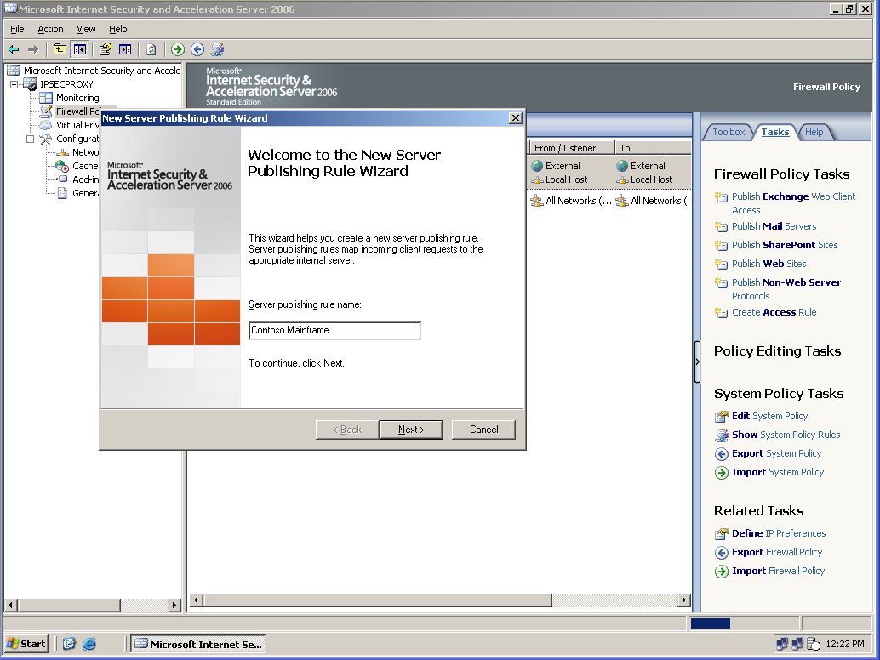
- On the Select Server page, in Server IP address, type the IP address of the server you are publishing, and then click Next. If the protocol is not in the list, use the New… option to create a new protocol definition.
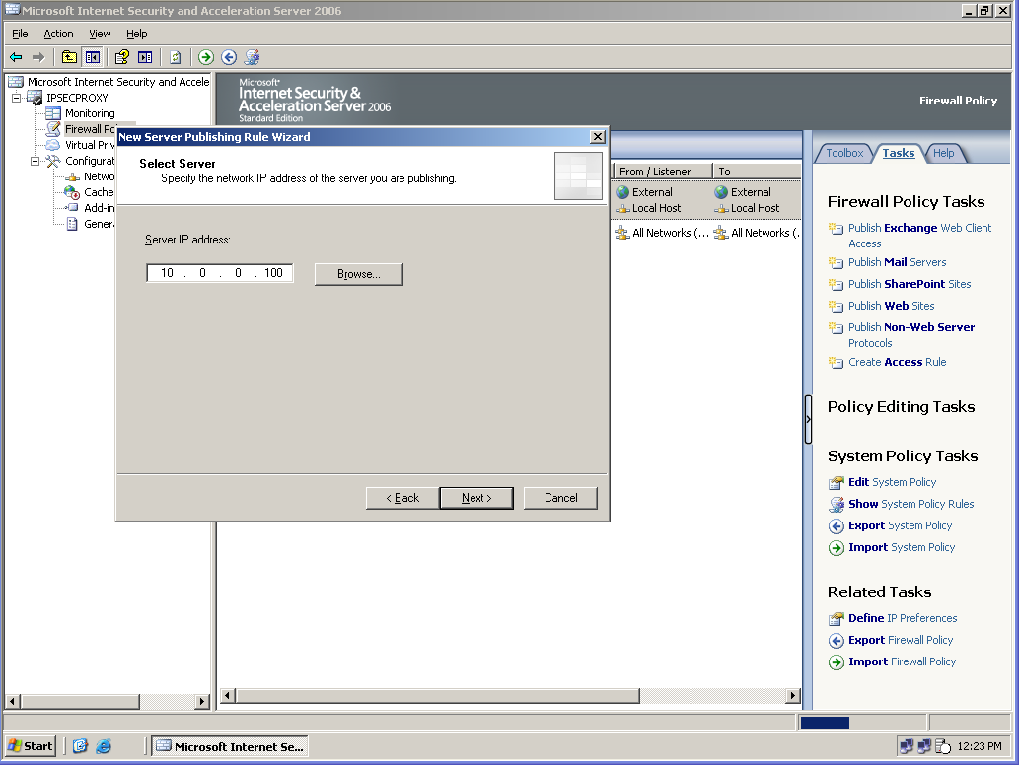
- On the Select Protocol page, from the Selected protocol drop-down list, select the protocol required to publish the server, and then click Next.
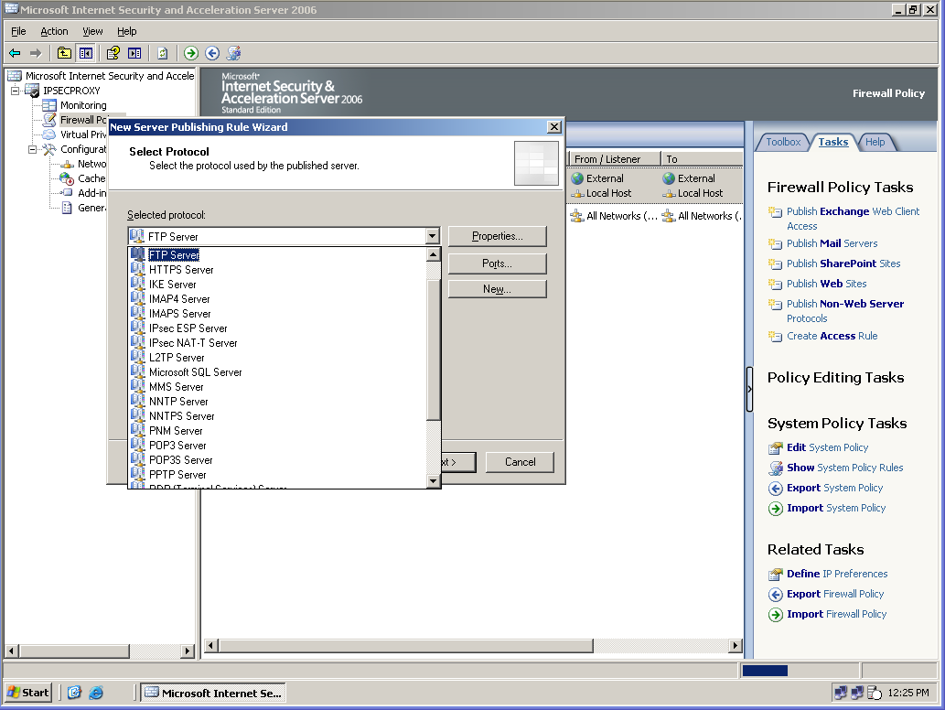
- On the Network Listener IP Addresses page, under Listen for requests from these networks, select the networks on which you want to listen for requests. For example, if you want to publish an IPsec-enabled server to the non-IPsec network, select External. Alternatively, if you are publishing a non-IPsec server to the IPsec-enabled network, select Internal.
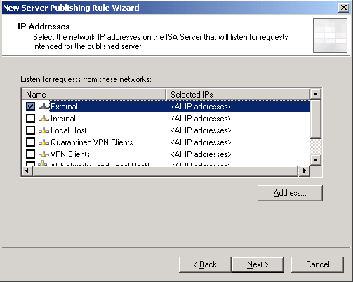
Note: You can select specific IP addresses that ISA Server will listen on. To do this, click the Address button, and then for the selected network, specify the IP addresses that ISA Server will listen on. You can use this feature to publish multiple servers on the same protocol by publishing each to a different IP address.
- Click Next.
- Review the information on the wizard summary page, and then click Finish.
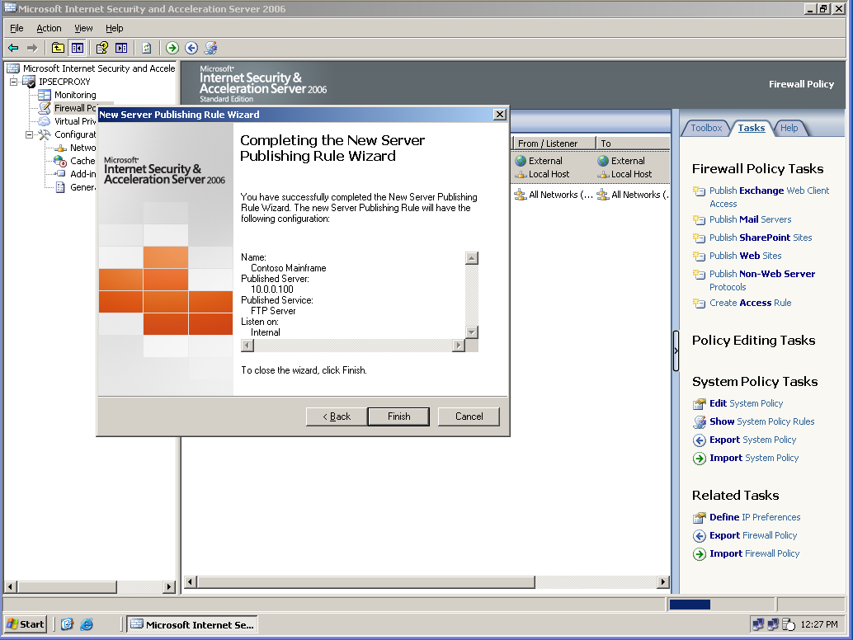
- On the Firewall Policy tab, under the Name column, double-click the new rule to open its properties.
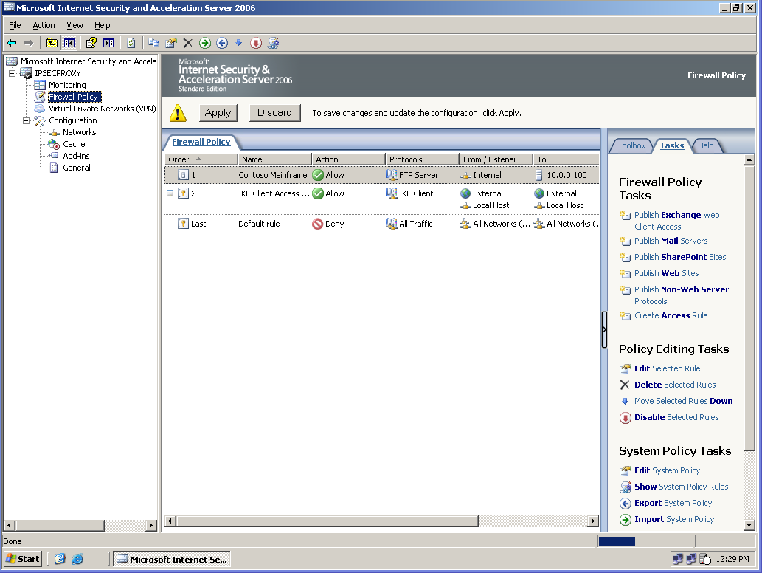
Note: On the To tab, under Requests for the published server, there is an option to have Requests appear to come from the ISA Server computer. This option can be used when you have not configured ISA Server as the default gateway on the published server. This approach has the disadvantage that the published server will be unaware of the address of the client, which is a problem for server applications that use the client address for logging or for policy decisions.
- In the details pane, click the Apply button to apply the publishing rule that is effective for the incoming traffic.
Creating a Web Publishing Rule
When to use a Web publishing rule:
- For Scenario 1, create a Web publishing rule to enable HTTP and/or HTTPS communication. The listener for the Web publishing rule should listen on the non-IPsec enabled network and publish a server on the IPsec-enabled network.
- For Scenario 2, create a Web publishing rule to enable HTTP and/or HTTPS communication. The listener for the Web publishing rule should listen on the IPsec-enabled network and publish a server on the non-IPsec network.
To create a new Web publishing rule, follow these steps:
- Open Microsoft ISA Server Management, expand the ISA Server computer node, and click Firewall Policy.
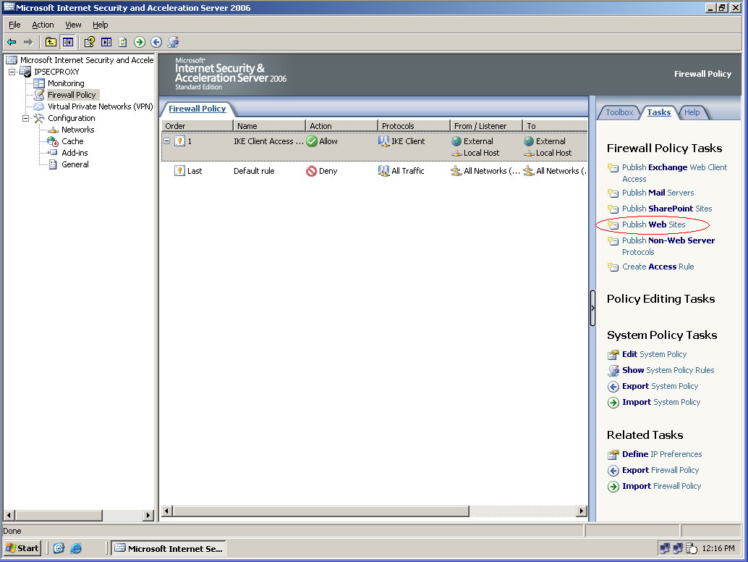
- On the task pane, in the Tasks tab, click Publish Web Sites to start the New Web Publishing Rule wizard.

- On the Welcome page, in the Web publishing rule name field, type a name for the rule, such as Publish internal Web server, and click Next.
- On the Select Rule Action page, ensure that the default Allow is selected, which will allow requests to reach your Web server according to the conditions set by the rule. Click Next.
- On the Define Website to Publish page, in Computer name or IP address, specify the Web server computer that hosts the Web site that you want to publish. This can be the computer name or the IP address of the computer. Verify that Forward the original host header is not selected. This is its default condition. In Folder, you can specify the Web site folder that you want to publish. If you leave this field blank, you will be publishing the entire site. Click Next.
Note: By default, ISA Server substitutes a host header that it uses to refer to the internal Web server, rather than sending the original host header that ISA Server received. Select Forward the original host header instead of the actual one on the Define Website to Publish page of the New Web Publishing Rule Wizard if your Web site has specific features that require the original host header.
- On the Public Name Details page, provide information regarding what requests will be received by the ISA Server computer and forwarded to the Web server. In Accepts requests for, if you select Any domain name, any request that is resolved to the IP address of the external Web listener of the ISA Server computer will be forwarded to your Web site.
- If you select This domain name and provide a specific domain name, such as www.fabrikam.com, assuming that domain is resolved to the IP address of the external Web listener of the ISA Server computer, only requests for http://www.fabrikam.com will be forwarded to the Web server.
- If you specify a folder in Path, such as News, that would also be required in the request: http://www.fabrikam.com/news. The required request format is shown in Site. Click Next.
- On the Select Web Listener page, specify the Web listener that will listen for Web page requests that should be redirected to your Web server, and then click Next. If you have not defined a Web listener, click New and follow these steps to create a new listener.
- On the Welcome page of the New Web Listener Wizard, type the name of the new listener, such as Listener on External network for internal Web publishing, and then click Next.
- On the IP Addresses page, select the network that will listen for Web requests. If you want ISA Server to receive requests from the non-IPsec network (you are publishing a server on the IPsec-enabled network to the non-IPsec network), the listener should be one or more IP addresses on the non-IPsec network adapter of ISA Server. You would therefore select External. If you want ISA Server to receive requests from the IPsec-enabled network (you are publishing a server on the non-IPsec network to the IPsec network), the listener should be one or more IP addresses on the Internal network adapter of ISA Server. You would therefore select Internal.
- Click Next.
- On the Port Specification page, make sure the HTTP port is set to 80 (the default setting). If you want to receive HTTPS requests, select Enable SSL, make sure the SSL port is set to 443 (the default setting), and provide the certificate name in the Certificate field. This requires that you have a digital certificate installed on the ISA Server computer. For more information about certificates, see Digital Certificates for ISA Server 2004 (http://go.microsoft.com/fwlink/?LinkId=20794). Click Next.
- On the Completing the New Web Listener Wizard page, review the settings, and click Finish. On the Select Web Listener page, click Next.
- On the User Sets page, make sure the default, All users, is displayed. This will allow any computer in the External network to access the published Web pages. Note that to restrict access to specific users, use the Remove button to remove All users and the Add button to access the Add Users dialog box. Click Next.
- On the Completing the New Web Publishing Rule Wizard page, scroll through the rule configuration to make sure that you have configured the rule correctly, and click Finish.
- In the ISA Server details pane, click Apply to apply the changes you have made.
Creating an Additional Access Rule
For Scenario 3, in addition to the access rule you had to create for all of the scenarios (allowing traffic on the IKE Client protocol from the IPsec-enabled network to the Local Host), you must create an access rule allowing access from the ISA Server’s internal network (the non-IPsec domain) to its external network (the IPsec domain) on the protocol of interest.
To create the access rule, follow these steps:
- In the Microsoft ISA Server Management console tree, select Firewall Policy.
- In the task pane, on the Tasks tab, select Create New Access Rule to start the New Access Rule Wizard.
- On the Welcome page of the wizard, enter the name for the access rule, and then click Next.
- On the Rule Action page, select Allow, and then click Next.
- On the Protocols page, select Selected protocols and click Add, expand All Protocols, select the needed protocol, click Add, and then click Close. On the Protocols page, click Next.
- On the Access Rule Sources page, click Add to open the Add Network Entities dialog box, expand Networks, select the network that hosts the non-IPsec computer, such as the Internal network, click Add, and then click Close. On the Access Rule Sources page, click Next.
- On the Access Rule Destinations page, click Add to open the Add Network Entities dialog box, expand Networks, select the IPsec-domain network, such as the External network click Add, and then click Close. On the Access Rule Destinations page, click Next.
- On the User Sets page, if your rule applies to all users, you can leave the user set All users in place and proceed to the next page of the wizard. If the rule applies to specific users, select All users and click Remove. Then, use the Add button to open the Add Users dialog box, from which you can add the user set to which the rule applies. The Add Users dialog box also provides access to the New User Sets Wizard through the New menu item. When you have completed the user set selection, click Next.
- Review the information on the wizard summary page, and then click Finish.
- In the Firewall Policy details pane, click Apply to apply the new access rule. It may take a few moments for the rule to be applied. Order your access rules to match your Internet access policy. If you change the order, you will need to click Apply to apply the changes.

Security Implications of this Solution
Using ISA Server as an IPsec gateway or proxy for interoperability is less secure than using only IPsec-compliant devices. The solution does not cover all parts of the network path, so administrators must continue to protect the non-IPsec machine using alternate means. Additionally, ISA Server cannot validate untrusted machines to the degree that the IPsec-protected network does, so ISA-allowed machine IP addresses are a possible avenue of attack.
Risks that cannot be mitigated with this solution include the following:

- Trusted users disclosing high value data
- Compromise of trusted credentials
- Untrusted computers compromising other untrusted computers
- Loss of physical security of trusted computers
- Lack of policy compliance mechanisms for trusted computers

Best Practices
For Server and Domain Isolation best practices, please see the deployment documents available at http://www.microsoft.com/sdisolation.

Related Links and Resources

Server and Domain Isolation TechNet Web site

http://www.microsoft.com/sdisolation

Introduction to Server and Domain Isolation with Microsoft Windows

http://www.microsoft.com/downloads/details.aspx?FamilyID=9a3e2b2b-695d-4ff9-bcb1-5f2f3001845e

Server and Domain Isolation Using IPsec and Group Policy Guide http://www.microsoft.com/technet/security/guidance/architectureanddesign/ipsec/default.mspx

Server and Domain Isolation Case Studies

http://www.microsoft.com/sdisolation

ISA Server
ISA Server Home Page: http://www.microsoft.com/isaserver
IPsec FAQ: http://www.microsoft.com/windowsserver2003/techinfo/overview/ipsecfaq.mspx

Community Resources
Peer Communities: http://www.microsoft.com/communities/default.mspx
Most Valuable Professional (MVP) program: http://www.microsoft.com/communities/mvp
User Groups: http://www.microsoft.com/communities/usergroups/default.mspx

