
Microsoft Forecaster

Microsoft Dynamics™ SL

Benefits
- Implement quickly
Deploy budgeting and planning data with ease throughout your organization with a simple, Web-based interface that uses familiar conventions such as drag-and-drop and a spreadsheet format.

- Take control of your budgeting process
Powerful forecasting and budgeting tools allow you to build a precision budget, control expenses, and project sales effectively.

- Adjust quickly to new opportunities
Take advantage of new opportunities
as they arise with capabilities that show you exactly where your budget is and where it’s going to be. Coordinate
plans immediately with your decision makers—regardless of location—using Web-based tools.

- Plan with precision
Create accurate high-level plans by
automatically spreading increases and
decreases across each of your planning
periods with data pulled directly from
Microsoft Dynamics SL General Ledger.

- Streamline your planning
Connect Microsoft Forecaster and
Microsoft Dynamics SL to manage your budget and planning with accurate information, access data from General Ledger, and drill back to source data.

Take control of the future of your organization with Microsoft Dynamics SL for Analytics–Forecaster. Meet business objectives and gain competitive advantage with budgeting and planning capabilities that allow you to plan more effectively and respond quickly to changing business needs.

Move
between budgets easily with the
Budget Version dropdown list.

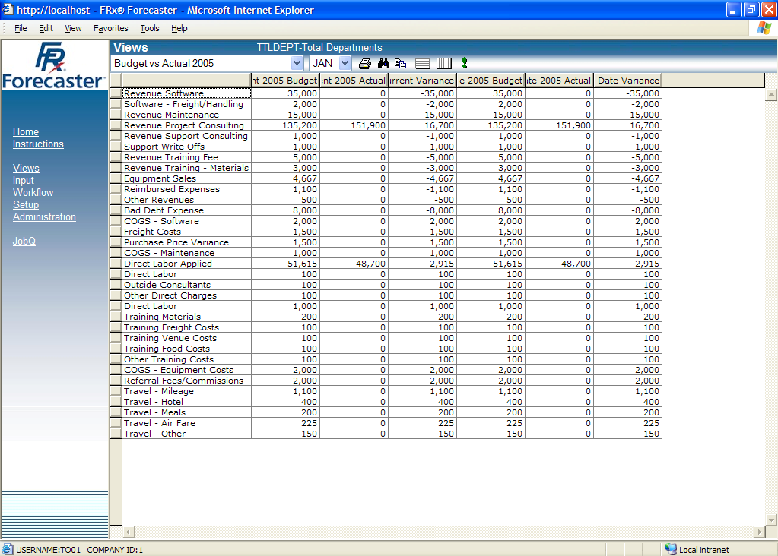

Establish
easy access, yet maintain user-based security, through the hyperlinked menu
Reduce
the learning curve with a spreadsheet look and feel.

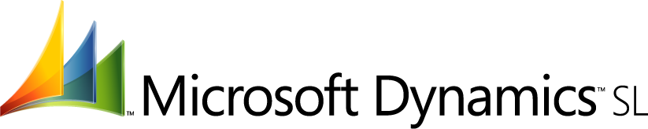

Online View Analysis  FEATURES  BENEFITS | View reports and budget plans online from anywhere in the world  and easily collaborate with your management team in a Web-based  environment.
Comprehensive Account Balances | Use line-item breakdowns to complete detailed planning of account balances for major aspects of your business, including human resources, capital expenditures, and revenue planning.
Extensive HR and Benefits Budgeting Options | Budget employee assets in multiple scenarios by adding more detailed budgeting data for specific personnel, including salary planning worksheets and flexible salary and bonus designations.
Detailed Capital Expense Budgets | Manage depreciation and other factors with ease when going through the budget process for your business models.
Dynamic Revenue Forecasting | Maintain control over your revenue forecasting process by making adjustments at any time to accommodate budgetary and planning changes.
Comprehensive Planning Control | Use flexible input screens to define up to 100 different periods from multiple budget versions and create calculated columns such as variances between plans.
Drag-and-Drop Consolidations | View your business from the top down with easy-to-manipulate scenarios and high-level views that let you quickly see the impact of  the changes on the planning process.
Workflow Control | Manage the planning process with extensive online collaboration between decision makers and automated features that allow them to enter their own data into predefined templates based on standard budgetary tools.
Automated Planning Coordination | Coordinate your budget and planning processes with automated  options such as reminder e-mails, as well as budget templates that managers can review and update to reflect their budget goals.
Automatic Data Mapping | Automatically extend your current financial data from other Microsoft Dynamics SL applications such as General Ledger, using ExpressLink to initiate the budgeting process and update existing budgets.
For more information about Microsoft Dynamics™ SL, visit: http://www.microsoft.com/dynamics/sl

This document is for information purposes only.
MICROSOFT MAKES NO WARRANTIES, EXPRESS, IMPLIED, OR STATUTORY, AS TO THE INFORMATION IN THIS DOCUMENT.

© 2005 Microsoft Corporation. All rights reserved.
Microsoft, The Microsoft Dynamics Logo,are either registered trademarks or trademarks of Microsoft Corporation or Microsoft Business Solutions ApS in the United States and/or other countries. Microsoft Business Solutions ApS is a subsidiary of Microsoft Corporation.

