

SQL Server 2005 and Oracle 10g Security Comparison

Author: Mitch Ruebush
Published: April, 2005
Summary: This paper compares the security features available in SQL Server 2005 and Oracle 10g R2. It shows that the same security features exist in both databases, but that SQL Server 2005 is significantly cheaper to purchase and own than Oracle 10g for the same functionality.

Copyright
This is a preliminary document and may be changed substantially prior to final commercial release of the software described herein.
The information contained in this document represents the current view of Microsoft Corporation on the issues discussed as of the date of publication. Because Microsoft must respond to changing market conditions, it should not be interpreted to be a commitment on the part of Microsoft, and Microsoft cannot guarantee the accuracy of any information presented after the date of publication.
This White Paper is for informational purposes only. MICROSOFT MAKES NO WARRANTIES, EXPRESS, IMPLIED, OR STATUTORY, AS TO THE INFORMATION IN THIS DOCUMENT.
Complying with all applicable copyright laws is the responsibility of the user. Without limiting the rights under copyright, no part of this document may be reproduced, stored in or introduced into a retrieval system, or transmitted in any form or by any means (electronic, mechanical, photocopying, recording, or otherwise), or for any purpose, without the express written permission of Microsoft Corporation.
Microsoft may have patents, patent applications, trademarks, copyrights, or other intellectual property rights covering subject matter in this document. Except as expressly provided in any written license agreement from Microsoft, the furnishing of this document does not give you any license to these patents, trademarks, copyrights, or other intellectual property.
Unless otherwise noted, the example companies, organizations, products, domain names, e-mail addresses, logos, people, places, and events depicted herein are fictitious, and no association with any real company, organization, product, domain name, e-mail address, logo, person, place, or event is intended or should be inferred.
© 2005 Microsoft Corporation. All rights reserved.
Microsoft and ActiveX are either registered trademarks or trademarks of Microsoft Corporation in the United States and/or other countries.
The names of actual companies and products mentioned herein may be the trademarks of their respective owners.

Contents

Executive Summary 1
The Security Equation Equals Technology, People, and Process 1
Cost/Benefit Analysis of Security 3
General Overview of Security Technologies 4
Authentication 4
Authorization 4
Cryptography 4
Certificates 4
Securing Database Resources 5
Core Database Security Feature Comparison 5
Account Management 6
Authentication 6
Isolation of User Accounts and Database Objects 7
Roles and Schemas 7
Execution with Least Privileges 9
Oracle 10g Authentication 9
Setting Up Windows Authentication on SQL Server 2005 11
Setting Up Windows Authentication on Oracle 10g 14
Auditing 16
Encryption 18
Network Encryption 19
Data Encryption 19
What About Costs? 20
So Which Database is More Secure? 21
The Importance of Security Patches 22
Conclusion 25
About the Author 26

Executive Summary
Security is becoming increasingly important as more networks are connected together. Your organization’s assets need to be protected, particularly databases which contain your company’s valuable information. Data has to be protected from hackers, thieves, your own employees, and competitors.
In response to this requirement, both Oracle and Microsoft have implemented strong security features into their database products. With the proper policies and practices, it is possible to protect your valuable data assets with both the databases. This paper compares the security offerings of the two databases in terms of features, functionality, cost, and ease of management.
Key Observations
Here are the key observations made by the author.
- By implementing the right set of policies and following the best practices recommended by the respective vendors, both Microsoft® SQL Server™ 2005 and Oracle 10g will both adequately secure and protect your data.
- Both databases provide essentially equivalent securing features. These features include User Authentication, Authorization, Auditing, Network Encryption, Data Encryption, and Single Sign-On (SSO).
- Managing security is significantly easier with SQL Server 2005 than with Oracle 10g. This translates to lower maintenance and administration costs for SQL Server over time.
- For equivalent functionality, SQL Server 2005 is substantially cheaper than Oracle. While Microsoft provides all the security features as built-in features of the database, Oracle provides many of the security features as extra-cost options. To get the same security on the Oracle platform found in SQL Server 2005, Oracle requires you to purchase the Enterprise Edition and the Advanced Security Option at a much greater cost.
- Fewer security vulnerabilities have been detected in SQL Server compared to Oracle—and Microsoft addresses the vulnerabilities quicker than does Oracle. This implies that days-of-exposure to risk is substantially lower with SQL Server than Oracle.

The Security Equation Equals Technology, People, and Process
Security is becoming increasingly important as more networks are connected together. Your organization’s assets need to be protected, particularly databases which contain your company’s valuable information. A survey from the CERT Coordination Center (operated by Carnegie Mellon University) for 2001 shows that:
- 90 percent of respondents had detected computer security breaches.
- 74 percent of the respondents acknowledged financial losses because of the security breaches.
- 70 percent reported incidents such as theft of proprietary information, financial fraud, system penetration, denial of service attacks, and sabotage of data or networks.
Securing a database environment involves more than just great technology because even the greatest technology can be overcome by careless people or an ineffective process. For example, technologies in the database allow you to enforce a secure password policy of fourteen characters and require complex passwords, but if a user writes down the password on a sticky note or gives it to an Information Technology staff impersonator over the phone, the technology is ineffective. Giga Information Group states that “security in the enterprise is a people and process problem, with technology trailing in third on the list of priorities for security officers.” (See “Security Decisions: Time for people, processes to supersede technology,” 26-June-2002 SearchSecurity.)
People and processes are the weakest link in security. Firewalls, antivirus software, cryptography, and intrusion detection systems are just tools that help knowledgeable people and good process secure a company’s resources. Your organization can spend money on the greatest technology, but this can quickly be overcome by an attacker if your organization does not have a process to address patching your servers or if your staff has not been trained to be wary of social engineering that attackers try to exploit. If effective people and processes equal good security, what can be done to improve these aspects of a secure environment? Several ideas come to mind:
- People inside the organization, whether intentional or not, are a potential source of the security breeches that come from within most organizations. Humans can be manipulated and are often the easiest target to use to get around security systems. People need to be trained not to be socially engineered and on what the companies security policies are. Training is an ongoing process because security is a dynamic entity. Teaching employees to recognize and report social engineering attempts can dramatically improve your organization’s security. Organizations need to look at security as being less than a budget line item and more of an educational issue and business process that needs to be addressed.
- Small- and medium-size businesses can have severe limitations as they try to implement a secure computing environment. Thanks to a small number of Information Technology administrators, lack of education or expertise, lack of applying patches and keeping virus definitions up to date, older operating systems, and limited Information Technology budgets, the Information Technology staff often cannot focus on the education and processes necessary for security.
- Threat modeling is essential to understand what threats exist to the server infrastructure and how to mitigate those threats. Organizations must emphasize that threat modeling has to focus on the entire environment and look at security tradeoffs.
Securing your organization costs money. Most businesses are trying to make money and need to keep expenses as low as possible. You will need to weigh the cost of securing the information your business uses and stores in the database server. You will need to weigh the cost of recovering your data and damage to your business’ image with what it costs to secure the information.
There is a tradeoff between confidentiality, integrity, and availability. When you are determining how to implement server security, these principles must be weighed and considered. Sometimes achieving a high level of one principle can result in a lower level of achievement in another principle; for example, when you make confidential data secure, the result might be that the data is more difficult to access.
The right way to improve an organization’s security is to focus on the approach of using multiple security mechanisms to achieve multiple layers of security. Although a single security mechanism can fail, the chances of multiple security mechanisms failing simultaneously are slim.

Cost/Benefit Analysis of Security
Not every organization needs the level of security that departments in the federal government or financial institutions require. Each organization needs to look at the cost of securing information versus the value of the information being protected. To aid you in the process of determining the steps your organization should take in determining the best course for establishing a secure environment, Microsoft has provided guidance to establishing a Security Risk Management Discipline (SRMD).
You can get guidance on security risk management in The Security Risk Management Guide on Microsoft TechNet.
The focus of this guide is to establish a security policy with the appropriate and most cost-effective level of security over the various assets in your organization. Establishing this policy has four essential steps:
- Assess Risk. Identify and prioritize risks to the business.
- Conduct Decision Support. Identify and evaluate control solutions based on a defined cost-benefit analysis process.
- Implement Controls. Deploy and operate control solutions to reduce risk to the business.
- Measure Program Effectiveness. Analyze the risk management process for effectiveness and verify that controls are providing the expected degree of protection.
The risk management process provides a consistent path for organizing limited resources to manage security risks to your organization’s assets. When you build a cost-effective control environment using this formal process, your organization gains the benefit of cost-effective controls and a program to measure the effectiveness of these controls. This will help your organization bring security to an acceptable level that will not be overly costly. You will need to consider the assets to secure at each layer and the appropriate controls to implement and measure at each layer—Physical, Network, Host Application, and Data.
Companies store large amounts of the data that they want to protect in their database servers and that is where most Information Technology groups focus their efforts—at protecting the application layer. This paper will focus on a comparison of the security features and cost effectiveness of the two most popular choices of databases on the Microsoft Windows® platform: SQL Server and Oracle.

General Overview of Security Technologies
Before you can begin to understand the specific technologies that each database provides, you will need a basic overview of some of the most common concepts found in the security industry. You need to understand the importance of each of these concepts when deciding what each database provides in terms of security.

Authentication
Authentication is the process of validating user credentials to determine if the user is allowed access to the network or resource. Authentication is most commonly encountered when you enter your user name and a password. This information is evaluated to determine if you are the user. The authentication process can be strengthened beyond the simple user name and password using cryptography techniques that vary from one-way hashes to smart cards that use strong encryption techniques. The authentication process verifies your identity. This information can be used to authenticate the individual on the network.

Authorization
After your identity is verified, the system can then determine what resources you are allowed to use. Authorization defines what resources you can use based on your authentication credentials. This allows network or application administrators to guard sensitive resources and allow resources to be shared on a network, but still feel confident that only the proper individuals will have access to the resource. Authorization is an effective and simple means of controlling access to resources, but it requires that you have a trusted source that stores the user names and passwords and it is not effective at preventing eavesdropping on the data traveling over a network. You will need to use cryptography to guard against these attacks.

Cryptography
Cryptography uses an algorithm to make information unreadable to individuals who do not have the key. The key is used to unlock or lock the data just as you would use a physical key in your house or car. Cryptography is used to prevent information from being revealed over networks or on systems that cannot be readily secured through authorization. Three key categories of technology are used in cryptography: hashes, symmetric encryption, and asymmetric encryption.

Certificates
X.509 certificates are the standard and are basically just information about an individual or organization that has been verified by a trusted third party so you can have some degree of confidence that the other party is who they say they are. Certificates can contain information about the individual or organization like their name, address, contact information, domain, and their public key, that can be used to encrypt messages and verify signatures. The information provided in a certificate is verified by a third-party certificate authority (CA) that is trusted by the parties exchanging the information. The CA signs the information so that it cannot be tampered with. This process can give you confidence that the other party is who they say they are when you exchange keys. Certificates are popular in many technologies that are used to encrypt content sent over a network.
For more information on cryptography and certificates see, “Cryptography, Certificates, and Secure Communications” on Microsoft TechNet.

Securing Database Resources
Databases contain a large amount of your company’s important and sensitive information. Many companies have invested money to make sure their databases perform well and are reliable, but companies probably do not spend as much time thinking through the cost of securing and maintaining a secure database environment. The initial cost of the database is one aspect, while the ease of securing and maintaining the system adds to the ongoing cost of the database product. Let’s compare the security features that SQL Server and Oracle offer in terms of ease of security management and ease of developing secure applications.

Core Database Security Feature Comparison
Because a database contains the most important information in the organization, let’s look at the key concepts that protect databases. The following table provides a summary overview of the security features found in each database product.
Table 1: Comparing Oracle and SQL Server

Security Feature | SQL Server 2005 | Oracle 10g Standard Edition | Oracle 10g Enterprise Edition | Oracle 10g Enterprise with Advanced Security Option
Integrated, Single Sign-On with Windows | YES | Not Available | Not Available | YES
Network Packet Encryption | YES | Not Available | Not Available | YES
Data Encryption | YES | Not Available | Not Available | YES
Public Key Infrastructure | YES | Not Available | Not Available | YES
Kerberos Support | YES | Not Available | Not Available | YES
Schemas | YES | YES | YES | YES
Database and Server Roles | YES | YES | YES | YES
Auditing | YES | YES | YES | YES
Profiles/Policies | YES | YES | YES | YES
Certificate Services | YES | Not Available | Not Available | YES
Execution with Least Privileges | YES | YES | YES | YES

SQL Server 2005 and Oracle 10g have comparable security features, but you have to pay extra for many of the features on Oracle by purchasing their advanced encryption pack and running it ONLY in Oracle 10g Enterprise Edition. Microsoft believes that everyone should have strong security, so SQL Server 2005 offers strong security features in all editions—Express, Workgroup, Standard, and Enterprise. This includes ensuring that making security is easy to manage with the administrative tools available in SQL Server instead of having to revert to configuration files.

Account Management

Authentication
SQL Server 2005 supports two modes of authentication: Windows Authentication and SQL Server Authentication.
Windows Authentication is the default and recommended authentication mode for SQL Server 2005. Windows Authentication provides a Single Sign-On solution (SSO) for Windows users making fewer passwords that a user has to remember, which means they will be less likely to write them down. In addition to taking advantage of a single user account, Windows Authentication can take advantage of Windows groups for security, making accounts easier to manage. Windows integration means that SQL Server 2005 can take advantage of the security policies applied to the Windows domain accounts such as password complexity and password expiration. Because this is the same password policy used by the Windows domain, you can have consistent password policies in your computing environment. Windows Authentication also takes advantage of the secure authentication protocols that Windows uses such as Kerberos and NT LAN Manager (NTLM) that encrypt passwords sent over a network.
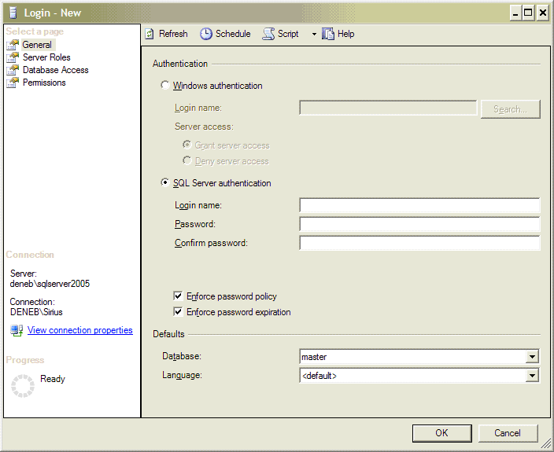
Figure 1: SQL Server 2005 authentication options and the new Enforce password policy and expiration
SQL Server Authentication is built into SQL Server and provides authentication for non-Windows-based clients or for applications using a simple connection string containing user IDs and passwords. While this logon is easy to use and popular with application developers, it is not as secure as Windows Authentication and is not recommended for use by Microsoft. SQL Server 2005 overhauls the SQL Server Authentication option.
First, it supports encryption using SQL-generated certificates if the new Microsoft Data Access Component (MDAC) client is used. Also, SQL Authentication is further enhanced by default because all client/server communication is encrypted by default in SQL Server 2005. Network encryption is not an option in the Oracle 10g Standard Edition.
Second, SQL Server 2005 supports Windows Group Policy concerning password complexity, password expiration, and account lockout in combination with Windows Server™ 2003. This means you can enforce the same password policy as your Windows accounts. Passwords are stronger because they are also case sensitive starting with SQL Server 2005.
SQL Server Authentication also requires an sa password on install regardless of the install mode as shown in Figure 2. This precaution takes no chances with possible bugs that may be exploited by malicious hackers.
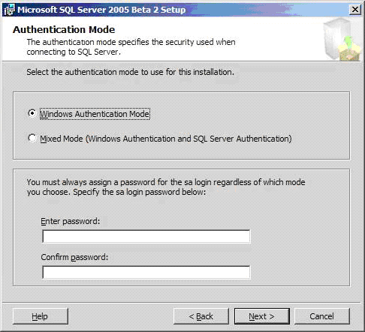
Figure 2: SQL Server 2005 Authentication Mode dialog box

Isolation of User Accounts and Database Objects

Roles and Schemas
Roles allow you to group users, making it easier to apply security to database objects or the server. You can assign permissions to a role and add or remove users to the role to assign or remove those permissions. SQL Server 2005 extends this concept to database objects through the use of schemas.
SQL Server 2005 makes managing users easier by breaking the link between users and the database objects they own. Instead of a user owning database objects directly, the schema owns the database object and the user is associated with the schema. You do not need to change the ownership of database objects before dropping a user, because the user no longer owns the object—the schema does. Schemas allow you to group database objects together so you can treat the objects as a single unit when applying permissions and ownership to the objects as shown in Figure 3. This makes security easier to manage because you can apply a role or user to the schema. For example, you could assign execution permissions to a role to all stored procedures in a schema with a single Transact-SQL statement. This makes it easier to manage security on a database with many objects. Multiple users can manage a schema and therefore the objects in the schema without having to assign permissions to each of the objects.
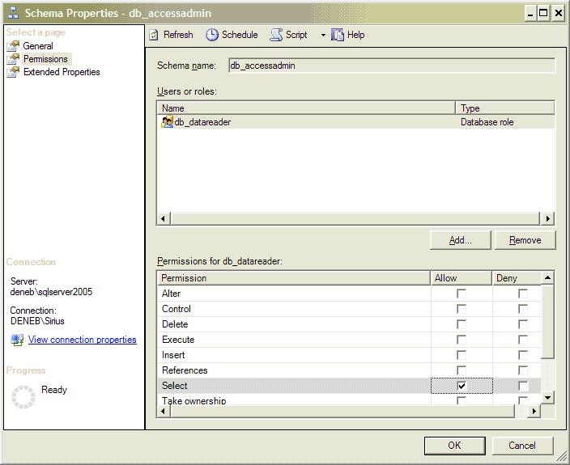
Figure 3: Setting permissions on the schema

Execution with Least Privileges
One of the hallmarks of a good security policy is to give the user the minimal permissions necessary to do their job. Another great new feature that SQL Server 2005 provides is the ability to execute a procedure as another user. This feature is only available in Oracle through writing some PL/SQL and is more difficult to use. In SQL Server 2005, you can use EXECUTE AS with stored procedures and user-defined functions. SQL Server 2005 also gives you the ability to change the security context in a routine as it is executing. The user will still need to have EXECUTE permissions on the stored procedure or function before the procedure or function that contains the EXECUTE AS clause can be executed. For example, you can use EXECUTE AS to support SQL Server ownership chains. SQL Server ownership chains allow you to assign permissions to a stored procedure, view, or function, but not the underlying database table. As long as the owner of the database object’s owner is the same as the table, the object will execute. If the owner is not the same, then explicit permissions need to be given to the user on the table, potentially allowing them more access to the data than necessary. The EXECUTE AS clause allows you to overcome breaks in ownership chains for stored procedures and user-defined functions. EXECUTE AS also acts as a medium for applying granular permissions to the database.

Oracle 10g Authentication
Oracle 10g supports authentication through the Oracle-based authentication, Windows Authentication, and the Advanced Security Option.
Oracle-based authentication stores the user name and password securely in the database and is supported from all platforms, similar to SQL Server Authentication. The password is secured through encryption. As in SQL Server 2005, you can apply policies to help manage the passwords of the Oracle database authentication accounts to provide a consistent password policy throughout the domain. Oracle database authentication is the default authentication mechanism for Oracle 10g. This is in contrast to Windows Authentication, which is the default in the SQL Server platform providing the user with the capability of using Kerberos, a very strong authentication protocol. If you want to use a stronger authentication protocol in Oracle, you would need to enable Windows Authentication or install the Oracle Advanced Security Option with the Enterprise Edition of Oracle 10g.
A configuration option not widely used with Oracle 10g is the integration with Windows Authentication. Using Windows Authentication would provide an Oracle user with similar benefits of using either NT LAN Manager or Kerberos for the authentication protocol and applying consistent password policies throughout the Windows domain. Oracle 10g supports Windows Authentication through two means: two special groups created on Windows and matching Oracle user accounts with the currently logged on Windows user. The Oracle install creates two Windows groups called ORA_DBA and ORA_OPER. You can use the Oracle Administration Assistant for Windows to add users to these groups as shown in Figure 4.
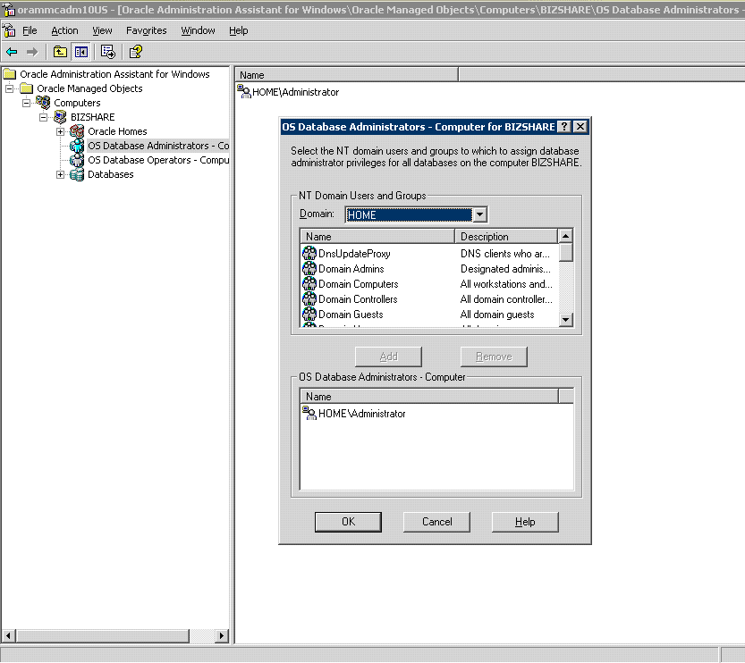
Figure 4: Adding a Windows user to the database administrators group to give SYSDBA access to the user
Any user in the ORA_DBA group can connect to an Oracle application as SYSDBA using a command similar to the following when logging into SQL*Plus:
sqlplus "/ as sysdba"
You will notice that no user ID is associated with the logon, but the logon can still be authenticated based on Windows Authentication with SYSDBA permissions (full access). If you do not want the account to have SYSDBA permissions, you can add users to the SYS_OPER group and the individual can perform limited database administrator (DBA) functions like performing database backups.
You can also use Windows Authentication for user authentication in the Oracle database. You can accomplish this by creating a user ID in the database that matches the Windows user ID with some limitations; for example, an Oracle user name cannot contain more than 30 characters.
Because Windows Authentication provides SSO, policies, and a secure authentication protocol, let’s compare setting up Windows Authentication on each platform.

Setting Up Windows Authentication on SQL Server 2005
Summary of steps involved:
- Launch SQL Server Management Studio.
- Navigate to the Server Security node.
- Choose the Windows account to create a login for SQL Server.
- On the Server tab, click Server Role to choose a server role for the account like System Administrator or Backup Operator.
- Click Database Access and select the databases that you want to give the user rights for.
To set up Windows Authentication on SQL Server 2005:
- Launch SQL Server Management Studio, as shown in Figure 5.
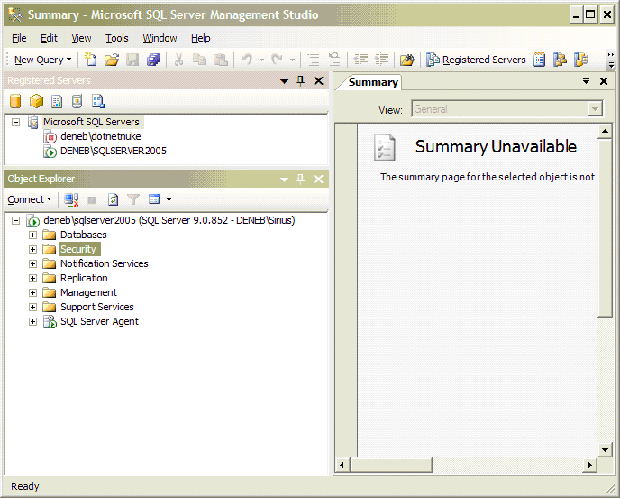
Figure 5: SQL Server Management Studio
- Open the node with your computer name, and then expand the Security node and click the Logins node as shown in Figure 6.
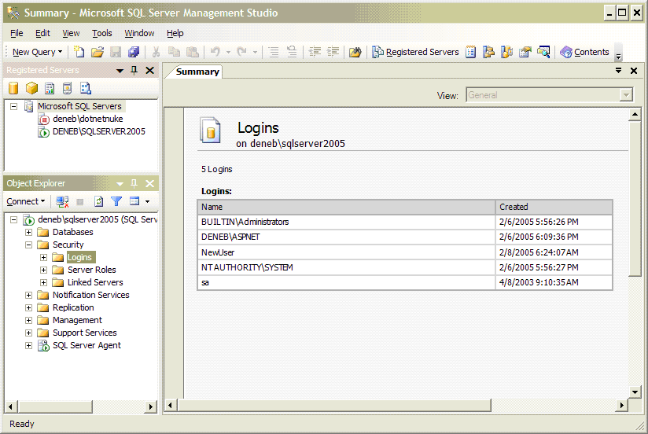
Figure 6: The Logins Node
- To create a SQL Server login for the Windows user account, right-click the Logins node and choose New Login… to open the SQL Server Login Properties dialog box. Click the Search… button by the Name field to choose a user as shown in Figure 7.
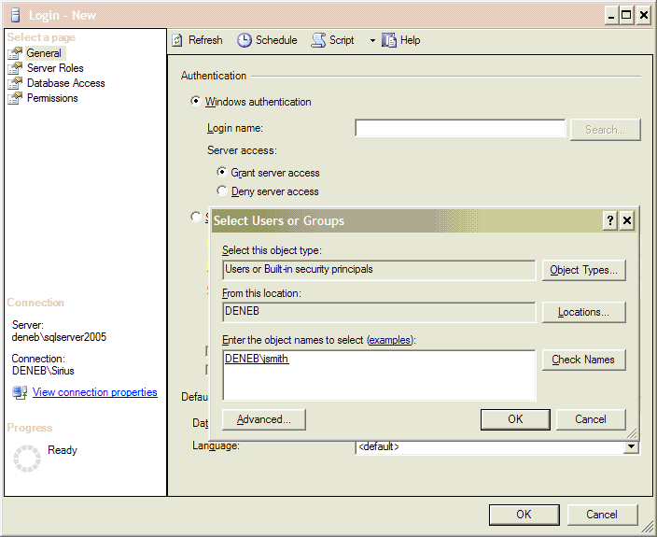
Figure 7: Choosing an existing Windows user
- Choose the database role or permissions for the user as shown in Figure 8.
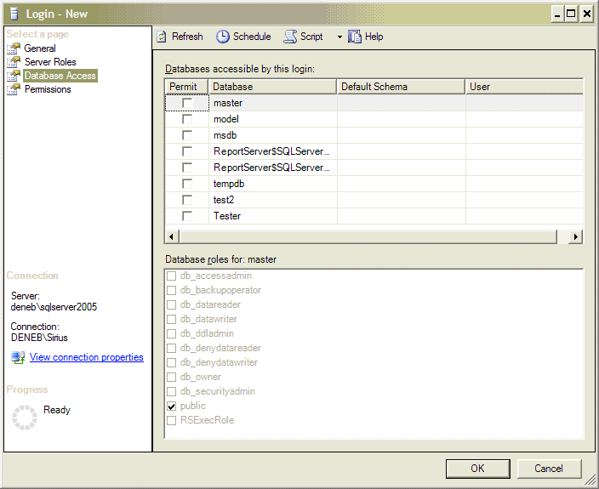
Figure 8: Choose a database role or permissions
- Choose the server role for the user as shown in Figure 9.
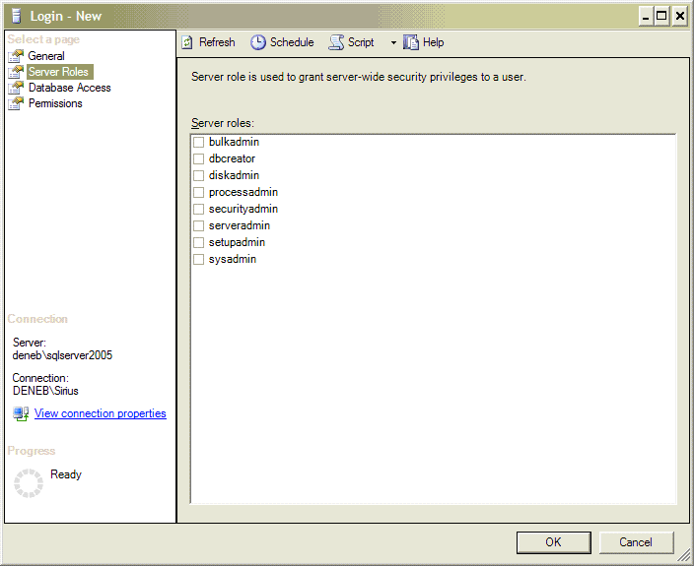
Figure 9: Server roles
- Click OK to complete the task.
Now let’s look at creating a database user who is linked to a Windows account in Oracle 10g.

Setting Up Windows Authentication on Oracle 10g
Summary of steps involved:
- Navigate to the sqlnet.ora file in the \%ORACLE_HOME%\network\admin folder.
- Edit the sqlnet.ora file with the appropriate information.
- Create users in the database that will be a regular user that match the Windows User IDs.
- Add the database user to the appropriate database roles.
- Add the Windows user to the ORA_DBA or ORA_OPER group for appropriate administrator access.
To set up Windows Authentication on Oracle 10g:
- You must enable Windows Authentication by navigating to a text configuration file called sqlnet.ora in the %ORACLE_HOME%\network\admin folder. (%ORACLE_HOME% is the location where you installed Oracle.)
- The sqlnet.ora file looks like the contents in Figure 10 and lets you configure how connections to the server will be made.
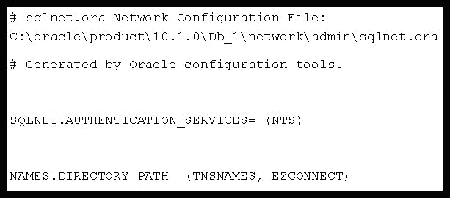
Figure 10: The sqlnet.ora file
- Change the NAMES.DIRECTORY_PATH of the sqlnet.ora file’s settings to accept ORA_DBA or ORA_OPER users:
NAMES.DIRECTORY_PATH= (TNSNAMES, EZCONNECT, HOSTNAME)
The NAMES.DIRECTORY_PATH controls how the client tool will connect to Oracle. Adding the HOSTNAME parameter will make sure you can find the server in a DNS-based Windows environment.
- Change the SQLNET.AUTHENTICATION_SERVICES parameter to the following:
SQLNET.AUTHENTICATION_SERVICES= (NONE, NTS)
The SQLNET.AUTHENTICATION_SERVICES parameter is initially set up to support Windows Authentication with the NTS setting, but this setting may cause many applications to fail, because Oracle authentication is not enabled. Adding the None parameter enables Oracle authentication and Windows Authentication, creating something similar to a mixed-mode security setting.
- You need to confirm the existence of the necessary Windows groups like ORA_DBA and ORA_OPER to enable DBA and Operators permissions for Windows Users.
- Add users to the ORA_DBA group to indicate who will be database administrators, and add users to ORA_OPER who will perform tasks like backups on the database. You can use the Oracle Administration Assistant for Windows to add users to the groups or to create the groups in the first place.
- From the Configuration and Migration Tools menu, choose Oracle Administration Assistant for Windows NT.
- Right-click the OS Database Operators group and choose Add\Remove… from the menu as shown in Figure 11.
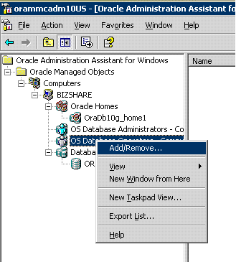
Figure 11: Add/Remove… option
- Select the user and the domain from the OS Database Operators dialog box and click the Add button. Click OK.
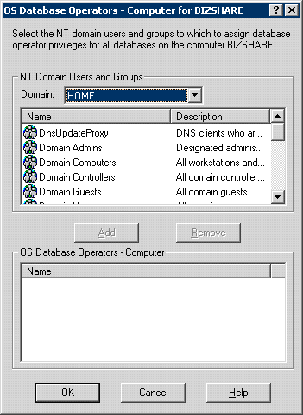
Figure 12: Select the domain and the Windows user
- For non-DBA type roles, you need to create a user in the database with the same name as a Windows user that exists.
- Make sure the following parameter in the init.ora file (%ORACLE_HOME%\database folder) is set as follows:
os_authent_prefix = “”
- If you change this parameter, you must restart Oracle.
- Create a user in the database using the following command (the user name must be in all caps).
create user "HOME\AMYJ" identified externally;
grant create session to "HOME\AMYJ";
This command creates a user called HOME\AMYJ in the Oracle database and that would have a corresponding Windows user.
As you can see, setting up security options in Oracle 10g can be more complicated than doing the same task in SQL Server.
Oracle also provides alternative authentication mechanisms to their Oracle 10g Enterprise Customers only through the Oracle Advanced Security Option at an extra cost. SQL Server provides these options to users through integration with Windows at no additional cost. The Oracle Advanced Security Option provides centralized authentication on Oracle to provide a SSO. It also provides support for third-party authentication protocols such as Kereberos, CyberSafe TrustBroker, SecurID, Identix, TouchNet II, and RADIUS.
Note Setting up User Authentication in Oracle 10g is more complicated than doing it in SQL Server.

Auditing
Auditing helps you track unauthorized user behavior on your systems and stop it. Auditing is especially useful to protect against rogue administrators or users with elevated privileges. A good auditing system allows you to filter for only the events that you deem important, so that you are not inundated with information. All of the database platforms provide for auditing in varying degrees.
SQL Server 2005 supports auditing in a number of ways. It uses the Windows Security EventLog, the SQL Profiler, and data definition language (DDL) triggers to provide auditing.
The Windows Security Eventlog is the main mechanism that Windows uses to track access to objects, use of rights, and account authentication success or failure. In addition to the OS level auditing found in the Windows Security Eventlog, SQL Profiler, as shown in Figure 13, provides a much more detailed level of auditing within SQL Server than does the Windows Security Eventlog.
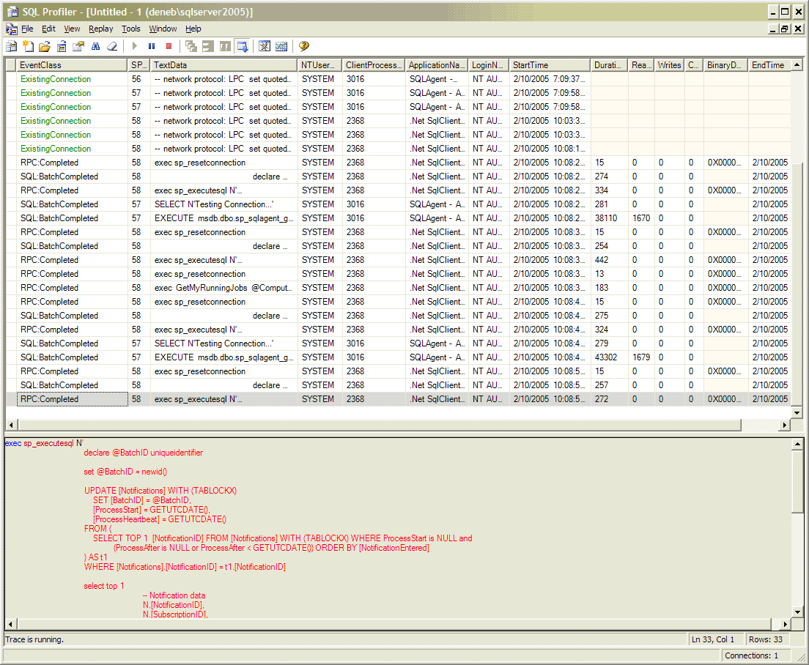
Figure 13: SQL Profiler interface
The SQL Profiler is a powerful tool for auditing SQL Server events. You can configure the events through the Trace Properties dialog box as shown in Figure 14.
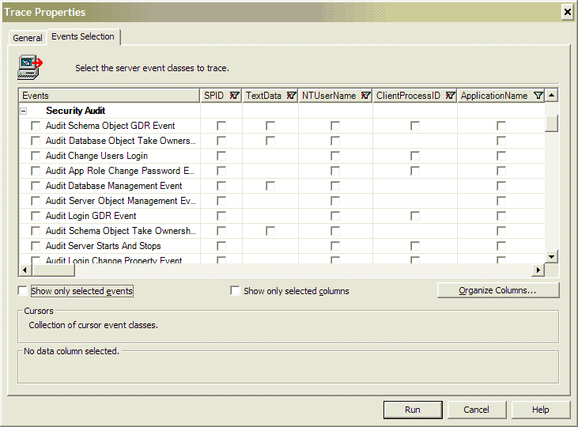
Figure 14: Trace Properties dialog box with very granular Security Audit
SQL Server 2005 includes a role that allows users who do not have system administrator rights to use SQL Profiler. This will help developers and auditors monitor the system without giving them extra rights. Between the Windows Security Eventlog and SQL Server Profiler, you can cover most of your auditing needs, except for Data Definition Language (DDL) usage.
DDL is the use of the SQL languages CREATE, ALTER, and DROP statements. SQL Server 2005 provides DDL triggers so you can determine when objects are created and deleted in the database and notifications through greater integration with the SQL Server Notification Services. SQL Profiler also includes new auditing capabilities for Microsoft SQL Server Analysis Services to improve auditing of OLAP data.
Oracle 10g provides fine-grained auditing that allows you to define audit policies capable of auditing objects, privileges, objects accessed, types of the SQL statements and so on. You can also enable alerts so that administrators can quickly be notified that there may be a problem. Oracle 10g auditing is more difficult to set up initially because you need to establish the audit event with a PL\SQL procedure and then added it to the audit policy. SQL Server 2005 will provide fine-grained auditing capabilities that are comparable to Oracle but that are easier to manage and report on through graphical user interfaces.

Encryption
Encryption is the process of making data unrecognizable to people who do not have the proper keys to read it. You have two key factors to worry about when dealing with data from a database: sending data over a network and storing data in the database.

Network Encryption
SQL Server 2005 includes in all editions that ability to encrypt the network traffic using many means like IP Security (IP SEC), and Secure Sockets Layer (SSL). In contrast, Oracle only provides encryption to their Oracle 10g Enterprise Edition at an extra cost through the Advanced Security Option.
Two widely used network standards are supported with SQL Server as alternatives for encrypting data sent over a network connection: SSL and IP SEC. These protocols are supported by Windows. SSL is supported through SQL Server integration with Internet Information Services (IIS) or through the certificate server included with SQL Server 2005.
SQL Server 2005 comes with its own certificate service to set up SSL for network encryption. The certificates created by SQL Server comply with the X.509v3 certificate standard. Certificates are used by SQL Server to create SSL connections and by SQL Service Broker. SQL Server takes measures to be more secure out of the box by responding only to encrypted client requests, and sending an encrypted data stream back only to the client in products such as Analysis Server.
IP SEC is also supported by Windows as an encryption channel for network connections. SQL Server provides features that cost much more with Oracle 10g Enterprise Edition with the Advanced Security Option when it comes to network encryption.
Oracle also provides encryption with the Oracle Advanced Security Option using the RSA and DES algorithms, similar to the types of encryption that SQL Server provides for data privacy. Oracle offers the ability to generate Message Digest version 5 (MD5) checksums on each packet it sends across the network. The database can then determine if any of the packets have been tampered with. Of course, using an encryption option such as SSL would provide hashing also, through it uses a more secure hash called Secure Hash Algorithm (SHA) that guards better against attacks.
Using encryption is a configurable option on either of these platforms. On Oracle 10g Enterprise Edition with the Advanced Security Option, encryption is off by default and you will need to turn it on, whereas SQL Server 2005 will ship with encryption enabled to provide the most secure environment. You will need to consider if your security policy includes data privacy because there is a trade-off between the level of security and the performance of the application.

Data Encryption
SQL Server 2005 provides data encryption directly in the database by using the integrated certificate server. SQL Server 2005 contains six built-in functions used to encrypt and decrypt data.
- EncryptByCert
- DecryptByCert
- EncryptByKey
- DecryptByKey
- EncryptByAssym
- DecryptByAssym
These functions allow you to use an existing certificate to encrypt data (most secure), a simple key (password), or an asymmetric (public/private key). SQL Server 2005 can create and manage its own certificates to provide very strong encryption of data stored in the database. Transact-SQL for SQL Server 2005 has been enhanced to support managing certificates as follows:
Creates a certificate:
CREATE CERTIFICATE MyCert
WITH SUBJECT = ‘My Subject’,
ENCRYPTION PASSWORD = ‘jfdsij380fukanfjcxvDJEOD#$fksdwr’,
EXPIRY_DATE = ‘12/31/2006’;
After the certificate is created, you can use the EncryptByCert function to encrypt the value and store it in a variable as follows:
DECLARE @VAL nvarchar(8000)
SELECT @VAL = EncryptByCert(Cert_ID(‘MyCert’), N’Some Message’)
You can then read the value back out of the field or variable by using the following DecryptByCert function:
SELECT CAST(DecryptByCert(Cert_ID(‘MyCert’), @VAL, N’ jfdsij380fukanfjcxvDJEOD#$fksdwr’) AS nvarchar)
With the integrated certificate service and more options for encryption, SQL Server 2005 goes beyond what Oracle offers even in the Advanced Security Option.
Oracle 10g Standard Edition does not provide encryption. You can get encryption if you purchase Oracle 10g Enterprise Edition and even then, Oracle only provides encryption through the separately licensed Advanced Security Option. Oracle provides its support for data integrity and data encryption with this option.

What About Costs?
Security is about more than technology. It involves people and processes, which can be the weakest link when paired with great technology. It is important that the database server support the people and processes as much as possible by providing management tools that are intuitive and easy to use for the average user. Oracle 10g comes with rudimentary tools (without paying extra for Oracle Management Server) that are not recognized as being easy to use. This makes it more difficult for an administrator to secure their server and their databases, which can lead to a breakdown in security. A DBA should know all about the database servers they manage, but this is not a reality in many companies.
No matter how good the technology is, if your security policies and procedures are not in place, if your users are not trained to think about security and avoid social engineering attacks, and if you do not physically secure your environment, then all the security features will not help. Security starts with policy and people. After you have the policies and procedures in place, you will need to choose adequate technology to implement your security policy in the most cost-effective way. The following table shows the difference in cost between the two products using data provided on both the Microsoft Web site and the Oracle Web sites about the cost of a per-CPU license:

Oracle 10g  Enterprise  Edition with Advanced Security Option | Oracle 10g  Standard  Edition | SQL Server 2005 Enterprise Edition | SQL Server 2005 Standard Edition | SQL Server 2005 Workgroup  Edition | SQL Server 2005 Express
$50,000 U.S. | Advanced security features are not available. | $24,999 U.S. | $5,999 U.S. | $3,899 U.S. | Free

This comparison shows that SQL Server provides a compelling story to a cost-conscience business when it comes to providing a high-quality database with advanced security features. SQL Server 2005 will improve upon these features by providing stronger default security settings, encryption of data, support for schemas, and more, matching the features found in Oracle’s latest database offering of Oracle 10g. SQL Server 2005 comes at a fraction of the cost and includes all of the security features as a standard part of the package. Oracle requires that you purchase the Advanced Security Pack and they will only sell you the Advanced Security Pack for Oracle Enterprise Edition, which will greatly increase your costs. This means that Oracle does not even provide basic security features such as integrated security for Single Sign-On, network packet encryption, public key infrastructure (PKI), or Kerberos as a standard feature of the database. These are available only as extra-charge options and only for the Enterprise Edition of the Oracle database. SQL Server 2005 has all of these options as standard features built into the core database product. Consequently, both products contain the same core security features, but businesses can save money and get the same security features by using SQL Server 2005.
So, how do the databases compare when we look at the features of each? They have the same features, but Oracle charges more for them.
You also will need to consider the cost that future hardware upgrades will incur. Microsoft announced that it will only be charging per socket with their per-CPU licensing model, whereas Oracle has announced that they will be charging per core. All major chip vendors are committed to using multiple cores per socket to continue to increase the processing power of their hardware. This means that your costs can more than double unexpectedly in a future upgrade which can greatly affect your cost of the product. See the CNET News article at http://news.com.com/McNealy+slams+Oracle+for+pricing+plans/2100-1012_3-5484341.html.

So Which Database Is More Secure?
Measures of how secure a database server is should include how many security bulletins, incidents, or advisories have been registered against the database. Security bulletins show the track record of the vendor regarding security.
A look at the number of security bulletins/advisories published for each database shows that Oracle has had more advisories over time than has Microsoft SQL Server products since the release of SQL Server 2000. Here are the statistics comparing Oracle and SQL Server published by a few independent sources in the recent few years.
Computer Incident Advisory Capability
- The Computer Incident Advisory Capability lists ten Oracle incidents since 2003 at http://www.ciac.org/ciac/bulletinsByType/vndr_oracle_bulletins.html, with three incidents in 2004 and seven in 2003.
- Microsoft SQL Server has had two incidents over the same period of time with one in 2004 and one in 2003 according to the same source. http://www.ciac.org/ciac/bulletinsByType/vndr_ms_bulletins.html#ms_sql
Carnegie Mellon Software Engineering
- The Carnegie Mellon Software Engineering Institute (http://www.cert.org/) lists nine Oracle Advisories in the last two years.
- The Carnegie Mellon Software Engineering Institute lists three SQL Server advisories during the same two-year period.
National Institute of Standards and Technology
- The National Institute of Standards and Technology (http://www.nist.gov/) reported 81 Oracle incidents using Oracle. (http://icat.nist.gov/icat.cfm?vendor_command=Oracle&product_command=Oracle)
- This same organization reported only 46 SQL Server incidents for the same period. (http://icat.nist.gov/icat.cfm?vendor_command=Microsoft&product_command=SQL%20Server).
Based on a review of security incidents/advisories, SQL Server has had about 50 percent fewer security incidents than does Oracle. This is evidence that SQL Server is more secure than Oracle. When a company considers data security, it also needs to consider the process they follow regarding applying patches and updates—if there is a security incident, companies need to patch their servers.

The Importance of Security Patches
Organizations are quick to focus on available security technology like firewalls and virtual private networks (VPNs) when securing their resources, but the real obstacle that many organizations face is trying to make the security technologies they choose work together and to provide a comprehensive security policy so that people, processes, and technology work together. Part of this policy is to provide good patch management. According to Forrester Research’s Michael Rasmussen, “This is because software will always have problems and the only real answer is to apply patches to systems, which involves people and processes.”
Software is a work in progress. It is never perfect and contains bugs. Sometimes these bugs will affect the security of the system and make it possible for a malicious individual to gain access to the system. Many organizations such as CERT and secunia.com track security-related bugs. The bugs are rated by these organizations on scales that generally move from benign to highly critical. You will need to monitor some of these sites and the application vendor’s Web site for new patches. You will need to improve your process to apply patches to the systems as part of your security process. Oracle and SQL Server both provide means for patching systems. We will compare the process of discovering the vulnerabilities and patches and the ease of patching the database servers.
Microsoft will publish security bulletins and patches as appropriate for SQL Server 2005. These bulletins help you understand and assess potential threats to your existing environments, and how to neutralize those threats. The SQL Server Web site (Figure 15) provides a quick link to the latest security bulletin on their product page.
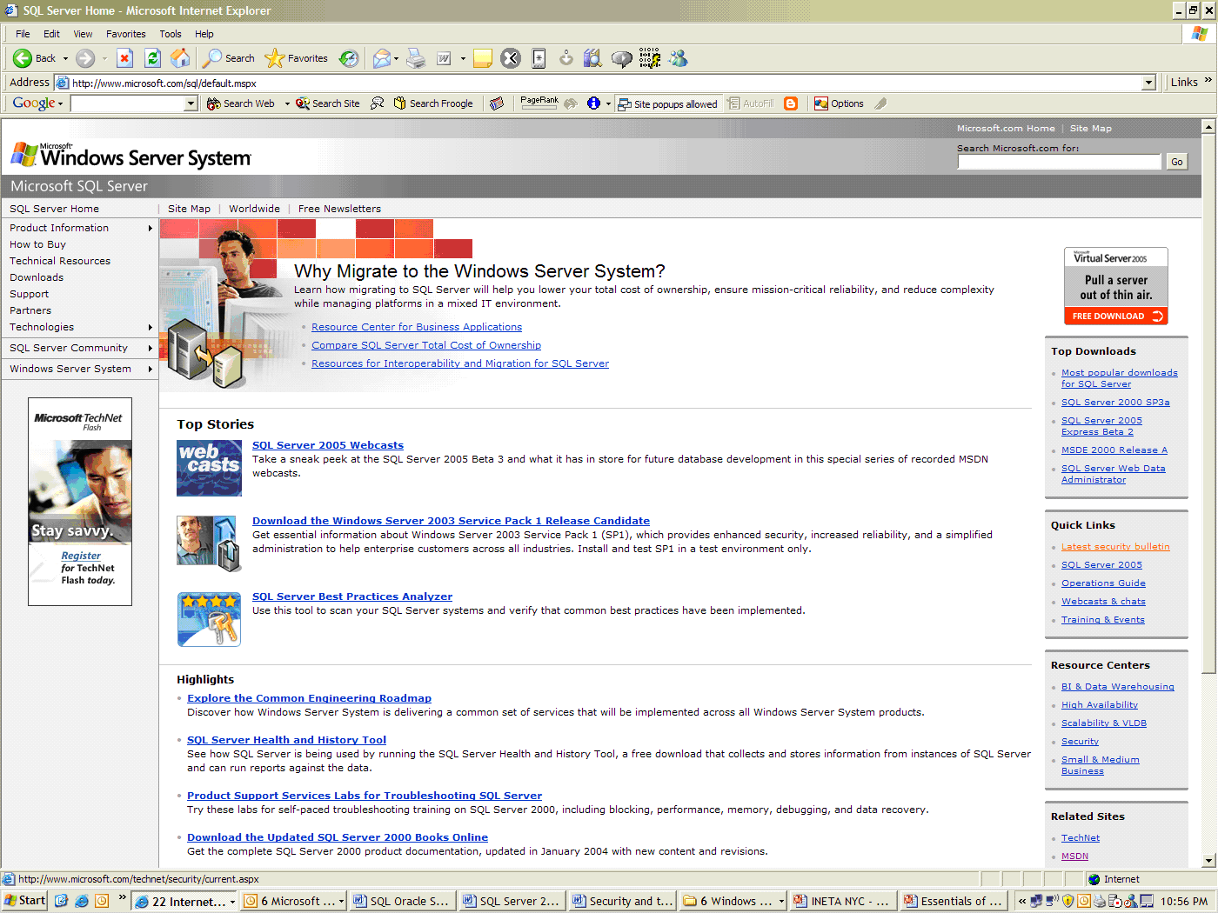
Figure 15: The SQL Server Web site
An administrator can read about the latest security techniques on this site as shown in Figure 16.
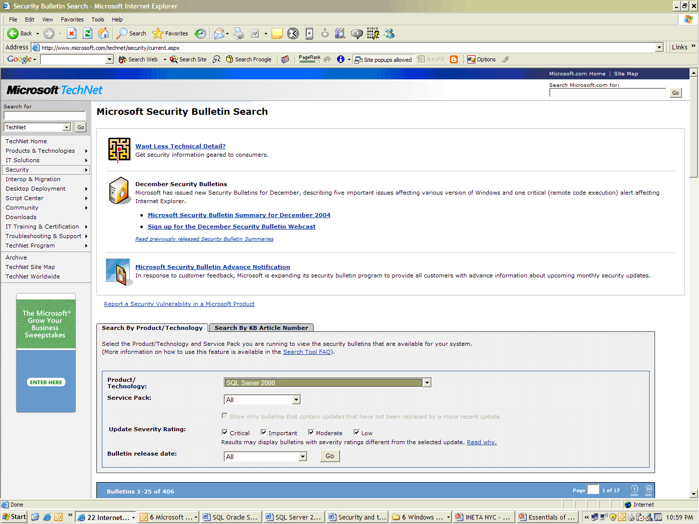
Figure 16: Microsoft Security Bulletin site
Oracle and Microsoft both do a good job at notifying customers that critical security patches exist. You can subscribe to security alerts on the Oracle Web site (Figure 17) or on the Microsoft Web site; both companies provide critical patches quickly. The sites are well organized and you should be able to quickly find the patch you are looking for.
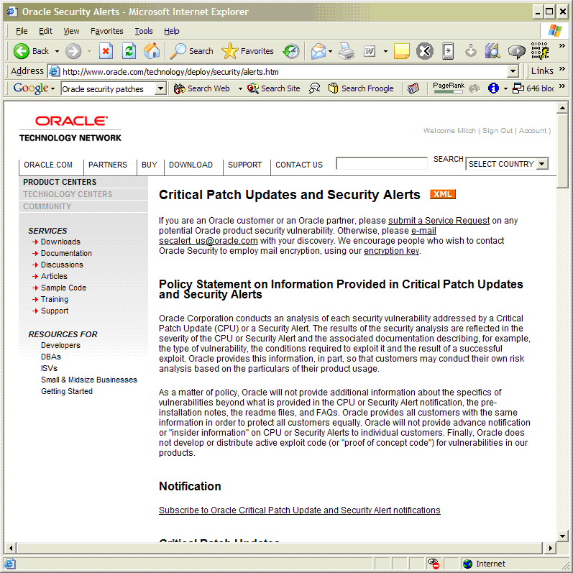
Figure 17: Shows Oracle’s Security Alert site

Conclusion
SQL Server 2005 and Oracle 10g both provide a secure database that is capable of handling the majority of database tasks for businesses. However, SQL Server 2005 excels because:
- SQL Server 2005 contains more security features than are included in Oracle 10g.Standard Edition or Enterprise Edition. A company must incur extra cost by purchasing the Advanced Security Option if they want to gain the security features that SQL Server 2005 includes, adding to the cost of the database server.
- Microsoft makes secure database technology available to all of their customers by providing the same security features across all their product line, while Oracle only provides all of their security features to their enterprise customers.
- It is easier to configure security in SQL Server 2005.
- SQL Server 2005 is easier for a developer to use to create secure applications.
- SQL Server 2005 has been developed under the Microsoft Trustworthy Computing Initiative, which will provide an even better platform for securing data.
- SQL Server 2005 has security features similar to those in the Oracle 10g Enterprise Edition (with the Advanced Security Option), but at a much lower cost and greater ease of use.
- Fewer security vulnerabilities have been detected in SQL Server compared to Oracle—and Microsoft addresses vulnerabilities quicker than does Oracle. This implies that days-of-exposure to risk is substantially lower with SQL Server than with Oracle.

About the Author
Mitch Ruebush, MCSD, MCDBA, MCSE, MCT, is a .NET Architect for ING DIRECT, fsb. He is a Microsoft Regional Director and Visual C#® MVP and has been developing on various Windows and UNIX platforms for 15 years. He has presented at Microsoft DevDays, Microsoft Security Summit, Visual Studio® .NET 2002 Launch, user group meetings, and MSDN webcasts. He currently believes that C# and .NET development is the most delightful platform to develop on, but he also designs and develops solutions in C, C++, Java, VB, VB.NET, PL/SQL, and Transact-SQL on Windows and Linux/UNIX. He is coauthor on MCAD/MCSD: Visual Basic® .NET Windows and Web Applications Study Guide, MCAD/MCSD: Visual Basic .NET XML Web Services and Server Components Study Guide, and MCSE: Windows Server 2003 Network Security Design Study Guide for Sybex.

This article was developed in partnership with A23 Consulting.

