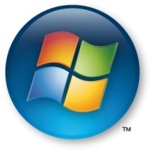

CATIA V5 on Windows Vista 64-bit:
Best Practices for deployment
Microsoft Corporation
Published: June 2008
Abstract
The Dassault Systèmes and Microsoft partnership provides solutions that improve user productivity, and accelerate product design in a 64-bit environment.
This guide is intended for companies considering running CATIA® V5 on Windows Vista 64-bit Editions.
As the process and the types of installation are mainly common for both platforms, companies that plan to deploy CATIA V5 on Windows XP 64-bit editions will also be interested in this guide.

The information in this document and any document referenced herein is provided for informational purposes only, is provided AS IS AND WITH ALL FAULTS and cannot be understood as substituting for customized service and information that might be developed by Microsoft for a particular user based upon that user’s particular environment. RELIANCE UPON THIS DOCUMENT AND ANY DOCUMENT REFERENCED HEREIN IS AT THE USER’S OWN RISK.
© 2008 Microsoft Corporation. All rights reserved.
MICROSOFT PROVIDES NO WARRANTIES, EXPRESS, IMPLIED OR STATUTORY, AS TO THE INFORMATION CONTAINED IN THIS DOCUMENT AND ANY DOCUMENT REFERENCED HEREIN. Microsoft provides no warranty and makes no representation that the information provided in this document or any document referenced herein is suitable or appropriate for any situation, and Microsoft cannot be held liable for any claim or damage of any kind that users of this document or any document referenced herein may suffer. Your retention of and/or use of this document and/or any document referenced herein constitutes your acceptance of these terms and conditions. If you do not accept these terms and conditions, Microsoft does not provide you with any right to use any part of this document or any document referenced herein.
Microsoft may have patents, patent applications, trademarks, copyrights or other intellectual property rights covering subject matter within this document. Except as provided in any separate written license agreement from Microsoft, the furnishing of this document does not give you, the user, any license to these patents, trademarks, copyrights or other intellectual property.
Information in this document, including URL and other Internet Web site references, is subject to change without notice. Unless otherwise noted, the example companies, organizations, products, domain names, e-mail addresses, logos, people, places and events depicted herein are fictitious, and no association with any real company, organization, product, domain name, e-mail address, logo, person, place or event is intended or should be inferred.
Microsoft, Active Directory, BitLocker, Internet Explorer, Windows, Windows Server, System Center Configuration Manager, System Management Server, Windows XP and Windows Vista are either registered trademarks or trademarks of Microsoft Corporation in the United States and/or other countries.
The names of actual companies and products mentioned herein may be the trademarks of their respective owners.

Introduction 5
Audience 5
Overview 5
About CATIA V5 6
Benefits of Windows x64 Editions 7
Scalability 7
Performance 9
Reliability 9
Security 10
Compatibility 10
Summary 11
Related Links 12
Benefits of Windows Vista 13
Deployment and management 13
Desktop configuration and deployment 13
Desktop management 14
Reducing Desktop Support Costs 15
Security and data protection 15
User Account Control 15
Windows Service Hardening 16
Data protection 16
Reliability and performance 17
Built-in reliability and performance diagnostics 17
System performance and reliability tracking 17
Summary 18
Related links 19
Planning a Windows Vista 64 bits deployment 20
Hardware assessment 20
Application compatibility 21
General information 21
Windows Vista 64-bit Editions requirements 21
Planning an application compatibility analysis 22
Tools and guidance 22
Typical issues 22
Temporary remedies 23
Desktop deployment 24
Planning a Windows Vista Deployment 24
Windows Vista Image creation process 24
Differences between 64-bit and 32-bit deployment 26
Summary 26
Related links 27
Planning a CATIA V5 deployment 28
Prerequisites for CATIA V5 installation 28
Operating system 28
Hardware 28
Choosing a method of installation 29
Local or code-server installation? 29
Choosing the method of local installation 30
Planning the management of the CATIA V5 service packs 38
Committing and Rolling back Service Packs 38
Service pack installation 38
Summary 39
Related Links 40
Planning data and CAA applications porting to 64-bit operating systems 41
CATIA V5 data porting 41
CAA application porting 41
General considerations 41
Porting guidelines 42
Summary 43
Related links 43
Conclusion 44

Introduction

Audience
This guide is intended for companies considering running CATIA® V5 on Windows Vista 64-bit Editions. It is designed to provide CATIA administrators and system administrators with the information they need to plan this deployment and help them to make the right choices.
As the process and the types of installation are mainly common for both platforms, companies that plan to deploy CATIA V5 on Windows XP 64-bit editions will also be interested in this guide.

Overview
This document proposes best practices to deploy CATIA on Windows Vista 64-bit Edition.
It also provides some key information on Windows Vista deployment and on System Center Configuration Manager (Microsoft’s latest Electronic Software Delivery solution) and links to documents that provide detailed information.
The document includes five chapters:
The first one, Benefits of Windows x64 Editions, is a presentation of the advantages of using a Windows x64 Edition for a CATIA V5 workstation.
Next, the chapter Benefits of Windows Vista deals with the key innovations in Windows Vista that enable companies to significantly reduce the Total Cost of Ownership (TCO) and to increase the security level of their Windows computers.
Once, you have decided to deploy CATIA V5 on Windows Vista 64-bit editions, the chapter Planning a Windows Vista 64 bits deployment will give you a view of the main phases of a Windows Vista deployment and the tools provided by Microsoft to simplify and lower the costs of a Windows Vista deployment.
The chapter Planning a CATIA V5 deployment presents in detail the different methods to install CATIA V5 and deploy CATIA service packs. It also provides guidance to choose the methods that best fit the company’s needs.
The last chapter, Planning data and CAA applications porting, provides guidelines for potential adaptations on CAA applications so that they can run on 64-bit Windows operating systems.

About CATIA V5
CATIA is Dassault Systèmes’ flagship Product Lifecycle Management (PLM) solution and the leading product development solution for all manufacturing organizations, from OEMs, through their supply chains, to small independent producers. The range of CATIA V5 capabilities allows it to be applied in a wide variety of industries, such as aerospace, automotive, industrial machinery, electrical, electronics, shipbuilding, plant design, and consumer goods, including design for such diverse products as jewelry and clothing.
CATIA addresses the complete product development process, from product concept specification through product-in-service, in a fully integrated and associative manner. Based on an open, scalable architecture, it facilitates true collaborative engineering across the multidisciplinary extended enterprise, including style and form design, mechanical design and equipment and systems engineering, managing digital mock-ups, machining, analysis, and simulation. By enabling enterprises to reuse product design knowledge and accelerate development cycles, CATIA V5 helps companies speed-up their responses to market needs.
In conjunction with ENOVIA® for global collaborative lifecycle management, DELMIA® for virtual production, SIMULIA® for virtual testing, and 3DVIA® for on-line 3D lifelike experiences, CATIA is a key component of collaborative PLM.
Much beyond pure CAD software packages, which provide geometry modeling features for design-centric companies, CATIA V5 delivers the keys to PLM for process-centric companies:
- Product to market. CATIA is about product creation. From the earliest product concept to production tooling, its concurrent engineering and design-in-context capabilities create value by enabling companies to create products and bring them to the market.
- Time to market. The unequalled process coverage of CATIA, combined with the native associativity among all of its applications, gives CATIA customers the means to reduce time to market.
- Right to market. CATIA's integrated analysis, simulation, synthesis, and optimization applications provide product engineering validation at each design step to ensure product quality and market acceptance.
- Lead the market. CATIA's advanced capabilities for collaborative engineering, knowledge capture, and re-use boost innovation and help to lead the market.

CATIA, DELMIA, ENOVIA, SIMULIA, and 3DVIA are registered trademarks of Dassault Systèmes or its subsidiaries in the US and/or other countries.

Benefits of Windows x64 Editions
Since the introduction of Microsoft® Windows® XP Professional x64 Edition in April 2005, the availability of hardware and software that support 64-bit computing has significantly increased. In addition, the current price of x86 and x64 processor-based computers is essentially identical.
There are 5 major areas where 64-bit computing offers critical benefits:
- Scalability—offers the support of much greater physical memory and virtual memory space.
- Performance—speeds up calculation for intensive computing operations and allows gain on I/O efficiency.
- Reliability—Windows x64 Editions benefit from the maturity and the stability of Windows x86 code.
- Security—new features in x64 processors and in x64 Editions enable better protection from malicious codes.
- Compatibility—The compatibility of x64 operating systems with existing 32-bit application enables a smooth and cost-controlled transition to 64-bit computing.

Scalability
The most obvious benefit to 64-bit computing is the larger memory address space available.
Table 1 highlights the difference between 32-bit and 64-bit memory limits.
General Memory Limits | 32-Bit | 64-Bit
User-mode virtual address space for each 32-bit process | 2 GB  3 GB if compiled with /LARGEADDRESSAWARE and system is booted with /3GB switch or IncreaseUserVa 3072 option | 2 GB  4 GB if compiled with /LARGEADDRESSAWARE¹
User-mode virtual address space for each 64-bit process | Not applicable | 8 TB
Kernel-mode virtual address space | 2 GB  1 GB if system is booted with /3GB switch or IncreaseUserVa 3072 option | 8 TB

Physical Memory and CPU Limits | 32-Bit Editions | 64-Bit Editions
Windows Vista Business, Enterprise or Ultimate Edition | 4 GB  1 to 2 processor sockets | 128 GB  1 to 2 processor sockets
Windows XP Professional | 4 GB  1 to 2 processor sockets | 128 GB  1 to 2 processor sockets

In 32-bit versions of Windows, by default, the operating system reserves 2 GB for kernel mode processes and limits applications to the remaining 2 GB of virtual memory address space.
It is possible to configure 32-bit versions of Windows to allocate 3 GB of memory to applications by using the /3GB switch or the IncreaseUserVa option according to the operating system². But, a 32-bit application can take advantage of a larger address space only if it was compiled with /LARGEADDRESSAWARE flag. Moreover, the /3GB switch and the IncreaseUserVa option reduce the amount of memory allocated for kernel mode software. Therefore, this configuration will not offer improvement for all programs and may introduce limitations.
The 64-bit architecture opens new frontiers: each 64-bit application has 8 TB of virtual address space. Furthermore, Windows x64 Editions can use up to 128 GB of RAM.
CATIA V5 32-bit Edition is a typical application compiled with /LARGEADDRESSAWARE flag that takes advantage of the 4 GB address space available on x64 architecture.
A 64-bit environment offers great productivity and improvements to the product design process for users of either CATIA V5 32-bit or CATIA V5 64-bit Edition:
- Full product assemblies for very complex models that typically had to be loaded by partial assemblies on Windows 32-bit can be loaded with Windows x64 Editions,
- For these complex models, extensive analysis or simulations can be done on an entire product instead of multiple runs on partial components, allowing global and more precise simulations.
- Computing high-definition realistic rendering is feasible for more complex models,
Moreover, Windows x64 Editions let one efficiently use the amount of memory available on the current computer generation.
CATIA V5 performance improves from larger amounts of memory which permit minimizing swapping to disk.

Performance
A major area of improved efficiency in the x64 architecture is the increased number of registers available. The x64 architecture uses twice as many general-purpose registers, each a full 64 bits wide.
With more registers, there is less need to write out persistent data to memory, only to have to read it back a few instructions later. This allows the compiler to generate more efficient code and leads to significant gains in programs speed. Another gain with the additional and wider registers is faster function calls. Up to four arguments can be passed in registers to a function, a big improvement over the x86 approach of pushing and popping arguments onto the stack for every operation.
The x64 architecture also doubles the number of 128-bit wide SSE/SSE2 registers to 16. These registers are used for floating point operations by 64-bit applications.
The performance of Dassault Systèmes products such as Simulation products is greatly improved thanks to these processor extensions. Benefits are completely dependent on the scenario and on the computer hardware.
Note: Some information about the performance impact of x64 architecture can be found in ”64-bit CATIA V5 on Intel XEON and XP Pro x64” white paper (http://download.microsoft.com/download/4/e/6/4e68d910-edf2-4771-be62-918f8bc7d55a/ABCG-64bit%20WP-Final_cover.pdf).
Another performance improvement with the x64 architecture is the gain in overall I/O efficiency and throughput. With support for greater physical memory and memory address space, caches can be substantially larger than in 32-bit Windows, enabling the Windows x64 Editions to fully utilize the improved I/O hardware available, such as PCI Express and PCI-X 266, to improve overall I/O performance. The larger address space allows more I/O to be in progress simultaneously.

Reliability
Windows XP Professional x64 Edition is built on the Windows Server 2003 Service Pack 1 code. So, you can expect the general system reliability to be comparable to Windows Server 2003 SP1 with which customers have experienced greater than 99.999% uptime.
Windows Vista benefits from the stability of the previous versions, and provides new reliability features such self-diagnostics. These features are described in the chapter titled Benefits of Windows Vista.
Beyond operating system reliability, Windows x64 Editions allow a better stability for CATIA V5 32-bit and 64-bit Editions. Indeed, with Windows 32-bit Editions, when an application's virtual memory space becomes exhausted or fragmented, users can experience errors or performance degradation and the application may cease to function correctly.
CATIA V5 users will immediately take advantage of Windows x64 Editions’ memory capabilities for scenarios that temporarily overstep the limit of 3 GB. Since users will not need to replay the scenarios anymore, Windows x64 Editions will allow productivity enhancements.

Security
Data Execution Prevention (DEP) and Microsoft's Patch Guard, presented below, provide an additional layer of security against threats.
With the introduction of x64 processors, both AMD and Intel added hardware support for DEP. The processor sets the No Execute bit (for AMD processors) or the Execute Disable bit (for Intel processors) on all entries in the memory address table that are for data only and should not be executed. If code attempts to execute within an area of memory marked as data only, Windows will raise a status access violation exception and terminate the process.
While DEP is not a substitute for anti-virus and anti-malware deployment, it is an important additional layer of protection against automated attacks. By default, DEP is activated and monitors essential Windows programs and services.
Moreover, Windows x64 Editions include a technology called Patch Guard that prevents non-Microsoft originated programs from patching the Windows kernel. Patch Guard, in addition to improving system stability by preventing code from accessing system components, makes it difficult for attackers to mask their presence.
All the applications running on x64 architecture benefit from a higher security level thanks to these two features.

Compatibility
The x64 Editions of Windows are essentially feature comparable with the 32-bit versions and are able to execute native 32-bit programs.
The mechanism that x64 Editions uses to run 32-bit applications is called Windows on Windows 64-bit, better known as WOW64. This mechanism is illustrated below:
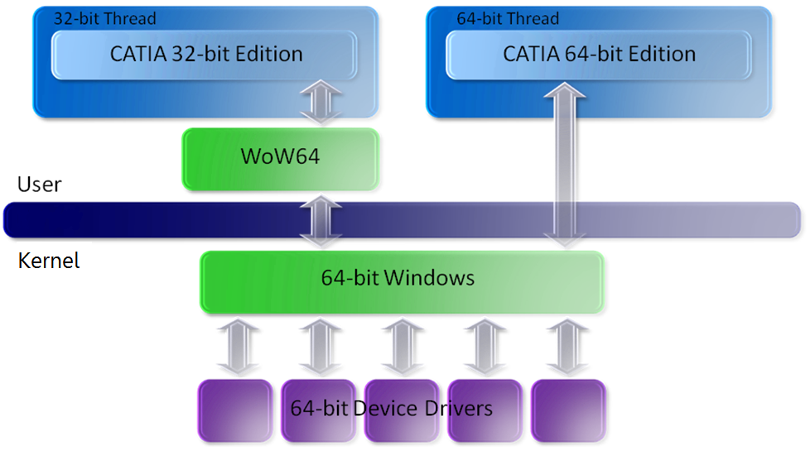
Figure 2: x64 Editions architecture
WOW64 isolates 32-bit applications from 64-bit applications and allows data exchange across the boundary through COM and remote procedure call (RPC) and through transparent cut and paste.
Because of the underlying hardware compatibility of the x64 architecture and the larger available memory space, CATIA V5 32-bit on x64 runs at similar speeds or even faster than on 32-bit operating system.
Although WOW64 supports graphical applications and services, it does not support:
- 16-bit and DOS applications,
- Legacy networking protocols such as NetBEUI, Data Link Control (DLC), and AppleTalk,
- 32-bit drivers and applications that depend on 32-bit kernel drivers.
It must also be mentioned that 32-bit applications cannot load 64-bit Dynamic-Link Libraries and 64-bit applications cannot load 32-bit DLL.
As 32-bit and 64-bit applications can run on the same workstation with Windows x64 Editions, smooth migrations to 64-bit are possible.

Summary
Since the introduction of Microsoft® Windows® XP Professional x64 Edition in April 2005, Windows x64 Editions have provided a highly compatible, high-performance and security-enhanced computing experience that takes advantage of much larger memory address space and more physical memory.
Certification on Windows XP 64-bit Edition dates from version V5R15 SP3 for CATIA V5 32-bit and from version V5R16 GA for CATIA V5 64-bit. In addition, the first CATIA V5 version certified on Windows Vista 64-bit Edition is V5R18 SP4
The Dassault Systèmes and Microsoft partnership provides solutions that take full advantage of the current hardware capabilities, improve user productivity, and accelerate product design in a 64-bit environment.
Indeed, full product assemblies for very complex models that typically had to be loaded by partial assemblies on Windows 32-bit can be loaded with Windows x64 Editions. It allows complex and extensive analysis or simulation, product updates and drawing generations on an entire product instead of multiple runs on partial components.

Related Links
- CATIA V5 Windows Certified Workstations List http://www.3ds.com/implementation/technology/windows/certified-workstations-list/
- Toyota Motor Experiences the Power of CATIA V5 on Microsoft Windows XP 64-Bit http://download.microsoft.com/download/8/5/1/851c52b9-cbd7-41ac-8004-dad46c0644c2/MS-TMC.doc
- 64-bit CATIA V5 on Intel Xeon and XP Pro x64 http://download.microsoft.com/download/4/e/6/4e68d910-edf2-4771-be62-918f8bc7d55a/ABCG-64bit%20WP-Final_cover.pdf
- Benefits of Microsoft Windows x64 Editions http://download.microsoft.com/download/9/e/9/9e9b9c02-4e68-46d5-83e3-86258e9e780c/Benefits_of_Windows_x64.doc
- Is Windows XP Professional x64 Edition Right for Me? http://download.microsoft.com/download/B/8/6/B868C664-13FC-4F91-9651-5B6D4F1A2F60/Is_Windows_XP_Professional_x64_Edition_Right_for_Me.doc
- Comparison of 32-bit and 64-bit memory architecture for 64-bit editions of Windows XP and Windows Server 2003
http://support.microsoft.com/default.aspx?scid=kb;en-us;294418

Benefits of Windows Vista
Windows Vista, Microsoft’s latest client operating system, benefits from previous operating systems feature and provides key innovations that enable companies to significantly reduce the Total Cost of Ownership (TCO) and to benefit from security enhancements for their Windows computers.
A white paper by IDC analysts about the Business Value of Windows Vista indicates significant gains for companies that have deployed Windows Vista using best practices.
Note: The document “Analysis of the Business Value of Windows Vista” by IDC is located at URL: http://download.microsoft.com/download/2/8/1/281dda34-b8fc-4b4c-9848-c6fa2ba8fa8a/IDC_vista_whitepaper.pdf.
As Windows Vista 32-bit and 64-bit Editions share the same code source, enhancements concerning the 3 main areas presented below apply to both editions:
- Deployment and management – New Windows Imaging format, new group policy settings are instances of features that make deployment and management easier, considerably reducing their costs,
- Security and data protection - Windows Vista is the most secure and trustworthy Windows operating system. Among new built-in security features, we can list Services hardening, drive encryptions and firewall enhancements.
- Reliability and performance – Self-diagnostic, self-correction features, and tools that facilitate diagnosis and repair allow decreasing downtime and increasing user productivity.

Deployment and management
Windows Vista simplifies desktop configuration, deployment and management and helps reduce desktop support costs.

Desktop configuration and deployment
The first important benefit Windows Vista offers is in desktop imaging: today, companies generally maintain many separate images due to the different hardware types or languages. Image evolutions, regression tests and image deployment are very costly processes in such situations.
With Windows Vista it is possible to deploy a single image to different computer hardware and machines in different languages. This leads to a drastic reduction of administrative and engineering costs.
Furthermore, the new Windows Imaging Format (WIM) is a file-based imaging format that offers interesting features:
- The image can be mounted to a directory. So, you can browse, copy, paste files without extracting or recreating the image,
- Customizations can be added offline in the image,
- Files that exist in multiple paths are only stored once so the image is smaller.
- Application of the image does not overwrite the contents of the drive so, you can selectively remove information.
As a result of the ability to modify the image offline, image evolutions require significantly less time and the risk of introducing unintentional configuration settings in the image is considerably reduced.
Moreover, unlike with Windows XP and earlier versions of Windows when most enterprises purchased third-party imaging products to deploy the operating system, imaging is built into Windows Vista. Companies can now achieve the same results with out of the box technologies.

Desktop management
Windows Vista gives administrators more control over their environments and provides tools that simplify common administrative tasks.
First, Windows Vista offers over 800 new Active Directory Group Policy configuration settings. For example, you can now centrally manage Power Settings, which can save as much as $50 per PC a year in energy costs. Group Policy is a very powerful tool. Indeed, with Group Policy settings, IT administrators have the ability to apply and even change the configuration settings remotely. Moreover, settings can be applied in a granular manner as it is possible to apply settings only for users on a particular site or on particular groups of users.
Secondly, Windows Remote Management (WinRM) is the Windows implementation of a secured standard-based protocol for computing management named Web Services for Management (WS-MAN). For instance, WinRM can be used to:
- Collect performance statistics (CPU, free memory, free disk space),
- Collect asset information (name, OS version, installed software),
- Change configuration information (stop & start Services) or
- Execute remote actions or commands (reboot, remote Shell),...
WinRM is powerful and also provides interoperability as most hardware vendors and 3rd party management tools support or plan to support WS-MAN. Moreover, WinRM is included in the operating system and may not need configuration on firewalls as it uses the standard ports HTTP and HTTPS.
WinRM is a successful way to deploy CATIA V5 described in the Remote installation paragraph of the chapter titled Planning CATIA V5 deployment.

Reducing Desktop Support Costs
Reducing the cost of support is a guiding principle of Windows Vista. Many Windows Vista features support this goal, either directly or indirectly.
Windows Vista automatically recovers from many types of failures, including failed services and corrupted system files. Indeed, every service has a recovery policy, so if it fails, Windows Vista may be able to restart it automatically. In addition, Windows Vista includes the new Startup Repair Tool that can automatically repair many cases of unbootable systems, avoiding operating system reinstallation.
Note: Information about the Startup Repair Tool is provided in “How Windows RE works” article present at http://technet2.microsoft.com/WindowsVista/en/library/d807a440-90ce-457-a23a-359ff2c9b9bf1033.mspx?mfr=true.
Furthermore, improvements to the Windows event logging infrastructure provide better information for troubleshooting: standards have been enforced so that events are meaningful and well documented. In addition, Windows components, that stored logging information in text files in previous versions of Windows, now add events to the event log. Administrators can also easily identify problems proactively with the event forwarding feature that allows administrators to manage events centrally.
Finally, Task Scheduler allows IT administrators to schedule tasks when a specific event occurs to automatically resolve common issues.

Security and data protection
Windows Vista is the first desktop operating system released since the beginning of Microsoft Trustworthy Computing Initiative. Microsoft developers now receive ongoing security training and leading security experts perform detailed security audits and testing. The end result is a fundamentally more secure platform with many new features to protect against the latest generation of threats.
Among these features, we will focus on User Account Control, Windows Service Hardening and BitLocker™ Drive Encryption.

User Account Control
Running without administrative privilege may be challenging with previous versions of Windows as some applications fail to run and end users get frustrated by the inability to perform common tasks such as adding printers. However, running as an administrator results in a desktop that is hard to manage and has the potential for high support costs.
In Windows Vista, User Account Control introduces changes to enhance the experience for non-administrative users. Tasks such as installing a printer or configuring a Virtual Private Network connection do not require administrator privileges.
Moreover, a user whose account is a member of the local Administrators group is logged in as a standard user by default. And, when the user wants to perform a task that requires administrative privileges, Windows Vista prompts the user for permissions. This process helps ensure that malware cannot silently install on a user’s computer.
User Account Control allows organizations to move to a better-managed desktop with potentially lower support costs.

Windows Service Hardening
In Windows Vista, the principle of least privilege to services has been applied with a new concept called Windows Service Hardening:
- Services are profiled to have only the privileges that they need.
- Fewer processes on Windows Vista use the SYSTEM account.
- Critical Windows services are restricted from doing abnormal activities in the file system, registry, network, or other resources that could be used to allow malware to install itself or attack other computers. For example, the Remote Procedure Call service in Windows Vista is restricted from replacing system files, modifying the registry, or tampering with another service configuration in the system (such as the antivirus software configuration and signature definition files).
Windows Service Hardening limits the damage attackers can do in the unlikely event that they are able to successfully compromise a service. As a result, the risk of attackers making permanent changes to the Windows Vista client or attacking other computers on the network is reduced.

Data protection
Theft or loss of corporate intellectual property is an increasing concern for organizations. Windows Vista has improved support for data protection at the document and machine level.
The integrated Rights Management client allows organizations to enforce policies around document usage. Rights Management Services (RMS) provides information security by encrypting information persistently so that as a file or e-mail message is transmitted through the enterprise or the Internet, only those who are authenticated and explicitly authorized to access it can do so.
Note 1: With CATIA V5R18 SP2 and higher versions, CATIA documents such as CATPart and CATProducts can be protected using RMS. The RMS client is built into Windows Vista and can be installed on Windows XP.
Note 2: Some information about RMS can be found in the Technical Overview of Windows Rights Management Services for Windows Server 2003 white paper (http://www.microsoft.com/windowsserver2003/techinfo/overview/rmenterprisewp.mspx).
In addition, the new BitLocker Drive Encryption enterprise feature adds machine-level data protection.
BitLocker Drive Encryption provides full volume encryption of the system volume, including Windows system files and the hibernation file, which helps companies to protect data from being compromised on a lost or stolen machine.
A Trusted Platform Module (TPM) 1.2 chip is used to store the keys that encrypt and decrypt sectors on the Windows hard drive.
BitLocker also stores measurements of core operating system files in a TPM chip. Every time the computer is started, Windows Vista verifies that the operating system files have not been modified in an offline attack.
If the files have been modified, Windows Vista alerts the user and refuses to release the key required to access Windows. The system then goes into a recovery mode, prompting the user to provide a recovery key to allow access to the boot volume.
With Windows Vista's full volume encryption, you can dramatically reduce the risk of an attacker compromising confidential files by using offline attacks. Full volume encryption provides assurance that an attacker will not be able to access CATIA V5 sensitive documents on that machine if a computer is lost or stolen.

Reliability and performance
Windows Vista provides tools that offer self-diagnostic, self-correction or facilitate diagnosis and repair.
New or updated tools also help IT Professionals monitor system performance and reliability of the computers they manage.
All these features combine to raise user productivity.

Built-in reliability and performance diagnostics
Windows Vista can self-diagnose a number of common problems including failing hard drives, memory problems and networking issues with corrective recommendations to users. For instance, a proactive detection of disk failures can allow data backup and avoid data loss.
In addition, performance diagnostics can detect and possibly self-correct performance problems such as slow application start-up, slow boot, and network-related delays.

System performance and reliability tracking
Windows Vista includes tools to track the system performance and reliability.
For instance, the Reliability Analysis Component calculates a reliability index which provides an indication of your overall system stability over time. It also keeps track of any important changes to the system (updates, application and driver installations).The trends in your system’s Reliability Index can be correlated with these events, making it easy to determine impact of a change on reliability.
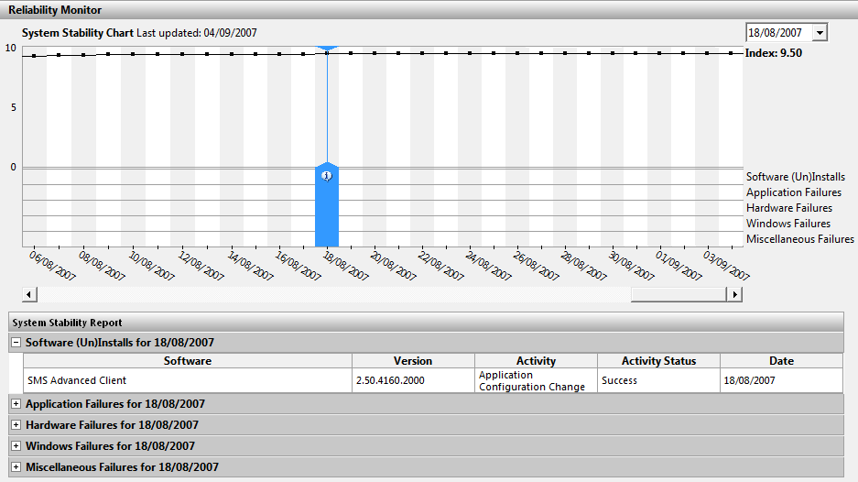
To reduce the time spent on performance issues, Windows Vista provides new performance counters and an improved Performance console that offers more detailed information. These tools give support personnel comprehensive data they can use to isolate this type of problems.

Summary
Windows Vista is designed to reduce computer’s total cost of ownership (TCO). Many features or tools combine to reduce TCO:
- The new Windows Imaging format and the suite of deployment and migration tools lower deployment costs.
- The great number of new Active Directory Group Policy settings and the new WinRM protocol for computing management empower remote administration.
- Self-detection and self-repair features such as the Startup Repair Tool and memory diagnostics help companies limit support costs and raise user productivity.
Security is a primary focus of Windows Vista. Windows Vista is the first desktop operating system released since the beginning of Microsoft Trustworthy Computing Initiative. Windows Vista provides features such as:
- Integrated Rights Management Services (RMS) client allows organizations to enforce policies around document usage.
- User Account Control that enhances experience from non-administrative users and allows organizations to move to a better-managed desktop with lower support costs.
- Windows Services Hardening that limits the damage attackers can do in the unlikely event that they are able to successfully compromise a service.
- BitLocker Drive Encryption enables encryption of Windows Vista system disk that can dramatically reduce the risk of an attacker compromising confidential files such as CATIA V5 documents.
All of these features will benefit to CATIA V5 users and administrators and allow a greater user productivity, a higher level of security and a simplified way to deploy desktops including CATIA V5.

Related links
- Information relative to deployment:
  - Microsoft Deployment Getting Started Guide:
http://technet.microsoft.com/en-us/library/bb891785.aspx
  - Microsoft Deployment http://technet.microsoft.com/en-us/library/bb456439.aspx
  - Windows Vista Deployment Enhancements:
http://technet.microsoft.com/en-us/windowsvista/aa905119
- Information relative to Group Policy:
  - Group Policy Settings Reference Windows Vista: http://www.microsoft.com/downloads/details.aspx?familyid=41DC179B-3328-4350-ADE1-C0D9289F09EF&displaylang=en
  - What's New in Group Policy in Windows Vista:
http://technet2.microsoft.com/WindowsVista/en/library/a8366c42-6373-48cd-9d11-2510580e48171033.mspx?mfr=true
- Information relative to security:
  - Windows Vista Security Guide: http://www.microsoft.com/technet/windowsvista/security/guide.mspx
  - BitLocker Drive Encryption:
http://technet.microsoft.com/en-us/windowsvista/aa905065.aspx
  - Technical Overview of Windows Rights Management Services
http://www.microsoft.com/windowsserver2003/techinfo/overview/rmenterprisewp.mspx
- Information relative to Startup Repair tool:
  - How Windows RE Works:
http://technet2.microsoft.com/WindowsVista/en/library/d807a440-90ce-4457-a23a-359ff2c9b9bf1033.mspx?mfr=true
- Information relative to WS-Man and WinRM
  - Technet blog: A Few Good Vista WS-Man (WinRM) Commands: http://blogs.technet.com/otto/archive/2007/02/09/sample-vista-ws-man-winrm-commands.aspx
  - MSDN: About Windows Remote Management
  - MSDN: Using Windows Remote Management
  - MSDN: Windows Remote Management Reference
  - SourceForge: Open WS-Man Project
  - DMTF (PDF): WS-Management Fact Sheet
  - DMTF (PDF): WS-Management Standard Document

Planning a Windows Vista 64 bits deployment
This chapter deals with Windows Vista Deployment for either new computers or upgrades from Windows XP operating system. In fact, the main project tasks are the same and deployment scenarios are very similar for both cases.
Windows Vista offers many new tools or features that simplify its deployment and limit costs as indicated in the Benefits of Windows Vista chapter.
A Windows Vista deployment involves three main tasks. These tasks are presented below with the associated tool provided by Microsoft.

Windows Vista^{tm}
Hardware assessment
Windows Vista Hardware Assessment Tool
Application Compatibility analysis
Application Compatibility Toolkit
Desktop deployment engineering
Windows Deployment Solution Accelerator

Hardware assessment
The goals of this assessment are:
- Identification of the Windows Vista compatibility of your current computers (in the upgrade scenario),
- Choice of new computers that have a Windows Vista logo,
- Verification of the presence of the configurations in the CATIA V5 certified workstations list.
The Microsoft Assessment and Planning Solution Accelerator allows companies to determine if computers present on the network are ready to run Windows Vista. This tool is useful for a deployment of Windows Vista on current computers.
It is agentless and uses WMI and SNMP to collect information from a single computer on the network. The tool provides Microsoft Word and Excel reports that contain information about:
- the compatibility for Windows Vista,
- the potential hardware or BIOS upgrade needs and
- the device drivers available on the Windows Vista installation DVD, the drivers that can be downloaded from Windows Update, and the devices that require contacting the manufacturer to obtain a driver.
Note: Information concerning availability of Windows Vista 64-bit device drivers is only provided by the Microsoft Assessment and Planning Solution Accelerator for computers with Windows x64 Editions operating system. If the computers are running Windows 32-bit Editions, the Microsoft Assessment and Planning Solution Accelerator provides availability of Windows Vista 32-bit device drivers.
For new computers, hardware requirements for Windows Vista are defined at: Windows Vista Enterprise Hardware Planning Guidance at URL: http://technet.microsoft.com/en-us/windowsvista/aa905075.aspx while the systems and hardware components certified for Windows Vista 64-bit Edition are present in the Windows Vista Hardware Compatibility List located at URL: http://winqual.microsoft.com/HCL/Default.aspx?m=v

Application compatibility

General information
Throughout the development of Windows Vista, many applications from a wide range of third-party vendors have been tested.
Note: This list of applications certified for Windows Vista is present at URL: https://winqual.microsoft.com/member/softwarelogo/certifiedlist.aspx.
Moreover, Windows Vista provides features that can automatically resolve typical compatibility issues or provides workarounds.
For instance, the Program Compatibility Assistant automatically specifies an appropriate “compatibility mode” for application setup designed to run with previous versions of Windows.
Note: For more information, see the Program Compatibility Assistant: frequently asked questions page of the Windows Vista Help and How-to web site.
However, there is a possibility that older applications may not work properly with some of the new technologies built into Windows Vista.
Note: Application compatibility analysis will focus on the applications present on the CAD workstations except for CATIA. Indeed, Dassault Systèmes supports CATIA V5R18 SP4 and higher versions on Windows Vista 64-bit Edition.

Windows Vista 64-bit Editions requirements
Windows Vista 64-bit Editions have specific requirements: 16-bit applications, 16-bit installers, 32-bit kernel mode drivers and 64-bit unsigned drivers are not supported anymore. Moreover, User Account Control automatic registry and system file redirection are not available for 64-bit applications. As a result of that, applications that try to modify protected registry locations and system files may fail.
Planning an application compatibility analysis
The main steps for an application compatibility analysis are:
- Software assessment: this first step is needed to estimate the workload of this phase.
- Analysis: during this step, applications are categorized, prioritized, rationalized and off-the-shelf applications are evaluated for compatibility using vendors information.
- Test and workarounds: Windows Vista compatibility of the companies’ specific developments is evaluated and if needed workarounds or fixes are developed.

Tools and guidance
The Microsoft Application Compatibility Toolkit (ACT) 5.0 is a toolkit that greatly simplifies all these steps. ACT allows administrators to:
- Make a software and hardware assessment,
- Identify applications that have compatibility issues thanks to new Windows Vista–specific compatibility evaluators and information provided by software vendors or online application communities that can be synchronized with ACT.
- Generate reports,
- Categorize and prioritize applications,
- Develop workarounds.
Note 1: ACT is not supported on 64-bit version of the Windows operating system. However, ACT does assist with migrating to a 64-bit version of the Windows operating system by reporting on 64-bit incompatibilities. In addition, you can use the Setup Analysis Tool (SAT), included in the toolkit, to detect 16-bit components and 32-bit device drivers, which are not compatible with the 64-bit version of Windows Vista.

Note 2: You can download Microsoft Application Compatibility Toolkit 5 at: http://go.microsoft.com/fwlink/?LinkID=82101
In addition, the Microsoft Deployment Solution Accelerator contains guidance to enable IT professionals to test applications for compatibility with Windows Vista, and mitigate compatibility issues discovered during the process.
Note 3: For more information, refer to the Microsoft Deployment Application Compatibility Guide at URL: http://technet.microsoft.com/en-us/library/bb960417.aspx.

Typical issues
The Windows Vista and Windows Server 2008 Developer Story: Application Compatibility Cookbook provides an overview of the known application incompatibility and the associated mitigations and fixes.
Common issues are:
- Applications that check OS version and get a higher number as expected: One of the workarounds for this issue is the compatibility mode feature that simulates the behavior of a previous version of Windows. A compatibility mode is a collection of shims which are DLLs that implement one or more Windows API hooks. Once installed, such hooks permit alternate functions to be called in place of the original functions. This allows simulation of the behavior of a previous version of Windows operating system. Shims are very powerful workarounds and ACT provides a tool to select specific shims and apply them to the desired application.
- Web sites that check the User Agent String for the IE version will get higher version number as expected: To mitigate this issue, it is possible to emulate Internet Explorer 6.0 using the User Agent String Utility until problematic sites have been updated.
- Internet Explorer 7.0 Protected Mode does not allow ActiveX to access to system or user’s files: In Windows Vista, Protected Mode is the default mode for Internet Explorer. This mode significantly reduces the ability of an attack to write, alter, or destroy data on the user's machine or to install malicious code as the Internet Explorer process runs with greatly restricted privileges. It allows ActiveX to write only to folders that have low-integrity label such as Temporary Internet Files or Favorites folders. When trying to write in directories with higher integrity level, files are automatically redirected. For instance when an ActiveX tries to write to the Documents folder it is redirected to the %userprofile%\Local Settings\Temporary Internet Files\Virtualized folders.
- ActiveX fails to install due to IE protected mode: the new ActiveX Install Services (AXIS) allows installing ActiveX as the LocalSystem account. This service downloads ActiveX only if the Host Url is present in the Allowed Installation Sites list deployed via Group Policy and installs the control only if it respects the configured signing policy.
- User Account Control causes installation or application to fail: When an application fails to install due to User Account Control, using elevated privilege or an application manifest to specify desired run level solves most of this type of compatibility issues.
- Applications or installers that try to modify protected resources fail: Windows Resource Protection does not allow protected resources modification. If the installer is renamed as setup.exe or any name containing the strings “update”, “install”, “setup”, application is detected as a legacy installer and “access denied error” messages are suppressed.
Note: Applications and installers can use the SfcIsFileProtected and SfcIsKeyProtected functions to determine whether a file or registry key is protected.

Temporary remedies
There are additional Microsoft technologies you can use to address application compatibility issues that might take some time to fully resolve. These technologies include:
- Virtual PC: You can use Virtual PC on a Windows Vista computer to keep a previous version of Windows. This allows running applications that only work properly with this version of Windows.
Note: As CATIA is supported on Windows Vista 64-bit, this information is only relative to other applications that can be present on the CAD workstations.
- Terminal Services: Older applications can also be hosted on a server. Windows Vista can connect to these applications through Remote Desktop.

Desktop deployment
The main goal of this chapter is to provide a high-level view of a Windows Vista deployment project. It also supplies information on the Microsoft Deployment Solution Accelerator.

Planning a Windows Vista Deployment
The key steps of the planning phase are:
- Identification of the deployment scenarios: Administrators must define which scenarios correspond to the project needs among the following scenarios:
  - Deployment of Windows Vista on new computers or,
  - Upgrade of the current Windows operating system or,
  - Reinstallation of the same version of Windows on computers or,
  - Replacement of computers with the same version of Windows.
- Definition of a deployment method: Instances of deployment methods are:
  - DVD,
  - USB drive,
  - Windows Deployment Services (WDS),
  - SMS 2003 OSD Feature Pack or System Center Configuration Manager,…
- Identification of the required infrastructure: Infrastructure needs are dependent on the chosen deployment method and can be relative to network or storage capacity or to the existence of a WDS or a System Center Configuration Manager infrastructure,
- Definition of all the configuration parameters applied during the process of deployment,
- Definition of the way to monitor the progress of deployment.

Windows Vista Image creation process
The Microsoft Deployment Solution Accelerator delivers guidance for the efficient deployment of Windows Vista. It also provides tools to automate desktop image creation and deployment and reduces development needs and the time to automate the deployment tasks.
Indeed, the deployment workbench allows:
- An easy and almost automatic installation of the needed environment for image creation,
- Generation of ISO and WIM image using Windows PE,
- Drivers injection,
- Language packs addition,
- Applications chaining
Note: this allows administrator to chain CATIA V5 installation with Windows Vista.
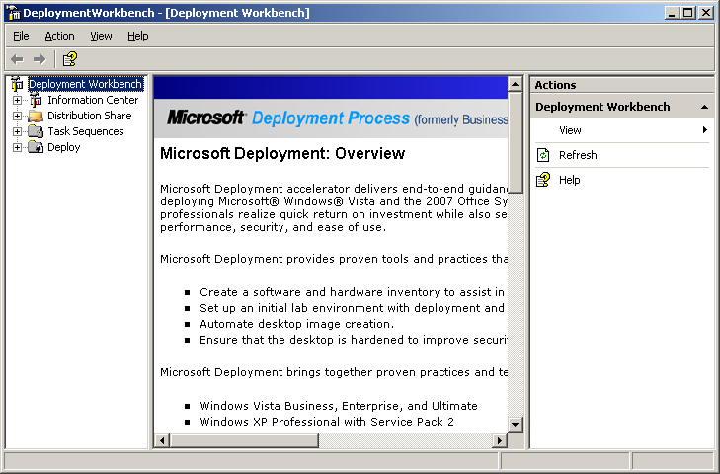
Microsoft Deployment also eliminates many of the custom scripting requirements by incorporating a stand-alone task sequencer derived from System Center Configuration Manager 2007. A sample upgrade scenario using the task sequencer is provided below.
- User settings are exported,

- The computer is backed up,

- Windows Vista is installed

- and then configured,
- Applications are installed and then,
- User settings are restored.

Differences between 64-bit and 32-bit deployment
In most instances, deploying 64-bit versions of Windows is the same as deploying 32-bit versions of Windows. However, the following differences need to be taken into consideration when deploying 64-bit versions of Windows:
- For a 64-bit version of Windows Vista, a 64-bit version of Windows PE is required and 64-bit versions of Windows PE 2.0 do not run 32-bit applications. However, it is possible to deploy a 64-bit version of Windows Vista Service Pack 1 with a 32-bit version of Windows PE 2.0.

- 64-bit applications are installed in a separate Program Files folder: 64-bit applications are installed in the Program Files folder and 32-bit applications are installed in the Program Files (x86) folder.

Summary
To reduce Windows Vista deployment costs for CATIA V5 workstations, Microsoft provides tools for each of the main tasks of a Windows Vista deployment project:
- Hardware assessment task: Asset assessment and Windows Vista compatibility diagnosis of the current computers can be done using Microsoft Assessment and Planning Solution Accelerator. This information will then be combined with CATIA V5 certified configurations to determine the computers that need upgrade.
- Application compatibility analysis can benefit from the Application Compatibility Toolkit for application assessments, compatibility issues identification and workarounds for applications present on the CAD Workstation in addition to CATIA V5.
- For Windows Vista deployment, the Microsoft Deployment Solution Accelerator offers an integrated environment for building images, operating system configuration and application installation.

Related links
- Information relative to hardware Assessment:
  - Microsoft Assessment and Planning Solution Accelerator:
http://www.microsoft.com/technet/solutionaccelerators/hardwareassessment/wv/default.mspx
  - Download the Microsoft Assessment and Planning Solution Accelerator:
http://go.microsoft.com/fwlink/?LinkId=83115
  - Windows Vista, Windows Vista Capable PC and Windows Vista Premium ready PC minimum hardware requirements: Windows Vista Enterprise Hardware Planning Guidance
http://technet.microsoft.com/en-us/windowsvista/aa905075.aspx
  - Windows Vista Hardware Compatibility List: http://winqual.microsoft.com/hcl/Default.aspx
- Information relative to Application Compatibility:
  - Download Microsoft ACT 5.0: http://go.microsoft.com/fwlink/?LinkID=82101
  - Microsoft Deployment Application Compatibility Guide:
http://technet.microsoft.com/en-us/library/bb960417.aspx
  - The Windows Vista and Windows Server 2008 Developer Story: Application Compatibility Cookbook:
http://msdn2.microsoft.com/en-us/library/Aa480152.aspx
  - “Make older programs run in this version of Windows” on the Windows Vista Help and how-to Web site:
http://windowshelp.microsoft.com/Windows/en-US/Help/bf416877-c83f-4476-a3da-8ec98dcf5f101033.mspx
- Information relative to Virtualization Solutions and Terminal Services:
  - Microsoft Virtual PC 2007: http://www.microsoft.com/windows/virtualpc/default.mspx
  - Technical Overview of Windows Server 2003 Terminal Services: http://www.microsoft.com/windowsserver2003/techinfo/overview/termserv.mspx
  - Virtual Server 2005 R2 SP1 Product Overview: http://www.microsoft.com/windowsserversystem/virtualserver/evaluation/vsoverview.mspx
- Information relative to Windows Vista deployment:
  - Microsoft Deployment Getting Started Guide:
http://technet.microsoft.com/en-us/library/bb891785.aspx
  - Microsoft Deployment: http://technet.microsoft.com/en-us/library/bb456439.aspx
  - In-depth discussion of deployment technologies and tools: Windows Vista Deployment Enhancements: http://technet.microsoft.com/en-us/windowsvista/aa905119
  - Windows Vista deployment: http://technet2.microsoft.com/WindowsVista/en/library/1d093249-41e9-458a-8297-489935eeabb11033.mspx

Planning a CATIA V5 deployment
The chapter focuses on three main points relative to CATIA V5 deployment and management:
- Prerequisites for CATIA V5 installation,
- The different methods to install CATIA V5,
- The different ways to deploy CATIA V5 service packs.
The main goal of this chapter is to provide IT professionals with information so that they could choose the options that fit their needs.
Before going deeper in these subjects, two points must be highlighted:
- Deploying CATIA V5 64-bit on a 64-bit platform is as simple as deploying CATIA V5 on Windows 32-bit Editions: the processes and the types of installation are the same.
- Whereas this document focuses on the deployment of the 64-bit version of CATIA V5 on Windows Vista 64-bit Editions, it is also possible to install either 32-bit or 64-bit Edition of CATIA V5 on Windows XP 64-bit Edition.

Prerequisites for CATIA V5 installation
The Program Directory document delivered with the CATIA V5 CD-Rom provides all the prerequisites: driver versions, operating systems hot fixes and components that are required for CATIA V5. The most important prerequisites are listed below:

Operating system
CATIA V5R18 SP4 64-bit Edition is supported on Windows Vista Enterprise and Business 64-bit Editions.

Hardware
For 64-bit platforms, the following hardware is recommended:
- Memory: 4 GB,
- Available Disk space: 4 GB,
- A certified hardware configuration.
Note 1: A list of the certified hardware configurations is published at URL: http://www.3ds.com/implementation/technology/windows/certified-workstations-list/
Note 2: System Center Configuration Manager, the latest version of Microsoft System Manager described in the Using System Center Configuration Manager 2007 chapter, provides software and hardware inventories that allow IT administrators to check the prerequisites before the deployment or to deploy CATIA V5 only on computers that match with the prerequisites.

Choosing a method of installation

Local or code-server installation?
There are two distinct ways to install and access CATIA Version 5:
- Local installation: CATIA V5 is installed locally on each workstation,
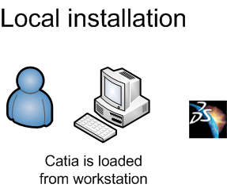
- Code-server installation: CATIA V5 is installed on a server and accessed remotely from clients on which only a runtime environment is installed but no code.
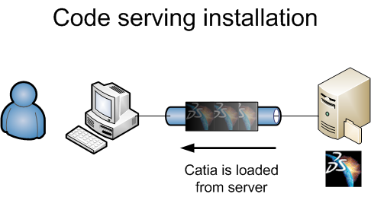
The advantages of a code-server installation are:
- Management: code is installed only on the servers and not on the clients. Installations and upgrades are done on a very low number of computers and can be done manually.
- Disk space usage: as code is installed on the servers only, disk space is saved on the clients.
The advantages of a local installation are:
- Performance: unlike the code-server installation, the code is not sent over the network therefore start time and computing times are not dependant on the network and server loads. Performance is only dependant on the hardware features (CPU, GPU and memory) of the workstation.
- Availability: Users can run CATIA V5 even when the network is down.
Recommendation: As disk space is not a concern anymore with current hardware and as the great majority of companies have a solution for software distribution, deploying CATIA V5 locally is a common option for customers. A local installation offers the best level of performance.

Choosing the method of local installation
There are multiples ways to install CATIA V5 locally:
- Manual installation,
- Unattended installation using a batch,
- Remote installation,
- A software distribution solution such as System Center Configuration Manager 2007.
These four installation methods plus the “compressed sources” installation, which can be combined with all these installation methods except the manual installation, are presented and compared below.
Note: As the installation steps and commands provided below may change, please refer to Dassault Système’s official documentation relative to the CATIA version you plan to deploy.

Manual installation
This method consists in inserting a set of installation CD-ROMs in the drive and in following instructions on screen. Several installation options will be offered.
On a Windows Vista computer, User Account Control detects the installation and asks for a confirmation to run setup.exe and you need to select Allow to start the installation.
If Windows Firewall is activated, during installation and when you start CATIA V5, a Windows Security alert can be raised. In order for the installation to be completed successfully and for the product to work, you need to unblock incoming communications to the Orbix® daemon and the CATIA main program.
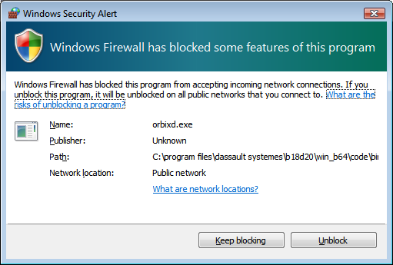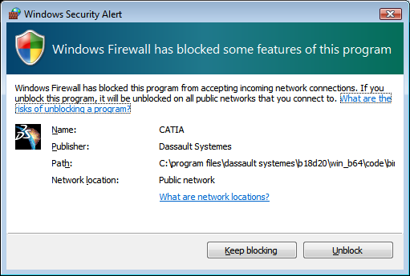
Note: for more information, see the unloading your product code on Windows article in the Installation & Deployment chapter from Infrastructure part of CATIA V5 documentation.

Batch installation
This method installs CATIA V5 without any interaction. The principle is:
- Copy CATIA V5 CD-ROMs on a server,
- Run a command prompt as administrator on the workstation,
- Go to the directory containing the installation sources, then to WIN64 folder,
- To install CATIA V5, execute a StartB command with the desired parameters,
- Go to VBA folder,
- Install silently Visual Basic Application 6.0.
See below an example of batch:
E:
CD WIN64
StartB -u "C:\Program Files\Dassault Systemes\B18" -newdir -l "MD2.slt DP2.slt"
CD ..\VBA
MSIEXEC /i VBA6.msi /q
Note: for more information, see the Installing in batch mode article in the chapter Installation & Deployment from Infrastructure part of CATIA V5 documentation.
If Windows Firewall is activated, you need to unblock incoming communications to the Orbix® daemon and the main CATIA program. This can be done using a netsh command.
Note: it is also possible to configure the Windows Firewall using Group Policy Objects.
See below an example of netsh command to unblock incoming communications to CATIA main program and Orbix daemon:
netsh advfirewall firewall add rule name="CATIA" dir=in action=allow program="C:\program files\Dassault Systemes\B18\win_b64\code\bin\cnext.exe" description=CATIA
netsh advfirewall firewall add rule name="orbixd" dir=in action=allow program="C:\program files\Dassault Systemes\B18\win_b64\code\bin\orbixd.exe" description=orbixd
In this sample, the “name” parameter corresponds to the rule’s name; the “program” parameter is the application path and the “description” parameter is the rule’s description.

Remote installation
This type of installation is a batch installation executed remotely. For this type of installation, you need to:
- Open a remote session on the client from the administrator workstation,
- Map a drive letter to a shared folder where installation sources are present,
- Execute the same batch as for the batch installation.
As RCMD is not available anymore on Windows Vista, information provided in the Distributing the Software To a Client Using the RCMD Command article in the chapter Installation & Deployment from Infrastructure part of CATIA V5 documentation applies only on Windows XP.
Windows Vista allows remote installation using the new WinRM protocol, described in the paragraph Desktop management of the chapter Benefits of Windows Vista 64-bit Editions.
WinRM have also been back-ported to Windows XP and so the installation described below applies to Windows Vista and Windows XP. This installation requires two steps:
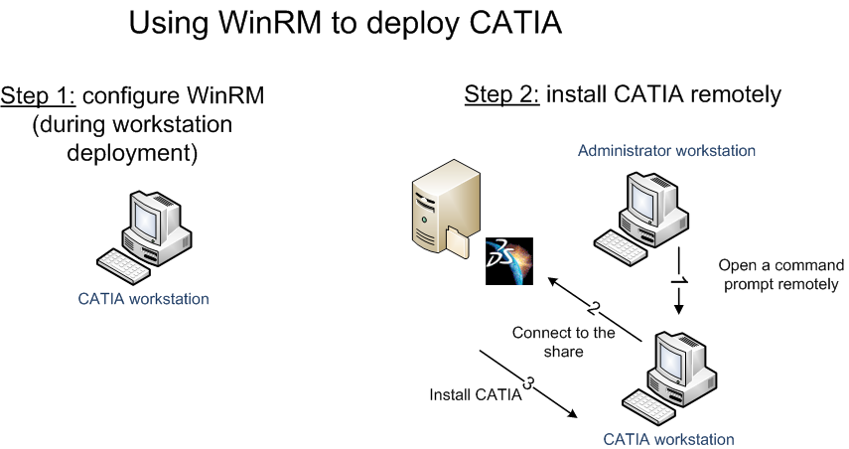
Step 1: WinRM configuration:
- Configure a WinRM listener on the workstation where CATIA V5 will be deployed:
WinRM is part of the operating system. However, to execute a command remotely, you must configure a WinRM listener. That’s why on the destination computer (CATIA workstation), it is necessary to launch the following command in a command prompt run as administrator:
WinRM quickconfig
And enter Y to create a WinRM listener and a firewall exception for Windows Management.
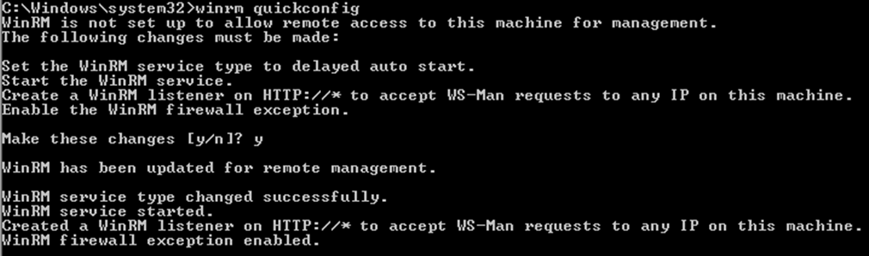
- In workgroup environment only, allow all accounts in the Administrators group to use WinRM on the destination computer:
When the involved computers are not in a Windows domain, User Account Control blocks access to the WinRM service except for built-in administrator account. To allow all accounts in the Administrators group to use WinRM, create the DWORD value LocalAccountTokenFilterPolicy below the HKLM\SOFTWARE\Microsoft\Windows\CurrentVersion\Policies\system key and set the value to 1.
Note 1: This configuration disables Remote UAC. For security reason, this configuration is not recommended but may be necessary in specifics contexts such as using WinRM in workgroups.
Note 2: The following Technet article provides methods to set the settings in a Windows Vista image: http://support.microsoft.com/kb/942817.
Note 3: The WinRM listener can be configured during the workstation deployment phase.
- In workgroup environment only, define the trusted hosts list on the administrator workstation (the computer from where the installation is launched)
If workstations are in a workgroup, Kerberos cannot be used and so mutual authentication cannot be established. It is then necessary to create a trusted hosts list. On the administrator workstation, it is necessary to run the following command in a command prompt run as administrator:
winrm set winrm/config/client @{TrustedHosts="computer_name1,computer_name2"}
where computer_name1 and computer_name2 are the names of the workstations where CATIA V5 will be deployed.
Note: A best practice in setting up trusted hosts for a workgroup is that the list should be as restricted as possible.
Step 2: installation of CATIA V5
- Start a command line remotely:
When using a local account for instance in a workgroup environment, a remote session can be opened using the following command:
winrs -r:name_of_the_destination_computer
-u:name_of_the_destination_computer\local_account_name -p:password cmd
where name_of_the_destination_computer is the name of the workstation where CATIA V5 will be deployed, local_account_name is the name of the administrator account used for installation and password is the associated password.
For an Active Directory domain environment, the command is similar:
winrs -r:name_of_the_destination_computer -u:domain_name\account_name -p:password cmd
where name_of_the_destination_computer is the name of the workstation where CATIA V5 will be deployed, domain_name is the Active Directory domain of the account named account_name and password is the associated password.

- Connect to the share that contains CATIA V5 installation sources :
Net use E: \\server_name\share_name
Where share_name is the name of the shared folder that contains the CATIA V5 installation sources stored on the server named server_name.
- Install CATIA V5:
E:
CD WIN64
StartB -u "C:\Program Files\Dassault Systemes\B18" -newdir -l "MD2.slt DP2.slt"
CD ..\VBA
MSIEXEC /i VBA6.msi /q

Note: If Windows Firewall is activated, you need to unblock incoming communications to the orbix daemon and the CATIA main program. This can be done using a netsh command provided in the batch installation paragraph.

Distribution in a compressed form
The principle of this type of installation is to install CATIA V5 on a computer, compress and copy the installation folder to the destination computer, uncompress the folder and then realize the necessary configuration operations.
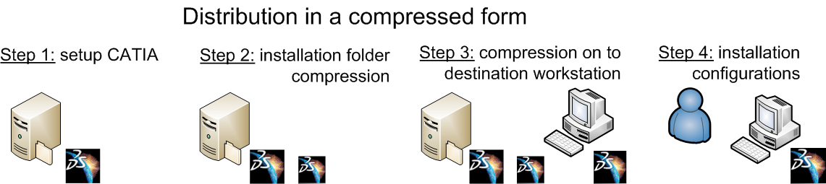
More precisely, installation operations are:
- Install CATIA V5 on a computer with the desired service pack level using the manual or batch installation type,
- Compress the installation folder using a third-party tool or native Windows compression feature,
- Copy and decompress the installation folder on the destination workstation,
- Silently install the Visual C++ 2005 runtime on the client with a command such as msiexec /i InstallDSSoftwarePrerequisites_x86_x64.msi /q for a Windows 64-bit Edition,
- Create the runtime environment: with a setcatenv command (an example is provided below), which particularly defines the name of the environment and the name of the folder containing the environment that will be called respectively MyEnvironment and MyEnvDirectory in the next commands.
- Create the shortcuts to the configuration tools using the command: setcatenv -tools -cs CATIA –e MyEnvironment –d MyEnvDirectory.
- Activate OLE support using the command: cnext /regserver -env MyEnvironment -direnv MyEnvDirectory,
- Optionally, install extended fonts using the command: VE0IFONT.exe -env MyEnvironment -direnv MyEnvDirectory,
- Install Visual Basic Application 6.0 using the command: msiexec /q /i VBA6.msi.
- Optionally, define communication ports using the command setV5Ports and create the backbone daemon with the command BBDemonService –create.
Sample batch for configuration:
CD \SOURCES\WIN64
MSIEXEC /i InstallDSSoftwarePrerequisites_x86_x64.msi /q
CD "\program files\Dassault Systemes\B18\win_b64\code\bin"
SETCATENV -p "c:\program files\Dassault Systemes\B18" -e V5R18 -d “%APPDATA%\DassaultSystemes\CATEnv” -a global -desktop yes -cs CATIA
SETCATENV -tools -cs CATIA -e V5R18 -d “%APPDATA%\DassaultSystemes\CATEnv”
CNEXT /regserver -env V5R18 -direnv “%APPDATA%\DassaultSystemes\CATEnv”
VE0IFONT -env V5R18 -direnv “%APPDATA%\DassaultSystemes\CATEnv”
CD \SOURCES\VBA
MSIEXEC /q /i vba6.msi
CD "\program files\Dassault Systemes\B18\win_b64\code\bin"
SETV5PORTS
BBDemonService -create
Note 1: when you use a compressed form, you cannot install a service pack in normal installation mode. You have to reinstall the application with the service pack in a compressed form.
Note 2: for more information, see the Distributing the Software in Compressed Form article in the chapter Installation & Deployment from Infrastructure part of CATIA V5 documentation.
Note 3: If Windows Firewall is activated, you need to unblock incoming communications to the Orbix daemon and the CATIA main program. This can be done using the netsh command provided in the batch installation paragraph.
Recommendation: independently from the distribution vector, the “distribution in a compressed form” allows limiting the impact of the CATIA V5 deployment on the network. With this method, only the programs and DLLs relative to the desired products are present in the compressed file. Moreover, you can install the desired service pack before compressing. This avoids the transfer of the full product and the service pack on the wire.

Using System Center Configuration Manager 2007
System Center Configuration Manager 2007 (SCCM), the latest version of Microsoft System Management Server, allows IT administrators to push applications, updates and configuration options to the client computers.
SCCM provides a very flexible means to deploy CATIA V5 on a network as it allows administrators to control over targeting of users or systems, specifying when an installation can take place, user interaction levels, restarts,…
System Center Configuration Manager features
SCCM main features are:
- Deploying operating systems,
- Deploying software applications,
- Deploying software updates,
- Metering software usage,
- Assessing variation from desired configurations,
- Taking hardware and software inventory,
- Remotely administering computer
Benefits for CATIA V5 deployment
With SCCM CATIA V5 can be deployed in a way that guarantees service to be maintained at a level appropriate for organizations:
- Deployment can be scheduled: as CATIA V5 is a critical application for business units such as Design or Engineering, it is generally deployed out of working hours. To handle this need, SCCM advertisements have a schedule that controls when the software is deployed and whether users can accept, postpone, or reject the software package.
Moreover, SCCM leverages best practices for deployment as it allows staged deployment such as to a pilot group first then to a specific department and finally to all.
- Controlled bandwidth utilization: CATIA V5 installation sources are about 1.1 GB. Deployment of such an application can load network links if deployment is not controlled. SCCM advertisements control how the package uses the network for the installation. Plus, SCCM uses the Background Intelligent Transfer Service (BITS) protocol that can significantly reduce the demands on network bandwidth when installing CATIA V5. Indeed, BITS uses spare network capacity to transfer SCCM packages to the client computers.
- Monitoring the deployment: Companies generally expect to use the same CATIA V5 version on all the workstations. In order to verify that the deployment of a new version is successful on all the workstations, SCCM provides reports.
How to deploy CATIA V5 with SCCM?
SCCM uses packages to deploy software applications, and within those packages, commands called programs that tell the SCCM client what executable files or command lines to run.
Advertisements¹⁵ are used to specify which collections receive the program and the package.
These tasks can be done at the same time using the SCCM Distribute Software Wizard or individually using specific wizard.
When deploying CATIA V5 with SCCM, you need to provide commands that allow a silent installation of CATIA V5. Adapted methods can be either a batch installation or a compressed form distribution. Preference goes to the compressed form distribution as installation is faster and installation sources are smaller.

Choose a method of installation
Methods are to be evaluated according to three criteria:
- Number of CATIA V5 workstations:
The higher the number of CATIA V5 workstations, the more you need to automate the installation. A manual installation is an appropriate solution for a company with fewer CATIA V5 workstations. An unattended installation and, better, a software distribution solution is recommended for larger companies in order to reduce administration costs.
- Software distribution solution and methods that are available and used in the company:
If available, a software distribution solution such as System Center Configuration Manager 2007 allows companies to lower deployment costs.
- Network bandwidth available for deployment:
A software distribution solution provides control over network impact due to deployment.
Recommendation: If available, use a software distribution solution such as System Center Configuration Manager 2007 to deploy CATIA V5 in a controlled manner. Indeed, SCCM allows CATIA V5 distribution but also software and hardware inventories for CATIA V5 prerequisites.

Planning the management of the CATIA V5 service packs
This chapter indicates how to manage CATIA V5 service packs. We will first describe the concept of commit and roll back and then present the different ways to install service packs.

Committing and Rolling back Service Packs
Before deploying a service pack on all the CATIA V5 workstations, a company will do some tests on a limited number of workstations. If the tests are successful, the deployment will be generalized. On the contrary, if the tests are not successful, the service pack will be uninstalled.
Service pack setup program allows saving the previous version of the files that have been modified by a service pack in order to allow service pack removal (or in other words service pack rollback).
It the service pack deployment is approved, the “old” files can be removed (or in other words the service pack is committed).
For the generalization of the deployment, automatic service packs commitment is possible.
Note 1: before the installation of a new service pack, it is necessary to commit or rollback the previous service pack. As a service pack contains all the modifications included in the previous service packs, it is not necessary to install all the service packs.
Note 2: for more information, see the Committing and Rolling Back Service Packs article in the chapter Installation & Deployment from Infrastructure part of CATIA V5 documentation.

Service pack installation
There are four ways to install service pack:
- Manually,
- Using a batch,
- Remotely,
- Using a software distribution solution.

Manual installation
As for the installation, this method consists in inserting a CD-ROM and selecting the desired options offered by the graphical user interface.
Note: if CATIA V5 is installed in multiple locations on the computer, you have to install service pack for each CATIA V5 installation.

Batch installation
The StartSPKB command allows you to silently install the service pack. For example, to install and commit an installation located in the directory named dir_CATIA the command is:
StartSPKB –u dir_CATIA –bC
Note: for more information, see the Installing a Service Pack article in the chapter Installation & Deployment from Infrastructure part of CATIA V5 documentation.

Remote installation and Software distribution solution
For both options, batch installation command presented above can be used.
Information about WinRM configuration for remote installation can be found in paragraph Remote installation of the chapter Choosing the method of local installation and information about deployment using SCCM is present in paragraph using System Center Configuration Manager 2007 of the same chapter.
Recommendation:
It is recommended to use the same method for CATIA V5 and Service Packs deployment to avoid development and maintenance of multiple processes.

Summary
This chapter provides IT professionals guidance on the main points relative to CATIA V5 deployment and management and highlights that a deployment of CATIA V5 64-bit on a 64-bit platform is as simple as deploying CATIA V5 on Windows 32-bit.

These main points are summarized below:
- Local installation vs. Code serving installation: local installation is a common option for customers as the great majority of companies have a solution for software distribution and this type of installation offers the best level of performance,
- Method to install CATIA V5 locally: The higher the number of CATIA V5 workstations, the more you need to automate and control the installation. System Center Configuration Manager 2007 reduces administration costs compared to other installation methods, enables scheduled deployment, saves network bandwidth utilization, and monitors deployment.
- Interest of “distribution in a compress form” installation method: To install CATIA V5 faster and to reduce the size of installation source, it is recommended to combine System Center Configuration Manager with an installation method named “distribution in a compressed form”. With this method, only the programs and DLLs relative to the desired products are present in the compressed file.
- Service pack installation: it is recommended to use the same method to deploy CATIA V5 and the services packs to avoid development and maintenance of multiple processes.

Related Links
- CATIA V5 certified hardware configurations: http://www.3ds.com/implementation/technology/windows/certified-workstations-list,
- Information about System Center Configuration Manager 2007:
  - What’s new in Configuration Manager 2007: http://technet.microsoft.com/en-us/library/bb680807.aspx
  - Configuration Manager 2007 Features: http://technet.microsoft.com/en-us/library/bb680550.aspx
- Information about WinRM configuration in a Windows Vista image:
  - How to change the Remote UAC LocalAccountTokenFilterPolicy registry setting in a Windows Vista image: http://support.microsoft.com/kb/942817

Planning data and CAA applications porting to 64-bit operating systems

CATIA V5 data porting
For 32-bit and 64-bit versions of CATIA V5, documents have the same format and are fully compatible. So, no data migration is needed when migrating to 64-bit version of CATIA V5 and the same document can be loaded and used by both versions of CATIA V5.
However, very big models may only be fully loaded in 64-bit version of CATIA V5.

CAA application porting

General considerations
The same source code can be used for 32-bit and 64-bit CAA applications, so your future CAA applications will run on both 32-bit and 64-bit platforms with no additional costs for development and maintenance.
You don’t need to rewrite your current 32-bit CAA applications but to take full advantage of the Windows Vista 64-bit platform, 32-bit CAA Applications have to be tuned and CAA Applications should be compiled on the Windows XP 64-bit environment. For companies that want to use 32-bit versions of CATIA on Windows Vista 64-bit, there is no need to port applications. The 32-bit CAA applications will also run on Windows Vista 64-bit, using the WOW64 protocol.
Note: The paragraph Compatibility of the chapter Benefits of Windows x64 Editions provides more information on WOW64.
The cases that need adaptations have been identified and documented in the CAA encyclopedia in which you can find the CAA V5 C++ 64-bit Operating System Support article that provides recommendations for application porting.
To simplify application porting, CAA V5 provides new types and macros. Indeed, in the 32-bit programming model, integer, long, and pointer data types are all 32 bits in length. Whereas in 64-bit Windows, only pointers expand to 64 bits; all other basic data types (integer and long) remain 32 bits in length. So, if addresses have been stored in unsigned long, source code must be modified for 64-bit Windows because, unsigned long remains a 32-bit value whereas all pointers are now 64-bit values. The new polymorphic data types allow developers to use a single data type that automatically sizes with both platforms without using preprocessor flags.
As the CAA RADE tools are available on Windows XP 64-bit since the V5R16 GA version and are integrated with Visual Studio 2005 since the V5R17 GA version, the same development environment is used for 32-bit and 64-bit applications.
CAA RADE environment for Windows Vista will not be delivered during the V5R18 life cycle so 64-bit applications must be built on Windows XP 64-bit.
Note: for information about Windows Vista application compatibility, please refer to the paragraph Application compatibility of the chapter Planning a Windows Vista 64 bits deployment.

Porting guidelines

Planning phase
The goal of this phase is the estimation of the time needed for the porting of your applications. This estimation can be based on the number of errors for a compilation of the 32-bit code with the 64-bit compiler.
In this phase, you also need to plan the priority for each application and to evaluate applications dependencies.
Note 1: If your application is dependent on other applications that have also dependencies, it is recommended to port applications in a bottom to top approach (i.e. to port first applications that have no dependency, then to port applications that have all their dependencies already ported, and so on).
Note 2: All the components involved in a 64-bit application must be native 64-bit.

Development & testing
As the objective is to enable the application to continue running with 32-bit operating systems and to run on 64-bit operating systems, it is recommended to not impact 32-bit run time of the applications and particularly:
- Not to change data format for persistent data and for data exchange and
- Use polymorphic data types.
To facilitate the convergence and avoid any regression either in 32-bit or in 64-bit, best practices are to follow this process iteratively:
- Recompile your code to 64-bit and test.
- Fix problems, recompile in 32-bit, and then test
- Recompile your code to 64-bit and test,...
To accelerate porting, define bug patterns and find portions of code that match the identified patterns to apply the corrections advised for such patterns.
And, once 64-bit pure convergence has been achieved, validate that 64-bit streamed documents are readable in 32-bit mode.
Note: As adding large amounts of memory on the workstation sometimes exposes previously unnoticed problems, 64-bit applications can take advantages of memory top-down tests. The “FAQ for Development on 64-bit Windows” article indicates how to force memory allocation in top-down order (cf. Related Links chapter below).

Summary
For 32-bit and 64-bit versions of CATIA V5, documents have the same format, and are fully compatible. So, no data migration is needed and documents can be used by both versions of CATIA V5.
Moreover, as the same source code can be used for 32-bit and 64-bit CAA applications, 32-bit and 64-bit versions of applications can be provided with no additional costs for development and maintenance.
However, 32-bit CAA applications may need some adaptations but the cases that need adaptation have been identified and documented in CAA encyclopedia (the CAA V5 C++ 64-bit Operating System Support article provides recommendations for application porting). New polymorphic CAA data types have been added to limit the impact of the convergence on 32-bit run time of CAA applications.

Related links
- Programming Guide for 64-bit Windows:
http://msdn2.microsoft.com/en-us/library/bb427430.aspx
- 64-bit Windows FAQs for ISVs:
http://msdn2.microsoft.com/en-us/isv/bb190525.aspx

Conclusion
64-bit operating systems, and particularly Windows Vista 64-bit Editions, offer a highly compatible, high-performance and security-enhanced computing experience.
With CATIA V5R18 SP4 and above versions on Windows Vista 64-bit operating systems, the Dassault Systèmes and Microsoft partnership makes available a solution that improves user productivity and accelerates product design.
In order to facilitate a CATIA V5 deployment on a Windows Vista 64-bit Edition, this guide provides best practices concerning on the one hand operating system and CATIA V5 deployment and on the other hand CAA application porting to 64-bit.

CATIA V5 and CAA applications are compiled by default with the /LARGEADDRESSAWARE flag enabled
The /3GB switch in the boot.ini for Windows XP corresponds to the IncreaseUserVa 3072 option in the Boot Configuration Data for Windows Vista.
SSE2 is short for Streaming Single Instruction-Stream, Multiple Data-Stream (SIMD) Extensions 2. SSE2 instructions are available on all x64 processors (and on some x32 processors). Programs compiled with Microsoft Visual Studio 2005 can exploit SSE2 instructions.
Imaging means deploying an entire operating system as a single file.
The Windows Vista Energy Conservation document which presents the savings in terms of both financial and environmental impact is located at URL: http://www.microsoft.com/whdc/system/pnppwr/powermgmt/VistaEnergyConserv.mspx.
WinRM is present natively on Windows server 2003 R2 (version 0.5) and on Windows Vista operating systems (version 1.0). An update to version 1.0 is available for Windows Server 2003 with Service Pack 1 or 2 (including R2 version) and for Windows XP with Service Pack 2 cf. (http://support.microsoft.com/kb/936059).
Windows RE is short for Windows Recovery Environment
CATIA V5 certified hardware configurations are listed at: http://www.3ds.com/implementation/technology/windows/certified-workstations-list,
If multiple versions of the same application are used, companies can consider using only one on the Windows Vista workstations.
Windows Deployment Services is a server update for Windows Server 2003 operating systems that replaces Remote Installation Services (RIS).
OSD feature pack allows capture and deployment of a Windows Vista image.
Orbix is a Registered Trademark of IONA Technologies PLC. Orbix is used for communication between clients and servers.
Workgroup environment means that the workstations and servers are not parts of an Active Directory domain.
This MSI file is present in the WIN64 folder of the CD-ROM for a Windows 64-bit Edition.
For companies that have already deployed System Management Server 2003, the Service Pack 3 is needed to manage Windows Vista computers.
In SCCM 2007, an advertisement is a technical object that specifies when and to whom a package and program will be advertised or deployed.
A package object contains the files and instructions for running installation on Configuration Manager clients.
Programs are commands associated with a package that tell a client what should occur on the client computer when the package is received. For example, a program can be used to install new software on clients, distribute data files, run virus-detection software, or update client configuration.
Collections are sets of resources used to direct Configuration Manager tasks such as distributing software to specific sets of clients. Collections can consist not only of computers, but also of Windows users and user groups as well as other discovered resources.

