Understanding Identity Lifecycle Manager “2”

Microsoft’s Identity and Access Management Strategy

Microsoft Corporation
Published: June 2008

Abstract
This paper provides an overview of the strategy for Microsoft® Identity Lifecycle Manager, with a focus on the upcoming release of Identity Lifecycle Manager “2”, and the features and benefits delivered through Microsoft’s approach.

This document supports a preliminary release of a software product that may be changed substantially prior to final commercial release, and is the confidential and proprietary information of Microsoft Corporation. It is disclosed pursuant to a non-disclosure agreement between the recipient and Microsoft. This document is provided for informational purposes only and Microsoft makes no warranties, either express or implied, in this document. Information in this document, including URL and other Internet Web site references, is subject to change without notice. The entire risk of the use or the results from the use of this document remains with the user. Unless otherwise noted, the companies, organizations, products, domain names, e-mail addresses, logos, people, places, and events depicted in examples herein are fictitious. No association with any real company, organization, product, domain name, e-mail address, logo, person, place, or event is intended or should be inferred. Complying with all applicable copyright laws is the responsibility of the user. Without limiting the rights under copyright, no part of this document may be reproduced, stored in or introduced into a retrieval system, or transmitted in any form or by any means (electronic, mechanical, photocopying, recording, or otherwise), or for any purpose, without the express written permission of Microsoft Corporation.

Microsoft may have patents, patent applications, trademarks, copyrights, or other intellectual property rights covering subject matter in this document. Except as expressly provided in any written license agreement from Microsoft, the furnishing of this document does not give you any license to these patents, trademarks, copyrights, or other intellectual property.

© 2008 Microsoft Corporation. All rights reserved.

Active Directory, Microsoft, MS-DOS, Visual Studio, Windows, and Windows NT are trademarks of the Microsoft group of companies.

All other trademarks are property of their respective owners.

Contents
Executive Summary 4
Delivering on the Promise 4
Realizing the Value of Identity Management 5
Managing Identities Must be Cost-Effective and Efficient 5
Identity Management Must Enhance Security 5
Identity Management Must Drive Business Value 6
Compliance is Critical 6
Microsoft’s Identity Management Approach 7
Identity Lifecycle Manager 2007 8
Features and Benefits of Identity Lifecycle Manager 2007 8
Identity Synchronization 8
Certificate and Smart Card Management 8
User Provisioning 8
Identity Lifecycle Manager “2” 9
Features and Benefits of Identity Lifecycle Manager “2” 10
Policy Management 10
Credential Management 12
User Management 12
Group Management 13
Conclusion 15

Executive Summary
The Microsoft strategy for identity management delivers a comprehensive solution to manage identities, credentials, and identity-based access policies across heterogeneous environments.
Today, Microsoft® Identity Lifecycle Manager (ILM) 2007 provides an integrated and comprehensive solution for managing the entire lifecycle of user identities and their associated credentials. It provides identity synchronization, certificate and password management, and user provisioning in a single solution that works across Windows and heterogeneous systems. As a result, IT organizations can define and automate the processes used to manage identities from creation to retirement.
The next version of Microsoft Identity Lifecycle Manager, Microsoft® Identity Lifecycle Manager "2" (ILM "2"), scheduled for release in the first quarter of calendar year 2009, extends the functionality of ILM 2007. New features empower end users with self-service tools integrated in Office and Windows. Additional features improve security and compliance through a robust business process framework.
New capabilities improve operational efficiency by automating common identity lifecycle management tasks and empowering end-users with self-help solutions. For organizations that want or need a more customized approach, Microsoft is implementing ILM "2" on common set of services that includes workflow, Web services APIs, and logging. These services can be utilized by customers and vendors to customize and extend the functionality of ILM "2" to meet their specific needs.

Delivering on the Promise
Microsoft ILM 2007, the evolution of Microsoft Identity Integration Server (MIIS) 2003, for the first time brings together traditional identity management with certificate and smart card management into one offering. Prior to ILM 2007, customers had to purchase products from different vendors and manually integrate the two offerings.
Enabling comprehensive identity & access management in the enterprise, Identity Lifecycle Manager “2” delivers an integrated identity management solution across heterogeneous systems and serves audiences across IT professionals, end users, and developers. In response to customer feedback that current identity management tools place an undue burden on IT departments and help desks without meaningful tools for end users, ILM “2” provides powerful self-service capabilities for Office end-users, rich administrative tools and enhanced automation for IT professionals and .NET and WS-* based extensibility for developers.
ILM “2” provides organizations with unique solutions to manage user accounts and access, password- and certificate-based credentials such as smart cards and identity-based policies across Windows and heterogeneous environments.
ILM “2” delivers capabilities that focus on empowering end users, IT professionals, and developers; delivering agility and efficiency through integration, automation, and self-service; and increasing security and compliance through tools for policy management and easier deployment and management of strong credentials.

Realizing the Value of Identity Management
Today’s IT enterprise must deliver identity and access management that is efficient, cost effective, and secure. The complexity of managing and securing users, devices, and services is increasing. Whether due to regulatory mandate or business growth, identity management is becoming more complex, and does often not deliver as much business benefit as it could. To put Microsoft’s strategy for overcoming these challenges in context, consider the following business issues and customer pain-points relating to identity management.

Managing Identities Must be Cost-Effective and Efficient
Nearly all organizations must manage identities, credentials, and resources across multiple directory trees and application-specific identity sources. Without a set of integrated management tools in place, identity management proves to be costly and inefficient for organizations.
Impact of inefficient identity management:
• High cost. Manual or semi-automated identity management can be costly and error-prone. Furthermore, when users cannot manage their own identity and access needs, they push those operations back to the help desk and other IT departments, at high expense to the business both in help desk costs and user productivity.
• “Best of breed” or custom-coded solutions can be costly and inflexible. Custom-coded solutions can be brittle and will not easily adapt to new business demands without additional engineering effort. Their management becomes more inefficient because of the new expert systems, consoles, dashboards, and applications that IT administrators must learn.
• Decreased IT Agility. When administrative and compliance activities demand regular manual intervention, IT cannot focus on strategic initiatives like delivering better IT governance, optimizing business processes, or supporting new business scenarios.

Identity Management Must Enhance Security
Ensuring that only authorized users can access business resources in a timely manner can be particularly expensive and challenging to accomplish, if the organization does not have a streamlined way to manage security of identities and their associated resources. For instance, if users are confronted with an overwhelming number of different passwords, or cannot perform common tasks such as resetting a password, they may take short cuts which have the potential to compromise security such as writing down passwords. In general, identity management helps improve the level of protection of corporate assets if it provides a comprehensive and integrated solution that supports secure processes across identity, credential, and resource management.
Impact when identity management doesn’t support secure processes:
• Increased risk of inappropriate access. In the worst case, inappropriate access can lead to data loss and intellectual property leakage, both of which can greatly impact the business.
• Productivity loss. If employees are locked out of a system that they need to use, and don’t have an easy way to gain access or reset their credentials, they cannot do their job.
• Credibility and agility loss. In today’s business climate of integrated systems, effective data protection is crucial to maximizing opportunities with partners.

Identity Management Must Drive Business Value
IT projects are assessed on their ability to enable more business to be done. Identity management should be leveraged to automate and integrate business processes. Whether it is order fulfillment, customer service or product development, business processes benefit from end-to-end workflow control and automation delivered through identity management. For instance, when new systems or employees can be seamlessly integrated into an enterprise with minimal additional effort and productivity impact as a result of an identity management investment, the investment enhances the business profitability. Strategic activities such as mergers and acquisitions can be completed more efficiently and with greater speed.
Impact of solutions that do not deliver business agility:
• Budgetary pressure. Identity management projects are viewed as a cost creator and not as business enabler.
• Strategic impact. Identity management projects are viewed as a tactical necessity instead of a strategic imperative thus reducing the solution’s efficiency.
• Process alignment. Identity management cannot maximize their contribution to the business if their systems hamper the business process.

Compliance is Critical
Regulatory compliance is a key driver of identity management among enterprises. Companies must be in a position to know who is accessing what data throughout the organization. Without an integrated identity management solution, organizations expose themselves to additional risk of noncompliance as well as inefficient processes around ensuring and maintaining compliance.
Impact of inefficient compliance:
• Increased costs. Manual auditing and monitoring across multiple systems is a costly endeavor for the enterprises.
• Increased risk of non-compliance. Manual auditing also introduces the potential for error and inadvertent non-compliance, which can result in legal and or financial issues.

Microsoft’s Identity Management Approach
With ILM 2007 and ILM “2”, Microsoft is taking an integrated approach to identity management. In ILM 2007, Microsoft integrated certificate and smart card management functionality with traditional identity management lifecycle, enabling customers to achieve new levels of efficiency through common management of identities and credentials, as well as improve security and compliance by making it easier to implement and manage strong credentials.
Delivering on comprehensive identity & access management in the enterprise, Identity Lifecycle Manager (ILM) “2” changes the current state of the art of identity management. ILM “2” brings powerful self-service capabilities for the end-user through integration in Office as well as rich administrative tools and enhanced automation for IT professionals in addition to .NET and WS-* based extensibility for developers. Microsoft’s approach is focused on:
• Empowering people. ILM “2” empowers end users, IT professionals, and developers by putting the right tools in the right hands. With ILM “2”, end users can easily perform self-service tasks with self-help tools integrated into Microsoft Office software. Likewise, ILM “2” provides IT with the tools they need to manage identities through a SharePoint-based policy management console, and developers have access to extensibility features through .NET and WS-*.
• Delivering agility and efficiency. By delivering automation and self-service, ILM “2” dramatically reduces the high costs and risk currently associated with identity management deployments. ILM “2” integrates enterprises’ heterogeneous identity infrastructure, including directories, databases, line of business applications. New extensibility points in ILM “2” enable management of heterogeneous strong authentication systems such as 3rd party Certificate Authorities and One-Time Password devices. This heterogeneous approach helps organizations maximize their existing identity infrastructure investments. By providing management across the identity infrastructure and integrating with familiar developer tools and technologies, ILM “2” makes it easier to enable business agility and new scenarios.
• Increasing security and compliance. ILM “2” provides policy management features that enable system auditing and compliance. By integrating the tools IT uses to manage identities, credentials, and resources, ILM “2” helps organizations integrate policies across the organization and secure the enterprise. Furthermore, with strong authentication management tools integrated in ILM “2”, organizations can more easily enjoy the security benefits of strong authentication.

Identity Lifecycle Manager 2007
In 2007, Microsoft released Identity Lifecycle Manager (ILM) 2007. ILM 2007 brings together the metadirectory and user provisioning functionality of Microsoft Identity Integration Server (MIIS) 2003 with the advanced certificate and smart card management capabilities of Certificate Lifecycle Manager. This combination delivers expanded customer benefits including integrated management for user provisioning and strong authentication processes.
ILM 2007 is designed to simplify and automate some of the most costly aspects of identity management, and provide a foundation for future identity integration and automation.

Features and Benefits of Identity Lifecycle Manager 2007
ILM 2007 delivers integrated identity synchronization, comprehensive certificate and smart card management and automated user provisioning in one solution.

Identity Synchronization
Combining identity data across multiple directories and systems yields automated account reconciliation, and consistency management for user accounts, credentials, and attributes. This means organizations with many different directories and other data repositories, such as a Human Resources application, can use ILM 2007 to synchronize user accounts across systems.
Organizations can also use ILM 2007 to synchronize e-mail address lists that are maintained by heterogeneous e-mail systems, such as Microsoft Exchange Server 5.5, Exchange Server 2000, and Lotus Notes. Organizations that have multiple Active Directory® domain service and Exchange forests can use ILM 2007 to build a single address book. This increases the value of identity integration by simplifying collaboration as well as increasing IT control.

Certificate and Smart Card Management
While strong authentication is becoming both desirable and in many cases a mandated technology used to verify and secure user identity, the cost and complexity of managing digital certificates and smart cards has slowed adoption or forced customers to trade security for business agility.
ILM 2007 is the only Microsoft Windows-based certificate management solution that provides turnkey deployment and is designed to require no custom development work to fully deploy. ILM 2007 also simplifies digital certificate and smart card deployment in an enterprise with services such as Microsoft Active Directory and Windows Server™ 2003 Certificate Services to lower the cost to deploy, manage, and maintain a certificate-based infrastructure.

User Provisioning
Organizations using ILM 2007 can define policies that automatically create user accounts, mail boxes, and group memberships in real-time so that new employees are productive immediately.
When a user changes roles within an organization, ILM 2007 automatically makes the necessary changes in heterogeneous target systems to add and remove access rights. For example, if a user moves from a role in sales to a role in marketing, ILM 2007 can remove them from sales-specific groups and add them to marketing-specific groups to deliver appropriate access permissions to perform their job function.

Identity Lifecycle Manager “2”
The next release of ILM, code named ILM “2”, will extend the functionality of ILM 2007 to further reduce the cost and inefficiency associated with the management of the entire identity life cycle.
Building on the certificate management process, user account provisioning and identity integration available in ILM 2007, ILM "2" aligns the management environment to the systems and processes most appropriate to the IT professional’s or business user’s role within an organization.
For example, the end user can most easily manage their group memberships from within Microsoft Outlook®, and the IT administrator is most productive when they can set policy and monitor security and workflow from a centralized system.
The following screenshot shows and example of this.
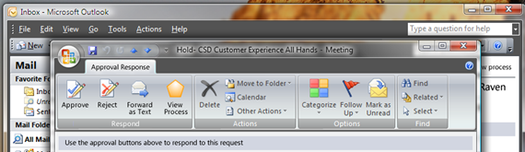
Figure 1: Approval workflow managed through Outlook

ILM “2” Feature Highlights:
Policy Management
- SharePoint-based console for policy authoring, enforcement & auditing
- Extensible WS-* APIs and Windows Workflow Foundation workflows
- Heterogeneous identity synchronization & consistency
Credential Management
- Heterogeneous certificate management with 3rd party CA support
- Management of multiple credential types, including OTP
- Self-service password reset integrated with Windows logon
User Management
- Integrated provisioning of identities, credentials, and resources
- Automated, codeless user provisioning and deprovisioning
- Self-service user profile management
Group Management
- Rich Office-based self-service group management tools
- Offline approvals through Office
- Automated group and distribution list updates

Features and Benefits of Identity Lifecycle Manager “2”
ILM "2" builds on the metadirectory, certificate and smart card management and user provisioning available in ILM 2007, and adds a rich management environment including integrated user management, self-service for comprehensive credential management, group management, policy management, and expanded extensibility and connectivity.

Policy Management
ILM "2" will deliver a framework for identity management automation and integration so all enterprise systems run using the same set of enterprise policies. This is accomplished through:
• Centralized policy authoring, enforcement, & auditing. As part of the ILM "2" release, Microsoft will deliver an intuitive SharePoint-based user interface that enables system architects and IT administrators to create rules governing users and groups using natural language descriptors and easy-to-use menu-driven controls. The policy management tools will also enable business owners and IT to audit events and business rules processed by ILM "2", and to act on that information in an automated manner. This provides a view into the state of compliance as well a mechanism to enforce business rules that support compliance.
• Extensible Windows Workflow Foundation-based workflows. ILM "2" includes rich, visual workflow management based on the Windows Workflow Foundation, which enables IT to quickly define, automate and enforce identity management policies. IT can use the integrated workflow in the approval / rejection process for actions such as creating accounts, or delegating tasks. For further extensibility and customization, ILM "2" will ship with WS-* based APIs that enable customization at both the platform and solution level. ILM "2" consumes Windows Workflow Foundation (WF) workflows, enabling organizations to import and reuse existing WF-based workflows in ILM "2". ILM "2" will also include a simplified configuration of synchronization with heterogeneous identity stores through synchronization rules. This will enable customized solutions to be delivered more cost effectively in less time as they require less specialized application knowledge or programming skills.
The following screenshot shows an example of this.

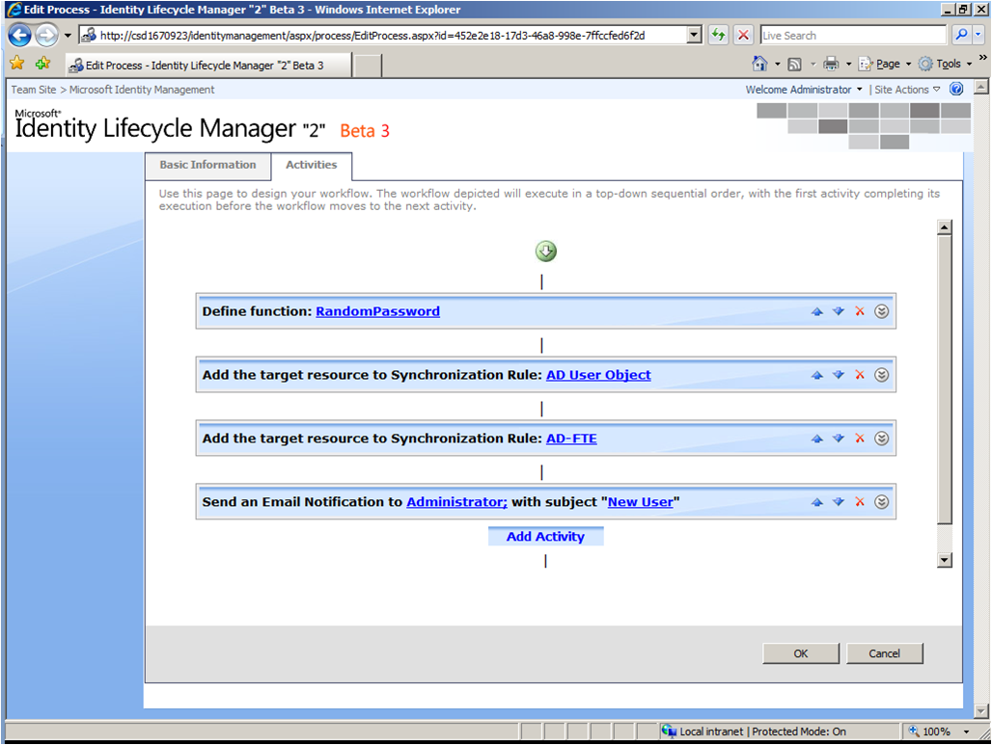
Figure 2: Menu-driven policy management and workflow

• Heterogeneous identity synchronization and consistency. ILM "2" delivers integration with a broad range of network operating systems, e-mail, database, directory, application, and even flat-file access. ILM "2" includes connectors for Active Directory, Novell, Sun, IBM, RACF, Top Secret, ACF/2, Lotus Notes, Microsoft Exchange Server, Oracle databases, Microsoft SQL Server™ databases, SAP and others. This provides organizations with the power to connect and synchronize the plethora of disparate sources of identity information in their company—all without the need to install software of any kind on the target systems. Since in some cases it might be necessary to connect to custom or legacy applications unique to a specific organization, Microsoft® Identity Lifecycle Manager "2" (ILM "2") enables companies to integrate and manage identities for these applications through the Microsoft Visual Studio® and .NET development environments.

Credential Management
ILM "2" provides the ability to manage multiple credentials in an integrated manner. IT professionals will have one place where they can look at user policies, define policies, and define smart card templates and processes for resetting PINs. With ILM "2" the end user’s experience will be very intuitive. Credential management activities for end users will be embedded in familiar applications and integrated with familiar tools, which reduces the cost of deploying identity management for the organization and enables easier and faster adoption. To implement these goals, ILM "2" provides:
• Credential lifecycle management integrated with provisioning. With ILM “2”, IT will be able to define policies that manage the provisioning process across user accounts and multiple types of credentials. This means that workflow in ILM "2" can be configured to automatically provision a user account, set their initial password, and kick off the process to issue smart cards and digital certificates to the user. For instance, ILM "2" can manage a user provisioning process that would not only issue a new user’s Active Directory account and set up their mailbox, but also issue the new user a one-time use password for them to activate their smart card.
• Management of multiple credentials such as 3rd party Certificate Authorities (CAs) and One-Time Passwords (OTPs). ILM "2" can be extended to manage a wide range of strong credentials that organizations use to secure resources. The certificate and smart card management capabilities introduced in ILM 2007 can now be extended to provide centralized management of additional strong authentication factors, including management of 3rd party CAs and OTP devices.
• Self-service password and PIN reset integrated with Windows logon. ILM "2" enables users to change and reset their own passwords and smart card PINs from the Windows desktop logon, and enables the help desk to reset them from a single location.
• Configurable authentication gates for self-service password reset. ILM "2" will ship with configurable question and answer authentication gates, and will include extensibility to build additional types of gates – for instance a gate that requires a user to insert their smart card and enter their PIN, or a gate that requires a user to enter a code sent to a mobile phone in order to authenticate to reset a password. The enrollment process for authentication gates can be configured to ensure that all users in an organization enroll – for instance requiring registration at login.
• Simplified sign-on by synchronizing passwords across systems. Importantly, ILM "2" provides a simplified sign-on experience through its identity synchronization capabilities, delivering the ability to synchronize passwords across heterogeneous systems.

User Management
One of the most important things Microsoft is delivering from a business standpoint is automated, codeless, user provisioning. ILM "2" delivers tools for integrated user management and self-service across enterprise applications without the costly coding of business rules or recoding of the target systems. These automated and centralized user management tools include:
• Codeless user provisioning. ILM "2" provides a user interface to configure provisioning rather than requiring customized code to be written. Automated provisioning allows organizations to easily define the provisioning workflows associated with adding a new user to the enterprise and provisioning them with access to appropriate applications in an automated manner.
• Integrated provisioning of identities, credentials, and resources. Using management tools delivered in ILM “2”, IT can create a policy to provision the appropriate accounts, resources, and credentials, associate to users, ensure the appropriate workflows are integrated into the process, and do this in a very seamless manner. This means that an enterprise can provide automated and integrated processes for new users when they come to the enterprise, which makes them more productive from day one. De-provisioning for users leaving the enterprise also becomes centralized and less complicated, which makes it easier to ensure complete de-provisioning and to handle future compliance audits.
• Self-service user profile management. New features in ILM "2" make it possible for users to manage their own identity information. IT can use ILM "2" to set policies to require workflows such as approvals for or notifications of these user-generated changes. For example, IT may choose to delegate management of mobile phone numbers to end users. Users would be able to use the ILM "2" portal to update this information. This helps keep identity data such as mobile phone numbers up to date so that users can be easily contacted in the process of doing business.

Group Management
ILM ”2” provides powerful capabilities out of the box that help increase the productivity of end users, frees up IT from repetitive tasks and provide better security and compliance outcomes. These features include:
• Rich self-service group management tools. ILM "2" provides self-service group and distribution list management integrated in Office to enable end users to manage their group membership requests using the collaboration tools they are familiar with for maximum productivity with minimal additional training. For example, utilizing the voting button functionality provided in Outlook to approve or reject membership requests, ILM "2" makes it possible for users to manage the membership of groups without requiring the assistance of the IT organization. With ILM “2” end users can use an Outlook add-in provided by ILM “2” to create distribution lists for new virtual teams and manage requests made by others to join a distribution list. The ILM “2” portal also includes this end-user functionality for group management, for organizations that do not use Outlook as their email client.
• Offline approvals through Office. Capabilities to manage group membership are in ILM "2" integrated into Microsoft Office. This enables users to use Microsoft Office to, for example, request membership in a group or manage approvals while they are offline.
• Automated group and distribution list updates. In addition to the self-service management of group membership, ILM “2” also supports the dynamic calculation of group members based on user attributes. With this feature, users are added and removed from groups automatically. For example, IT can configure a group that is used to control access to the resources of a team so that only the manager and the direct reports are members. In this case, ILM “2” can calculate the group membership based on the manager attribute of the user objects. In case of changes to the team such as members joining or leaving the team, the group membership is automatically updated. Dynamic group membership helps reduce the manual interaction required to effectively protect resources.

Conclusion
The strategy and priorities outlined in this paper are intended to help customers get the most out of the Microsoft infrastructure while making their IT enterprise more efficient, agile, and secure. Because Microsoft delivers a rich management environment that uses tools most appropriate for each type of user, Microsoft lifts barriers and complexity while lowering the costs associated with identity management.
Imagine having an integrated view of all users and their permissions based on a sound business policy. Also imagine eliminating the manual provisioning processes that are only noticed if they break down. Feel secure knowing that you can scale provisioning processes for sudden increases in hiring of new employees without negatively impacting other customer service level agreements.
Users will be productive on day one of their employment as their accounts, credentials, and resources will be automatically provisioned in heterogeneous directories and applications across the enterprise.
If users need additional access, the workflow that supports that decision can also be automated so the decision to grant access can remain with the appropriate approver. This is Microsoft’s strategy for identity management, to make identity management much easier by putting the right tools in the right hands.

