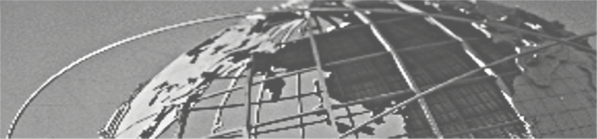

Microsoft Terminal Services

Education
Keewatin Community College

Manitoba community college chooses Microsoft Terminal Services to remotely support its extensive IT infrastructure.

Published: Date
With central campuses in The Pas and Thompson, Manitoba, Keewatin Community College (KCC) offers diploma and certificate level programs to 2,500 students spread over 24 nothern communities. A small team of IT support staff was struggling with supporting an extensive IT infrastructure spread over the colleges campuses, some of which are located in communities so remote they can only be accessed by plane. With the goal of reducing the cost and improving quality of IT support, the college chose to deploy Microsoft Terminal Services in order to allow for remote network support.
Based in The Pas and Thompson, Manitoba, Keewatin Community College (KCC) offers diploma and certificate level programs and courses covering a wide area of interests. KCC’s geographical intake spans 80 per cent of Manitoba and includes eight regional learning centers and outreach into an estimated 24 northern communities. Approximately 200 staff members work to ensure the quality of education for a student body numbering nearly 2,500.

Students and faculty have access to over 600+ PCs that are spread throughout KCC’s regional centers and rural facilities and are supported and maintained by a team of six IT professionals.

“Providing support for a PC network of this magnitude is challenging under the best of conditions,” states Daryl Kines, Director of IT Technology, KCC. “Our IT department is responsible for keeping things running smoothly in a sometimes technologically hostile environment—remote areas that are often only accessible by plane and where temperatures can sink to fifty below zero.”

The challenge for Daryl and his team was clear—how could a small team of IT administrators efficiently and cost-effectively maintain and service a large network spread across thousands of kilometers and located in several remote communities?

The solution? Microsoft® Terminal Services—a remote learning/support solution that leverages satellite technologies. Working with KCC, Microsoft helped create an affordable, scalable and robust system that has assisted in extending the life of Keewatin’s existing PC infrastructure and now allows the Keewatin IT team to support all of the institution’s PCs through remote access.

The concept is simple, yet very innovative—Terminal Services enables a fast PC to be used as a server and, through an ethernet network, slower PCs can use the server for all processing needs. In other words, the PC with the fastest processing capability does all the work. This has allowed KCC to extend the life of older machines by over two years. This has resulted in significant IT budget savings, which were re-invested in technology to further improve the system and has helped increase access to technology for KCC’s students.

Another advantage of the Terminal Services solution is that it now allows the Keewatin IT team to hook up remotely from their offices to almost any PC on the network in order to make necessary upgrades or adjustments. “In the past, we’d have to travel for several hours to do the simplest support tasks for our PCs. Now, we can do it all from our desks. Terminal Services makes this possible. The time and resource savings have been significant,” states Kines.

What does the future hold for KCC’s IT infrastructure? Kines is optimistic, “Terminal Services has made it possible for us to cut down on costs and has given us the financial flexibility needed to upgrade our existing IT assets. This summer, we’ll be installing Microsoft Office XP and Windows® XP operating system throughout our network and also moving forward to Windows 2003 Server which has enhanced functionality for Terminal Services.”

For More Information
For more information about Microsoft products or services, call the Microsoft Sales Information Center at (800) 426-9400. In Canada, call the Microsoft Canada Co. information Centre at (800) 563-9048. Outside the 50 United States and Canada, please contact your local Microsoft subsidiary. To access information via the World Wide Web, go to:

http://www.microsoft.ca/casestudies
http://www.intrawest.com

This case study is for informational purposes only. MICROSOFT MAKES NO WARRANTIES, EXPRESS OR IMPLIED, IN THIS SUMMARY.

© 2003 Microsoft Corporation. All rights reserved. Microsoft, Active Directory, Windows and Windows NT are either registered trademarks or trademarks of Microsoft Corporation in the United States and/or other countries. Other product and company names mentioned herein might be the trademarks of their respective owners.
0X00

