Microsoft Business Solutions−Axapta
sales force automation
Microsoft® Business Solutions–Axapta® Sales Force Automation helps you manage your customer relations more effectively, giving you the insight to help identify your customers’ needs and make optimal sales and marketing decisions.

Key Benefits:
- Increase sales force productivity and effectiveness

- Easily identify and seize sales opportunities

- Company-wide overview of all customer and prospect-related activities

From lead generation and customer contact, through initial quotations, to closing of sales and proactive account management, Microsoft Axapta Sales Force Automation helps your sales and marketing organization become more effective.
Microsoft Axapta Sales Force Automation lets your entire business work with the same user-friendly application—from accounting, production and logistics to sales and marketing. And most features can be set up to match your business processes, so the software conforms to your company practices, not the other way around.
The Sales Force Automation module is the foundation of our Sales and Marketing solution, which includes the Sales Management, Marketing Automation and Telemarketing modules.

Increase sales force productivity and effectiveness
Microsoft Axapta Sales Force Automation is literally your sales department’s toolbox, containing the tools to organize contact information, track opportunities, manage accounts and establish and monitor the sales pipeline. Time previously wasted on manual, repetitive administrative tasks can be spent more productively by taking care of customers and making sales.
By giving your sales teams insight into each of your customer’s needs and purchasing habits, Microsoft Axapta Sales Force Automation helps manage customer relationships more effectively. All customer, prospect and vendor information can be accessed and updated through the Business Relations window. This presents all information related to the sales flow, including outstanding sales orders, current offers, activities, forecast data and related documents.
Using this real-time information, up-selling and cross-selling opportunities can be identified and future behavior predicted, to attract and retain customers with the highest lifetime value for your company.
A workbook containing day, week and month planners gives you an instant overview of all sales activities with, “to do” lists and activity details, and helps them work more efficiently. View sales quotations and open orders, or check the calendar for your colleagues. You can also synchronize appointments, tasks and contact persons with Microsoft Outlook® manually or automatically.
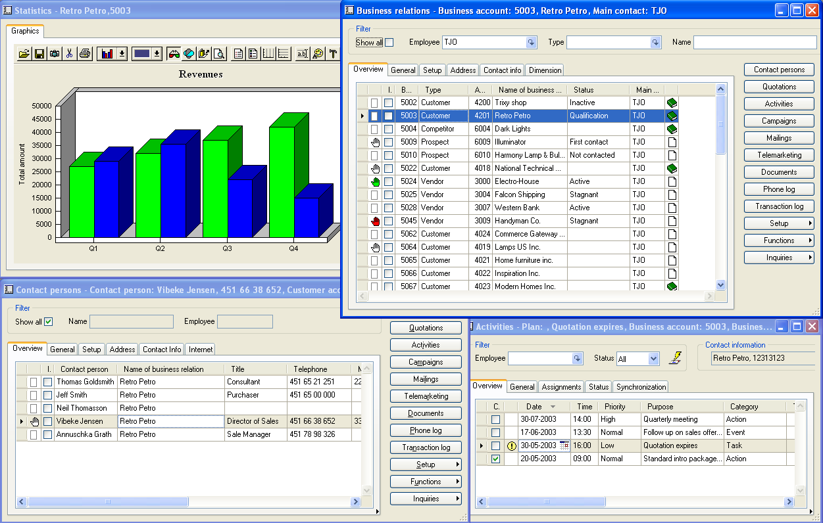

Make document handling easier with a document list containing all documents organized by contact person, sales order, quotation or activity assigned to that business relation. E-mails sent from the contact window of Microsoft Axapta Sales Force Automation are automatically stored in the document management system of Microsoft Axapta. Documents can be dragged and dropped from Microsoft Axapta to a Microsoft Outlook e-mail.

Identify and act on sales opportunities
You can quickly view and manage the sales pipeline, from opportunity management to win/loss and SWOT analyses, which helps you identify new opportunities, meet customer demands and make confident and accurate decisions based on real-time information.
The quotation functionality lets you make instant quotations based on customer buying history, price simulations, stock availability and delivery dates. If the contact receiving the quotation is not already a customer, the system will automatically create a customer profile, making the information available to the supply chain when the quotation is converted to a sales order.
You can assign a different status to each quotation, which helps you maintain a complete overview. You can use win/loss and SWOT analysis to help focus future sales efforts. Microsoft Axapta Sales Force Automation can also analyze all sales against a budget, or a specific activity with a customer against the revenue of that customer.
Monitor current and past sales
See all relevant customer information at a glance

Communicate with any type of business relation your company may have

Follow up on generated leads and offers through automated activity generation that is fully integrated with Microsoft Outlook

With Enterprise Portal, remote employees and salespeople on the road can use Sales Force Automation to get contact data, produce quotations and update company sales information from wherever they are, over the Internet.
You can even import sales-prospect contact information from third party database vendors, to help identify opportunities and proactively initiate contact with customers and prospects. The mailing feature helps you generate and manage mailings of newsletters, product catalogs and other material, using a selection in the database.

Company-wide insight into customers and prospects
Microsoft Axapta Sales Force Automation is integrated with other modules in Microsoft Axapta, giving customer-facing employees and back office staff real-time information from other relevant parts of the business, so every employee can become a customer expert.
For example, using Microsoft Axapta Sales Force Automation, employees can quickly and easily retrieve relevant customer information to help solve a customer’s problem. However, the management stays in control, deciding how much access each department or individual should have to company business information. Also, the system can track every contact with the customer and trace all transactions.
Back office staff can use information from the sales process to keep up with demand and limit excess stocks. You can assign percentage probability values to sales quotations to help make more accurate and timely sales forecasts.
Data from other parts of the system can also be used to alert colleagues to crucial customer-specific information, such as customers with poor payment records. Use the Note-It function to insert short notes for other users regarding a business relation, contact person or quotation.

Microsoft Business Solutions–Axapta
Microsoft Axapta Sales Force Automation is part of Microsoft Business Solutions–Axapta, a customizable, scalable and global Enterprise Resource Planning (ERP) solution that provides you with a fast and powerful way to gain a competitive advantage.

For more information about Microsoft Axapta
To learn more about Microsoft Axapta, contact your local Microsoft Business Solutions Office or Microsoft Certified Business Solutions Partner at the following Web address. They have the expertise to meet your specific business needs.

About Microsoft Business Solutions
Microsoft Business Solutions, a division of Microsoft, offers a wide range of integrated, end-to-end business applications and services designed to help small, midmarket and corporate businesses connect better with their customers, employees, partners and suppliers. Microsoft Business Solutions applications optimize strategic business processes across financial management, analytics, human resources management, project management, customer relationship management, field service management, supply chain management, e-commerce, manufacturing and retail management. These applications are designed to help businesses succeed and achieve their goals. More information about Microsoft Business Solutions can be found at www.microsoft.com/BusinessSolutions.

Address:
Microsoft Business Solutions
Frydenlunds Allé 6
2950 Vedbaek
Denmark
Tel +45 45 67 80 00
Fax +45 45 67 80 01
www.microsoft.com/BusinessSolutions
Key Features | Description
Easy to Use | - Intuitive layout and structure  - User-adjustable menus, forms and reports  - User-adjustable layout of main tables and journals  - Windows commands including ‘copy and paste’ to and from Axapta  - Advanced sorting and filter options  - Built-in user Help, including an integrated manual  - Option to e-mail, phone and fax directly from Microsoft Axapta  - Application can be run in different languages  - Microsoft Office integration
Sales Force Automation Overview | - One window containing business relationships of multiple types  - Easy access to related information such as sales orders, quotations, projects, activities, mailings and documents for a given business relation/contact person  - Overview of financial key figures for each business relationship  - Quotations closely integrated to sales orders and master planning  - Automated processes  - Generate mass mailing campaigns based on database selections  - Detailed sales process for easy tracking and follow-up of opportunities and results
Contact Management Overview | - Contact management for customers, vendors, prospects and other business relationships  - Activity management, appointments and tasks synchronization with Microsoft Outlook  - Drag and drop files, documents and e-mails from Windows Explorer and Microsoft Outlook into the Microsoft Axapta document system  - Transaction logging on selected tables  - Import business relationships with contact persons  - Computer telephone integration using TAPI  - Send e-mail and SMS messages to individuals or groups  - Generate mailings based on database selections

System Requirements
To obtain all of the features mentioned in this fact sheet,  the following modules and technologies are required: | - Microsoft Business Solutions−Axapta 3.0  - Microsoft Business Solutions−Axapta Financials I  - Microsoft Business Solutions−Axapta Trade Series  - Microsoft Business Solutions−Axapta Sales Force Automation  - Microsoft Business Solutions−Axapta Master Planning  - Microsoft Outlook  - CTI system
20 April, 2004
The information contained in this document represents the current view of Microsoft Corporation on the issues discussed as of the date of publication. Because Microsoft must respond to changing market conditions, it should not be interpreted to be a commitment on the part of Microsoft, and Microsoft cannot guarantee the accuracy of any information presented after the date of publication.
This document is for informational purposes only. MICROSOFT MAKES NO WARRANTIES, EXPRESS, IMPLIED OR STATUTORY, AS TO THE INFORMATION IN THIS DOCUMENT.
Complying with all applicable copyright laws is the responsibility of the user. Without limiting the rights under copyright, no part of this document may be reproduced, stored in or introduced into a retrieval system, or transmitted in any form or by any means (electronic, mechanical, photocopying, recording, or otherwise), or for any purpose, without the express written permission of Microsoft Corporation.
Microsoft may have patents, patent applications, trademarks, copyrights, or other intellectual property rights covering subject matter in this document. Except as expressly provided in any written license agreement from Microsoft, the furnishing of this document does not give you any license to these patents, trademarks, copyrights, or other intellectual property.

© 2003 Microsoft Business Solutions ApS, Denmark. All rights reserved. Microsoft, Outlook, and Axapta are either registered trademarks or trademarks of Microsoft Corporation, Great Plains Software, Inc., FRx Software Corporation, or Microsoft Business Solutions ApS or their affiliates in the United States and/or other countries. Great Plains Software, Inc., FRx Software Corporation, and Microsoft Business Solutions ApS are subsidiaries of Microsoft Corporation. The names of actual companies and products mentioned herein may be the trademarks of their respective owners. The example companies, organizations, products, domain names, email addresses, logos, people and events depicted herein are fictitious. No association with any real company, organization, product, domain name, e-mail address, logo, person, or event is intended or should be inferred.

