

Deploying Microsoft Software Update Services

Microsoft Corporation
Published: January 2003

Abstract
This white paper describes the deployment of Microsoft® Software Update Services, a new tool for managing and distributing critical Windows patches that resolve known security vulnerabilities and other stability issues in Microsoft Windows 2000, Windows XP, and Windows Server 2003 operating systems.
Software Update Services leverages the successful Windows Automatic Updates service first made available in Windows XP, and allows information technology professionals to configure a server that contains content from the live Windows Update site in their own Windows-based intranets to service corporate servers and clients.
The purpose of this white paper is to help plan and deploy the Software Update Services solution. Readers are walked through all necessary installation and configuration steps required to deploy both a server running Software Update Services and the Automatic Updates client.
The target audience of this document is the IT administrator that is planning, evaluating, or deploying the Software Update Services software in order to automatically and securely keep Windows computers in their network up-to-date with security patches and other critical updates.
The information contained in this document represents the current view of Microsoft Corporation on the issues discussed as of the date of publication. Because Microsoft must respond to changing market conditions, it should not be interpreted to be a commitment on the part of Microsoft, and Microsoft cannot guarantee the accuracy of any information presented after the date of publication.
This document is for informational purposes only. MICROSOFT MAKES NO WARRANTIES, EXPRESS OR IMPLIED, AS TO THE INFORMATION IN THIS DOCUMENT.
Complying with all applicable copyright laws is the responsibility of the user. Without limiting the rights under copyright, no part of this document may be reproduced, stored in or introduced into a retrieval system, or transmitted in any form or by any means (electronic, mechanical, photocopying, recording, or otherwise), or for any purpose, without the express written permission of Microsoft Corporation.
Microsoft may have patents, patent applications, trademarks, copyrights, or other intellectual property rights covering subject matter in this document. Except as expressly provided in any written license agreement from Microsoft, the furnishing of this document does not give you any license to these patents, trademarks, copyrights, or other intellectual property.
The example companies, organizations, products, people and events depicted herein are fictitious. No association with any real company, organization, product, person or event is intended or should be inferred.
© 2002, 2003 Microsoft Corporation. All rights reserved.
Microsoft, FrontPage, IntelliMirror, Jscript, SharePoint, Windows, Windows Media, and Active Directory are either registered trademarks or trademarks of Microsoft Corporation in the United States and/or other countries/regions.
The names of actual companies and products mentioned herein may be the trademarks of their respective owners.
This document is best viewed onscreen in Microsoft Word 2000 or Microsoft Word XP in Print or Web Layout View.

Contents
Introduction 4
Software Update Services and other software-distribution technologies 4
Software Update Services Solution Features 5
Automatic Updates client feature summary 6
Security Features in the Software Update Services solution 6
Getting Started with Software Update Services 7
Determining Hardware Requirements 7
Language Support 7
Software Update Services components 7
Setting up your server running Software Update Services 7
Setting up Software Update Services on a domain controller or Microsoft Small Business Server 2000 with Service Pack 1 7
Application Compatibility with Software Update Services 8
Setting up Software Update Services 9
Configuring Software Update Services 10
Proxy Server Configuration 12
Working in DNS and NetBIOS Environments 13
Selecting Your Content Source 13
Handling Updated Content 14
Storage of Updates and Supported Client Languages 14
Default Configuration after performing a typical installation 16
Software Update Services Common Administration Tasks 17
Synchronizing Content 17
Approving Updates and Timing Issues 19
Reviewing server actions and server health 19
Synchronization log 19
Approval log 19
Synchronizing Content With Another Server Running Software Update Services or Manually Configured Content Distribution Point 20
Synchronizing the list of approved packages 22
Creating a content distribution point 23
There are two ways to create a content distribution point: 23
Secure Administration 24
Testing Content for Software Update Services Deployment 26
Staging Content Before Applying It To Your Production Environment 26
Planning a Software Update Services Deployment 27
Deploying Software Update Services Server 27
Scale-out model 27
Network Load Balancing and Software Update Services 28
Configuring your servers running Software Update Services to use NLB 29
Server Backup and Disaster Recovery 31
Restoring Software Update Services after a Disaster 37
Using NTBackup to Restore Software Update Services 39
Getting Started with Automatic Updates 44
Requirements 44
User Experience 44
Configuration options 44
Download Behavior 45
Installation Behavior 45
Scheduled Installation 46
System Events 47
Client Scenarios 47
Managed Desktop 47
Managed Server 48
Managed Data Center Server 48
Deploying the Automatic Updates Client 49
Standalone Installation of the Automatic Updates client 49
Central Deployment of the Automatic Updates Client 49
To deploy using IntelliMirror (for Active Directory users only) 49
Deploying the Automatic Updates client Via Self-Update 50
Configuring the Automatic Updates client software 51
Policy Configuration 51
Using Group policy 51
Configuring Automatic Updates Group Policy settings 53
Configure the behavior of Automatic Updates 53
Reschedule wait time 54
No automatic restart with logged on users 57
Interaction with other policies 60
Redirecting Automatic Updates to a Server Running Software Update Services 60
Configuration Options in a Non-Active Directory Environment 61
Troubleshooting 64
Software Update Services 64
Automatic Updates client 65
Appendix A: Understanding Security and Software Update Services Setup 66
Installation Location Of The Software Update Services Web Site: 66
Case 1: Default Web site running 66
Case 2: Default Web site stopped, but another Web site is running and bound to port 80 66
Case 3: No Web sites are running 67
What components of IIS need to be present prior to installing Software Update Services? 67
IIS Lockdown Configuration 67
What happens to IIS Lockdown when I uninstall Software Update Services? 68
Accessing the SUS Administrator Web Site 71
Where is the content stored for Software Update Services? 72
Appendix B: Software Update Services Event Log Messages 74
Appendix C: Client Status Logging 80
Possible <Plat_id> Values 84
Error Codes Delivered by Automatic Updates 88
Related Links 93
Feedback 93

Introduction
Software Update Services (SUS) is a component of the Strategic Technology Protection Program (STPP) that builds on the success of the current Microsoft Windows Update technologies. SUS provides a solution to the problem of managing and distributing critical Windows patches that resolve known security vulnerabilities and other stability issues with Microsoft Windows operating systems. This software updates Windows® 2000, Windows XP, and Windows Server 2003 operating systems on any corporate network.
Today, system administrators have to check the Windows Update Web site or the Microsoft Security Web site frequently for patches. Then they have to manually download patches that have been made available, test the patches in their environment, and then distribute the patches manually or by using their traditional software-distribution tools. SUS solves these problems.
SUS provides dynamic notification of critical updates to Windows client computers whether or not they have Internet access. Additionally, this technology provides a simple and automatic solution for distributing those updates to your corporate Windows desktops and servers.
The SUS solution is made up of two components:
- A computer running Windows 2000 or Windows Server 2003 running SUS.
- An update to the automatic updating technology in Windows 2000, Windows XP and Windows Server 2003.

Software Update Services and other software-distribution technologies
Software Update Services is designed to deliver critical updates for computers running Windows 2000 and higher operating systems inside your corporate firewall as quickly as possible. It is not intended to serve as a replacement to your enterprise software-distribution solution, such as Microsoft Systems Management Server (SMS) or Microsoft Group Policy-based software distribution. Many customers today use solutions like SMS for complete software management, including responding to security and virus issues, and these customers should continue using these solutions. Advanced solutions such as SMS provide the ability to deploy all software throughout an enterprise, in addition to providing administrative controls that are critical for medium and large organizations.

Software Update Services Solution Features
Today, many corporate customers do not want their users going to an Internet source for updates without first testing these updates in their production environment. Microsoft is providing an installable version of the Windows Update server for use inside your corporate firewall. SUS allows customers to install a Windows server component on an internal server running Windows 2000 or later that can download all critical updates and security patches as soon as they are posted to the Windows Update Web site.
The network administrator also receives e-mail notification when new critical updates have been posted so you can very quickly and easily apply these updates to your Windows 2000 servers, as well as Windows 2000 Professional and Windows XP Professional client computers.
Features:
- Software Update Services server. This is the server component, installed on a computer running Windows 2000 Server or Windows Server 2003 inside your corporate firewall. It allows your internal server to synchronize with the Windows Update Web site whenever critical updates for Windows 2000 and Windows XP are made available. The synchronization can be automatic or can be performed manually by the administrator. After the updates are downloaded to your server running SUS, you can decide which ones you want to publish, and then all clients configured to use that server running SUS will install those updates.
- Content. Servers running SUS will support only the following content types for the first release of SUS: Windows critical updates, and Windows security roll-ups.
- Automatic Updates client. This is the client component to be installed on all of your Windows 2000 servers and all of your Windows 2000 and Windows XP client computers so that they can connect to your internal server running SUS. You can control which server each client computer connects to, and schedule when the client performs installations of critical updates either manually via the registry or by using the Active Directory® service Group Policy. The new Automatic Updates client is supported on Windows 2000, Windows XP, and the Windows Server 2003 family of operating systems.
- Ability to service large numbers of clients: Servers running SUS can be configured to synchronize content from the live Windows Update Download servers. They can also be configured to download content from a content distribution point that is created manually by the administrator. Second-tier servers running SUS can synchronize both content and the list of approved packages. This simplifies that update management process by enabling you to manage updates from a central location.
- Staged deployment. Staged deployment is done using multiple servers running SUS. You can set up one server in your test lab to publish the updates to lab client computers first. If these clients install correctly, you can then configure your other servers running SUS to publish their updates to the rest of your organization. This way, you can ensure that these changes do not harm your standard desktop operating environment.
- Support for networks not connected to the Internet. Servers running SUS can be set up to synchronize content from other installations of SUS or from manually created content distribution points. This allows you to set up SUS in a network not connected to the Internet. The Automatic Updates client also does not require any access to Internet when redirected to a local server running SUS.

Automatic Updates client feature summary
SUS requires a special version of Automatic Updates. This updated Automatic Updates client software builds on the Automatic Updates client that was shipped in Windows XP. It now runs on Windows 2000 Professional, Windows 2000 Server, and Windows 2000 Advanced Server (Service Pack 2 or higher). It also runs on computers running Windows XP Professional, Windows XP Home Edition, and the Windows Server 2003 family.

This update adds the following features to the Windows XP Automatic Updates client:
- Support for downloading approved content from a server running SUS.
- Support for scheduling installation of downloaded content.
- All Automatic Updates options are configurable by using Group Policy Object Editor or editing the registry.
- Support for systems where no local administrators are logged on.
- Support for Windows 2000.

The Automatic Updates client software will be included with the following Microsoft products:
- Software Update Services 1.0 Service Pack 1
- A standalone setup package (Windows Installer MSI package)
- Windows 2000 Service Pack 3
- Windows XP Service Pack 1
- Windows Server 2003 family of operating systems

Security Features in the Software Update Services solution
- Software Update Services. A server running SUS can download packages from either the public Microsoft Windows Update servers or from another server running SUS. During any of these downloads, there is no server-to-server authentication carried out. All content downloaded by SUS is signed by Microsoft. SUS does not trust any content that is not signed or is incorrectly signed. Since SUS 1.0 Service Pack 1 supports only Windows critical updates and security rollups, all content is checked to see that it has a been correctly signed by Microsoft.
Administration of SUS is completely Web-based. The administrator can choose to administer the server over a standard HTTP connection or over a secure SSL enabled HTTPS connection.
Automatic Updates client. The Automatic Updates client can download packages from either the public Windows Update site or from a server running SUS. Before installing any packages that have been downloaded, SUS checks to confirm that the package has been signed by Microsoft. If the package is not correctly signed, it will not be installed.
The Automatic Update client also checks the CRC on each package after downloading it to confirm the package was not tampered with.

Getting Started with Software Update Services

Determining Hardware Requirements
The minimum configuration for a server running Software Update Services is:
- Pentium III 700 MHz or higher processor.
- 512 megabytes of RAM.
- 6 gigabytes (GB) of free hard disk space for setup and security packages.
This configuration will support approximately 15,000 clients using one server running SUS.
If you are using SUS in an enterprise environment with thousands of clients and various sites and WAN links, refer to the section "Planning a Software Update Services Deployment" in this document to plan your deployment and for a description of some of the advanced features of SUS.

Language Support
SUS is supplied in English and Japanese language versions.
Note These languages are for the administration and installation of SUS. Both the English and Japanese versions of SUS can support clients of any locale.

Software Update Services components
Software Update Services has three main components:
- A new synchronization service called Windows Update Synchronization Service, which downloads content to your server running SUS.
- An Internet Information Services (IIS) Web site that services update requests from Automatic Updates clients.
- A SUS administration Web page.

Setting up your server running Software Update Services
Software Update Services runs on Windows 2000 Server with Service Pack 2 or higher, and on the Windows Server 2003 family of operating systems. The server computer must be running IIS 5.0 or higher and Internet Explorer 5.5 or later. The Setup program will not allow you to install the software if your computer does not meet these requirements.
Note SUS must be installed on an NTFS partition. The system partition on your server must also be using NTFS.

Setting up Software Update Services on a domain controller or Microsoft Small Business Server 2000 with Service Pack 1
Software Update Services Service Pack 1 enables you to set up SUS on a domain controller or a computer running Microsoft Small Business Server 2000 with Service Pack 1. This functionality was previously not available in the SUS 1.0 release.
Secure by Default
The SUS Setup includes default settings that help keep your network and the server running SUS secure. When you install SUS on a computer running Windows 2000 Server or Microsoft Small Business Server 2000 with SP1, the setup utility installs IIS Lockdown 2.0. This includes installing and configuring IIS URL Scanner 2.5.
If you have previously installed IIS Lockdown or URL Scanner, then the SUS setup utility will not attempt to install the IIS Lockdown tool again; none of your IIS Lockdown tool settings are modified, and none of the information in the IIS metabase is deleted. This functionality is new for SUS SP1.
The default installation option for IIS on Windows Server 2003 family includes all of the security work performed by the IIS Lockdown tool on Windows 2000. Thus, the installation routine does not run the IIS Lockdown tool on Windows Server 2003 family installations; however, setup does make one change to IIS on Windows Server 2003 family installations to allow access to ASP pages. Refer to Appendix A for more details.
Note: When you uninstall SUS, the settings applied by IIS Lockdown are not removed, leaving your server in a more secure state. To understand all of the IIS Lockdown settings that will continue to apply after you have uninstalled SUS, refer to Appendix A.

Understanding Software Update Services Setup
Refer to Appendix A for the following information:
- How the installation location of the SUS Web site is determined.
- Changes that Setup will make to the IIS metabase.
- Changes made by the IIS Lockdown tool that will be run as part of setup.
- Details on how to use additional components of IIS like SharePoint Team Services, Microsoft FrontPage® extensions or ASP.NET applications on the same server as SUS.

Application Compatibility with Software Update Services
The recommended configuration to run Software Update Services is to install SUS on a server that will be dedicated to running just SUS.
This does not mean that you can not run other services on the same server as SUS. But you need to make sure that there are no compatibility issues with the other applications and SUS.
Other applications that may rely on IIS being configured in a particular way or that are not compatible with some configurations of the IIS URL Scanner may have some problems.
To ensure success, you should do the following:
- Read Appendix A of this Deployment Guide to understand the changes that will be made to your system when SUS is installed.
- Test for application compatibility issues on a test server and not on your production server.

The following is a list of applications that have been tested and can be used with SUS:
- FrontPage Server Extensions
- SharePoint™ Team Services
- ASP.NET applications

Setting up Software Update Services

Step 1: Get the installation program
Download the Software Update Services setup package from the SUS page on www.microsoft.com. You can navigate to this page using the following URL: http://go.microsoft.com/fwlink/?LinkId=6930.
The actual files required to install SUS are included in a package named Sus10sp1.EXE. This file is approximately 33 megabytes (MB) in size.
Copy the Sus10sp1.EXE file to the server on which you plan to install SUS.
Step 2: Install Software Update Services Service Pack 1
Note: You can configure SUS SP1 during or after Setup by using the SUS administration Web pages.
The following steps will install SUS SP1 with the default configuration. The following section, "Configuring your server running Software Update Services Service Pack 1," covers post-Setup configuration options.
Note: If you installed SUS version 1.0, you do not need to uninstall it to install SUS SP1.

To set up a Software Update Services Service Pack 1 server with the default configuration
- Double-click the Sus10sp1.exe file to begin the installation process.
- On the Welcome screen of the Setup Wizard, click Next.
- Read and accept the End User License Agreement, and then click Next.
- Select the Typical check box.
SUS will be installed with the default settings. To configure your server, see the next section, “Configuring Software Update Services.”
The next page of the wizard gives you the URL that client machines use to interact with the SUS server that you are installing. Make a note of the URL, and then click Install.
In some cases, SUS SP1 setup runs the IIS Lockdown tool. Refer to Appendix A for more details.
You can learn more about the IIS Lockdown tool and the Windows Security Toolkit CD at: http://www.microsoft.com/security. Refer to Appendix A for details on the configuration performed by the IIS Lockdown tool during SUS Setup.
The Finish page for the SUS Setup Wizard appears next. It provides a URL that you can use to load the SUS administration Web pages. Make a note of this URL.
Note: SUS setup also adds a Start menu shortcut to the administration Web pages in the Administrative Tools folder called Microsoft Software Update Services.
Clicking Finish in the setup wizard closes it and opens the SUS administration Web site in Internet Explorer. You are now ready to configure and use SUS.

Configuring Software Update Services
The two main tasks that you can perform with SUS are synchronizing content and approving content. Before you can perform those actions, you need to configure your server.
You can configure all of your SUS options after running Setup by using the SUS Web administration tools.
Using Internet Explorer 5.5 or later, go to http://<yourservername>/SUSAdmin to begin administration of your server running SUS, as shown in Figure 1.
Note: If you try to connect to the administration site with a version of Internet Explorer older than version 5.5 you will see an error page reminding you to upgrade your Internet Explorer software.
You can also navigate to this page by using the shortcut on your Start menu that was created by the SUS Setup Wizard. (Click Start, click Programs, click Administrative Tools, and then click Microsoft Software Update Services.)
Note: You must be a local administrator on the computer running SUS to view this Web site.
Note: If you try to navigate to the administration site and get the error “http 500-12: Application Restarting Error”, press F5 to refresh your browser.
Figure 1 Software Update Services server administration page
In the navigation pane, click Set Options to begin configuring SUS.
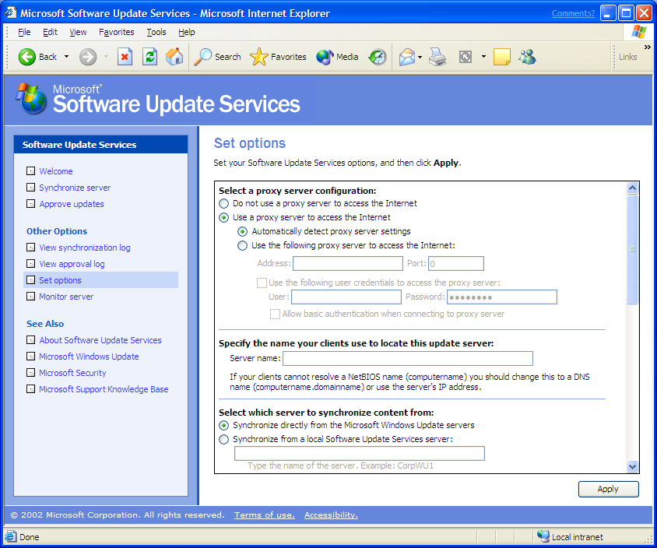
Figure 2 Set options page

Proxy Server Configuration
If your server running SUS needs to use a proxy server to connect to the Internet, configure your proxy server on the Set options page under Select a proxy server configuration.
If you are not using a proxy server, click Do not use a proxy server to access the Internet.
If you are using a proxy server, click Use a proxy server to access the Internet.
If your network supports automatic proxy server configuration, click Automatically detect proxy server settings.
Note When your server is configured to automatically detect proxy server settings, it will also automatically detect if there is no proxy server.
If your network does not support automatic proxy server configuration, click Use the following proxy server to access the Internet.
If you would like to bypass the proxy server for local addresses, select the checkbox beside Bypass proxy server for local addresses.
If your proxy server requires a user ID and password to access the Internet, select the checkbox beside Use the following user credentials to access the proxy server and also enter the user ID and password in the text boxes. Additionally if your proxy server requires credentials but uses basic authentication, then you should also select the checkbox beside Allow basic authentication when using proxy server.
Note: If you are using SUS on a Small Business Server computer that has a Microsoft Internet Security and Acceleration (ISA) Server that requires authentication, the username should be in the following format: DomainName\Username.

Working in DNS and NetBIOS Environments
Your client computers running the Automatic Updates client will need to connect and download content from your server running SUS.
In most environments, the client computers will be able to locate the Intranet server running SUS using the NetBIOS name of the server (for example, http://SUSServer1). If this matches your environment, no additional configuration is required.
Other environments may require client computers to use the DNS name to locate the server running SUS (for example, http://servername.domain). If this is the case, you must configure a DNS name for that server. This is important because clients use this DNS name to download updates from SUS.
To configure the DNS name that clients use to locate the SUS server, enter the DNS name under Specify the name your clients use to locate this update server, in the Server Name: field. Make sure that clients can use this DNS name to connect to your server running SUS.

Selecting Your Content Source
You can synchronize content on your server running SUS from the Internet-based Windows Update servers, from another installation of SUS, or from a manually-configured content distribution point.
You can configure your content source on the Set options page under Select which server to synchronize content from.
To synchronize content from the Microsoft.com Windows Update servers, click Synchronize directly from the Microsoft Windows Update servers.
To synchronize content from another server running SUS or a manually-configured content distribution point, click Synchronize from a local Software Update Services server. In the text box, enter the name of the server from which to synchronize.
If you are synchronizing from another server running SUS or a server with a manually-configured content distribution point, enter the name of the server. You can enter it as: HTTP://<Servername> or <Servername>. Alternatively, if you are working in a DNS environment, you can also enter the name of the server to synchronize from using its DNS name such as: HTTP://<Servername.domain>/
For details on synchronizing a server running SUSinternally, refer to the section “Synchronizing Content With Another Server Running Software Update Services or Manually-Configured Content Distribution Point" later in this document.

Handling Updated Content
As new security patches and roll-ups are released, they are posted to the Microsoft Windows Update download servers so that you can download them and host them locally on your server running SUS.
During synchronization, content that is updated will be marked on the Approve updates page as “Updated.”
The administrator can customize the behavior for items that were approved by the administrator, but then had the actual content of the package updated during synchronization:
Option 1: An approved item should continue to be approved if later updated during synchronization.
To select this option for handling updated content, click Automatically approve new versions of previously approved updates on the Set options page.
Option 2: An approved item should be automatically “unapproved” if it is updated during a synchronization.
To select this option for handling updated content, click Do not automatically approve new versions of previously approved updates. I will manually approve these later on the Set Options page.
You should select the second option if you want to test the updates package before having it downloaded and installed by your client computers.

Storage of Updates and Supported Client Languages
Two types of data are included during the synchronization of your server running SUS:
- The metadata or “dictionary objects” that describe the available packages and their applicability. This information is downloaded in a file named Aucatalog1.cab.
- The actual package files that contain the updates.
During synchronization, the Aucatalog1.cab file is always downloaded. As the administrator, you have the choice of whether or not to download the actual package files referenced in the metadata.
If you choose not to download the actual package files, the packages will remain on the Microsoft Windows Update servers. In this mode the computers running Automatic Updates will connect to your server running SUS, read the list of approved packages, and then download just the list of approved packages from the live Microsoft Windows Update servers on the Internet. This option allows you to take advantage of the live Microsoft Windows Update servers that are placed across the globe and also to maintain control of the updates your clients are installing.
To select this option, click Maintain the updates on a Microsoft Windows Updates server on the Set options page.
If you choose to download the packages and save the updates to a local folder, they will be stored on your server running SUS. In this mode, the computers running Automatic Updates will connect to your server running SUS, read the list of approved packages, and then download them directly from the server running SUS.
To select this option, click Save the updates to a local folder on the Set options page.
In addition to being able to make the choice to store content locally, you can go one step further and select the locales for which you would like to host content. This is done by selecting the checkbox beside each language you would like to support.
When supporting Windows Update content storage locally, you can add or remove locales that your server running SUSsupport at any time.
Best Practice: If you change the list of locales you support, you should immediately synchronize after making this change to make sure you download the appropriate packages for the locales that you may have added.

Note: When you remove a locale from the list of locales to support and synchronize with Windows Update, any packages that were previously downloaded for that locale remain. Windows Update does not delete packages from your server. Although these packages still exist on the server, clients from the corresponding locale would not receive them unless the locale was entered in the supported locale list.

Best Practice: If you change your SUSconfiguration from Maintain the updates on a Microsoft Windows Update server to Save the updates to a local folder, immediately perform a synchronization to download the necessary packages to the location that you have selected.
To immediately perform synchronization:
- Go to the SUS administration Web site.
- Click Synchronize server in the navigation pane.
- Click Synchronize Now to begin the synchronization.

Best Practice: If you host content locally, only select the locales for which you require content. For example, if all of your computers use English and German locales, select only English and German; only these packages will be downloaded. This will greatly reduce the amount of content that you need to synchronize.
If you choose to download content in all locales, your initial server synchronization with the Microsoft Windows Update servers will be close to 600 megabytes of data. By comparison, if you only select one or two locales to download, your initial synchronization will be approximately 150 megabytes.
Note Selecting locales to support determines which package files are downloaded into the content store and also the locales that will be offered to client computers.
Consider the example of an administrator who configures SUS so that it is storing content locally and has only selected English in the supported locales list. This administrator then approves a number of security fixes and synchronizes with Windows Update. SUS retrieves the English language version of the approved security fixes. If a Japanese local client computer requiring these security fixes connects to this installation of SUS, it is not updated. This is because the Japanese language version of the update is not available on this particular server running SUS.
Note: If your proxy server requires authentication, then you must select “Save the updates to a local Folder” This is because the Automatic Updates client only supports proxy servers that do not require authentication and it therefore will not be able to download updates from the live Windows Update Download servers if it needs to go through a proxy server that requires authentication.

Default Configuration after performing a typical installation
The default configuration after a typical installation is as follows:
- Software updates are downloaded from the Internet based Windows Update Download Servers.
- The proxy server configuration for the server running SUS is set to Automatic.
- If you do not use a proxy server, this will be detected.
- If you do use a proxy server, this will only work if your proxy server supports auto-configuration. If not, you will need to configure the proxy server name and port.
- Downloaded content is stored locally.
- Packages are downloaded in all supported languages.
- Packages that are approved and then later updated by Microsoft are not automatically approved.
- Server will return its NetBIOS name, such as <Servername>, when returning the URLs to clients that indicate which packages the clients should download. An example of a URL that would be returned is: http://<Servername>/Content/cab1.exe.

Software Update Services Common Administration Tasks

Synchronizing Content

To synchronize your server with the Microsoft Windows Update servers
- On the SUS Web site home page, click Synchronize server in the navigation bar.
- Click Synchronize Now. When the synchronization is complete, the list of updates you can approve appears on the Approve updates page.
- You will be notified whether the synchronization was successful. For more information about current or past synchronizations, and the specific update packages that were downloaded, click View synchronization log in the navigation bar.
You can choose to set a schedule for synchronizations to occur automatically.
To set up automatic synchronization
- To set a schedule for synchronizations to occur automatically, or turn off the current schedule, click Synchronize server in the navigation bar, and then click Synchronization Schedule.
Note If a scheduled synchronization is not successful, SUS will try again four times with 30 minutes between each attempt. To customize the number of retries performed during an automatic synchronization, click the drop-down list in the Synchronization Schedule dialog box.
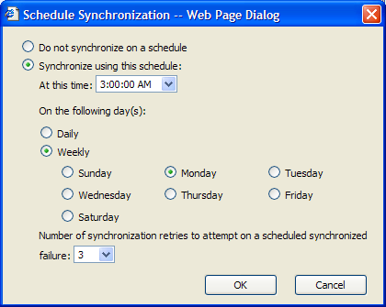
Approving Updates
To approve updates for distribution to your client computers
- Click Approve updates in the navigation bar, select the updates that you want to distribute to your client computers, and then click Approve.
Note: If you don’t want any packages to be available to your client computers, clear all check boxes, and then click Approve.
You will be notified that the approval was successful. For more information about which updates you have approved, click View approval log in the navigation bar.
Note: The updates that you approved will be downloaded only by client computers that have the updated Automatic Updates client installed and configured. For more information, see “Getting Started with the Automatic Updates client” later in this document.
Update Status
For each item on the Approval Page, status is displayed in the corner of the item description. The different status types are as follows:
- New. This indicates that the update was recently downloaded. The update has not been approved and will not be offered to any client computers that query the server.
- Approved. This means that the update has been approved by an administrator and will be made available to client computers that query the server.
- Not Approved. This indicates that the update has not been approved and will not be made available to client computers that query the server.
- Updated. This indicates that the update has been changed during a recent synchronization.
- Temporarily Unavailable. An update is in the “Temporarily Unavailable” state if one of the following is true:
The associated update package file required to install the update is not available.
A dependency required by the update is not available.
Note You will only see this status message when content is being stored locally.
To get more information about a particular update
Click Approve updates in the navigation bar, and then click the Details link under the update name.
The Details page includes the following information:
- The *.cab files associated with the package.
- The locale(s) for each *.cab file.
- The operating system(s) required for each *.cab file.
- A link to the actual *.cab file used to install the package, and any command-line setup options that need to be used to install the package.
- An optional link to the Read more page about the update in the Info column.
Note If there is a link with more information in the Info column, you must have access to the Internet to read the information.

Approving Updates and Timing Issues
Every 22 hours minus a random offset, your Automatic Updates client computers will poll the server running SUS for approved updates to install. If there are any new updates that need to be installed, the client computer will begin to download these new approved updates.
Note: When an approved update has been installed, SUS does not uninstall the update if it becomes unapproved.

Reviewing server actions and server health
Because most SUS tasks involve the synchronization and approval of updates, two logs (synchronization and approval) are provided to the administrator. These logs are stored in XML files in an administrator-accessible folder on the server.
A server-monitoring Web page is provided so you can view the status of updates for target computers, because these are stored in the server’s memory and might occasionally need to be refreshed.

Synchronization log
A synchronization log is maintained on each server running SUS to keep track of the content synchronizations it has performed.
This log contains the following synchronization information:
- Time that the last synchronization was performed.
- Success and Failure notification information for the overall synchronization operation.
- Time of the next synchronization if scheduled synchronization is enabled.
- The update packages that have been downloaded and/or updated since the last synchronization.
- The update packages that failed synchronization.
- The type of synchronization that was performed (Manual or Automatic).
The log can be accessed from the navigation pane of the administrator's SUS user interface.
You can also access this file directly using any text editor. The file name is history-Sync.xml and it isstored in the <Location of SUS Website>\AutoUpdate\Administration directory.

Approval log
An approval log is maintained on each server running SUS to keep track of the content that has been approved or not approved.
This log contains the following information:
- A record of each time the list of approved packages was changed.
- The list of items that changed.
- The new list of approved items.
- A record of who made this change; that is, the server administrator or the synchronization service.
The log can be accessed from the navigation pane in the administrative user interface.
You can also access this file directly using any text editor. The file name is History-Approve.xml and it is stored in the <Location of SUS Website>\AutoUpdate\Administration directory.
Event Log Messages
The synchronization service generates an Event Log message for every synchronization performed by the server and if any major errors are encountered by the synchronization service.
Event Log messages are also generated whenever the list of approved updates on the server changes.
A complete list of Event Log messages generated by SUS is available in Appendix B.

Monitor Server Page
SUS keeps information about available updates in metadata cache. The metadata cache is an in-memory database that SUS uses to manage updates. The cache includes metadata that identifies and categorizes updates, as well as information on update applicability and installation. The Monitor Server page provides the administrator with a view of the current contents of the metadata cache.
Using the information from the Monitor Server page, the administrator can tell how many updates are available for each of the products on the network. SUS refreshes the metadata cache each time the administrator performs synchronization. The Monitor Server page also indicates the last date and time that the metadata cache was updated.
SUS retrieves text files that contain the information for the metadata cache. These text files are loaded into the metadata cache during synchronization and then saved to disk. Although the text files are loaded automatically into the metadata cache during synchronization, the administrator can also refresh the cache manually

Synchronizing Content With Another Server Running Software Update Services or Manually-Configured Content Distribution Point
A server running SUS can be synchronized using the public Windows Updates servers, from another server running SUS, or from a manually-configured content distribution point.
Synchronizing from another server running SUS or manually-configured content distribution point is useful in the following scenarios:
- You have multiple servers running SUS in your organization and you do not want all of the servers to access the Internet to synchronize content.
- You have sites that do not have Internet access.
- You want the ability to test content in a test environment and then be able to push the content that you have tested to your production environment.
- You can synchronize content from one server running SUS to another server running SUS.
Figure 3 Server running Software Update Services synchronizing from another server running Software Update Services
In this figure, server A running SUS is synchronizing content over the Internet from the public Windows Update servers. We refer to server A as the parent. Server B running SUS is configured to synchronize content from server A running SUS. We refer to server B as the child.
To make sure this configuration is successful you need to maintain the following configuration.
Server A running SUS must:
- Be configured to “Save updates to a local folder” on the Set options page.
- Be configured to support all the locales that child servers might request on the Set options page.

Server B running SUS must:
- Be configured to “Synchronize content from a local Software Updates Services server” and correctly provide the name of Server A on the Set options page.
- Be configured to “Save updates to a local folder” on the Set options page.
- Only select locales to support that are also supported on Server A. Otherwise the server will try to synchronize for locales that do not exist on Server A.

Synchronizing the list of approved packages
In addition in being able to synchronize content from another server running SUS or a manually-configured content distribution point, you can also synchronize the list of approved packages. This is useful in an environment where your administrator wants to select the list of approved packages and would like this list of approved packages to flow down to child servers along with the content.
To synchronize the list of approved items along with the content, when synchronizing from a local server running SUS or a manually-configured content distribution point, select the Synchronize list of approved items updated from this location (replace mode) check box on the Set options page.
After you make this selection, the child server will synchronize the list of approved packages from the parent server during the synchronization. This operation is carried out by making a copy of the approved packages on the parent server and using this list on the child. The end result is that the parent and child have the same list of approved items.
Note: When you make the choice of synchronizing the list of approved items, you will not be able to alter the list of approved items on the child server. It will be the same as the parent. The user interface to make changes to the list of approved items on the child server will be unavailable along with the Approve button on the Approve updates page.
Figure 4 Servers running Software Update Services synchronizing content and in one case also synchronizing a list of approved updates from a content distribution point

Creating a content distribution point

There are two ways to create a content distribution point:
Note: Whether automatically or manually configured, content distribution points must always use port 80. You cannot use any port other than 80 for a content distribution point.
A. Automatic. When you install SUS, a content distribution point is automatically created on that server. When this server is synchronized, its content is updated from the Windows Update download servers. The content distribution point is located in the currently running IIS Web site under a Vroot named /Content.
If you choose to maintain content on Microsoft.com, this automatic content distribution point will be empty.
B. Manual. You can also manually create a content distribution point on a server running Internet Information Server (IIS) version 5.0 or higher. The server with the manual content distribution point does not require an installation of SUS.

To create a manual content distribution point
- Confirm that IIS is installed.
- Create a folder named \Content
- Copy all the files and folders under the \Content\cabs directory from the source server running SUS to the \Content directory on the server with the manually-created content distribution point:
- Copy the following files under the VROOT of the default web site
- <root of the SUS Web site>\Aucatalog1.cab
- <root of the SUS Web site>\Aurtf1.cab
- <root of the SUS Web site>\approveditems.txt
- Create a VROOT called “Content” and point to the “\Content\Cabs” directory

Note: You can only deploy content that has been synchronized via SUS to other manually-created content distribution points.
In other words, you are taking content from the \Content folder on a server running SUS that can connect to the Internet, and copy this content to the manually-created content distribution point. Remember to copy the complete \Content directory.

To set up Software Update Services to synchronize from a manually-created content distribution point
- Take one of the following actions, depending upon the whether the server running SUS is using Windows 2000 Server or Windows Server 2003.
- If you are using Windows 2000 Server, proceed to step 2 immediately.
- If you are using Windows Server 2003, see the topic “Accessing the SUS Administrator Web Site,” on page 74 before proceeding to step 2.
2. Go to the SUS Administration Web site: http://<Servername>/SUSAdmin.
3. Click Set Options.
4. Under Select which server to synchronize content from, click Synchronize content from a local server running Software Update Services.
5. In the text box, enter the name of the server that is running SUS, or a server with a manually-created content distribution point from which you want to synchronize. Enter the server name as: http://<Servername> or just <Servername>.

Secure Administration
You can administer a server running SUS by using Internet Explorer from a remote computer. By default, all administration is done over HTTP using the URL: http://<servername>/SUSAdmin.
Only users with local administrator privileges on the server on which SUS is installed can use the SUS administration Web site.
Using the HTTP protocol means that all communications are sent using clear text over the network without any encryption during your administration session.
You have two choices for secure administration:
- Administer the server only locally and not from a remote computer.
- Use secure HTTPS/SSL for server administration.
To use HTTPS for secure administration of SUS, use the following steps to turn on HTTPS:
First get a valid digital certificate for server authentication from your organization. This certificate should be stored in the local machine store of the server that you would like to administer.
After you have the certificate installed, use the following steps to turn on secure administration using HTTPS.
To apply the certificate
- Start the IIS administration MMC snap-in.
- Right-click the Web site where SUS is installed, and then click Properties. SUS is typically installed under the Default Web site.
- On the Web Site tab, set the SSL port to 443.
- On the Directory Security tab, click Server Certificate. This starts the Web Server Certificate Wizard. Click Next.
- Click Assign an existing certificate. Click Next.
- Select the certificate that you created for SSL authentication. Click Next.
- Confirm that this is the correct certificate. Click Next.
- Click Finish.
- Click OK to close the dialog box.
To enable SSL for the correct directories
- Right-click the \autoupdate\administration folder in the navigation pane, and then click Properties.
- Click the Directory Security tab.
- Under Secure Communications, click Edit.
- Select the Require secure channel (SSL) check box.
- Select the Require 128-bit encryption check box.
- Click OK twice.
- Repeat these steps for the following additional directories:
\autoupdate\dictionaries
\Shared
\Content\EULA
\Content\RTF
Note: The \Content\EULA and \Content\RTF directories do not appear until SUS has performed at least one successful synchronization.
To test the process
- Navigate to https://<servername>/SUSAdmin to begin administration.

Testing Content for Software Update Services Deployment
Although there are no features built into the user interface for staging content, you can successfully perform some basic staging before approving content.
There are two options for testing content:
- Set up a test server running SUS in a test lab, and have a test client computer running your standard operating environment and the new Automatic Updates client download and install the packages you want to test.
- Connect the test client computer to the Windows Update site on the Internet using your browser and this URL: http://windowsupdate.microsoft.com. You can apply the packages that you want to test on that client. Remember that you will only see the updates that are applicable to the test machine.

Staging Content Before Applying It To Your Production Environment
There are two ways to stage content before applying it to computers in your production environment:
Have one server running SUS for testing and another for production-environment client computers. Perform the testing using the test server running SUS. Once the content is tested, approve items on the production-environment server.
Use a manually-configured content distribution point. Do your testing with a test server running SUS and test client computers. Once testing is complete, copy the list of approved items and tested content to a manually-configured content distribution point. Configure the production servers running SUS to automatically download this content along with the list of approved items. In this configuration, the production servers are children of the test server. Thus, the children servers automatically get the tested content and list of approved items.
To place tested content on a manually-configured content distribution point and have servers running SUS synchronize with this content, see “Creating a content distribution point“ earlier in this document.

Planning a Software Update Services Deployment
Table 1 details how varying types of customers might deploy SUS.
Type of Organization | Infrastructure | Synchronization Notes
Small- or medium-sized business | Single server running SUS | Requires Internet connectivity to synchronize
Enterprise | Multiple servers running SUS | At least one server running SUS will require access to the Internet to synchronize. Others can synchronize content by either connecting to a server running SUS or a manuallyconfigured content distribution point.
High security with disconnected networks | Multiple servers running SUS | In a high-security organization, the Intranet is usually disconnected from public networks such as the Internet. In this setting, clients can synchronize content from either an automatic or manual content distribution point. However, at least one server running SUS must have Internet connectivity.
Table 1. Types of Software Update Services deployments

Deploying Software Update Services Server
First, determine the configuration model that is appropriate to your organization using Table 1.

Scale-out model
Large organizations, highly secure organizations, or organizations whose users are spread across sites and WAN links will want to use a multiple server model when deploying SUS.
There are three approaches that allow SUS to scale out by using multiple servers:
- Multiple independent servers running SUS, where each server is managed independently and each server synchronizes content over the Internet from Microsoft.com. This is an extension of the single-server model.
- Multiple servers running SUS that all synchronize content within the organization's Intranet using a separate server running SUS or a manually-configured content distribution point as the synchronization source. The various servers running SUS can be scattered geographically to accommodate network topology. For example, if you have a remote site that has a number of clients and has poor connectivity to the central office, you would want to place a server running SUS at the remote site.
- Multiple servers running SUS combined with a Network Load Balancer. If you have a large number of clients and also have good network connectivity to all of these clients you may want to consider creating a central farm of servers running SUS combined with a Network Load Balancer.
In the second and third approach, one server synchronizes with Microsoft.com. This server that has Internet connectivity is called the parent server running SUS. Child servers running SUS are configured to synchronize from this parent server running SUS, or from a manually-configured content distribution point. The child servers can perform manual or automatic synchronizations against the parent. This synchronization can include updates and the list of approved updates, or just the updates. This method of synchronization only exposes a single server to the Internet while using several internal servers running SUS to distribute the load.

Network Load Balancing and Software Update Services
Network Load Balancing, a clustering technology included in the Windows® 2000 Advanced Server and Datacenter Server operating systems, enhances the scalability and availability of mission-critical, TCP/IP-based services, such as Web, Terminal Services, virtual private networking, and streaming media servers. You can use Network Load Balancing to distribute IP traffic to multiple servers running SUS in a cluster. Network Load Balancing transparently partitions the client requests among the servers and lets the clients access the cluster using one or more “virtual” IP addresses. From the client’s point of view, the cluster appears to be a single server that answers these client requests. As enterprise traffic increases, network administrators can simply plug another server into the cluster. Using Network Load Balancing, you can configure clients to use a single location for updates, and have multiple servers be able share the burden of handling the requests to this location.
Refer to the “Related Documents” section at the end of this white paper for links to more detailed information on Network Load Balancing. Refer to the next section for details of setting up a cluster of servers running SUS.
This scenario is illustrated below:
Figure 5 Network Load Balancing and Software Update Services

Configuring your servers running Software Update Services to use Network Load Balancing
In the previous section we explain the benefits of using SUS and network load balancing together. The following is a list of configuration steps required to implement this.
Create a SUS manually-configured content distribution point This content distribution point will host the content that you want your servers running SUS to offer including the list of approved items. Refer to the “Creating a content distribution point” section in this document for more information. Make sure that your manually-configured content distribution point contains content for all the locales you need to support.
Make sure that you have installed one of the following operating systems on all servers that will be running SUS and Network Load Balancing. We will refer to these as your Network Load Balancing host. The operating systems that support Network Load Balancing are:
- Windows 2000 Advanced Server
- Windows 2000 Datacenter Server
- Windows Server 2003, Enterprise Edition
- Windows Server 2003, Datacenter Edition
The following are the steps you need to configure servers running SUS in a Network Load Balancing cluster:
- Configure SUS on each of your Network Load Balancing hosts using the Set Options page.
- Make sure content is being stored locally. In “Select where you want to store updates:” select Save the updates to a local folder.
- Select the content locales your client computers need. Make sure to set the same list of supported locales on each of your Network Load Balancing hosts. You can select these by checking the box beside the locale you want to support.
- Configure your server to synchronize from the manually-configured content distribution point. Under “Select which server to synchronize content from”, select Synchronize from a local Software Update Services server. Enter the name of the server that contains the manually-configured content distribution point.
- Configure your server to also synchronize the list of approved items from the manually-configured content distribution point. Under “Select which server to synchronize content from:” select Synchronize list of approved items updated from this location (replace mode).
- Install and configure the Network Load Balancing service on each of your Network Load Balancing hosts:
Refer the documentation provided with Network Load Balancing for specific installation and configuration procedures.
You should install Network Load Balancing in Unicast mode with a single NIC in each server, since all of servers are on your Intranet.
Figure 6 shows the necessary components and network connections:.

Figure 6 Configuring your servers running Software Update Services to use Network Load Balancing

When running Network Load Balancing in the Unicast configuration with a single network card in each server, keep the following in mind:
- Each server in the cluster will be able to synchronize content from the manually-configured content distribution point.
- The servers will automatically determine which server in the cluster should respond to a client request that comes to the virtual IP Address that represents the cluster.
- You cannot communicate between servers. You will not be able to sit at the console of one of the servers in the cluster and access resources on another server in the cluster.
- To administer any of the servers in the cluster, you need to be at the console of that server, or use a remote client outside of the cluster to administer a server in the cluster.
- You use the actual name of each server to administer it. For example to change the configuration of server1 in Figure 6 above, you would still use: http(s)://Server1/SUSAdmin.
Once you have installed and configured the Network Load Balancing service on each of the servers running SUS, you will have a virtual IP Address that needs to be used to access the cluster. You may want to register this IP address with a friendly name on your DNS Servers or WINS servers.
Configure your client computers to point to this cluster using the virtual IP Address of the cluster or the name that you registered in DNS or WINS. (example: http://<SUSCluster>.

Server Backup and System Recovery
In the event that the server running SUS should encounter a boot failure, or any other scenario where the server may require having the operating system and/or the SUS software re-installed, it is a good idea to have a recovery plan in place.
In order to have a fully functional server running SUS after a failure, you need to backup the Web site directory that the administration site was created in, the SUS directory that contains the content, and the IIS IIS metabase.
Start by creating a backup of the IIS metabase using the IIS MMC Snap-in, shown in Figure 7. In the IIS console, select the server to backup and from the Action menu select Backup/Restore Configuration.
IIS Console
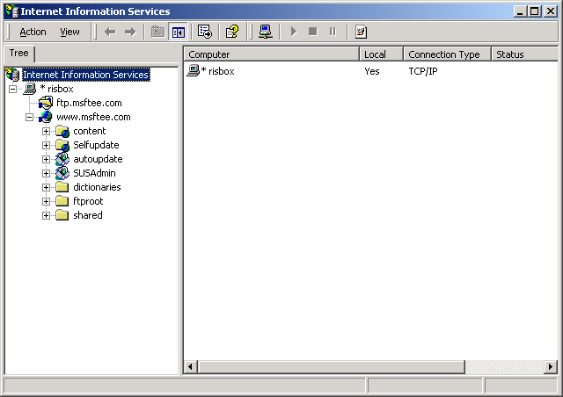

Figure 7 Server Backup and System Recovery

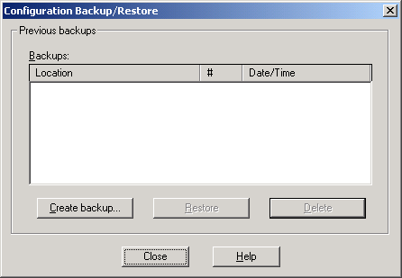
Figure 8 Configure Backup/Restore
In the Configuration Backup/Restore dialog box, click Create backup.
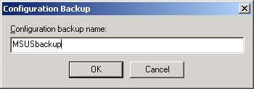
Figure 9 Configure Backup
In the Configuration Backup dialog box, type a name for the configuration backup and then click OK.
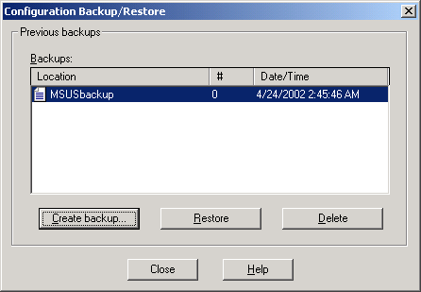
Figure 10 Verify backup in Configuration Backup/Restore
Verify that the backup is listed in the Configuration Backup/Restore dialog box, and then click Close.
After creating the IIS metabase backup, run NTBackup to backup the data. Figure 11 shows that the C:\Inetpub\wwwroot (Default Web Site) and the C:\Inetpub\msus directories (Content Storage Location) are selected for backup. Figure 12 shows %windir%\system32\inetsrv\metaback (IIS metabase). All of this data is required for proper operation of SUS and IIS after the data has been restored.
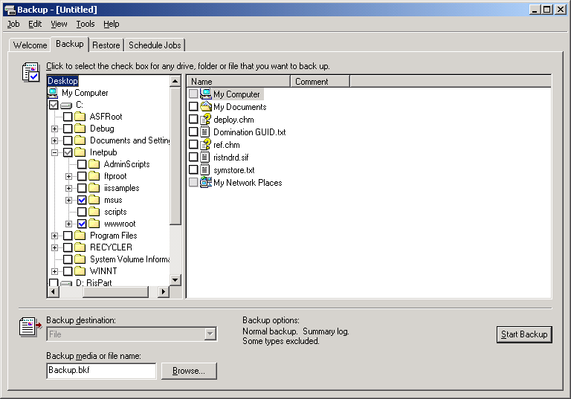
Figure 11 Using NTBackup to backup the administration site and SUS content
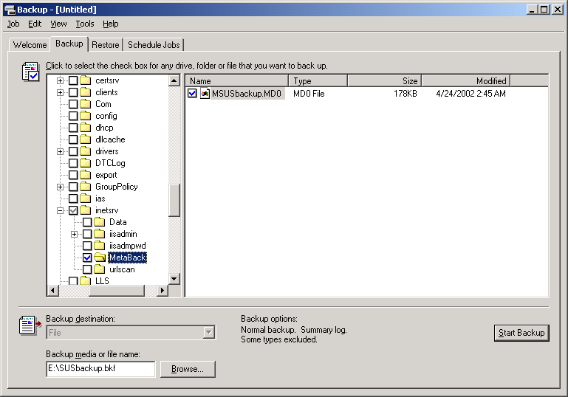
Figure 12 Using NTBackup to backup the IIS metabase
After selecting the content to backup (in this example, C:\Inetpub\wwwroot; C:\Inetpub\msus; and %windir%\system32\inetsrv\metaback), select a backup destination. This can be a tape drive (preferred), or a file stored on a local disk. Once the backup destination is selected, click Start Backup. The dialog box shown in Figure 13 will appear and you can customize the backup and media descriptions and set the backup to occur on a schedule. When you are finished entering these settings, click Start Backup.

Backup job information
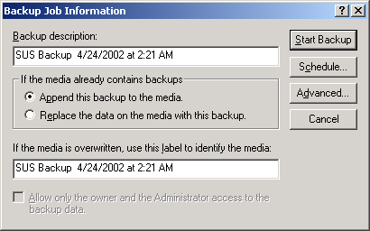
Figure 13
After clicking Start Backup, the Backup Progress dialog box is shown.
Backup Progress
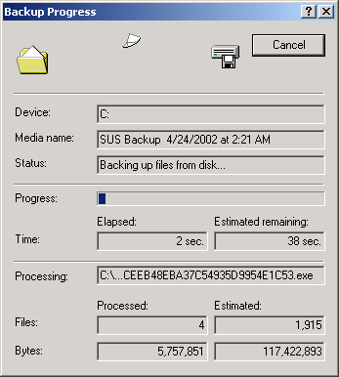
Figure 14
When the backup is complete, a dialog box will appear as shown in Figure 15.
Backup Complete
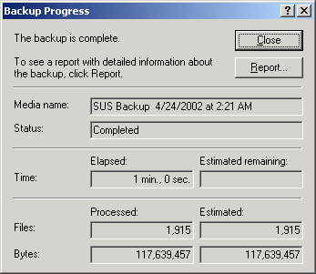
Figure 15
It is a good idea to create regular backups since new content is often synchronized to the server running SUS. The IIS metabase contains information about all updates provided through SUS so a new backup of the metabase should be created using the IIS Console before running NTBackup to backup the data to media.

Restoring Software Update Services after a Failure

Steps for IIS 5
IIS 5 servers use SIDs specific to the server making it impossible to restore the metabase to a new installation on the same hardware or to a different computer. If it is possible to uninstall IIS rather than re-install the operating system the following steps can be performed:
- Uninstall SUS.
- Physically disconnect the server from the network to ensure that the server remains virus-free.
- Uninstall IIS – this should automatically uninstall URLScan. This action will also undo any modifications set by the IIS Lockdown tool.
- Re-install IIS.
- Re-apply the latest service pack and security-related IIS patches.
- Run the IIS Lockdown tool.
- Re-install SUS.
- Skip to the heading titled “After installing Software Update Services.”
- If it is necessary to re-install Windows 2000 Server after a failure, the administrator will have to re-install SUS, re-synchronize the content, and re-approve the updates. There is no supported method for restoring the data from backup in this scenario.

Steps for IIS 6
After a failure occurs where it is necessary to re-install the operating system, the following steps should be taken in the order shown before restoring the data back to the server. These steps will only work on IIS 6 servers.
- Physically disconnect the server from the network. This is to ensure that the server is kept free of viruses before re-installing the SUS software.
- Install the same operating system the server was previously running.
- When installing the operating system, be sure to give the server the same computer name it previously had.
- When installing the operating system be sure to install the same IIS components the server previously had installed. At minimum this should include the WWW service.
- After the operating system is installed, ensure that the latest service pack and security fixes are installed. If the server must be connected to the network to perform these actions, be sure to run the IIS Security Wizard before connecting the server to the network.
- Install SUS in the same directory it was previously installed to.

After installing Software Update Services
- Run NTBackup to restore the most recent backup of the server running SUS . Open NTBackup and select the Restore tab. It may be necessary to catalog the backup before NTBackup will display the data in the backup set. To do so, expand the backup media (in Figure 16, this would be SUS Backup 4/24/2002 at 2:21 AM), right click the backup data (in this example C:), and select Catalog.
- Once the data has been catalogued, select the data to restore. This will be the SUS content directory, the IIS site that contains the SUSAdmin and AutoUpdate virtual directories, and the IIS metabase backup.

Using NTBackup to restore SUS
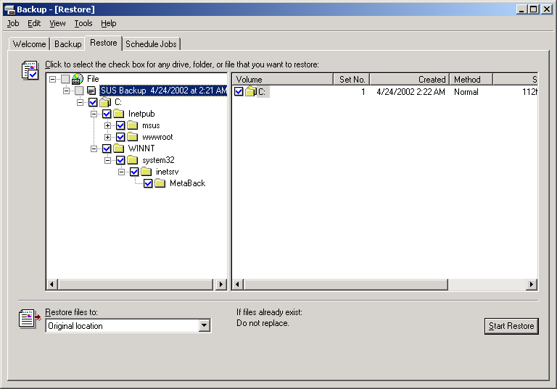
Figure 16. NTBackup
In “Restore files to:”, select Original Location, and click Start Restore. The Confirm Restore dialog box will be displayed. Click OK to begin the restore.
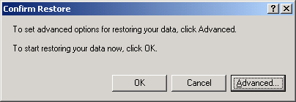
Figure 17. Confirm Restore Dialog box
The restore progress dialog box will be displayed while the data is being restored from backup.

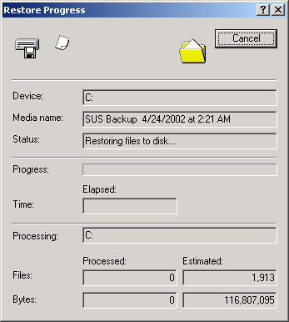
Figure 18. Restore Progress dialog box
When the restore is complete the dialog shown in Figure 19 will appear. To see if any errors were encountered during the restore, click Report. Otherwise, click Close.
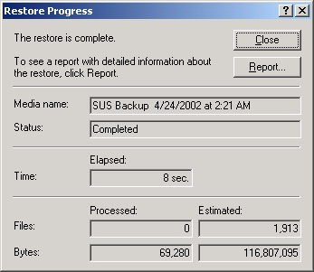
Figure 19. Restore Complete

After restoring the data to the hard disk, the IIS metabase needs to be restored. Open the IIS MMC snap-in, select the server to restore the metabase to, and from the Action menu select Backup/Restore Configuration.
Figure 20. Internet Information Services console

Figure 21. Backup Restore Configuration dialog box
In the Backup/Restore Configuration dialog box, select the backup configuration that was just restored from tape and click Restore. The dialog box shown in Figure 22 will be displayed:
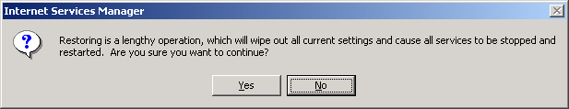
Figure 22. About to Restore dialog box
Click Yes. After several minutes, a dialog box will appear telling you if the restore was a success or failure.
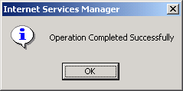
Figure 23. Restore Complete dialog box
At this point SUS should be installed and operating as though the server had never encountered a failure. To verify this, open the SUS Administration Web site and check the Set Options page to see if the old settings are in place, and the Approve Updates page to see if the previously approved updates are still approved.

Getting Started with Automatic Updates

Requirements
To use the SUS software, client computers must be running the updated Automatic Updates client available with SUS.
Automatic Updates can be used on the following operating systems:
- Windows 2000 Professional, Windows 2000 Server, and Windows 2000 Advanced Server (all with Service Pack 2 or higher), Windows XP Professional, Windows XP Home Edition, and Windows Server 2003 family.

User Experience

Configuration options
A local administrative user can configure Automatic Updates by using a wizard that is displayed twenty-four hours after connectivity to the update service is established on a computer. Alternatively, the administrative user can configure Automatic Updates locally by using the Automatic Updates configuration page in Control Panel (in Windows XP, go to System properties; in Windows 2000, go to Automatic Updates properties), or remotely by using Group Policy or by configuring registry entries. The System properties configuration options are shown in Figure 24.

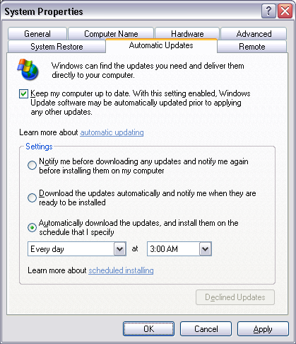
Figure 24 System properties
These options give the administrative user control over how they want updates downloaded and installed on their computer. They can select:
- To be notified before updates are downloaded, and notified again before the downloaded updates are installed.
- Updates to be downloaded automatically, and the administrative user notified before updates are installed.
- Updates to be downloaded automatically and installed based on the specified schedule.
Notification is through a notification-area icon and balloon as shown in Figure 25, and events are logged in the system event log.
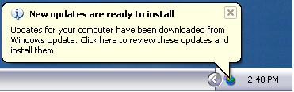
Figure 25 Notification area display

Download Behavior
Automatic Updates downloads updates based on the configuration options that the administrative user selected. It uses the Background Intelligent Transfer Service (BITS) to perform the download by using idle network bandwidth. If Automatic Updates is configured to notify the user of updates that are ready to download, it sends the notification to the system event log and to a logged-on administrator of the computer. If no administrator is logged on, Automatic Updates waits for a user with administrator credentials to log on before offering the notification

Installation Behavior
The installation behavior is dependent on the configuration options previously selected.
If Automatic Updates is configured to notify the administrative user of updates that are ready to install, the notification is sent to the system event log and to the notification area as shown in Figure 26.
When a logged-on administrator clicks the balloon or notification area icon, Automatic Updates displays the available updates to install as shown in Figure 27. The administrative user must then click the Install button to allow the installation to proceed. If the update requires a restart of the computer to complete the installation, a message is displayed stating that a restart is required. Until the system is restarted, Automatic Updates cannot detect any additional updates that might be applicable to the computer.
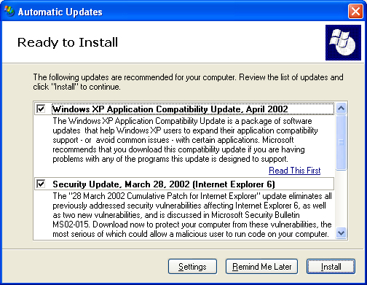
Figure 26 Automatic Updates Ready to Install dialog box
The Remind Me Later button provides a way for the installation to be deferred. The options are: 30 minutes, 1 hour, 2 hours, 4 hours, 8 hours, tomorrow, and in 3 days.
Scheduled Installation
If Automatic Updates is configured to install on a set schedule, applicable updates are downloaded and marked as ready to install. A logged-on administrator is notified by the notification-area icon, and an event is logged to the system event log. If the icon or balloon is clicked at this time, the user sees a dialog box similar to Figure 26 but with the Remind Me Later button appearing dimmed. Installation can be done at this time.
At the scheduled day and time, Automatic Updates installs the update and restarts the computer (if necessary), even if there is no local administrator logged on. If a local administrator is logged on, Automatic Updates displays a warning that an installation is about to begin, as shown in Figure 27. If a restart is required and a user is logged on, a similar countdown dialog box is displayed, warning all logged in users about the impending restart.
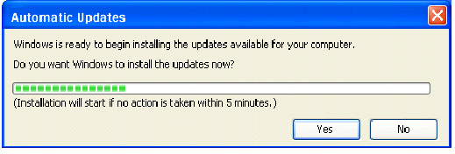
Figure 27 Automatic Updates pre-install countdown dialog box

System Events
The Automatic Updates client writes events to the system event log to notify users of operations being performed. These events can be collected and analyzed by other event-log monitoring tools. The events cover the following scenarios:
- Unable to connect: The Automatic Updates client is unable to connect to the update service (Windows Update or the server running SUS) and therefore cannot download and install updates according to the set schedule. Windows will continue to try to establish a connection. (Event ID 16).
- Install ready – no recurring schedule: Downloaded updates that are ready to install are listed in the event. To install the updates, an administrator needs to log on to the computer, where they see the notification area icon and install the updates. (Event ID 17).
- Install ready – recurring schedule: Downloaded updates that are ready to install are listed in the event. Additionally, the date and time for the scheduled installation of those updates is listed. (Event ID 18).
- Install success: Successfully installed updates are listed. (Event ID 19).
- Install failure: Updates that failed to install are listed. (Event ID 20).
- Restart required – no recurring schedule: To complete the installation of the listed updates, the computer must be restarted. Until the computer has been restarted, Windows cannot search for or download new updates. (Event ID 21).
- Restart required –recurring schedule: To complete the installation of the listed updates, the computer will be restarted within five minutes. Until the computer has been restarted, Windows cannot search for or download new updates. (Event ID 22).

Client Scenarios
The following details some common client and server scenarios and recommends \ configuration options for Automatic Updates for each of these scenarios.

Managed Desktop
The IT administrator has set the Automatic Updates policy such that Automatic Updates client performs a scheduled installation every day at 3 AM if any critical update is available. When the update has been successfully downloaded, Automatic Updates logs an event that an update is ready to install on the scheduled day and time. Then a pre-installation countdown dialog box is displayed to the first found locally logged on administrator (if one exists), for a five-minute duration. If an administrator is logged on to the system, he or she can stop the installation from proceeding, and the installation is scheduled for the next day at 3 AM. If no administrator is logged on, or if the countdown is not stopped, the installation automatically proceeds. If there are locally logged on users, they will be presented with a notification that the machine is about to restart if the updates installed require a restart to complete the installation.
Recommended Automatic Updates configuration:
- "AUOptions"=“4”
- "ScheduledInstallDay"=“0”
- "ScheduledInstallTime"=“3”

Managed Server
The IT administrator has set Automatic Updates to perform a scheduled installation every Saturday at 3 AM. When the critical update has been successfully downloaded, Automatic Updates logs an event that an update is ready to install on the scheduled day and time. When the installation is ready, Automatic Updates displays a balloon in the notification area (or status area in Windows 2000) to the first found locally logged on administrator (if one exists), for a five-minute duration. The balloon states that there are updates ready to install. Because the policy was set to perform the scheduled installation, the local administrator cannot deselect any items nor set a reminder. The local administrator chooses to not install at this time and closes the Automatic Updates “Ready to install updates” window. The Automatic Updates icon in the notification area remains to allow the administrator to interact with the system at any time prior to the scheduled installation. If the scheduled installation time has not yet been reached and the admin logs on again, it is possible for the local administrator to see the notification again to perform the installation. Provided the installation hasn’t already occurred, on Saturday at 3 AM, the pre-install countdown dialog box is presented to the first found administrator session (if one exists), and the installation automatically proceeds.
Recommended Automatic Updates configuration:
- "AUOptions"=“4”
- "ScheduledInstallDay"=“7”
- "ScheduledInstallTime"=“3”

Managed Data Center Server
The IT administrator has set Automatic Updates to automatically download critical updates and to notify when the updates are ready to install. When the update has been successfully downloaded, Automatic Updates logs an event that an update is ready to install and that an admin must interact with Automatic Updates to install the update. An administrator remotely checks the system events on the Data Center Server computer and sees an event stating that an update is ready to install. The administrator determines the next available planned system maintenance window and executes on their documented change notification plan. On the day and time of the scheduled maintenance, the administrator logs on to the server and interacts with Automatic Updates to install the critical update.
Recommended Automatic Updates client configuration:
- "AUOptions"=“3”

Deploying the Automatic Updates Client
You can install the updated Automatic Updates client on your clients by using one of the following methods:
- Install Automatic Updates client using the MSI install package.
- Self-update from the STPP version Critical Update Notification (CUN).
- Install Windows 2000 Service Pack 3 (SP3).
- Install Windows XP SP1.
- Install Windows Server 2003.
Using the MSI setup for the updated Automatic Updates client is the preferred method of updating computers running Windows 2000 and Windows XP.
Note: After completing the deployment mentioned in this section, please see “Configuring the Client” later in this document for assistance in configuring the Automatic Updates client to get updates from the server running SUS.

Standalone Installation of the Automatic Updates client
To perform the installation of the Automatic Updates client on a standalone computer, just run the WUAU22.msi file. You can download WUAU22.msi from the SUS Web page on www.microsoft.com. To navigate directly to this page use the following URL: http://go.microsoft.com/fwlink/?LinkId=6930.
This installation package can be used on Windows XP or Windows 2000 SP2.
Note: This package is supported only in English (wuau22.msi), Japanese (wuau22jpn.msi) and German (wuau22ger.msi) for this release. It will be available in other languages when the final release of this product is available. You may install the English version on other locale operating systems.

Central Deployment of the Automatic Updates Client
Since a Windows Installer-based setup program is available for the Automatic Updates client, you can use any of the following methods to centrally deploy the client:
- Microsoft IntelliMirror® management technologies. (if you have Active Directory).
- Microsoft Systems Management Server (SMS)
- A simple logon script
Prior to using any of these methods to deploy the client software, you should create a manually-configured content distribution point. Basically you need to make the WUAU22.msi file available to your Windows clients on a file share.

To deploy using IntelliMirror (for Active Directory users only)
- Using the Active Directory Users and Computers MMC snap-in, create a Group Policy Object (GPO). Be sure that the computers you are interested in deploying to are within the scope of the GPO.
- Using the Group Policy Object Editor, edit the GPO.
- Click Computer Configuration, then click Software Settings.
- Right-click Software Installation, then click on New , and then click package.
- Enter the path to the WUAU22.msi file on your manually-configured content distribution point.
- Click Open.
- Click the radio button beside Assigned and then click OK.
- Allow time for polices to replicate through the domain.
- Restart the client computers.
The packages should be installed at startup time when the policies are processed. The application will be installed in the context of the local computer, so be sure that authenticated users have rights on the source folders.

Deploying the Automatic Updates client Via Self-Update
The CUN client that came with the STPP compact disc can self-update to the Automatic Updates client through the SUS server. The CUN clients can be redirected to take the self-update software from the server running SUS. Set the following registry keys on the computer:
- Open Registry Editor.
- Navigate to HKEY_LOCAL_MACHINE\SOFTWARE\Microsoft\Windows\CurrentVersion\WindowsUpdate\Critical Update
- Create SelfUpdServer value under this key as REG_SZ..“SelfUpdServer”=”http://<YourServer>/SelfUpdate/CUN5_4”
- Navigate to HKEY_LOCAL_MACHINE\SOFTWARE\Microsoft\Windows\CurrentVersion\WindowsUpdate\Critical Update\Critical Update SelfUpdate
- Create SelfUpdServer value under this key as
REG_SZ. ”SelfUpdServer”=”http://<YourServer>/SelfUpdate/CUN5_4”
Note: <YourServer> is the name of your server running SUS.
Note: The “Critical Update SelfUpdater” task is responsible for the self-update. First, check whether this task is present in the scheduled tasks. Looking at the properties of this task should tell you when the self-update is supposed to happen. You can right-click the task to run it so that it will attempt the self-update. Without this intervention, CUN will attempt a self-update every 24 hours.
Note: After the self-update completes, one task may be left over as it was not able to be removed during the self-update. Because the CUN executables were deleted, the scheduled task would have no effect.
To confirm that the Automatic Updates client installed successfully
- Click Start, and then click Run.
- Type: %windir%\system32\
- Right-click Wuaueng.dll, and then click Properties.
- On the Version tab, confirm that the version number is 5.4.3630.2550 or higher.

Configuring the Automatic Updates client software
Once you have installed the Automatic Updates software, you will want to configure it either by using the Automatic Updates user interface or using policy-based configuration.
Before configuring the client computer, you will want to make the following decisions:
- 1. How do you want Automatic Updates to function?
- 2. Do you want Automatic Updates to pull updates from Microsoft Windows Updates servers or from a server running SUS on your local network?
Note The setting to redirect a computer running Automatic Updates to use a server running SUS is only available using the registry-based policy. Using a server running SUS is the preferred solution if your corporation’s proxy server requires authentication. Automatic Updates will not be able to contact the Microsoft Windows Update servers on the Internet through a proxy server that requires authentication. Your server running SUS has the ability to support proxy servers that require authentication and will be able to download content from the Windows Update Download servers when these types of proxy servers are used.
If you make configuration changes using the user interface, these changes can be changed only by local administrators of that computer. If you make configuration changes using policy, local administrators will not be able to change these settings.

Policy Configuration
Depending on your environment, there are different ways to apply policies to your clients. The preferred method is Group Policy, but policies can also be set using Windows NT 4 System Policy, or by setting registry keys directly.
The behavior of Automatic Updates can be controlled by configuring Group Policy settings in an Active Directory environment. Administrator-defined configuration options driven by Group Policy always take precedence over user-defined options. In addition, Automatic Updates options in Control Panel are disabled on the target computer when administrative policies have been set.
Not:e The refresh interval for Group Policy can be set for a computer to check for updated policies. When policies are updated or refreshed, Automatic Updates immediately processes those changes.
Group Policy settings can be configured centrally using Active Directory or directly on a client computer by using the Local Group Policy Object. To learn more about Group Policy and the Active Directory, refer to the “Group Policy White paper” listed in the “Related Links” section of this white paper.
The following section details how to deploy policy settings to configure the client by using Group Policy.

Using Group policy
In a test or workgroup environment, the easiest way to deploy Group Policy settings is with the Local Group Policy Object. The following steps walk you through how to use the Local Group Policy Object to configure Automatic Updates.
To load policy settings using the Local Group Policy Object
- You will need the WUAU.adm file that describes the new policy settings for Automatic Updates. WUAU.adm is automatically installed into the %windir%\inf directory when you install Automatic Updates.
- You can load %windir%\inf\wuau.adm as an administrative template in the Group Policy Object Editor:
- Click Start, and then click Run.
- Type GPEDIT.msc to load the Group Policy snap-in.
- Under Computer Configuration, right-click Administrative Templates.
- Click Add/Remove Templates, and then click Add.
- Enter the name of the Automatic Updates ADM file: %windir%\inf\WUAU.adm
- Click Open, and then click Close to load the wuau.adm file.
Once it is loaded, you will be able to configure policy settings for Automatic Updates. For more information, see the following section, “Configuring Automatic Updates policy settings from the Group Policy Object Editor.”
Note: This ADM file is also available on the server running SUS in the %windir%\inf directory.

To load policy settings using Group Policy in Active Directory
- You will need the WUAU.adm file that describes the new policy settings for the Automatic Updates client. WUAU.adm is automatically installed into the %windir%\inf folder when you install Automatic Updates.
- You can load %windir%\inf\wuau.adm as an administrative template in the Group Policy Object Editor.
- On an Active Directory domain controller, click Start, and then click Run.
- Type DSA.msc to load the Active Directory Users and Computers snap-in.
- Right-click the Organizational Unit (OU) or domain where you want to create the policy, and then click Properties.
- Click the Group Policy tab, and then click New.
- Type a name for the policy, and then click Edit. This opens the Group Policy Object Editor.
- Under either Computer Settings or User Settings, right-click Administrative Templates.
- Click Add/Remove Templates, and then click Add.
- Enter the name of the Automatic Updates ADM file: %windir%\inf\WUAU.adm
- Click Open.

Configuring Automatic Updates Group Policy settings

To start configuring the settings for your clients in the Group Policy Object Editor
- Click Computer Configuration, and then expand Administrative Templates.
- Click Windows Components, and then click Windows Update. The two policies that you can set appear in the right pane.
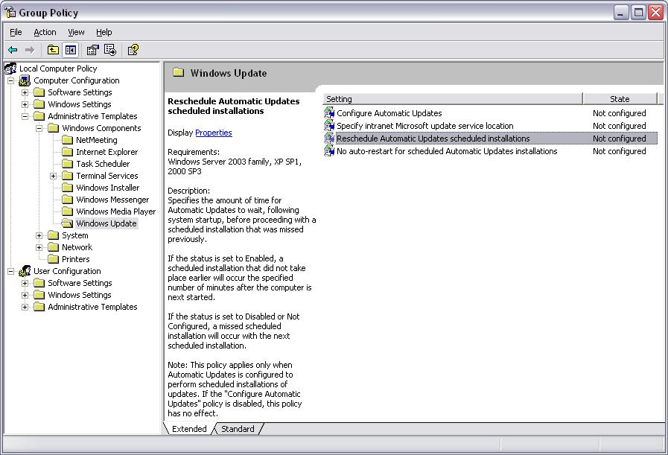
Figure 28 Group Policy setting to configure Automatic Updates service
Note: Different OUs or security group filtering can be employed if the administrator wants to deploy different Automatic Update policies to different groups. For more information, refer to the Group Policy white papers noted in the References section below.
Note: If you are using Windows XP clients with the Logon Optimization (turned on by default), it may take more then one restart for software installation to apply. For more information refer to the Windows XP in the Windows 2000 Server environment in the References section at the end of the document.

Configure the behavior of Automatic Updates
To configure the behavior of Automatic Updates, open Configure Automatic Updates. If the Automatic Updates service is enabled via this Group Policy setting, one of the following three options must be set (in the drop-down menu below Configure automatic updating):
Notify for download and notify for install
This option notifies a logged-on administrative user prior to the download and prior to the installation of the updates.
Auto download and notify for install
This option automatically begins downloading updates and then notifies a logged-on administrative user prior to installing the updates.
Auto download and schedule the install
If Automatic Updates is configured to perform a scheduled installation, the recurring scheduled installation day and time is also set.
Possible options for scheduled installation days and times are:
- Day: “Every day” and “Every Sunday” to “Every Saturday”
- Time: 12 AM to 11 PM in 24-hour format (00:00 to 23:00)
Note: When configuring Automatic Updates though Group Policy, the policy will override the preferences set by the local administrative user to configure the Windows client. If the administrator removes the policies at a later date, the preferences set by the local administrative user will be used again.
Note: Configuring Automatic Updates though Group Policy disables the user interface options in Control Panel. When setting a scheduled install, the Remind Me Later button in the Ready to Download Update and Ready to Install Update dialog boxes is disabled.
If this policy is disabled, the Automatic Updates client software does not perform any system updating, and any available updates must be downloaded and installed manually by going to the Windows Update site at http://windowsupdate.microsoft.com.

Reschedule wait time
To set the wait time between the time Automatic Updates starts and the time it begins installations whose scheduled time has passed, the administrator can create the RescheduleWaitTime registry value in HKEY_LOCAL_MACHINE\SOFTWARE\Policies\Microsoft\Windows\WindowsUpdate\AU. The value is a DWORD with a range of 1 to 60, representing 1 minute to 60 minutes (1 hour).
If a scheduled installation is missed (because the client computer was turned off) and RescheduleWaitTime is not set to a value between 1 and 60, Automatic Updates waits until the next scheduled day and time to perform the installation. If a scheduled installation is missed and RescheduleWaitTime is set to a value between 1 and 60, then Automatic Updates reschedules the installation to occur at the Automatic Updates service start time plus the number of minutes specified in RescheduleWaitTime.
There are 3 basic rules for this feature:
When a scheduled installation is missed, the installation will be rescheduled for the system startup time plus the value of RescheduleWaitTime.
Changes in the scheduled installation day and time via the Control Panel or Policy are respected over the rescheduled time.
The rescheduled time is respected over the next calculated scheduled day and time if the “next calculated scheduled day and time” is later than the rescheduled time. The “next calculated scheduled day and time” is calculated as follows:
- When Automatic Updates starts, it uses the currently set schedule to calculate the “next calculated scheduled day and time”.
- The resulting day and time value is then compared to the ScheduledInstallDate.
- If the values are different, Automatic Updates performs the following actions:
- Sets a new “next calculated scheduled day and time” within Automatic Updates.
- Writes this new “next calculated scheduled day and time” to the ScheduledInstallDate registry key.
- Logs an event stating the new scheduled installation day and time.
Figure 29 shows the dialog for rescheduling the wait time.
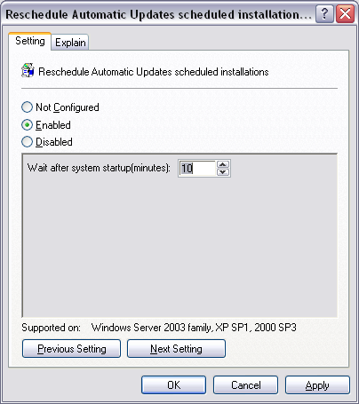
Figure 29, Rescheduling the client wait times

Example1: IT admin wants installation to occur immediately following system startup
- IT administrator schedules update installations to occur every day at 3 AM.
- IT administrator sets the RescheduleWaitTime registry value to 1.
- Automatic Updates finds an update, downloads it, and is ready to install it at 3 AM.
- End user does not see the “ready to install” prompt because she does not have administrative privileges on her computer.
- User turns her computer off.
- The scheduled time (3 AM) passes while the computer is off.
- User turns on the computer.
- When Automatic Updates starts, it recognizes that it missed its previously set scheduled installation time and that RescheduleWaitTime is set to 1. It therefore logs an event stating the new scheduled time (one minute after the current time).
- If no one logs in before the newly scheduled time (1 minute interval) the installation begins. Since no one is logged in, there is no delay and no notification. If the update requires it, Automatic Updates will restart the computer.
- The user logs in to the updated computer.

Example 2: User wants the installations to occur fifteen minutes after the Automatic Updates service starts.
- IT admin schedules update installations to occur every day at 3 AM.
- The administrator of the client computer (the local administrator) sets the RescheduleWaitTime registry value to 15.
- Automatic Updates finds an update, downloads it, and is ready to install it at 3 AM.
- The local administrator ignores the prompt to install the update.
- The local administrator turns the computer off
- The scheduled time passes while the computer is off.
- The local administrator turns on the computer.
- When Automatic Updates starts, it recognizes that it missed its previously set scheduled install time, and that RescheduleWaitTime is set to 15. It therefore logs an event stating the new scheduled time (fifteen minutes after the current time).
- The local administrator logs on prior to this newly scheduled time.
- After Automatic Updates has been running for 15 minutes, it proceeds with the scheduled installation.
- The local administrator is notified five minutes before installation begins by the countdown timer.
- The timer expires and the installation proceeds.

No automatic restart with logged on users
To prevent Automatic Updates from restarting a computer while users are logged on, the administrator can create the NoAutoRebootWithLoggedOnUsers registry value in HKEY_LOCAL_MACHINE\SOFTWARE\Policies\Microsoft\Windows\WindowsUpdate\AU. The value is a DWORD and must be either 0 (false) or 1 (true). If this value is changed while the computer is in a restart pending state, it will not take effect until the next time an update requires a restart.
When the admin creates and sets the NoAutoRebootWithLoggedOnUsers registry key to 1, the restart countdown dialog that pops up for the logged on user (active and inactive) will change in the following ways:
Users with administrator credentials | Users without administrator credentials
The No button will be active. | The No button will be inactive.
The Yes button will be active if they are the only administrator logged on at the time the restart dialog appears. | The Yes button will now be active only if the non-administrator is the only non-administrator logged on at the time the restart dialog appears. However, the Yes button will be inactive if the user’s local security policy prohibits restarting.
The restart countdown progress bar and the text underneath the progress bar will not display. | The restart countdown progress bar and the text underneath the progress bar will not display.

Figure 30 shows the dialog for rescheduling the wait time.
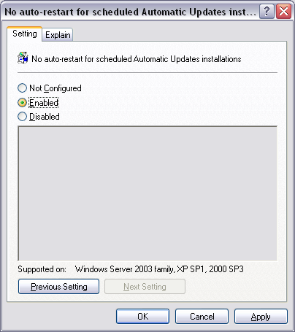
Figure 30: Configuring No automatic restart with logged on users

Example 1: non-administrator user on a workstation
This scenario assumes that the following conditions have been set up by the IT administrator:
IT administrator schedules updates to be installed every day at 3 a.m.
IT administrator requires users of desktops to run as non-administrative users.
IT administrator sets NoAutoRebootWithLoggedOnUsers to 1.
- The user is assigned Shut down the system privileges via Group Policy.
Resulting client behavior:
- Automatic Updates detects and downloads an update and sets the scheduled installation time to 3 AM.
2. The logged on non-administrative user leaves the workstation locked at the end of the day.
3. At 3 AM the scheduled installation proceeds.
4. This update requires a restart to complete the installation, so Automatic Updates pops up a dialog to the users locked session saying that a restart is required.
5. At 9 AM the user unlocks the workstation and sees the prompt to restart.
6. The user is unable to click No to dismiss the dialog, but because she is the only user on the workstation, she can click Yes. There is no timeout, so she can accept the prompt to restart at a time that is convenient for her.

Example 2: non-admin users on a server
This scenario assumes that the following conditions have been set up by the IT administrator:
By default, users who do not have administrative privileges are not allowed to restart Windows Servers. This is enforced by the local security policies.
Multiple non-administrator users are logged on at the time the scheduled installation begins.
The installation requires that the computer be restarted.
Resulting client behavior:
Users are notified.
When the installation requires restarting the computer, all logged on users are notified with a popup that the computer must be restarted.
Event ID 21 is written to the system event log:
Restart Required: To complete the installation of the following updates, the computer must be restarted. Until this computer has been restarted, Windows cannot search for or download new updates.
- Security Update - March 16, 2002
Non-administrator users are not allowed to dismiss the dialog by clicking No.
These non-administrator users don’t have permissions to restart the server, so the Yes button is also disabled.
If new users log on, they also receive the notification that the server needs to restart.
Users log off.
Upon each log off, Automatic Updates tests to see if there are any users still logged on.
When there are no logged-on users and therefore there is no opportunity for user data loss, Automatic Updates writes Event ID 22 to the system event log as shown below, and begins the shutdown procedure.
Restart Required: To complete the installation of the following updates, the computer will be restarted within five minutes. Until this computer has been restarted, Windows cannot search for or download new updates.
- Security Update - March 16, 2002

Summary of behavior for NoAutoRebootWithLoggedOnUsers settings
The following table shows the difference in behavior with NoAutoRebootWithLoggedOnUsers enabled (set to 1) or disabled or not configured (not set to 1).
Scenario following a scheduled installation | With NoAutoRebootWithLoggedOnUsers enabled | With NoAutoRebootWithLoggedOnUsers disabled or not configured
No users logged on | Automatic restart immediately following installation | Automatic restart immediately following installation
Single user with administrative privileges | Restart notification that allows user to initiate the shutdown or postpone it.  This notification does not have a countdown timer. Therefore the user must initiate the system shutdown. | Restart notification that allows user to initiate the shutdown or postpone it.  This notification has a 5 minute countdown timer. When the timer expires, the automatic restart begins.
Single user with restart privileges but no other administrative privileges | Restart notification that allows user to initiate the shutdown but not to postpone it.  This notification does not have a countdown timer. Therefore the user must initiate the system shutdown. | Restart notification that allows user to initiate the shutdown but not to postpone it.  This notification has a 5 minute countdown timer. When the timer expires, the automatic restart begins.
Single non-administrator without restart privilege | Restart notification that does not allow the user to initiate the shutdown or postpone it.  This notification does not have a countdown timer. Therefore the user must wait for an authorized user to initiate the system shutdown. | Restart notification that does not allow the user to initiate the shutdown or postpone it.  This notification has a 5 minute countdown timer. When the timer expires, the automatic restart begins.
Administrator while other users are logged on | Restart notification that does not allow the user to initiate the shutdown but does allow the user to postpone it.  This notification does not have a countdown timer. Therefore the user must initiate the system shutdown. | Restart notification that does not allow the user to initiate the shutdown but does allow the user to postpone it.  This notification has a 5 minute countdown timer. When the timer expires, the automatic restart begins.
Non-administrator with restart privilege while other users are logged on | Restart notification that does not allow the user to initiate the shutdown or postpone it.  This notification does not have a countdown timer. Therefore the user must initiate the system shutdown. | Restart notification that does not allow the user to initiate the shutdown or postpone it.  This notification has a 5 minute countdown timer. When the timer expires, the automatic restart begins.
Non-administrator without restart privilege while other users are logged on | Restart notification that does not allow the user to initiate the shutdown or postpone it.  This notification does not have a countdown timer. Therefore the user must wait for an authorized user to initiate the system shutdown. | Restart notification that does not allow the user to initiate the shutdown or postpone it.  This notification has a 5 minute countdown timer. When the timer expires, the automatic restart begins.

Note: After the logged on user(s) log off and there are no remaining logged-on users, Automatic Updates will restart the computer to complete the installation of the update.

Interaction with other policies
If the “Remove access to use all Windows Update features” Group Policy setting (located in User Configuration\Administrative Templates\Windows Components\Windows Update) is enabled, Automatic Updates will not notify that logged-on user. Because this is a user-based value, it makes a local administrator appear as a non-administrator so that user will not be able to install updates. With this policy enabled, the Automatic Updates service still runs, and if configured as such, a scheduled installation can still occur.
The “Remove access to use all Windows Update features” setting is available only on Windows XP and is not present or supported on Windows 2000.
If the “Remove links and access to Windows Update” Group Policy setting (located in User Configuration\Administrative Templates\Start Menu and Taskbar) is enabled, then Automatic Updates will continue to work for updates from your server running SUS. Users with this policy set will not be able to get other updates from the Windows Update Web site that you have not approved on your server running SUS. If this policy is not enabled, the Windows Update icon will remain on the Start menu for local administrators to visit the Windows Update Web site. This Windows Update icon will allow local administrative users to install software available on Windows Update that the Software Update Service administrator has not approved. This happens even if you have specified that Automatic Updates should get approved updates from the server running SUS.

Redirecting Automatic Updates to a Server Running Software Update Services
Administrators can use Group Policy in an Active Directory environment or can configure registry keys to specify which server running SUS should be used by clients. Group Policy can also be used to specify a statistics server where download and installation status is posted. See Figure 32. The statistics server is an IIS 5.0 or higher server with logging enabled.
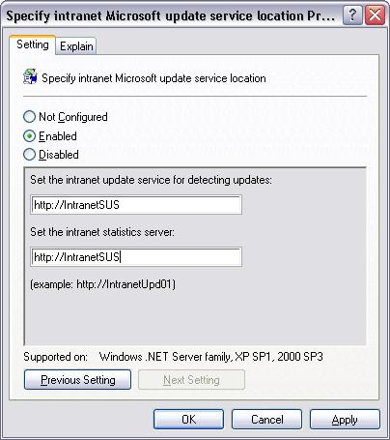
Figure 32 Group Policy setting to specify the server running Software Update Services
Using this Group Policy setting, you can configure the server running SUS that your Windows clients will be redirected to. You also specify a server to which you would like Automatic Updates to send statistics to. The computers running Automatic Updates software send success or failure information about the download and installation of updates to the IIS logs of the specified statistics server.
Note: The statistics server must be running IIS. The statistics sent to the server will be stored in the IIS logs. See Appendix C for more information.
If a server running SUS is not specified, Automatic Updates gets updates from the public Windows Update service on the Internet.
Note: The server running SUS and the statistics server can be the same computer.

Configuration Options in a Non-Active Directory Environment
In a non-Active Directory environment, an administrator can set registry settings to configure Automatic Updates.
Note: You will need to manually create these registry keys.
You can set these registry keys in several ways:
- By manually editing the registry using Regedit.exe.
- By centrally deploying these registry keys using Windows NT 4-style System Policy.
You can add the settings below to the registry at this location:
HKEY_LOCAL_MACHINE\Software\Policies\Microsoft\Windows\WindowsUpdate\AU
RescheduleWaitTime
Range: n; where n = time in minutes (1-60)
Registry value type: REG_DWORD
NoAutoRebootWithLoggedOnUsers
Set this to 1 if you want the logged on users to choose whether or not to reboot their system
Registry value type: REG_DWORD
NoAutoUpdate
Range = 0|1. 0 = Automatic Updates is enabled (default), 1 = Automatic Updates is disabled.
Registry Value Type: Reg_DWORD
AUOptions
Range = 2|3|4. 2 = notify of download and installation, 3 = automatically download and notify of installation, and 4 = automatic download and scheduled installation. All options notify the local administrator.
Registry Value Type: Reg_DWORD
ScheduledInstallDay
Range = 0|1|2|3|4|5|6|7. 0 = Every day; 1 through 7 = the days of the week from Sunday (1) to Saturday (7).
Registry Value Type: Reg_DWORD
ScheduledInstallTime
Range = n; where n = the time of day in 24-hour format (0-23).
Registry Value Type: Reg_DWORD
UseWUServer
Set this to 1 to enable Automatic Updates to use the server running Software Update Services as specified in WUServer below.
Registry Value Type: Reg_DWORD
Note: When configuring Automatic Updates directly though the policy registry keys, the policy will override the preferences set by the local administrative user to configure the client. If the administrator removes the registry keys at a later date, the preferences set by the local administrative user will be used again.
To determine which server running Software Update Services your client computers and servers go to for their updates, place the following two settings in the registry at this location:
HKEY_LOCAL_MACHINE\Software\Policies\Microsoft\Windows\WindowsUpdate
WUServer
Sets the SUS server by HTTP name (for example, http://IntranetSUS).
Registry Value Type: Reg_SZ

WUStatusServer
Sets the SUS statistics server by HTTP name (for example, http://IntranetSUS).
Registry Value Type: Reg_SZ

Troubleshooting

Software Update Services
No new updates appear on the Approve updates page after I synchronize my server.
Either there are no new updates since you last synchronized the server, or your memory caches are not loading new updates properly. To reload your memory caches, click Monitor server in the navigation bar, and then click Refresh.

The SUS Administration Web site is not functioning properly:
When I try to synchronize my server, nothing happens.
I can't change my settings on the Set options page.
I keep getting a message that says my synchronization service is not running.
Your synchronization service may not be working properly.
To restart the synchronization service
- Click Start, and then click Run.
- Type services.msc, and then click OK.
- In the results pane, right-click Windows Update Synchronization Service.
- Click Restart.

I can't access the SUS Administration Web site, or Automatic Update clients cannot connect to the server running SUS.
You may need to restart IIS (the Web server).
To restart IIS
- Click Start, and then click Run.
- Type services.msc, and then click OK.
- In the results pane, right-click World Wide Web Publishing Service.
- Click Restart.
Note: If you are using SUS on a Small Business Server computer that has a Microsoft Internet Security and Acceleration (ISA) Server that requires authentication, the username should be in the following format DomainName\Username.
Note: If you are using Windows Server 2003, security features may prevent you from accessing the Administrator Web site until you configure the server for access. For more information, see “Accessing the SUS Administrator Web Site” on page 74.

Automatic Updates client
How do I determine if the Automatic Updates service is running?
On Windows 2000:
- Right-click My Computer, and then click Manage.
- Expand Services and Applications, and then click Services.
- Verify that Automatic Updates appears on the list of services. If it appears, double-click the Automatic Updates entry, and view the Service Status.
On Windows XP:
- Click Start, click My Computer, and then click Manage.
- Expand Services and Applications, and then click Services.
- Verify that Automatic Updates appears on the list of services. If it appears, double-click the Automatic Updates entry, and check the Service Status.

I’ve completed installing the Automatic Updates client, but it doesn’t appear to be getting updates from the server running SUS.
In the “Configuring the Client” section, you can direct your Automatic Updates client computers by either setting a policy or directly setting a registry key. On the Windows client computer, ensure that the following values exist:
HKEY_LOCAL_MACHINE\Software\Policies\Microsoft\Windows\WindowsUpdate
WUServer=”http://<YourServer>”
WUStatusServer=”http://<YourServer>”
HKEY_LOCAL_MACHINE\SOFTWARE\Policies\Microsoft\Windows\WindowsUpdate\AU
UseWUServer=dword:00000001
Note: <YourServer> should be replaced with the name of your Windows server running SUS.
Whenever Windows Update client components update a Windows computer, the %windir%\Windows Update.log file is updated with information regarding the download and installation of the packages. This log file will have a series of log entries, for example:
2002-03-25 19:08:47 Success IUENGINE Querying software update catalog from http://intranetSUS/autoupdate/getmanifest.asp
If entries like this one do not exist, the Automatic Updates service on that client computer has not yet attempted to query the server for updates. The client waits approximately 24 hours between attempts to query the server for updates.
On the server side, Automatic Updates will make requests like the following when querying the server for updates:
2002-03-25 19:08:48 127.0.0.1 – 127.0.0.1 80 POST /autoupdate/getmanifest.asp - 200 Mozilla/4.0+(compatible;+Win32;+WinHttp.WinHttpRequest.5)

Appendix A: Understanding Security and Software Update Services Setup

Installation Location Of The Software Update Services Web Site:
Depending on the configuration of IIS prior to installing SUS, the location of the SUS Web site will vary.

Case 1: Default Web site running
This is the default case that you encounter if you just installed IIS on your server or if the Default IIS Web site was running.
In this case, Setup installs the SUS Web site under the default Web site. All the required components are installed in either folders or VRoots under the default site, such that they do not interfere where any Web sites or Vroots currently running in the default Web site.
Setup does install the following files under root of the default Web site, but none of these will interfere with any existing Web sites:
- wutrack.bin
- IUcert.cab
- IUIdent.cab
The following figure illustrates the files and folders that are created in the default Web site:
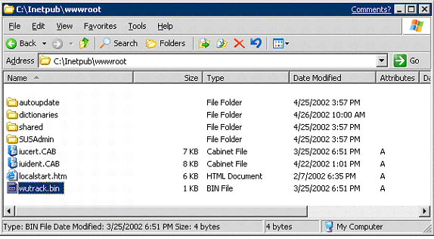
Figure 33. Files and folders in default Web site

Case 2: Default Web site stopped, but another Web site is running and bound to port 80.
If the default Web site is not running, and you have another Web site running and bound to port 80, prior to installing SUS, Setup will install SUS administrative Web pages into the site that is currently bound to port 80.
Everything else is the same as Case 1 above.

Case 3: No Web sites are running
If no Web sites are running, and you install SUS, Setup will create a new Web site at port 80 called SUS and will install SUS administrative Web pages into that Web site.
Everything else is the same as Case 1 above.

What components of IIS need to be present prior to installing Software Update Services?
If you install IIS 5.0 on Windows 2000 or IIS 6.0 on any of the Windows Server 2003 family of operating systems with the default set of components, you will have everything you need to run SUS.
Specifically, if you want to just install the minimum IIS components to use SUS, then you should install the following IIS components prior to the installation of SUS:
- Common Files
- Internet Information Services Snap-In
- World Wide Web Server
What Changes will Setup make to my IIS configuration? (in the IIS metabase)
The following IIS metabase properties are changed during SUS set up:
IIS configuration to ensure that IIS does not start more than one thread per process
Property | Value
w3svc/AspProcessorThreadMax | 1
IIS configuration for throttling the number of threads based on CPU usage
Property | Value
w3svc/AspThreadGateEnabled | True

IIS Lockdown Configuration
When SUS is installed on a Windows 2000 Server, the setup utility determines whether IIS Lockdown 2.0 or URL Scanner 2.5 have been installed. If not, SUS setup will automatically install and configure both of them. These utilities are distributed by Microsoft to secure IIS using templates. The type of lockdown template used is determined dynamically during setup. For most Windows 2000 platforms, the “dynamic web” template is used. However, on Microsoft Small Business Server 2000 with Service Pack 1, the “sbs2000” template is used. If the either of these templates is installed prior to running SUS setup, setup will not make any changes to the lockdown settings.
The following table details the configuration that is automatically applied by the SUS Setup. You do not need to perform any actions. This table details the changes that will be made during the installation of SUS to IIS to make it more secure.

Option | Software Update Server setting
Remove Script Mappings: ASP | Enable .ASP files
Remove Script Mappings: IDQ | Disable
Remove Script Mappings: SHTML, SHTM, STM | Disable
Remove Script Mappings: IDC | Disable
Remove Script Mappings: printer | Disable
Remove Script Mappings: HTR | Disable
Remove Sample Web files | Remove them
Remove Scripts Virtual Directory | Remove them
Remove MSDAC virtual directory | Remove it
Disable WebDAV | Disable WebDav
Prevent IIS anonymous user from executing system utilities | Prevent it
Prevent IIS anonymous user account from writing Web content | Prevent it
Parent path | Disable it

Note: IIS Lockdown is not applied when installing SUS on Windows Server 2003, since IIS 6.0 is by default in a secure mode. But the setup for SUS will make the following change to IIS 6.0 for the Windows Server 2003 family:
Setup enables Asp.dll, which can be done by setting a property in the IIS metabase:
ISAPIRestrictionList: = “0”, “asp.dll”
This disables all script mappings other than Asp.dll.

What happens to IIS Lockdown when I uninstall Software Update Services?
When you uninstall SUS, Setup does not remove the changes made by the IIS Lockdown tool.
The following list contains the specific settings in IIS that are changed and the state that they will be left in after uninstalling SUS:
Software Update Services Windows 2000 IIS Lockdown configuration:
[dynamicweb]
label="Dynamic Web server (ASP enabled)"

Enable_iis_http=TRUE
Enable_iis_ftp= FALSE
Enable_iis_smtp= FALSE
Enable_iis_nntp= FALSE
Enable_asp= TRUE
Enable_index_server_Web _interface= FALSE
Enable_server_side_includes= FALSE
Enable_internet_data_connector= FALSE
Enable_internet_printing= FALSE
Enable_HTR_scripting= FALSE
Enable_webDAV= FALSE
Disable_Anonymous_user_system_utility_execute_rights= TRUE
Disable_Anonymous_user_content_directory_write_rights= TRUE
Remove_iissamples_virtual_directory=TRUE
Remove_scripts_directory=TRUE
Remove_MSADC_virtual_directory=TRUE
Remove_iisadmin_virtual_directory=TRUE
Remove_iishelp_virtual_directory=TRUE
UrlScan_Install=TRUE
UrlScan_IniFileLocation=urlscan_dynamic.ini
AdvancedSetup =
UninstallServices=FALSE
The following list contains the specific settings in IIS that are changed and the state that they will be left in after uninstalling SUS from Microsoft Small Business Server 2000 with Service Pack 1:
label="Small Business Server 2000"

Enable_iis_http=TRUE
Enable_iis_ftp= FALSE
Enable_iis_smtp= TRUE
Enable_iis_nntp= TRUE
Enable_asp= TRUE
Enable_index_server_web_interface= TRUE
Enable_server_side_includes= FALSE
Enable_internet_data_connector= FALSE
Enable_internet_printing= FALSE
Enable_HTR_scripting= FALSE
Enable_webDAV= TRUE
Disable_Anonymous_user_system_utility_execute_rights= TRUE
Disable_Anonymous_user_content_directory_write_rights= TRUE
Remove_iissamples_virtual_directory=TRUE
Remove_scripts_directory=TRUE
Remove_MSADC_virtual_directory=TRUE
Remove_iisadmin_virtual_directory=TRUE
Remove_iishelp_virtual_directory=TRUE
UrlScan_Install=TRUE
UrlScan_IniFileLocation=urlscan_sbs2000.ini
AdvancedSetup =
UninstallServices=FALSE

label="Small Business Server 2000"

Enable_iis_http=TRUE
Enable_iis_ftp= FALSE
Enable_iis_smtp= TRUE
Enable_iis_nntp= TRUE
Enable_asp= TRUE
Enable_index_server_web_interface= TRUE
Enable_server_side_includes= FALSE
Enable_internet_data_connector= FALSE
Enable_internet_printing= FALSE
Enable_HTR_scripting= FALSE
Enable_webDAV= TRUE
Disable_Anonymous_user_system_utility_execute_rights= TRUE
Disable_Anonymous_user_content_directory_write_rights= TRUE
Remove_iissamples_virtual_directory=TRUE
Remove_scripts_directory=TRUE
Remove_MSADC_virtual_directory=TRUE
Remove_iisadmin_virtual_directory=TRUE
Remove_iishelp_virtual_directory=TRUE
UrlScan_Install=TRUE
UrlScan_IniFileLocation=urlscan_sbs2000.ini
AdvancedSetup =
UninstallServices=FALSE

Your current URLScan settings may be found at:
%windir%\system32\inetsrv\urlscan

Accessing the SUS Administrator Web Site
Security enhancements in Windows Server 2003 may result in problems accessing the SUS site after you install SUS 1.0 SP1. This section lists common situations and the actions you should take to ensure that you can access the SUS web site.
- SUS is installed on the default web site running with a specific IP address.
In Internet Explorer, add http://ipaddress to the Local Intranet list. Close the browser. Open a new browser using http://ipaddress/SUSAdmin.
- You are using the Microsoft Software Update Services icon under Administrative Tools to administer the SUS server.
Ensure that http://computername is added to local Intranet list from the client IE browser. Double clicking the icon invokes http://computername/SUSAdmin.
- You are using another computer within the intranet to administer SUS Server.
Ensure that http://SUSServer_computername is added to the Local intranet site list from the client Internet Explorer browser. This is only necessary if the computer from which you are administering the SUS server is running Windows Server 2003.
Note: http://localhost is added to Local Intranet list by default.
- You need to add a site to the trusted list
Open Internet Explorer->Tools->Internet Options->Security. Select Trusted Sites and click Sites. Add the site that you want to access in the text box. Close all the dialog boxes
- You need to add a site to the Local Intranet site list
Open Internet Explorer->Tools->Internet Options->Security. Select Local Intranet and click Sites and then click Advanced. Add the site that you want to access in the text box. Close all the dialog boxes

Where is the content stored for Software Update Services?
When you install SUS, the location to store content is determined. If you select typical installation during set up, Setup finds the NTFS drive on your server that has the most free disk space and creates a folder called SUS and places the folders for content there.
If you select custom install during set up, you can choose an alternate location for SUS to store its content as long as the drive is using NTFS
How to use additional components of IIS (Share Point Team Services/FrontPage Extensions/ASP.NET)
The following only applies to running SUS on the Windows Server 2003 family of operating systems. FrontPage and Share Point Team Services should run in the default configuration on Windows 2000 servers.
For security purposes, SUS disables a number of ISAPI handlers when installed on the host IIS server. This can disable existing functionality for sites that rely on any of the following technologies:
- ASP.NET
- FrontPage Server Extensions
- Share Point Services
If you have Web sites that rely on any of the above components, you will need to re-enable the necessary ISAPI handlers after SUS Setup is completed.
To enable an ISAPI handler, perform the following steps:
- Launch the Internet Information Services (IIS) snap-in, found in the Administrative Tools folder on the Start menu.
- Right-click on the server node, and then click Security. This will launch the IIS Security Lockdown Wizard.
- Click Next until you get to the Enable request handles page.
- Under ISAPI Handlers, click each ISAPI handler you want to enable. See below for a screen-shot showing this dialog box.
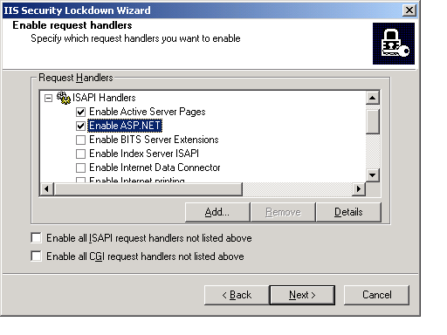
Figure 34
Once you have selected the desired set of ISAPI handlers to enable, proceed through the rest of the wizard.
For ASP.NET pages, you need to enable the ASP.NET ISAPI Handler.
For FrontPage Server Extensions and Share Point, you need to enable the following ISAPI Handlers:
- admin.dll
- fpadmdll.dll
- author.dll
- owssvr.dll
- shtml.dll

Appendix B: Software Update Services Event Log Messages
The following is the complete list of Event Log messages that could be reported on your server running SUS. All of these events are logged on the server to the System Log.
_______________________
EventID=101
Severity=Error
SymbolicName=MSG_SYNC_FAILED
Language=English
Software Update Services encountered a failure during synchronization.

View the synchronization log on this server for details of what failed during synchronization. To view the synchronization log, go to the Software Update Services Admin Web site (http://<YourServerName>/SUSAdmin), and click the View synchronization log link. (Error %1: %2)

User Action
Try synchronizing the server again to see if the error occurs again. To synchronize the server, go to the Software Update Services Admin Web site, and click the Synchronize server link. Then click the Synchronize Now button.

Additional Data
The most common reason for failed synchronization is incorrect proxy server configuration. If you are using a proxy server, please confirm your configuration by going to the Software Update Services Admin Web site and clicking the Set options link. Confirm your configuration in the results pane.

For troubleshooting information, see the Microsoft Software Update Services Deployment Guide.
_______________________
EventID=102
Severity=Error
SymbolicName=MSG_SYNC_CANCELLED
Language=English
Software Update Services did not complete synchronization. An administrator cancelled the synchronization.

This server may not be completely up-to-date, due to the cancelled synchronization.

User Action
To start the synchronization operation again, go to the Software Update Services Admin Web site (http://<YourServerName>/SUSAdmin), and click the Synchronize server link. Then click the Synchronize Now button.

For more information about administering a server running Software Update Services, see the Microsoft Software Update Services Deployment Guide.
_______________________
EventID=103
Severity=Warning
SymbolicName=MSG_WARN_INVALID_CERT
Language=English
Software Update Services did not complete synchronization. During the synchronization, a file was downloaded that was not correctly signed by Microsoft.

'%1' downloaded from '%2' has a digital signature that is missing or not valid.

As a security measure, Software Update Services checks all content to confirm that it originated from Microsoft and has been correctly signed with the Microsoft certificate.

User Action
If you are configured to synchronize content from the Windows Update Download servers, try synchronizing again. This problem may be due to the file being corrupted during download.

If you are configured to synchronize content from another server running Software Update Services on your intranet, try synchronizing again as well. If this still does not succeed, confirm that the server you are synchronizing from has not been tampered with.

Additional Data
The problem may be one of the following:
The certificate has expired.
The file was incorrectly signed.
The file was tampered with.
The file was corrupted during download.
_______________________
EventID=104
Severity=Success
SymbolicName=MSG_SYNC_SUCCEEDED
Language=English
Software Update Services successfully synchronized all content.

Your server is completely up-to-date.

User Action
To view the list of files that may have been added, removed, or updated during this synchronization, see the synchronization log.

To see the synchronization log, go to the Software Update Services Admin Web site (http://<YourServerName>/SUSAdmin), and then click the View synchronization log link.

For more information about administering a server running Software Update Services, see the Microsoft Software Update Services Deployment Guide.
_______________________

EventID=105
Severity=Informational
SymbolicName=MSG_SYNC_SUCCEEDED_WITH_ERRORS
Language=English
Software Update Services successfully synchronized some content during this synchronization. However, not all items were downloaded successfully.

Items that were not downloaded will not be available for approval, nor will they be available for your clients to download from this server.

User Action
For more details about the items that were not downloaded and why, see the synchronization log.

To see the synchronization log, go to the Software Update Services Admin Web site (http://<YourServerName>/SUSAdmin), and then click the View synchronization log link.

Try synchronizing your server again to see if the error occurs again. To synchronize your server, go to the Software Update Services Admin Web site, and click the Synchronize server link. Then click the Synchronize Now button.

For more information about administering a server running Software Update Services, see the Microsoft Software Update Services Deployment Guide.
_______________________
EventID=106
Severity=Error
SymbolicName=MSG_MISSING_WWWROOT
Language=English
Software Update Services has encountered a problem.

The synchronization service that is used to download content to your server cannot locate the Internet Information Services Web site where Software Update Services should be installed.

This problem has prevented the synchronization service from starting. This server will not be able to provide any content to clients that access this server.

User Action
Please run Microsoft Software Update Services Setup again.

For more information about administering a server running Software Update Services, see the Microsoft Software Update Services Deployment Guide.
_______________________
EventID=107
Severity=Warning
SymbolicName=MSG_SETTINGS_LOAD_ERROR
Language=English
Software Update Services failed to load some configuration information. Examples of configuration information include: proxy server configuration, content location, and client locales to support. Because not all configuration information was loaded successfully, the default settings will be used instead.

User Action
To confirm your configuration, go to the Software Update Services Admin Web site (http://<YourServerName>/SUSAdmin), and click the Set options link.

Additional Data
One or more errors occurred while loading the settings file '%3'. (Error %1: %2)

For more information about administering a server running Software Update Services and for a list of the default values, see the Microsoft Software Update Services Deployment Guide.
_______________________

EventID=108
Severity=Warning
SymbolicName=MSG_SETTINGS_SAVE_ERROR
Language=English
Software Update Services failed to save some configuration information. Examples of configuration information include: proxy server configuration, content location, and client locales to support.

Because some configuration information was not saved, some features might not perform as expected.

User Action
Confirm your configuration by going to the Software Update Services Admin Web site (http://<YourServerName>/SUSAdmin) and clicking the Set options link.

Additional Data
One or more errors occurred while saving the settings file '%3'. (Error %1: %2)
For more information about administering a server running Software Update Services, see the Microsoft Software Update Services Deployment Guide.
_______________________

EventID=109
Severity=Warning
SymbolicName=MSG_DELETE_TEMP_CATALOG_ERROR
Language=English
Not all temporary files were successfully deleted during the last content synchronization.

During content synchronization, Software Update Services creates and uses some temporary files on this server. When synchronization is complete, Software Update Services deletes all temporary files.

Additional Data
Unable to delete temporary file '%3'. (Error %1: %2)

For more information about administering a server running Software Update Services, see the Microsoft Software Update Services Deployment Guide.
_______________________

EventID=110
Severity=Warning
SymbolicName=MSG_DELETE_OLD_CATALOG_ERROR
Language=English
The catalog was not successfully deleted after the last synchronization.

During content synchronization, Software Update Services stores on this server a copy of the old catalog that lists the available updates.

When synchronization is complete, Software Update Services deletes the old catalog.

Additional Data
Unable to delete old catalog file '%3'. (Error %1: %2)

For more information about administering a server running Software Update Services, see the Microsoft Software Update Services Deployment Guide.
_______________________
EventID=111
Severity=SUCCESS
Language=English
The list of Software Update Services updates that are available on this server has been successfully changed.

User Action
To view the changes that were made to the list of approved updates, see the approval log.

To see the approval log, go to the Software Update Services Admin Web site (http://<YourServerName>/SUSAdmin), and then click the View approval log link.
Additional Data
The user %1 changed the list of approved updates.

For more information about administering a server running Software Update Services, see the Microsoft Software Update Services Deployment Guide.
_______________________

EventID=112
Severity=FAILURE
Language=English
The list of Software Update Services updates that are available on this server failed to be updated.

The previous list of approved updates continues to be in effect.

User Action
To view the current list of approved updates, see the approval log.

To see the approval log, go to the Software Update Services Admin Web site (http://<YourServerName>/SUSAdmin), and then click the View approval log link.

Restart the Windows Update Content Synchronization Service by clicking Start, clicking Run, and then typing Services.msc . Right-click Windows Update Synchronization Service in the results pane, and then click Properties. Click Stop, and then click Start.

After restarting the service, try again to change the list of approved packages. Go to the Software Update Services Admin Web site, and then click the Approve Items link.

Additional Data
The user %1 attempted to change the list of approved packages, but this change was not successfully applied.
For more information about administering a server running Software Update Services, see the Microsoft Software Update Services Deployment Guide.

Appendix C: Client Status Logging
As mentioned in the “Group Policies” section earlier in this document, you can configure the Automatic Updates client to return status messages to a statistics server. This server needs to be an IIS server. The IIS logs are used to determine the client status.
Note: If your statistics server is different from your server running SUS, you need to copy the \<root of the SUS Website>\Vroot\WUtrack.bin file to the root of your statistics server.

What are the IIS logs?
These are logs that IIS writes to when IIS receives requests for a file. The Automatic Update client sends results back to the SUS IIS server that are logged in the IIS logs together with any other logging that IIS is currently configured to perform.

Where can I find the IIS logs?
The default location for the IIS logs is %WINDOWS%/system32/LogFiles/W3SVCx where x is an integer. The format of the file name for the log files is exyymmddhh.log for example ex02042215.log

How can I change where IIS writes the logs?
You can change where IIS stores log files by following these steps:
- Open IIS.
- Right click the Default Web Sites folder and click Properties
- On the Web Sites tab in Default Website Properties, click Properties.
- In the Extended Logging Properties dialog box, change the Log File Directory to another location.
Note: Changing the location of where IIS stores the log files does not change the content of the logs. You can also change the format and data that is included for each entry in the log in the Extended Logging Properties dialog box.
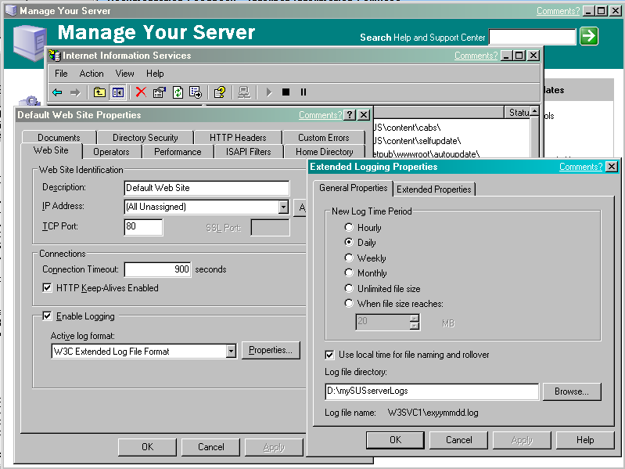
Figure 35. Changing default location of IIS logs

What will I find in the IIS logs?
Whatever IIS is configured to log will appear in these logs. The information logged to these files can be tailored by changing the settings in IIS.

How do I alter IIS to only log events sent by the Automatic Updates client?
IIS can be configured to only write the logs sent by the Automatic Updates client. You can configure file logging on your IIS server so that only requests for Wutrack.bin are logged, thus reducing the amount of non-status traffic. This can be done as follows:
- Open Internet Information Services.
- Right–click the on “Default Web Sites” folder, and then click on “Properties”.
- On the Home Properties tab in the Default Website Properties dialog box, uncheck Log Visits.
- In the right pane of the IIS window, right-click wutrack.bin, and then click Properties.
- Click the File tab of the wutrack.bin Properties dialog box, and then check Log Visits.

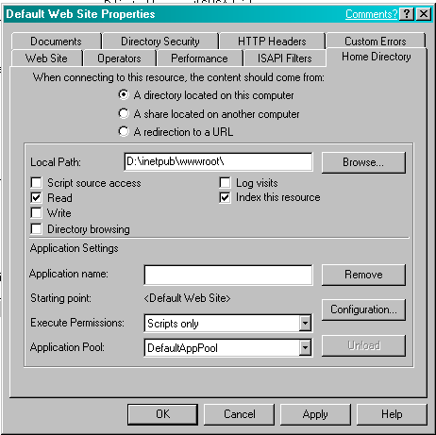
Figure 36. Disabling all logging
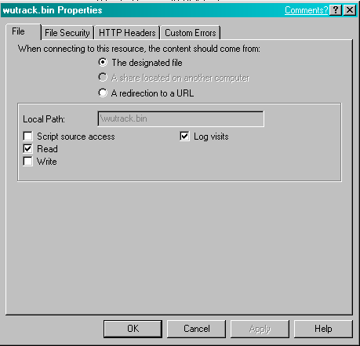
Figure 37 Enabling logging for Automatic Updates Client only

When does the Automatic Updates client return results that IIS will log?
The Automatic Updates client returns status on the following:
- During Self-update: self-update pending, ,
- After Self-update: self-update success/failure
- During Detection : initialization success/failure
- After Detection: detection success, detection failure
- After Download: download success/declined/failure
- After Installation: installation success/declined/failure
As well as receiving status from the Automatic Updates client, IIS will also receive similar status reports when the user visits the Windows Update Web site. These will also be logged against “wutrack.bin”.

Interpreting the Automatic Updates Information logged by IIS
The status entries returned to the server running SUS are in the following format:
/wutrack.bin?U=<ping_ID>&C=<client>&A=<activity>&I=<item>&D=<device>&P=<platform>&L=<language>&S=<status>&E=<error>&M=<message>&X=<proxy>
/wutrack.bin
?U=<ping_ID>
&C=<client >
&A=<activity>
&I=<item>
&D=<device>
&P=<platform>
&L=<language>
&S=<status>
&E=<error>
&M=<message>
&X=<proxy>

Where:

Ping ID is a unique identifier, so you can determine the number of unique computers getting updates from your server running SUS.
Client is a value representing the client type issuing the status response. In the case of the SUS, the correct values are: “AU” used for actions such as download and installation, and “IU” used for actions such as initialization. ”IU_Site” will be used when users visit the Windows Update Web site.
Activity specifies the activity the component has performed. The value can be any of the following:
"n" – Initialization:
This activity is here for diagnostic purposes. Both successes and failures for such activity will be logged so that you can determine the percentage of failure cases.
"s" – Self-update:
This activity is here for diagnostic purposes. Both failures and successes for this activity will be logged.
"d" – Detection:
This activity is here for diagnostic purposes. Failures and those unable to produce an update item will be logged.
"w" – Download:
This activity is here for both diagnostic and reporting purposes. Failures and successes as well as cancellations and declinations, if applicable, will be logged.
"i" – Installation:
This activity is here for both diagnostic and reporting purposes. Failures and successes with no reboot, as well as successes with reboot, and declinations, if applicable, will be logged.
Item stores a string that identifies the item the client component was dealing with. The value should be an empty string (“”) if not used.
Device stores the ID of the device being dealt with. For non-device items, this value should be an empty string (“”).
Platform provides the platform version information of the client operating system. This field stores a string resulting from concatenating various platform related information in the following format:
<maj_os_ver>.<min_os_ver>.<build_num>.<plat_id>.<suite_mask>.<prod_type>.<processor_arch>
The following information will assist in determining the platform:
<plat_id> identifies the operating system platform.
Possible <Plat_id> Values
<plat_id> Value | Description
1 | Win32 technology – for example, Windows 95/Windows 98/Windows Millennium Edition
2 | Windows NT technology – for example. Windows NT/Windows 2000/Windows XP

The next table details the possible values for <suite_mask>, which is a set of bit flags that identify the product suites available on the system. This member can be a combination of the following values:

<suite_mask> Value |  | Description
1 |  | Microsoft Small Business Server is installed.
2 |  | Windows 2000 Advanced Server or Windows Server 2003Windows Server 2003 Enterprise Server is installed.
4 | Microsoft BackOffice components are installed.
10 | Terminal Services is installed.
20 | Microsoft Small Business Server is installed with the restrictive client license in force.
80 | Windows 2000 DataCenter Server is installed.
100 | Single-user version of Terminal Services is installed.
200 | Windows XP Home Edition is installed.

<prod_type> indicates additional information about the system. This member can be one of the following values:
<prod_type> Value | Description
1 | The system is running Windows NT 4.0 Workstation, Windows 2000 Professional, Windows XP Home Edition, or Windows XP Professional.
2 | The system is a domain controller.
3 | The system is a server.

<processor_arch> specifies the system's processor architecture. This value can be one of the following values:
Description | <Processor_arch> value
PROCESSOR_ARCHITECTURE_INTEL | 0
64-bit Windows: PROCESSOR_ARCHITECTURE_IA64 | 6
64-bit Windows: PROCESSOR_ARCHITECTURE_AMD64 | 9
64-bit Windows: PROCESSOR_ARCHITECTURE_IA32_ON_WIN64 | 10

Language stores a language identifier of the client operating system in human-readable form, such as "en-US".
Status indicates the status of the activity being logged. Here is a list of possible values (some do not apply to all component/activity combinations):
“s” – Succeeded:
The activity was performed completely and successfully.
“r” – Succeeded (reboot required):
The activity was successfully performed to the extent that the computer had to be rebooted in order for the client component to proceed.
“f” – Failed:
The client component failed to perform the activity, due to reasons other than cancellation by user.
“c” – Cancelled:
The activity was cancelled by user at the client computer when it was in progress.
“d” – Declined:
The activity was declined by user at the client computer. This value should be used when the user specifies the activity not be performed, normally upon an object.
“n” – No items:
No update items were available for the client component to perform the activity. This value is here to make obsolete the “DUNODRIVER” activity code in Windows Update version 3.
“p” – Pending:
Any information returned is used by developers/support for resolving issues for customers.
Error is an 8-digit hexadecimal value that specifies the result of the activity performed—for example, "800C0005". It should contain a “0” string when it is not used. This field is to indicate the cause of the status for the activity performed.
Message could include an explanation of an encountered error. Typically, this field is used to report what went wrong with an activity. The value should be an empty string (“”) if not used.
Proxy stores the timestamp of the status message. The timestamp format is YYMMDDHHMMSSmmm.

The following are examples that the Auto Update client will provide to the status server:
Self-update
Pending:
/wutrack.bin?U=<ping_ID>&C=AU&A=w&I=&D=&P=<platform>&L=<language>&S=p&E=0&M=4.0&X=<proxy>
Succeeded:
/wutrack.bin?U=<ping_ID>&C=AU&A=w&I=&D=&P=<platform>&L=<language>&S=s&E=0&M=4.0&X=<proxy>
Failed:
/wutrack.bin?U=<ping_ID>&C=AU&A=w&I=&D=&P=<platform>&L=<language>&S=f&E=<error>&M=4.0&X=<proxy>

Detection
Succeeded:
/wutrack.bin?U=<ping_ID>&C=AU&A=d&I=&D=&P=<platform>&L=<language>&S=s&E=<error>&M=items:<itemcount>&X=<proxy>
Failed:
/wutrack.bin?U=<ping_ID>&C=AU&A=d&I=&D=&P=<platform>&L=<language>&S=f&E=<error>&M=<message>&X=<proxy>

Download per update
Succeeded:
/wutrack.bin?U=<ping_ID>&C=AU&A=w&I=<item>&D=&P=<platform>&L=<language>&S=s&E=0&M=&X=<proxy>
Failed:
/wutrack.bin?U=<ping_ID>&C=AU&A=w&I=<item>&D=&P=<platform>&L=<language>&S=f&E=<error>&M=<message>&X=<proxy>
Cancelled by user:
/wutrack.bin?U=<ping_ID>&C=AU&A=w&I=<item>&D=&P=<platform>&L=<language>&S=c&E=0&M=&X=<proxy>
Declined by user:
/wutrack.bin?U=<ping_ID>&C=AU&A=w&I=<item>&D=&P=<platform>&L=<language>&S=d&E=0&M=&X=<proxy>

Installation per update
Succeeded:
/wutrack.bin?U=<ping_ID>&C=AU&A=i&I=<item>&D=&P=<platform>&L=<language>&S=s&E=0&M=&X=<proxy>
Pending (for exclusive packages):
/wutrack.bin?U=<ping_ID>&C=AU&A=i&I=<item>&D=&P=<platform>&L=<language>&S=p&E=<error>&M=<message>&X=<proxy>
Failed:
/wutrack.bin?U=<ping_ID>&C=AU&A=i&I=<item>&D=&P=<platform>&L=<language>&S=f&E=<error>&M=<message>&X=<proxy>
Declined:
/wutrack.bin?U=<ping_ID>&C=AU&A=i&I=<item>&D=&P=<platform>&L=<language>&S=d&E=0&M=&X=<proxy>

Error Codes Delivered by Automatic Updates
This is a list of the common error code arguments that can be received from Automatic Updates. This is not an exhaustive list as we return whichever error we encounter which may not have come from any of our components.
Error | Description | Details
8007042b | ERROR_PROCESS_ABORTED | The process terminated unexpectedly.
80072733 | DLOAD_FAILURE | A non-blocking socket operation could not be completed immediately.
8007001e | AN ERROR OCCURED CALLING DLLREGISTER SERVER | NULL
80070001 | An error occurred during transmission: A network connection with the remote server could not be established. | NULL
ffffffff | Cancel | The user canceled the transaction
800704c7 | Cancelled by user | NULL
800703fd | Cannot create a stable subkey under a volatile parent key. | Cannot create a stable subkey under a volatile parent key.
800c0008 | Cannot download the information you requested. | NULL
80070570 | Cannot open file | NULL
80070015 | Cannot open please verify the path and file are correct or The_device_is_not_ready | NULL
80070017 | Data error (cyclic redundancy check). | Data error (cyclic redundancy check).
80004004 | E_ABORT | Operation aborted error
80004005 | E_Fail | General error or Unknown Error
80070006 | E_Handle | Handle not valid error
80070057 | E_INVALIDARG | One or more arguments are not valid error.
800705aa | Error loading resources | NULL
80070005 | ERROR_ACCESS_DENIED | Access is denied. The authentication method is not supported.
800703f5 | ERROR_CANTWIRTE | The configuration registry key could not be written.
e000022b | ERROR_DI_DONT_INSTALL | NULL
8007045a | ERROR_DLL_INIT_FAILED | NULL
e0000234 | ERROR_DRIVER_NONNATIVE | NULL
800700ff | ERROR_EA_LIST_INCONSISTENT | The extended attributes are inconsistent.
80072f76 | ERROR_HTTP_HEADER_NOT_FOUND | The requested http header could not be located
80072f78 | ERROR_HTTP_INVALID_SERVER_RESPONSE | The server response could not be parsed.
80072f7c | ERROR_HTTP_REDIRECT_FAILED | NULL
80072efd | ERROR_INTERNET_CANNOT_CONNECT | Cannot connect to the Internet server
80072efe | ERROR_INTERNET_CONNECTION_ABORTED | The connection with the server has been terminated.
80072eff | ERROR_INTERNET_CONNECTION_RESET | The connection with the server has been reset.
80072ee4 | ERROR_INTERNET_INTERNAL_ERROR | An internal error has occurred.
80072ee7 | ERROR_INTERNET_NAME_NOT_RESOLVED | The server name could not be resolved. DNS Error. Please try a different root DNS (Like UUNET)
80072ee2 | ERROR_INTERNET_TIMEOUT | The request has timed out. The connection to this Internet site took longer than the allotted time.
e000020d | ERROR_INVALID_CLASS_INSTALLER | NULL
800701a9 | ERROR_INVALID_FUNCTION | NULL
8007051b | ERROR_INVALID_OWNER | This security ID may not be assigned as the owner of this object.
8007045d | ERROR_IO_DEVICE | The request could not be performed because of an I/O device error.
800703e5 | ERROR_IO_PENDING | NULL
e0000219 | ERROR_NO_ASSOCIATED_SERVICE | NULL
800703fb | ERROR_NO_LOG_SPACE | System could not allocate the required space in a registry log.
80070103 | Error_No_More_Items: | Windows has determined that the selected driver is not the best driver for your machine.
e000020b | ERROR_NO_SUCH_DEVINST | NULL
80070008 | ERROR_NOT_ENOUGH_MEMORY | The system is out of memory.
800703e3 | ERROR_OPERATION_ABORTED | The I/O operation has been aborted because of either a thread exit or an application request.
800700e7 | ERROR_PIPE_BUSY | NULL
80070715 | ERROR_RESOURCE_TYPE_NOT_FOUND | The specified resource type cannot be found in the image file.
e0000101 | ERROR_SECTION_NOT_FOUND | NULL
80070080 | ERROR_WAIT_NO_CHILDREN | There are no child processes to wait for.
80070643 | Fatal error during installation | NULL
800c0002 | http can not find the file specified | http can not find the file specified
80070190 | HTTP_STATUS_BAD_REQUEST (400) | 400 // invalid syntax. The request could not be processed by the server due to invalid syntax.
80070193 | HTTP_STATUS_FORBIDDEN (403) | 403// Server is too busy to process request. The server understood the request, but is refusing to fulfill it.
800701f8 | HTTP_STATUS_GATEWAY_TIMEOUT (504) | 504 // timed out waiting for gateway. The request was timed out waiting for a gateway.
8007019b | HTTP_STATUS_LENGTH_REQUIRED (411) | This is a known issue. Possibly relating to proxy servers that don't support http1.1. The server refuses to accept the request without a defined content length.
80070194 | HTTP_STATUS_NOT_FOUND (404) | 404// Cabs or page is not found. The server has not found anything matching the requested URI (Uniform Resource Identifier).
80070197 | HTTP_STATUS_PROXY_AUTH_REQ (407) | 407 error (proxy authentication required) - need specific password/user to access. Proxy authentication required.
80070198 | HTTP_STATUS_REQUEST_TIMEOUT (408) | The server timed out waiting for the request.
800701f4 | HTTP_STATUS_SERVER_ERROR (500) | The server encountered an unexpected condition that prevented it from fulfilling the request.
800701f7 | HTTP_STATUS_SERVICE_UNAVAIL (503) | 503// Server is to busy to process request. The service is temporarily overloaded.
800703e6 | Invalid access to memory location | NULL
800700c1 | is not a valid Win32 application | not a valid Win32 application.
0x3 | iuctl.dll and iuengine.dll are not the correct version | iuctl.dll.dll and iuengine.dll are not the correct version and are unable to be updated.
0x1 | iuctl.dll is not the correct version | iuctl.dll is not the correct version and is unable to be updated.
fffffb4a | JET_errDatabaseCorrupted | NULL
fffffbf8 | JET_errFileAccessDenied | NULL
fffffc0d | JET_errOutOfMemory | NULL
ffffff99 | JET_errOutOfThreads | NULL
80070070 | Method '~' of object '~' failed Not enough Hard Drive Space | NULL
800a1391 | Microsoft Jscript® runtime 'Recordset1' is undefined | Jscript error “undefined identifier"
800a0005 | Microsoft VBScript runtime error Invalid procedure call or argument: 'fs.OpenTextFile' | NULL
800a01b6 | Microsoft VBScript runtime error Object doesn't support this property or method: | NULL
80000007 | Operation aborted | NULL
80070490 | Permission denied / [Problem initializing or using session variables] or Element not found | NULL
800701f6 | Proxy was unable to forward the request to the destination server | NULL
c0000005 | STATUS_ACCESS_VIOLATION | NULL
c000013a | STATUS_CONTROL_C_EXIT | NULL
c0000142 | STATUS_DLL_INIT_FAILED | NULL
c000001d | STATUS_ILLEGAL_INSTRUCTION | NULL
c0000006 | STATUS_IN_PAGE_ERROR | NULL
0x0 | Success | NULL
8007000d | The Data is invalid. Cannot open | NULL
8007048f | The device is not connected. | NULL
800705af | The paging file is too small for this operation to complete | NULL
80070020 | The process cannot access the file because it is being used by another process | NULL
8007041f | The service database is locked | NULL
80070426 | The service has not been started | NULL
80070004 | The set of folders could not be opened. You do not have sufficient privileges to access the file. Personal Folders | NULL
8007007e | The specified module could not be found | NULL
80070430 | The specified service has been marked for deletion | NULL
80070002 | INSTALL_FAILURE | Error_File_Not_Found: The system cannot find the file Specified.
80070003 | The system cannot find the path specified. | Windows Update folder does not exist or the V4 folder within Windows Update is missing. (The correct code path is something like this: %Program Files%\WindowsUpdate\V4)
800b0100 | TRUST_E_NOSIGNATURE | NULL
800b0003 | TRUST_E_SUBJECT_FORM_UNKNOWN | NULL
800b0004 | Trust_E_Subject_Not_Trusted; The subject is not trusted for the specified action. | The subject is not trusted for the specified action. (Digital Signatures on file D:\Program Files\WindowsUpdate\V4\iuident.cab are not trusted)
80070714 | Version unavailable or Invalid | The specified image file did not contain a resource section.
80072EE7 | DLOAD_FAILURE | The requested lookup key was not found in any active activation context.
801901F4 | Invalid interface string | Invalid interface string

Related Links
For more information, see the following resources:
- Software Update Services Home Page at: http://go.microsoft.com/fwlink/?LinkId=6930.
- Applying Service Pack 1 to Microsoft Software Update Services version 1.0 at: http://go.microsoft.com/fwlink/?LinkId=6930
- Software Update Services Overview at: http://go.microsoft.com/fwlink/?LinkId=6927
- Automatic Updates Group Policy Settings (.adm files) at: http://go.microsoft.com/fwlink/?LinkId=12954
- Microsoft Security at: http://www.microsoft.com/security/ Web site.
- Microsoft Windows Update at http://www.windowsupdate.microsoft.com Web site.
- Understanding Group Policy white paper at: http://www.microsoft.com/windows2000/techinfo/howitworks/management/grouppolwp.asp Web site.
- Managing Windows XP in a Windows 2000 Server Environment at: http://www.microsoft.com/windowsxp/pro/techinfo/administration/policy/default.asp.
- Network Load Balancing Technical Overview at: http://www.microsoft.com/windows2000/techinfo/planning/clustering.asp.

Feedback
To provide feedback about Microsoft Software Update Services or this white paper, write to Software Update Services Feedback at: cwufdbk@microsoft.com.

