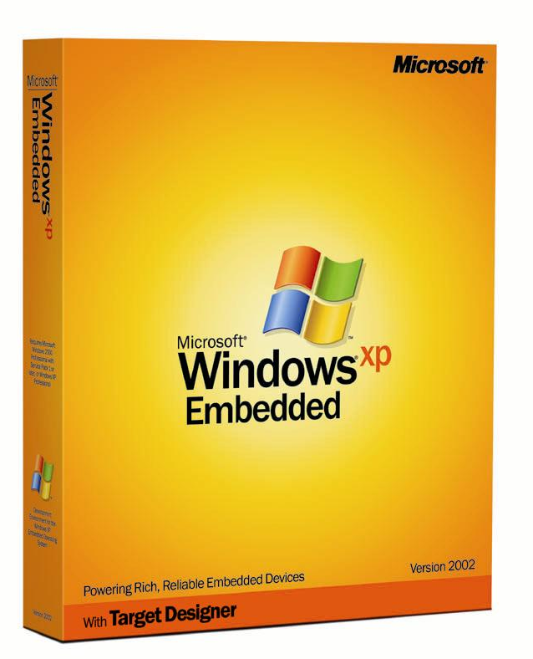
Windows XP Embedded is the operating system and development platform delivering the power of the Windows operating system in componentized form to rapidly build reliable and advanced embedded devices.

Based on the same binaries as Windows XP Professional, Microsoft® Windows® XP Embedded allows developers to choose from over 10,000 individual feature components to achieve optimum functionality in a reduced footprint. Windows XP Embedded also allows you to reduce time-to-market by taking advantage of a familiar programming model and a powerful set of tools. In addition, Windows XP Embedded delivers industry-leading reliability, performance, and security along with the latest multimedia, Web browsing, power management, and device support.

For More Information

Please visit the Windows XP Embedded Web site at http://www.microsoft.com/windows/embedded/xp/default.asp.
Choose from over 10,000 individual feature components based on Windows XP Professional binaries to achieve optimum functionality in a reduced footprint.
- Windows Embedded Studio tools enable you to select only the features you want, to create a customized device design.
- Build devices that enable rich multimedia and Web browsing experiences, using features such as Windows Media® Player 8, DirectX® 8 and Internet Explorer 6.
- Bring up your device and store your image via a variety of technologies, such as booting from flash, floppy, PXE and CD.
- Choose from a number of ways to seamlessly deploy and service your image, such as Remote Boot, System Deployment Image Manager, Device Update Agent and WinPE.

Reduce time-to-market by taking advantage of a familiar programming model and a powerful set of tools.
- Use standard commodity PC hardware and run Win32® applications, drivers and services.
- Take advantage of familiar features such as drag-and-drop and the overall look and feel of the desktop version of the product.
- Leverage the knowledge and expertise of more than 6 million developers worldwide who are using Microsoft Visual Studio® .NET for rapid application development.
- Use a rich end-to-end tool suite to quickly build a platform based on requirements of your target device.

Windows XP Embedded provides industry leading reliability, performance and security technology to enable dependable solutions.
- Built upon the proven code base on of Windows XP, Windows XP Embedded takes advantage of a 32-bit computing architecture, fully-protected memory model, and features such as device driver rollback and driver signing.
- Supports industry security standards such as Kerberos, IPSec, and Smart Card, providing enterprise-level security for your device.
- Based on a smaller, more modular platform (than Windows XP Professional), which inherently leads to even higher reliability.

What Windows XP Embedded Includes:
Versatile embedded-enabling features, such as flexible boot and storage options and headless support.

Powerful Windows Embedded Studio development tools:
  - Target Designer: Create, customize, and build a bootable run-time image
  - Component Designer: Create or modify components.
  - Target Analyzer: Analyzes content of target hardware and creates a file to import into Target Designer or Component Designer.
  - Component Database Manager: A tool for effectively managing your component database and repositories.

To develop with Microsoft Windows XP Embedded, you need:
- PC with 500 MHz or higher processor
- CD-ROM or DVD-ROM drive
- Microsoft Mouse or compatible pointing device

Additional items or services required depending upon the Windows XP Embedded installation type chosen:
For tools-only configuration:
- Microsoft Windows 2000 with Service Pack 2 or later, or Windows XP operating system
- 128 MB of RAM minimum, 256 MB or higher recommended
- Microsoft Internet Explorer 5.5 or later
- 20 MB of available hard-disk space
- VGA or higher resolution monitor, 1024x768 display recommended
For database-only configuration:
- Microsoft Windows 2000 with Service Pack 2 or later, or Windows XP operating system, minimum; Windows 2000 Server with Service Pack 2 or later recommended
- 128 MB of RAM minimum, 256 MB or higher recommended
- 3 GB of available hard disk space
- Network connection
- VGA or higher resolution monitor
For tools and database configuration on a single computer:
- Microsoft Windows 2000 with Service Pack 2, or Windows XP operating system
- 256 MB of RAM minimum; 512 MB or higher recommended
- Microsoft Internet Explorer 5.5 or later
- 3.2 GB of available hard-disk space
- VGA or higher resolution monitor, 1024 x 768 display recommended

For information about the Remote Boot service, visit:
http://www.microsoft.com/windows/Embedded/xp/evaluation/features/remoteboot.asp

