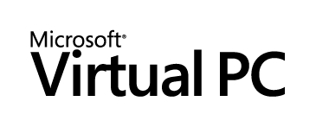
Microsoft®
By Jerry Honeycutt
Published November 2003
Abstract
Microsoft® Virtual PC 2004 allows users to conveniently run multiple operating systems on a single computer. Users can switch operating systems as easily as they switch applications—instantly, with a mouse click. As a migration tool, Virtual PC provides a cost-effective safety net for certain employees to run critical legacy applications on an interim basis while you continue migrating to a new operating system. Virtual PC also helps companies more rapidly develop, test, support, and deploy applications. This document presents a technical overview of Virtual PC and how it can benefit your company.

The information contained in this document represents the current view of Microsoft Corporation on the issues discussed as of the date of publication. Because Microsoft must respond to changing market conditions, it should not be interpreted to be a commitment on the part of Microsoft, and Microsoft cannot guarantee the accuracy of any information presented after the date of publication.
This white paper is for informational purposes only. MICROSOFT MAKES NO WARRANTIES, EXPRESS OR IMPLIED, IN THIS DOCUMENT.
Complying with all applicable copyright laws is the responsibility of the user. Without limiting the rights under copyright, no part of this document may be reproduced, stored in or introduced into a retrieval system, or transmitted in any form or by any means (electronic, mechanical, photocopying, recording, or otherwise), or for any purpose, without the express written permission of Microsoft Corporation.
Microsoft may have patents, patent applications, trademarks, copyrights, or other intellectual property rights covering subject matter in this document. Except as expressly provided in any written license agreement from Microsoft, the furnishing of this document does not give you any license to these patents, trademarks, copyrights, or other intellectual property.
© 2003 Microsoft Corporation. All rights reserved. Microsoft, MS-DOS, Active Directory, the Office logo, Windows, the Windows logo, and Windows NT are either registered trademarks or trademarks of Microsoft Corporation in the United States and/or other countries.
The names of actual companies and products mentioned herein may be the trademarks of their respective owners. Microsoft Corporation • One Microsoft Way • Redmond, WA 98052-6399 • USA
Contents
Acknowledgments 3
Virtual PC Overview 4
Virtual PC Features 7
PC Virtualization 8
Virtual Hard Disks 9
Networking 10
Virtual Machine Additions 12
Virtual PC Requirements 13
Virtual PC in Action 15
Installation 15
Configuration 15
Guest Operating Systems 17
Guest Applications 19
Virtual PC Scenarios 20
Legacy Support 20
Technical Support 21
Quality Assurance 22
Training 23
Migration Testing 23
Summary 26
For More Information 27

Acknowledgments
Bryan Chee, Microsoft Corporation
Kurt Schmucker, Microsoft Corporation
Carla Huffman, Microsoft Corporation
Robert Larson, Microsoft Corporation
Ben Armstrong, Microsoft Corporation
Elsa Rosenberg, Studio B Productions
David Talbott, Studio B Productions

Virtual PC Overview
Microsoft® Virtual PC 2004 is software that lets users run two or more x86 operating systems on their computers—concurrently. It prevents complicated multi-boot configurations in environments where people must use multiple operating systems (whether because of incompatible legacy applications or as a safeguard during migration). Users install multiple guest operating systems in virtual machines. Figure 1 shows Microsoft Windows® XP Professional with two virtual machines open: Windows NT® Workstation 4.0 and Windows 98. Virtual PC emulates a physical computer so exactly that the applications users install in them don’t distinguish the virtual machine from a physical computer. Instead of installing operating systems on multiple, costly computers or creating unwieldy multi-boot installations, you can install the operating systems in multiple, inexpensive virtual machines. Changes that users make in virtual machines don’t affect their physical computers. Virtual PC makes using multiple operating systems easier.
Figure 1. Windows NT Workstation 4.0 and Windows 98 Guest Operating Systems in Windows XP
Virtual PC is a time and cost-saving solution in any scenario in which users must run multiple operating systems. In the enterprise, it provides you a low-cost safeguard for maintaining legacy applications during migration. And it allows employees to run mission-critical legacy applications temporarily while you continue migrating to a new operating system, such as Windows XP. The result is you don’t have to delay a cost-saving deployment until your company can replace or update mission-critical legacy software. You also don’t need to purchase additional equipment just to support legacy software that doesn’t run on the corporate-standard version of Windows. Instead, you can deploy Windows XP with Virtual PC to allow users who must run applications that are incompatible with Windows XP. Then, they can install a compatible version of Windows or OS/2 in a virtual machine and run the legacy application in that virtual machine. Once the operating-system migration is complete and the legacy applications are updated, you can remove Virtual PC from those computers and install the applications in Windows XP.
Other scenarios in which people typically use multiple operating systems include technical support, quality assurance, and training. In the case of technical support, Virtual PC helps support technicians provide quicker responses and reduce call times. Rather than maintaining multiple computers or restarting computers for different support calls, they can simply start a pre-built virtual machine that matches the caller’s configuration—almost instantly. With Virtual PC, test engineers are able to test applications against a wider variety of configurations in shorter amounts of time. Virtual PC provides quicker turnaround times for training rooms and enables more diverse classes based on more configurations. Table 1 summarizes the benefits, and the section “Virtual PC Scenarios” provides more information about how Virtual PC benefits all of these scenarios.
Table 1. Virtual PC Benefits
Scenario | Description | Benefits
Migration | - Run older legacy applications while migrating to a new operating system  - Pilot and test new operating systems in a controlled, fail-safe environment | By enabling employees to run mission-critical legacy applications temporarily while you continue migrating to a new operating system, such as Windows XP, Virtual PC provides you a low-cost safeguard for maintaining legacy applications during migration. So Windows XP Professional deployments can continue on schedule, even when faced with unanticipated application compatibility issues. This allows Microsoft customers to take advantage of the ROI and productivity gains of more current operating systems.  Compared to the current approach of using individual computers or networks dedicated to each test configuration, Virtual PC is less expensive, quicker to set up and use, and more flexible.

Scenario | Description | Benefits
Technical Support | - Support multiple operating systems on a single computer without rebooting the computer or buying additional computers  - Set up numerous user-specific configurations on a single computer for real-time scenario testing and evaluation | Virtual PC reduces call times, improves response time, reduces hardware and operating costs, and enables more timely support for customers.
Quality Assurance | - Test and document software on different operating systems on one computer  - Compare application look and feel in multiple environments simultaneously  - Test potentially unstable prerelease software in a safe, isolated environment | Virtual PC enables a more timely and cost-effective development and testing process, resulting in improved software quality and reduced time-to-market.
Training | - Train people on any x86 operating system without purchasing additional computers  - Dramatically reduce classroom turnaround time by instantly switching configurations | You can support more users while minimizing equipment costs and setup time and make it easier for a single instructor to manage a multiple-operating system class.

Virtual PC Features
The benefits of using Virtual PC include the following:
- Configurability. Users can configure virtual machines, add or remove memory, and install or uninstall applications. Users can create a variety of environments, and Virtual PC is so easy to use and configure that most users require no training at all. Also, the product lets you control the configuration of Virtual PC in locked-down environments.
- Easy installation. Virtual PC gives users two options for adding new guest operating systems. First, they can install a guest operating system manually. This is almost identical to installing the operating system on a physical computer. In migration scenarios, you’ll probably build configurations in advance and then deploy them to users.
- Standardization. Since the virtual machine hardware does not change between physical computers, using one physical computer, you can configure and test upgrades and installations on virtual machines, and then you can deploy throughout your company a standard configuration that avoids bugs caused by minor differences between hardware platforms. This approach eliminates exhaustive testing on computer after computer.
- Convenience. Users switch between operating systems as easily as they switch between applications. They simply click the window containing the virtual machine. They can pause individual virtual machines so they stop using CPU cycles on the physical computer. They can also save virtual machines to disk and restore them at a later time. The restoration process normally takes a few seconds—much faster than restarting the guest operating system. Users manage running, paused, and saved virtual machines through a single, convenient user interface.
- Host integration. Integration makes interoperability between the guest and host operating systems easy. For example, users can copy, paste, drag, and drop between guest and host. Virtual PC provides Virtual Machine Additions that you install in a guest operating system to enable this functionality.
Each virtual machine acts like a standalone computer. It has its own sound, video, hard disk and network cards and its own processor. And each virtual machine runs its own operating system. Users can install and run most x86 operating systems in a virtual machine. Microsoft fully supports the following operating systems running in a virtual machine on Virtual PC: Windows 95, Windows 98, Windows Me, Windows NT 4.0 Workstation, Windows 2000 Professional, Windows XP, MS-DOS®, OS/2 Warp Version 4 Fix Pack 15, OS/2 Warp Convenience Pack 1, and OS/2 Warp Convenience Pack 2. Users can also install Windows Server operating systems and numerous third-party operating systems, including Red Hat Linux, Novell NetWare, and others. Any application that users install in their virtual machines work normally, including business, education, entertainment, Internet, and other programs. And devices that users connect to their physical computers, such as printers, modems, CD-ROM drives, and so on, work normally in their virtual machines. Standard USB input devices such as keyboards and mice are supported through PS/2 emulation, but Virtual PC does not support USB devices that require their own drivers. Virtual machines also don’t see the physical computer’s hardware video card as a native device, so you can't install your own video card drivers. In addition, SCSI devices are not supported in a virtual machine.
The following sections provide an overview of the technologies in Virtual PC. The section “PC Virtualization” describes how Virtual PC virtualizes computers. The section “Virtual Hard Disks” describes the types of virtual hard disks that Virtual PC provides. And the section “Networking” describes the different networking modes that are available in a virtual machine.

PC Virtualization
Normally, computers run one operating system at a time. As Figure 2 shows, applications run on top of the operating system. The operating system uses device drivers to address the computer’s hardware. And the hardware includes the mouse and keyboard, processor, memory, disk drives and drive controllers, video cards, network cards, and other physical devices. In other words, a computer contains one set of devices, runs one operating system at a time, and has one set of applications on that operating system.
Figure 2. Physical Computers
On the other hand, Virtual PC uses virtual machine technology to run two or more operating systems and their related applications at the same time, as Figure 3 shows. In fact, only the physical computer’s resources, such as memory and disk space, limit the number and variety of operating systems and programs that users can run. The more memory that’s available, the more operating systems the user can run at the same time.
As shown in the figure, guest operating environments rely partially on emulated hardware and partially on virtualized hardware. Virtual PC emulates many of the virtual machine’s hardware in software. Emulated hardware components include the interrupt controller, DMA controller, IDE/ATA controller, non-volatile RAM, real-time clock, buses, I/O controller, keyboard controller, memory controller, programmable timers, and power-management hardware. Virtual PC then uses the host operating system to interact with any external devices – like the CD-ROM, floppy, keyboard, mouse or physical display.
Figure 3. Virtual Machines

Virtual Hard Disks
Virtual PC supports virtual hard disks in a number of powerful and flexible ways. Users can associate several virtual hard disks with each virtual machine. Virtual PC supports the following types of disks:
- Dynamically expanding virtual hard disks. Virtual hard disks are a single file that users create on the physical computer’s hard disk. The virtual hard disk file will dynamically expand as users write data to them. They initially use very little space, and expands up to the maximum size of the disk.
- Fixed-size virtual hard disks. Like dynamically expanding virtual hard disks, fixed-size virtual hard disks are a single file that users create on the physical computer’s hard disk. The file is approximately the same size as the virtual hard disk and doesn’t grow or shrink in size. For example, if a virtual hard disk is 2 GB, the virtual hard disk file is 2 GB.
- Linked virtual hard disks. Virtual PC supports linked virtual disks hard disks, which link directly to a disk in the physical computer. This advanced capability allows you to leverage already existing hard disk configurations.
Virtual PC also supports two other virtual hard disk features that you can use with the above virtual hard disk types:
- Differencing virtual hard disks. Differencing virtual hard disks allow multiple users and multiple virtual machines to use the same parent virtual hard disk at the same time. Virtual PC stores any changes to the virtual hard disk in the differencing virtual hard disk. For example, you can store a parent virtual hard disk on the network to share it with many users, and then Virtual PC stores any changes that they make in local differencing virtual hard disks.
- Undo disks. Undo disks allow users to delete any changes they make to the virtual hard disk during a session (a session lasts from the time the virtual machine is started until it is closed). Virtual PC stores these changes in a separate temporary file; and then at the end of the session, users can save, commit, or delete the changes. Undo disks allow users to start with the exact same virtual disk every time. For example, you can use undo disks to test a deployment scenario in a safe environment and delete the changes at the end of the session. The next time you start the virtual machine, it will be in a clean state ready for another test.

Networking
Virtual PC supports four networking modes:
- Not connected. The virtual machine appears to not be connected to any network.
- Local Only. The virtual machine communicates with other running virtual machines on the ‘Local only’ network. No traffic transmits over the wire to other computers and no traffic is exchanged with the host operating system.
- Virtual networking. With virtual networking, shown in Figure 4, each virtual machine looks like a separate workstation on the network. It’s able to transmit packages to other computers connected to the network, including the host operating system and other virtual machines.
Figure 4. Virtual networking
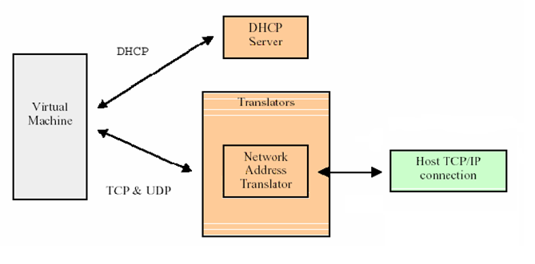
- Shared networking (NAT). Shared networking is helpful when using dial-up Internet services. Virtual PC allows guest operating systems to get an IP address dynamically, as Figure 5 shows, without redialing the ISP. Several virtual machines share a single external IP address for accessing the outside network, which Virtual PC accomplishes by using integrated Network Address Translation (NAT) with a DHCP server.
Figure 5. Shared networking

Virtual Machine Additions
Virtual Machine Additions is installed on the guest operating system and is particular to the given guest operating system. They provide a high level of integration between the host and guest operating systems. Features include integrated mouse, time synchronization, cut & paste, drag & drop, folder sharing, and arbitrary screen resolutions. Full integration support is only available for Windows guest operating systems. Partial levels of integration support are available for other supported platforms.

Virtual PC Requirements
Before you set up and install Virtual PC, make sure that the computer you plan to use meets or exceeds the minimum requirements. The product itself, not including guest operating systems, requires less than 20 MB of disk space. Each guest operating system requires substantially more disk space, however. The computer must have at least enough memory to cover the requirements of the operating system running on the physical computer, in addition to all operating systems you plan to run simultaneously on virtual machines. The operating system that runs on the physical computer is called the host operating system and the operating systems that run on virtual machines are called guest operating systems.

Following are the minimum system requirements for the physical computer and the host operating system.
- An x86-based computer with one of the following processors: AMD Athlon/Duron family or Intel Celeron or Pentium II, III, or 4 family; 400 MHz minimum, 1.0 GHz or faster recommended. You can run Virtual PC on a multi-processor computer, but it uses only one processor.
- CD-ROM or DVD drive.
- Super VGA (800 x 600) or higher resolution monitor recommended.
- Keyboard and Microsoft mouse or compatible pointing device.
- Host operating system: Windows© XP Professional, Windows 2000 Professional, or Windows XP Tablet PC Edition.

To determine the minimum physical memory requirements for Virtual PC, refer to Table 2. Just add the requirement for the host operating system that you’ll be using (i.e., Windows XP Professional or Windows 2000 Professional) to the requirement for the guest operating system that you’ll be using. If you’ll be using multiple guest operating systems, total the requirements for all the guest operating systems that you need to run simultaneously. The following examples assume that your specified physical memory requirement is 256 MB for Windows XP:
- Users will run Windows 98 and Windows NT 4.0 as guest operating systems concurrently on Windows XP. The minimum memory requirement is then 256 MB + 64 MB + 64 MB = 384 MB.
- Users will run Windows 95 or Windows Me as guest operating systems on Windows XP at different times. The minimum requirements is then 256 MB + 96 MB = 352 MB.
Table 2. Minimum Hard Disk and Memory Requirements
Guest Operating System | Minimum Memory | Minimum Hard-Disk Space
MS-DOS 6.22 | 32 MB | 50 MB
Windows 95 | 32 MB | 500 MB
Windows 98, Windows 98 Second Edition | 64 MB | 500 MB
Windows Millennium Edition (Windows Me) | 96 MB | 2 GB
Windows NT Workstation 4.0, Service Pack 6 or Higher | 32 MB | 500 MB
Windows 2000 Professional | 96 MB | 2 GB
Windows XP Home Edition | 128 MB | 2 GB
Windows XP Professional | 128 MB | 2 GB
OS/2 Warp Version 4 Fix Pack 15, OS/2 Warp Convenience Pack 1, OS/2 Warp Convenience Pack 2 | 64 MB | 500 MB

NOTE: Virtual PC can only use the available non-paged physical RAM in the host.

Virtual PC in Action
The following sections—Installation, Configuration, Guest Operating Systems, and Guest Applications—describe Virtual PC’s capabilities.

Installation
Virtual PC is simple to install. Any administrator can run the Virtual PC setup program, which guides the user through the straightforward installation process that Figure 6 shows. And installation doesn’t require a reboot. The first time you start Virtual PC, it guides you through the process of creating the first virtual machine.
NOTE: The host networking adaptors will momentarily lose network connection during the Virtual PC Network switch driver installation.
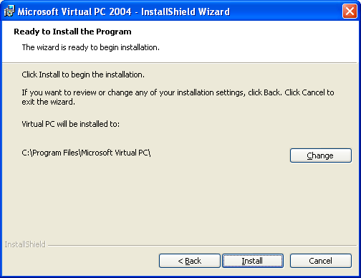
Figure 6. Virtual PC Installation

Configuration
After installing Virtual PC, you configure it to suit your requirements. Virtual PC has a number of options that control how the product interacts with the physical computer, allocates resources, and so on. Figure 7 shows the product’s Options dialog box on which you can configure the following groups of settings:
- Restore at Start. You can choose whether to restore running virtual machines when you launch Virtual PC.
- Performance. You can configure how much processor time virtual machines get when they’re in the foreground versus the background. You can also tune the background performance of Virtual PC.
- Full Screen Mode. You can configure Virtual PC to use the optimal video resolution and color depth of virtual machines running in full-screen mode.
- Sound. You can configure Virtual PC to mute sound coming from all virtual machines.
- Messages. You can suppress all of the Virtual PC messages or reset them so that messages you chose to ignore by clicking Don’t show this message again appear again.
- Keyboard. You can configure the host key, which is the key that you use to take control of the mouse after the virtual machine captures it. You can also configure Windows key combinations to apply to the virtual machine, physical computer, or the virtual machine only when it’s in full-screen mode.
- Mouse. You can configure whether virtual machines capture the mouse when you click in their windows.
- Security. You can configure security features that lock down specific Virtual PC features unless the user is a member of the local Administrators group. This setting is useful in enterprise environments, particular when you use Virtual PC as a migration tool.
- Language. You can configure the language that Virtual PC uses for its user interface.
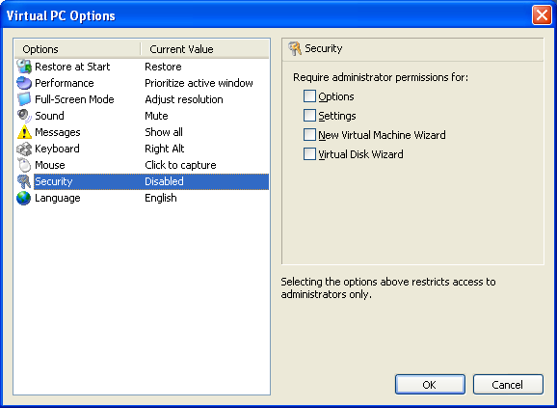
Figure 7. Configuring Virtual PC

Guest Operating Systems
After installing and configuring Virtual PC, the next step is creating a virtual machine and installing an operating system in it. Most often, you’ll install an operating system by running its setup program in the virtual machine. You use the same methods, such as booting from the CDROM or starting the computer by using MS-DOS or Microsoft Windows Preinstallation Environment, and then running the setup program. Figure 8 shows Windows XP installing in a virtual machine. Please note that you need to ensure that you are appropriately licensed for all guest operating systems, as guest operating system licenses are not included with a Virtual PC license.
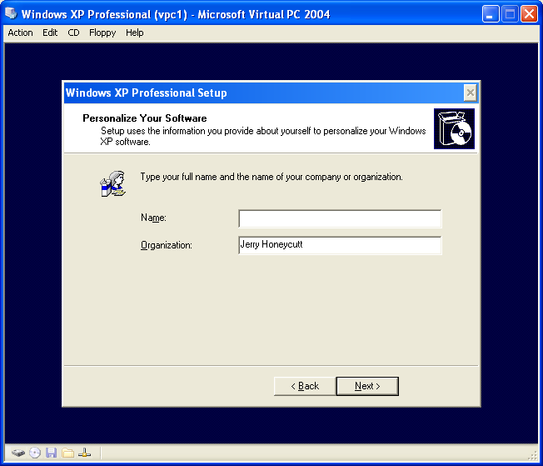
Figure 8. Installing Windows XP in a Virtual Machine
After creating a virtual machine and installing an operating system on the virtual hard disk, you can distribute the virtual hard disk to other users. As you read in the section “Virtual Hard Disks,” there are three options available. First, you can distribute the virtual disk as-is, which means that users can change their copies of the virtual disk as they require. Second, you can distribute the disk or post it to the network as a differencing virtual hard disk. In this scenario, Virtual PC stores users’ changes in local differencing files instead of changing the original virtual disk that you distributed or posted to the network. Last, you can configure the virtual machine with undo disks, giving users the choice of deleting or saving their changes when they end a session.
Virtual PC gives you complete control of each virtual machine’s configuration. As Figure 9 shows, you can change the virtual machine’s memory allocation. You can mount up to three virtual hard disks, configure how the virtual machine mounts the CD-ROM drive and whether it automatically detects the physical computer’s floppy disk drive, and connect to shared folders on the physical computer. You can also configure the virtual machine’s ports, networking connections, and so on.
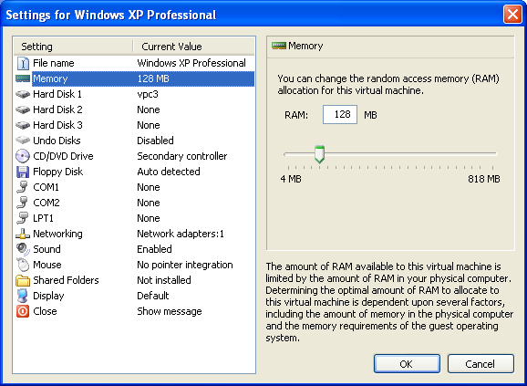
Figure 9. Configuring Individual Virtual Machines
To better integrate virtual machines with the physical computer, you can use Virtual Machine Additions, which is on the product CD. Virtual Machine Additions is a package that you install in the guest operating systems to better integrate the guest and host operating systems. It adds support for Drag and Drop, folder sharing, improved mouse integration, joystick support, international keyboard support, DOS-based CD-ROM support, optimized video drivers, and time synchronization.

Guest Applications
After configuring a virtual machine and installing an operating system in it, the final step is to install applications in the guest operating system. Virtual PC automatically mounts any CD that you insert in the physical computer’s CD-ROM drive in the guest operating system’s virtual CD-ROM drive. To install an application, you simply install the application from the CD normally.

Virtual PC Scenarios
Virtual PC enables a variety of scenarios. For example, it enables operating system migrations in environments that use legacy applications that aren’t compatible with Windows XP. It enables you to test configurations before deploying them to real users and enables help-desk technicians to better support users who might run varieties of operating systems. The Virtual PC features that enable these scenarios include the following:
- Ease of use. Users switch between operating systems and applications with a mouse click. They don’t need to repetitively restart the physical computer with each operating system.
- Reduced total cost of ownership (TCO). Rather than purchasing multiple computers, one for each operating system, you can run multiple operating systems on a single computer without requiring multi-boot configurations.
- Stability. Guest operating systems don’t affect the physical computers’ day-to-day operations. Virtual PC prevents guest operating systems from accessing the host or other guest operating systems. If a guest operating system becomes unstable, it has no effect on other guest operating systems or the host operating system. Running legacy applications using Virtual PC enhances the PC’s stability.
- Legacy support. After migrating to new hardware and operating systems, users’ legacy applications might not run or they might run unstably. Users can install the operating system with which those programs are compatible in a virtual machine, however, and then run them stably.
- Responsiveness. Virtual PC increases help-desk technicians’ customer responsiveness. They can answer inquiries faster. By using Saved States, they can quickly start a pre-built virtual machine that matches callers’ configurations.
- Quality work. With Virtual PC, users who rely on multiple operating system configurations can produce higher quality work. For example, Quality Assurance can test new products with greater ranges of operating systems in less time by using Virtual PC to test them.
- Training. With Virtual PC, instructors can train students by using a variety of configurations, quickly and easily. Training rooms require less time to set up between sessions, too.

Legacy Support
Virtual PC enables companies to take advantage of new operating systems while continuing to support legacy applications that aren’t compatible with them. Some of the applications on which companies rely may not run on Windows XP. If you’re migrating to Windows XP and have a legacy application that doesn’t work in it, then you might have believed you had two choices. You could scratch your deployment until the developers update the legacy applications, or you could allow people who use those applications to have two computers until the developers update them.
Now you can install Virtual PC on those users’ computers, which allows them to run the operating system version with which those legacy applications are compatible. If your accounting department uses bookkeeping software that works only in Windows 98, you can delay the migration until the vendor updates the software. Better yet, you can install Windows XP and Virtual PC, create a virtual machine, install Windows 98 as a guest operating system, and then install the bookkeeping software in that virtual machine. Those users can reap all of the benefits that Windows XP offers but continue using their bookkeeping software in their virtual machines.

Technical Support
Virtual PC reduces call times, improves response times, and lowers support costs.
Help desks support several varieties of hardware and software configurations. The combinations of Windows versions, application versions, service packs, hot fixes, and so on become unwieldy. The best-case scenario is that help-desk technicians must maintain multiple computers or restart their computers to support people who use various configurations. The worst case is they don’t have access to a configuration that a caller is using, and so the technicians guess or fly blind and caller satisfaction suffers.
With Virtual PC, help-desks are better able to duplicate callers’ environments, including the operating systems, applications, service packs, and other variations. Help-desk technicians can build these environments in advance and then, when a user calls for support, load the environments in seconds from a file server, CD-ROM, DVD, and so on. For example, help-desk technicians who use Windows XP can still support Windows 98, Windows Me, Windows NT, and Windows 2000 users (see Figure 10) without maintaining multiple computers or starting their computers with a different operating system, which are costly and time consuming options. Instead, they simply start a pre-built virtual machine in saved state, which takes seconds, and then continue the call.
Figure 10. List of Guest Operating Systems
Virtual PC does more for the help desk than provide instant access to varieties of configurations. For example:
- Virtual PC enables help-desk technicians to support users in safe, isolated environments. If the computer crashes when the help desk is testing users’ problems, the crash affects only the virtual machine. The crash doesn’t affect other virtual machines or the host operating system.
- Virtual PC enables help desk technicians to start with a clean operating environment every time. Instead of wasting time restoring a configuration to a pre-test state, reloading the operating system, and installing applications, they simply use undo disks and discard changes after the support call. Doing this allows the virtual machine to start undo disks with the same configuration each time.
In migration scenarios, Virtual PC enables the help desk to support a wider variety of configurations. Technicians have instant access to the new operating system as well the operating systems it replaces.

Quality Assurance
Virtual PC enables quality assurance engineers to test software in more environments faster.
Quality assurance engineers must test their applications on a vast number of configurations. For example, Windows developers often design software that works with different language versions of Windows 98, Windows Me, Windows NT, Windows 2000, and Windows XP. The combinations of operating systems doesn’t even account for the varying hardware. Test engineers must test their applications in all of the support operating systems.
Testing this software on all of the possible configurations isn’t practical. But Virtual PC provides a way for test engineers to verify their software against multiple operating systems and language versions, as Figure 11 shows. And they can test their software faster because each virtual machine starts within seconds, and they can switch between virtual machines with a mouse click. Also, Virtual PC provides an isolated environment for testing their software. If the software crashes, the crash doesn’t affect the physical computer, and they can restart the virtual machine quickly.
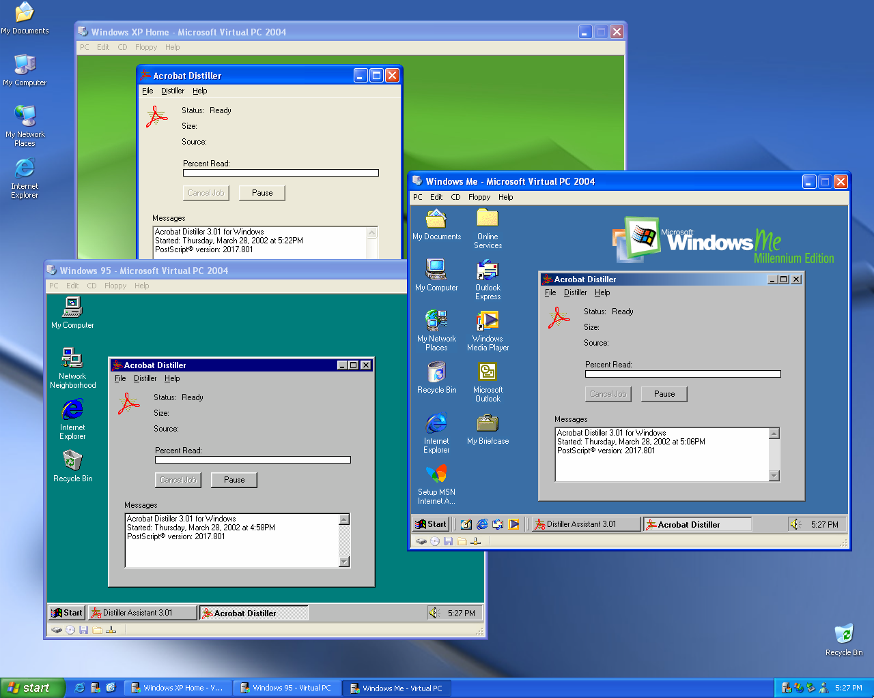
Figure 11. Testing in Multiple Versions of Windows

Training
Virtual PC enables companies to better train their employees while reducing their hardware investments.
Trainers can offer more classes based on more configurations because they maintain each configuration as a virtual machine. And they can provide training classes that once required multiple computers (client/server training) by using a single physical computer.
Virtual PC also reduces setup time for training classes. Instead of building configurations from scratch or loading disk images on training computers before each class, trainers can use undo disks and configure the virtual machine to always discard changes. The virtual machine starts with the same configuration each time. Trainers simply start the virtual machine they require for the class.

Migration Testing
Using Virtual PC is a low-risk alternative that provides a less expensive, faster, and more flexible way to test operating system migration.
Testing and deploying new operating systems and applications is a complex, expensive process. And recovery is tedious and slow when installations fail or technicians must roll them back.
You can use Virtual PC to test combinations of operating systems and applications, even legacy applications, in a safe environment. For example, you can use Symantec Ghost to install four disk images to four virtual machines simultaneously, as demonstrated in Figure 12. After testing each disk image, you can simply throw away the virtual hard disk to discard your changes without affecting the local computer. You can also use Virtual PC to pilot test with real users. Deploying a configuration to virtual machines doesn’t disrupt users’ current computing environment, and IT doesn’t need to repartition or install a new virtual disk. Users can run Windows XP in virtual machines, and their existing environments remain unchanged. And you can install these pre-built virtual machines on users’ computers in minutes.
After testing the configuration, IT can exchange the physical computer’s configuration with the virtual machine’s configuration. First, IT can create a virtual machine based on users’ existing configurations and keep it handy if IT needs to roll users back to their original configurations. Then, users can install the tested configuration on their computers.
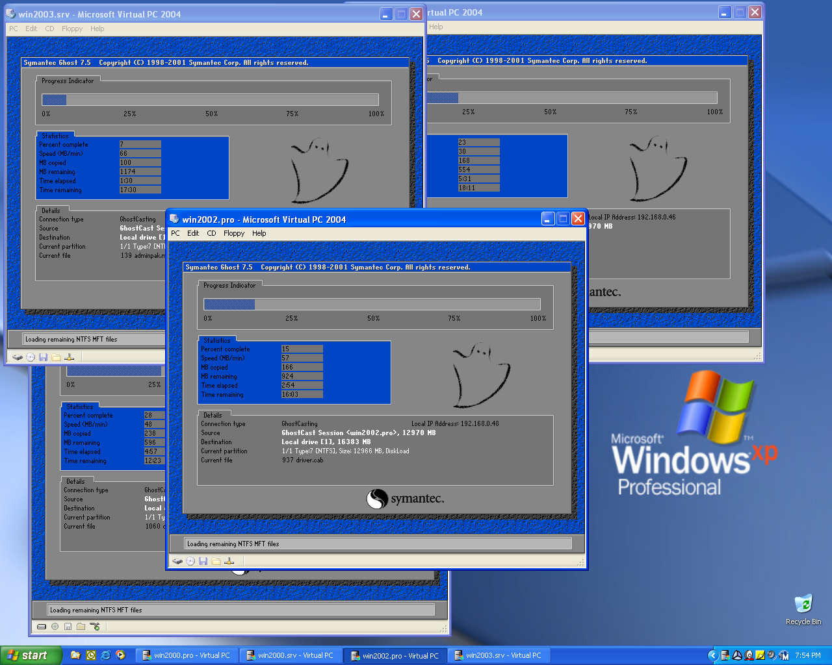
Figure 12. Testing Disk Images Using Virtual PC

Summary
Virtual PC allows users to run multiple operating systems without using multiple computers or rebooting the host. The benefit is significant in migration scenarios, particularly when legacy applications are involved. Rather than delaying a migration because a legacy application isn’t compatible with the version of Windows that you’re deploying, you can continue the deployment normally. You can then install Virtual PC for users who must run those legacy applications and install a compatible version of Windows and the legacy application in a virtual machine. As a result, your company takes advantage of the new operating system’s capabilities, but users still have access to the legacy applications on which they rely to do their jobs.
In addition to supporting legacy applications, Virtual PC provides benefits in other scenarios—technical support, quality assurance, and training. In the case of technical support, Virtual PC helps support technicians provide quicker responses and reduce call times. Rather than maintaining multiple computers or restarting computers for different support calls, they can simply start a virtual machine that matches the caller’s configuration—almost instantly. With Virtual PC, test engineers are able to test applications against a wider variety of configurations in shorter amounts of time. And Virtual PC provides quicker turnaround times for training rooms and enables more diverse classes based on more configurations. Table 1 summarized the benefits, and the section “Virtual PC Scenarios” provided more information about how Virtual PC benefits all of these scenarios.
Virtual PC is a low-cost migration tool that will return the investment you make in it many times over. Not only does Virtual PC enable migration scenarios that might otherwise falter, but it also provides a low-cost way to test them. In addition to providing value in migration scenarios, Virtual PC helps customers more rapidly develop, test, support, and deploy software.

For More Information
- Microsoft Virtual PC 2004
- Microsoft Acquisition of Connectix Virtual Machine Technology—Frequently Asked Questions

