SQL Server 2005 Metadata

Authors: Mark Chaffin, Brian Knight
Published: 2005
Summary: This white paper covers several interesting and unique methods for managing metadata in SQL Server Integration Services, Analysis Services and Reporting Services using built-in features including data lineage, business and technical metadata and impact analysis.
Copyright
This is a preliminary document and may be changed substantially prior to final commercial release of the software described herein.

The information contained in this document represents the current view of Microsoft Corporation on the issues discussed as of the date of publication. Because Microsoft must respond to changing market conditions, it should not be interpreted to be a commitment on the part of Microsoft, and Microsoft cannot guarantee the accuracy of any information presented after the date of publication.

This White Paper is for informational purposes only. MICROSOFT MAKES NO WARRANTIES, EXPRESS, IMPLIED OR STATUTORY, AS TO THE INFORMATION IN THIS DOCUMENT.

Complying with all applicable copyright laws is the responsibility of the user. Without limiting the rights under copyright, no part of this document may be reproduced, stored in or introduced into a retrieval system, or transmitted in any form or by any means (electronic, mechanical, photocopying, recording, or otherwise), or for any purpose, without the express written permission of Microsoft Corporation.

Microsoft may have patents, patent applications, trademarks, copyrights, or other intellectual property rights covering subject matter in this document. Except as expressly provided in any written license agreement from Microsoft, the furnishing of this document does not give you any license to these patents, trademarks, copyrights, or other intellectual property.

Unless otherwise noted, the example companies, organizations, products, domain names, e-mail addresses, logos, people, places, and events depicted herein are fictitious, and no association with any real company, organization, product, domain name, e-mail address, logo, person, place, or event is intended or should be inferred.

© 2005 Microsoft Corporation. All rights reserved.

Microsoft, ActiveX Data Objects, Outlook, Visual Basic, Visual C++, Visual Studio, and Windows are either registered trademarks or trademarks of Microsoft Corporation in the United States and/or other countries.

The names of actual companies and products mentioned herein may be the trademarks of their respective owners.

Table of Contents
Introduction 1
Business-Oriented Metadata in SQL Server 2005 2
Database Engine 2
Analysis Services 4
Dimension Attributes 4
Translations 5
Actions 5
Dimension Intelligence 5
Report Builder 6
Technical Metadata in SQL Server 2005 7
Integration Services 7
Data Flow Enhancements 7
Auditing/Logging 9
SSIS Metadata API 13
SSIS Logging 13
Data Source Views 14
Metadata Intelligence 16
Metadata Intelligence Tools in SQL Server 2005 16
Extending SQL Server 2005 BI Metadata Samples 20
Microsoft SQL Server 2005 BI MetaData Samples Toolkit : Step-by-Step 22
About The Authors 25

Introduction
What is metadata? The short answer is that it’s data about data. Although that sounds like a cop-out, the long answer continues to fill volumes of books and befuddle both technical staff and business users. Our primary goals in this whitepaper are to discuss a few different approaches and methods for creating, maintaining, managing and accessing metadata for the purposes of augmenting reporting and analysis systems and how to use features in the SQL Server 2005 platform for metadata to improve overall end user experiences.
What is metadata used for? Depending on your viewpoint, metadata is used to add context and understanding about data that users are accessing, or to hide complexity from end users who aren’t required to know or understand the technical details of data. It can also be used by systems to determine data types, if and when data last changed, what changes were made to data, what the structure and relationships are between data. It is also used by applications and systems to perform type checking, data validation and auto formatting of data.
On most Business Intelligence projects, metadata will likely fall into one of two classifications, business or technical, based on usage. Just a few examples of metadata include: data models, schemas, tables, columns, indexes, cubes, reports. This data is created by data modeling tools, databases, report writing tools, ETL tools, and of course, end users. We’ll discuss some of these tools and where metadata can be created, configured and maintained in later sections.
For the developer, Analysis Services (SSAS) has a huge new feature called the UDM or Universal Dimensional Model. The UDM enables the developer to create a single, unified logical model for both OLAP and relational reporting via XML for Analysis or OLE DB for OLAP. SSAS also has a new object model called AMO or Analysis Management Objects that enables developers to programmatically manage the multidimensional metadata.
In SQL Server Integration Services, the developer can configure and design packages that extract and organize metadata from the source systems, ‘attach’ it to the data that’s being transformed and cleansed (while adding ETL process metadata), and ultimately load it to the data warehouse and metadata databases.
Perhaps the most innovative feature addition to SQL Server 2005 that pertains to metadata, is the Report Builder capability. Using Report Builder, a developer or administrator can use business metadata to help end users better understand the data without having to understand the underlying data structures.
In this whitepaper, we’ll discuss how to tie a few of these new features together to address the core need of how to manage and present business and technical metadata together in using SQL Server 2005. In this whitepaper, we’ll discuss:
- How SQL Server handles business and technical metadata.
- How to integration metadata and lineage into your SSIS package to handle challenges from compliance laws like Sarbanes-Oxley.
- How to tap into metadata using the SQL Server BI Metadata Samples Toolkit
- How to extend the SQL Server BI Metadata Samples Toolkit

Business-Oriented Metadata in SQL Server 2005
Business-oriented metadata includes metadata that an end user can access and is used to help better explain how data is source, configured or calculated. In SQL Server 2005, metadata is pervasive through the platform products starting with the database engine and continuing through the other servers and applications. Each server exposes metadata programmatically as well as through functionality included in the respective design and administrative tools.
Business-oriented metadata encompasses table and column names and descriptions, specifying a caption for a table or column, specifying an input mask for applications to validate data, specifying formatting rules, storing the business definition of the data element or even who is responsible for managing the object; all in the database engine.
Business metadata is also supported in both Analysis Services and Report Builder. While Analysis Services requires the front-end reporting or analysis tool to support metadata, its inclusion in the engine supports a consistent, manageable approach to business metadata. We’ll be covering the use of business metadata by all of these areas in the upcoming topics.

Database Engine
In the database engine, SQL 2005 expands on SQL 2000 by adding support for extended properties to nearly all database objects. Extended properties can be used for rich metadata management because each table and column (as well as most other objects in the relational engine) can have multiple extended properties that can each contain up to 7500 bytes of data. Since these properties are scriptable and are part of the structure of each object, developers can make use of these properties to store business-level definitions of each object.
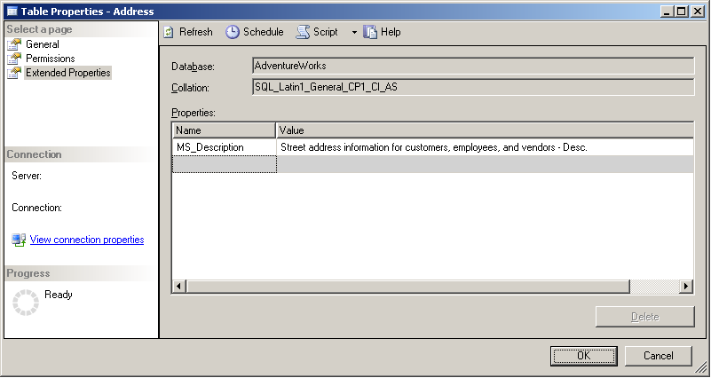
For example, to view a table’s extended properties, open SQL Server Management Studio, navigate to the database you want to work with, open the ‘Tables’ folder and right-click on the table object you want to review, then select ‘Properties’. The figure below shows the extended properties for the AdventureWorks Person.Address table. As you can see, an extended property already exists called “MS_Description”.
This extended property is created when a description is added to a table or column definition when modifying a table through its property page. However, you have the capability to add many more extended properties. These extended properties can be managed through T-SQL statement calls as listed below:
Action | Statement
Add an extended property | sp_addextendedproperty
Update an extended property | sp_updateextendedproperty
Delete an extended property | sp_dropextendedproperty
View an extended property | fn_listextendedproperty or sys.extended_properties

In the following T-SQL example, the ‘MS_Description’ extended property is updated with a new value:
USE AdventureWorks;
GO
EXEC sys.sp_updateextendedproperty
@name = N'MS_Description',
@value = N'New Description for the Address table',
@level0type = N'SCHEMA', @level0name = Person,
@level1type = N'TABLE', @level1name = Address;
GO
To display all of the table-level properties (including the one we just updated) in the Person schema, execute the following T-SQL example:
USE AdventureWorks;
GO
SELECT objtype, objname, name, value
FROM fn_listextendedproperty (NULL, 'schema', 'Person', 'table', default, NULL, NULL);
GO
which will return the result:
objtype | objname | name | value
TABLE | AddressType | MS_Description | Types of addresses stored in the Address table.
TABLE | Contact | MS_Description | Names of each employee, customer contact, and vendor contact.
TABLE | ContactType | MS_Description | Lookup table containing the types of contacts stored in Contact.
TABLE | CountryRegion | MS_Description | Lookup table containing the ISO standard codes for countries and regions.
TABLE | StateProvince | MS_Description | State and province lookup table.
TABLE | Address | MS_Description | Street address information for customers, employees, and vendors - Desc.

Analysis Services
In Analysis Services, a developer is embedding business metadata throughout the application when they create Data Source Views (DSVs), dimensions, dimension types, hierarchies, cubes, translations, actions and many other objects. All of these objects contain, manage and display metadata in different ways. This business metadata-oriented group of objects enhances the data an end user will interact with by adding the metadata directly to the structures or taking action based on the metadata associated with an object. In this section, we’ll dig into some of these features.

Dimension Attributes
Compared to the previous version of Analysis Services 2005, Dimension Attributes consist of what were formerly member properties, levels and hierarchies. Dimension Attributes now define the dimension hierarchy (and levels), and all supporting properties become alternate hierarchies (with a default “All” level). In other words, dimensions are a collection of attributes that either define one of many hierarchies or provide grouping of dimension members. The figure below shows the Product dimension from the Adventure Works DW Analysis Services database. As you will see, every level listed in the hierarchies in the “Hierarchies and Levels” pane corresponds to an Attribute in the lower pane.
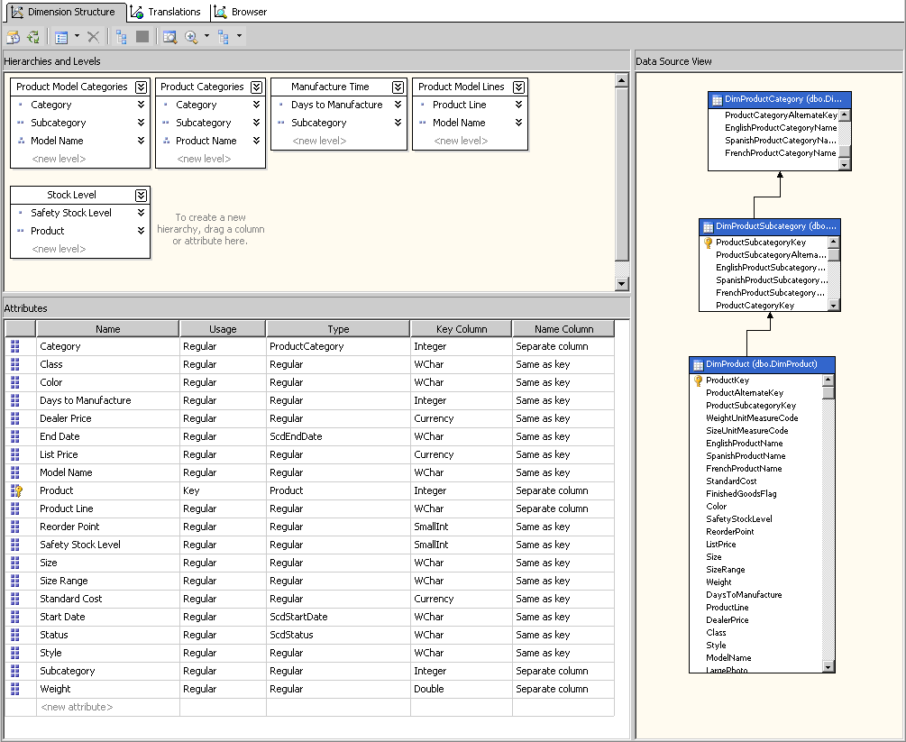
However, attributes that do not define levels in a hierarchy can become hierarchies of their own, similar to building a virtual dimension in Analysis Services 2000.
Once created, you can add attributes to hierarchies and edit attribute properties in the Dimension Designer. Each attribute can be bound to two columns in a dimension table for both key and name columns.

Translations
Attributes in Analysis Services include support for multiple locales through the use of translations. Unlike Analysis Services 2000 where locales were supported only for the data, Analysis Services 2005 supports multiple languages for the metadata and structural elements. Every element from the dimension name itself to the levels, member attributes, hierarchies and member names can have a different translation. In the figure below, the Product dimension’s translation table is shown. Notice that the Product dimension, the [All Product] member and the unknown member all have translations as well as every level of each hierarchy.

Actions
Actions are MDX statements associated with dimensions, levels, members or cells that allow client applications to perform tasks including starting an application using the selected item as a parameter. Client applications can also provide seamless ‘links’ to other applications for metadata or data lookup. For example, a business user browsing a cube notices that a particular customer has recently made a large purchase. The business user can select from a list of actions that the client application provides, one of which can be to send an email to the customer, based on the stored email address of the customer.
Actions provide an easy way for end users to step from focusing on specific data to acting on the data in ways that are context sensitive and metadata-driven. This, in effect, closes the loop between analysis and activity. Actions are managed in cubes and associated with Attribute members, Cells, Cubes, Dimension Members, Hierarchies, Hierarchy members, Levels or Level members.

Dimension Intelligence
Out of the box, Analysis Services contains metadata functionality to define dimension types which can be used to determine behavior of the dimension or allow reporting and analysis applications to add functionality based on these settings. Several of the dimension types have specific purposes and are used by other parts of the platform. For example, if you have a Currency dimension and set its type appropriately, SQL Server Management Studio uses this information to set the appropriate conversion rules. Other types that have additional behavior enhancements include Account and Time.

Report Builder
Report Builder is a significant new component added in SQL Server 2005 Reporting Services (SSRS) that allows business users to explore and browse information without having to understand the technical schema that may be supporting the information. Report Builder is an abstraction layer over the physical schema of a database. Report Builder allows business to explore data in an ad hoc fashion using familiar Microsoft Office paradigms. Business users use Report Builder to create Reporting Services reports using Report Definition Language (RDL), which can be published like other SSRS reports to a centralized reporting server.
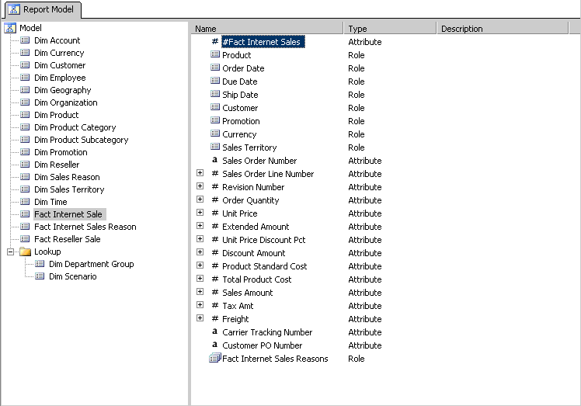
Business users interact with data from SQL Server or Analysis Services using a pre-defined Report Model which is created using the BI Development Studio. Models can be created using the Report Model Wizard which speeds development time, but makes assumptions and inferences based on automatic data exploration. You should expect to continue to refine the model after the wizard completes. In the sample below, a model has been created using the Wizard from the Adventure Works DW relational database.

Technical Metadata in SQL Server 2005
This next section discusses enhancements to the platform that support the back-office functions and focus on built-in capabilities of Integration Services, the Unified Dimensional Model and Data Source Views.

Integration Services
Integration Services (SSIS) provides the developer a rich and sophisticated set of tools to manage, manipulate and move data from sources to targets. Out of the box, metadata is contained in the SSIS packages themselves and the audit trail of package executions, as well as the data that travels through the package transformations (via lineage). We’ll discuss each of these in the upcoming sections.

Data Flow Enhancements
In Integration Services, a new data transformation called a “Derived Column” transformation has been added. Using this derived column transformation, a developer can add a column or columns to the data transformation process that can be based on existing variables or expressions. These variables or expressions can be set during the execution process and can contain technical metadata such as the file name of the source of the data row, the date/time of the processing, the Integration Services package that transformed the data, or other metadata as appropriate. In the example below, you can see how the Derived Column transform can be used to read technical metadata about the package that can be used in an audit. For example, if you want to see what version of the package executed and when, you can use this type of example.

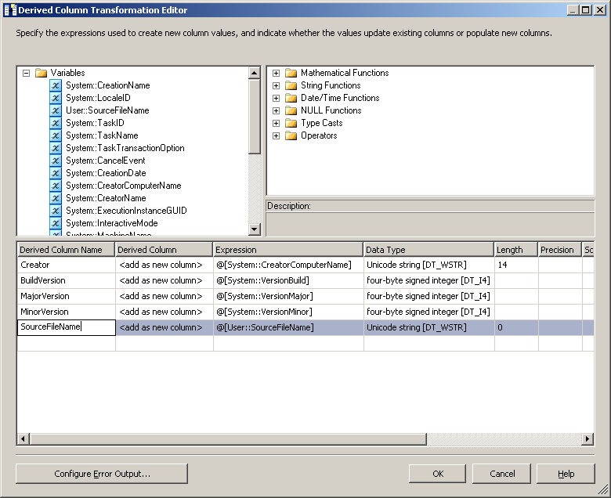
The data lineage capability in SSIS uses this feature to add more information to the data as it is being processed. The Derived Column transform also allows inclusion of other types using system variables into the data flow for auditing purposes. Add the variable quickly into the Derived Column transform by dragging it from the upper-left box. If you type it in, prefix the variable with @[System::VariableName] (replacing VariableName with the system variable you’d like to use from the below table). Here are a few of the system variables you can include into your package to better audit your package and the lineage of the data being imported:

Variable | Description
ContainerStartTime | The time when the container began to execute.
LocaleID | The locale used for the data flow task.
TaskID | The TaskID for the data flow task
TaskName | The name of the task instance.
TaskTransactionOption | The transaction option that the task uses.
CreatorComputerName | The name of the computer that created the package.
CreatorName | The user name that created the package.
ExecutionInstanceGUID | The execution instance of the package.
InteractiveMode | Indicates whether the package is being executed interactively by a user or through the DTExec utility (which jobs will use).
MachineName | The machine name where the package is running.
PackageID | The unique GUID for the package.
PackageName | The package’s name.
StartTime | The time when the package was executed.
UserName | The user name the started the package.
VersionBuild | The package version.
VersionComments | String variable that lists any comments that are in the package.
VersionGUID | The GUID that represents the unique package version.
VersionMajor | The major version for the package.
VersionMinor | The minor version for the package.

You’re of course not limited to system variables. You may also have a need to use user variables in your Derived Column transform. For example, you may read a header record to determine the batch ID for the extract. You can then load that batch id into a variable and then into the data flow using a Derived Column transform.

Auditing/Logging
Sarbanes-Oxley is a new American law that regulates the accountability of publicly owned companies. The main purpose of the law it to make sure the financial statement that a company reports is legitimate and that there’s no room for someone to manipulate it. As you can imagine, preventing the manipulation of the financial statement has a lot of IT impact. Some interpret the law to mean that you must audit who loaded each row into a database and when it arrived.
If you work for a company where auditing is important you can capture that type of lineage in SSIS easily using the Audit transformation. The Audit transformation adds extra columns to the data flow that contains lineage data about the package, task or system. Here is a list of potential values you can add to the data flow in SQL Server 2005:

Value | Description
Execution Instance ID | The unique identifier (GUID) that contains the execution instance of the package.
Package ID | The GUID that contains the unique ID for the package.
Version ID | The GUID that contains the unique ID for the version of the package.
Package Name | The name of the package.
Execution Start Time | The time when the package began to execute.
User Name | The name of the user that executed the package.
Task Name | The name of the Data Flow task that contains the Audit transformation.
Task ID | The GUID for the Data Flow task that contains the Audit transformation.
Machine Name | The name of the machine where the package was executed.
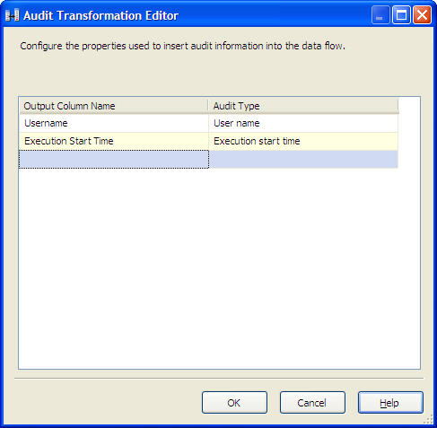
To add this lineage to your SSIS package, drag the Audit transform from the toolbox onto your data flow and drop it on the data flow design surface where you wish to begin auditing. Double-click on the transform to configure it as shown below:

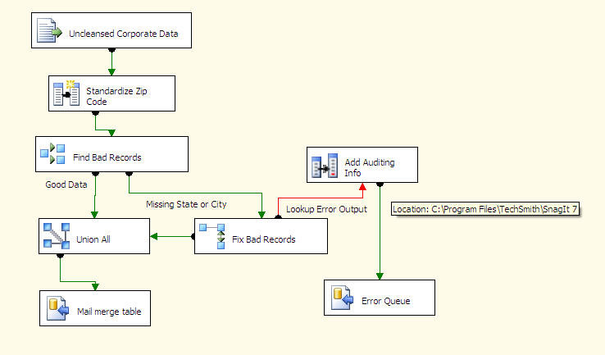
This transformation would most frequently be used to capture lineage data of records that SSIS had to manipulate or that it couldn’t load. For example, for rows containing errors that couldn’t be corrected automatically, you may wish to add auditing data to the row before inserting it into an error queue as shown below. This lineage will help an operations person debug the source of the error as shown in the below screenshot.

Fig : Audit Package Example
To do this type of auditing on error rows, you would have to configure the error output from a transform or connection. The ability to configure how to handle errors at a row-level is one of the most significant enhancements in SSIS over DTS. In DTS, your entire package was more likely to fail if a single record contained an error (like a foreign key violation). Additionally, in DTS, you may spend hours debugging the issue and then have to rerun a five hour package.

Error outputs easily solve this problem by allowing you to specify how you’d like SSIS to handle the error. You can choose to ignore the error, fail on the error or redirect it to a different path in the pipeline. The advantage to redirecting the row is you can attempt to cleanse the row, and, if that doesn’t work, direct it to an error queue to be manually corrected the next morning.
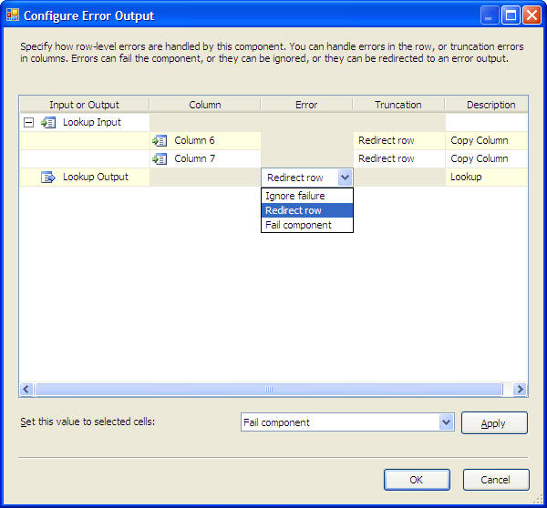
To configure a transform or connection to output records that have failed to a different path, you can click on Configure Error Output in most transforms or click the Error Output page in a Source or Destination. Once you have the dialog box open (shown below), specify how you’d like to handle the error. There are two different classes of errors: truncation errors and transform or connection specific errors. A truncation error occurs when you try to move more data into a column than will fit. A transform or connection specific error will vary based on the transform or connection you’re using. A source and destination might have conversion errors, while the transform might have errors specific to the transform. For example, a Lookup transform will have an error if the record could not be found in the lookup operation. The type of error can be seen in the right Description column below.

Fig : Error Output

SSIS Metadata API
As with the other SQL Server BI components like Reporting Services, SSIS packages can be viewed as an XML file. The easier way to access the metadata though is through the sophisticated SSIS API. There are dozens of classes, interfaces and enumerations you can use in the Microsoft.SqlServer.Dts.Runtime namespace. For example, the ConnectionInfo class contains information about a connection on a computer and the ConnectionInfos collection is a collection of all the connections on a computer.

SSIS Logging
In SQL Server 2005, SSIS can log information about the package’s runtime to any of the five log providers: text file, SQL Profile trace, SQL Server table, XML file or a Windows Event log. You can also write to two different providers if you wish to audit in a multitude of ways. If none of these logging providers fit your appropriate requirements, you always have the option of building a custom logging provider.
The most common log provider to use is the SQL Server table provider. This is because you can then write Reporting Services Reports that can be viewed or subscribed to see a package’s status. If you select this provider, you must select which Connection Manager you wish to write to and then the events you wish to log (shown below). You can log each time a warning or error occurs or any information message.
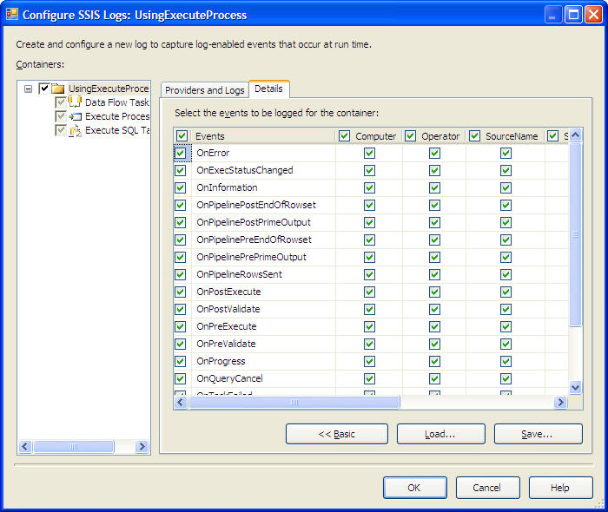

Fig: Logging Config

Inside the database of your choosing, a sysdtslog90 table will be created. The sysdtslog90 table can grow rather large so you will need to schedule something to eventually archive the table. The table is full of operational data like when each task started and stopped and the success of each one. The most important column in the table is the message column that stores the verbose result of that step.

Data Source Views
When working in Analysis Services, a developer can filter unnecessary objects from a data source by creating and using a data source view or DSV. A DSV can present schema information such as tables and views from multiple data sources in a single, unified view of the metadata. A DSV can also be used to join the data from a data warehouse to its associated metadata.
The DSV is where you can define a business view of your data that makes the backend processes transparent. For example, you may have a table in the UDM that translates Siebel column names like E432K3 to First Name. The user then would not have to open his data dictionary to find out what E432K3 is and his productivity will increase drastically. Your staffing requirements should also decrease after the initial UDM is created as you won’t have to have a data expert and instead the power of reporting is pushed to the business users.

In Integration Services, the advantages of using data source views include the following:
- A DSV can be defined once and then used by multiple data flow components.
- A DSV can be refreshed to reflect changes in its underlying data sources.
- A DSV also allows developers to develop cubes and packages without having live connections to the source data systems by caching the metadata from the data source from which it’s built.
- A DSV can focus the lists of objects that appear in the user interface of data flow components, speeding up the design interface.

Metadata Intelligence
In a large enterprise environment, you may have dozens if not hundreds of SSIS packages that run at various times to load a myriad of tables. Let’s say that you have a new DBA who decides it will be more optimal to turn a column into a small integer from a varchar field. So, what will be the impact? The change, no matter how small it is, may create the need to change 15 packages. The metadata solution pack is one of the discovery tools you can use to explore the impact of a change like this.
There are a few approaches you could take to analyze the metadata of BI systems like SSIS. One approach you could use is to look at the XML files that make up each package using XPATH queries. The approach that was taken in the SQL Server BI Metadata Samples Toolkit that we’re about to discuss is to load up the package into memory as the runtime engine does and walk the package using the SSIS API.

Metadata Intelligence Tools in SQL Server 2005
In order to solve the metadata challenge a team at Microsoft has developed a free set of utilities and samples called the SQL Server BI Metadata Samples Toolkit. The kit gives you a jump start in developing your own solution for impact analysis or you can take the Microsoft solution right out of the box. SQL Server BI Metadata Samples Toolkit includes the following items to help you create your own metadata solution:
- DependencyAnalyzer.exe – Tool that evaluates and loads into a database the lineage on SSIS packages, Analysis Services and SQL Server. All the source code for this program is provided.
- DependencyViewer.exe – A tool that lets you graphically see the dependencies and lineage of objects in the lineage repository. Source code is provided for this program.
- Data Source View – A DSV that connects to the lineage repository (SSIS META database) that can be used by Reporting Services.
- Lineage Repository – A database called SSIS_META that can be used to house metadata from nearly any system.
- Reports – Some standard reports for impact analysis studies. You will find two key reports out of the box with several sub-reports.
- Report Model – A report model that you can use with Report Builder to allow end-users to create ad-hoc reports.
- Integration Services Samples – A few sample packages to start auditing and viewing lineage on.
To use the tools, first create an empty database for the lineage repository called SSIS_META and then populate it by running the SSIS_META_creation.sql script while using the database in SQL Server Management Studio. You can then execute DependencyAnalyzer.exe as a console application with no switches set to scan the local default instance. The reason this has been created as a console application is so it can be scheduled through SQL Agent as a job that automatically scans your system nightly or weekly. You can also run DependencyAnalyzer.exe /? to see all the additional switches you can pass to the program. You can also see the available switches in the below table:

Swtich | Description
/depDb:<string> | ADO.Net SqlConnection compatible connection string to dependency database location. Default  value: 'Server=localhost;database=SSIS_Meta;Integrated Security=SSPI;' (short form /d)
/folders:<string> | Root folders of file system packages. (short form /f)
/isDbServer:<string> | SQL Server where SSIS packages are stored. Default value:'localhost' (short form /i)
/isDbUser:<string> | SQL Server user that has access to stored SSIS packages
/isDbPwd:<string> | SQL Server password for getting access to stored SSIS packages
/recurse[+|-] | Whether to recurse file system sub folders when  enumerating objects. Default value:'+' (short form /r)
/batchMode[+|-] | Whether to start execution without asking the user to continue. Default value:'-' (short form /b)
/skipSQL[+|-] | Whether to skip enumerating packages in SQL Server. Default value:'-' (short form /s)
/skipSSIS[+|-] | Whether to skip enumerating packages completely. Default value:'-'
/asCon:<string> | AMO compatible connection string to Analysis Services. Default value:'Provider=msolap;Data Source=localhost;' (short form /a)
/skipAS[+|-] | Whether to skip enumerating Analysis Services objects. Default value:'-'
@<file> | Read response file for more options

With the metadata now scanned, you can run reports against the SSIS_META database to see the impacts of making a database change. There is also another tool you can use to perform an impact analysis study. The DependencyViewer.exe executable ships with SQL Server 2005 BI Metadata Samples Toolkit to help you navigate through the dependencies. The tool helps you run a quick impact analysis graphically to determine what packages will be impacted by you making a change to a data source.
In the DependencyViewer’s interface, click the Load button to connect to the local repository and browse through the tree. If you select a SQL Server table, you will see (highlighted in blue) where in the package the table is used. The below example shows you some sample Anaylsis Services cube that ship with SQL Server and how the impact analysis would look on one of those data sources.
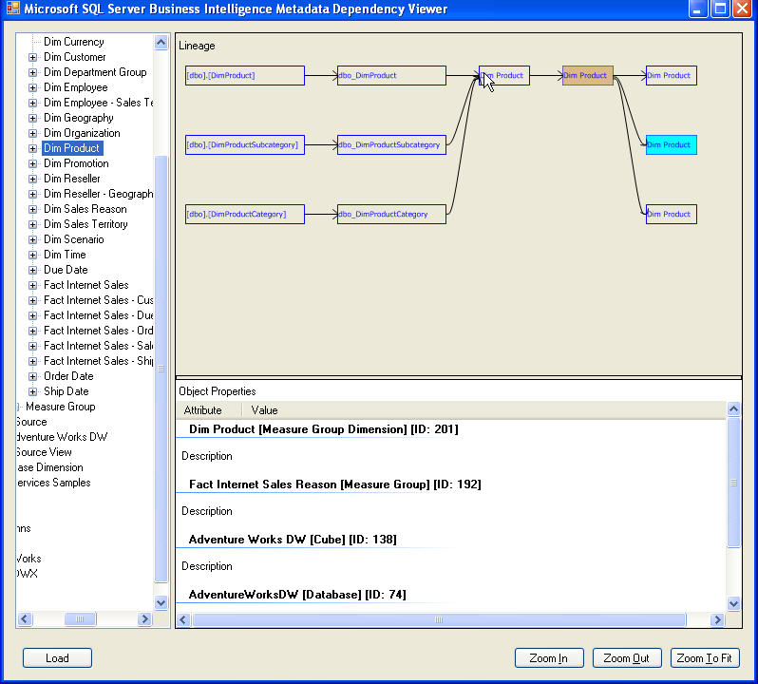
If you select an object, the box turns blue and you can see the description of the object (if one exists) in the Object Properties window. The object you selected in the left tree is brown. Everything to the left of that brown box is the lineage that loaded that object and everything to the left to that box would be impacted if you change that object. In the below example, you can see three tables were the source of the product dimension. From there, Product is represented in three measure groups in three cubes.

Inside the SQL Server 2005 BI Metadata Samples Toolkit, you’ll find loads of impact analysis and metadata Reporting Services reports. You’ll also find a report model for users to create ad-hoc reports with using Report Builder and a data source view (SSIS META.dsv) to humanize the data.
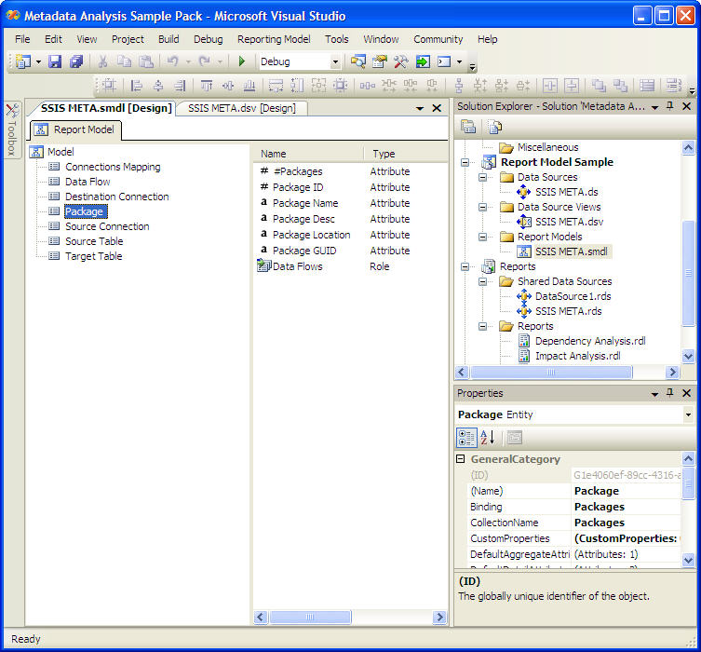
The SSIS_META.dsv data source view extrapolates the few tables that ship with the Metadata Analyzer out to many more virtual tables. Each table represented in the DSV is a named query and is hierarchical, with the Packages table being the top of the hierarchy. The SSIS META.smdl report model is bound to the SSIS META.dsv and the smdl file has the hierarchy and table links already defined for you as shown in the below screenshot. The report model allows you to create an ad-hoc report using Report Builder. For more information on how to use the smdl file, look at the step-by-step guide in this whitepaper.

You can use the SSIS_META.dsv file to simplify creating a report in Reporting Services. You won’t have to know how to get to the underlying tables. Instead you can walk the hierarchy shown below. The underlying tables and views are discussed in the next section.

Extending SQL Server 2005 BI Metadata Samples
To extend the SQL Server 2005 BI Metadata Samples Toolkit you will need to have some familiarity with the schema of the SSIS_META database. You will want to do most of the table access through the views that are provided, as this gives you a cleaner look into the system. The underlying table structure is flexible enough to load metadata from almost any tool. To make the metadata user friendly though, you’d want to add additional views to support your new customized objects. Here is a list of views that come out of the box:

View Name | Description
Connections | A list of all the connections.
ConnectionsMapping | Shows which source connections map to a target connection.
DataFlows | Shows each data flow task.
LineageMap | Shows the source and target for each lineage object.
ObjectRelationships | Shows the relationships between objects.
Packages | Contains a list of every package being monitored.
SourceTables | Tables that are defined as sources in a package.
TableLineageMap | Shows the mapping between the source and target tables.
TargetTables | Tables that are defined as targets in a package.

Of course viewing the data is nice but if you’d like to extend the schema to support other ETL systems like Ab Initio or modeling repositories, you’re going to have to know how to insert into the back-end tables. Here is the schema for SSIS_META database.

Table Name | Description
Audit | A template table to help you build an audit of your loads.
ObjectAttributes | Contains name to value pairs for each attribute. For example, PackageGUID and then the GUID for the package.
ObjectDependencies | Creates a hierarchy of metadata and maps sources to destinations.
Objects | Any object that you’d like to record lineage on, e.g. a table, a data flow task, or a connection.
ObjectTypes | Contains all the object types like transformations, tasks and dimensions.

One key point to mention if you do decided to extend the tool by inserting your own data into these tables is that the DependencyAnalyzer tool will purge and refresh the tables. You will need to develop some process to load these tables after the DependencyAnalzyer execution. The DependencyAnalyzer tool can also be customized to fit your needs as the source code is provided as shared source.
As we mentioned, the tool can be extended to scan additional metadata like Business Objects (BO) or ErStudio. If you choose to do this, you’ll need to create an additional enumerator in the Visual Studio project. You’ll also need to add integrate your enumerator into the program.cs file. Below is a list of C# files that you can use as a model in the Dependency Analyzer tool.

File | Description
CommandLineArguments.cs | Contains the command line switches that are used in the Dependency Analyzer.
FileEnumerator.cs | Enumerates through your files that are used in SSIS packages.
NativeMethods.cs | Contains the objects used to interop the assembly with COM for converting ProgIDs to CLSIDs.
Program.cs | Contains the core shared objects for the program that calls the enumerators.
RelationalEnumerator.cs | Enumerates through the relational database tables.
Repository.cs | Contains the objects to use the SSIS_META database.
SSASEnumerator.cs | Enumerates through the SQL Server Analysis Services databases.
SSISEnumerator.cs | Enumerates through the Integration Services packages.

Microsoft SQL Server 2005 BI MetaData Samples Toolkit : Step-by-Step
In this step-by-step guide to using the SQL Server 2005 BI Metadata Samples Toolkit, we assume you already have a SSIS package imported on your SQL Server instance. If you haven’t created a SSIS package yet, install the SSIS sample packages. If you selected to install the samples, they will be located in the \Program Files\Microsoft SQL Server\90\Samples\Integration Services\Package Samples directory. You will just need to import them.
- Download the SQL Server 2005 BI Metadata Samples Toolkit from MSDN.
- Uncompress the file and run the setup file in the package. For the purpose of this guide, we’ll show the program running from the C:\Program Files\Microsoft\Microsoft SQL Server Metadata Samples, which is the default location.
- Connect to your SQL Server that will hold your metadata repository and create a database called SSIS_META.
- Open a new query menu and run the SSIS_META_creation.sql sql file that is in the C:\program files\Microsoft\Microsoft SQL Server Metadata Samples\SQL directory. The program is now fully installed and ready to use.
- Open the MetadataReportingSamples.sln in the C:\program files\Microsoft\Microsoft SQL Server Metadata Samples directory. This will open Visual Studio 2005. You must have the full version of the product installed to see some of the projects inside this solution. Right-click on the DependencyAnalyzer and DependencyViewer projects and click Build on each.
- Go to the C:\program files\Microsoft\Microsoft SQL Server Metadata Samples\DependencyAnalyzer\bin directory (it may be under \bin\debug based on what mode you built the project in) and run the DependencyAnalyzer.exe. This will load the SSIS_META database for the first time with data.

With the metadata now scanned, you can begin to report on the lineage. You have a few choices for reporting. You can use the DependencyViewer tool in the C:\program files\Microsoft\Microsoft SQL Server Metadata Samples\DependencyViewer\bin directory or you can create your own Reporting Services or ad-hoc reports using the Report Builder. If you’d like to utilize the report model that ships with the MetaData Analyzer, you will need to perform the following steps:
- Open the Reporting Services project that ships with MetaData Analyzer and deploy the report project to your Reporting Services server.
- Connect to the Report Manager website and click the Models folder (the default location of the project).
- Click Report Builder to open the Microsoft Report Builder tool. If this is your first time running the application, it may take some time for the application to install.
- Select SSIS META as your source for your data when you create a new report.
- Title the first example report “Packages with Metadata”.

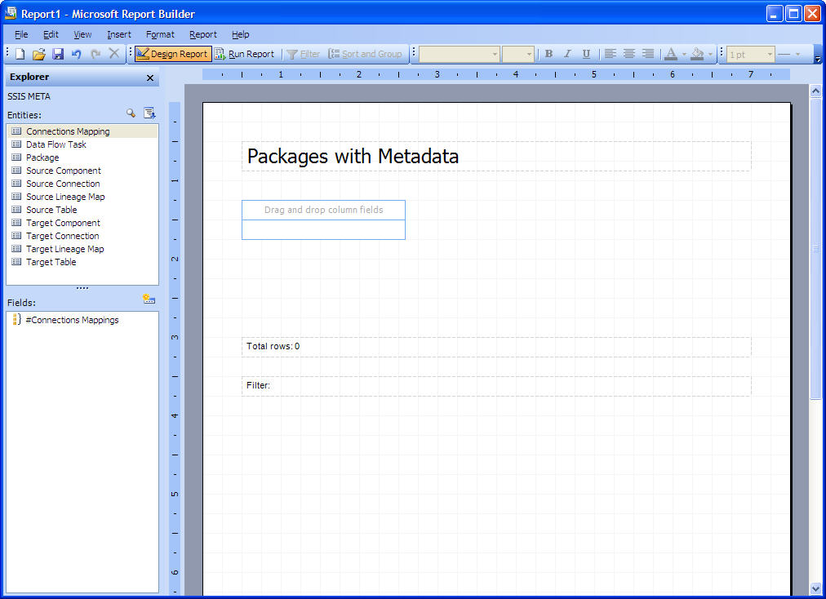

- Drag and drop the Package entity from the left box onto the column area and resize the PackageLocation column to fit inside the report.
- Click Run Report to see a preview of the report. Notice that you can click on a package name to see more details about the package.
- If you’re satisfied with the results, click Save to deploy the report to your Reporting Services server.
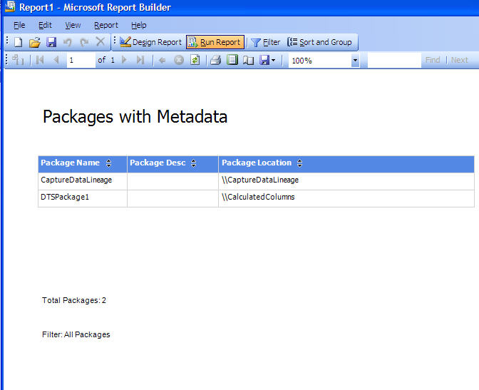
This is an easy way to grant your users and developers access to your metadata in an ad-hoc fashion. Since the report model already contains the hierarchies, the user can navigate through the metadata and create a much more detailed report with filters.

About The Authors
Mark Chaffin is the Co-Founder and Managing Partner for Business Intelligence with Florida Technology (www.floridatechnology.com), a leading, provider of enterprise Business Intelligence solutions on the Microsoft platform. He has been the primary architect of many business intelligence solutions for clients in many verticals including retail, consumer packaged goods, healthcare, finance, marketing, banking, technology, and sports and entertainment. He has experience in data mining, transactional application architecture, Internet application architecture, database administration and database design. He is also the co-author of SQL Server 2000 Data Transformation Services, from Wrox Press, and has authored many articles on business intelligence, SQL Server, DTS and Analysis Services. He is also a frequent speaker at Microsoft and SQL Server conferences including PASS and TechEd.

Brian Knight, SQL Server MVP, MCSE, MCDBA, is the co-founder of SQLServerCentral.com and was recently on the Board of Directors for the Professional Association for SQL Server (PASS). He runs the local SQL Server users group in Jacksonville. Brian is a contributing columnist for SQL Server Standard and SQL Magazine and also maintains a weekly column for the database website SQLServerCentral.com. He is the author of Admin911: SQL Server (Osborne/McGraw-Hill Publishing) and co-author Professional SQL Server DTS and Professional SQL Server 2005 SSIS (Wrox Press). Brian has spoken at conferences like PASS, SQL Connections and TechEd.

