Business ANalytics for Microsoft Business Solutions–Navision
Business Analytics for Microsoft® Business Solutions–Navision® helps you gain business insight, make faster smarter decisions, and equip your employees to contribute to your growth

Key Benefits:
- Gain insight into your business.
- Sharpen your competitive edge with smarter, faster decision making.
- Help each employee drive the success of your business.

Analyze and Understand Your Data, Your Way
Designed for core small businesses and lower midmarket segment companies, Business Analytics turns your data into business-critical information quickly and simply.
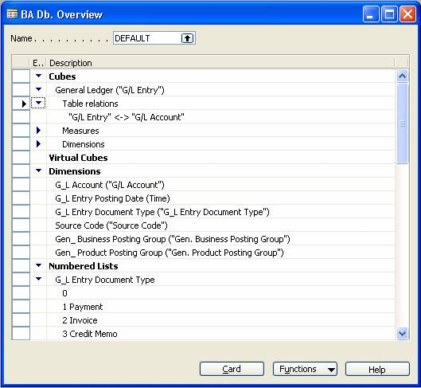

By selecting tables and fields from the Microsoft Navision database, users can set up and define cubes quickly using the Business Analytics Configurator.
Business Analytics provides two offerings: basic and advanced. Both offerings enable deeper understanding of information generated from Microsoft Navision and help ensure that everyone in your organization has easy access to the same accurate, current data so that they can focus on spotting trends, problems, and opportunities, and can generate reports that fuel smart strategic and operational decisions.
The Basic offering delivers Microsoft Navision information in predefined or customized information
units, called Online Analytical Processing (OLAP) cubes, directly to users’ desktops. Users can access and analyze data—within a familiar Microsoft® Excel 2003 interface or another front-end solution—with easy-to-use tools that enable straightforward analysis and provide a quick overview of business conditions. Economizing their time, users can easily define, customize, save, and re-use OLAP cubes. As they develop a strong focus on understanding business conditions, employees can more effectively practice successful business management.
The Advanced offering supports businesses that have more complex reporting and analysis needs, while maintaining the simplicity and ease of use that are hallmarks of Microsoft Navision. Working within a graphical interface that is similar to Microsoft® Outlook® 2003, users can gain a 360-degree view of business performance and quickly set up and review graphical displays and reports. To arrive at a deeper understanding, users can perform targeted analysis of detailed information. With the Business Analytics Web Viewer, decision makers have quick access to critical Microsoft Navision data from any location with an Internet connection.

Gain Accurate and Timely Insight into Your Business
With the advanced offering, you can tailor Business Analytics for Microsoft Navision to swiftly generate the information views that are most relevant to your data analysis requirements. Business Analytics can be a critical element in defining your business strategy.
Instead of waiting for the busy IT department to generate a report of sales for a particular product in a specific region, you can generate your own report almost instantly. Rather than waiting for the end of the month to analyze the performance of your sales team, you can generate simple, effective analytical views at any time. You will be able to make sound strategic decisions in little time.
Business Analytics includes pre-defined functionality for frequently occurring reporting needs; it also enables you to define and easily modify OLAP information cubes to meet information needs specific to your business, or create new cubes based on these relationships.
Business Analytics equips you to stay on top of your business at all times. With the Advanced offering, you can set up the system to notify you by e-mail if crucial numbers change—for example, if your profit drops below a certain percentage.

Sharpen Your Competitive Edge with Smarter, Faster Decision Making
Using the data stored in Microsoft Navision, Business Analytics can help empower employees at multiple levels in your company to make confident decisions based on facts. You can involve the experience and contributions of a much larger group of employees in driving the company toward increased competitiveness.
Business Analytics gives you and your employees a targeted view of your business that allows for clear overviews and quick comparisons whenever they are required. You can rapidly spot trends and identify weak areas and take immediate action. Because your colleagues can access all of the analytical views, you can share your insights, strengthen your arguments for a plan of action, and back decisions up.

Help Each Employee Drive the Success of Your Business
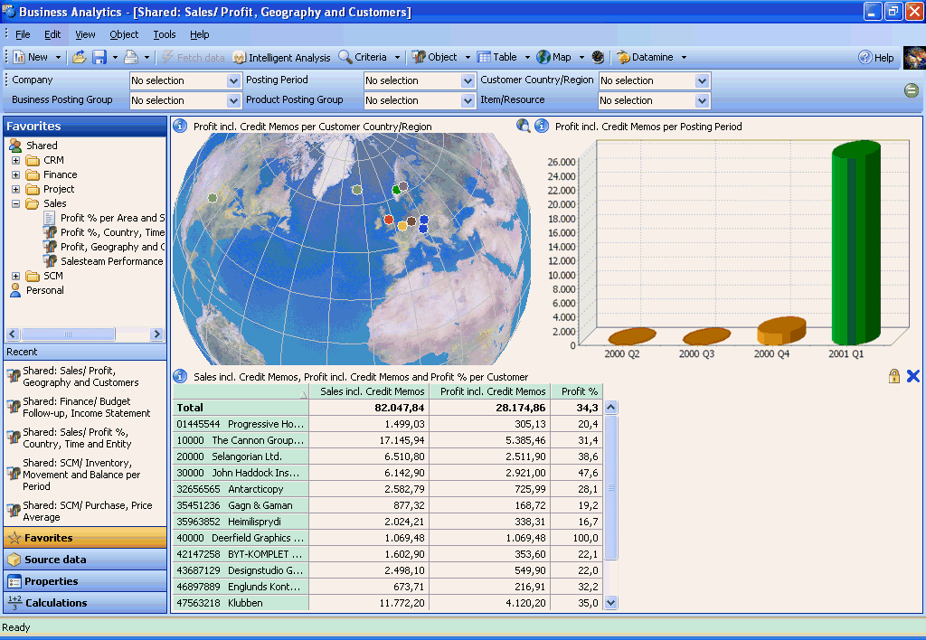
Your employees are experts in their fields—so it makes sense that they should interact with information that is critical to their roles simply and quickly, without having to get an intermediary involved. Business Analytics is a highly practical tool that allows you and your employees to carry out report-writing tasks that were until recently the preserve of IT specialists. This saves time and money and gives key individuals the independence to get on with the job in hand.
The Advanced offering of Business Analytics has an intuitive Outlook-style interface that has a familiar feel for many users, and thereby reduces the time needed for training.
In order to make you as productive as possible from the start, the advanced offering of Business Analytics delivers pre-defined functionality that includes Finance, Sales, CRM, SCM, and Project (Jobs). Automatic installation of these components reduces your implementation time for Business Analytics, so you can begin to analyze your business information quickly.
To simplify information access and reporting, you can use wizards to create reports from scratch and add new fields, tables, or entire business areas quickly and easily.

Technology Summary
Business Analytics is integrated into your existing Microsoft Navision system, giving you the full benefit of access to your stored data.
A Data Transformation Services (DTS) package pulls data from Microsoft Navision into SQL tables. From here, other DTS packages transform and structure these tables into multidimensional cubes processed in Microsoft® SQL Server® Analysis Services.
With the Basic offering, you can configure OLAP cubes using a set of forms within Microsoft Navision. An engine configures DTS packages for data transfer, and sets up schema for OLAP cubes and data mart tables. Out of the box, there are five main categories: Sales, Finance, CRM, SCM, and Project (Jobs).
The Advanced offering provides a front-end tool that enables you to work with these cubes and build simple or complex queries within each of the categories. Using the latest .NET technology, you can also access the capabilities of Business Analytics from a Web browser.

Ask Your Partner
To learn more about Microsoft Business Solutions– Navision, contact your Microsoft Certified Business Solutions Partner. They have the expertise to design a solution that fits your specific business needs. Or, visit our website at:
http://www.microsoft.com/BusinessSolutions

About Microsoft Business Solutions
Microsoft Business Solutions, a division of Microsoft, offers a wide range of integrated, end-to-end business applications and services designed to help small, midmarket, and corporate businesses become more connected with customers, employees, partners, and suppliers. Microsoft Business Solutions' applications optimize strategic business processes across financial management, analytics, human resources management, Project (Jobs), customer relationship management, field service management, supply chain management, e-commerce, manufacturing, and retail management. The applications are designed to provide insight to help customers achieve business success. More information about Microsoft Business Solutions can be found at www.microsoft.com/BusinessSolutions.

Address:
Microsoft Business Solutions
Frydenlunds Allé 6
2950 Vedbaek
Denmark
Tel +45 45 67 80 00
Fax +45 45 67 80 01
www.microsoft.com/BusinessSolutions

Key Features | Description
Analytical Views | Generate simple, effective, analytical views of your business’s critical information at any time, using predefined and easy-to-use functionality.
familiar user interface integrated with users’ desktops | Business Analytics Base Functionality enables users to work directly with Excel, which they already know and use. Business Analytics Advanced offers a graphical interface, similar to Microsoft Outlook, for detailed analyses, maintaining the simplicity and ease of use that characterize Microsoft Navision. Or, use a front-end solution of your choice.
analyses tailored to your needs | Business Analytics Base Functionality: From within Microsoft Navision, define and easily modify OLAP information cubes to meet data needs specific to your business, or create new cubes based on these relationships. Save and reuse cubes.
Automate report generation | Business Analytics Advanced: With the Schedule option, set up a report once and have Business Analytics distribute it automatically, with updated information, to the relevant people via e-mail.
Multiple Objects in One view | Business Analytics Advanced: View multiple objects such as a table, a pie chart, or a global map in one view.
Customizable Objects | Business Analytics Advanced: Once an object such as a table or a graph has been created it can be saved, retrieved, and updated at any time.
Use Business Analysis across Your entire organization | Business Analytics Advanced: Business Analytics comes with five key functional areas including Finance, SCM, CRM, Sales, and Project (Jobs); you can use these capabilities across your organization as soon as implementation is complete.
notification | Business Analytics Advanced: Set up the system to notify you by e-mail if crucial numbers change, for example, if your profit drops under a certain percentage. You can choose to be notified daily, weekly, or monthly.
Web-enabled | Business Analytics Advanced: Using the Business Analytics Web Viewer, you can access and update online all existing views and objects for which you have permission, anytime and anywhere. To use the Business Analytics Web Viewer, you simply require a Web browser and an Internet connection.
Microsoft SQL Server Analysis Services | A Data Transformation Services (DTS) package pulls data from Microsoft Navision into SQL tables. From here, other DTS packages transform and structure these tables into multidimensional cubes processed in Microsoft SQL Server Analysis Services.

System Requirements
To obtain all of the features mentioned in this fact sheet,  the following modules and technologies are required: | Microsoft® Windows® NT (Intel) version 4.0, SP6a, Workstation or Server; Microsoft® Windows® 2000; Microsoft® Windows® XP; Microsoft® Windows® 2003  Microsoft SQL Server 2000, SP3  Microsoft Analysis Services (from Microsoft SQL Server), SP3  (Please note Microsoft SQL Server has its own requirements, which are not listed here. Please check with your Microsoft Certified Business Solution Partner for more information.)  Hardware Resources  Hard disk space:  About 360 MB (full installation incl. two language modules)  About 110 MB (minimal installation incl. two language modules)  Memory:  60 MB free memory with default cache settings
© 2004 Microsoft Business Solutions ApS, Denmark. All rights reserved. Microsoft, Great Plains, Navision, Visual Studio, and Windows are either registered trademarks or trademarks of Microsoft Corporation, Great Plains Software, Inc., FRx Software Corporation, or Microsoft Business Solutions ApS or their affiliates in the United States and/or other countries. Great Plains Software, Inc., FRx Software Corporation, and Microsoft Business Solutions ApS are subsidiaries of Microsoft Corporation. The names of actual companies and products mentioned herein may be the trademarks of their respective owners. The example companies, organizations, products, domain names, e-mail addresses, logos, people, and events depicted herein are fictitious. No association with any real company, organization, product, domain name, e-mail address, logo, person, or event is intended or should be inferred.

