Executive Summary
IT Business Benefits |  | Benefit | Source or Derivation
IT Business Benefits | People | 1:200 ratio of IT operational staff to servers—service levels maintained with fewer staff  25% savings in vendor helpdesk costs | Standardized change and configuration management processes have improved productivity, reduced mistakes, and reduced Helpdesk calls. Extensive automation has been achieved with Microsoft products such as Microsoft® Systems Management Server (SMS) 2003
IT Business Benefits | Infrastructure | Availability service level agreement (SLA) exceeded: availability increased from 99.9% to 99.99%  49% reduction in Incidents | Change and configuration management processes with SMS 2003 inventory, monitoring, and deployment have improved service quality, reduced unplanned downtime, and reduced incidents per change.
IT Business Benefits | Operations | Eight hours to deploy critical security updates to managed servers worldwide | Use of SMS 2003, the Active Directory® directory service, and Group Policy have reduced time to deploy worldwide.
The challenges Microsoft IT faces in maintaining a complex and dynamically changing IT infrastructure will be instantly recognizable to any company where IT is crucial to business success:
- Identifying and keeping track of the location, configuration, and status of network, telephony, server, and desktop devices.
- Taking control of changes; managing the impact of changes; and minimizing unplanned downtime.
- Identifying and remedying security vulnerabilities.
- Recording installed software and controlling software deployments.
- Identifying and remedying licensing issues, and removing illegal or undesirable software installations.
Although technology is necessary to address these challenges, technology alone is not sufficient. A company also needs excellence in process and operations to meet business demands for reliable, available, and high-security IT services.
Microsoft IT is committed to continuous improvement in its management of the company’s global IT environment. The Microsoft Operations Framework (MOF) is the bedrock of this ongoing improvement program.
MOF is a collection of best practices, principles, and models, providing guidance on achieving high availability, reliability, and security. Based on IT Infrastructure Library (ITIL) industry-standard best practices, it offers a structured approach to achieving operational excellence on the Microsoft platform.
Change Management and Configuration Management are key MOF disciplines. In line with MOF guidance, Microsoft IT has re-engineered its change management processes to improve day-to-day business operations and achieve business benefits.
Effective change management depends on configuration management processes that accurately and comprehensively account for managed IT assets and configurations. As part of its regular validation of critical processes, Microsoft IT has recently reassessed its approach to configuration management. The result is an initiative to redesign IT configuration management architecture and tools, by using next-generation Microsoft technologies.
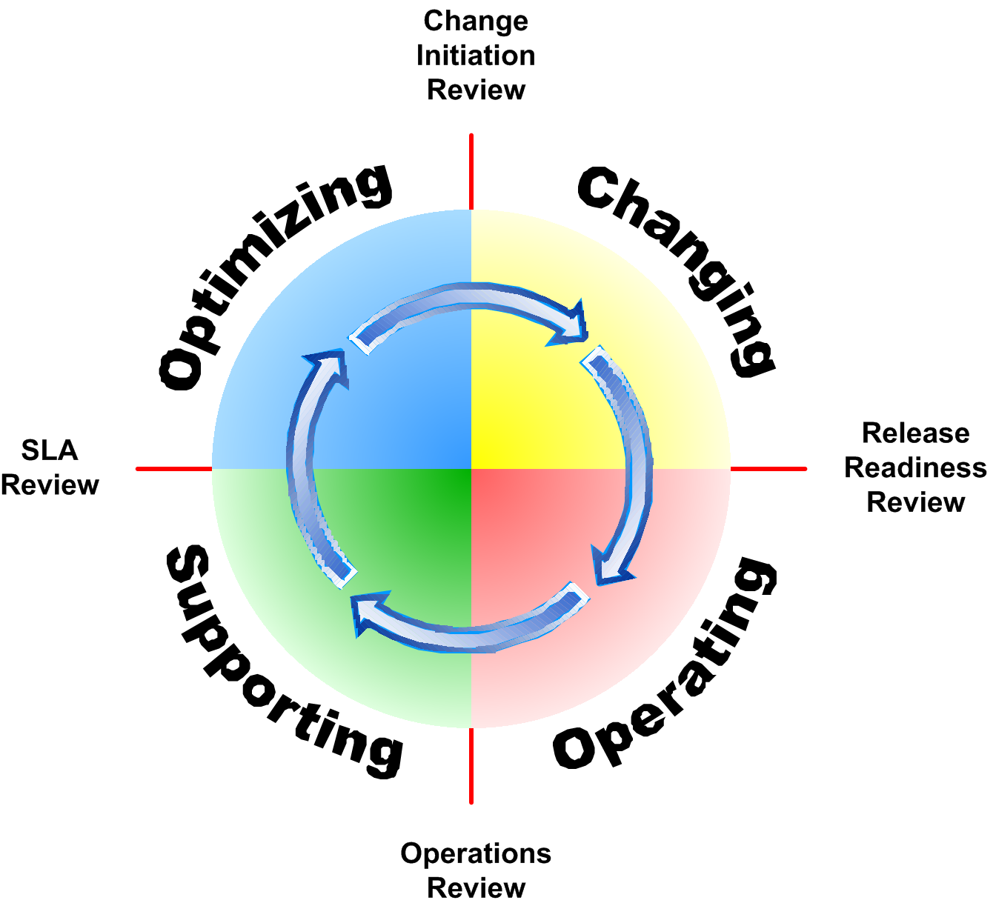
The MOF optimization cycle
Change Management and Configuration Management belong to the Changing quadrant
_____________________________________________________

Change
Change is any modification, introduction, or elimination of an IT component that may affect an IT service level or otherwise affect the functioning of the IT environment or its components.
____________________________________________________

Microsoft Change Metrics
- 81,000 infrastructure and service changes annually
- 17 percent growth in change activity over the past year
- 4 percent of all changes require Change Advisory Board review
- 11:1 change to incident ratio
Global Microsoft IT Environment
The Microsoft enterprise is large, complex, and constantly changing. The following data gives some idea of the environment that Microsoft IT manages (numbers are approximate):
- Nearly 500 sites in 96 countries/regions
- More than 90,000 users of IT
- More than 300,000 IT devices
- More than 150,000 desktop computers
- More than 10,000 network devices
- More than 600 core telephony devices
- More than 2,500 software applications
- More than 9.5 million remote connections per month
Change Management

Situation
Microsoft IT's goal is a Model Enterprise that is continuously optimized by the use of Microsoft products and operations principles. Three years ago, unplanned changes were affecting infrastructure availability and staff productivity. A MOF assessment revealed the following areas for improvement:
- Unaffiliated local process models for change management
- Inconsistent processes for managing infrastructure change activities
- No change governance and no process owners
- No common process language
- Exceptions common and not well documented
- Around 60 percent of all IT service request transactions due to change management activities
- Multiple tools impairing ability to manage change
- Tools used inconsistently to solve process problems

Solution
With executive backing, Microsoft IT launched a Service Improvement Project (SIP) to implement MOF change management processes, reviews, and best practices.

Change Management SIP Outcome
Microsoft IT has appointed a change manager, along with discipline owners who have responsibility for driving ongoing process optimization.
All changes to infrastructure have an associated change request. Changes are categorized according to their urgency, risk, and potential severity. Microsoft IT has developed a list of known change types to asses risk. It has also established a change approval model, with approval at the level appropriate to review the change based on risk. Levels range from automatic approvals to Change Advisory Board reviews prior to approval.
The ITChange tool is used to request changes and to process the requests through review and approval. Approved changes are communicated by change notification messages.
The Change Advisory Board has membership drawn from service managers, change initiators, operations, security, customer interfaces, and engineering. The Emergency Change Advisory Board approves emergency change requests, with on-call approval contacts authorized to deal with urgent requests.
The Microsoft IT monthly scorecard includes a change management key performance indicator, rolled up to the director and chief information officer level. The metric is the number of incident tickets resulting from changes. Currently, there are about 81,000 changes per year, with an average of one incident per 11 change activities.

Change Management SIP Benefits
- True control and governance, with educated staff
- Increased operations process maturity and established continuous improvement cycle
- Established standardized processes for the efficient handling of changes
- Reduced number of change-related incidents
- Significant efficiencies and cost savings as a result of reduced unplanned downtime and reduced incidents arising from planned changes
- Improved calibration of IT service metrics

SIP Lessons Learned
- Gain executive and midlevel support and proactive backing.
- Spend more time on awareness and training.
- Expect an increase in changes to be documented as a result of process compliance.
- Expect people issues from a perception of additional bureaucracy.
- Use the MOF Risk and Team models.
Configuration Management
Effective configuration management governance requires the identification, recording, and updating of all managed components in the infrastructure—applications, network, telephony, servers, and clients.
Microsoft IT has achieved tight standardization of hardware and software configurations, using the following internal applications and Microsoft products for configuration item monitoring, data collection, and deployment of changes:
- ITConfig serves as the authoritative source for managed network and server devices. ITConfig data is fed to business applications and to infrastructure management tools.
- SMS 2003 is used for software update deployment and for automated hardware and software inventory across server and client environments. Microsoft IT makes SMS inventory detail available to other infrastructure management and reporting applications, including ITConfig.
- Microsoft Windows Server™ 2003 Automated Deployment Services (ADS) is used for server operating system build-out.
- Active Directory and Group Policy are used for appropriate configuration items. As an example, when security identified Internet Protocol security (IPsec) Require Mode as the appropriate vehicle to segment unmanaged, vulnerable entities from the managed, up-to-date computing population, Microsoft IT used Group Policy to deploy the desired IPsec configuration across the enterprise.
- IPAK is an internally developed packaging tool for updates, hotfixes, and service packs for data center platforms, applications, and drivers. Microsoft IT requires data center servers to be within two versions of the current IPAK version, with new IPAKs released twice a year. IPAK is also used for the selective application and correct sequencing of third-party driver updates.

Ongoing Optimization
The MOF cycle of optimization and change continues in the Microsoft IT configuration management discipline. Microsoft IT has set up an Enterprise Configuration Management (EMC) initiative to develop the next-generation solution, working toward the following goals:
- A comprehensive architecture across all technology domains for enterprise configuration management
- A definitive source for configuration items, with improved consistency in reporting
- Reduced dependence on costly internal tools
The Configuration Management Database (CMDB) is the foundation of infrastructure management. A federated CMDB will be central to the new integrated configuration management solution. The ITConfig schema will be scaled back, to be replaced by a federated data model for those attributes and methods that are authoritatively controlled by SMS and Microsoft Operations Manager (MOM). Microsoft BizTalk® will provide the integration framework; System Center Reporting Manager and Microsoft SQL Server™ 2005 will provide data aggregation and data warehouse functionality.
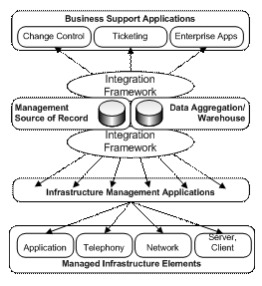
EMC architecture
Anticipated benefits of the initiative include savings of about $1.5 million US per year as a result of reduced tools, reduced process complexity, elimination of preventable service outages, and reduced security risks.

Typical Change and Configuration Management Situation
As efforts to maintain security in Microsoft have grown, the number of software updates for the desktop computer environment has increased. In this situation, challenges in patch management include:
- Inventories of software updates must be thorough and efficient.
- Patch management must be sufficiently automated.
- The impact of the update deployment must be assessed, and the change process must be controlled.
- The amount of employee downtime caused by installing software updates must be limited.

Solution
Microsoft IT turned to SMS 2003 to manage the deployment of security updates and other software updates across the enterprise. Process improvements in the fields of change and configuration management ensured an effective environment in which to use SMS 2003.

Benefits
- More efficient planning, assessment, scheduling, and review of deployment changes.
- Improved inventory capability: A reliable inventory has contributed to a proactive approach to providing security for the corporate network.
- More efficient deployments of software updates: The elimination of custom scripting has shortened the packaging of updates from 5 to 10 business days to no more than 4 business days—and usually within 1 day.
- Reduction of unplanned downtime: Users can choose the best time to install a software update within a grace period.

Products
- SMS 2003
- Windows Server 2003
- Microsoft SQL Server 2000
- Active Directory
- Microsoft Baseline Security Analyzer (MBSA)

For More Information
Contact your local Microsoft office at http://www.microsoft.com/worldwide or visit http://www.microsoft.com/technet/itshowcase
© 2005 Microsoft Corporation. All rights reserved.
This document is for informational purposes only. MICROSOFT MAKES NO WARRANTIES, EXPRESS OR IMPLIED, IN THIS SUMMARY. Microsoft, Active Directory, BizTalk, Windows, and Windows Server are either registered trademarks or trademarks of Microsoft Corporation in the United States and/or other countries. The names of actual companies and products mentioned herein may be the trademarks of their respective owners.

