
I
SOLUTIONS

Microsoft Dynamics™ and Microsoft® Office System: Delivering Business Value Through Interoperability

White Paper

Date: April 12, 2006

http://www.microsoft.com/dynamics


Table of Contents
Introduction 3
Familiar to Your People 4
Common Interface 4
Role-based Approach 5
Increased Efficiency 6
Fits With Your Systems 8
Fuels Productivity 10
Enable Confident Decision Making 12
Summary 14

Introduction
At Microsoft, we understand the impact your people have on your business: align your employees around a strong business plan and give them the tools they need to contribute and execute, and you can create business success. When people are equipped with the right tools, they can tackle complex business challenges while simultaneously increasing productivity, ultimately contributing to the bottom line. So, how can business management software improve employee productivity? Business solutions must become more intuitive, familiar, and easy to learn.
One of the challenges that has emerged in the workplace is that for people to do their jobs, they are required to switch between unstructured personal productivity tools and structured business applications. The reality of working in both unstructured and structured environments applies not only to the data they work with but also to their daily processes and tasks.
Business management solution users spend most of their time “heads down” in the business application, but they also need to use communication and desktop productivity tools. They manage information differently, and they perform tasks that are specific to the role they have. Business management solutions have very structured data, very controlled data, and appropriately so. To empower these users, the business solution needs a familiar user interface that is easy to learn. It needs to be “process-centric,” organized around the typical things that employees do through the course of a day. It needs to be role-based. And, it needs to provide a bridge between the worlds of structured business applications and unstructured desktop productivity software, all in an efficient and sensible manner.
Then there are the business owners, decision makers, and knowledge workers who spend the majority of their time doing email and creating ad-hoc documents while working within productivity and communication tools like Microsoft Office Outlook® 2003, Microsoft Office Word 2003 and Microsoft Office Excel®. These users need business information captured by the “transactional” part of the business solution. To address the needs of these users, business data must be easily accessible to the employees doing personal productivity work. The need for blurring the line between these two worlds of structured and unstructured data is clear, and Microsoft is delivering solutions to bridge the gap.
The result is a user experience that is familiar and easy to use and built around the way people in the company work. We call this a “role-based” approach. Software that’s role-based and targeted around the specific jobs people do can provide tremendous insight and help drive company-wide productivity.
When a business management solution works the way your current technology works, it can fit easily into your existing systems and can help you maximize your technology investment. Software that’s role-based and targeted around the specific jobs people do can provide tremendous value and insight because it:
- Is familiar, helping reduce the time required to learn how to use it, freeing up time to focus on what matters most.
- Fits with your systems, helping to maximize your investment in Microsoft technology.
- Fuels your business productivity, automating your business-critical operations and adapting to fit into your type of business, helping to ensure the most relevant insight.
- Helps enable confident decision making, providing you with more complete insight across your organization.

This paper is designed to provide Microsoft Dynamics™ customers and partners with examples of how Microsoft Dynamics and Microsoft Office System work together. Common business scenarios are used to demonstrate the business value that can be gained by utilizing the interoperability between Microsoft Dynamics and Microsoft Office System. Additional resources with more detailed information about how business management solutions from Microsoft integrate with Microsoft Office System are provided at the end of this paper.

Familiar to Your People
What if business management technology could free you and your employees to focus on what’s truly important for your business? What if technology reflected the ways in which people throughout your company actually work? Microsoft Dynamics works like other Microsoft products you and your people are familiar with, helping reduce the time required to learn how to use it, and freeing up time to focus on what matters most. Designed with a focus on the roles people play throughout your company, Microsoft Dynamics delivers an individualized, task-based user experience and allows your employees to easily customize and automate it based on their own preferences and work style. That can mean less training and development time and a quicker return on your investment.

Common Interface
Microsoft continues to build integrated, adaptable business management solutions that are evolving toward a common look and feel, mirroring that of Microsoft Outlook, without sacrificing the requirements for concentrated transaction entry that is appropriate for specific users of a business application. A familiar user experience can help lower training costs while empowering users to get more out of the application.
For example, you have a new employee join your accounting staff, and he is focused on accounts receivables (AR). This AR clerk is familiar with Microsoft Office System applications. With a business management solution from Microsoft, (in this example, Microsoft Dynamics™ GP) he can walk up to the system, look at it and quickly gain a sense for how to use it. The navigation is list-based, and cascading menus provide smooth, easy, and fast access. A list of user favorites provides the clerk with quick access to frequently-used areas of the business solution. This allows for easy customization and personalization of the navigation pane, improving productivity and employee efficiency. Your employees can move seamlessly from one application to the next, helping them remain efficient and productive.
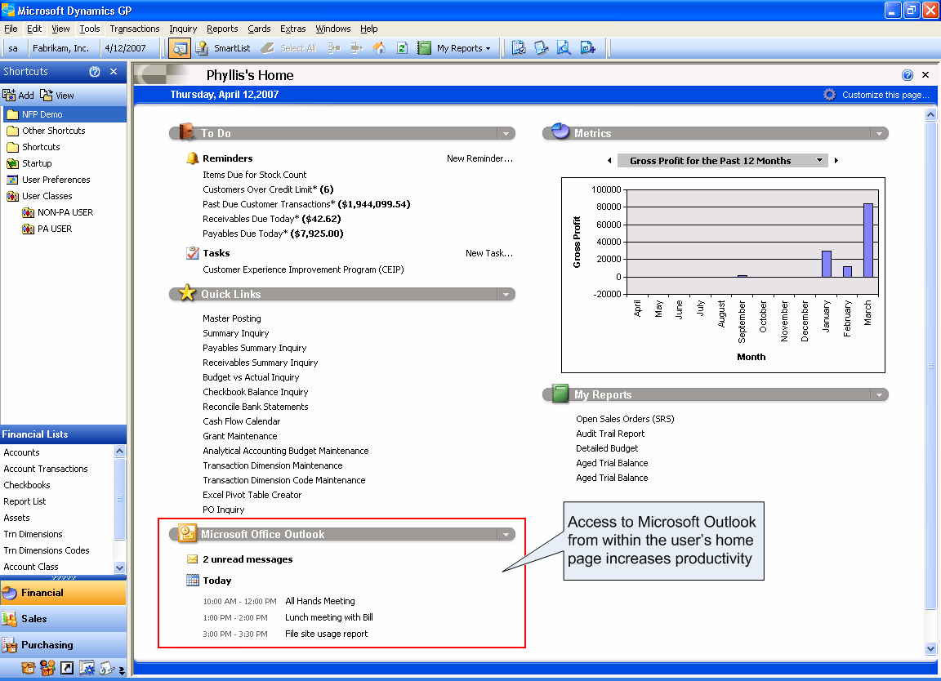
Figure 1: Microsoft Dynamics has an interface that is familiar to your people. Home pages surface your Microsoft Outlook inbox and calendar to help increase productivity.

Role-based Approach
Microsoft Dynamics includes a role-based design that presents relevant information and processes to individual users in a variety of business roles. Role-based access helps ensure the right data is at every user’s fingertips, while simultaneously limiting access to the data the user does not need. Home pages can be customized with more targeted information that provides the at-a-glance view of the business measurements that are most important to a person’s role, helping enable them to make timely, accurate decisions. Furthermore, role-based access helps provide security to sensitive data because users only see the information for which their role has access.
Microsoft Dynamics applications are built using a research driven, "customer centric" approach to understanding business; we call this approach the Microsoft Dynamics Customer Model. This critical planning artifact consists of sets of people organized into departments doing work together. This allows us to better understand our customers' processes, departments, and most importantly, the people or personas that are using our solutions. This model was created based on real world research in more than 2,000 companies across the globe. With 61 roles established to date, the model is continually enhanced and developed with findings from ongoing research projects.
Preconfigured role-based home pages within Microsoft Dynamics are designed specifically for the various roles of people, ranging from the accounting manager to the payroll administrator. The information on employees’ home page is continually updated and helps direct them to the tasks that are a key focus for their particular role. In addition, they’ll be able to personalize their page, adding and changing it to truly reflect the work that they do every day. Furthermore, since most users find it important check their email and calendar throughout the day, the home page not only surfaces the user’s inbox but also his/her calendar. In the example above, the accounting manager must have easy access to general ledger transactions as well as quick access to her calendar and email within Microsoft Outlook.

Increased Efficiency
All too often, users find themselves entering data twice or looking for information on different systems, possibly causing costly errors and reducing efficiency. Business solution users also distribute structured data in an ad-hoc manner with those users who do not need complete access to the business solution. Microsoft Dynamics and Microsoft Office System work together to improve process efficiency, providing employees with instant access to relevant business information, viewable from within Microsoft Office System documents. This helps maximize productivity by delivering accurate and up-to-date information access to all employees, regardless of their role.
A department manager wants her assistant—who is not a Microsoft Dynamics user—to draft a letter to a customer regarding a previously placed order. While working in Word, when the assistant enters pertinent customer information that’s stored in the business solution, he can instantly drill back on that customer data from within the Word document to see the customer’s latest order in real time, and he can include a thank you for that order in the letter he is about to send.
Without this integration, the assistant would need to request this customer data from someone with full access to the business solution, impacting multiple people’s productivity and efficiency.
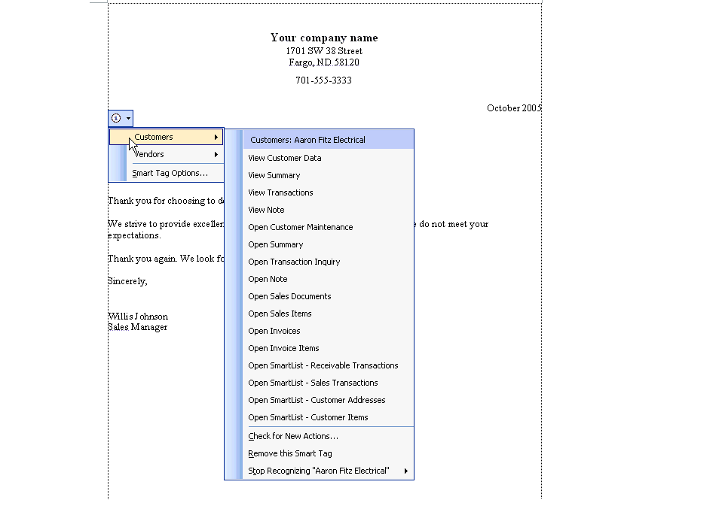
Figure 2: Microsoft Office users can access Microsoft Dynamics data from within Word.

Reporting, budgeting, and forecasting can all be exhaustive and time consuming, yet very necessary steps in a successful business. Using trusted tools that are familiar to most people helps increase productivity and decrease the learning curve. Microsoft Dynamics allows users to review, edit, and manipulate data with the widely used spreadsheet application Excel with as little as one click of the mouse.
Additionally, using Excel to view and analyze data from Microsoft Dynamics and Microsoft Dynamics™ CRM allows users to quickly provide non-system users information they need. For example, a manager wants a list of the most profitable items emailed to his sales force. Using the export functionality from within Microsoft Dynamics, he can easily export this data to Excel and email the information directly to the sales team. When the sales team receives the data, they can also drill back to the item detail using Smart Tags functionality, which resides in Microsoft Dynamics and is based on the security access the employees given what’s appropriate to their role.
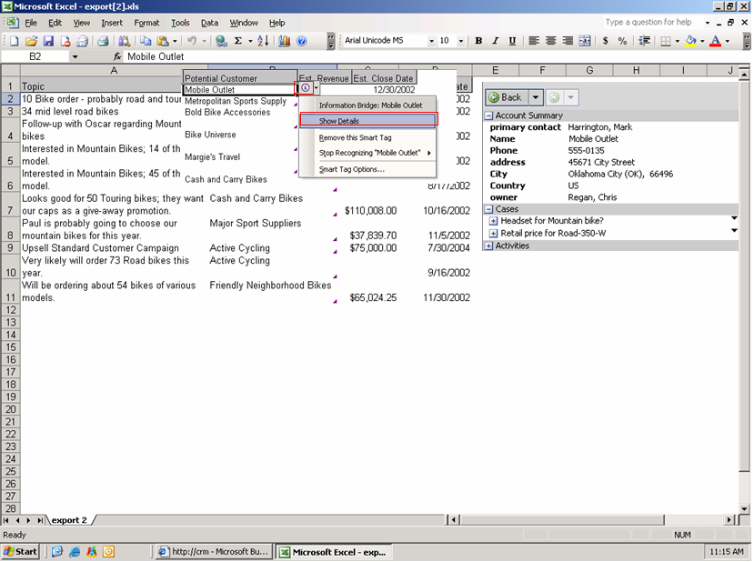
Figure 3: Microsoft Dynamics data can be shared with non-system users from within Excel through Smart Tags functionality.

At times, organizations find their employees struggle to adopt new technologies and applications, which can result in a poor return on investment for the company. Microsoft Dynamics helps organizations realize the potential of their business applications investment without requiring users to fundamentally change the way they do their jobs. Companies find their employees are empowered by the use of familiar tools that help increase their productivity.
With Microsoft Dynamics CRM, a sales representative can manage all sales data, campaigns, and marketing information from within Microsoft Outlook. Contacts and opportunities can be viewed, updated, and shared across the organization. In addition, current product information, new leads, and contracts related to the sales process can be accessed. This can all be done from within Microsoft Outlook without the need to learn a different system or toggle back and forth. Additionally, for a Microsoft-centric organization, Microsoft Dynamics CRM enables use of existing IT investments, training, and technologies.
Barriers to successful CRM implementations in the past have been the lack of employee adoption, use, and compliance across the organization. A key advantage of Microsoft Dynamics CRM is its native integration to core Microsoft products, which helps organizations mitigate risks of poor user adoption. Users can easily perform tasks because they are familiar and do not require moving between multiple applications. For example, a sales representative can track customer contacts and sales data in Microsoft Outlook as well as view activities, accounts, competition, and more.
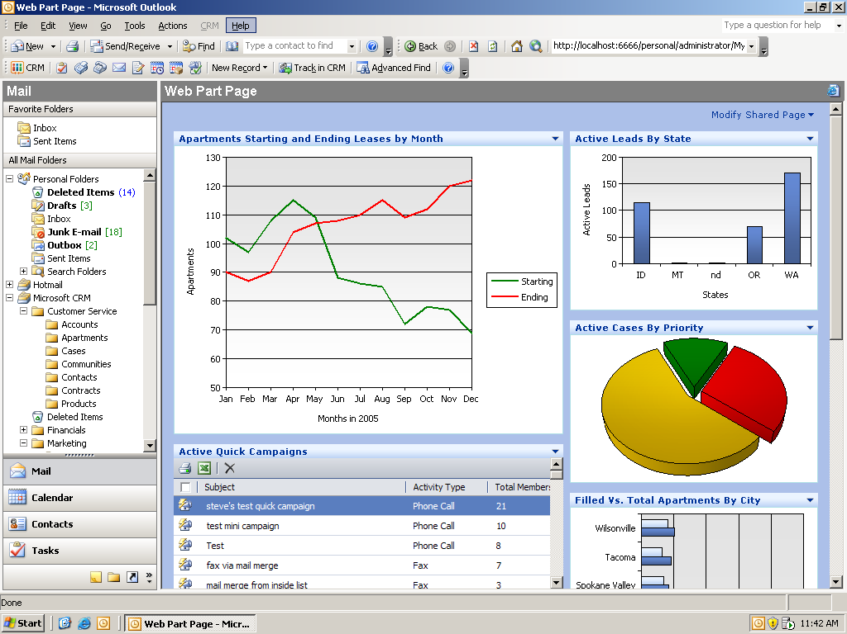
Figure 4: Microsoft Dynamics CRM allows employees to track customer contacts and sales data in Outlook as well as view activities, accounts, competition, and more.

Fits With Your Systems
When a business management solution works the way your current technology works, it fits easily and seamlessly into your existing systems and helps you maximize your technology investment. Microsoft Dynamics works the way your current technology works and fits easily into your systems, helping to maximize your investment in Microsoft technology and ease IT administration. This in turn allows your employees to use a powerful business management solution within a familiar environment.
Microsoft continues to execute on its strategy to deliver business management solutions that fit with customers’ existing systems. Microsoft Dynamics Snap, a collection of programs that “snap” into Microsoft Office System, help enable information workers to easily coordinate and manage data in Microsoft Dynamics business management solutions using the familiar interface of Microsoft Office System.
The first Microsoft Dynamics Snap solutions include Timesheet Management Snap-In, Vacation Management Snap-In, and two versions of a Business Data Lookup Snap-In, one for Microsoft Dynamics CRM and the other for Microsoft Dynamics™ AX.
These solutions are designed for information workers who use Microsoft Office and need to access business information and business processes managed by their back end Microsoft Dynamics business management solutions. Most people want to be able to do this without opening multiple programs, cutting and pasting data, or having to master the full complexity of all of the software in a company.
As an example, a consultant working with his customer will coordinate meetings and appointments using Outlook. These calendar events are linked with, in this case, Microsoft Dynamics AX time entries, eliminating the need to correlate tasks and helping reduce errors as a result of users having to transpose data from one program to another. Additionally, it is not necessary for the consultant to engage Microsoft Dynamics AX – all work is completed within Outlook, yet his time allocation is appropriately tracked in the billing application.
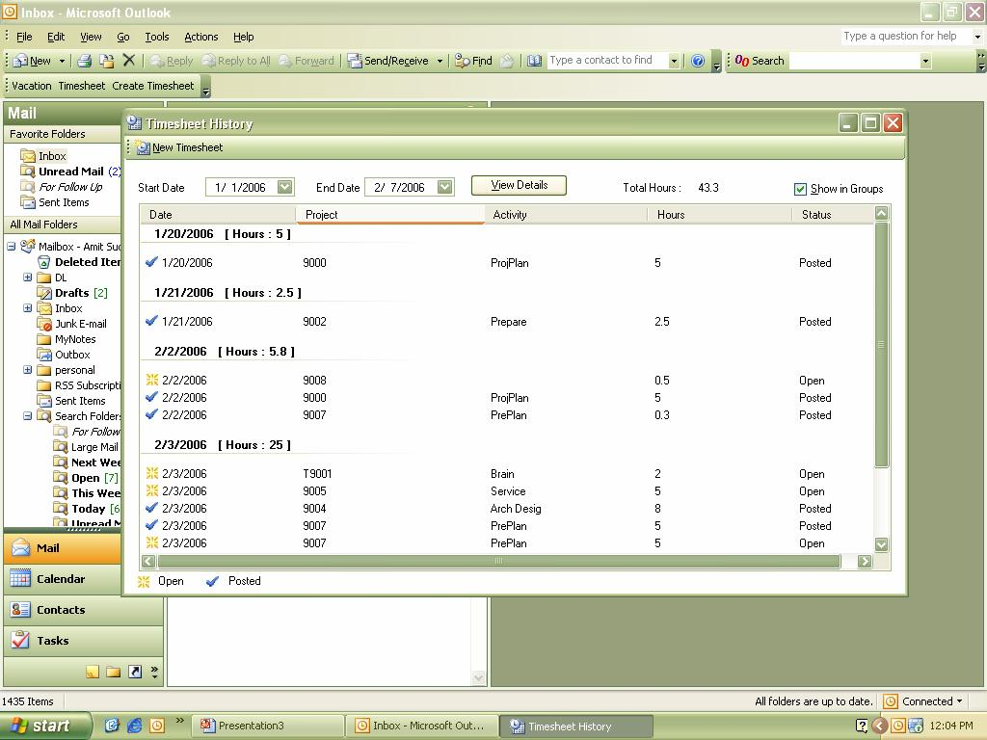
Figure 5: Outlook calendar events are linked with Microsoft Dynamics AX time entries with the Timesheet Management Snap-In.

With the Business Data Lookup Snap-In, users can access Microsoft Dynamics data easily from within Microsoft Office System as well as store Microsoft Office System documents as part of the Microsoft Dynamics database. With a single repository of customer communications, both structured and unstructured data, employees can increase productivity and experience greater operational efficiency.
As an example, a sales representative’s communication is attached to her customers’ Microsoft Dynamics CRM record. When working with her customers, she can quickly find all related information since it is stored in one place. It’s not necessary for her to dig through multiple applications and folders to successfully complete a sale. In addition, while she is on leave from the office, her peers can easily manage her customer relationships, maintaining a high level of customer care.
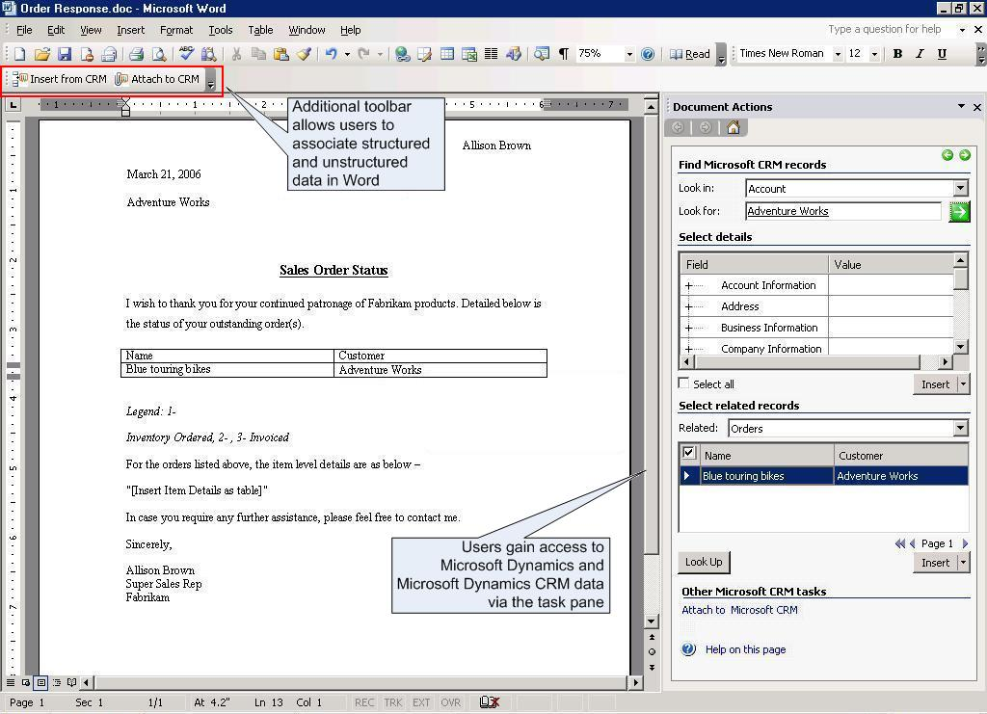
Figure 6: Microsoft Word users can link structured and unstructured data and access Microsoft Dynamics and Microsoft Dynamics CRM information.

While utilizing role-based tasks and data sharing within Outlook and Word for Microsoft Dynamics is not new to Microsoft Dynamics business management solutions (such features as time management and vacation requests previously existed), the method in which Microsoft delivers these applications is. Microsoft partners and independent software vendors (ISVs) can benefit by using the shared source code in the Microsoft Dynamics Snap solutions to enhance or customize the shipped solutions to more closely map to specific processes or to use them as examples to build new composite applications for their customers.

Fuels Productivity
Microsoft Dynamics helps fuel productivity by automating business-critical operations and adapting to fit into a customer’s type of business, helping ensure the most relevant insight. How? With a user experience modeled around tasks and roles and the processes they engage in – all integrated with familiar productivity tools like Microsoft Office System.
Microsoft Windows SharePoint® Services technologies facilitate collaboration within an organization and with partners and customers. Users in an organization can easily create, manage, and build their own collaborative Web sites and make them available throughout the organization. In addition, team and site managers can coordinate site content and user activity easily. The Windows SharePoint Services environment is designed for easy and flexible deployment, administration, and application development.
With integration between Microsoft Dynamics and Windows SharePoint Services technologies, collaboration is fostered among your employees, vendors and customers. And, by integrating financial, customer relationship and supply chain processes to help maximize both internal and external efficiencies, costs can be reduced and performance can be improved.
A CFO frequently seeks the most recent details about the company’s cash flow situation or expenses for a given reporting period. Using Windows SharePoint Services and Microsoft Dynamics, a summary of key performance indicators (KPIs) for sales can be displayed on the executive dashboard in real time and can be accessed using a Web browser.
As a result, the CFO has the information she needs to make decisions, and with a click of the mouse she can easily “drill down” on any summary-level information to review the individual transactions behind the executive dashboard information. Windows SharePoint Services and Microsoft Dynamics provide an automatic way to display financial and operational information and provide easy access to detailed sales information.
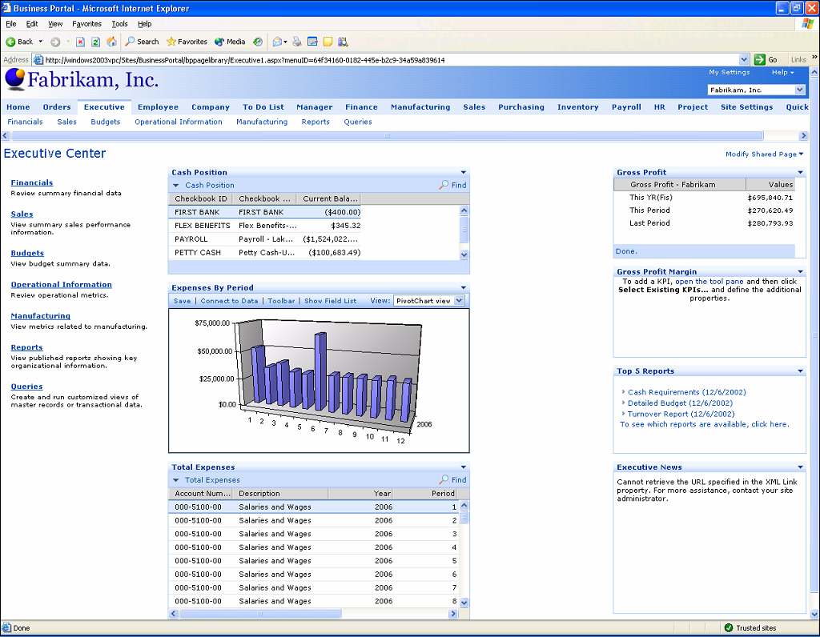
Figure 7: Microsoft Dynamics shares information with Windows SharePoint Services, allowing users to create executive dashboards to view financial, sales, and operational information.

Microsoft Dynamics uses document workplaces created using Windows SharePoint Services to enable employees to collaborate and work together on processes such as invoicing, customer order tracking and reporting. For example, salespeople can access customer accounts and sales history, as well as enter orders. Purchasing supervisors can look up inventory levels and lead time information, and production designers can edit a bill of materials (BOMs) right from Windows SharePoint Services.
Companies can create secure company-wide intranets that allow employees to access only what is appropriate for their role. This helps ensure that employees have access to relevant and timely information, which in turn helps increase productivity.
Organizations benefit from their employees utilizing familiar applications that do not require additional training. A shipping department could quickly mark a sales order as fulfilled or salespeople could access their customer lists without learning a new system. By utilizing Microsoft Dynamics and Windows SharePoint Services, companies realize time and cost savings, promote educated decision-making, and increase data integraty.
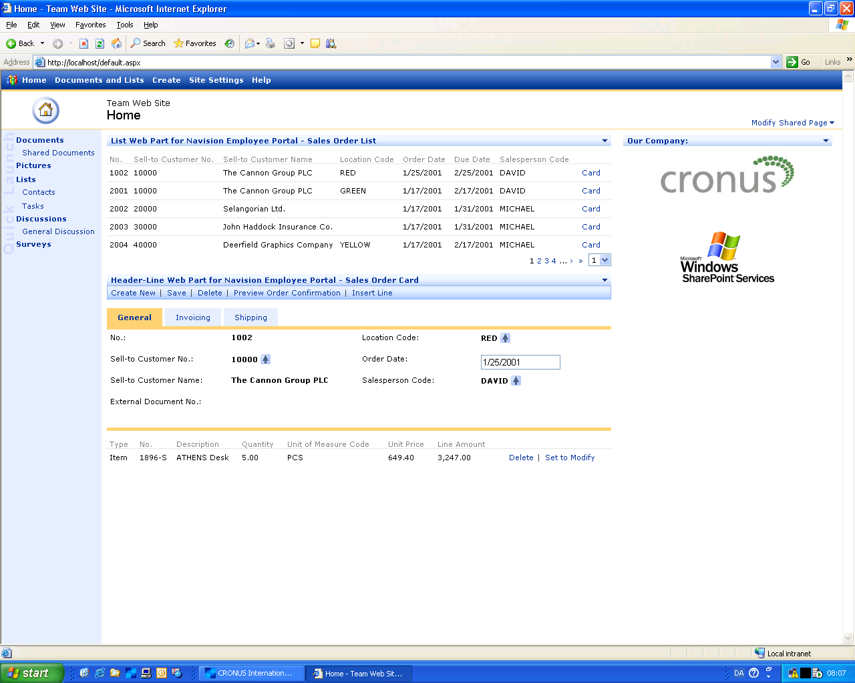
Figure 8: Users can review and edit sales orders easily with Microsoft Dynamics and Windows SharePoint Services.

Enable Confident Decision Making
Business is demanding. You need the ability to respond to the challenges with confident, informed decisions. Microsoft Dynamics helps you respond to changing business conditions by providing insight into your organization so you and your people can make timely and informed decisions with increased confidence. With Microsoft SQL Server™, Excel, Microsoft Office Business Scorecard Manager analysis tools and Microsoft Dynamics working together, you gain access to critical data. That data can be easily analyzed, and your employees get the information they need in the way they want, using a tool that is already familiar to them.
Microsoft Dynamics provides business analysis solutions, such as Excel pivot tables, in an intuitive graphical user interface. Additionally, Microsoft’s business intelligence solutions enable On-Line Analytical Processing (OLAP) via the Data Transformation Services of Microsoft SQL Server. This enables users to see 360-degree views of the business performance. It not only generates a quick overview of core business data, but it also helps ensure that everyone in the organization gets the business insight they need to make strategic and operational decisions based on the latest accurate data. In addition, users can use all the standard Excel tools for analysis and reporting, including direct analysis of tables and records, without having to generate data cubes. These solutions support pre-defined KPIs that help users to chart their company’s and department’s performance easily. And, it’s also easy for users to create their own thresholds and rules for when they want to receive automatic alerts. They can tailor the system to meet their particular needs.
Microsoft Office Business Scorecard Manager is a comprehensive scorecard and dashboard application that provides knowledge workers with deep contextual insight into business drivers. Information is presented in a collaborative environment so teams can work from the same real-time information and share work as they progress through a business process. Along with Windows SharePoint Services, Business Scorecard Manager and Microsoft Dynamics help empower end users to build, manage, and consume scorecards using familiar, easy-to-use applications in a collaborative environment.
A bike shop owner wants to analyze her product line profitability. By viewing the dashboard, she has deep contextual insight into which product lines are profitable and which ones are under performing. She can easily “drill down” further on those product lines that are not meeting goals. Is she carrying the right style, colors, and brands? How does her inventory differ from the competitor down the street? Is her sales team educated and knowledgeable about how to sell the underperforming brands? Would a sale or special sales incentive result in increased volume? Or have existing discounts already resulted in margin erosion? By using Microsoft Dynamics in conjunction with Business Scorecard Manager, her inventory is easily and clearly transparent, aiding to make the right decisions for her business.
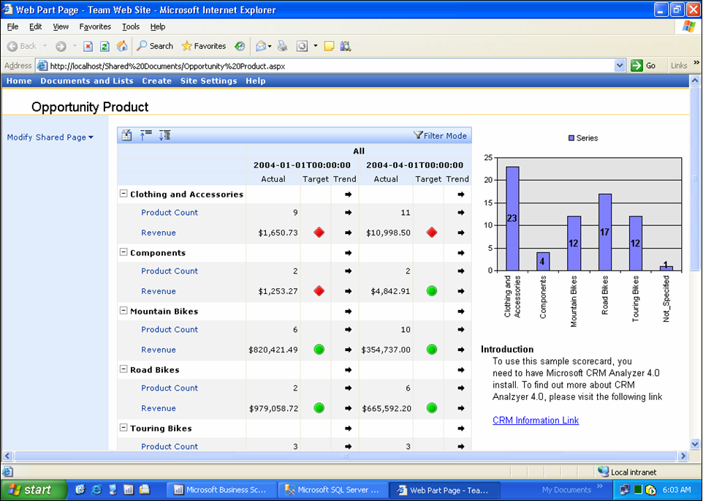
Figure 9: Organizations can access scorecards to help understand the state of their business by using Windows SharePoint Services, Microsoft Business Scorecard Manager and Microsoft Dynamics.

Microsoft realizes that your company’s business processes can be a competitive advantage, but in today’s business environment, documenting and auditing business processes is a requirement to compete in the global marketplace and a legal necessity in some cases. Microsoft Dynamics includes an accelerator that works with Windows SharePoint Services and Microsoft Office InfoPath® 2003 to track document modifications using audit trail features. Microsoft Dynamcis also offers a compliance repository for general reference materials to help companies ensure they are following the highest accounting standards and governmental legislation.

Summary
Using Microsoft Dynamics, you can help increase the productivity of employees throughout your business in less time. With an already familiar Microsoft Office System user interface, your employees will be able to take advantage of the innovations within Microsoft Dynamics with a minimal amount of training time. Microsoft Dynamics is designed to correlate with specific roles that people possess in companies like yours. And it’s designed to allow employees throughout your business to customize and automate it according to their preferences and work styles. Microsoft Dynamics means business management solutions. For your employees, that means software that works the way they do. For your business, that can mean an accelerated return on your investment – and a business that’s managed more smoothly, more effectively and more profitably.

Microsoft Dynamics is a line of integrated, adaptable business management solutions that enables you and your people to make business decisions with greater confidence. Microsoft Dynamics works like and with familiar Microsoft software, automating and streamlining financial, customer relationship and supply chain processes in a way that helps you drive business success.

U.S. and Canada Toll Free 1-888-477-7989
Worldwide +1-701-281-6500
www.microsoft.com/dynamics

© 2006 Microsoft Corporation. All rights reserved.
Microsoft, Excel, FRx, InfoPath, Microsoft Dynamics,Microsoft Dynamics AX, Microsoft Dynamics GP, Microsoft Dynamics NAV, Microsoft Dynamics SL, the Microsoft Dynamics logo, Outlook, SharePoint, Windows, the Windows logo, and Windows Server are either registered trademarks or trademarks of Microsoft Corporation, FRx Software Corporation, or Microsoft Business Solutions ApS in the United States and/or other countries. Microsoft Business Solutions ApS and FRx Software Corporation are subsidiaries of Microsoft Corporation.

The information contained in this document represents the current view of Microsoft Corporation on the issues discussed as of the date of publication. Because Microsoft must respond to changing market conditions, this document should not be interpreted to be a commitment on the part of Microsoft, and Microsoft cannot guarantee the accuracy of any information presented after the date of publication.
This White Paper is for informational purposes only. MICROSOFT MAKES NO WARRANTIES, EXPRESS, IMPLIED, OR STATUTORY, AS TO THE INFORMATION IN THIS DOCUMENT.
Complying with all applicable copyright laws is the responsibility of the user. Without limiting the rights under copyright, no part of this document may be reproduced, stored in or introduced into a retrieval system, or transmitted in any form or by any means (electronic, mechanical, photocopying, recording, or otherwise), or for any purpose, without the express written permission of Microsoft Corporation.
Microsoft may have patents, patent applications, trademarks, copyrights, or other intellectual property rights covering subject matter in this document. Except as expressly provided in any written license agreement from Microsoft, the furnishing of this document does not give you any license to these patents, trademarks, copyrights, or other intellectual property.

