Real Time Communication Benefits
IT business benefits |  | Benefit | Source or derivation
IT business benefits | People | - Users save 68 minutes per week, per person.  - Productivity increases 15-20%, freeing time for customer contact and support. | - Microsoft Internal Client Satisfaction Survey.  - User Survey, National Technology Partner Sales and Support Team.
IT business benefits | Network | - Improved server consolidation: reduced number of servers from 19 to 15, including five new servers for new functions.  - Increased service levels and enhanced security | - Using Active Directory integration, the Live Communications Server 2005 deployment was reduced from 19 servers to 15, which includes five servers for new functions such as federation, load balancing, and database servers.  - More secure internal and remote access that is easier to set up and manage.  - URL and attachment filtering permit a more secure IM environment  - Result of deployment of a more available, more scalable, and higher-performance two-tier server farm configuration.
 | Operations | - 80% of "Critical Situation" support requests escalated within one-hour goal.  - International development issues reduced by 50 minutes per week.  - Cost savings of $2,250 per person, per year. | - User Survey, Technical Account Manager team.  - Development issue reduction based on survey and interview data from a recent case study engagement performed at Microsoft.  - Average salary of $50,000, $25 per hour.
Establishing enterprise-wide presence was essential to Microsoft. Presence is real-time information that describes a particular user’s location and availability to communicate. Also considered essential was providing the ability to instantly communicate and share message, voice, and video information and data.
By deploying Live Communications Server 2005 and Communicator 2005, this functionality is available to end users in one quick, easy, and highly secure system. Being able to detect a person's presence—whether that person is in the office, logged on through remote access, or online but not logged on to the corporate environment—has given Microsoft a new level of agility, which is essential in a competitive corporate environment. Today, more than 95,000 staff at Microsoft are set up to use Communicator, with over 68,000 unique users of the system every month. It has rapidly established itself as a business-critical system.
Situation
As a large, geographically dispersed organization, Microsoft needed an intuitive, real-time collaboration system that would eliminate time-critical delays caused by conventional means of communications, such as voice mail and e-mail. The collaboration system needed to facilitate quick question-and-answer sessions, provide immediate Microsoft Outlook® contact information, provide real-time presence information about all users, and facilitate file and application sharing. The system also needed to facilitate real-time communication with business partners.
The centralized global Helpdesk required a real-time communication system that would allow remote, hands-on information sharing and support at the desktop computer.
Like any large organization, Microsoft faced significant telephone toll costs. Microsoft sought to reduce these tolls.
Many instant messaging systems facilitate instant communication, without the need to implement the underlying security requirements essential for businesses that need to protect intellectual property. Microsoft realized, from both business integrity and security standpoints, that it needed an instant messaging system that would enable security features. For example, the system needed to block client-to-client file transfers, and it needed to enforce encrypted business conversations over a public network.
Solution
Microsoft Information Technology (Microsoft IT) implemented a high-availability solution based on Microsoft Live Communications Server 2005 Enterprise Edition. The system supports over 100,000 simultaneously active users.
The collaborative features of Live Communications Server 2005 and Communicator 2005 enable Microsoft staff to get real-time information, without having to wait for responses to e-mail and voice mail. Live Communications Server 2005 provides instant messaging, audio/visual conversations, remote assistant, remote white boarding, file sharing, application sharing, notifications, and presence awareness. Instant messaging conversations can easily be changed to video, voice, conference, or file-sharing sessions.
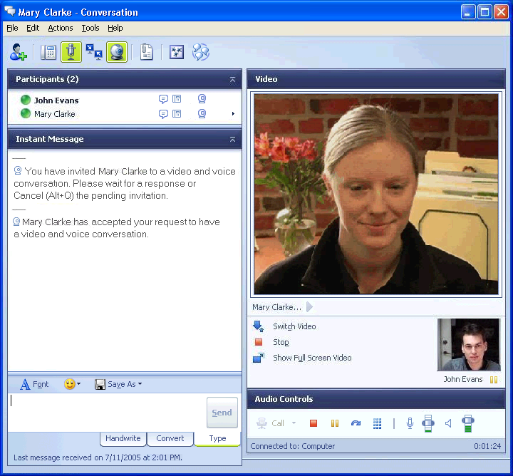

Communicator 2005 real-time meetings
Because the applications integrate fully across Active Directory and the Microsoft Office System applications, such as Sharepoint, they provide a single point of contact by integrating Outlook functionality. Communicator 2005 integrates the following Outlook features:
- Contact information, such as phone number, location, and alias, is automatically prepopulated into the Communicator client.
- Find functionality in Communicator 2005 searches the Outlook Global Address List.
- Outlook Out of Office messages are incorporated into Communicator 2005.
- User availability reflects the status of their Outlook calendars.
By incorporating this information, users always know the status of their teams, no matter how geographically dispersed they may be.
Live Communications Server 2005 and Communicator 2005 filled a need for instant meetings because they provide a method for users to collaborate internationally with colleagues, without needing to organize meetings in advance.
Live Communications Server 2005 SP1 addressed the requirement to collaborate with business partners in real time. A service federation feature enables users to communicate and collaborate in real time with users at other companies, with security features enforced. The partner company needs to run LCS Communications Server 2005 SP1 access proxy server inside its environment.
With continually decreasing bandwidth costs, Microsoft chose to take advantage of its existing data infrastructure to use voice over Internet Protocol (VoIP). Communicator has also extended real-time communication to include the management of incoming and outgoing telephone calls over private branch exchange (PBX) networks, public switched telephone networks (PSTNs), and VoIP networks.
Microsoft is taking advantage of these benefits by using Live Communications Server 2005 and Communicator 2005. With more than 400 individual sites worldwide, the rich collaboration systems have enabled employees to reduce travel. The systems have also reduced reliance on expensive stand-alone conferencing equipment.
Live Communications Server 2005 and Communicator 2005 have delivered the following security features on both client and server:
- Data encryption
- Strong authentication
- Security federation
- Advanced logging and compliance
- URL and attachment filtering
In addition, Live Communications Server 2005 is fully integrated through the Microsoft Windows Server™ operating system, which has realized key benefits such as single sign-on, policy-based management, and common management of the system through familiar Microsoft Windows®–based systems.

Products and Technology
- Live Communications Server 2005 Service Pack 1
- Communicator 2005
- Microsoft Windows XP Professional SP2
- Microsoft SQL Server™ 2000
- Microsoft Windows Server 2003 with Active Directory
- Microsoft Operations Manager 2005
- Microsoft Identity Integration Server 2003 for cross-forest directory synchronization
Documentation and links to all Live Communications Server 2005 installation and product requirements can be found at http://office.microsoft.com/en-us/FX010908711033.aspx.

Live Communications Server 2005 SP1 Remote User and Federated Access Architecture
There are two roles for the primary servers in the server pool: front-end servers and database servers. Additionally, to support external Internet access and inter-organization federation of real-time communication services, one or more Live Communications Server 2005 access proxy servers may be deployed in the perimeter network. Live Communications Server 2005 director servers may be required in situations that require specialized Session Initiation Protocol (SIP) message routing.
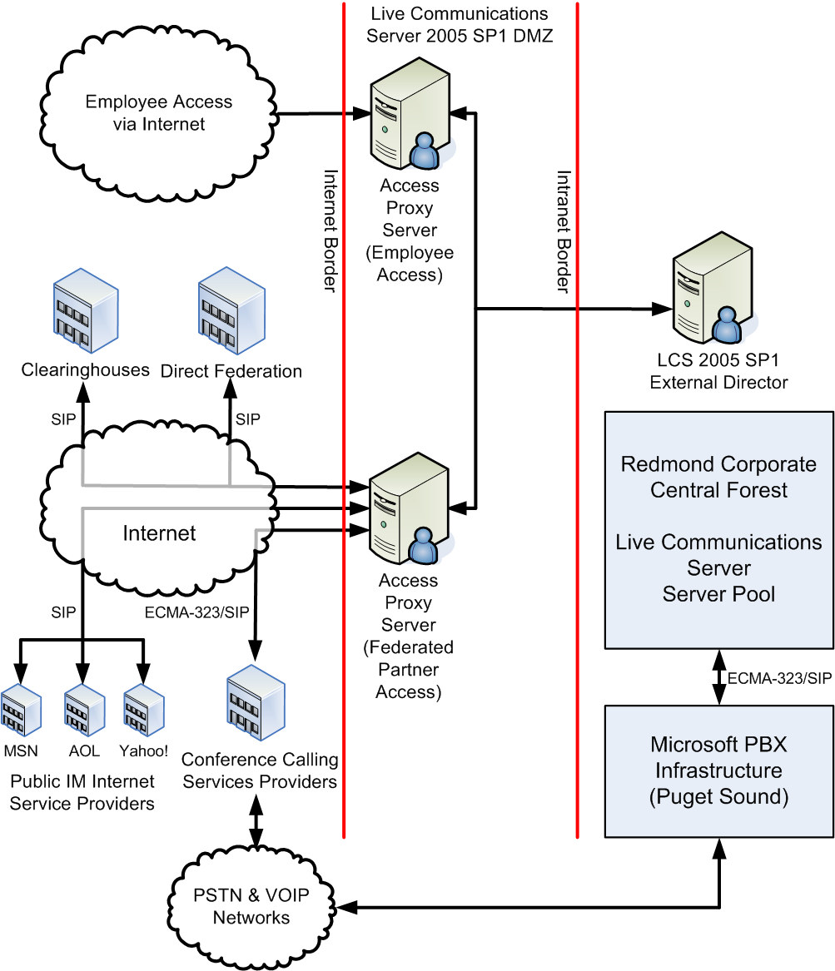
Live Communications Server 2005 architecture
Global Microsoft IT Environment
- 95,000 users enabled for Live Communications Server
- 68,000 unique users of Live Communications Server per month
- More than 300,000 computers and devices
- More than 400 sites supported worldwide
- Global virtual help desk
- More than 3 million internal e-mail messages per day
- More than 8.8 million external e-mail messages per day
- More than 6.8 million e-mail messages blocked per day
- More than 7.5 million remote connections per month

For More Information
For more information about Microsoft products or services, call the Microsoft Sales Information Center at (800) 426-9400. In Canada, call the Microsoft Canada information Centre at (800) 563-9048. Outside the 50 United States and Canada, please contact your local Microsoft subsidiary. To access information through the World Wide Web, go to:
http://www.microsoft.com/worldwide or visit http://www.microsoft.com/technet/itshowcase
© 2005 Microsoft Corporation. All rights reserved.
This document is for informational purposes only. MICROSOFT MAKES NO WARRANTIES, EXPRESS OR IMPLIED, IN THIS SUMMARY. Microsoft, Active Directory, Outlook, Windows, and Windows Server are either registered trademarks or trademarks of Microsoft Corporation in the United States and/or other countries. The names of actual companies and products mentioned herein may be the trademarks of their respective owners.

