
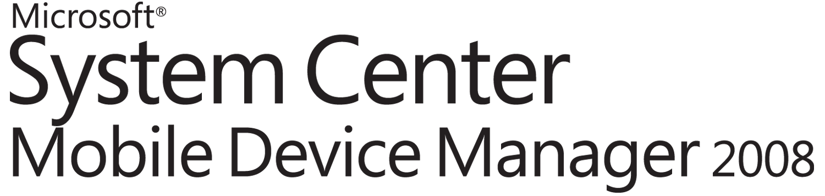

Microsoft®
System Center Mobile Device Manager 2008
An Introduction for Business Audiences



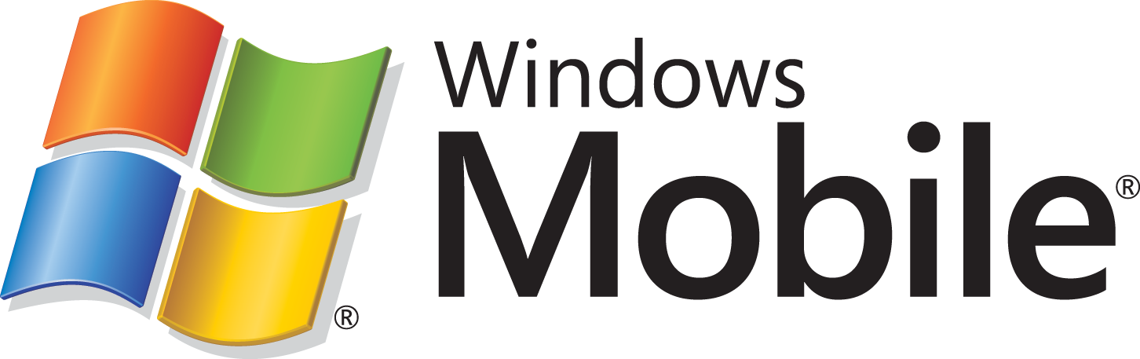

Table of Contents
Executive Summary 3
Introduction 3
System Center Mobile Device Manager 4
Mobile Device Manager in Action 5
Security Management 5
Device Management 5
Mobile VPN 6
Summary 6

Executive Summary
A growing number of companies are making “mobile workforce enablement” a business priority. Yet giving mobile employees access to corporate information means little if the TCO exceeds the benefits, information is left unprotected, and mobilizing a workforce does not yield a sufficiently quick ROI. This paper examines the major business and management challenges confronting enterprises interested in mobile solutions. Also, it explains how Microsoft® System Center Mobile Device Manager 2008 offers a new security and device management product which organizations can use with their existing technology investments to help reduce costs, while investing in innovative technologies that can help enhance security. The paper then concludes by looking at different business scenarios and how Mobile Device Manager effectively addresses them.

Introduction
Worldwide, more and more companies are supporting a workforce who perform their jobs outside of the office. Strategy Analytics currently estimates the number of mobile professionals to be approximately two thirds of all workers. These workers require greater access to corporate data, anytime, anywhere. By giving them access to the real-time data and vital information they need while on the go, these companies are seeing many benefits such as greater worker productivity, greater cost savings by replacing paper-based processes, and increased customer satisfaction through faster responses to customer needs. However, while mobile deployments can be used to drive strategic competitive advantages, some enterprises may encounter challenges such as the following:
Keeping information safeguarded. Mobile devices are by their very nature susceptible to being damaged, lost, or stolen. This can endanger the privacy of corporate data as well as affect the productivity of the person whose device was compromised. You must ensure that sensitive information is safeguarded without limiting the effectiveness and efficiency of your mobile workers or raising the risk of intellectual property falling into the wrong hands.
Delivering reliable and secure remote access. Workers today want their desktops at their fingertips. They want to be close to their contacts, calendars, and information. They want easy access to line-of-business applications and corporate forms. Having remote access helps improve customer service, make sales, and improve decision-making. But mobility alone does not guarantee access to the corporate network anywhere and anytime. Loss of transmission and dropped signals are just some of the issues frustrating users when they’re on the go. You require reliable and consistent access for your mobile workforce with enhanced security features that enhance their productivity.
Minimizing maintenance costs. In making attempts to personalize their devices, many employees try to install unauthorized software. This can affect how the device performs. It can also leave your network more susceptible to viruses and malware, which can cause untold frustration not to mention a heavy financial burden. You must have resources to easily control your mobile network and subsequently reduce maintenance costs.
Providing powerful productivity tools. Choosing a mobile solution is only half the battle. You need to be able to get your mobile devices up and running and out to employees quickly to realize a faster ROI. The mobile devices must also be tracked constantly to ensure that they comply with standards set by the IT. If mobile device monitoring is inefficient, you may lose time, money, and resources to constantly monitor and remedy the situation.
Easy scaling. Many mobile solutions deliver great features and functionality for today. But what about tomorrow? Too many companies find themselves continually reinvesting in infrastructure components because the dynamics of the company have grown, rendering the old solution obsolete, too expensive to manage, and reducing the return on investment. You need a solution that can meet the demands of your company, while future-proofing your technology investments.
Simplifying management environment. The majority of mobile security and device management solutions in enterprises present a complex network of pieces and platforms that cost time, money, and effort. You need a single point of management for reducing IT costs.

System Center Mobile Device Manager
System Center Mobile Device Manager takes the complexity out of device management, security, and deployment, increasing your productivity and performance. Offering greater control of Windows Mobile® 6.1 devices for a low total cost of ownership, Mobile Device Manager helps organizations protect their network and corporate data from unauthorized mobile device access, keeping that information safeguarded even if devices are lost or stolen.
With Mobile Device Manager, you get a single, comprehensive management console, enabling an organization to make sure that all of their mobile workers have necessary security updates. In addition, Mobile Device Manager provides workers with a single, secure point of access to corporate data and line-of-business applications, Intranet files, and data on shares that they need to be successful while away from the office.
Mobile Device Manager works well with an organization’s existing Microsoft infrastructure, simplifying management and reducing costs by eliminating the need to purchase additional software or redundant middleware. In addition, Mobile Device Manager supports many users on a single server, reducing the cost and complexity of deployment and maintenance, and boosting employee performance.
Mobile Device Manager in Action
Mobile Device Manager empowers organizations with a robust security and device management platform for Windows Mobile 6.1 devices. The three primary areas of focus concern security management, device management, and Mobile VPN. The following scenarios provide examples of how Mobile Device Manager benefits each focus area.

Security Management
Business Challenge. The field service personnel at Contoso use mobile devices to complete sales orders and billing matters onsite, reducing paperwork and data-entry errors while improving customer service and productivity. Because Contoso lacks a central security management solution, they have little control over their mobile fleet of devices. Executives never felt comfortable that corporate data was protected at all times. A few employees in the past misplaced their devices, putting important company data at risk of falling into the wrong hands. Trying to remotely wipe information off the lost devices took too much time.
Solution. Mobile Device Manager gives IT enterprise control over what software can be installed and run on Windows Mobile 6.1 devices within a company’s mobile network. This helps the devices run faster and also keeps malware from getting onto a device or into the network. IT can also easily lock down communications and camera functionality, helping ensure that a company maintains compliance.
Mobile Device Manager uses an “always on” (when connected to a carrier’s wireless or a Wi-Fi network) connection for remote device wipe. As a result, if a device is lost or stolen, IT can instantly wipe a device, reducing the chances of corporate data being compromised by reducing the window of opportunity. In addition, Mobile Device Manager enables file encryption for sensitive files or corporate data, further protecting sensitive information, especially if a device is not quickly reported or recognized as lost or stolen. This can greatly reduce lost employee hours and keep productivity levels high.

Device Management
Business Challenge. Contoso finds it expensive to deploy and manage its mobile solution. The IT department has trouble standardizing their mobile devices and getting them out to their employees with the proper applications and programs. They also struggle with tracking the number of devices in the network. In addition, the device management solution consists of many different moving parts that require more time to monitor and don’t interact well with existing infrastructure components. Furthermore, in the future, Contoso will likely have to reinvest in new infrastructure components to answer for the company’s expected growth.
Solution. With Mobile Device Manager, Contoso gets comprehensive device management within a single simple console. Full inventory data for all devices enrolled in the enterprise provides detailed information about each device including device model, make, and deployed software updates.
Over-the-air software distribution and updates with full control over which updates are distributed to whom delivers standardized devices that can easily be distributed to their personnel. Mobile Device Manager also works well with many Microsoft reporting tools already in place at Contoso, saving time and money. And because Mobile Device Manager is designed to support many users per server, Contoso can easily scale the solution as the company grows, leading to minimal TCO and reduced maintenance and support costs.

Mobile VPN
Business Challenge. Many people at Contoso are frustrated because they can’t get into the corporate network when and where they need to or run simple applications such as expense reports on their mobile devices. This keeps them from accessing their applications or downloading corporate forms when they are with their customers. Sometimes, it prevents them from making a sale. They also have to make decisions on the fly without having the proper information to make the best decision. And when they do get access, they often get disconnected with clients at inopportune moments. This affects their productivity. Even worse, it weakens their relationship with their customers. At the same time, IT discourages use of certain mobile applications and/or anytime anywhere access to corpnet, because they don’t feel confident in providing remote access to corporate data and mobile LOB applications.
Solution. Mobile Device Manager provides a robust firewall for security–enhanced network access. This means safe access to corporate data and mobile LOB applications on Windows Mobile 6.1 devices, giving users the tools they need to make better decisions, increase sales, and strengthen customer relationships. Mobile Device Manager delivers fast reconnect technology that enables users to seamlessly roam in their mobile environments. This can help drive employee productivity, revenues and ROI.

Summary
Mobile Device Manager provides more reliable, lower-cost manageability and more secure access to your corporate network. With Mobile Device Manager, you can help protect your network and corporate data from unauthorized mobile device access, and keep that information safeguarded even if devices are lost or stolen. Mobile Device Manager supports a large number of users on each server, is highly scalable, reducing cost and complexity of deployment and maintenance, and boosting employee performance.

Strategy Analytics, Mobile Business Application Outlook 2006 Strategy Analytics

