Overview
Mobile devices are a critical part of your IT infrastructure; they connect information workers to your corporate network wherever and whenever they need access to corporate data. Managing these devices has been a challenge, though. System Center Mobile Device Manager 2008 delivers on three core areas — Security Management with full Active Directory integration and support for over 130 security policy settings, Device Management for OTA provisioning, inventory, and reporting, and an IPsec-based Mobile VPN connectivity to secure your Windows Mobile 6.1 platform and mobile LOB applications on the device. System Center Configuration Manager delivers proven, robust capabilities for managing your IT systems. It has been deployed across thousands of customers and proven to scale across the most distributed of organizations. As customers consider how they will converge management of mobile devices and their other client devices, Configuration Manager is the best solution for managing the combined desktops, servers and mobile devices environments. This document provides an overview of key device management capabilities of System Center Mobile Device Manager 2008 and System Center Configuration Manager.
Microsoft System Center Mobile Device Manager 2008
System Center Mobile Device Manager (SCMDM) 2008 is a comprehensive management solution that is designed to enable efficient control of Windows Mobile 6.1 devices and provide reliable, low-cost, and consistent manageability that works well with your existing Microsoft infrastructure, and helps enable more secure access to the corporate network. SCMDM adds mobile device management to the rest of your corporate asset management capabilities, giving you a single point of unified management for all corporate Windows Mobile 6.1 devices. SCMDM extends your management environment to mobile devices by delivering:
- Full integration with Active Directory. Mobile devices can be joined to Active Directory domains, and they can receive over 130 Group Policy settings so you can define user and device groups, and automatically apply consistent settings for mobile device usage.
- Self-service device provisioning and bootstrapping so that you can quickly set up new devices
- Full inventory data for all enrolled devices in the enterprise in one console, including device model, make, and software updates deployed. SCMDM is designed to work well with existing Microsoft monitoring and reporting tools, with the ability to run robust reports based on SQL Server 2005.
- Rich software targeting capabilities so you can deploy targeted firmware and software updates. Software distribution is based on Microsoft’s proven and widely deployed WSUS 3.0 technology.
- Enterprise-level control over which applications may, and may not, be run on managed devices. SCMDM’s application allow and deny feature empowers you to decide which software applications may run on which devices for productivity, compliance, or other reasons.
SCMDM 2008 breaks new ground by including powerful IPsec-based mobile VPN capabilities. It provides a robust, secure way for mobile devices to connect to line-of-business applications data on the corporate network, using industry standard protocols (including IKEv2 and MobIKE). Performance optimization in a mobile environment is achieved via Fast Reconnect and Session Persistence, and the IPsec tunneling encapsulates all underlying traffic, including any SSL traffic from another source such as ISA Server 2006, to protect critical IT assets and secure the mobile device platform.

Microsoft System Center Configuration Manager
Configuration Manager is the solution to comprehensively assess, deploy and update your servers, clients, and devices – across physical, virtual, distributed and mobile environments. Configuration Manager provides the control necessary to more effectively manage change in today’s dynamic IT infrastructures. It delivers robust capabilities including comprehensive deployment and updating functionality, enhanced insight and control, and optimization for Windows with extensibility beyond. Built on key Microsoft technologies such as Windows Server Update Services (WSUS), Active Directory, and the Windows architecture, and leveraging System Center knowledge-driven IT management, Configuration Manager helps administrators improve IT productivity and efficiency. With Configuration Manager, administrators gain the capability to manage mobile devices using technologies integrated with their desktop management infrastructure, including ability to run a comprehensive asset inventory, deploy software, manage settings and enforce password policies. It offers support for a broad range of platforms including WinCE, ARM, and Windows Mobile devices. Through partners who have built on published SDK, you can also manage Blackberry, Palm and Symbian devices.
SCMDM 2008 + Configuration Manager: Comprehensive Management and Mobility
SCMDM 2008 and Configuration Manager can work together to manage and secure all your mobile, desktop, and server information assets. SCMDM 2008 focuses on comprehensive mobile device and security management and secure mobile business applications’ access for 6.1 Windows Mobile devices, while Configuration Manager provides broad-based management capabilities for mobile devices and desktop, laptop, and server computers. These products provide customers with choice and flexibility around managing corporate assets as first class citizens. Based on your IT needs and goals, you can deploy one or the other or both products.
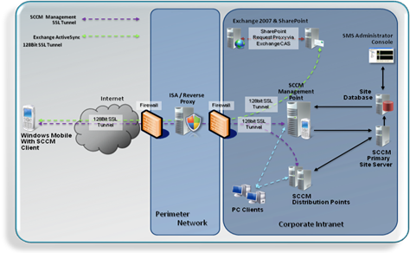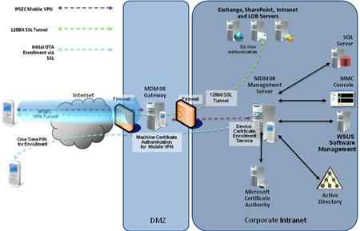
Additional Information
For more information on System Center Mobile Device Manager, see www.windowsmobile.com/mobiledevicemanager
For more information on Configuration Manager, see www.microsoft.com/systemcenter/configmgr
For more information on Windows Mobile devices for business, see http://www.microsoft.com/windowsmobile/enterprise/
©2007 Microsoft Corporation. All rights reserved. This data sheet is for informational purposes only. MICROSOFT MAKES NO WARRANTIES, EXPRESS OR IMPLIED, IN THIS SUMMARY. Microsoft, FrontPage, System Center, Exchange Server, Windows, the Windows logo, Windows Mobile, Windows Server, and Windows Server System are either registered trademarks or trademarks of Microsoft Corporation in the United States and/or other countries. All other trademarks are property of the respective owners.

