# Role-Based Template for SharePoint My Sites: Sales Account Manager

***Functional Overview for***

***Business Decision Makers***

### With personalization becoming an increasingly important business need and the key to effective collaboration, Microsoft® Office SharePoint® Server 2007 offers My Site, a personal site that pulls together summary views of personal information and provides full control over information "for me, by me, and about me." Role-Based Templates for SharePoint My Sites are custom templates designed for Office SharePoint Server 2007 and tailored to address the unique needs and requirements of specific roles. They are envisioned as extensions to the standard My Site functionality, providing a personal portal and dashboard data relevant to your role.

### Role-Based Templates for SharePoint My Sites can provide enhanced business insight and help drive company-wide productivity through a common interface to access priority information from varied sources and systems related to job roles, individual responsibilities, and surrounding processes. The templates display information in a way that is familiar and easy, and is built around the way people in the company work, enabling business decision-making with greater confidence.

### Description of Template

Sales Account Managers direct and coordinate the sales of product and services for business. They spend a lot of time reviewing and analyzing data and information. They support different business units of a company on a wide range of issues, such as opportunity management and customer relationship management. They are required to build customer relationships with a vision of strategic fit, longevity, and trust.

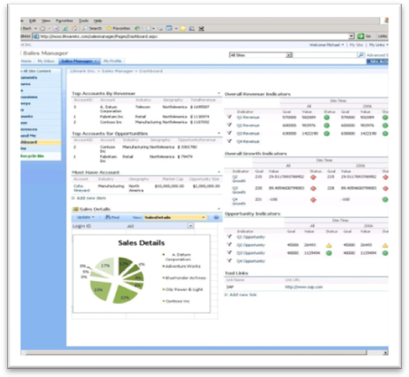

The Sales Account Manager role-based template for SharePoint My Sites helps managers streamline the process of analyzing sales and opportunity information for their overall decision making. The template assists in customer account tracking against a set of performance metrics, such as quarterly revenue, growth, and opportunity. It also provides a graphical view of the geographical distribution of product sales and opportunities. The overall design of this Role-Based My Site template is to help Sales Account Managers attain their goals of customer satisfaction and revenue augmentation.

**Sample Activities Performed in this Role-Based My Site Template**

Role-based My Site templates aim to provide a “one-stop shop” experience that enables users to view and access information relevant to their jobs by unlocking data buried in various business systems. These templates come with sample data. The following example shows how this template might be used in a typical organization.

Michael is a Sales Account Manager in Litware Inc’s Sales department. Like many information workers, he starts his day by accessing his personal productivity tool, Microsoft Office Outlook**®** 2007. Since his company has deployed Microsoft Office SharePoint Server 2007 and Role-Based My Site templates, he also logs into his personal My Site page. He recalls seeing a meeting request email from a customer contact at FabriKam Inc. regarding a big opportunity with a high conversion rate. Instead of going back into Office Outlook 2007, he takes a quick glance through his messages in the E-mails section of his My Inbox page and accepts the meeting. He also sees under the User Tasks section that he had assigned a task to himself to update the meeting notes for a teleconference that he attended with FabriKam Inc. yesterday evening for a proposal. He goes to the References page and updates the same to Recent Meeting Outcomes library using the Microsoft Office InfoPath® 2007 form template.

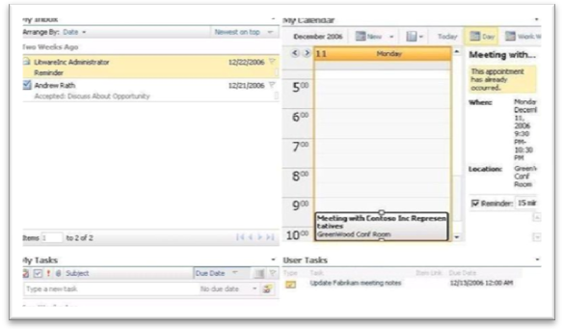

Later in the day, Michael receives a call from a customer, Contoso Inc., saying that they have not received the product that was to be delivered yesterday and the delay is pushing their delivery deadlines. Michael makes frantic calls, locates the delivery hold-up and contacts the customer back to resolve the issue. He visits the Accounts page to update this issue relating to Contoso Inc. and realizes that there was already an issue raised in the recent past. He also views the Account level matrix information, which includes quarterly revenue/opportunity and growth on the KPI Tracking page, providing him an overall view of his accounts. During the process he sees that there is a big opportunity with an account for a Collaboration Server solution and decides to discuss a strategy with his account team to strike the deal. Using the presence integration, Michael sees one of his account team members online, sends an instant message regarding the deal and sets up a meeting for the next day.

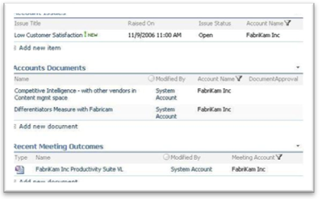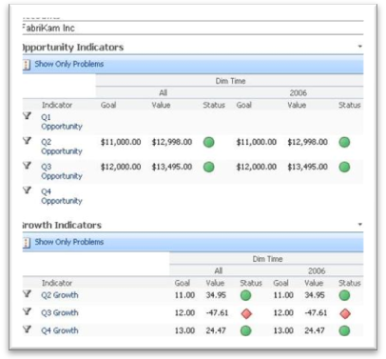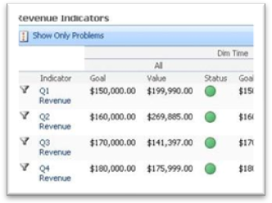

Michael goes for a coffee break and bumps into another sales account manager who asks Michael to check out the announcements. Back in the office, he checks out his Around Me page to see the “Feather in the Cap” award for one of Michael’s accounts for being the fastest growing account in the organization. Michael goes to his Career page to update the self objectives, and adds it to his Awards and Rewards.

Michael goes to the sales portal from the list of internal links on the References page to see that he stands fourth in the organization in terms of overall revenue. He now aims at moving into the top three, so he visits his Dashboard and the KPI tracking page to get an overall perspective of his accounts, including Revenue and Opportunity. He sees two top opportunities, one from Contoso Inc. and one from Fabrikam Inc., and decides to close them as soon as possible.

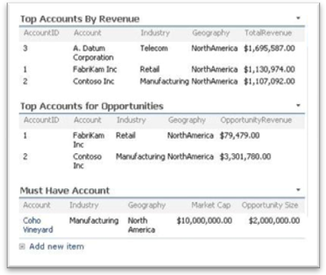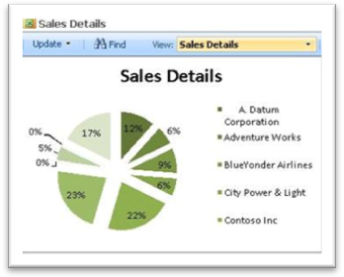

He begins to compile some research for the FabriKam Inc. meeting in the afternoon. He goes to the References page, picks up templates from the corporate repository, and refers to case studies and documents to prepare for the customer presentation. Once done with the presentation, he uploads it to the Accounts Documents library on his Accounts page, which routes the document through an Approval Workflow to his supervisors. After the document gets approved, he sends out a message to his FabriKam Inc. contact about the agenda for the meeting. The meeting with FabriKam Inc. looks to be a success and Michael is optimistic about the opportunity.

**About Microsoft Office SharePoint Server 2007**

Microsoft Office SharePoint Server 2007 is an integrated suite of server capabilities that can help improve organizational effectiveness by providing comprehensive content management and enterprise search, accelerating shared business processes, and facilitating information-sharing across boundaries for better business insight. Office SharePoint Server 2007 supports all intranet, extranet, and Web applications across an enterprise within one integrated platform, instead of relying on separate fragmented systems. Additionally, this collaboration and content management server provides IT professionals and developers with the platform and tools they need for server administration, application extensibility, and interoperability.

**More Information**

For more information on the technologies described in this article, please visit:

Microsoft Office SharePoint Server 2007:

<http://www.microsoft.com/sharepoint>

Role-Based Templates for SharePoint My Sites:

<http://go.microsoft.com/?linkid=6060804>