Application Template: Competitive Analysis Site
Technical Overview for
IT Professionals
Microsoft® Windows® SharePoint® Services 3.0 is technology in Windows Server® that offers an integrated portfolio of collaboration and communication services designed to connect people, information, processes and systems both within and beyond the organizational firewall. Now available at no additional cost, Windows SharePoint Services makes it simpler for IT professionals to implement and manage a team collaboration infrastructure. Application Templates are tailored to address the needs and requirements for specific business processes or sets of tasks for organizations of any size. The templates provide out-of-the-box, customizable scenarios which solve business needs as well as providing a starting point for partners and developers looking to build more sophisticated Windows SharePoint Services solutions.

Description of Template
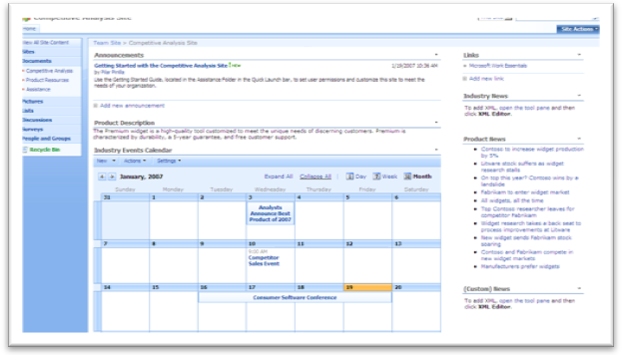
The Competitive Analysis Site application template for Windows SharePoint Services 3.0 helps teams organize and structure the work done to analyze competitors, their products and their services. The site contains several useful techniques, including an industry calendar, links to product news and competitor’s websites and documents with templates of common competitive analysis techniques. The site’s calendar functionality also allows users to automatically create event specific ‘sub-sites’ to manage meeting objectives, track attendees, capture notes and assign action items. As with most Windows SharePoint Services 3.0 based sites, the Competitive Analysis Site integrates with the 2007 Microsoft Office system with features such as automated alerts, RSS feeds and synchronization of Calendar items. This site also includes a web-part to capture XML-based product and industry news feeds from external sites.

Activities Performed in this Application Template
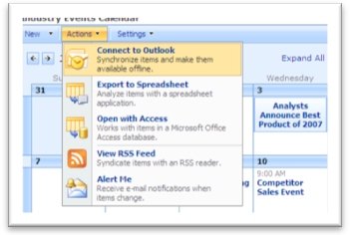
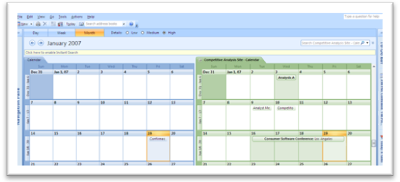
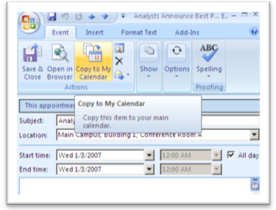
- Tracking of Industry Events: The industry event calendar allows team members to track events that are of interest to the team. Team members can create new event items from within the Competitive Analysis Site or from within Microsoft Office Outlook® 2007. Once the Event Calendar is connected to Office Outlook 2007, event items created within Office Outlook 2007 are synchronized with the Competitive Analysis Site, and are then available to all other team members. Members can also choose to ‘copy’ the event from the Competitive Analysis Site calendar to their main Microsoft Exchange Server based calendar.

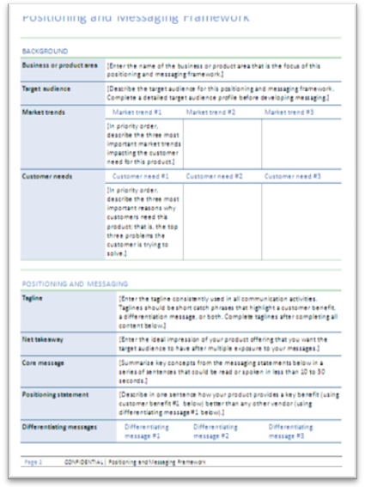
Another function of the Industry Event calendar is the ability for team members to automatically generate meeting or event sub-sites without the need to contact the IT department. Embedded workflow within the application template allows users to choose which type of meeting site they wish to create and generates the site with the click of a button.

- Company Competitive Analysis Template Documents: Included in the Competitive Analysis Site are several Microsoft Office Excel® 2007 templates of industry techniques for structuring competitive analyses. The template includes structures for Product Competitive Analysis, including company and product profiles, features & benefits, sales and distribution elements and market share information. Other tabs on the spredsheet include formats for traditional SWOT (Strenghts, Weaknesses, Opportunities, Threats) Analysis and a Market Share Analysis graph. Team members can collaborate on these templates and save them back to the Competitive Analysis Site for future reference.
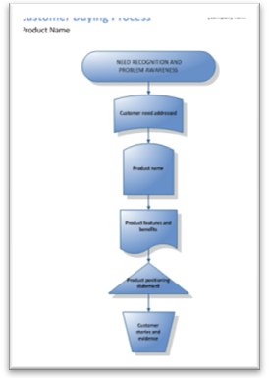
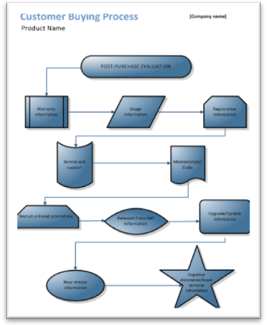
- Product Competitive Analysis Template Documents: Analyzing ompetitor’s products can be made more structured by utilizing the Microsoft Office Visio® 2007 and Microsoft Office Word® 2007 templates provided in the product resources tab. Team members can collaborate to outline the customer buying process from Need & Problem Awareness, Information Search and Alternatives through to Purchase and Post-Purchase Evaluation. In addition, the application template provides a structure for analyzing a product’s positioning and messaging framework.

Site Lists and Libraries
Competitive Analysis: Use this library to host in progress and completed competitive analyses
Product Resources: Use this library to host analyses on company and competitor products and services using the included templates.
Calendar: Track important team and industry events and link them to your existing Office Outlook 2007 calendar.

Customizing SharePoint Sites and Templates
Microsoft Office SharePoint Designer 2007 is a Web site development and management program that provides powerful tools to build, customize, and contribute to Windows SharePoint Services sites using the latest Web design technologies and established standards in an IT-controlled environment.
Use Office SharePoint Designer 2007 to create and deploy interactive solutions without having to write code. Automate business processes, such as document approval, custom event notification and other collaboration tasks with the workflow designer. Create reporting and tracking applications using data views and forms to easily gather and aggregate data from outside your site and from lists and document libraries on the Web.
Extend your solution by building advanced interactive Microsoft ASP.NET pages. Insert and edit controls with the same powerful activity menus and control property grids previously found only in the Microsoft Visual Studio® development system.

Technical Dependencies
The Competitive Analysis Site application template has the following technical requirements:
- Microsoft Windows SharePoint Services 3.0*
- Microsoft Office Excel 2007
- Microsoft Office Word 2007
- Microsoft Office Visio 2007
- Microsoft Office Outlook 2007 (optional)

*Review Windows SharePoint Services 3.0 system requirements for additional information:
http://www.microsoft.com/technet/windowsserver/sharepoint/techinfo/sysreqs.mspx

More Information
For more information on the technologies described in this article, please visit:

Microsoft Windows SharePoint Services 3.0:
http://www.microsoft.com/sharepoint

Microsoft Office SharePoint Designer 2007:
http://office.microsoft.com/sharepointdesigner

Application Templates for Windows SharePoint Services:
http://www.microsoft.com/sharepointapps

