Graph Dynamic Linear   
Equations

**Student Handout**

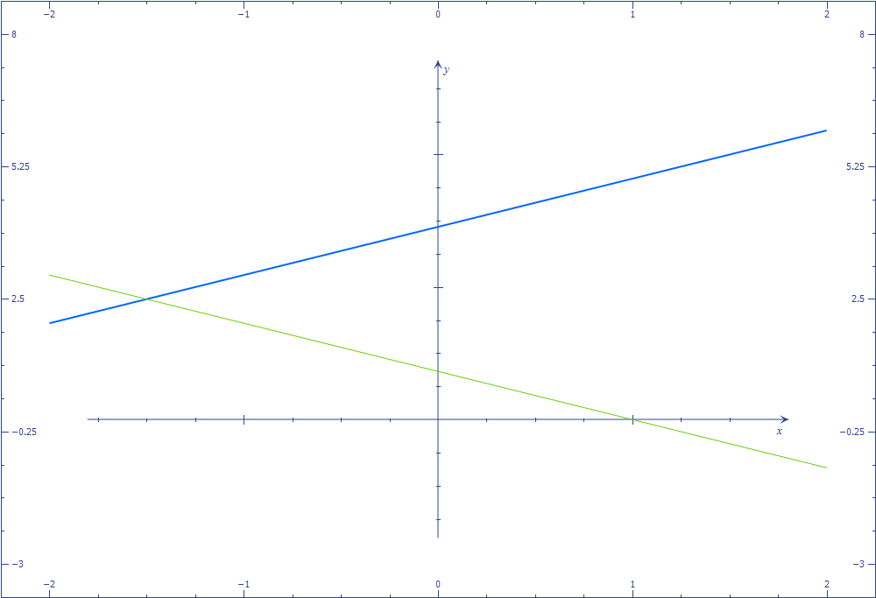

Activity 1: Investigate dynamic linear equations by graphing them

1. Graph y = mx +b in Microsoft Math. Animate **b** from -2 to 2.  
     
   Describe what happens to the graph when b = -2.   
     
      
     
   Describe what happens to the graph when b = 0.   
     
      
     
   Describe what happens to the graph when b = +2.
2. Animate **m** from -2 to 2.  
     
   Describe what happens to the graph when m = -2.   
     
      
     
   Describe what happens to the graph when m = 0.   
     
      
     
   Describe what happens to the graph when m = +2.
3. Now graph y = -3x + 5 on the same axes. Set m and b for y = mx + b so that both graphs coincide. What are m and b when the graphs become the same line? ______________________________________________________________
4. Now set m and b so that the two lines are parallel. What are m and b when the lines are parallel?   
     
   Is there more than one correct answer for m or b?   
     
   Explain why.
5. Now set m and b so that the two lines appear to be perpendicular. (Be sure to click on the Proportional Display Button.) What are m and b when the lines appear to be perpendicular?   
     
   Is there more than one correct answer for m or b?   
     
   Explain why.

Activity 2: Check for understanding

Answer the following questions. Graph on Microsoft Math if you need to confirm your thinking.

1. T or F The graph of y = 2x + 1 crosses the y axis at (0,2).
2. T or F The graphs of y = -x – 1 and y= -x+1 are parallel.
3. T or F The graph of y =3x -1 is rising from left to right.
4. T or F The graph of y = -3x + 1 is falling from left to right.
5. What has to be true of y = mx + b so that its graph will fall from left to right?
6. Write the equation for a line that is horizontal.
7. Where does y = -x -3 cross the y axis?
8. Write a linear function that has a graph that is steeper than the graph of y = x + 1.
9. Write a linear function that has a graph that is falling from left to right and crosses the y axis at (0, -4)
10. Write a linear function that has a graph that is parallel to y = x - 4.
11. Write a linear function that has a graph that is perpendicular to y = -2x + 1.

Activity :3 Use a dynamic linear equation to solve a problem in real life

Read the following scenario and answer the questions:

Excellence Rental Car charges $35 per day + $0.19 mile for its Premier Plan. Excellence Rental Car has other rental plans that charge different amounts. To show customers the differences in the plans, the owner wanted to create a graph of her plans and run the graph as part of an advertisement in the newspaper.

She started playing around with the Premier Plan charges on a graph.

1. First, she reduced the amount of the per-day charges. What was the effect on the graph of the Premier Plan when she did this?____________________________________

________________________________________________________________

1. Next, she increased the cost per mile. What was the effect on the graph of the Premier Plan?_____________________________________________________________

_________________________________________________________________

When she looked at the graphs of her other car rental plans, one plan turned out to be parallel to the graph of the Premier Plan.

1. What can you conclude about this other plan? ______________________________

_________________________________________________________________

Activity 4: Explain the conditions and effects of graphing linear equations

Write a paragraph explaining what happens to the graph of y = mx + b when the parameters m and b are changed. Imagine you are explaining it to a classmate who was not at school today.   
   
   
   
   
   
   
   
   
Write a paragraph explaining the requirements on y = mx + b for two lines that are parallel or perpendicular.