Explore population density

Tools

How to find a video in Encarta

- Launch Microsoft Student 2008. Type your search words (flamingo colony) in the search box at the top of the page.
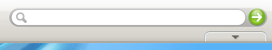
- Press Enter, or click .

The search results list displays the closest matches to the term you searched for. Results are divided into categories:  - Articles - Dictionaries  - Maps - Web Links  - Photos & More (This includes the videos) - Quotations  Best Matches contains the most relevant results across all categories. To see only results within a specific category, click that category. | 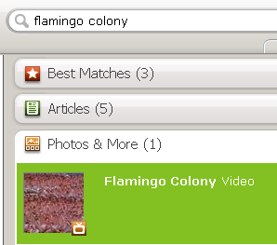
Tip 1
To hide the search results list, move the mouse away from it. To display it again, click the Show Search Results List button under the Search box or click the green arrow again.
Tip 2
Notice the video icon. When you are searching for resources, look for the video icon if you are interested in finding other videos.
Tip 3
Another way to find videos is to go to the Student 08 Homepage>Discover and Learn>Games and Fun Stuff>Videos Folder.

How to use the statistical map

- On any page of Encarta, click the Homework Tools button at the top.  - Under Geography Tools, click World Atlas. | 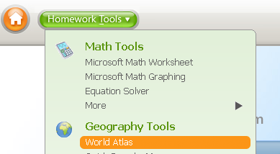
- In the list on the right of map styles, click Statistical. | 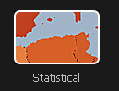
- Click Choose Statistic. | 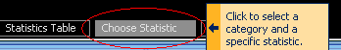
- Click Population, and then click Population Density.  The corresponding map appears. | 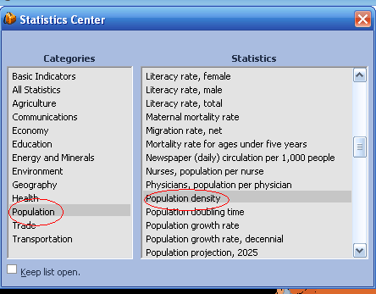
- To view the selected statistic for all countries, click Statistics Table. | 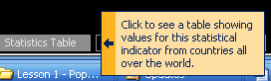

How to navigate World Atlas

You can use the following buttons to navigate the map.
Button | Description
 | To move the map, click this button, and then drag the hand across the map.
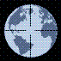 | Drag the pointer over the globe in the direction you want to move the map.
Click the plus and minus signs, or drag the slider, to zoom.

When you zoom in and out on the center of a map, the zoom tool slider displays the distance above the Earth from which the map is viewed.
 | To select a part of the map for copying, printing, or magnification, click this button, and then drag a box around the area of the map that you want to use.
 | View latitude-longitude information on an atlas map.
 | Measure the distance between two or more points on an atlas map.
 | Add a note to a location on the map.

How to use Map Trek

- Click the Homework Tools button. Under Geography Tools, click Map Treks. | 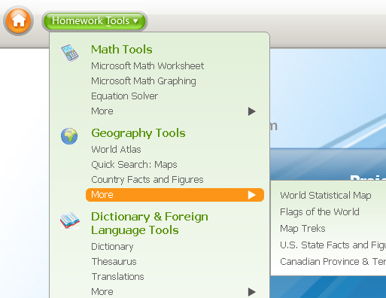
- Click Population Density. | 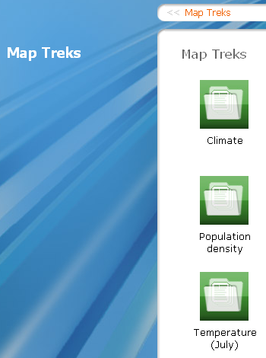
- Click a tour. | 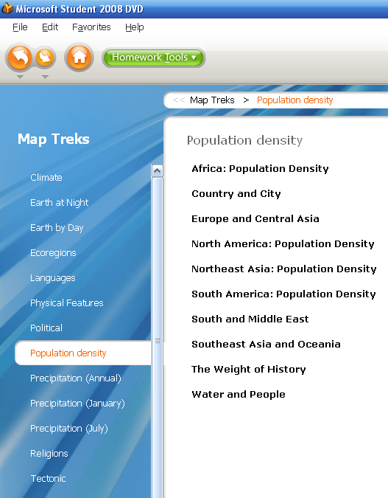
- In the Map Trek dialog box, do one of the following to view a tour stop:  In the right pane, click a tour stop.  Click Back or Next.  The corresponding atlas map appears. | 